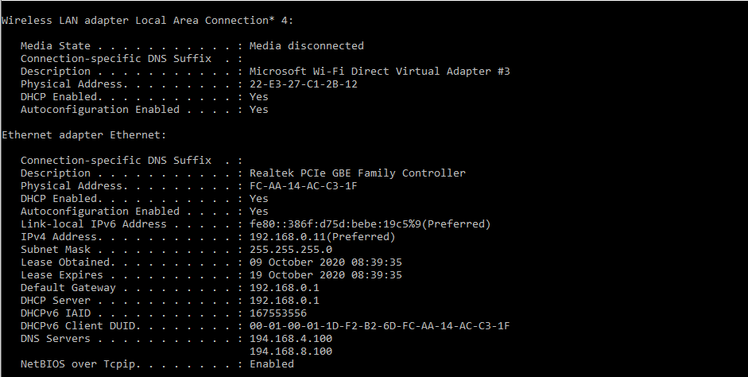

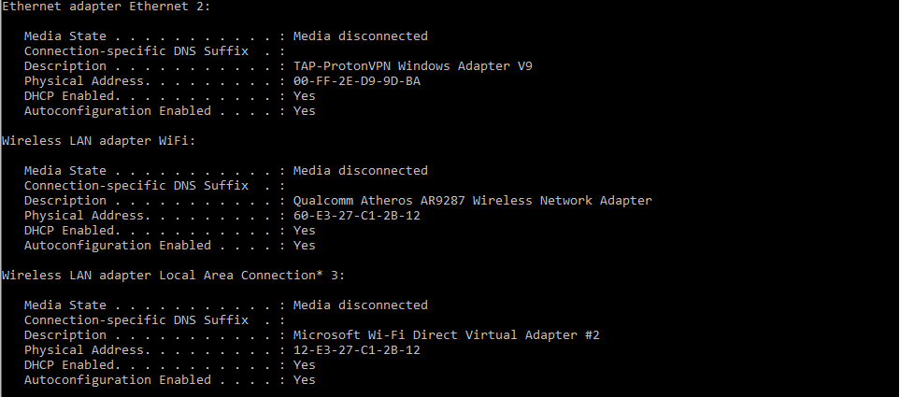

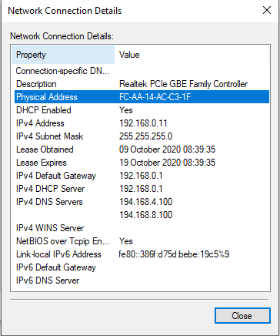
 |  | Unique Identifier for the
Manufacturer OUI |  | Interface |  | Vendor Name
60-E3-27-C1-2B-12 | 60:E3:27 |  |  | Tp-Link Technologies Co.,Ltd.
FC-AA-14-AC-C3-1F |  | FC:AA |  | :14 Giga-Byte Technology Co.,Ltd.

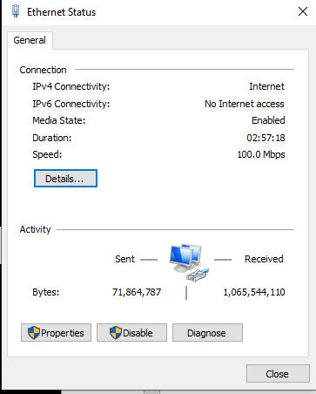 I’m using ethernet connection. I couldn’t do step 12 and 13 because I don’t have wireless connection.

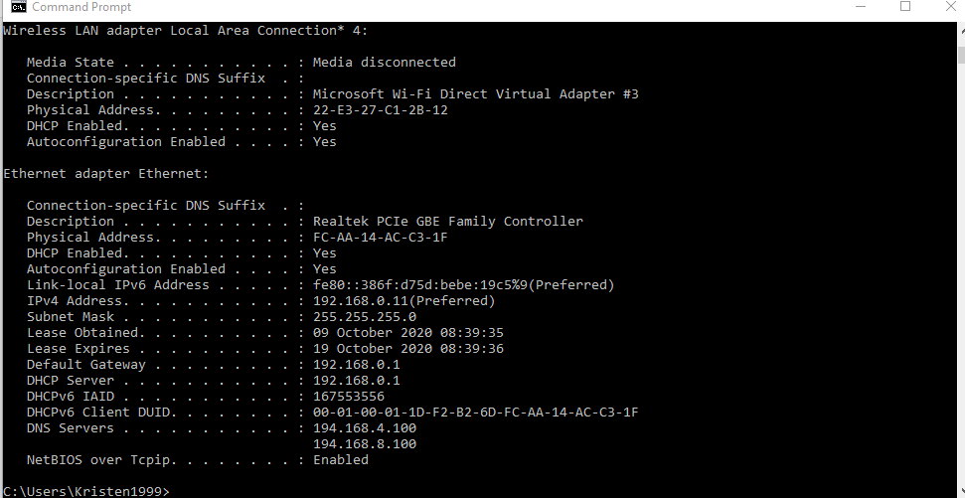

Due to the fact I don’t have wi-fi I did not do step 12-25.



