RYAN DUGMORE
STUDENT ID- 2023914
RESEARCH METHODOLOGY

Introduction
In this chapter, the research methodology will be explained to consider how South Wales Police disrupts serious and organised crime on the public roads. By explaining this, it will help achieve in answering the main objectives of this research which are;
- Identifying the great effects that serious and organised Crime has on its offenders and the victims.
- Assessing the disruption tactics in which South Wales Police use in order to overcome Serious and Organised Crime.
- Analysing whether the tactics that are used by South Wales Police are effective in preventing Serious and Organised crime on the public roads.
Research methodology is procedures, techniques, and a system of models that can be used in order to assist with finding the results of a research problem (Panneerselvam, 2014, p.3). There are two types of research in which are used, which are primary and secondary research. Primary research is research in which is collected first hand by the researcher, rather than research that is based upon information found in books or on the internet (Lowe and Zemliansky, 2011, p.153). Secondary research is referred to as the analysis of the primary research, and it can review the primary research evidence in which is collected (Bermingham,2020).

Research Strategy
An internet questionnaire is going to be distributed in order to obtain research information for myself, as questionnaires are an effective way of finding a mixture of qualitative and quantitative data. A questionnaire will be compiled from a series of questions, with the purpose of it being to gather information from the respondents (Mcleod, 2023). Qualitative data is information in which cannot be measured or counted, with the focus of this data being on exploring subjective experiences, attitudes and opinions through the researcher’s observation (McLeod, 2023). Qualitative date will be aimed to be obtained by asking the persons taking part in the questionnaire questions which are open ended. An open-ended question will allow the respondent to demonstrate themselves more freely on a given topic and allows the respondent to use their own terminology (Fauvelle, 2019). Quantitative data is information in which can be measured or counted, and this form of data is seemed to be more universal and fixed (Stevens, 2020). Quantitative data is going to be obtained by the respondent by asking them closed questions, which differs from the open-ended questions asked in order to obtain qualitative data. Closed-ended questions are more straight to the point and allow the respondent to have a limited number of options to respond with (Dossetto, 2023). By using a questionnaire with both open and closed questions, it will allow a variation of responses from the persons who are taking part, which will consist of responses that are more direct, and responses in which have more of an opinion from the persons who are taking part. There will be a mixture of questions which will allows the respondent to tick boxes, and on other questions allows the respondent to free type and give more of a detailed response to what is being asked. It is important that my target sample is aimed towards police officers who are working within South Wales Police, as they will already have a good understanding of the main objectives of this research, therefore they will be able to provide detailed responses to what is being asked of them. The questionnaire will have a range of approximately 10-15 questions, with it predicting to reach a sample size between 40 and 100 people. The findings from the research are going to be analysed into pie charts and bar graphs, as the data the information obtained in this format is easily understandable, however it is important that the pie charts and bar graphs are highlighted in a way which is relevant and coheres (Amaresan, 2019).

Research Onion
Saunders et al. (2007) developed what is now known as the research onion, which explains the different decisions that will be made when a person is creating and developing a research methodology (Phair and Warren, 2021). According to Melnikovas (2018), the research methodology has its starting point with the main philosophy, which chooses methods and strategies, approaches, as well as the conclusion of time horizons. This altogether takes the research logic to the research design.
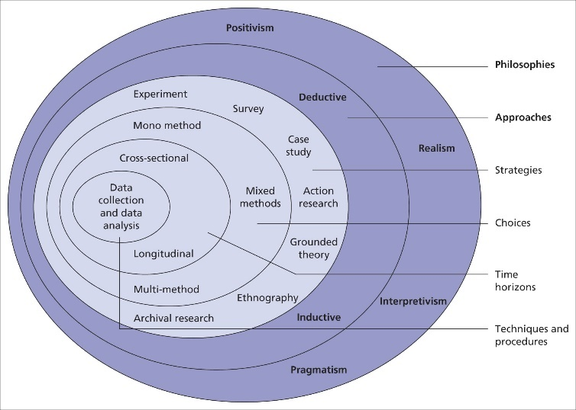
The Research Onion, (Saunders et al. 2007).

Limitations and ethical issues
There may be limitations and ethical issues when conducting the questionnaire which I have considered prior to my commencement. The main limitation in which may result in issues arising for my research, is the work commitments of those who I wish to involve. As my target sample is going to be police officers within South Wales Police, I am aware that they already have busy schedules, therefore asking them to take part in my questionnaire may add to the pressure in which they are already under. As a result of this, it is important that my questionnaire does not consist of too many questions, so that the persons who are taking part and aren’t committing too much of their time.
I have also considered ethical issues which may arise and how I will overcome these. Persons who are going to take part in the questionnaire are going to remain anonymous, therefore no personal data such as their names, date of birth, addresses will be obtained or stored. The potential for harm must be considered, such as psychological harm or social harm. This may deter persons taking part in my questionnaire, therefore I will need to ensure that the welfare and safety for those taking part is paramount. Also, participation is voluntary, therefore no pressure will be added to those persons who wish not to take part, and the persons who are to take part are to be made aware that they can withdraw at any point.

Summary
In summary, the research methodology relating to the question of “How South Wales Police disrupts serious and organised crime” has been explained, which will assist me in the next chapter of my research in creating a questionnaire. The feedback which is received from the questionnaire that I create will be analysed and discussed in further detail.
WORD COUNT-1018

References
Bermingham, R. (2020). Study designs: secondary research. post.parliament.uk. Available at: https://post.parliament.uk/study-designs-secondary-research/ (Accessed 14 Jun. 2023).
Dossetto, F. (2023). Open-Ended vs. Closed-Ended Questions: User Surveys Examples. Available at: https://www.hotjar.com/blog/open-ended-questions/ (Accessed 14 Jun. 2023).
Fauvelle, L. (2019). Qualitative research: open-ended and closed-ended questions. Market research consulting. Available at: https://www.intotheminds.com/blog/en/qualitative-research-open-and-closed-ended-questions/#:~:text=Instead%2C%20open%2Dended%20questions%20are (Accessed 14 Jun. 2023).
Lowe, C. and Zemliansky, P. (2011). Writing Spaces 2: Readings on Writing. Google Books, Parlor Press LLC, p.153. Available at: https://books.google.co.uk/books?hl=en&lr=&id=sqoWEAAAQBAJ&oi=fnd&pg=PA153&dq=what+is+primary+research&ots=Hdu2EltsJv&sig=9hxDkcN2oiLeriGKG8XRm9soE7c#v=onepage&q=what%20is%20primary%20research&f=false (Accessed 14 Jun. 2023).
McLeod, S. (2023). What’s the Difference between Qualitative and Quantitative research? Available at: https://www.simplypsychology.org/qualitative-quantitative.html (Accessed 14 Jun. 2023).
Mcleod, S. (2023). Questionnaire: Definition, examples, design and types. Simply Psychology. Available at: https://www.simplypsychology.org/questionnaires.html (Accessed 15 Jun. 2023).
Melnikovas, A. (2018). Towards an Explicit Research Methodology: Adapting Research Onion Model for Futures Studies. Journal of Futures Studies, 23(2), p.5. doi:https://doi.org/10.6531/JFS.201812_23(2).0003. (Accessed 14 Jun. 2023).

Panneerslevam, R. (2014) RESEARCH METHODOLOGY. Google Books, PHI Learning Pvt. Ltd., p.3. Available at: https://books.google.co.uk/books?hl=en&lr=&id=-pBeBAAAQBAJ&oi=fnd&pg=PP1&dq=research+methodology&ots=W2fBA2X9Qt&sig=YlMpbBAnlwSMW1weBBkskWW8t6E#v=onepage&q=research%20methodology&f=false (Accessed 14 Jun. 2023).
Phair, D. and Warren, K. (2021). Saunders’ Research Onion: Explained Simply. Available at: https://gradcoach.com/saunders-research-onion/ (Accessed 14 Jun. 2023).
Stevens, E. (2020). What is Quantitative Data? Available at: https://careerfoundry.com/en/blog/data-analytics/what-is-quantitative-data/ (Accessed 14 Jun. 2023).
Swetha Amaresan (2019). How to Analyze Survey Results Like a Data Pro. Available at: https://blog.hubspot.com/service/survey-results (Accessed 15 Jun. 2023).

