

Problem Solving and Decision Making
Students Name : Veronica Capatina
Students ID : 2113726
Module code : (BMSW4004_LON)
Lecturer name : Saqib Shamim
Submission date : 03\09\2022

Table of Contents
Introduction 3
Definition of a problem 3
Techniques of solving a Problem 3
Complex problem in the workplace 4
Scope of the problem 4
Impacts 5
Analysis of the information on the identified problem for an informed decision making 5
PESTLE analysis 5
Political factors 5
Economic factors 5
Social factors 5
Technological factors 6
Legal factors 6
Environmental factors 6
SWOT analysis 6
Strengths 6
Weakness 6
Opportunities 7
Threat 7
Propose a range of alternative solutions to the problem 7
An evaluation of alternative solution 7
The problem-solving models 7
The alternative solution 7
Identification of the most appropriate solution 8
Plan for implementation of the solution 9
Evaluation of the outcome 9
Communication of the plan to the stakeholders. 10
Monitoring the change 11
Conclusion 11
Reference 12

Introduction
Every company organization encounters a few common and complicated issues during their everyday operations. For businesses to grow and participate to the establishment of their brand name, problem-solving is a crucial component (Aarikka-Stenroos et al., 2012). Every corporate enterprise deal with the issue of employee-employer conflict. An organization's management team needs to be capable of handling problems as they arise. The management should make judgments quickly so that problems can be solved right away. Because managers should value their ability to make decisions quickly that affect their company (Drucker and Peter, 2017). This role play will highlight the problems that the employees face in the workplace and the reasons for job dissatisfaction in the workplace.

Definition of a problem
Simple terms, an issue is everything or anything that is perceived as unpleasant or detrimental and needs to be handled with and solved. A problem is defined as a perceived disagreement between an activity's current state and its ideal state in the business dictionary. Another way to characterise an issue is as a departure from accepted practises, standards, or the status quo (Muthukrishna, et al., 2019).

Techniques of solving a Problem
There are numerous strategies for resolving unforeseen occurrences in managers' and employees'—operations inside a company. The fishbone diagram, commonly known as the Ishikawa diagram, is a strategy for resolving issues. This method, which aids staff in avoiding solutions that ultimately lead to more serious issues, is thought to have been developed by Japanese quality expert Dr. Kaoru Ishikawa. The corporation refers to this as a complex problem. To focus dialogue during panel discussions, a fishbone diagram is crucial, (Margaret Rouse, 2015). The skeleton or bones of a fish are contrasted using a diagram. Fishbone diagrams are often drawn from right to left, having smaller, more detailed "bones" branching off from each big "bone" of the fish.
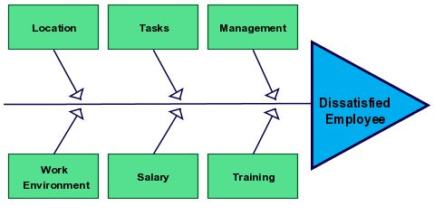

Complex problem in the workplace
It is challenging to characterise a complicated problem since it differs from person to person and company to company (Sustaining Community, 2018). For another company firm, a situation that is extremely difficult for Diageo may be very straightforward. Any issue could get difficult at some point.
Job dissatisfaction was the main complex in the workplace and the employees who are the min stakeholders in the organization were not happy. Job dissatisfaction was brought in by the employees feeling that they are not paid well, the lack of a proper way and a clear instruction sin the workplace (Chufor and Lena, 20210. This problem is a very complex problem for the company as their main stakeholders are not satisfied at all.

Scope of the problem
The company's workers may be affected by this issue. The unions, distributors, and rival businesses might benefit from this conflict. Job performance and everyday routines may be hindered. The consistency of the shift patterns might be ruined (Jakobsson et al., 2021). Given that Diageo is a multinational corporation, they risk losing their share of the global market. The business's initiatives might all be lost. The bottom rung of the organizational hierarchy in terms of human resources might encounter this complexity in the company's shareholders. This could consequently lead to the merging of numerous other issues.
Some of the scopes of this problem is stated below:
- Underpayment
- Lack of meaning behind a role
- Poor management
- Poor communication ways by the management

Impacts
Job unhappiness can have a detrimental effect on your bottom line in addition to lowering productivity and motivation (Herzberg and Frederick, 2008). When workers are not motivated by their jobs, then become less effective and provide high-quality services. Some of the consequences of job dissatisfactions includes low productivity in an organization, lack of motivation among the employees, the employees will be absent for work, frustrations among the employees and the lack of interest to work. This will result in the company’s productivity reducing drastically.

Analysis of the information on the identified problem for an informed decision making

PESTLE analysis
PESTLE analysis is used to analyses the macro environmental factors that occurs in the workplace. The political, economic, social, technological, legal and environmental factors will be analyzed (Perera and Rashain,2017).

Political factors
The company has been able to have a lot of political factors such as trade restrictions from the government of the UK. The shortage of the workforce also has caused a lot of impacts on the working environment where it has led to the increase of the workload of the employees. With the current governments regulations and restriction due to the covid-19 pandemic, it has caused a lot of changes in the workplace (Yang et al., 2018).

Economic factors
With the current pandemic the economy of the UK has been affected. The UK is known of its high economy. Companies have also been affected rise in the economy where the companies have resulted to cut off labor cost so as to meet the changes in the economy.

Social factors
With shifting societal values and client preferences due to the covid-19, the organisation is now trying to modify their workplace to be able to meet the restrictions that have been imposed by the government of the UK. The interactions of the employees in the workplace have been limited and some of the employees have been asked to work from home.

Technological factors
In terms of the technological component, incorrect use of cutting-edge innovation, including artificial intelligence as well as virtual reality, is preventing quality - related facilitation, negatively affecting workplace mechanization, and directly affecting workplace flexibility (Gatta et al., 2019).

Legal factors
The company has been able to maintain the counties code of conduct of conducting business. Diageo company has got legal policies that has enable it to succeed in its business and the business environments.

Environmental factors
Some of the factors that has affected the working environment is the failure of the organizations and the companies to implement the corporate social responsibility in the workplace. The government of UK has set up laws that will see the organizations being able to adequately preserve the environment by disposing their waste appropriately.

SWOT analysis
SWOT analysis will help in identifying and solving of the problems in the organization. It entails the strengths, weakness, opportunities, and the strengths (Sarsby and Alan., 2016).

Strengths
- Competent personnel’s to be able to resolve the problem early
- Availability of funds to be able to solve the problem
- Identification of the challenge earlier

Weakness
- Poor management
- Unmotivated employees
- Poor direction from the management to employees

Opportunities
- Job training
- Availability of alternative solution

Threat
- Customers dissatisfaction
- Productivity loss and profit loss
- Low employee turnout

Propose a range of alternative solutions to the problem

An evaluation of alternative solution
The workers in the Diageo are dissatisfied with the work in the working environment. The company can employ several ways of solving the problem within the organisation workplace.

The problem-solving models
Simon's model was recognized in 1979, although Sprague as well as Carlsson will shortly offer incorporation that was not included in Simon's initial work (1982). Simon's three-part framework for identifying drawbacks consists of the Intellect part, in which the decision-maker looks for signs that a move is about to end, the Layout part, in which the approaches are established and analysed, and finally the Selection part, in which one of the alternative solutions is picked and put into action. The Choice Phase symbolises the pinnacle of the decision-making process, yet the model is overly simplistic and can be used for any problem-solving endeavour. However, this model makes it simple to trace the whole identiﬁcation of HVT, the usage of a joint effort is necessary in the whole decision-making cycle is merely implied and requires to be depicted. The Boyd's model contains four stages: observe, organise, choose, and act (Campitelli eta al., 2010).

The alternative solution
From the interview, the most cause of job dissatisfaction within the organizations is the underpayment of the employees and they feel that the work load they perform is not equivalent to what they are being paid. Here are the various alternatives that have been approached to enhance job satisfaction in the workplace.
- Salary increments to the employees
- Addition of labor to reduce the workload
- Provision of a clear instruction in the workplace.
- There should be also a proper communication between the employees and the managements.

Identification of the most appropriate solution
To choose the best solution, there are numerous possibilities available. In order to determining the best answer, we will be scoring the options in a variety of categories to complement the problem technique (Badger, 2019). The PMI chart will be used to identify the appropriate alternative solution
Plus | Minus | interesting
Salary increase will increase the employee motivations (+5)  Salary increment encourages the employee’s satisfaction and the hard work of the employee (+2)  total (+7) | The employees might work for less hours as expected (-2)  It might be difficult in tracking the employee’s performance (-2)  (-4) | We might achieve employee satisfaction and company profits by increasing their salaries to enhance the employee’s productivity

From the PMI chart, the plus has overweighted the negative hence it shows the company will use the plus to mitigate the challenge on job dissatisfaction.

Plan for implementation of the solution
Employees are the pillars of the workforce in the organization. The company has taken steps to be able to have a satisfied employee at the workplace.
Problem | Method | Time
Job dissatisfaction | The method that will be used to solve the job dissatisfaction in the organization is the increasement of their salaries as per their grievances they employees feel that their work is not equivalent to their pay. | From next month the pay rise will be implemented

Evaluation of the outcome
Some of the outcome of salary increment in the organisation includes that the productivity of the employees and the better teamwork will be realized in the workplace. Employees also will be motivated to work well withing their given role in the working environment hence satisfaction of the employees (Kabir et al., 20110. Having a satisfied employee increases the employees hard work and it ensure that they achieve the companies’ goals. A proactive and a productive employee will always need to be motivated at their workplace. One of the ways of motivating such employee is by increasing their salaries. Although they are various ways of ensuring that the employees in an organization are happy and satisfied, salary increment is seen as the most reward that an employer uses to appreciate the worker for the work that he or she is doing in the organization. Some of the ways of ensuring there is satisfaction at workplace includes having a conducive working environment for the workers, ensuring that the employees health and safety is maintained, allocation of the employees to their roles as per their experience and a good communication channel in the workplace.

Communication of the plan to the stakeholders.
The implementations of changes in any company requires the approval of the stakeholders. The stakeholder in the company includes the management, the employees, consumers and the owner of the business.
Stakeholder | Interest | Key  Issues | Communication Vehicle | Frequency | Comments
The management | They are responsible for the changes that occurs within the organization | Rise in profit | SMS, Zoom meetings and emails | Ever noon time before the implementation was finally completed | Implementation of the solution requires that managements are involved in its making (Li & Liu, 2018).
Customer | It is interested with the companies’ actions | Alerting them when it’s done | Media platforms | At least two days before the plan is implemented | Customers are essential to the company so keeping then informed is our priority
The employees | Its has got a huge impact on the company’s production and profit realization (Ball, 2019). | Keeping the work production high and making the company realise its main goals. | SMS, notice board and also meetings | A month before its implemented | Making the employees know the changes will see the employees be motivated and valued

Monitoring the change
The organisation can be able to achieve and complete the implementation of a plan by following the following steps’ identification of the change, develop the plan, communicate changes, reasons for change, feedback, launching of the change, monitor the change and finally evaluate the change (Sanghera and Paul., 2019).
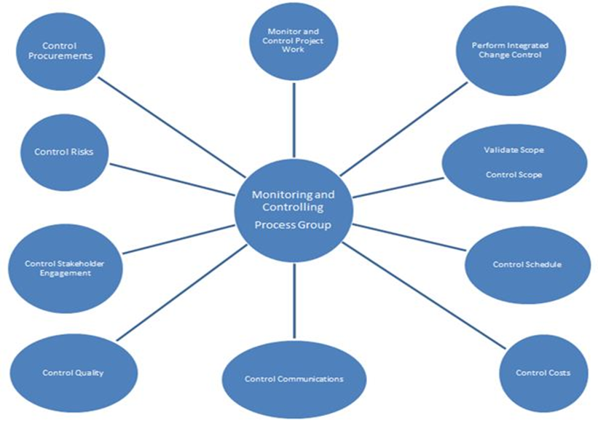

Conclusion
Any firm would benefit greatly from learning regarding problem-solving and decision-making techniques. They must be familiar with the numerous instruments for complicated problem handling in their line of work. Diageo being one of the international recognized companies, it faced a problem within its workplace where the employees was not satisfied about their job. The company have been able to employ several techniques to identify the unsatisfactory problem within their workplace and have come up with an appropriate plan to be able to deal with the problem. Additionally, the organization has communicated with the stakeholders and an effective plan to monitor and control the solutions has also been put in place.

Reference
Aarikka-Stenroos, L. and Jaakkola, E., 2012. Value co-creation in knowledge intensive business services: A dyadic perspective on the joint problem solving process. Industrial marketing management, 41(1), pp.15-26.
Badger, M., 2019. Generalized rectifiability of measures and the identification problem. Complex Analysis and its Synergies, 5(1), pp.1-17.
Campitelli, G. and Gobet, F., 2010. Herbert Simon's decision-making approach: Investigation of cognitive processes in experts. Review of general psychology, 14(4), pp.354-364.
Chufor, L., 2021. THE PERCEPTION OF JOB STRESS BY EMPLOYEES AND ITS EFFECT ON EMPLOYEES PRODUCTIVITY: A Comparative qualitative study of Ecobank in Cameroon and Nigeria.
Drucker, P., 2017. Concept of the Corporation. Routledge.
Gatta, V., Marcucci, E., Delle Site, P., Le Pira, M. and Carrocci, C.S., 2019. Planning with stakeholders: Analysing alternative off-hour delivery solutions via an interactive multi-criteria approach. Research in Transportation Economics, 73, pp.53-62.
Herzberg, F., 2008. One more time: How do you motivate employees?. Harvard Business Review Press.
Jakobsson, R., Olofsson, E. and Ambrose-Oji, B., 2021. Stakeholder perceptions, management and impacts of forestry conflicts in southern Sweden. Scandinavian Journal of Forest Research, 36(1), pp.68-82.
Kabir, M.N. and Parvin, M.M., 2011. Factors affecting employee job satisfaction of pharmaceutical sector. Australian journal of business and management research, 1(9), pp.113-123.
Muthukrishna, M. and Henrich, J., 2019. A problem in theory. Nature Human Behaviour, 3(3), pp.221-229.
Perera, R., 2017. The PESTLE analysis. Nerdynaut.
Rouse, M., Fishbone diagram, 2015. URL: https://whatis. techtarget. com/definition/fishbone-diagram (2018-08-26).
Sanghera, P., 2019. Monitoring and Controlling the Project Work. In PMP® in Depth (pp. 439-478). Apress, Berkeley, CA.
Sarsby, A., 2016. SWOT analysis. Lulu. com.
Sustaining Community, (2018). What are complex problems? Also available at: https://sustainingcommunity.wordpress.com/2014/11/06/complex-problems/. [Accessed on: July 15, 2018]
Yang, Y., Huang, L. and Ma, M., 2018. Breaking the beam search curse: A study of (re-) scoring methods and stopping criteria. arXiv preprint arXiv:1808.09582.

