Slide 1: Title Slide

Slide 2: Introduction

The chosen topic is the sustainability of food waste and its effectiveness. The growing environmental awareness, changes in customer requirements, and tougher regulatory demands contribute to the emergence of sustainability as a major concern in the hotel and hospitality industry. Food waste is also a major operational and environmental problem in the hotel industry that leads to financial deficit and carbon emissions. The targeted area of this research is to reduce the amount of food waste in hotel businesses through the implementation of intelligent approaches to inventory management as an element of sustainability. The presentation critically examines how such practices can help to minimise operational losses and, reduce the environmental impact.

Slide 3: Background
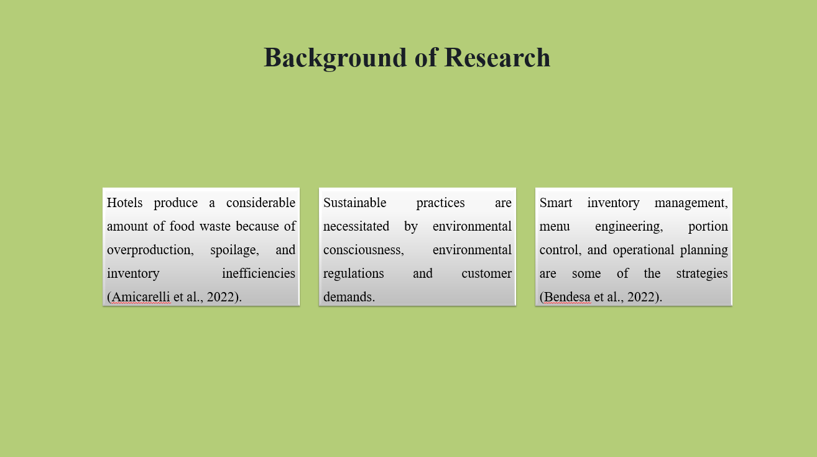
The hospitality industry generates food waste in large quantities due to excessive production, spoilage, and poor inventory control (Amicarelli et al., 2022). Sustainability has become a priority due to the increased environmental awareness, regulation, and customer demands. Some of the strategies adopted by hotels to minimise waste include smart inventory systems, menu engineering, portion control, and operational planning. This presentation relies on the Triple Bottom Line model and secondary research in order to measure the environmental, economic and social performance of these programs.

Slide 4: Literature Review

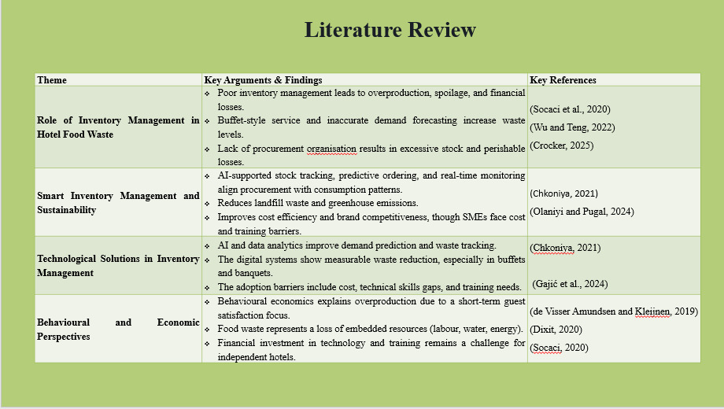
Inventory mismanagement has been cited in the literature as one of the key contributors to food waste in the hotel industry, especially in buffet systems where excess production is done to satisfy the guests. According to recent research, smart inventory systems that operate on AI and predictive analytics are one of the most promising sustainability tools. Through these systems, spoilage, landfill wastes and operational costs are reduced, and environmental performance is improved within the Triple Bottom Line model. The adoption is not even among small and medium-sized hotels because of the financial and technical barriers. Behavioural economics also argues that the reason why so much managerial decision-making is focused on short-term guest experience, as opposed to long-term sustainability objectives.

Slide 5: Literature Review: Key Theories
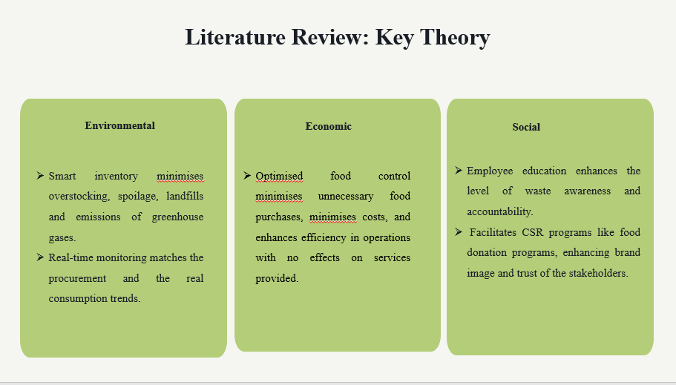
Triple Bottom Line is a framework that was developed by Elkington to assess the sustainability on environmental, economic, and social levels. This model is closely related to food waste reduction in the hospitality environment. Smart inventory systems would lower carbon emissions and landfill waste through overproduction prevention. Optimised procurement is economical in terms of the costs incurred to conduct operations and increases profitability without influencing the guest experience. Inventory management on a social level promotes the involvement of staff and facilitates corporate social responsibility efforts like the redistribution of surplus food. TBL, thus, offers an overall model that can be used to assess the contribution of intelligent inventory management to the operational effectiveness as well as the long-term sustained value creation within the hotel industry.

Slide 6: Literature Review- Research Gap

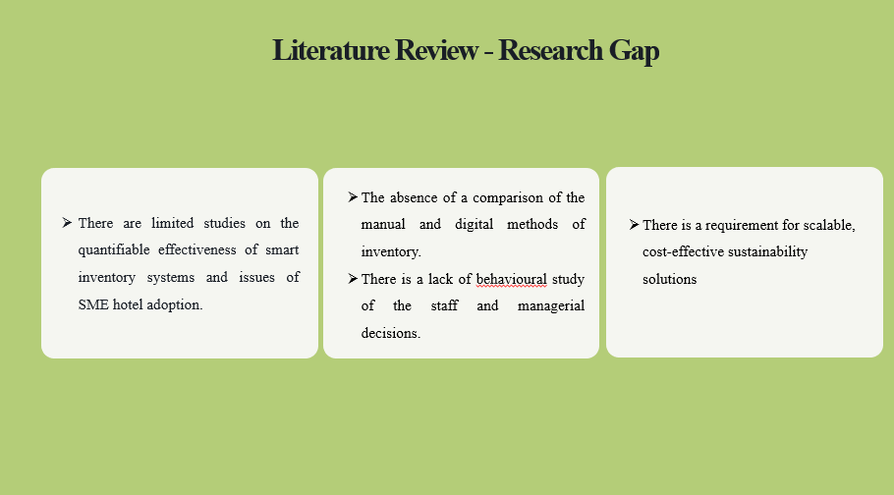
Despite the substantial scholarly interest in the field of food waste in the hospitality sector, the existing research gap is evident. The available literature centres on the general sustainability strategies, but does not provide the quantifiable effects of smart inventory management systems. The comparative analysis of the traditional manual form of stock control and the digital systems that are driven by AI. Moreover, such behavioural aspects as the decision-making by managers and compliance among staff members are under-researched. Hotels of small and medium sizes have their own financial and technical limitations, but the literature on this issue is rather limited. This paper would thus endeavour to fill these gaps by critically analysing the smart inventory practices as a sustainability solution, both operationally and strategically.

Slide 7: Method: PESTEL
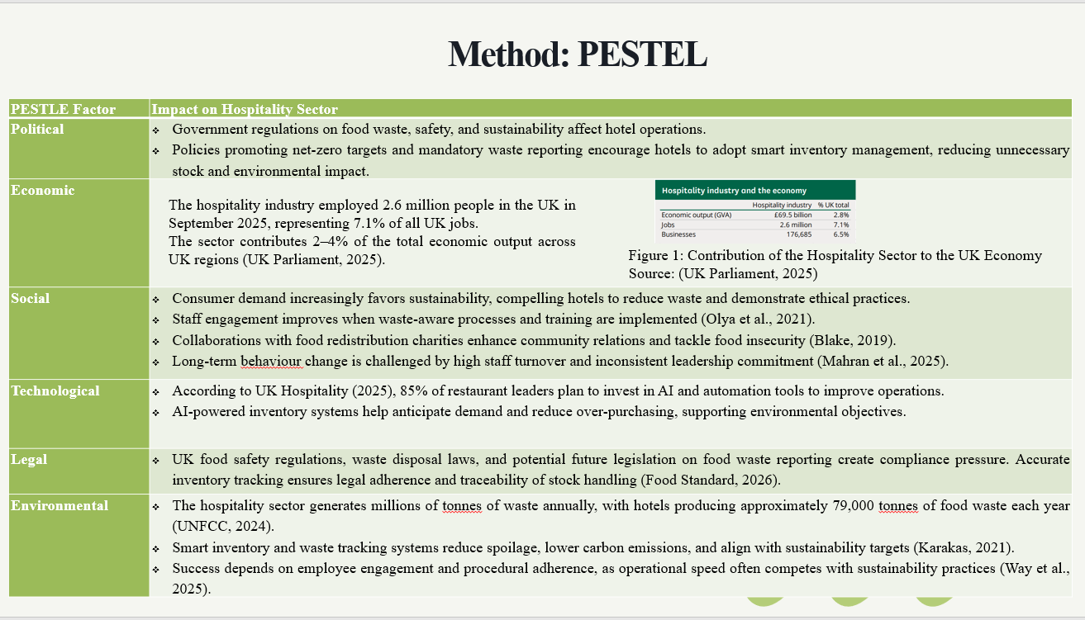

Slide 9: Critical Evaluation

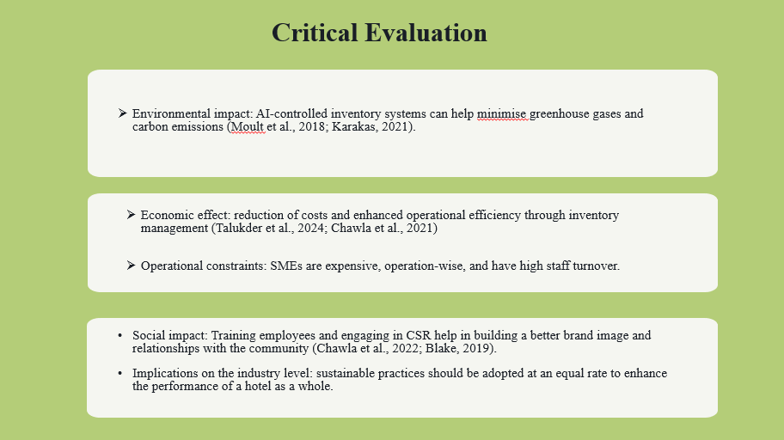
Environmentally, the reduction of food waste minimises the emission of greenhouse gases, especially the methane generated in landfills. Inventory systems based on AI allow hotels to predict demand and avoid unneeded food purchases, which also helps in carbon reduction goals (Karakas, 2021). Financially, an effective waste management strategy saves money by improving stock turnover, proper demand planning, and simplified operations in a luxury hotel to facilitate financial performance (Chawla et al., 2021). Training and employee engagement are socially important in defining pro-environmental behaviours. Corporate social initiatives like partnering with food redistribution charities enhance the brand image and support the well-being of the local community (Chawla et al., 2022). The critical analysis demonstrates that, in case food waste reduction is organised in terms of environmental, economic, and social factors, hotels can become more sustainable in terms of their performance and efficiency. However, to successfully implement it, there is a need to balance the adoption of technology, staff engagement, and resources to attain the long-term returns.

Slide 10: Strengths and Limitations of Industry Responses
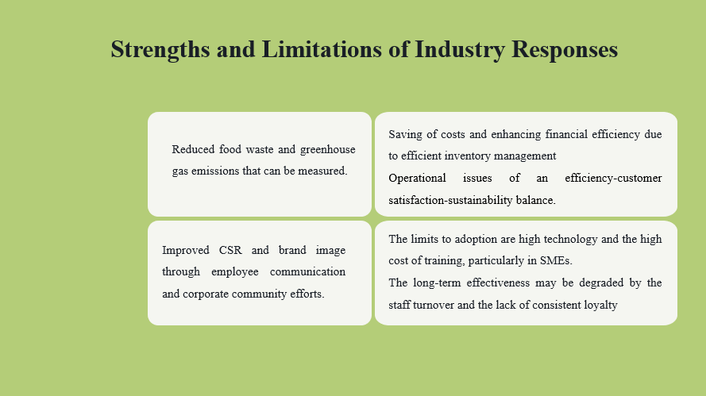

The main strengths are a decrease in waste and greenhouse emissions due to AI inventory systems cost reduction through improved stock management, and a rise in CSR owing to the involvement of the staff and collaboration with charity organisations. The weaknesses include high prices, turnover of staff and operational problems.

Slide 10: Recommendations
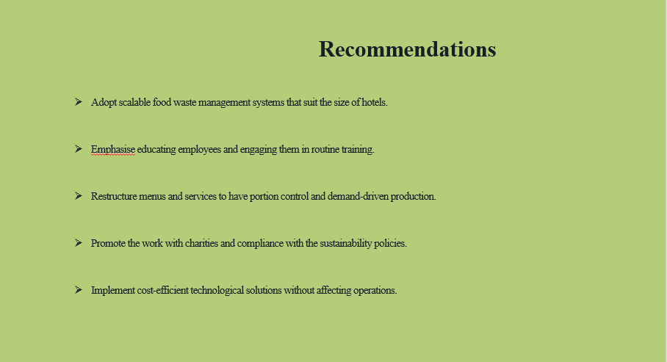

According to the analysis, the initial recommendation is that hotels are supposed to embrace scalable food waste management systems. Big chains have the opportunity to use advanced digital tracking systems, and smaller hotels can afford to focus on manual audits and simple prognosis instruments to minimise wastage without incurring excessive expenses.
Education of employees is vital, frequent training guarantees employees’ knowledge about the environmental and financial consequences of food waste and helps them become aware of the minimisation efforts. Redesign of the menu and service, especially in buffets and banqueting services, can reduce excess food production by controlling the portions and engineering the menu with demand-based preparation. Technology solutions must be adaptable and affordable enough to assist hotels in tracking and predicting the use of food, and do so without impacting operations or customer satisfaction.
Slide 11: Conclusion
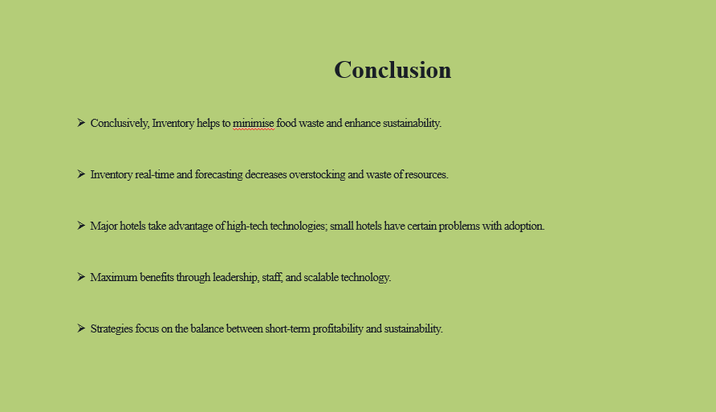
Conclusively, inventory management is an important instrument of minimising food waste in hospitality, which will create quantifiable environmental, financial, and operational gains. Online inventory, forecasting techniques, and real-time delivery services will assist in curbing overstocking, spoilage, and waste of resources utilised, which will enhance sustainability besides increasing cost effectiveness. Whereas big hotel chains can afford to use developed technologies to make the maximum impact, small hotels struggle with investments, staff training, and workflow modifications. The results are achieved when inventory management is incorporated into the core processes, backed by leadership, and augmented by staff involvement and scalable technological solutions.

Slide 12: References
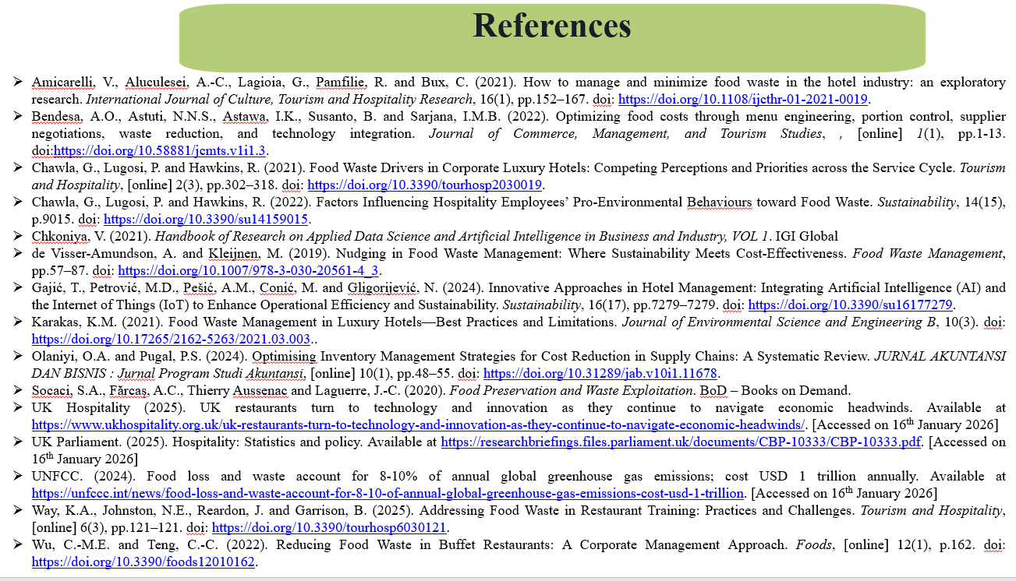

Amicarelli, V., Aluculesei, A.-C., Lagioia, G., Pamfilie, R. and Bux, C. (2021). How to manage and minimize food waste in the hotel industry: an exploratory research. International Journal of Culture, Tourism and Hospitality Research, 16(1), pp.152–167. doi: https://doi.org/10.1108/ijcthr-01-2021-0019.
Bendesa, A.O., Astuti, N.N.S., Astawa, I.K., Susanto, B. and Sarjana, I.M.B. (2022). Optimizing food costs through menu engineering, portion control, supplier negotiations, waste reduction, and technology integration. Journal of Commerce, Management, and Tourism Studies, , [online] 1(1), pp.1-13. doi:https://doi.org/10.58881/jcmts.v1i1.3.
Chawla, G., Lugosi, P. and Hawkins, R. (2021). Food Waste Drivers in Corporate Luxury Hotels: Competing Perceptions and Priorities across the Service Cycle. Tourism and Hospitality, [online] 2(3), pp.302–318. doi: https://doi.org/10.3390/tourhosp2030019.
Chawla, G., Lugosi, P. and Hawkins, R. (2022). Factors Influencing Hospitality Employees’ Pro-Environmental Behaviours toward Food Waste. Sustainability, 14(15), p.9015. doi: https://doi.org/10.3390/su14159015.
Chkoniya, V. (2021). Handbook of Research on Applied Data Science and Artificial Intelligence in Business and Industry, VOL 1. IGI Global
de Visser-Amundson, A. and Kleijnen, M. (2019). Nudging in Food Waste Management: Where Sustainability Meets Cost-Effectiveness. Food Waste Management, pp.57–87. doi: https://doi.org/10.1007/978-3-030-20561-4_3.
Gajić, T., Petrović, M.D., Pešić, A.M., Conić, M. and Gligorijević, N. (2024). Innovative Approaches in Hotel Management: Integrating Artificial Intelligence (AI) and the Internet of Things (IoT) to Enhance Operational Efficiency and Sustainability. Sustainability, 16(17), pp.7279–7279. doi: https://doi.org/10.3390/su16177279.
Karakas, K.M. (2021). Food Waste Management in Luxury Hotels—Best Practices and Limitations. Journal of Environmental Science and Engineering B, 10(3). doi: https://doi.org/10.17265/2162-5263/2021.03.003..
Olaniyi, O.A. and Pugal, P.S. (2024). Optimising Inventory Management Strategies for Cost Reduction in Supply Chains: A Systematic Review. JURNAL AKUNTANSI DAN BISNIS : Jurnal Program Studi Akuntansi, [online] 10(1), pp.48–55. doi: https://doi.org/10.31289/jab.v10i1.11678.
Socaci, S.A., Fărcaş, A.C., Thierry Aussenac and Laguerre, J.-C. (2020). Food Preservation and Waste Exploitation. BoD – Books on Demand.
UK Hospitality (2025). UK restaurants turn to technology and innovation as they continue to navigate economic headwinds. Available at https://www.ukhospitality.org.uk/uk-restaurants-turn-to-technology-and-innovation-as-they-continue-to-navigate-economic-headwinds/. [Accessed on 16th January 2026]
UK Parliament. (2025). Hospitality: Statistics and policy. Available at https://researchbriefings.files.parliament.uk/documents/CBP-10333/CBP-10333.pdf. [Accessed on 16th January 2026]
UNFCC. (2024). Food loss and waste account for 8-10% of annual global greenhouse gas emissions; cost USD 1 trillion annually. Available at https://unfccc.int/news/food-loss-and-waste-account-for-8-10-of-annual-global-greenhouse-gas-emissions-cost-usd-1-trillion. [Accessed on 16th January 2026]
Way, K.A., Johnston, N.E., Reardon, J. and Garrison, B. (2025). Addressing Food Waste in Restaurant Training: Practices and Challenges. Tourism and Hospitality, [online] 6(3), pp.121–121. doi: https://doi.org/10.3390/tourhosp6030121.
Wu, C.-M.E. and Teng, C.-C. (2022). Reducing Food Waste in Buffet Restaurants: A Corporate Management Approach. Foods, [online] 12(1), p.162. doi: https://doi.org/10.3390/foods12010162.

