Marketing plan written for

CROWN PLAZA

Student Name: Andreea Marin

__________________________________________________

Student ID number: 2206723
___________________

Marketing Essentials BMIH4005

Lecturer: Ruth Taylor-Davies

________________________________

Table of Contents
Component A: Marketing Plan 3
Introduction 3
Marketing Mix 3
Marketing Environment (Micro) 4
Marketing Environment (Macro) 5
Creating Customer Value and Engagement 5
Effective use of Digital Marketing 6
Conclusion and Recommendations 6
Component B: Presentation 8
Introduction 8
Marketing Mix 9
SWOT Analysis 9
PESTLE Analysis 10
Creating Customer Value and Engagement 11
Effective use of Digital Marketing 11
Conclusion and Recommendations 12
References 13

Component A: Marketing Plan

Introduction
The name of the hotel is Crown Plaza. This is basically an international organisation which has it headquarter in London (www.crowneplaza.co.uk.,2022). Some of the customers of this organisation are business owners and conference attendees. It has been determined that Crown Plaza is mainly owned by Intercontinental Hotels Group which also owns Intercontinental Hotels and Resorts and Holiday Inn Hotels and Resorts. The geographical area which is mainly covered by Crown Plaza are London, Europe and Middle East. The main purpose of the marketing plan is to attract new consumers towards this hotel organisation. This marketing plan is mainly prepared for “Crown Plaza”. The marketing plan will mainly provide an effective evaluation of the marketing mix. This will be supported by SWOT Analysis and PESTEL Analysis for evaluating the micro and macro factors. The marketing plan will also involve the use of digital marketing.
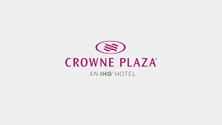
Figure 1:Crown Plaza
Source: (Anastasiadou, et al., 2022)

Marketing Mix
The marketing mix of Crown Plaza can be explained as follows.
1. Product: Crown Plaza mainly offers hotel and accommodation services in London. Some of the major products and services which are available in this organisation involves hospitality Services.
2. Price: The pricing strategy which is used by Crown Plaza in London is premium pricing strategy. Premium prices are offered after effective evaluation of the market conditions.
3. Place: It is determined that the organisation mainly tries to create a link with the customers through its online presence and website. The organisation mainly uses direct distribution channels in order to offer services to the customers. From the stakeholder’s analysis, it has been determined that Crown Plaza has a group of stakeholders which are businesses, franchise, customers, employees and government.
4. Promotion: Crown Plaza mainly focuses on using various social media platform and digital technology for promoting its services among the consumers. Some of the widely used social media platforms are YouTube and Facebook.

Marketing Environment (Micro)
SWOT Analysis: The identification of the micro environment factors which create an impact on Crown Plaza is possible with the help of SWOT Analysis.
1. Strength: This hotel chain has a good reputation in the market. This is used for the purpose of increasing its profit level (Bowie, et al., 2017). However, Crown Plaza also provides best quality hospitality services to the consumers. This acts as a strength for the organisation.
2. Weakness: It has been determined that some of the weaknesses prevailing in Crown Plaza are in terms of traditional business model. This creates certain level of obstructions and hindrance in the conduct of the activities of the organisation.
3. Opportunities: The major opportunity which is provided to Crown Plaza is the use of digital promotion techniques for marketing its products and services among the consumers of UK. This helps in improving the performance of the organisation.
4. Threats: One of the major threats associated with this hotel chain is in terms of excessive level of competition prevailing in the hospitality industry.
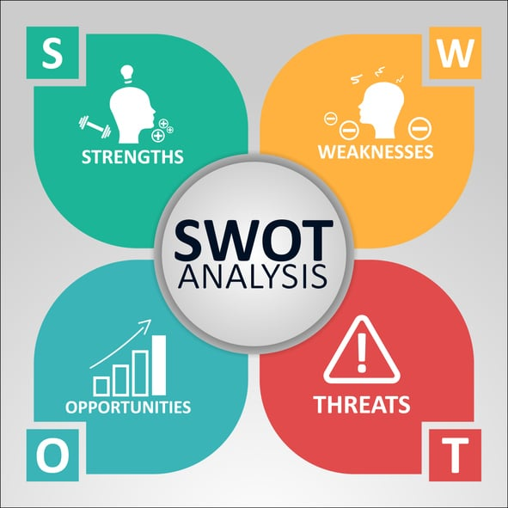
Figure 2:SWOT Analysis
Source: (Chaffey and Ellis- Chadwick, 2019)

Marketing Environment (Macro)
PESTLE Analysis (positive and negative impact): The micro environment factors which surround Crown Plaza is explained with the help of PESTEL Analysis. The positive and negative impact of these factors on the marketing strategy has been explained as follows.
1. Political factor: Some of the political factors which influence the activities of Crown Plaza are political stability and government policies. The positive impact of the political factor has helped in selecting the best marketing strategy for the organisation. The political factor has created a negative impact in terms of inefficiency in the marketing (Ghauri, 2014).
2. Economic factor: Some of the economic factors which influence the activities of this organisation are inflation rate, that advent of the covid-19 pandemic and growth rate. High rate of inflation has helped in increasing the revenue of organisation and has promoted a positive impact on the marketing strategy. Moreover, the advent of the covid-19 pandemic has led to a negative impact on the marketing strategy.
3. Social factor: Social factors which create an impact on the activities of Crown Plaza are demographics, consumers behavior, preference of the consumers and demand of the consumers. Changes in the consumer behavior create a negative impact on the marketing strategy of the organisation. Timely identification of the consumer preferences helps in creating a positive impact on the marketing strategy.
4. Technological factor: Technological factors mainly involve the use of latest technology of Artificial Intelligence, Machine Learning and Internet of Things. This has created a positive impact on marketing strategy (Housden, 2008). Increase in the expenditure creates a negative impact on the marketing strategy
5. Legal factor: Crown Plaza focuses on following all the legal rules such as Employees Law, Consumer Protection Act, Environment Protection Act and Human Rights Act. This helps in undertaking the best marketing strategy for the organisation. This is a positive impact.
6. Environmental factor: The environmental factors mainly involve following sustainability practices for providing protection to the environment. This helps Crown Plaza to achieve the positive impact on its marketing strategy (Jobber and Ellis-Chadwick, 2020).

Creating Customer Value and Engagement
This marketing plan is mainly prepared for “Crown Plaza”. The marketing plan will mainly provide an effective evaluation of the marketing mix. Crown Plaza mainly creates customer value by offering best quality hospitality services to the consumers at an affordable price. Creation of customer value helps the organisation to retain its existing visitors and increase its potential visitors by 10%. The visitor’s engagement has been created by offering discounts and offers on the regular basis. It is determined that the marketing channels which will be used for creating customer engagement and customer value are social media platform.

Effective use of Digital Marketing
Use of digital marketing in the marketing activities: Digital marketing is used by Crown Plaza in order to conduct its marketing activities (Kotler, et al., 2022). It is determined that all the marketing activities are mainly managed and controlled by the head of the marketing department of the organisation. Timely measures are undertaken in order to make sure that social media platforms is effectively used for promoting the product of services of the organizations.
Marketing message to attract a new customer to the hotel: The main marketing message which will be delivered to attract new consumers in Crown Plaza has been provided. The main marketing message is “to promote maximum level of sustainability at the time of offering marketing activities to the consumers”.

Conclusion and Recommendations
Challenges in the marketing plan: From the marketing plan it can be easily concluded that there are certain challenges observed in the marketing plan (Rashidovna, 2022). It has been determined that there are certain elements of marketing strategy which are not explained effectively. It is also identified that Crown Plaza is not able to use the digital marketing strategies effectively. It can be observed that one of the major challenges associated with the marketing plan is lack of analysis of the internal factors.
Recommendations to overcome the challenges: There are certain recommendations which are provided to improve the marketing plan. Some of the recommendations are listed as follows.
1. It is recommended that Crown Plaza should focus on using social media platform for marketing (Vásquez Villagómez, 2022).
2. The organisation should focus on identifying the taste and preferences of the consumers in order to provide customer satisfaction.
3. Proper measures should be undertaken in order to evaluate the marketing strategy adapted by the competitors (Weinland and Smith, 2022).

Component B: Presentation
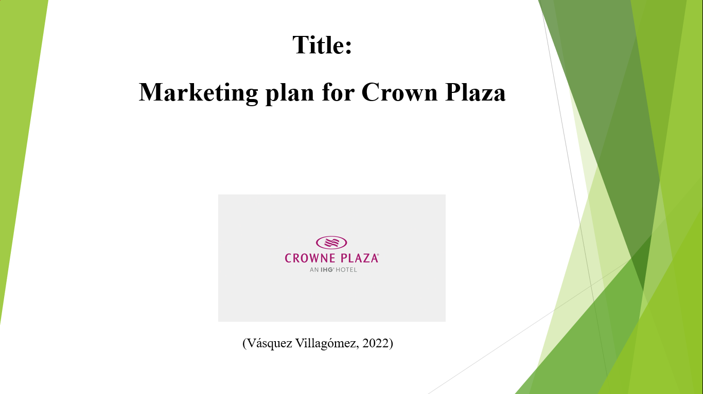

Introduction

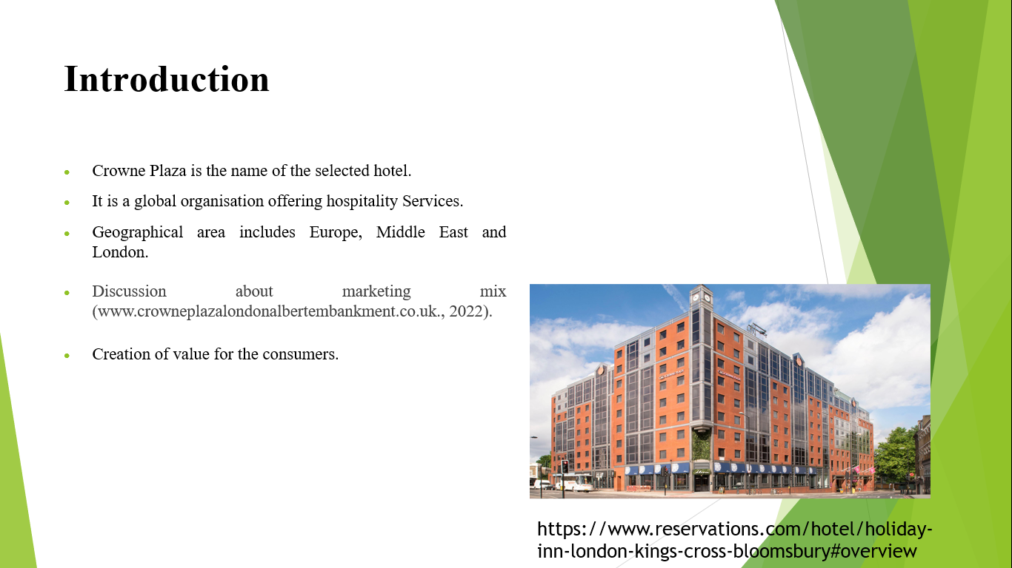Crowne Plaza is the name of the selected hotel chain. This is basically an international organisation which operates in Middle East, Europe and London.

Marketing Mix
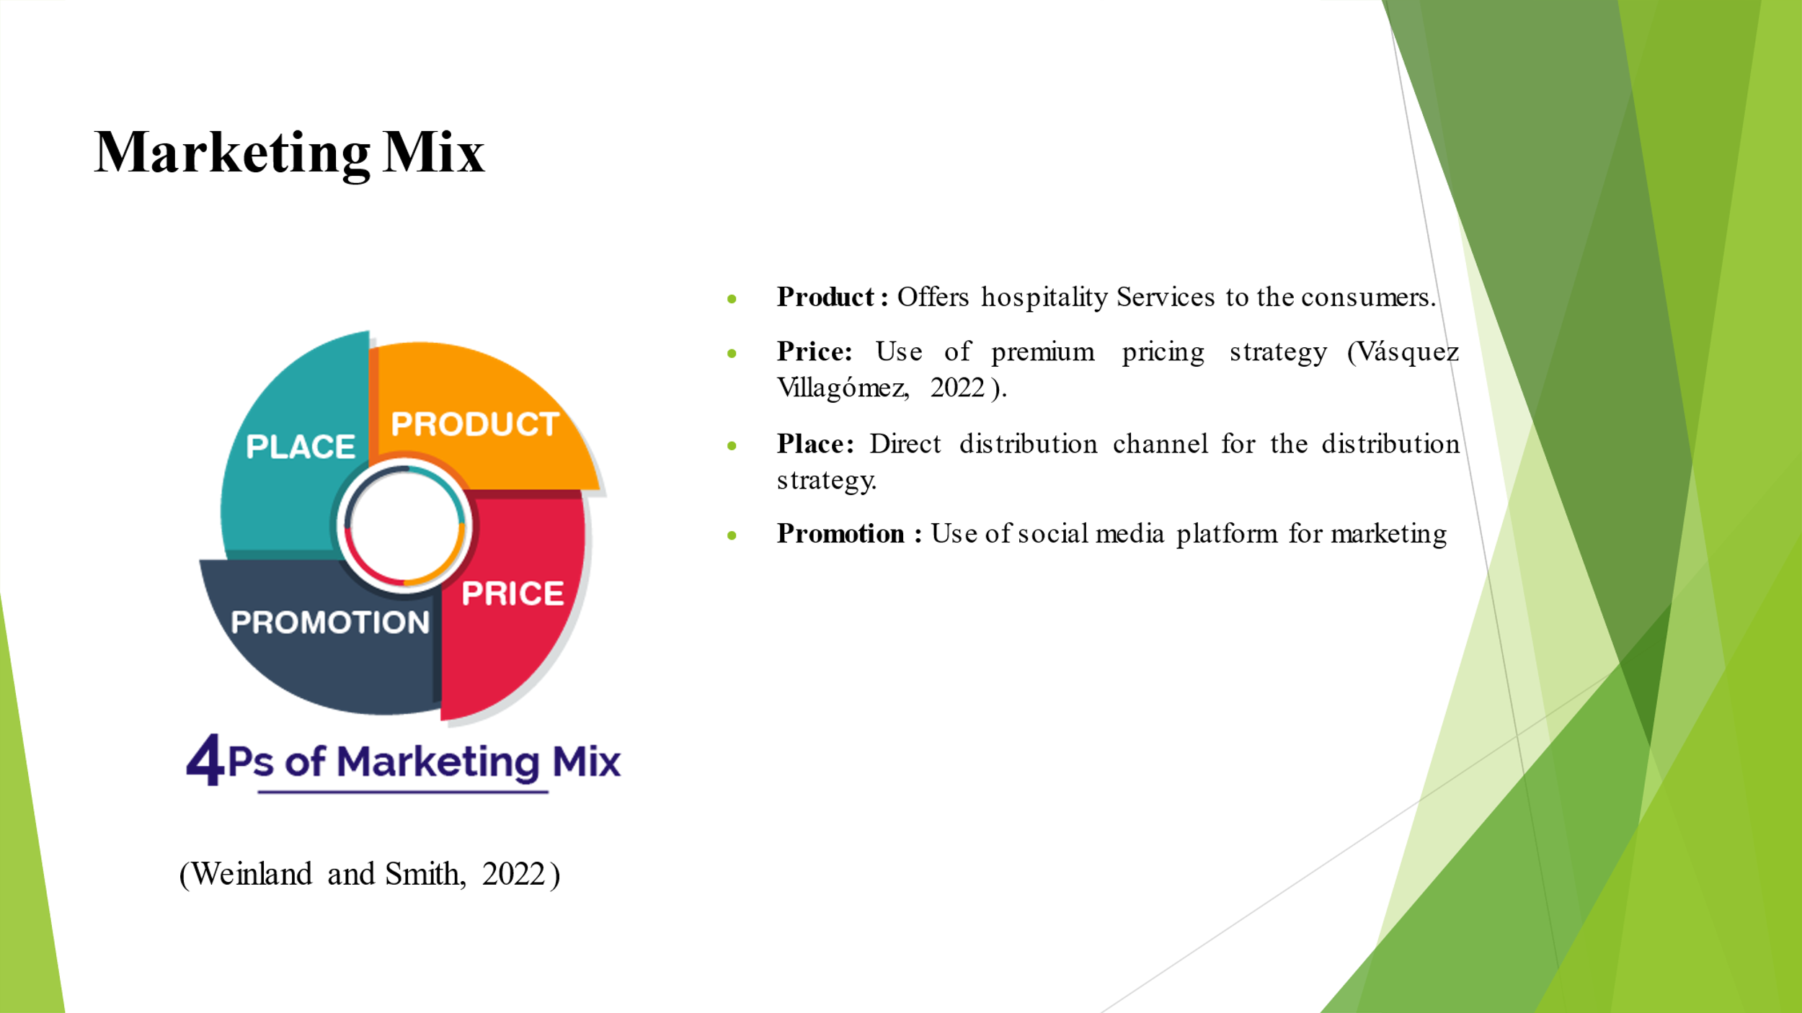It is determined that different types of hospitality Services are offered to the consumers. The pricing strategy is premium pricing strategy. The distribution strategy involves the use of direct distribution channel. The promotion strategy involves the use of social media platform for marketing.

SWOT Analysis
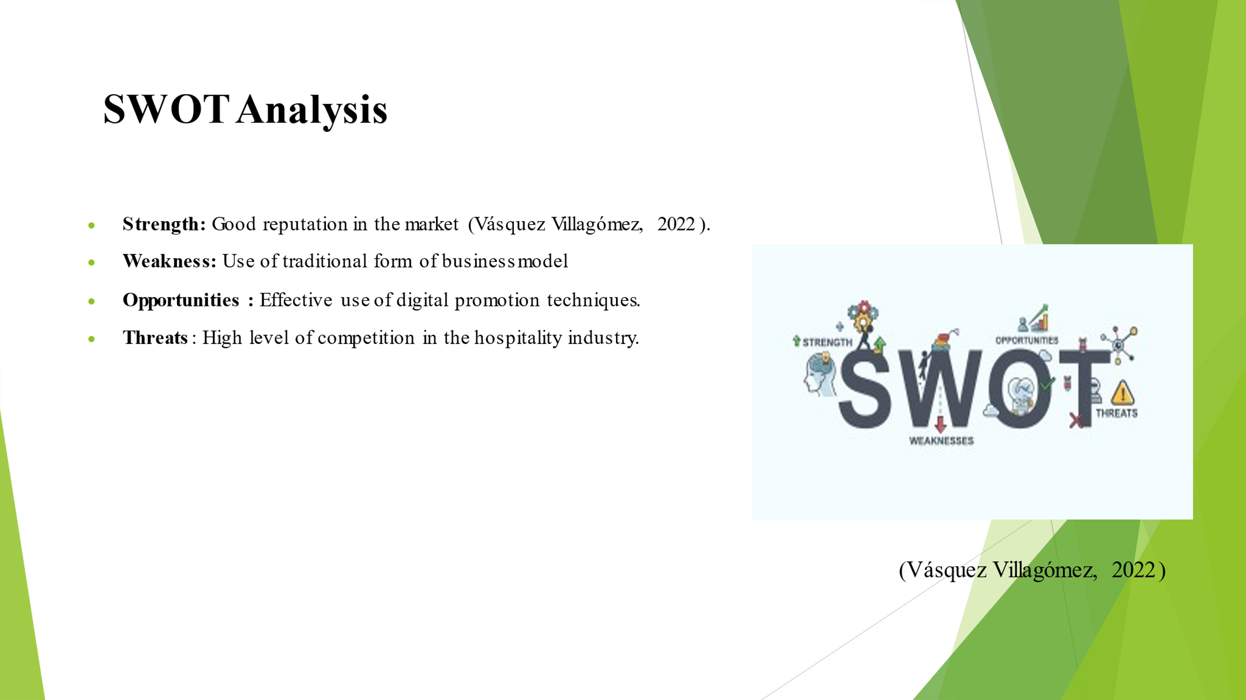The good reputation of Crown Plaza acts as a strength. The weakness is in terms of traditional form of business model. The opportunity involves use of digital promotion techniques. The threat is in terms of high level of competition.

PESTLE Analysis
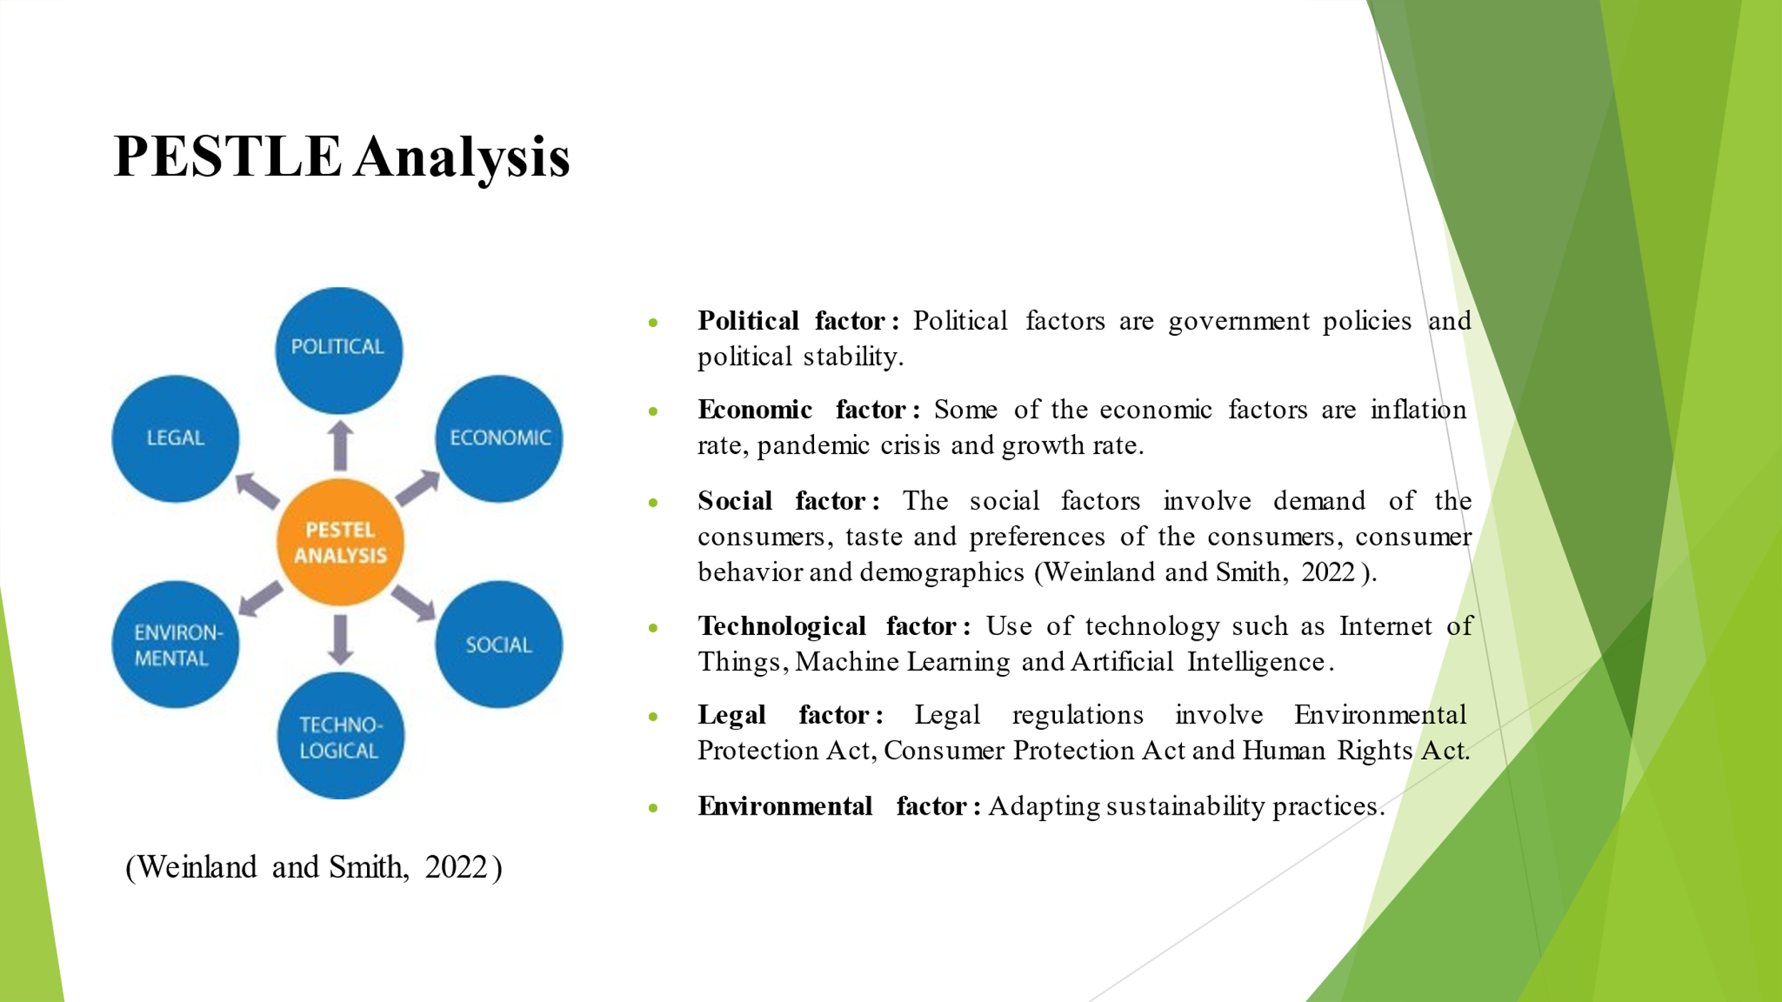It is determined that some of the factors which influences the macro environment of Crown Plaza are political stability, government policy, Inflation rate, pandemic crisis, growth rate, demographics, consumer behavior, demand of the consumers, use of latest technology, compliance with the legal regulations and adapting sustainability practices.

Creating Customer Value and Engagement
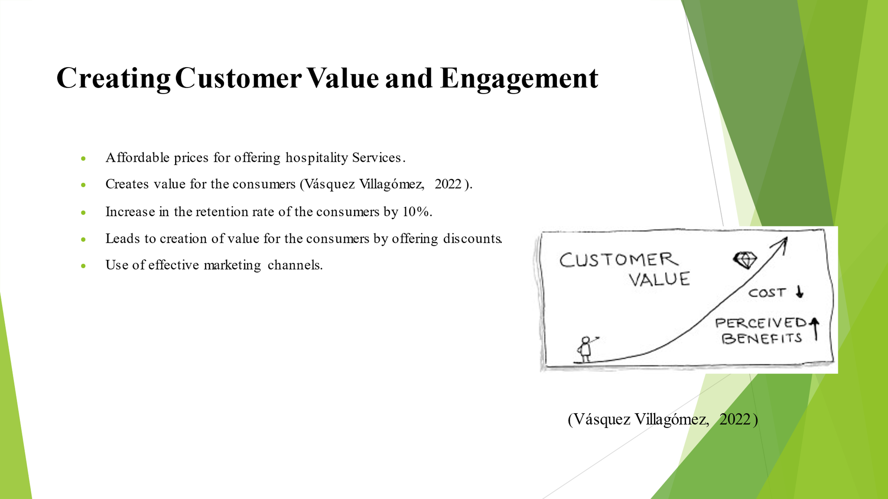Creation of customer value helps the organisation to retain its existing visitors and increase its potential visitors by 10%.

Effective use of Digital Marketing
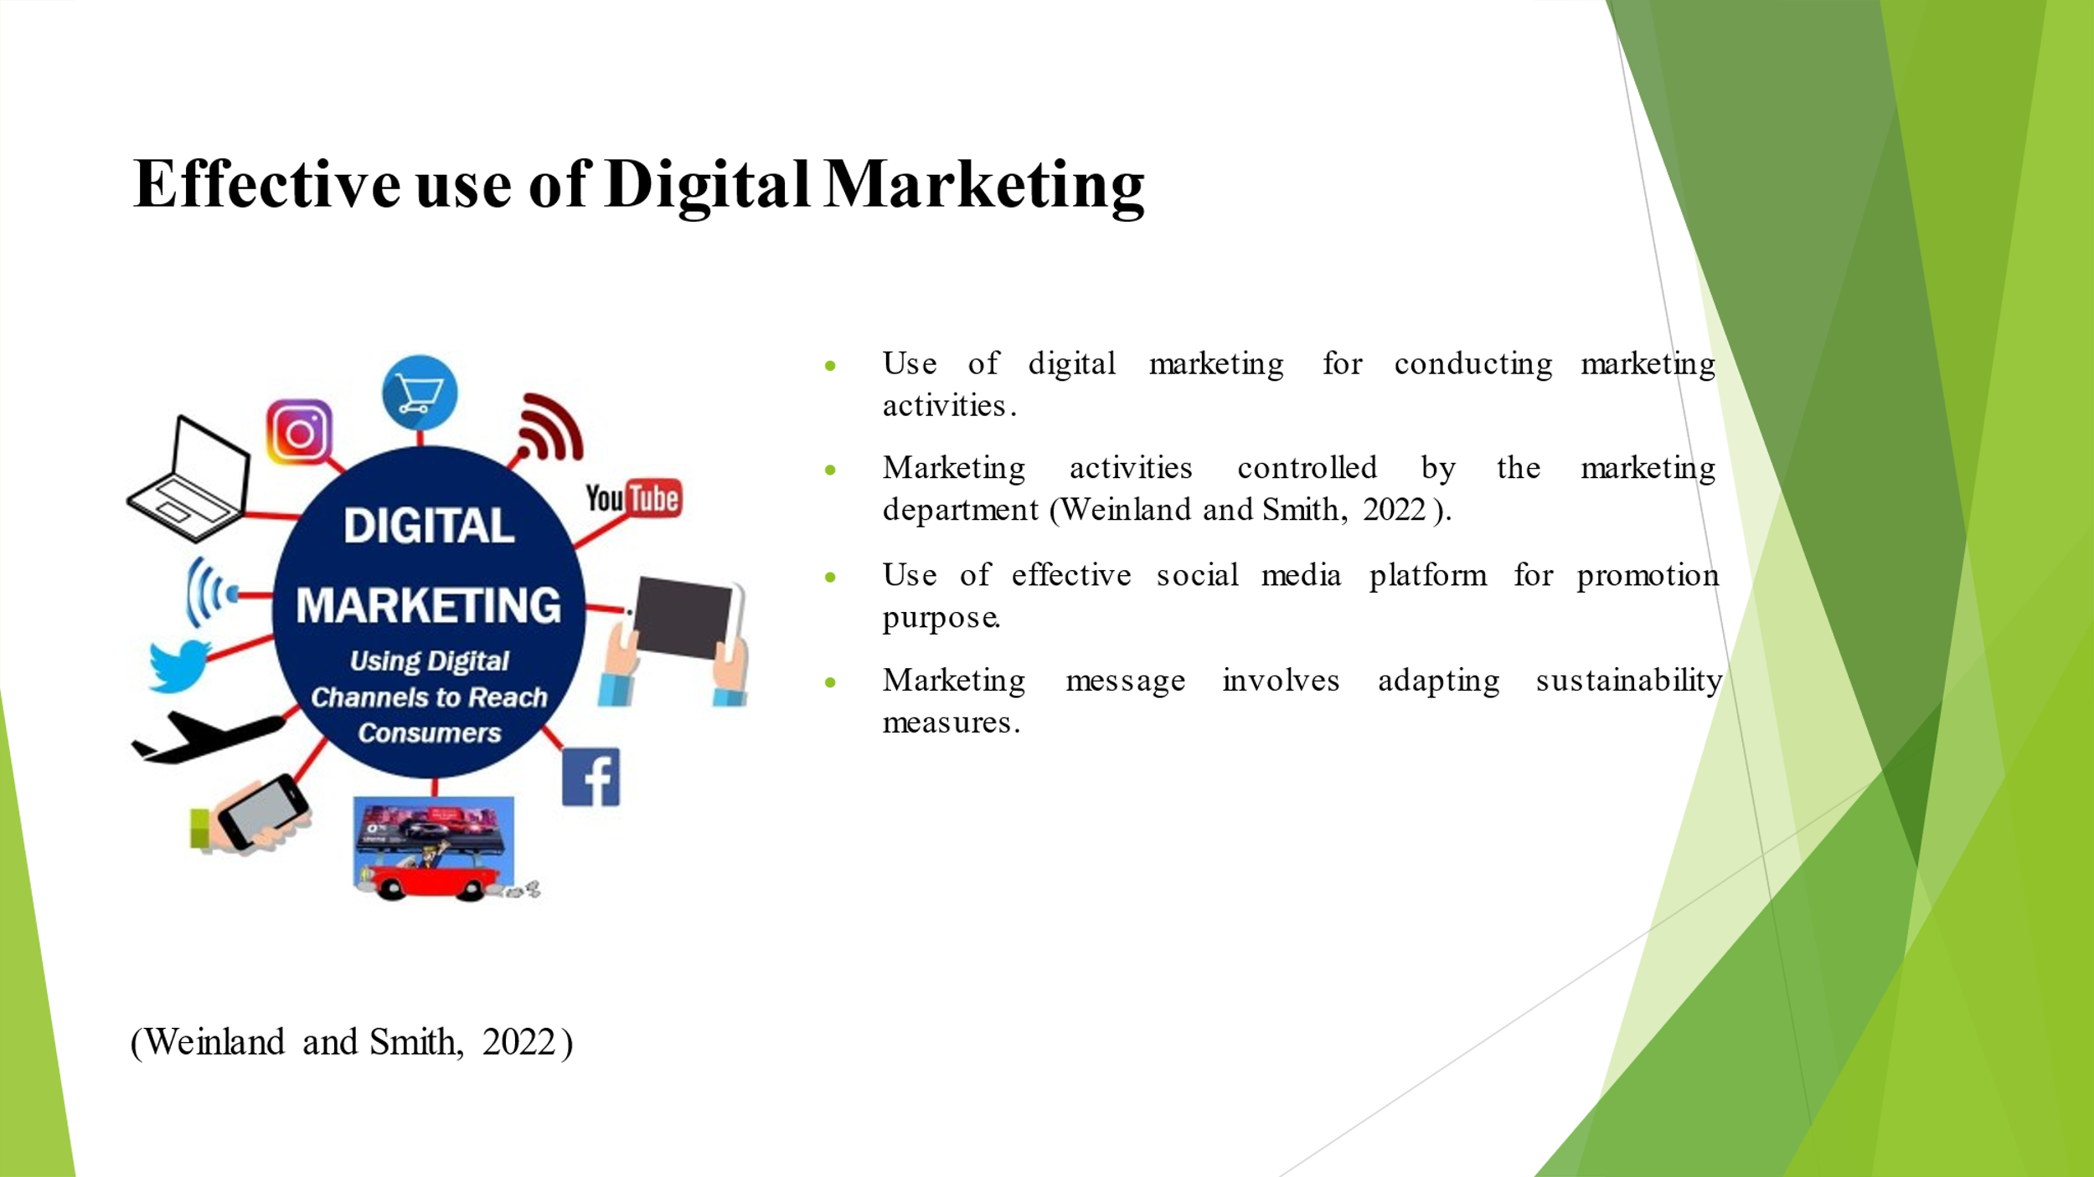
Digital marketing is used by Crown Plaza in order to conduct its marketing activities. The main marketing message which will be delivered to attract new consumers in Crown Plaza has been provided

Conclusion and Recommendations
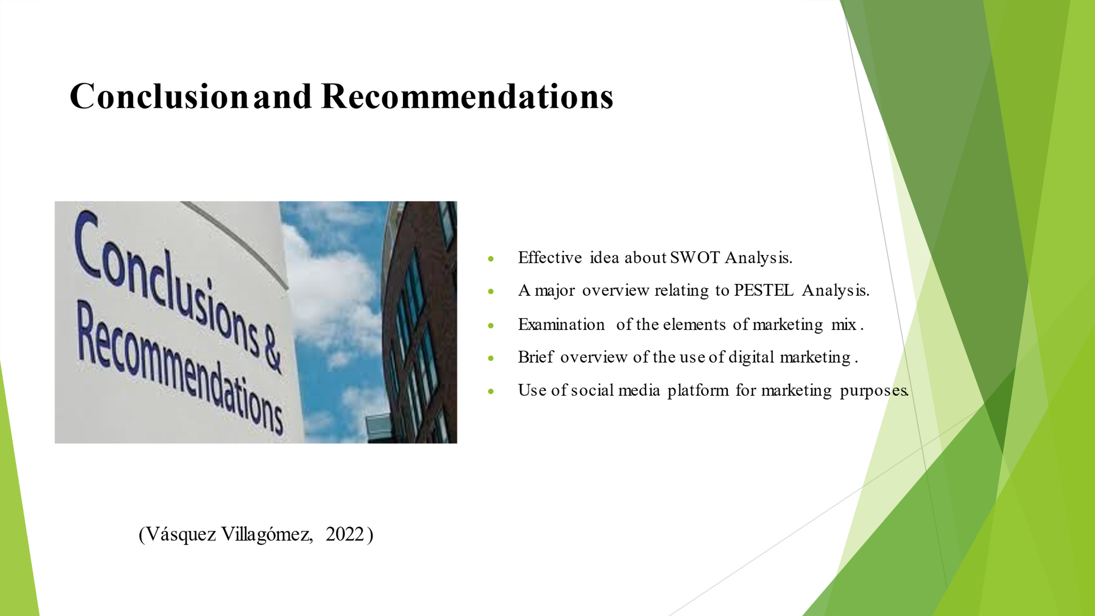A discussion about the marketing mix have been provided. The promotion strategy involves the use of social media platform for marketing.
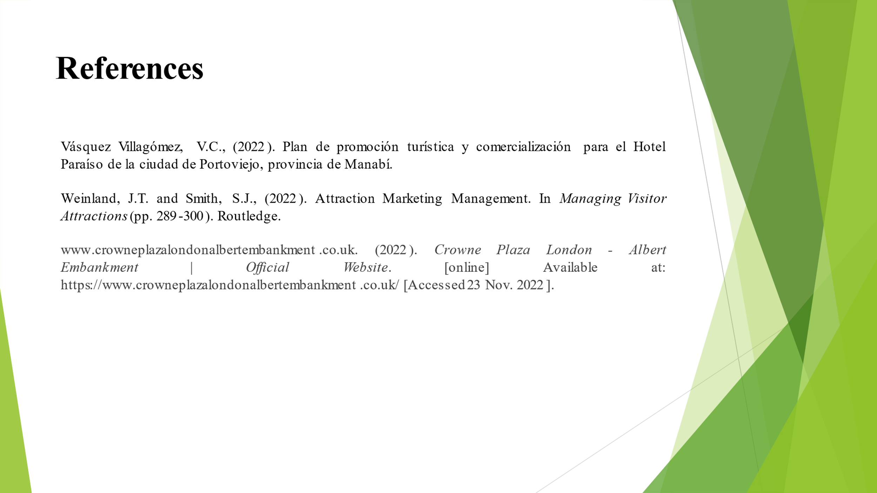

References
Anastasiadou, P., Sarantakou, E., Maniati, E. and Tsilika, E., (2022). Exploring Stakeholders’ Perspectives on Hotel Design. In Transcending Borders in Tourism Through Innovation and Cultural Heritage (pp. 239-255). Springer, Cham.
Bowie, D. Buttle, F. Brookes, M and Mariussen, A (2017). Hospitality Marketing. 3 rd ed, Routledge, London.
Chaffey, D and Ellis- Chadwick, F. (2019). Digital Marketing. 7 th ed, Pearsons, London.
Dzhandzhugazova, E.A., Kosheleva, A.I., Gareev, R.R., Nikolskaya, E.Y. and Bondarenko,
A.P., 2016. Business administration in hotel industry: problems and solutions (by the example
of the Russian Federation). International Journal of Applied Business and Economic
Research, 14(14), pp.651-660.
Ghauri, P N (2014). International Marketing, 4 th Ed, McGraw Hill, London.
Housden, M. (2008). Marketing Research & Information, Butterworth Heinemann, Oxford.
Jobber, D. and Ellis-Chadwick, F (2020). Principles and practice of marketing. 9th ed. London.
Kotler, P., Armstrong, G., Harris, L. and He, H., (2020). Principles of marketing. 8 th European ed, London: Pearson Education Limited.
Rashidovna, A.M., (2022). FEATURES OF HOTEL MARKETING RESEARCH. Indonesian Journal of Innovation Studies, 18.
Vásquez Villagómez, V.C., (2022). Plan de promoción turística y comercialización para el Hotel Paraíso de la ciudad de Portoviejo, provincia de Manabí.
Weinland, J.T. and Smith, S.J., (2022). Attraction Marketing Management. In Managing Visitor Attractions (pp. 289-300). Routledge.
www.crowneplazalondonalbertembankment.co.uk. (2022). Crowne Plaza London - Albert Embankment |Official Website. [online] Available at: https://www.crowneplazalondonalbertembankment.co.uk/ [Accessed 23 Nov. 2022].

