Fiona Pearce
Student Number: 2300216
UWTSD Primary PGCE

ECAD 7004
Design, conduct and critically evaluate a close-to-practice research project focusing on the model of the transformative teacher in developing practice that has a positive impact on the learner.

Word Count: 4905

My targets from Assignment ECAD 7003

 | Targed/target | Yr hyn yr wyf wedi'i wneud yn yr aseiniad hwn  What I have done in this assignment...
Targed/Target 1 | Engage with the Harvard referencing guide to ensure that you are referencing accurately, particularly when citing the same source/year (2022a, 2022b etc.) | I have tried to do this.
Targed/Target 2 | Ensure that you are comparing and contrasting views on topics to demonstrate criticality in your work. | I have tried to do this.

Aim, focus and purpose of the research / Research Context
Throughout the researcher’s first and second teaching practice placements, following previous experience as a Teaching Assistant, the increasing use of individual whiteboards by learners of various ages and in diverse subjects has been noted. This is somewhat due to the emphasis on Assessment for learning (AfL) in the new curriculum for Wales. Reflecting on their use also formed a small part of a recent assignment related to AfL. This has resulted in a curiosity to learn more about how, when and why they are used, and with what results and implications for both the learners as well as the teacher, with a view to informing and developing her future practice, to produce a positive impact on pupils’ learning. Whilst as a practitioner who has made use of individual whiteboards in class, she has experienced some of the benefits of their use to the teacher, her knowledge of how learners perceive their use is limited and consequently justifies exploration. The following Research Question for this project has therefore been developed: What are the perceptions of Year 3/4 learners of the use of individual whiteboards?

The research will be undertaken with a group of Year 3/4 learners in a mixed ability class of 25. Their school will be referred to as School X for the purpose of anonymity and data protection for research participants, following both British Educational Research Association (BERA) ethical guidelines for educational research (2018) and the UWTSD Research Ethics and Integrity Code of Practice (2022).

According to their last Estyn Inspection Report in 2017 (Estyn), School X is an English medium primary school with 170 pupils aged 3-11 with seven mixed-age classes. Around 38% of pupils have additional learning needs, well above the national average, and around 23% of pupils are eligible for free school meals, slightly above the national average.

By reviewing existing literature and policy documents as well as designing and applying appropriate methodologies for research, followed by analysis of the outcomes leading to changes to practice where appropriate, the following Professional Standards for Qualified Teacher Status (QTS) will have been evidenced: Pedagogy, Professional Learning and Innovation.

Overview of relevant literature
For the purpose of understanding the concept of how a teacher is transformative, it is necessary to consider how teaching becomes transformative, both in terms of how it evolves through reflective practice by teachers, to make an increasing positive impact on learners’ progression. The etymology (Harper, 2024), of the word transform is mid-14c, from old French transformer, meaning to change the form of; and from Latin transformare, meaning to change in shape or metamorphose.

There has been much literature and research on the practice of formative assessment, which has been shown to be transformative in education. Hattie (2009) did considerable research, showing that being assessment literate could have a great positive impact, equating to children being one year ahead in terms of learning. When children are assessment literate, they take ownership of their learning journey, through metacognition. They are able to make a conscious decision about how to make progress, having interpreted and reflected on feedback, and identified next steps. Wiliam (2018) emphasises that some learners are affected more greatly than others by the quality of their teachers, and the impact of initiatives such as styles of learning has not had any particularly discernible result. He is however keen to point out, that the impact of the use of formative assessment does correlate to higher achievements in education. This builds on his own previous work with Black (1998) where they stressed the importance of learners being aware of, and understanding success criteria, to be able to succeed. Clarke (2014) is also strongly in favour of formative assessment, stating that it is the most effective way of increasing achievement and getting children ready to be lifelong learners.

One of the key tools for formative assessment involves the use of individual whiteboards, for learners to be able to show the teacher their understanding at that point in the lesson. Hattie (2012) emphasises the importance of teachers being aware of and working to lessen the gap between what they are teaching and what the learners are actually learning. Pit stops in the lesson, to assess their learning, addresses this, for example by using strategies such as showing answers or ideas on individual whiteboards. The Teachers TV video ‘Deep Learning with mini whiteboards’ (2010) gives further evidence to how students’ visual literacy is developed through the use of mini whiteboards, as the students show their understanding through their drawings of castles from different periods.

Welsh government research (2010) explored how the use of individual whiteboards increased pace and use of thinking time when children were asked to note ideas before sharing. This allowed all learners to contribute to the lesson by showing their answers, rather than just those called upon to respond. This then enabled teachers to ascertain levels of understanding across the class, and identify and address misconceptions immediately.

Use of individual whiteboards has been shown to affect learners’ engagement, both individually and collaboratively, although some research shows it is more effective for pair work than group work (Macrie-Shuck & Talanquer, 2021), as even when groups were established, students tended to move to working in pairs using the whiteboards. In contrast, research into students’ perceptions of whiteboard use, evidences the positive effect of the collaborative use of whiteboards, leading to students benefitting from peer-to-peer learning, and feeling better prepared for class (Wood & Kutcher, 2017). The teachers noted the benefits of making thinking visual, through using the whiteboards, enabling any misconceptions to be identified and addressed early.

(Freeman, et al., 2014) show that student performance improved more through active learning like this than through traditional passive teaching methods. Furthermore, Bandura’s work on social learning evidences how individuals are motivated through social interaction and collaboration (1971). Bandura’s work on self-efficacy (1997), shows how the level of self-belief in one’s ability to do a task is linked to the amount of motivation to participate. It is demonstrated how using whiteboards collaboratively could also provide opportunities for observing others receiving positive feedback, then wanting it for themselves, and so increasing their own level of engagement.

Whiteboarding, where groups work collaboratively to contribute ideas and work through challenges together has been shown to be another effective engagement tool leading to increased understanding (Megowan-Romanowicz, 2016). Individual whiteboards can be used in the same way, for noting ideas for later contribution to the class or group.

Experienced teachers have realised the benefits of using mini whiteboards, realising they made lessons more inclusive and engaging, and gave students freedom without the worries of correct spelling or neatness, as well as providing much greater understanding to the teacher of the learners and their progress (Gunton, 2020).

Explanation of Case Study
In order to begin to understand the meaning of case study research, the etymology of the word case should be explored. As detailed by the online Etymology Dictionary (Harper, 2024), case finds its root in early 13th century old French cas meaning a happening, Latin casus meaning opportunity, and Latin capsa, meaning box or repository. Hence leading to the definition of a case study understood as an event enclosed in a restricted frame.

Gall, Gall & Borg (2004), define a case study as studying a phenomenon in-depth in its natural context and from the participants’ perspective. Similarly, Thomas (2023) explains the study of a case is to understand one particular case in depth, rather than for it to provide clarification for others. By its nature it is restricted, a small sample is used to enable the researcher to focus on the detail. The limitations are recognised of the results’ analysis referring to this specific case, and therefore not being able to be used to create generalisations representative of a wider population. Wieviorka,1992, as cited in Thomas, (2023), clarifies further that there are two distinct and essential parts in a case study, namely “a subject and an analytical frame or object”. For the purposes of this research project, the subject is the learners, who will provide the lens through which the researcher will be able to view the object – namely the perceived use of individual whiteboards.

Denscombe (2014) advises researchers to make a careful choice of strategy, ensuring it fit for purpose. Having critically evaluated various potential strategies, a case study approach has been chosen as appropriate for this research project, as its focus is distinct and fairly self-contained. It consequently provides opportunity for deeper exploration to discover insightful outcomes to the research question. By the nature of the small-scale research involved, and the considerable time constraints laid down, it has been necessary to identify only a small number of participants for the project, in order to ensure feasibility before the project deadline. As Denscombe (2014) emphasises, it is crucial to have “access to data sources,” and consequently learners from the researcher’s class in the current teaching placement school have been identified as potential participants, and once ethical approval has been obtained, they will be invited to participate in the initial stage of the research, namely completing questionnaires. This will be followed by more in-depth research involving a very small group. It is hoped to select research participants from each ability level in class, in order to attempt to be representative of the whole class as far as possible, although the limitations imposed by the number of learners returning consent forms are recognised.

Adelman et al, 1980, as cited in Cohen et al (2018) outlines several advantages to the case study approach, including that they are a “step to action” and that their findings are in a more publicly accessible form than some other research findings. Considering advantages in the same way, Nisbet and Watt, 1984, as cited in Cohen et al (2018), add that a single researcher is needed rather than a team, and due to their small size they can discover unique features which could be hidden or overlooked in larger-scale projects. Disadvantages noted by Nisbet and Watt include the possibility of observer bias, even acknowledging strategies employed to address reflexivity. The case study will be exploratory in nature, aiming to understand the learners’ opinions, experiences and attitudes without any preconceived hypotheses. When selecting participants for the semi-structured interview following the more general questionnaire, the researcher will aim to ensure the inclusion of those whose perceptions differ, in order to enable a deeper exploration of wide ranging views and lessen the chance of unintentional researcher bias or preconceptions.

Research Methods
Whilst with the small numbers of learners, and the varied methods of data collection involved, it is hoped to obtain findings of interest, it is however recognised that their analysis will be particular to those learners participating in the research. According to Ragin & Becker (2010), the degree of relevance and potential transferability of the findings to other cases, depends on the shared features, for example class size, demographic and the learners’ ages. Consequently, in order to enhance transparency and the credibility of the findings, the researcher provided a detailed description of the context.

When considering which research methods would be most suited to the project, observation was not regarded as appropriate for the principal reason that the research question relates to learners’ perspectives. By its nature, the process of observation provides data on what the researcher herself observes, rather than on the perceptions of those being observed (Denscombe, 2014).

Research questionnaires however obtain information directly from participants, thereby providing the data from the perspective of the person asked. The ability to pose the exact same questions to each participant is possible as questionnaires contain a written list of questions. This method is therefore consistent for all those involved, and allows the standardised data to be analysed effectively (Denscombe, 2014). The potential problem of the reading ability of participants causing comprehension difficulties was overcome by the researcher being present to assist with reading out the questions if requested, although participants would complete the questionnaire individually on ipads, with no other input from the researcher.

It was felt that as the researcher had built a good relationship with the participants by getting to know them as their student teacher over some time, that they would feel able to be honest and open with their answers rather than responding with the aim of somehow pleasing the researcher. Furthermore, it was hoped that the established relationship would also provide the motivation to participate, the effort required to complete the questionnaire responsibly, and also result in valid responses. The familiar setting of their own school with a known and trusted person as the researcher would provide an informal, unthreatening environment for the children, overcoming problems affecting reliability such as shyness or the children answering what they think the researcher ‘wants to hear’ (Cohen, et al., 2018).

The researcher emphasised the importance of this ‘University level’ research, which she was excited to give them the opportunity to be involved with. This had the aim of informing the participants that they needed to take the whole process seriously, as their answers were of importance, and could “contribute to some real outcome that affects them personally”’ (Denscombe, 2014)

For the reasons outlined above, it was decided to create a questionnaire, with Microsoft Forms (Appendix D), for the proposed research, followed by a semi-structured interview. As the researcher would be present, oral instructions and background information to the research were able to be given, together with reminders relating to the option to withdraw at any time and to omit questions if so desired.

It was decided to use a variety of questioning techniques, both to engage interest, provide accessibility and choices as well as to obtain useful data. The number of questions was limited to ten, both due to the young age of the respondents (age 7-9), and to maintain interest and avoid questionnaire fatigue. Having entered their unique identifying number for the research, ensuring confidentiality, the Likert scale was used for the next question, immediately providing participants with reassurance about the task involved, and the ability to express their opinion independently with ease, especially for those with lower reading or writing ability. This was followed by four questions with multiple choice answers, and the possibility of choosing more than one option if desired. At this point an open-ended question was posed, with the aim of eliciting a more reflective, in-depth response, and to enable deeper exploration at a later stage. Two further multiple-choice questions followed and lastly an open-ended question asking for any further comments, with possible suggestions for issues to be considered. The limitations of only using two open-ended questions for the research questionnaire were recognised, however it was considered appropriate due to the young age of the participants, their writing ability and also time constraints.

Initially, the researcher had planned to have a larger participant group for the questionnaires, having invited the whole class of 25, but as only nine children returned the consent forms, and subsequently two withdrew from the research before giving their assent, the initial research group was limited to seven. On the day of the semi-structured interview, one of these was absent, which led to the remaining six being invited to take part in the second part of the research. The strategy of intermethod mixing, ie using more than one method of data collection, is advantageous as it can “provide multiple sources of evidence – a cardinal rule in educational research” (Johnson & Christensen, 2014).

Semi-structured interviews are the most frequent choice for small-scale research (Thomas, 2023), due to their structured list of questions to be used as a guide, with the flexibility of delving deeper into any answers as required and enabling resulting discussions. The researcher deemed the semi-structured interview format suitable for the age of the children, by providing a structure for generating initial responses. Pupil voice is of paramount importance in the new curriculum for Wales (Welsh government, 2022), and will be evident through this method of data collection.

The questions for the semi-structured interview (APPENDIX E) were written by the researcher after studying the responses to the questionnaire, in order for it to be purposeful in its deeper exploration into any particular areas of interest raised. The questions therefore related to similar topics as for the questionnaire, such as experience, advantages and disadvantages, benefits and challenges, learning and understanding, engagement, improvement suggestions and any other comments regarding their perceived use of whiteboards. However, given the semi-structured interview format, open-ended questions allowed for diverse contributions and perspectives to be given during the group discussions which were enabled by interactive dialogue between researcher and participants.

Data Presentation and Analysis Method(s)
Following data collection during a research project, it is vital to analyse findings to comprehend what has been discovered, in terms of discrete data and also identification of common themes, before being able to present results. It is essential to adopt a clearly ordered presentation method to ensure clarity and ease of understanding by the audience.

A variety of methods was chosen, reflective of the data to be presented. The data from the questionnaire was put into Microsoft Excel spreadsheets, and then different charts created. For example, where the Likert scale had been used to ascertain children’s relative level of agreement with statements about how they feel about using whiteboards, such as ‘I love them’ and ‘They help with my learning’, a horizontal, colour coded bar chart was selected. This clearly showed their responses in percentages. For other questions where children were allowed to select more than one answer, pie charts were chosen, to make it clear which options had more, and which had fewer or even no votes. This resulted in the researcher’s ability to engage in thematic analysis – where common themes are noted. Given the small number of participants in the research project, for the two open-ended questions it was decided to present the actual responses, to show a fuller picture of the children’s views. This in turn enabled the researcher to create the questions for the semi-structured interview which would follow.

In order to present data findings from the semi-structured interview, the researcher chose to collate key themes and present them in a written format. This was to illustrate the detail given and enable the participants’ perspectives to be shared.

It should be stated here that the researcher endeavoured to ensure the trustworthiness of the research, by following certain processes. Through using questionnaires as well as a semi-structured interview, triangulation was employed to produce a broader data range and enhance credibility. In addition, this approach produced a cross-validation of findings, to increase reliability, enable a greater level of understanding and lessen the risk of bias. The limitations imposed by the number of returned consent forms, and hence restricted size of the research, weakened the transferability of the findings. However, the particpants, although few in number, were quite diverse. Although mostly of higher ability than the average in their class, a number had additional learning needs, and one had English as an additional language. The dependability of the research was demonstrated through clear recording of research methods and data collection procedures. The possibility of researcher bias was considered and then limited by engaging in reflexivity through critically examining positionality. This helped to ensure confirmability of the project.

Ethical Considerations
Before undertaking any research, it is essential for ethical approval to be obtained and ethical standards to be strictly adhered to throughout the research process, in order to ensure the research is beneficial and to minimise risk of harm. Appendix A shows the application submitted by the researcher for ethical approval required by UWTSD to meet the University’s Research Ethics and Integrity Code of Practice (2022), the UWTSD Research Data Management Policy (2022) and BERA ethical guidelines for educational research (2018). As the research study involved minors, the researcher explained the process to the potential participants, of obtaining consent from parents/guardians, and then the need for them to give their own personal assent separately as well, if they wished to take part; of their right to withdraw from the research at any time; and the fact that the research would be confidential. Appendix B shows the information letter and consent form. Potential risks to participants were addressed, honest responses were requested with no adverse consequences, and it was clarified that non-participation or withdrawal would not have any detrimental effect to themselves. Prior to the research starting, the researcher clearly outlined the process again to the children with parental consent, and they were asked to complete a form giving their assent, shown in Appendix C. This was clearly understood by the children, as two chose to withdraw at this stage. The children were given a research number rather than using their name on the questionnaire, in order to ensure confidentiality, and anonymity of results recorded. It was made explicit that the children were free to omit any questions they chose not to answer, with the exception of the first one – giving their research number. The participants were also informed of their right of access to the research results on request.

Results / Analysis of results / Discussion
Questionnaire
(NB question 1 asked children to enter their research number in order to provide anonymity).

Question 2
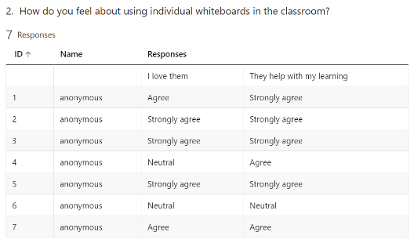
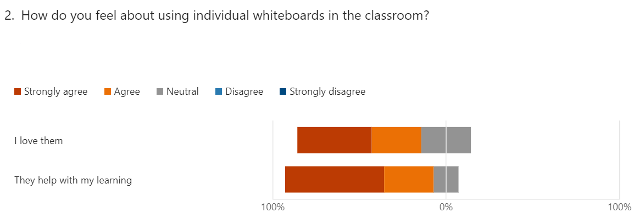

The results clearly indicate that 6 out of the 7 children clearly like or love using the whiteboards, only 1 was neutral and none disliked them. This shows their overwhelmingly positive perceptions of their use, leading the researcher to conclude that their use should be continued and developed further in some way. This conclusion is strengthened by previous research outlined in the literature review, showing how effective using whiteboards is, in involving every child in the lesson, and therefore increasing their engagement level.

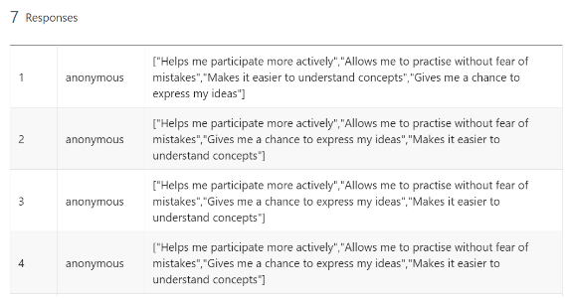
Question 3
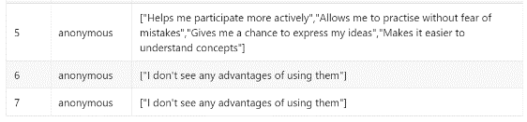
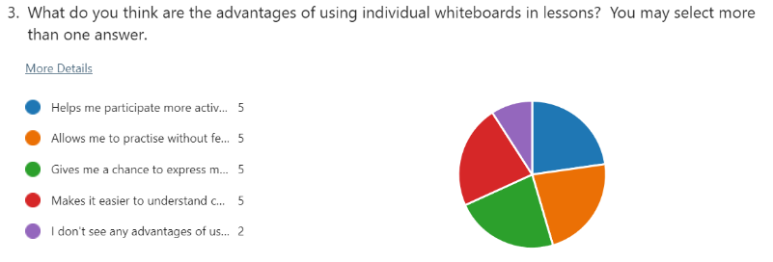

The pie chart clearly shows that the majority of children (5/7) considered there to be strong advantages of using whiteboards in lessons, indeed all of these ticked all five options given for potential advantages. It was interesting to note these answers further to question 1. Participant no.4 was neutral about liking them, but could clearly see their advantages. Also, although participant no.7 liked them, they declared that there were no advantages in their use.

Question 4
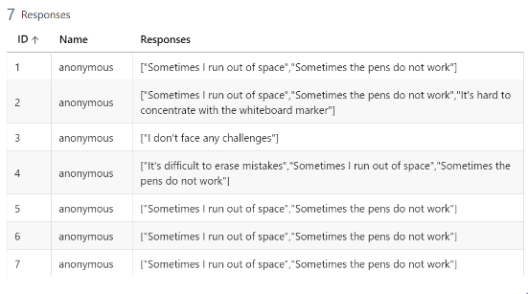
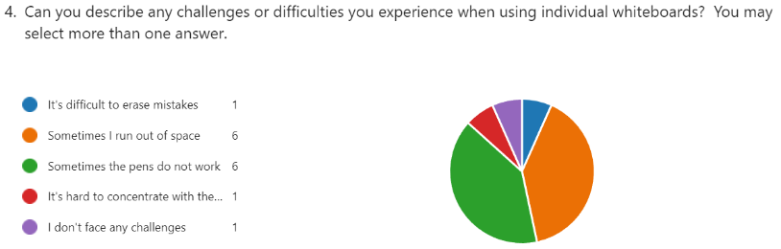

The results from this question were very clear too, with the same challenges experienced by the overwhelming majority of children. The main issues were running out of space, due to the size of the whiteboards, and also of pens sometimes not working. These are significant perceptions to note and the researcher will be able to recommend strategies to address these findings. It was noted that one child indicated a problem with erasing mistakes, perhaps due to perceived lack of access to a rubber, a problem easily rectified as a supply on each table is known to be available.

Question 5

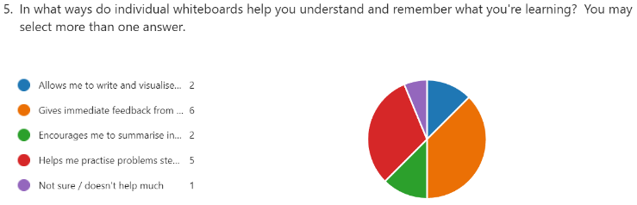
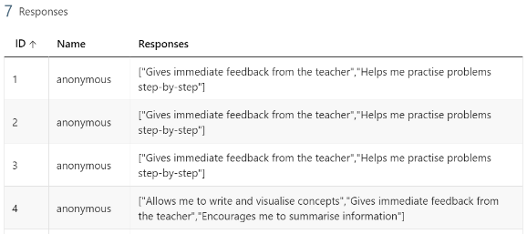
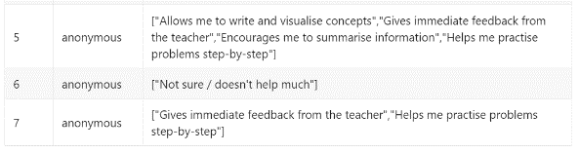

‘Gaining immediate teacher feedback’ was a popular choice here, confirming the advantages of Assessment for Learning (AfL) (Clarke, 2014). Children also perceived the whiteboards as being useful for being able to ‘practise problems step-by-step’ on the whiteboards, indicating a high level of motivation and engagement. The low number choosing ‘encourages me to summarise information’ and ‘allows me to write and visualise concepts’ may be because the class has not yet had much experience of using whiteboards for this purpose, but the researcher noted this could be a way to develop their future use.

Question 6
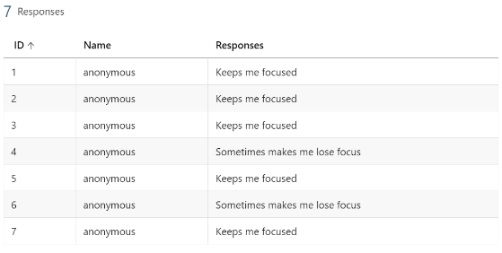
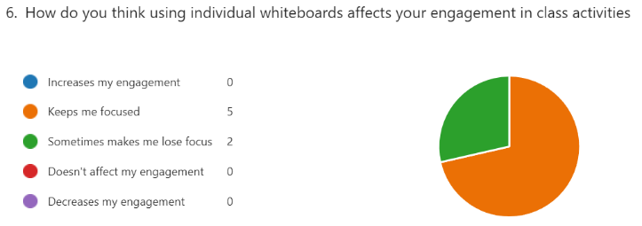
These results were significant in that no one chose the three options including the word ‘engagement’. The researcher reflected, it was possible that either they were unsure of the word’s meaning, and/or felt they were too similar to the options regarding level of focus, and so omitted these options. This led to the decision to reword these questions for any future research.

Question 7
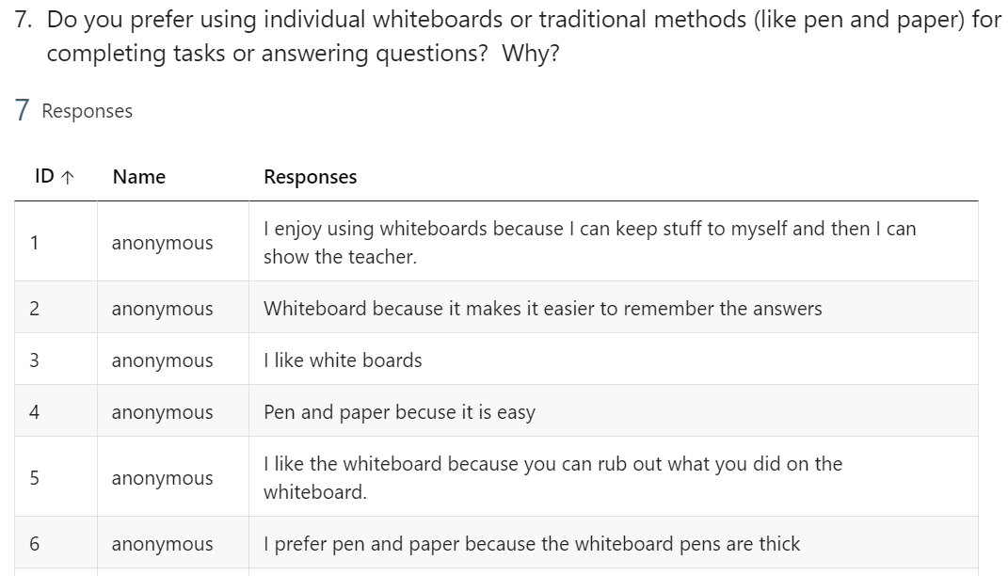

Recognising the constraints of multiple-choice answers, this question allowed for wider responses with justifications. The researcher was interested, and admittedly surprised to learn that some of the children preferred to use pen and paper, due to ease of use, and the thickness of the whiteboard pens. Referring back to question 4, where 6/7 cited the challenge of lack of space, the researcher reflected that a choice between whiteboards and paper could resolve these issues. Giving learners choices and allowing them pupil voice is a key to their success (Lyle, et al., 2010). The importance of pupil involvement in decision making is recognised by the Curriculum for Wales (Welsh government, 2022), the United Nations Convention on the Rights of the Child (UNCRC), and also the School Effectiveness Framework (SEF) (Welsh government, 2008). Of the 5/7 children who preferred whiteboards, reflective reasons were noted, including privacy, using it as an aide-memoire, and reducing fear of mistakes.

Question 8
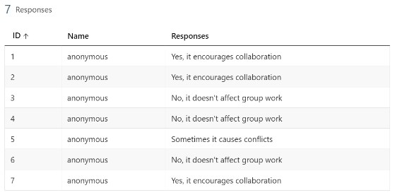
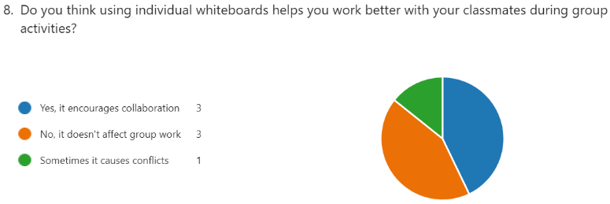

The researcher noted a clear split here, with equal numbers declaring using whiteboards encouraged collaboration, or did not affect group work. The researcher reflected that this could be due to children’s individual preferred learning style, and how they chose to use their whiteboard. It should also be noted that whiteboards were more often used individually in class, but potential for collaborative use could be further explored. Noting that one child felt they sometimes caused conflicts, the researcher took this issue forward to the semi-structured interview for deeper discussion.

Question 9
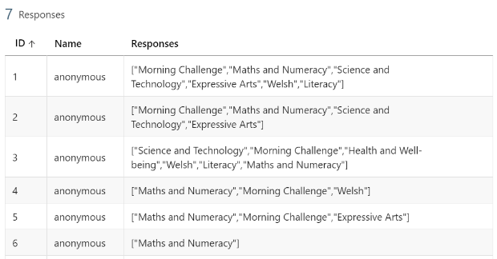
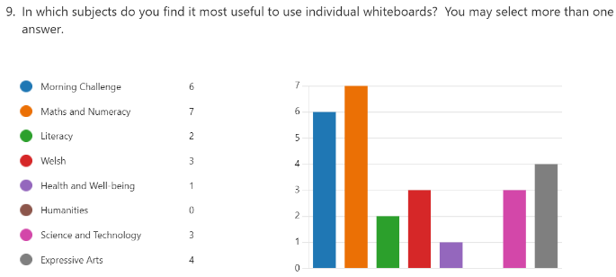

These responses partly reflected the amount of subject use the whiteboards were given by the teacher. It was noted that the whiteboards are used far more in Maths and Morning Challenge than in other subjects, a matter of possible interest for future research.

Question 10

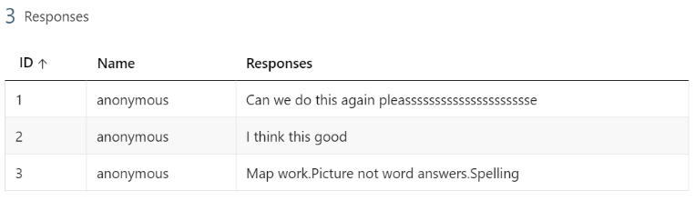

Three children added further comments, two of which clearly expressed their enjoyment in taking part in the research, and being able to have their views heard. One child suggested ways in which they would like to use whiteboards in future, namely for map work, giving pictorial answers rather than words, and spellings, all of which will be passed on to relevant parties, and included in future practice, reflecting the recognition of pupil voice.

Semi-structured interview
This involved six of the original seven children, delving more deeply into the responses from the questionnaire. The findings were as follows: Whiteboards were useful for morning challenge, however not for Welsh, as the focus, as per School X Welsh policy, is on Welsh oracy skills. Their use for maths was popular as children could hide their answers and prevent others copying before showing the teacher. The issues of pens running out and of others taking the best pens, were of great concern to most of the group, as it caused difficulty in completing tasks. Whiteboards were found helpful for writing practice, as mistakes were erasable; for generating ideas for story writing without concerns about spellings; and for checking if spellings look right before committing them to paper. A further perceived usefulness was for drawing number lines enabling marking jumps to the nearest ten. In addition, they were beneficial for noting ideas before contributing to group work. The disadvantage of hands becoming dirty was also raised.

Conclusions
Having undertaken the research project and reflected upon the findings, the researcher concluded that the methods chosen were valid and appropriate for collecting data from the children on their perceived use of individual whiteboards. The constraints applied by the multiple-choice questions were negated by the accessibility of the questionnaire for young children, and also by the semi-structured interview participation which followed, allowing for more detailed responses. The eager participation and comments of wanting to further their pupil voice experience through further research involvement or school council participation, indicates that the children felt comfortable with the experience, allowing them to speak freely. The small-scale nature of the research due to time constraints means that the generalisation of findings could be limited, however some valid points were made which could well be applicable for other children of the same age, based in a similar setting.

An interesting future research project to follow this would be a comparative study, exploring the perceptions of younger or older children of the use of individual whiteboards. Alternatively, switching to teachers’ perspectives, with an investigation into teachers’ practices, experiences and challenges faced in using whiteboards effectively in the classroom. These would provide the researcher with the opportunity to develop her professional learning through increased understanding of research and theories related to pedagogy.

Recommendations
The findings would certainly inform future practice and research, and will also shared with colleagues to benefit children in their settings. The recommendations made by the researcher would be based upon the children’s responses, validating the research project and encouraging the children and their peers to participate another time should the opportunity arise.

Providing a supply of pens and paper as an alternative to whiteboards, and also ensuring either a better supply of working pens, or for children to name their pens to encourage responsibility. The possibility of introducing whiteboard pencils would also be investigated and trialled as an alternative option, as they do not run out and are more environmentally friendly, although they can be harder to erase.

As whiteboard use was generally found to be popular for most subjects, the researcher would endeavour to introduce them in other subjects across the curriculum where they have not featured as much in her setting, such as humanities.

In the event of further research, the researcher would address the potential issue of the effect of timing, and choose a different time for the semi-structured interview, to prevent it being slightly rushed at the end of the school day.

References
Bandura, A., 1971. Social learning theory. 11th ed. New York: General Learning Press.
Bandura, A., 1997. Self-efficacy: the exercise of control. 1st ed. s.l.:W H Freeman.
BERA, 2018. Ethical guidelines for educational research. 4th ed. London: British Educational Research Association (BERA).
Big heart media producer: Teachers TV/UK Department of Education, 2010. Resources: deep learning with mini whiteboards. [Online]
Available at: https://video.alexanderstreet.com/watch/resources-deep-learning-with-mini-whiteboards
[Accessed 6 May 2024].
Black, P. & Wiliam, D., 1998. Inside the black box - Raising standards through classroom assessment. 1st ed. London: G L Assessment.
Clarke, S., 2014. Outstanding formative assessment: culture and practice. 1st ed. London: Hodder Education.
Cohen, L., Manion, L. & Morrison, K., 2018. Research methods in education. 8th ed. Abingdon: Routledge.
Cohen, L., Manion, L. & Morrison, K., 2018. Validity and reliability in interviews. In: Research methods in education. Abingdon: Routledge, pp. 271-276.
Davidson, N. (., 2021. Pioneering perspectives in cooperative learning: theory, research, and classroom practice for diverse approaches to CL. 1st ed. New York: Routledge.
Denscombe, M., 2014. Questionnaires. In: The good research guide: for small-scale social research projects. Maidenhead: Open University Press, p. 241.
Denscombe, M., 2014. The good research guide: for small-scale social research projects. 5th ed. Maidenhead: Open University Press.
Estyn, 2017. A report on x primary school. [Online]
Available at: https://www.estyn.gov.wales/system/files/2020-08/xxxxxxxxxx%xxxxxPrimary%xxxxxSchool.pdf
[Accessed 30th March 2024].
Freeman, S. et al., 2014. Active learning increases student performance in science, engineering and mathematics. Proceedings of the national academy of sciences, 111(23), pp. 8410-8415.
Gall, J. P., D, G. M. & Borg, W. R., 2004. Applying educational research: a practical guide. 5th ed. London: Pearson.
Gunton, E., 2020. Why I fell in love with mini whiteboards. The Times Educational Supplement, 25 September.
Harper, D., 2024. Online etymology dictionary. [Online]
Available at: https://www.etymonline.com/
[Accessed 31st March 2024].
Hattie, J., 2009. Visible learning: a synthesis of over 800 meta-analyses relating to achievement. 1st ed. London: Routledge.
Hattie, J., 2012. Visible learning for teachers: maximising impact on learning. 1st ed. London: Routledge.
Johnson, R. B. & Christensen, L., 2014. Methods of data collection. In: R. Hester, ed. Educational research: quantitative, qualitative and mixed approaches. London: SAGE, pp. 223-226.
Lyle, S., David, H. & Newcomb, J., 2010. The teaching and learning research programme in Wales: improving learning by taking account of learners' perspectives, Cardiff: Welsh government.
Macrie-Shuck, M. & Talanquer, V., 2021. How students use whiteboards and its effects on group work. Journal of chemical education, 98(12), pp. 3723-3730.
McNiff, J., 2013. Action research: principles and practice. 3rd ed. Abingdon: Routledge.
Megowan-Romanowicz, C., 2016. Whiteboarding: a tool for moving classroom discourse from answer-making to sense-making. The physics teacher, Volume 54, pp. 83-86.
Ragin, C. C. & Becker, H. S., 2010. What is a case? Exploring the foundations of social inquiry. 11th ed. Cambridge: Cambridge University Press.
Thomas, G., 2023. Case study. In: J. Seaman, ed. How to do your research project. London: Sage Publications Ltd, pp. 154-160.
Thomas, G., 2023. Semi-structured interviews. In: J. Seaman, ed. How to do your research project. London: Sage, pp. 207-209.
UWTSD, Coleg Ceredigion, Coleg Sir Gâr, 2022. Research Data Management Policy. [Online]
Available at: https://www.uwtsd.ac.uk/about/governance-and-management/strategies-and-policies
[Accessed 3 May 2024].
UWTSD, 2022. Research ethics & integrity code of practice. [Online]
Available at: https://www.uwtsd.ac.uk/research/research-integrity-and-ethics
[Accessed 3 May 2024].
Welsh Assembly government, 2010. How to develop thinking and assessment for learning in the classroom, Cardiff: Welsh Assembly government.
Welsh government, 2008. School effectiveness framework. [Online]
Available at: https://dera.ioe.ac.uk/id/eprint/7732/7/1331_Redacted.pdf
[Accessed 5 May 2024].
Welsh government, 2010. Why develop thinking skills and assessment for learning, Cardiff: Welsh government.
Welsh government, 2022. Developing a vision for curriculum design. [Online]
Available at: https://hwb.gov.wales/curriculum-for-wales/designing-your-curriculum/developing-a-vision-for-curriculum-design/#curriculum-design-and-the-four-purposes
[Accessed 9th February 2024].
Wiliam, D., 2018. Embedded formative assessment. 2nd ed. Bloomington: Solution Tree Press.
Wood, K. E. & Kutcher, L. W., 2017. A tale of two classrooms: active learning in STEM classes using whiteboards. Journal for research and practice in college teaching, 2(1).

APPENDICES (submitted separately)
Appendix A – UWTSD Application for Ethical Approval
Appendix B – Parent/guardian letter and consent form
Appendix C – Child letter and assent form
Appendix D – Microsoft Forms questionnaire
Appendix E – Semi-structured interview questions

