

Introducing the Modern Workplace- LCBB4003

Organisational Structure & Culture in airline industry - British Airways
by Constantin Gabriel Tacea (2122369)

Module Coordinator: Hoang Dang Nguyen

Contents
INTRODUCTION 3
British Airways 3
DIMENSIONS WHICH INFLUENCED THE EVOLUTION OF BRITISH AIRWAYS 3
IMPROVEMENTS 4
Corporate ethics – SCANDAL 5
ORGANIZATIONAL CULTURE - British Airways 5
Organizational structure 6
Factors which influence individual behaviour at workplace 7
Conclusions 8
Reference list 8

INTRODUCTION

In order for a company to work and all the organizational objectives to be achieved we resort to Management, which is the instrument by which the organization develops itself, and creates its mission and vision. Management resorts to functions such as: planning, organization, management and control of people and resources in order to assure the good functioning of activities.
Management is present in all the types of activity and through a hierarchized structure, the activities are based on the fulfilment of management process. Each industry is based on a management structure. The aeronautic management is based on the planning of a good activity and development engineering.
Being a fully technologized, attractive and innovative environment, management in aeronautic industry must be attentive and organized according to the workforce requirements and continuous development. By management, the airline companies have many methods of continuous and sustainable development of characteristic processes of aeronautic activities, by assuring the compliance with the national, European or international norms.

British Airways

British Airways was founded in 1916 and was owned by the Government until 1970. It is the second largest company in United Kingdom and operates in 70 countries and over 170 locations. It has over 1500 employees and 170 fleets.
British Airways was not best-performing at the beginning of privatization, between the years 1970 and 1980 the company recorded unfavourable results and went on a descending path, then in the middle of 1990s it became leader on the market, the most profitable airline company and became a top-rank employer.

DIMENSIONS WHICH INFLUENCED THE EVOLUTION OF BRITISH AIRWAYS

In order to achieve performance, the new management style focused on employees. “A healthy climate increases employee motivation, catalysing more effective performance”.They identified the 6 dimensions which according to Atkinson and Frechette of Forum Corporation influence the work environment and determine the motivation of workforce. (Mullins: Organisational Behaviour in the Workplace, 2019, pp……………………………….).
First of all, they clarified the mission and vision of organization, explained to the employees the objectives and policies of the company and the role of each team member. The training of people was the first commitment undertaken in order to implement change. The staff was trained and the management emphasized the training of people, made them have a positive attitude, trust their own forces, reach personal and professional objectives, handle stress and get confidence in their own forces and in the company. Considering the new management culture based on satisfaction of employees, the performances started to appear. Performance and quality standards appeared, which made the company a market leader. The employees are encouraged to work in team for a good functioning of work and to feel the belonging to the organization. Thus, the employees began to feel mutually supported and feel responsible for what they do. The efforts of employees willing to change were recognized and bonused. Following the 6 dimensions achieved which caused beneficial changes, the employees started to feel fulfilled at workplace which made work more efficient. All the aspects outlined around the human resource brought change, motivation, trust/confidence, responsibility and made a leader of British Airways.
Motivation was the one that pushed the workforce towards a new organizational culture.
Herzberg’s motivation-hygiene theory can be seen in the behavior of companies for change:

Hygiene - Lower order needs | Motivatia- Hhigher order needs:
Increasing the level of the company means safety at the workplace; | Trainings based on increasing self-esteem;
Company policy based on growth; | Career advancement;
Good working conditions for employees in order to change their attitude; | Recognition of the beneficial attributions brought to the company;
 | Attribution of responsibilities;
 | Awareness of achievements;
Hight JOB DISSATISFACTION 0 JOB SATISFACTION Hight
(Self Report)
(Source: Self-report,2022)

IMPROVEMENTS

British Airways has focused on technological progress and have:
- Introduced quality management and control;
- Invested in technical systems (computerized reservation);
- Developed installations;
- Invested in equipment/aircraft;

Corporate ethics – SCANDAL

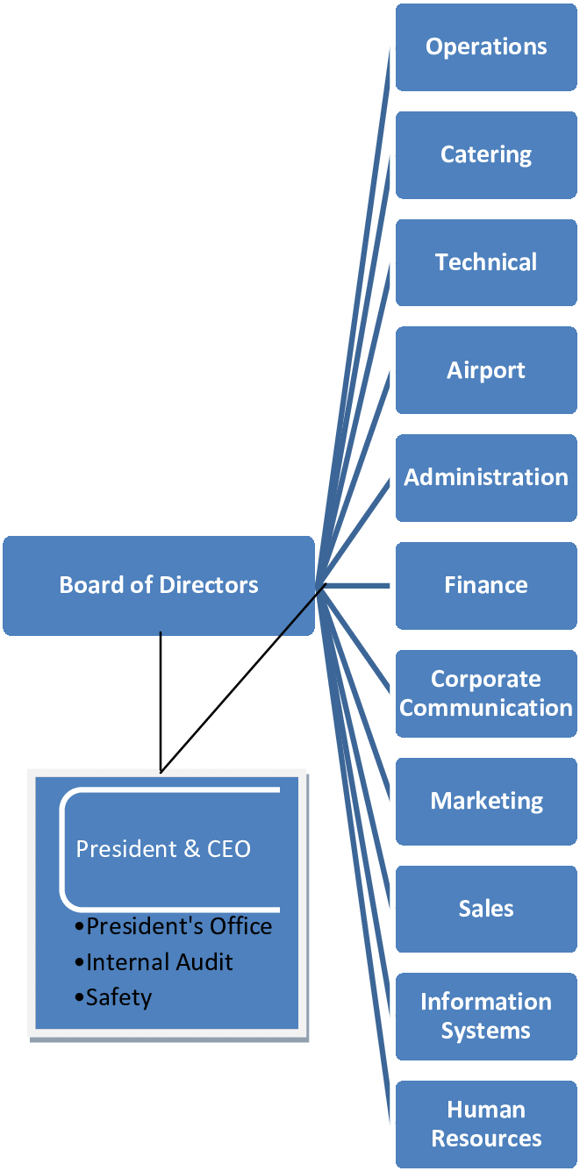
All the decisions that led to success were threatened by the competition market. The low-cost carriers and the alliances between rivals struck the organic growth based on motivation of workforce and security in work promoted by British Airways. The corporate ethical norms were mistaken by the company management, and rescue policies were imposed which involved voluntary dismissals and employment on a lower remuneration grid. This attitude instilled in employees the idea of strike and according to Wilkinson, Grugulisrena, A. K. (2013) about 70% of flights were cancelled, the moral decreased significantly, the first privatization losses were recorded (244 million GPB) and finally, in 2000, the general manager Bob Ayling resigned. “Demoralised and resentful staff can be potentially disastrous to customer satisfaction.” (Wilkinson, A., GrugulisIrena, Kellner, A. K. (2013) “Managing Culture at British Airways.”, pp………………………….).

ORGANIZATIONAL CULTURE - British Airways

A company which has a complex of values, expectations and policies and guides and informs about the initiatives and actions of team members has an organizational culture.
The role culture is highlighted in British Airways by definition of function of each member. The control chain is well-defined by the organization chart of the company, and the roles, obligations and responsibilities are well-known. The CEO has been Sean Doyle since 2020.
Following the global pandemics COVID 19, the company recorded significant decreases and the industry established: resolution methods and fight against problems by communication, creative analysis and motivating environment – the Culture of tasks.
Source: Bangkok Airways Limited

The cultural norms are established, the organizational culture is the package of values and norms which manage the way in which the workforce interacts with people and the situations from external environment (suppliers, customers). The employees of British Airways are customer-oriented and have a positive and right attitude towards the customers. The management initiated many projects designed for the customers. For instance, the customers are suggested to sign insurances for their voyage in case of cancellation or multiple risks, by preventing the possible future inconveniences not related to the activity of the airline company.
“Increasingly, organizational behavior is ; likely to take place in projects. Projects are a form of organizing in which individuals are temporarily but interdependently linked to achieve a specific outcome or set of outcomes. These outcomes can include the production of ideas or products, solutions to problems, y provision of a service, or the construction of public or private infrastructure; they may be innovation projects, where the outcomes are very exploratory or they may be explicitly ed mission-based such as putting a man on the moon.” (J.Barling, Stewart, Cooper, The SAGE Handbook of Organizational Behavior, ……………………pp…………..)

Organizational structure

The organizational structure managed to create the management process, by respecting a hierarchical order, and by establishing organizational activities which can be: planned, organized, managed and controlled-evaluated.
In order to reach economic performances, British Airways signed a merger agreement in 2008 with Iberia, but each of the two companies preserved their names. In 2010, the current CEO International Airlines Group, Willie Walsh announced the intention of possible future acquisitions. By this operation, we can see how the former CEO BA used all the economic resources to render more efficient the activity of the airline company, which had economic growth as result.
For a good organizational structure, there are teams and team leader who monitors the activities of organization and the responsibilities of each department, and they are coordinated for the good functioning of department. The employees are guided to have a flexible attitude and good reaction times to adjust to unpredictable changes (COVID 19 pandemics). For an organizational structure to work and to avoid strikes, a fair remuneration is desired.
The organizational structure is hierarchical, being a company of large sizes, and the employees are hired on various steps/levels, one above the other, representing a long command chain.
Without a good organizational culture and structure, an airline company such as British Airways would not be able to handle various problems and would not reach economic, productive and qualitative performances. Workforce is distributed by:
- department and activities - financial, sales, flights, pilots, accounting, human resources, management;
- area- it operates in 70 countries and over 170 locations;
The organizational culture is under continuous development, change and learning. They use operating systems which gather information and contribute to organization, there are reports distinguished by departments. This instrument is very important for the performance of managerial functions in the airline company.
Quality management must ensure a full audit of all formalities and activities of the airline company for growth of quality performance indicator.

Factors which influence individual behaviour at workplace

“HR strategies may deal with quantifiable issues such as resourcing and skill acquisition but are equally likely to refer to qualitative factors such as engage ment, commitment, motivation, good employee relations and high employment standards. The rela tionship between the pursuit of policies in these areas and individual and organizational performance may be difficult to establish.” (Armstrong, Michael, “Armstrong's handbook of human resource management practice” ……………….pp…………..)
Management is based on many activities and functions: planning, organization, management, evaluation and control.
Planning establishes the steps for reaching the objectives and goals. British Airways had a vision towards the employees of the company. The company plan to succeed after the decline of 1070s-1980s was to invest in employees. They restored their motivation, they sought to change the attitude and built confidence in their own skills. The plan succeeded and at the beginning of 1990s, British Airways reach the top position in aeronautic industry.
Organization of human and physical resources led to the achievement of plans and the reaching of objectives. The continuous training of workforce, investments in new equipment, changing of half a fleet, the opening towards technology and use of software laid the bases of management.
Management is the factor that is directed towards employees and involves motivation. British Airways a imposed the policy “People are first” in impasse, and in 1997, after the demotivation of employees a strike started among the workforce.
Evaluation-Control (Adjustment) reflects on planning and adjustment of wrong decisions.
By the five functions, the individual behaviour is remarked. The individual attitude towards workplace leads to various behaviours depending on the management decisions. The decisions, planning and organization directed towards the well-being of employee positively influence the activity of the company, while the drastic policies on the individual can create chaos and disorder at workplace.
“Everyone has a range of comfort within which they can feel steady and safe. Stress occurs when the individual feels that they are working outside of that comfort zone. Individuals will differ when they feel discomfort. The effects of stress will differ too; for some, the incidence of stress may energise and activate but for others it may immobilise.” (Mullins, Laurie, Jacqueline, “Organisational Behaviour in the Workplace”, 2019, …….pp……)
Management proposes two dimensions one based on financial and economic side and on productivity, and the other based on state of mind and moral of employees. The two dimensions must combine for the performance of the company. The motivation of employee and his/her behaviour towards work are one of the main functions which influence the concern towards productivity and economy.
The leader is responsible for the good functioning of teams. The individual behaviour can be adjusted by the behaviour of the leader towards the employees.
According to Katz (1950) there are two dimensions about the leader: the behaviour directed towards the needs and relations of employees and the behaviour connected to workplace, which is focused on the fulfilment of tasks.

Conclusions

In British Airways, the organizational structure succeeded to create the management process, by respecting a hierarchical order, establishing organizational activities. The organizational performances of the airline company are based on the hierarchical type of organizational structure, the employees are hired on different steps, one above the other – representing a long command chain.
In management two dimensions are classified, one based on the productive and economic or financial side and the other dimension which reflects people. In order to have economic performance and productivity, the moral and desire for work of the staff must be supported. British Airways was successful by approaching a policy focused on people, which supports motivation at workplace and can positively influence productivity and performance.
The leader attentive to the needs of employees, the team work spirit, flexible schedule, facilities of staff in training and development are just a few of the aspects which influence individual behaviour at work in British Airways.
The study has the purpose to make an analysis of the company British Airways which recorded both increases and decreases in its performance and evolution. The problems faced by the company were solved on time and led to the re-evaluation of actions by correcting the managerial mistakes by increasing the cooperation and team work spirit between employees and managers.
If we have to remain with only one lesson from the study above, it would be that the Motivation of people can bring performance – this was one of the important factors which led British Airways to the top place where it is today.

Reference list

- Wilkinson, A., GrugulisIrena, I. and Kellner, A. K. (2013) “Managing Culture at British Airways.” Available at: https://www.researchgate.net/publication/303063497_Managing_Culture_at_British_Airways [Accessed: 5 September 2022]
- Armstrong, Michael, Armstrong's handbook of human resource management practice, Available at: https://r2.vlereader.com/Reader?ean=9780749465513 [Accessed 7 September 2022].
- Julian Barling, Stewart R Clegg, Cary L Cooper, The SAGE Handbook of Organizational Behavior: Volume Two: Macro Approaches (2008), Available at: https://books.google.ro/books?hl=ro&lr=&id=Qb5C7mj-rjEC&oi=fnd&pg=PP2&dq=Barling+J+and+CooperC+(2008)+Handbook+of+Organizational+Behavior,+Sage&ots=aeWnQba3YI&sig=tb5_S0YSPBuHIC1VGo5OYywAy-c&redir_esc=y#v=onepage&q=Barling%20J%20and%20CooperC%20(2008)%20Handbook%20of%20Organizational%20Behavior%2C%20Sage&f=false, [Accessed: 5 September 2022].
- Jacqueline E McLean author; Laurie J Mullins, Organisational behaviour in the workplace (2019), https://ebookcentral.proquest.com/lib/trinity/reader.action?docID=5830196, [Accessed 5 September 2022].
- Britishairways (2022) Britishairways.com. Available at: https://www.britishairways.com/cms/global/pdfs/corporate_responsibility_report_2006/the_BA_way_in_the_workplace.pdf, [Accessed: 6 September 2022].
- Comparably (2022) British Airways’ Logo British Airways, Comparably.com. Available at: https://www.comparably.com/companies/british-airways, [Accessed: 7 September 2022].
- Nevett, K. (2018) “British Airways enhances Cabin Crew training with new apprenticeship programme,” Airline Staff Rates. charlotteASR, 4 December. Available at: https://www.airlinestaffrates.com/british-airways-enhances-cabin-crew-training-with-new-apprenticeship-programme/ [Accessed: 7 September 2022].
- Katz, D, Maccoby, M and Morse, N C (1950) Productivity, Supervision and Morale in an Office Situation, Ann Arbor, MI, University of Michigan Institute for Social Research. Available at: https://ezproxy.uwtsd.ac.uk/login?url=https://www.jstor.org/stable/1030188 [Accessed: 6 September 2022].
- Herzberg’s Motivation Theory – Two Factor Theory. Available at: https://expertprogrammanagement.com/2018/04/herzbergs-two-factor-theory/ [Accessed: 5 September 2022].
- britishairways.co, British Airways- Travel Insurance. Available at: https://www.britishairways.com/en-gb/flights-and-holidays/travel-insurance [Accessed: 7 September 2022].
- British Airways and Iberia sign merger agreement, (2010). Available at: http://news.bbc.co.uk/2/hi/business/8608667.stm, [Accessed: 7 September 2022].
- news.bbc.co.uk, Organisational Culture: Definition, Importance, and Development. https://www.achievers.com/blog/organizational-culture-definition/ [Accessed: 5 September 2022]

