Task 2
Reflection and Academic Report
Student ID:
Date of Submission:
Contents
Task 2A: Reflective Report 3
Introduction 3
Description 3
Feelings 3
Evaluation 3
Analysis 3
Conclusion 4
Action Plan 4
Task 2B: Time management Report. 4
Introduction 4
Why Time Management Matters 5
Time Management Strategies 5
Use of Time Management in my studies. 6
Conclusion 6
References 7

Task 2A: Reflective Report

Introduction
This reflection examines the presentation I gave on the topic of becoming a paramedic in a duration of five minutes. The intention is to look back on what transpired, my mood, what was good, what was not good, and what I could do better in future. The reason I am applying the Gibbs Reflective Cycle is that it enables a clear framework that is used to explain an experience and strategize to make some improvements (Adeani, Febriani and Syafryadin, 2020).

Description
It can be stated that during the presentation I also explained the reasons to be a paramedic. Besides this, I also provided the information about the five essential skills that are very important for this position. Furthermore, I also discussed two of my weaknesses that involves emotional resilience and time management. This presentation was presented to my tutor and was of a duration of five minutes.

Feelings
Initially there was a feeling of nervousness. As I am not a person who likes talking in front of audience. However, there was also a fear of forgetting certain points. I was having a script of the presentation that resulted in creating a sense of confident during the presentation. Besides this, I also sensed that my delivery would be better.

Evaluation
The good aspect of the presentation was that my structure was clear. I described my points one after another and provided reasons behind each skill. My other strength was that I prepared everything and was able to remember most of my main points (Gupta, 2022). One of the negative factors was that I occasionally checked my notes instead of the eye contact. I also talked too quickly than I intended and this rendered some sections less understandable.

Analysis
It can be stated that this experience will provide assistance in understanding the impact of preparation and time management on the quality of the presentation. I was more confident when I planned my thoughts properly. According to the communication theory, proper intonation and eye contact make the audience to remain attentive and hence my poor eye contact minimized the impact of my message. My nerves also indicate that I require practice in delivering a speech more often because my anxiety can be seen as an influence on the delivery and pacing.

Conclusion
In conclusion, I came to realize that I am a good idea person that should learn better to be confident and clear in what I am saying.

Action Plan
I intend to practice more next time without notes so as to have better eye contact. I also would like to train myself to do slow talking (Rizzo and Berger, 2023). I should prepare better with the assistance of time-management tools and stress-management techniques.
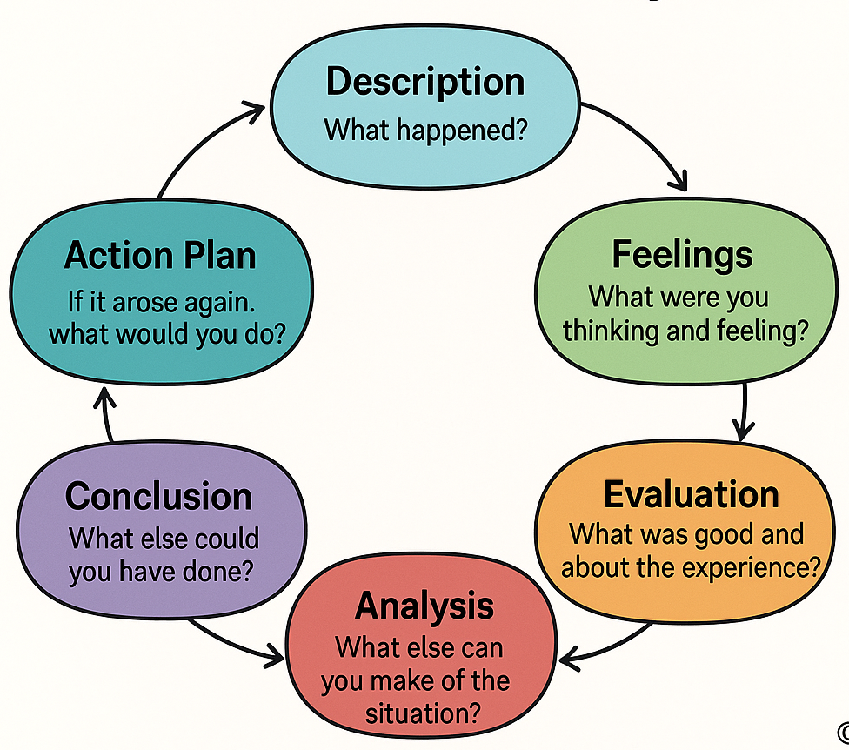
Figure 1: Gibbs Reflective Cycle
Source: Self-created

Task 2B: Time management Report.

Introduction
This report explains why time management is important, and the way it helps in effective learning. Time management refers to the arrangement of time on how to allocate time to tasks. The report will discuss the importance of the time management, outline some of the useful strategies, and demonstrate how these strategies apply to my personal studies.

Why Time Management Matters
Time management is relevant to students as it makes them do their assignment in time and minimizes stress (Aeon, Faber and Panaccio, 2021). Late work usually has a negative effect on students since they have to hurry and deliver the work. Time management helps to achieve higher grades since students are able to plan and revise their works and they are not under pressure of writing at the last minute. Lack of time management may cause deadlines to be missed, misunderstanding and anxiety. Employment also demands time management because numerous employment opportunities need one to meet deadlines, prioritise work and remain organized (Aeon, Faber and Panaccio, 2021). Indicatively, in health care or emergencies, good time management can assist the employees to be in control of activities in a safe and effective manner.

Time Management Strategies
Prioritisation is one of the strategies that works. This requires making decisions that prioritize the tasks, and those, which could be postponed (Wolters and Brady, 2020). Tasks can be divided in terms of urgency and importance with the use of such tools as the Eisenhower Matrix (Khedmatinejad and Asadi, 2021). The other helpful strategy is having a digital calendar, like a Google Calendar, where the deadlines and notices can be scheduled. This prevents losing of crucial activities. The third plan is to develop to-do lists daily or weekly (Wolters and Brady, 2020). These subdivide tasks leading to small steps, and help one to focus better. Lastly, it is easier to accomplish small segments of big assignments and then de-stresses and tasks become easier to undertake.
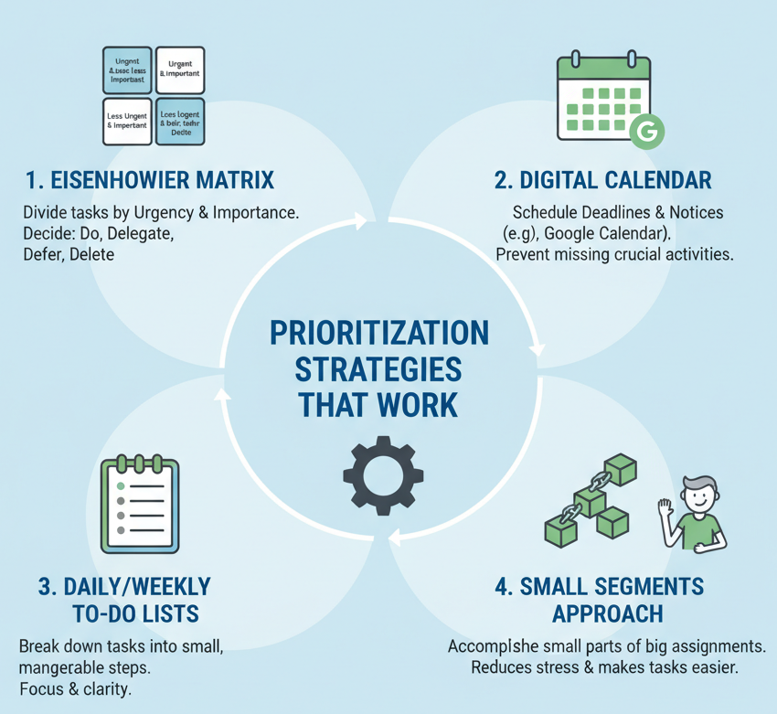
Figure 2: Strategies
Source: Self-created

Use of Time Management in my studies.
Google Calendar helps me to remember about my deadlines and plan my work in the field of my own studies. I also make short to-do lists to enable me to concentrate on the most significant activities within a day (Wolfel, 2024). Such strategies make me remain organised, though I continue to underestimate the time required in assignments. I am trying to get this better by planning ahead and dividing tasks into small segments.

Conclusion
In conclusion, time management is very important skills which is very useful in education and employment. The stress can be lessened and performance enhanced through activities like prioritisation, use of calendar planning and dividing work into steps.

References
Adeani, I.S., Febriani, R.B. and Syafryadin, S. (2020). Using Gibbs’ Reflective Cycle in Making Reflections of Literary Analysis. Indonesian EFL Journal, 6(2), pp.139–148. doi:https://doi.org/10.25134/ieflj.v6i2.3382.
Aeon, B., Faber, A. and Panaccio, A. (2021). Does Time Management Work? a Meta-Analysis. PLOS One, [online] 16(1). doi:https://doi.org/10.1371/journal.pone.0245066.
Gupta, C. (2022). Self-Assessment Through Reflection. JALT Postconference Publication - Issue 2021.1; August 2022, 2021(1), p.63. doi:https://doi.org/10.37546/jaltpcp2021-08.
Khedmatinejad, H. and Asadi, S. (2021). Time Management and Decision-Making for Reading in Public Library Clients Based on the Eisenhower Matrix. Quarterly Knowledge and Information Management Journal, [online] 8(1), pp.63–72. doi:https://doi.org/10.30473/mrs.2022.61568.1491.
Rizzo, G.L.C. and Berger, J.A. (2023). The Power of Speaking Slower. [online] Social Science Research Network. doi:https://doi.org/10.2139/ssrn.4580994.
Wolfel, M. (2024). DEVELOPING A TIME-MANAGEMENT APPLICATION FOR STUDENTS. [online] Escholarship.org. Available at: https://escholarship.org/uc/item/8tj3n7zq.
Wolters, C.A. and Brady, A.C. (2020). College students’ time management: A self-regulated learning perspective. Educational Psychology Review, [online] 33(4), pp.1319–1351. Available at: https://link.springer.com/article/10.1007/s10648-020-09519-z.

