CONTINENTAL HOTEL BUDGET PLAN

STUDENT NAME: MIHAELA ADRIANA CRISTIAN
STUDENT ID: 2017346
MODULE NAME: FINANCIAL MANAGEMENT FOR THE HOTEL INDUSTRY
MODULE CODE: BMIH5007, BMIH5002
LECTURER: DALE CLARKE

Table of Contents

Executive Summary ……………………………………………………………………………3

Task 1: Budget Calculations ………………………………………………………………….4
Task 2 ……………………………………………………………………………………………..5
- Introduction ……………………………………………………………………………..5
- Zero Based Budgeting…………………………………………………………………5

2.1 Definition and Evaluation of the process of zero-base budgeting ……………5

2.2 Advantages of Zero-based budgeting over Traditional Based ………………...7

2.3 How the Organisation Might Introduce Zero-based Budgeting ………………..8
- Conclusion ………………………………………………………………………………9
- Reference List …………………………………………………...…………………… 10

Executive Summary
In the first task, we have to prepare a budget planner, a cash flow forecast for the upcoming year of Continental Hotel which is a 15-room hotel situated in London. The budgeted income and expenses will be clearly categorised under different tables to get a clear view of the total income and expenses so that the budget can be easily calculated. This will lead to a clear division of monthly income and monthly expenditure which will provide a clearer view of the budget requirements. In the second task, a report will be made which will talk about the zero-based budgeting technique and how to implement this in a hotel like Continental Hotel. We will also come across the advantages of this technique over the traditional budgeting method.

Task 1 Budget Calculations
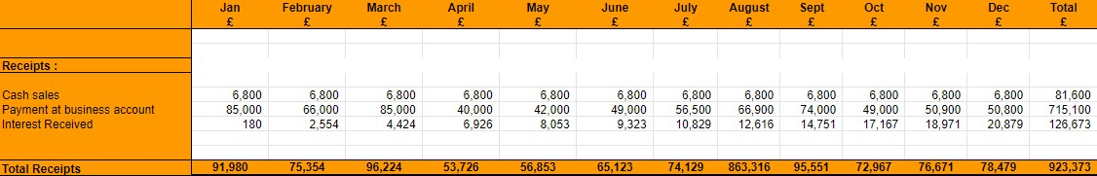
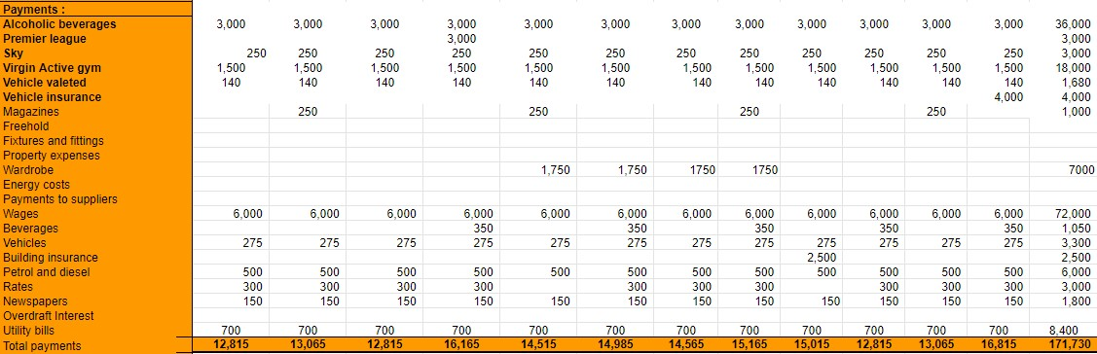

TASK 2

Introduction
In this report, we will start defining and understanding the meaning of zero-based budgeting which will be followed by evaluating the steps in the process of the whole system. After that, we will discuss the advantages of zero-based budgeting and why it is better than traditional-based budgeting. Taking the case of Continental Hotel, we will then decide how the zero-based budgeting system can be introduced in the organisation. We will send the report with a conclusion of all the points discussed and provide a short summary of the whole report which will be followed by the reference list.

1. Zero-based Budgeting

2.1 Definition and evaluation of the process of zero-based budgeting
ZBB establishes goals to be accomplished after starting with a zero balance. The current year's activities are examined in detail. After the evaluation, the management can decide to continue funding an ongoing project at the same amount as last year. However, it is very probable that financing will change based on fresh facts, either increasing or decreasing (Haxholli, 2015). In contrast to traditional budgeting, which is based on prior budgets, zero-based budgeting requires all spending to be justified for each and every month. This strategy requires that each action be justified, the cost of each function be examined, and then the funds be allocated in accordance, regardless of how much money has previously been budgeted for any particular line item.
By freeing up resources to spur development and innovation and enabling businesses to radically alter what they do and how they operate, zero-based budgeting facilitates large-scale transformation (BCG, 2022)
A zero base is a tool to control everything a company spends money on and operates in government and non-profit organisations, and does not eliminate the need for detailed cost budgets. Zero-based thinking can be applied everywhere - in direct manufacturing and sales as well as in service and support departments. The successful implementation of
Zero-Based Budgeting (ZBB) lies in the conviction of the employees of the benefits. Companies with employees who have a lot of trust in management are more likely to be successful with ZBB. To be successful, a company needs strong sponsorship from the top.
Leaders need to motivate and engage people in their organisations correctly (Stretch,2020). The process of zero-based budgeting can be understood with the help of the diagram given below.
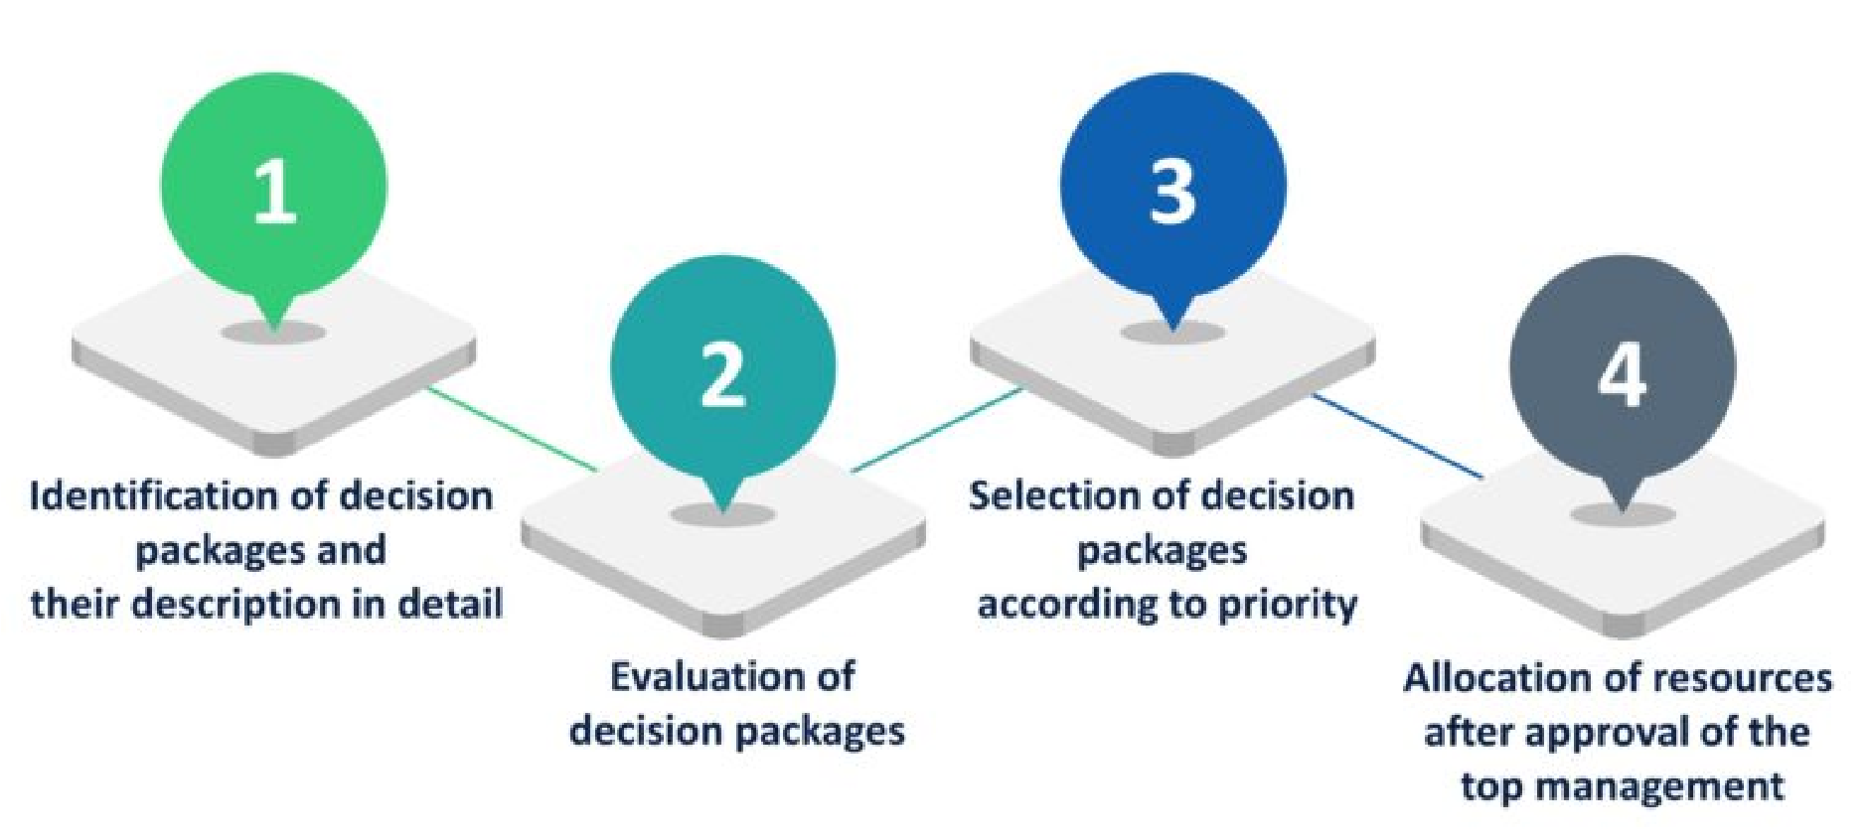
Three phases will be taken in the information collecting process for this project: (i) the identification and evaluation of program services; (ii) the creation and assessment of performance metrics; and (iii) the analysis of program budget and expenditures (O’Shea, 2018). The process starts with the identification of activities and functions to be performed during the process which includes identifying all the expenses required for each month. Then all of the functions and activities identified are evaluated and analysed which is followed by selecting the best possible way of performing the process. This evaluation is done by the managers and they check if the expenses included are justified or not. After that, come to the selection process where the expenses are selected based on their priority and needs. Here the necessities are selected first and then come other additional expenses. Finally, resources are allocated according to the selected way.
ZBB entails a company deciding that its prospective cost savings justify the adoption's increased complexity and resource intensity. The theory holds that some organisations, such as those with prospector strategies or high task ambiguity, benefit more from a specific practice than other organisations (Coyte, Messner & Zhou, 2021)

2.2 Advantages of Zero-based budgeting over Traditional Based
In conventional planning, businesses use the budget from the previous period as a starting point and add to it. Companies only need to justify new spending because typically each budget grows slowly in comparison to the budget for the prior month. Zero-based budgeting differs from typical budgeting in those businesses that utilise it to build the budget from a "zero base" for each new month. Even recurrent and long-standing costs must be justified before being included in the new budget (Investopedia, 2019).
ZBB was successful in cutting certain agency budgets and slowing the rate of growth in others. In addition, it promoted more line management involvement in budget planning and served to inform senior city officials about how municipal agencies function. (Moore, 1980). Employee involvement in budgeting and efficient budgetary control is considered to be crucial strategies for improving organisational performance (Obigbemi, 2013) More advantages of zero-based budgeting can be discussed below.
● Effective resource distribution by the department:
Zero-based budgeting, which ignores previous data in favour of current data, aids in efficient resource allocation among departments. According to research, management engagement in the budget process increased significantly after ZBB implementation. As a result, there were closer linkages between all levels of management and more clarity regarding the goals and demands placed on the different projects (Ibrahim, 2019). Zero-based budgeting system makes sure that there is an effective resource distribution by the department which means the work is equally divided among the departments and no department is loaded with a lot of work at the same time making sure that no department should not be underutilised at the same time. That is the reason zero-based budgeting leads to optimal utilisation of resources in the organisation.

● Cost Reduction
Zero-based budgeting aids in cost reduction since it provides a clear view of expenses as opposed to the conventional way of budgeting, which entails making arbitrary modifications to the budget from the previous year. The good news is that users using zero-based budgeting tend to be slightly more effective in attaining their expense objectives. Sixty-three percent of respondents worldwide who did not perform ZBB did not accomplish their cost objectives, whereas 58 percent of those who did employ ZBB did. (Deloitte, 2019). This is the reason why there is a reduced cost in zero-based budgeting since all the unnecessary expenses are not taken into account and only those specific expenses are included in the budget which is needed in a month. Within the first four months of a new ZBB programme, one firm recently saw savings of 11% in its operational budget. In this case, gaining more insight into labour costs, implementing new approval levels to regulate the demand for contract labour, resuming procurement activities to renegotiate rates, and altering "make versus buy" decisions all resulted in immediate cost reductions (McKinsey & Company, 2014).

● Enhances strategic growth and transparency
Zero-based budgeting guarantees that the selection process is transparent and encourages strategic growth by facilitating an efficient and clearly defined procedure that is carried out with careful planning and mapping. Increase budget transparency, empower line managers, and ensure that your expenditure truly advances your company's objectives with the help of zero-based budgeting (Phillips, 2019).

● Managers are required to justify all operating expenses
Zero-based budgeting requires managers to consider how every dollar is spent throughout each planning cycle. This method also requires them to justify all operating costs and determine which sections of the business generate money (Investopedia, 2019). So, it becomes the responsibility of the managers to make sure that all the expenses are included and also make sure that no unnecessary expenses are included in the budgeting since they have to justify each and every expense they include in the budget. This ensures that the managers make the most efficient budget which works best for the firm's budget requirements.

2.3 How the Organisation Might Introduce Zero-based Budgeting
To demonstrate the efficacy of its strategy, the FCC uses a zero-based budgeting technique for awarding assistance funds. The FCC determines which technology would most likely increase the availability of broadband in selected locations at the lowest support funding cost using a model. The FCC then concedes that it is impossible to halt funds to new
beneficiaries immediately. (Glass, Stefanova, & Prinzivalli, 2014). In order to introduce a zero-based budgeting system in Continental Hotel all the costs should be identified, followed by revenue and other financial needs that are needed for the business. Then follow the process of zero-based budgeting which is explained in detail in the above sections. One of the first provinces to use zero-based budgeting (ZBB) is Hubei. ZBB was first incorporated into the provincial budgeting process in 1993. However, ZBB adoption was not regularised prior to the DBR (Ma, Bunch & Tang, 2006).
A new procedure needs education and training, especially one that emulates the strictness of ZBB. Understanding the new strategy and the infrastructure supporting it should be a part of training (Serven, 2018)
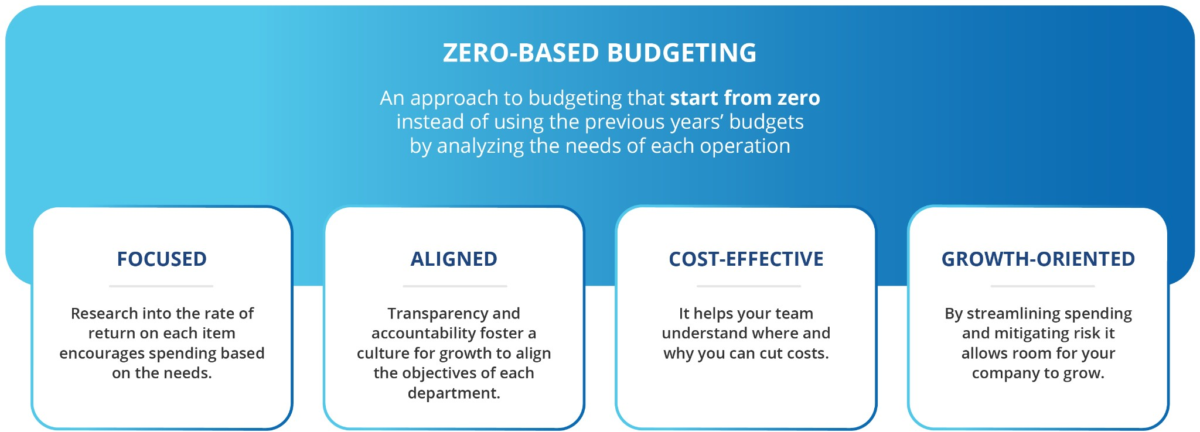

Conclusion
To summarise we have learned the meaning and process of zero-based budgeting at the start of the report which showed brief steps involved in the process of zero-based budgeting and briefly explained to us why it is important for an organisation to adopt a zero-based budgeting system which leads us to the advantages in comparison to a traditional budgeting system like cost reduction, effective management, and optimum utilisation of resources. After that, we studied how a hotel like Continental Hotel can introduce a zero-based budgeting system in their hotel which will lead to their benefit in cost savings and effective budget-making.

Reference list
BCG Global. (2022). Zero-Based Budgeting. [online] Available at: https://www.bcg.com/capabilities/zero-based-budgeting/overview [Accessed 28 Jun. 2022].
Coyte, R., Messner, M. and Zhou, S. (2021). The revival of zero‐based budgeting: drivers and consequences of firm‐level adoptions. Accounting & Finance. doi:10.1111/acfi.12884.
Deloitte (2019). Zero-Based Budgeting | Deloitte US. [online] Deloitte United States. Available at: https://www2.deloitte.com/us/en/pages/operations/articles/zero-based-budgeting.html [Accessed 5 Jul. 2022].
G, R. and hi (2021). What is Zero based budgeting? – How to implement it! [online] Finlawportal. Available at: https://finlawportal.com/zero-based-budgeting-how-to-implement-it/ [Accessed 25 Jun. 2022].
Glass, V., Stefanova, S. and Prinzivalli, J. (2014). Zero-based budgeting: Does it make sense for universal service reform? Government Information Quarterly, 31(1), pp.84–89. doi: 10.1016/j.giq.2013.05.022.
Haxholli, B. (2015). Zero Based Budgeting in KCS Implementing Zero Based Budgeting Method in Kosovo Correctional Service. Theses. [online] Available at: https://scholarworks.rit.edu/theses/8765 [Accessed 28 Jun. 2022].
Ibrahim, M. (2019). Designing zero-based budgeting for public organizations. Problems and Perspectives in Management, 17(2), pp.323–333. doi:10.21511/ppm.17(2).2019.25.
Investopedia. (2019). Zero-Based Budgeting: Benefits and Drawbacks. [online] Available at: https://www.investopedia.com/ask/answers/051515/what-are-advantages-and-disadvantages-zerobased-budgeting-accounting.asp [Accessed 5 Jul. 2022].
Ivankovič, G. and Jerman, M. (2011). Comparative analysis of budgeting in the Slovene hotel industry. Tourism and hospitality management, 17(1), pp.91–100. doi:10.20867/thm.17.1.7.
Kagan, J. (2019). Zero-Based Budgeting (ZBB). [online] Investopedia. Available at: https://www.investopedia.com/terms/z/zbb.asp [Accessed 24 Jun. 2022].
Luceo || Official Website. (n.d.). Zero Based Budgeting (ZBB). [online] Available at: https://luceocc.com/en-US/post/4/zero-based-budgeting-zbb [Accessed 3 Jul. 2022].
Ma, J., Bunch, B. and Tang, C. (2006). Zero-based budgeting in china: experiences of Hubei province. Journal of Public Budgeting, Accounting & Financial Management, 18(4), pp.480–515. doi:10.1108/jpbafm-18-04-2006-b006.
Moore, P. (1980). Zero-Base Budgeting in American Cities. Public Administration Review, 40(3), p.253. doi:10.2307/975379.
O’Shea, J. (2018). Viability of Zero-Based Budgeting Methods in the City of Albuquerque. Shared Knowledge Conference. [online] Available at: https://digitalrepository.unm.edu/skc/2018/posters/54/ [Accessed 29 Jun. 2022].
Obigbemi, Imoleayo F (2013). Employee participation in budgeting and budgetary control: A tool for enhancing organizational performance - Covenant University Repository. Covenantuniversity.edu.ng, [online] 1(11), pp.1–11. doi: http://eprints.covenantuniversity.edu.ng/2672/1/60.pdf.
Phillips, K. (2019). Zero-based budgeting: How to avoid year-end panic spending. [online] AccountingWEB. Available at: https://www.accountingweb.co.uk/community/blogs/kevin-phillips/zero-based-budgeting-how-to-avoid-year-end-panic-spending [Accessed 5 Jul. 2022].
Pickup, I. (1985). Budgetary control within the hotel industry. International Journal of Hospitality Management, 4(4), pp.149–155. doi:10.1016/0278-4319(85)90052-0.
Serven, L. (2018). What is zero-based budgeting? 8 tips for implementation. [online] Planning and Analytics Blog – Board International. Available at: https://blog.board.com/budgeting-planning-forecasting/top-tips-implementing-zero-based-budgeting/644/. [Accessed 2 Jul. 2022].
STRETCH, J. (2020). Zero-based budgeting: A practical understanding. [online] Accountancysa.org.za. Available at: https://magazine.accountancysa.org.za/articles/zero-based-budgeting-a-practical-understanding [Accessed 6 Jul. 2022].
www.mckinsey.com. (2014). Five myths (and realities) about zero-based budgeting | McKinsey. [online] Available at: https://mckinsey.com/business-functions/strategy-and-corporate-finance/our-insights/five-myths-and-realities-about-zero-based-budgeting [Accessed 5 Jul. 2022].

