Zuhua Liu (1706153)

Business Intelligence Systems-Data Analysis & Mining

Name: Zuhua Liu
Student P Number: 1706153
Module Title: Business Intelligence Systems
Assignment Title: Business Intelligence
Systems-Data Analysis & Mining
Lecturer’s Name: Dr Nik Whitehead

Content
1 Introduction 3
2 Description of dataset 4
3 Variation of sales and profits 5
3.1 Variation of sales 5
3.2 Variation of profits 8
4 Trends for profit and sales 12
5 Forecast for profit and sales 15
6 Market basket analysis of items 17
7 Business recommendations 18
8 Conclusion 19
Reference 20

1 Introduction
Business intelligence [1] is the application of artificial intelligence, data mining, data warehouse and other advanced technology. According to business objectives of enterprises, staffs need to use analysis and mining enterprise data, which will reveals the hidden and unknown knowledge or verification rules, so as to support the intelligent management and decision of enterprises and improve the core competitiveness of enterprises. Staffs do not need to know programming and much computer technology. They should know how to use BI tools and create charts, figures, maps and dashboard to show the economical state of company and analysis the trends. There are many BI tools, such as Zoom data and Tableau. Enterprises choose different tools depending the requirements.

The aim of this essay is to get the development trends for company in Canada and forecast the sales and profits in Canada. This report will analyze the adventureworks databases by Tableau, including the variation in sales and profit over time, trends for sales and profit, forecasts for sales and profit and market basket analysis. This essay will also focus on how to solve these problems and give some business advice based on the trend of sales and profit in Canada so that organization can get some policies to improve their profit.

2 Description of dataset
A dataset [2] is a collection of data, usually in the form of a two dimensional table. Each column represents a specific variable and each line corresponds to a member of dataset. A dataset also have different structure depending on the user’s target. This dataset includes a lot of tables. By dragging sheets, it can create an inner connection (Figure 1). These tables were merged together and a new table is built.
Figure1 structure of tables

Many attributes [3] are in the new table containing available values and missing values. Suffix, Class, Style, Online Order Flag and discount are null, which means that these values are not necessary for analysis.
However, there are also some important attributes, such as standard cost, list price, order quantity, unit price, line total, order date, subtotal, tax amount, freight and total due. Stand cost is the cost for materials and production. List price is a label price, but unit price is the price in different store which is the real sale price for one item. Line total is the total amount calculated by unit price multiply by order quantity, therefore, line total is also the sales. Adding whole invoice can get subtotal and it does not contain tax and shipping cost. Total due is the sum of subtotal, tax amount and shipping cost. When it comes to profit, one item’s profit equals unit price minus standard cost, therefore, order quantity multiply by one item’s profit can get the all profits.

3 Variation of sales and profits
From this image (figure 2), the blue color line is below zero which illustrates that the company has been losing money especially in 2002 reaching its trough of wave. For sales, it had a decreasing trend since 2001 and began to fall after 2002.

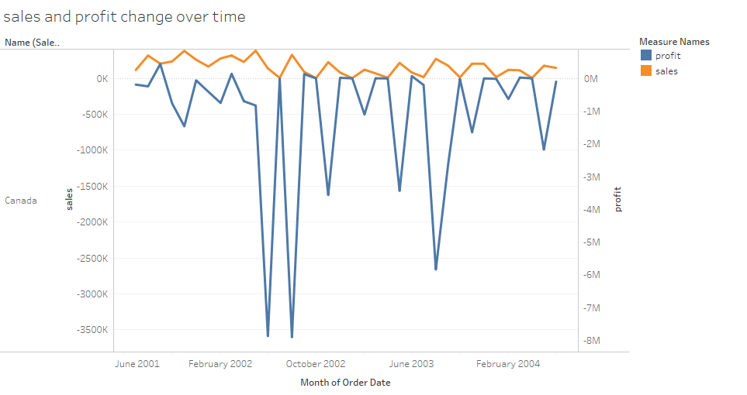
Figure 2 sales and profits change over time

3.1 Variation of sales
After uploading data to Tableau [4][5], using the Calculated Field editor to create a group for sales and profit. This essay for Canada is based on the calculation of sales[6]: sales = line total.

Over the year 2001- 2004, the sales has changed a lot (figure 3). In 2001, sales in canada were 1511319 and it rose to 2237914 in 2002 which was almost over 50%. However, After this year, sales started decreasing and it was just 570416 in 2004 which was only in the ratio of one to four comparing to 2002. Many reasons may lead to this trend and some main categories also changed over time and were a little anomalous.
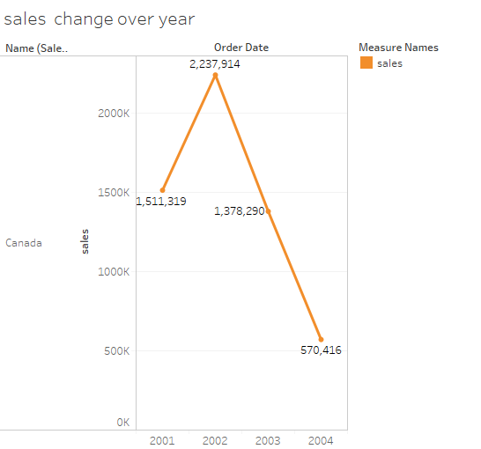
Figure 3 sales change over time in Canada from 2001 to 2004

There are four main categories(figure 4), accessories, bikes, clothing and components for this company in Canada. Bikes are the main products of the company, with the largest proportion. Each main categories have some subcategories.
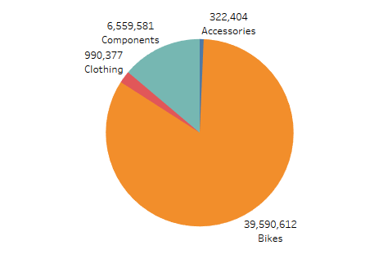
Figure 4 sales for categories
For accessories (figure5), this company did not sell some products until 2002 or 2003 like bike racks, bottles and cages, cleaners, etc. Helmets was the most popular item in accessories and its sale also was the highest among this products through it was reduced by 50 percent in 2004 comparing other years. Tires and Tubes sales was very terrible and it was just 16 in 2004.

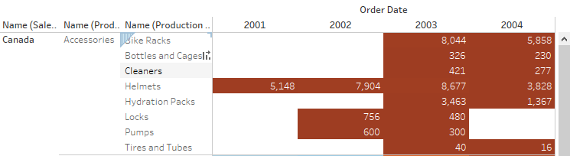
Figure 5 sales for accessories

For bikes (figure 6), every items sales is close. Roads bikes reached its peak 1258775 in 2002 and it began decreasing. Every subcategories was decreasing from 2003 to 2004.
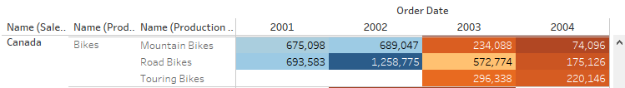
Figure 6 sales for bikes

For clothing (figure 7), Jerseys had the highest sales between 2001 and 2004. Its sales also start decreasing since 2003.
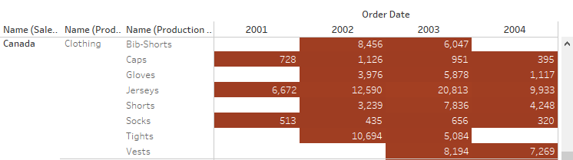
Figure 7 sales for clothing

For components (figure 8), mountain frames and road frames was the main product which get the most of the sales. It was not until 2003 that it began to sell some products like bottom brackets, chains, cranksets, etc. There are also few sales of these products.

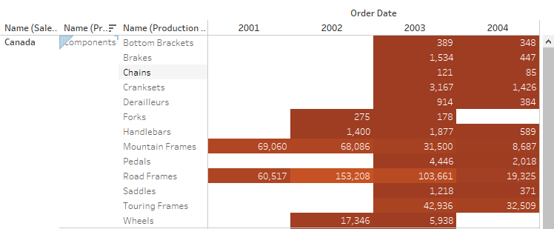
Figure 8 sales for components

In conclusion, from 2002 to 2004, the company has a large drop in total sales and this company may face some economic problem.

3.2 Variation of profits
This business report for Canada is based on the calculation of profits [7]: profits= (unit price – standard price)*order quantity.

Over the year 2001- 2004, the trend of profit change is like a trough (figure 9). In 2001, profits in Canada were -10518460 and it decreased to -209221979 in 2002. However, After this year, profits started increasing and it was just -9883956 in 2004. The strange thing is that the company has been in a state of loss and has reached its biggest loss at the end of 2002, and the loss rebounded in the following years.
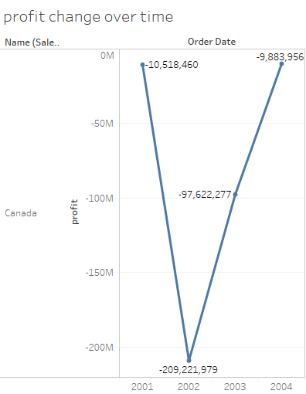
Figure 9 Profits change over time

There are four main categories (figure 10), accessories, bikes, clothing and components for this company in Canada. Only accessories has been in a state of profit, and all other products have a loss, especially the serious loss of bikes.
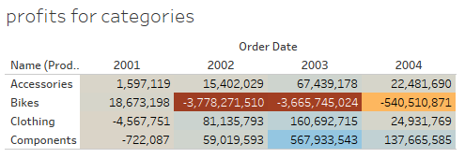
Figure10 profits for categories

For accessories (figure11), this company did not sell some products until 2002 or 2003 like bike racks, bottles and cages, cleaners, etc. Helmets accounted for the biggest profit, but in 2004 profits fell to 1/4 in 2003. All subcategories in accessories made money.
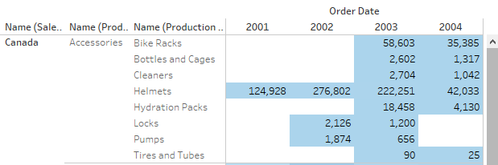

Figure 11 profits for accessories

For bikes (figure 12), only mountain bikes made some money in 2001,2003 and 2004, and other subcategories are in a state of loss.
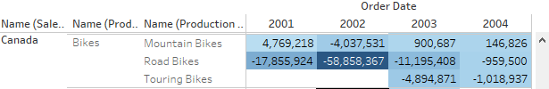
Figure 12 profits for bikes

For clothing (figure 13), Jerseys had the highest loss between 2001 and 2004 ,and caps also have been lost money all the time. Other products were in a good state.
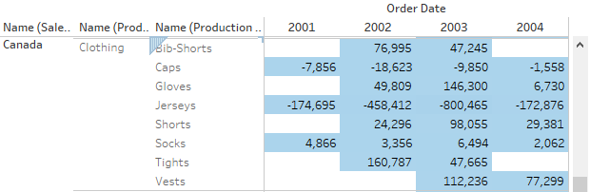
Figure 13 profits for clothing

For components (figure 14), mountain frames is a major profit product, and only road frames has been in a loss.
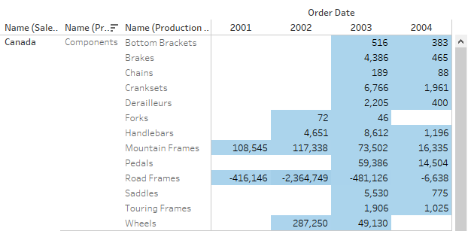
Figure 14 profits for components

In conclusion, from 2002 to 2004, the company has been in a loss in total profits. To solve this problem, this company can improve some subcategories unit price especially bikes like road bikes and touring bikes. The company is developing in a good direction in general.

4 Trends for profit and sales
Trend lines[8][9] in Tableau can predict the trend about the data how sales and profits will change over the next financial period. For sales, it has been in a downward trend since 2001. The change between 2001 and 2002 was not particularly obvious, and sales began to decline significantly after 2002. According to trend lines[10], sales may pick up after 2004.
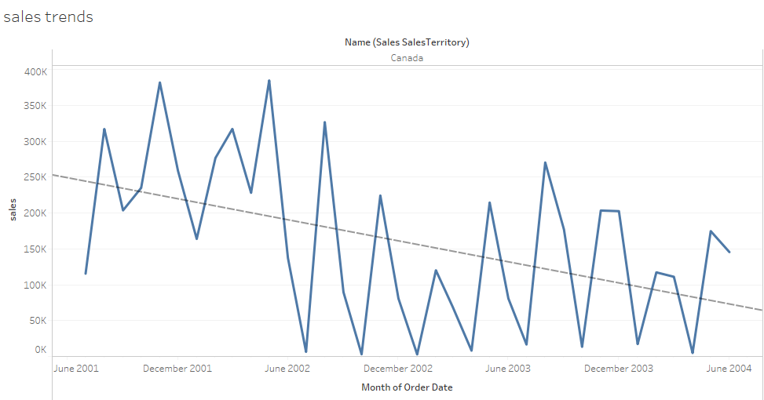
Figure 15 sales trend

For profits (figure 16), its trend is an arc. Profits fell considerably from 2001 to 2002, and then rebounded. In general, the company has been in a loss.
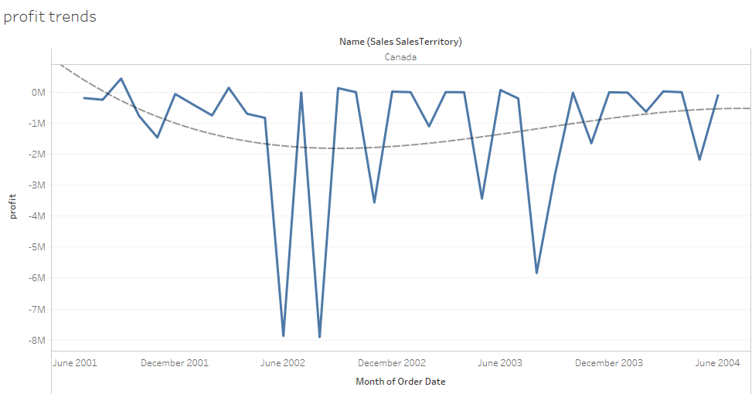
Figure 16 profits trend

For some categories and subcategories scatter plot with sales and profits (figure 17,18,19 , 20 and 21), Trend lines of accessories show a good trend, each product is in growth. Bikes inside road bikes and touring bikes showed a downward trend, in which there has been a significant increase in mountain bike.

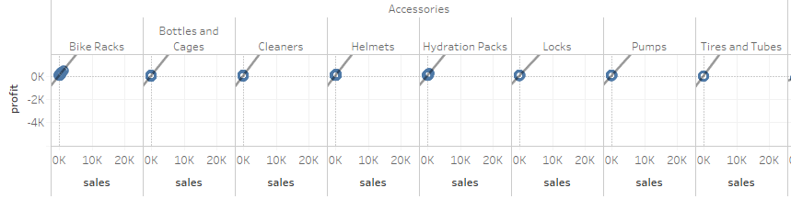
Figure 17 scatter plot with sales and profit trend for accessories

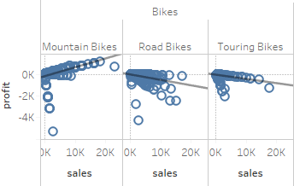
Figure 18 scatter plot with sale and profit trend for bikes

For clothing, caps and jerseys show a downward trend, other sub-directory products are profitable.
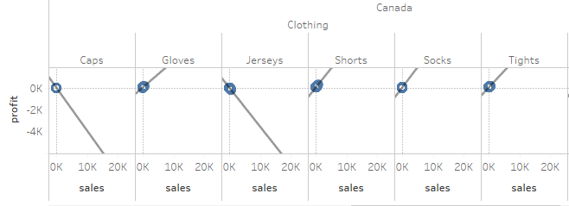
Figure 19 scatter plot with sale and profit trend for clothing

For components, Each subcategory product trend is good except for the road frames.
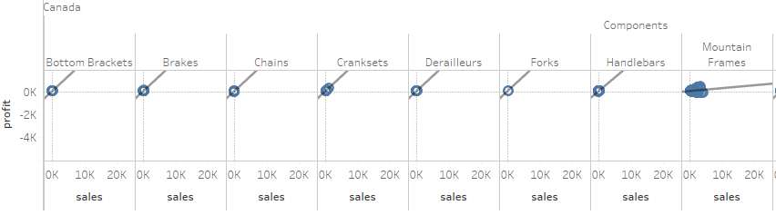
Figure 20 scatter plot with sale and profit trend for components (1)

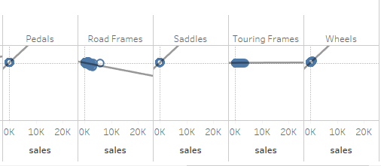
Figure 21 scatter plot with sale and profit trend for components (2)

5 Forecast for profit and sales
Forecasting [11][12] is about the future value of forecasting measures. There are many mathematical models for forecasting. Tableau uses a model known as exponential smoothing. In exponential smoothing, recent observations give a relatively heavier weight of old observations. These models capture the evolutionary or seasonal nature of data and push them to the future. The predicted result can also be a field created in the visualization. Tableau uses one-off dimensions and a measure field to create predictions.

In terms of the forecast trend for sales (figure 22), the curve is wavy and undulating. The company's sales in Canada in 2005 will have a smooth over and will not continue to decline quickly.

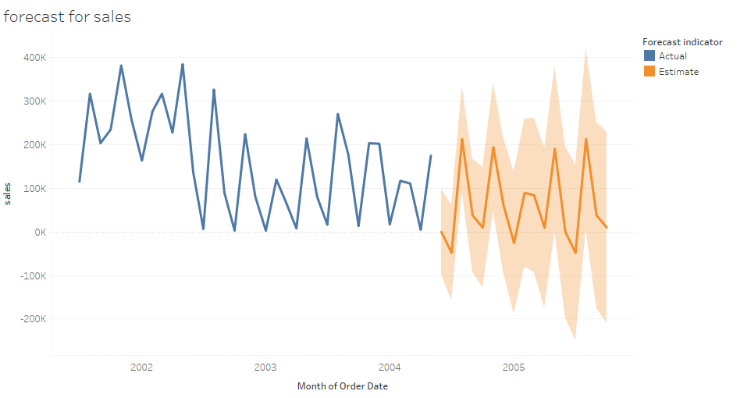
Figure 22 forecast for sales

As for profits (figure 23), the decline in its shape, and a profit above zero for some time, shows that the company's profit will continue to grow in 2015, gradually from loss to profit.
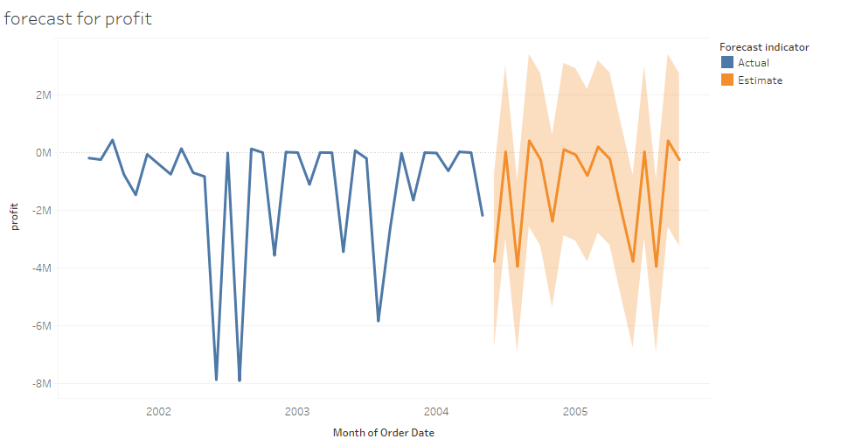
Figure 23 Forecast for profit

6 Market basket analysis of items
Market basket analysis [13][14] can be used to discover and understand customer buying behavior. It can be used to solve related problems in order to analyze the sales of non-class products and the degree of user's preference, so that the company can make corresponding decisions. Before performing this type of analysis, you need to set up a data source to help perform the analysis.

From market analysis table(figure 24), the color of number shows the number of individuals who purchased products which are most common to buy together. According to the color of its figures, you can see the relationship of each product. Seeing from the table, these colors can be divided into three main groups in Canada.
- Road bikes and Road frames
- Jerseys and Road bikes
- Helmets and Road bikes
The green one is the most import one which has the biggest number and it means that Road bikes and Road frames are most common to buy for clients. Jerseys and Road bikes are the second one that people may buy both. Helmets and Road bikes are also popular for people to buy together.
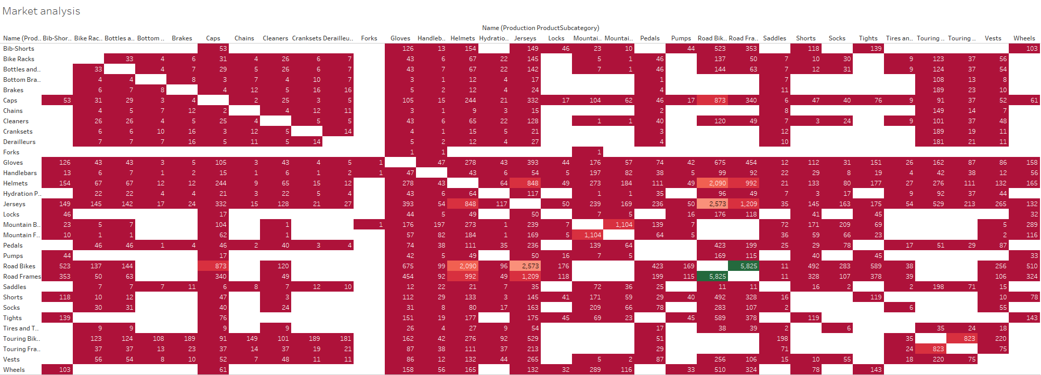
Figure 24 heat map showing market basket analysis of subcategories

7 Business recommendations
The above analysis shows that road bikes are one of the company's biggest losers, probably because the company wanted to open up a market for road bikes in Canada in return for a rise in sales on a nonprofit basis. Based on the company's sales and profits analysis, we can conclude that the company's sales have been declining, and profits are gradually rising. In order to open up the bicycle market in Canada, the company sells some products below the standard cost to attract customers. Sales are relatively small on some products and profits on some products have been at a loss. In order to maintain the company's long-term development, the following recommendations are made (for the specific products in the above analysis, suggestions are given only in the overall situation):

- To increase the selling price of some products to obtain more profits like bikes which are the main reason for losing money;

- Continue to bike as the company's flagship product and try to promote the company's other products;

- For some products with fewer sales, the company can choose to stop production according profits of product.

- Combine Market basket analysis to produce the products which people purchase commonly.

8 Conclusion
Overall, this essay analyze the adventureworks database by Tableau for company’s operations from changing of sales and profits, the trend for sales and profits, forecasting for sales and profits and market basket analysis. By analyzing, this report also describe the situation of this company for some categories and subcategories and give some advice for company’s long term development.

Reference
[1] Mary K.Pratt, “What is BI? Business intelligence definition and solutions | CIO.” [Online]. Available: https://www.cio.com/article/2439504/business-intelligence/business-intelligence-definition-and-solutions.html. [Accessed: 16-Dec-2017].
[2] Margaret Rouse, “What is data set? - Definition from WhatIs.com.” [Online]. Available: http://whatis.techtarget.com/definition/data-set. [Accessed: 16-Dec-2017].
[3] “How to Create an Invoice.” [Online]. Available: https://www.solaraccounts.co.uk/help/how-to-create-an-invoice.php. [Accessed: 16-Dec-2017].
[4] M. Monsey and P. Sochan, Tableau® for dummies®. .
[5] Université du Québec. Direction des bibliothèques et du soutien à l’enseignement et l’apprentissage. and Université du Québec. Groupe d’intervention et d’innovation pédagogique., Le Tableau. Direction des bibliothèques et du soutien à l’enseignement et l’apprentissage (DBSEA) en collaboration avec le Groupe d’intervention et d’innovation pédagogique (GRIIP) Université du Québec.
[6] Christopher Carter, “How to Calculate Sales Revenue in Accounting | Chron.com.” [Online]. Available: http://smallbusiness.chron.com/calculate-sales-revenue-accounting-18906.html. [Accessed: 02-Jan-2018].
[7] “How to Calculate Profit: 12 Steps (with Pictures) - wikiHow.” [Online]. Available: https://www.wikihow.com/Calculate-Profit. [Accessed: 02-Jan-2018].
[8] C. Henry, “Tableau des operations financieres,” Rev. économique, vol. 6, no. 3, p. 387, May 1955.
[9] P. S. Molly Monsey, “How to Add Trend Lines in Tableau - dummies.” [Online]. Available: http://www.dummies.com/programming/big-data/big-data-visualization/how-to-add-trend-lines-in-tableau/. [Accessed: 02-Jan-2018].
[10] Internet business newsweekly. NewsRX.
[11] Daniel G. Murray, “How to auto generate forecasts with Tableau | Computerworld.” [Online]. Available: https://www.computerworld.com/article/2488480/business-intelligence/how-to-auto-generate-forecasts-with-tableau.html. [Accessed: 02-Jan-2018].
[12] Tom Brown, “Simple forecasting using Tableau - The Information Lab.” [Online]. Available: https://www.theinformationlab.co.uk/2010/07/13/simple-forecasting-using-tableau/. [Accessed: 02-Jan-2018].
[13] “How to Better Understand and Use Linear Trend Models in #Tableau.” [Online]. Available: https://3danim8.wordpress.com/2013/09/11/how-to-better-understand-and-use-linear-trend-models-in-tableau/. [Accessed: 02-Jan-2018].
[14] MAUREEN O’DONNELL, “Market Basket Analysis Using R and Shiny | InterWorks, Inc.” [Online]. Available: https://www.interworks.com/en-gb/blog/modonnell/2016/01/15/market-basket-analysis-using-r-and-shiny. [Accessed: 02-Jan-2018].

