BUSINESS PLAN FOR
CULTURAL EXCHANGE HOMESTAY HOST

Produced By:

GROUP MEMBERS:
Student Name | Student No.
Viorica Cornelia Lacatas | 2117500
Lavinia Mihaloiu | 2113467
Bianca Beatrice Matal | 2244785
Rekha Begum | 2125644
Diana Radu | 2240776

Dated: _____15 October 2024_________

Module Name: Entrepreneurship
Module Code: BMIH5001
Lecturer Name: Chris Wilkin

CONTENTS

 |  |  | PAGE
1. | Executive Summary |  | .........................................…………4
2. | The Business Idea |  | .........................................…………5
3. | The Team |  | .........................................…………7
4. | Market Research |  | .......................................…………14
5. | Marketing Plan |  | ………………….............................16
6. | Key Resources |  | .......................................………....18
7. | Finances & Start-Up Support |  | ………….......................................19
APPENDICES:
Appendix A |  |  | SWOT Analysis
Appendix B |  |  | PEST Analysis
Appendix C  Appendix D  Appendix E  Appendix F  Appendix G |  |  | Copy of Pitch Supporting Material  Pricing List  Increasing in international student enrolment  Trends in student UK International Student Growth  Office space to rent

AI Declaration:

Grammarly – Vocabulary and writing.
Google scholar –Reference.

1. EXECUTIVE SUMMARY
Business Name and Location: Cultural Exchange Homestay-London
(Viorica Lacatas)
Overview:
Cultural Exchange Homestay Host has the potential to give guests a new experience of stay with local families in their own home, living and loving with them. This concept of perfect authentic interaction will construct meaningful interrelations between travellers and the local community. Guests will take part in family activities, culinary classes, and as part of local traditions, which can improve understanding and appreciation of local lifestyle.
Market Opportunity: (Lavinia Mihaloiu)
Cultural Exchange Home stay provides authentic travel experiences and helps meet the growing demands for the same globally, mainly targeting millennials and Gen Z travellers interested in cultural immersion and personalised experience.
Marketing Plan: (Bianca Matal)
Differentiate pricing strategy will be beneficial for this business as it will help in developing a competitive pricing for the homestay business. On the other hand, digital marketing and traditional marketing will be essential promotional strategy for this business.

Financial Snapshot:
The first investment is projected at £200,000, which will cover a range of essential expenses including setup and establishment cost, marketing effects, and ongoing operational expenses. This capital will be crucial for laying a strong foundation for the business and ensuring we have the necessary infrastructure and resources in place. For the first year, we expect a turnover of £250,000, based on the first traction and customer acquisition. As we progress into later years, we expect significant growth in revenue as we strengthen our brand presence, refine our service offerings, and build a loyal customer base. This growth will be driven by our focus on continuous improvement and delivering exceptional value, which will further enhance our market position and generate increasing returns.

Short-term Goals:
Partner with at least 50 local families to offer diverse port-folio hosting opportunities
Achieves an occupancy rate of 70% in the first year.
A good web presence ties into a user-friendly website and active participation on social media. (Viorica)

2. THE BUSINESS IDEA

2.1 The Product/Service
Company Name: Cultural Exchange Homestay Host
Location: London, UK
Sector: Hospitality and Tourism
Cultural Exchange Homestay Redefines Hospitality: Guests stay with local families in London for truly immersive and authentic cultural experience. Our services are not just accommodation: it's an enriching experience through cooking lessons, local excursions, and active participation in family activities, allowing guests to engage vibrantly with London’s lifestyles.
Factures and Benefits
Cultural Immersion: The guests immerse themselves in everyday life around the London, getting direct knowledge of the customs, traditions, and cuisine of the local community.
Guest Experience: Every stay is customised based on what the guests are interested in; their experiences become unforgettable and, to some tailored according to what would suit a guest.
Value Proposition:
Community Engagement: Interaction visitors with local families helps enhance social contact while fostering cultural exchange, resulting in longer-lasting memories and friendships.
Value Proposition:
Cultural Exchange Homestay Host position itself uniquely within the market by offering the opportunity for authentic relationships between travellers and local cultures. (Davari, D., & Jang, S. (Shawn). 2023).

2.2 SWOT Analysis Summary

Strengths Weaknesses
Unique concept merging accommodation with cultural experiences. | Initial establishment and marketing cost may pose financial challenges.
Strong partnerships with local families ensuring authenticity. | Quality of experience heavily depends on the hospitality skills of host families
Personalised service tailored to individual guest preferences.

Opportunities Threats
Growing demand for cultural and experiential travel. | Competition from tradition from British Council, Education First and InterTrip Travel.
Potential collaborations with language schools and travel agencies. | Economic downturns affecting travel spending.
Expansion opportunities to other major cities in the UK and internationally. | Changes in travel regulations or local tourism policies.

3. THE TEAM

3.1 Key Personnel
Name and Company Position
Viorica Cornelia Lacatas .
Cultural Exchange Homestay – General Management. (£30.000 a year.)
Professional Summary:
Dedicated and compassionate professional with extensive experience in both the hospitality and caregiving sectors. Looking for a positional where can use my skills in customers services and patient care to contribute to a dynamic team.
Work History:
Carer,01/2022-till now.
• Provided personal care to elderly and disabled clients, including assistant with bathing, dressing, and grooming.
• Administered medication as prescription and monitoring clints' health condition.
• Helped with mobility and physical therapy exercise.
Waitress01/2014 to 01/2019.
• Ensuring guests feel welcomed and valued.
• Clearly conveying orders and responding to customers' needs.
• Handing multiple tables, orders, and tasks simultaneously.
• Noticing small details, like meal preferences or table settings.
• Understanding menu items, ingredients, and specials to answer question
Skills and Experience:
• Over 5 years of experience in the hospitality industry, specialising in guest relations and cultural tourism.
• Bachelor of Fashion Design – Colegiul Economic Emanuil Gojdu.
Role and Responsibilities:
• Oversee overall business operation and strategy.
• Lead marketing efforts to promote the business and build partnerships.
• Ensure high –quality customers experiences and services.

Name and Company Position:

Lavinia Mihaloiu
Front Desk Operations Agent –£26,945 per year (Indeed, n.d.)

WORK HISTORY
2024- 2021 Warehouse Associate Amazon
utilised Amazon’s internal system to track and update orders, communicate with customers and process returns.
• assist with inventory management, ensuring the correct products were shipped on time.
2021- 2018 Waitress – Florentino's Tenby
• delivered high quality customer service (greeting guests, order taking, serving)
• handled cash and card payments
• worked effectively in a team, ensuring all restaurant operations were good during busy hours
2018-2016 Maternity
2016-2009 Front Office Assistant Service- BMW –Dealer Auto- Contempo Cars SRL
2009-2007 Front Office Assistant- Honda- Dealer Auto- Virago Impex SRL
2007- 2005 Assistant Manager –Tourism Agency SC Ciprianii Tours SRL

Skills and Experience: over 3 years working in Hospitality Industry- customer- facing that development
• Welcoming guests
• Booking management
• High quality guest assistance

Role and Responsibilities:
• Guest check-in and check- out (greet guests and provide them with essential information)
• Reservation management (handle guest reservations: modifications, cancellations, update any special requests) using the booking system
• Customer service and guest assistance (answering questions about local areas, or finding quick solutions to any issues or complaints, guest feedback)
• Payment processing
• Support for daily operations (collaborate with other team members: administrative staff, housekeeping etc)
• Ensuring a comfortable and enjoyable stay

Name and Company Position:
Bianca Beatrice Matal
Cultural Exchange Homestay – Digital Marketer (£ 27,135 per year)
Professional Summary:
Dynamic professional with a solid background in customer service, bartending and bar management. Proven track record of leading high-performance teams to achieve and exceed objectives. Committed to delivering excellence, with a focus on teamwork, training, staff development.

Skills and Experience: Over 4 years on hospitality industry, especial with customer service management
• Excellent Customer Service
• Strong Leadership and Team building
• Exceptional Organizational Ability
• Collaborative Team Player
• Languages: English, Romanian, Italian, Spanish
Work History:
La Parrilla (Bartender)
February 2018 to November 2018
• Mixed and served drinks in accordance with customers’ requests and house recipes.
• Maintained a clean and organized bar area, ensuring compliance with health and safety regulations.
• Built rapport with regular customers, enhancing their overall experience and encouraging return visits.
La Parrilla Restaurant (Bar Manager)
Swansea – November 2018 to January 2020
• Managed daily bar operations, including staff scheduling, inventory control and customer service.
• Trained and supervised bartenders to ensure consistency in service and drinks quality.
• Resolved customers complaints and ensured a positive customer experience.
Cavendish Park Home Care (Hostess)
• Serving food to residents on the dining room
• Tidy up and clean the kitchen and the dining room after meals
Education:
• Don Lorenzo Milani, Verona (High School)
• NVQ Level 2 - Tourism Verona

Role and Responsibilities:
• Develop, implement, and manage online marketing strategies to promote products, services or brands using various digital channels.
• Manage all the marketing campaigns that promote a company and its products.
• Create content and manage social media online presence.
• Collaborate and communicate with other teams.

Name and company Position:
Rekha Begum
Finance Manager (23,000 per year)
Cultural exchange homestay- Experience finance manager with a background in financial planning and analysis. Adapt at developing budgets is forecasting and statistic financial initiatives. Strong analytical skills with a proven ability to interpret complex data and offer actionable insights. Excellent communicator and team player, committed to enchanting financial performance and supporting organisation objectives

Skills and Experience:
Work History
Carer (2013-2015)
Provided care for a disabled child, which involved assisting with bathing, changing diapers, dressing, grooming, and administering medication. Prepared meals and assisted with feeding. Engaged the child in outdoor activities and facilitated social interactions.

Food Production Operative (2015-2018)
Responsible for collecting equipment and food components from storage (e.g., rice, chicken, sauces, vegetables). Ensured that all staff were effectively feeding the production line and accurately weighing the required quantities of ingredients.

Quality Assessor (2019-2024)
In my role as a Quality Assessor, I ensured that the production line was set up correctly. Verified that the meals being prepared met quality standards and that there was no cross-contamination of food products. Monitored product temperatures and completed all necessary documentation.

Role and Responsibilities:
• Talk to clients about their finance and plans
• Research financial products and explain them simple and clearly.
• Meet performance and sell targets.
• Produce financial reports.

Name and Company Position: Diana Elena Radu, Key Recourses Responsable
Skills and Experience: skills: experience in resource planning, supplier relationships, risk management; team worker.

Role and Responsibilities: identifying key resources, planning and allocation, monitoring and optimization, relationship management, evaluation and reporting.

3.2 Skills Gaps & Key Partners
Cultural Liaison Officer:
- To enhance guest experience though local cultural insights and activities (Koc, 2020).

- Skill Gap: Need ability in local customs and languages.

3.2.1 Additional Staff Requirements (Roles and Responsibilities):
IT Support Specialist:

- To manage and support the business’s online booking system and website.
- Skill Gap: Technical skills for digital tools and platforms.
Sales Executive:
- To focus on building partnerships with travel agencies and tour operation.
- Skill Gap: Experience in sales and relationship building in the tourism sector.
3.2.2 Training and Development:
Customer Services Training:
- Provider: Local hospitality training organization ( Hyasat, Al-Weshah, and Kakeesh, 2022).
- Focus: Enhancing costumers' skills for staff.
- Cost: Approximately £500 for two-day workshop.
Culturally Sensitive Training:
- Provider: Cultural competence training consultant.
- Focus: Improving understanding and appreciation of diverse culture among staff.
- Cost: Estimated £300 for a half –day session.
Digital Marketing Course:
- Provider: Online learning platform (e.g., Coursera or LinkedIn Learning).
- Focus: Upskilling in digital marketing strategies and social media management. Cost: free Google

3.2.3 Outsourced Support / Key Partners:
Local Tourism Board:

- Purpose: Collaborate on marketing initiatives and gain access to resources (Graci,2020)
- Specialist Services: Support in promoting local attractions and events.
- Cost; Typically, no fee, funded through tourism promotional grands.
IT Services Provider:
- Purpose: Outsource IT support for website management and troubleshooting.
- Specialist Service: Support online booking system and date security.
- Cost: Estimated £100 per month for ongoing support.
- M
- Purpose; Develop and executive digital marketing campaigns.
- Specialist Services; Ability in SEO, PPC and content marketing.
- Cost: Starting at £ 1,000 per campaign, depending on scope.

4. MARKET RESEARCH- Lavinia Mihaloiu

4.1 Market Information, Trends and External Factors

The Cultural Exchange Home Stay Host program is the business selected because it is a new and existing trend in hospitality sector. Uk cultural diversity and solid educational institutions make cultural exchange home stay program more attractive (British Council, 2024). The program’s primary goal to connect young professionals, international students and cultural tourists with British host families to provide them with a rich cultural exchange experience beyond traditional tourism’s reach.

The UK is among the top destinations for international students. The Higher Education Statistics Agency data for 2022/2023 show that international student enrolment in the UK continued to climb to the new peak of 758,855. This latest figure represents 12% increase in enrolments over the 675,200 for 2021/2022 (Hesa, 2024) see Appendix E.
Appendix F indicates the primary sender of the students to UK universities. China and India were the key customers sending 173,190 and 154,260 students to UK universities (ICEF Monitor, 2024). Because most countries sending students to the UK are non- English-speaking countries outside the EU block, such as India, China, Nigeria and Pakistan, there is a higher demand for cultural exchange program for the students. Secondly, a study by Visit Britain indicates the cultural tourism represents 30% inbound tourism
Demand for Experiential Travel: According to a report by Booking.com, 87% of travellers crave more immersive experience while visiting a new place which explains the demand for genuine travel experiences that Cultural Exchange Homestay helps bridge.
Cultural Tourism: According to a report by the Worls Tourism Organisations (UNWTO), around 40% global travellers' express interest in cultural heritage experiences, with cultural tourism growing at 15% per year. These trends show that travellers increasingly value opportunities to connect with local traditions and customs while abroad.
Market Size: the Uk travel and tourism market size is estimated to be around £145 billion in 2023, while there are forecasted opportunities for growth, at a CAGR of 3.3% over the next 5 years, showing a strong recovery with consumer spend on travel experiences.

PEST Analysis Finding (Appendix B)

4.2 Customer Profiles

1. International student aged 18- 25 years. Based on Hesa statistics this group of students seeks affordable and authentic experiences during their studies in the UK (Naim, 2024). The student values community integration and cultural learning meaning they prefer homestay hosting to school residences. (Naim, 2024)
2. Young professional aged 25- 35 years. An international professional who seeks
to improve their language and cultural skills will prefer a budget cultural exchange homestay host programme to alternative accommodation. (Grand View Research 2022)
3. Retired aged 55 years and above. Many older travellers or tourists prefer extended stays focusing on cultural exchanges. Homestays within the UK provide an enrichment means of engaging with the locals for cultural exchange.

4.3 Competitor Profiles

- Education First (EF) is an internationally recognised institution that offers homestay host programs, especially for its language programs, to enhance cultural exchange. The institution strengths in this area are that it provides 24/7 support services. (Education First, 2024). The primary weakness of the program is that it is costly and provide less personalised services to the customer because it operates in large volumes.
- British Council provides cultural exchange programs focusing on structured education exchange programs (British Council, 2024)
The institution’s approach targets formal and informal cultural exchange platforms to ensure the program’s flexibility.

- Cultural Immersion Travel Companies (e.g. Intrepid Travel):
These companies often focus on group travel experiences rather than individual homestays (Dey, Mathew, and Chee- Hua, 2020). Expertise in organising immersive travel experiences and strong reputation among adventurous travellers, is one of the strengths but they have less personalised service due to the group nature of their offerings.

Competitive Strategy: Cultural Exchange Homestay will emphasize our personalised approach, allowing guests to create their unique itineraries and experiences with local families (Kromidha, Gannon, and Taheri, 2023). Cultural Exchange Homestay will focus on providing custom-made cultural experiences and building relationships with guests, setting us apart as a niche provider in the market (D. Zaridis et al.)

USP is the Unique Selling Proposition:
USP for Cultural Exchange Homestay- a real commitment to immersion in the culture through personalised experiences and local engagements, as well as strong partnership, present us as a unique alternative to traditional lodging options in London. Our focus will be the meaningful guest host relationship, making sure every visitor leaf with long lasting memories and a much deeper understanding of London’s rich culture (Melas, 2023).

5. MARKETING PLAN - Bianca Beatrice Matal

5.1 Price
Cultural Exchange Homestay Host will provide a wide range of accommodations, priced according to the size and/or the location of the accommodation. The company will be implementing a differential pricing strategy (Bräuning et al., 2023). Key accommodations provided by the company will include duplex houses, 2/3/4 bedrooms flats, countryside bungalows, urban private residence houses in and around London. Among these accommodations, the most expensive homestay options, in decreasing order, would be the urban private residences, countryside bungalows and duplex houses. They will be priced at £350, £275 and £250 per week. These prices will depict the accommodation’s promise of high-end facilities, connectivity and the availability of a variety of food options [Refer to appendix D]. The most budget-friendly would be the multi-bedroom flats priced differently based on their location as urban facilities would charge an extra convenience fee.

5.2 Product
The company will offer a range of homestay accommodations in various urban and countryside locations. All our hosts be asked to maintain cultural aesthetics at their home, encouraging them to display any unique cultural mementos or decorations on display. Sometimes, guests do not follow the cultural aesthetics which threated the long-term cultural homestay sustainability. However, experienced designer should not influence based on the customers demand (An et al. 2024). The homestays will display small posters or banners at the front gate with the company’s logo to help our guests easily identify their accommodation from the neighbouring establishments. Finally, our hosts will receive customised cultural exchange information booklets and welcome kits, made using recycled paper as well as eco-friendly packaging material to further accentuate our commitment to sustainability (Lin et al., 2023).

5.3 Placement
Guests can book homestays at our accommodations through our individual website as well as other popular online platforms such as Linguastay, Lingoo and Worldpackers. The company will also promote with local travel agencies who could also help our customers choose the most suitable accommodation alternative. Thus, the company would be implementing both direct and indirect delivery channels for service delivery as customers could book both through the company website as well as through 3rd party platforms (Cloudbeds, 2024).

5.4 Promotion
The company will implement a combined market strategy comprising both traditional and digital market channels. Travel photographs shared by the customer/host on the company website and social media pages like Facebook and Instagram. To maximise customer engagement, customers will be welcome to share their reviews and feedback on the company website as well as other review platforms like Tripadvisor (Chen et al., 2021). Finally, the company will partner with local travel and lifestyle magazines to incorporate traditional marketing strategies.

6 KEY RESOURCES

Cultural exchange Homestay runs primarily through the homes of local families, so no extensive production or sales space is needed (Dong ,2020). However, a small administrative office will be essential for managing bookings, coordinating with host families and providing customer service. Ideally, this office will be in a central area of London to ease accessibility. Office rental rates in London vary depending on location; for instance, a small office space in Central London averages between £500 to £1000 per month, while business rates are approximately £100 to £200 monthly.

6.2 Equipment

The essential equipment for Cultural Exchange Homestay will include administrative tools such as computers, phones, and booking software to manage customer reservations (Rungraweewan, maneeniam,and Waedoko,). Basic office furniture like desks, chairs, and filing systems will also be needed. Additionally, digital marketing tools, such as a subscription to social media management platforms like Hootsuite, costing around £100 per month, will support promotional efforts. For internal operations, we may use cloud-based booking platforms such as Booking. Com's Partner Hub.

6.3 Key Suppliers

Key suppliers will include local providers for welcome kits, which may have traditional British snacks, guidebooks and souvenirs (Westcott,2020. Sourcing from suppliers like British Delights for snack items (estimates cost £5 per kit) and local printing services for customised guidebooks (around £2 per booklet) will be important. Additionally, our booking software partner, Booking. com, will serve as a crucial supplier for managing online bookings and transactions, typically charging a commission of 15% per reservation.

7. FINANCES AND START-UP SUPPORT
Expected Expenditure and Income for Year 1
EXPENDITURE | Year 1  £
Company Registration | 50
Rent/Rates | 52,500
Staff Wages | 107,080
Travel/Accommodation | 2,000
Telephone (mobile) | 600
Broadband | 360
Utilities | 2,000
Marketing and materials | 10,000
Insurance | 1,500
Capital Expenditure/Equipment | 5,000
Training & Development | 1,530
Accounting/Legal | 1,800
Outside Services | 3,000
Stock/Materials Purchases | 2,500
Bank Charges | 300
Office Consumables | 1,000
Loans Repayments | 4,000
Total Expenditure | £195,220

INCOME | £
Sales A (Basic Accommodation Packages) | 70,000
Sales B (Premium Packages) | 50,000
Sales C (Local Experiences & Add-ons) | 15,000
Capital Introduced | 10,000
Funding (Small Business Grant) | 5,000
Loans/Borrowing | 20,000
Total Income | £170,000

YEAR ONE PROFIT/LOSS | £
Total Income | 170,000
Total Expenditure | 195,670
Profit/Loss | £250,200

7.1 Financial Summary
Breakdown of Major Expenditures
The above –mentioned financial projections have been derived after thorough market and analyses of Cultural Exchange Homestay:
Expenses Distribution:
- Company Registration (£50): Holds fees associated with shares registration with the Companies House and other various fees during the formation of business.
2. Rent/Rates (£52,500): It includes rent for a small office in London and the monthly expense is around £1,500.
3. Staff Wages (£107,080): Hires two part-time support staff with ability in guest coordination, experience planning and administrative work.
4. Travel/Accommodation (£2,000): To pay for the local meetings with the partners or potential hosts and part of the guests’ transportation to some experience.
5. Marketing and Materials (£10,000): Mainly the online advertisements, social media posts, and support by written material for the promotion of service targeting travellers and local hosts.
Income Projections:
Sales from Guest Stay (£70,000): Estimated income from approximately 300 guest stayng for an average of £200 per night.
6. Insurance (£1,500): Comprises public and business risks to protect the guests and the business.
7. Capital Expenditure/Equipment (£5,000): For everyday needs including laptops, software, and furniture for putting up an office space.
8. Training & Development (£1,530
): To ensure the members of the organization learn how to handle issues to do with guests, their treatment and reactivity to the cultural background.
9. Loans Repayments (£4,000): Projected expenses to be paid back on a start-up business loan that has been taken to cover the early expenses.
Income Estimation
1. Sales A – Basic Accommodation Packages (£70,000): Income generated from corporate and basic homestay packages available to the consumers. By applying the ideas of the given year with 200 bookings on average at £250 per stay.
2. Sales B – Premium Packages (£50,000): Sales from additional services like extravaganza trips, wine-tasting sessions and cooking classes are suggested at £400 for each booking of the premium package for approximately 75 bookings per annum.
3. Sales C – Local Experiences & Add-ons (£15,000): Income from point-sellings such as touring, learning how to cook, and other local experience products.
4. Capital Introduced (£10,000): Money owners use their own money to finance the initial needs of a company or a business.
5. Funding – Small Business Grant (£5,000): A subvention from local tourism or a program of support for small businesses.
6. Loans/Borrowing (£20,000): Start-up cost loan, to pay business set-up and equipment expenses; one-third is repayable over the first year and the balance is over the next two years.
Start-Up Support
• Local Government Grants: Cultural Exchange Homestay fits into the “Small Business Start-Up Grant” for the Tourism and Hospitality Sector. This is a non-returnable fund of £5,000 to cover the cost of organizations or companies who encourage cultural interchanges as well as potential visitors or tourists.
• Tourism Partnerships: Possible partnerships with tourism boards and local tour operators, the company’s networking, and visibility, as well as promotional possibilities for joint work.
• Business Mentorship Programs: Access to programs such as London & Partners’ “Business Growth Program” will also involve the assistance of this experienced specialized business personnel and tools required in the growth of the business.
By detailing these figures and connecting them to various operational and strategic elements of the business plan (such as staffing and marketing strategies), the financial summary showcases a comprehensive and realistic approach to the business’s financial planning.

APPENDICES

Appendix A – SWOT Analysis

SWOT Analysis Summary
Strengths Weaknesses
Unique concept merging accommodation with cultural experiences. | Initial establishment and marketing cost may pose financial challenges.
Strong partnerships with local families ensuring authenticity. | Quality of experience heavily depends on the hospitality skills of host families
Personalised service tailored to individual guest preferences.

Opportunities Threats
Growing demand for cultural and experiential travel. | Competition from traditional hotels and platforms like Airbnb.
Potential collaborations with language schools and travel agencies. | Economic downturns affecting travel spending.
Expansion opportunities to other major cities in the UK and internationally. | Changes in travel regulations or local tourism policies.

Appendix B – PEST Analysis

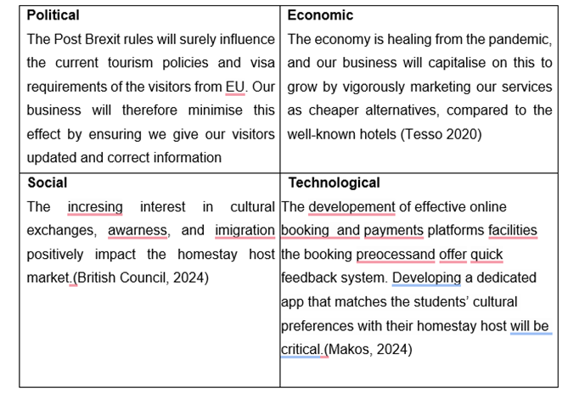

Appendix C – Copy of Pitch Supporting Material

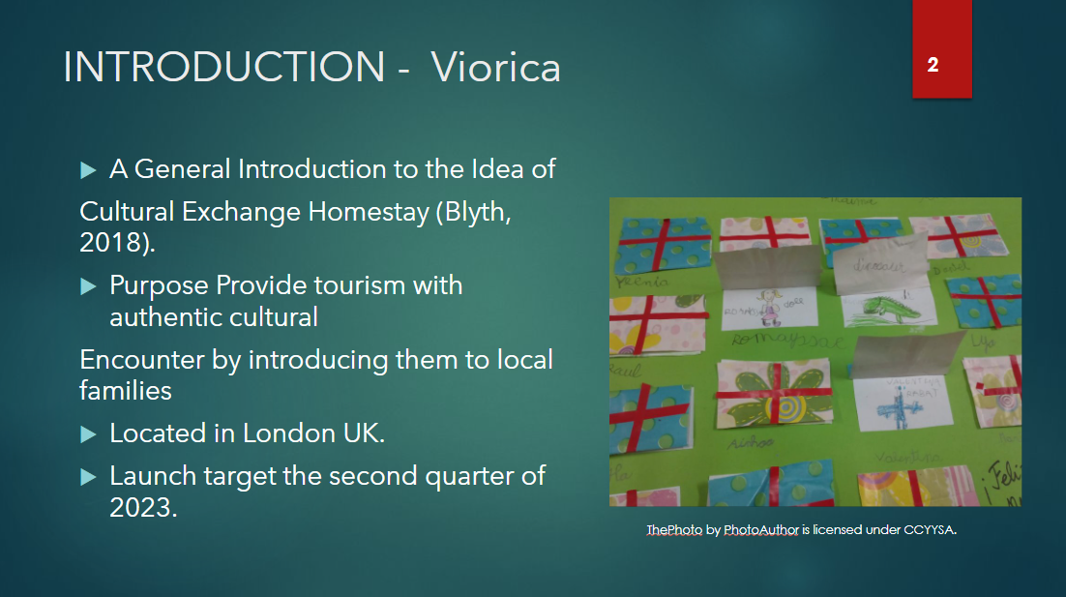
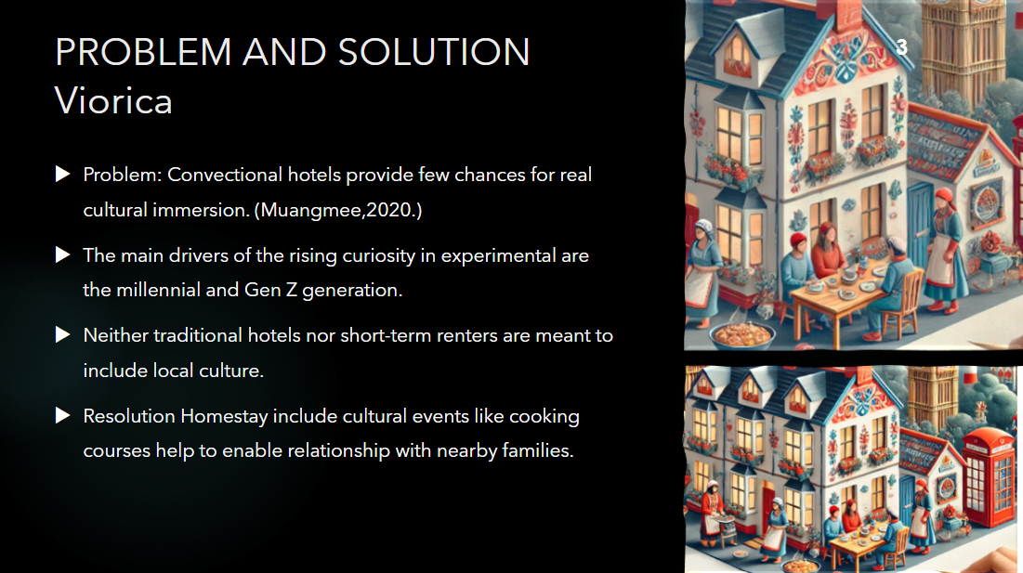

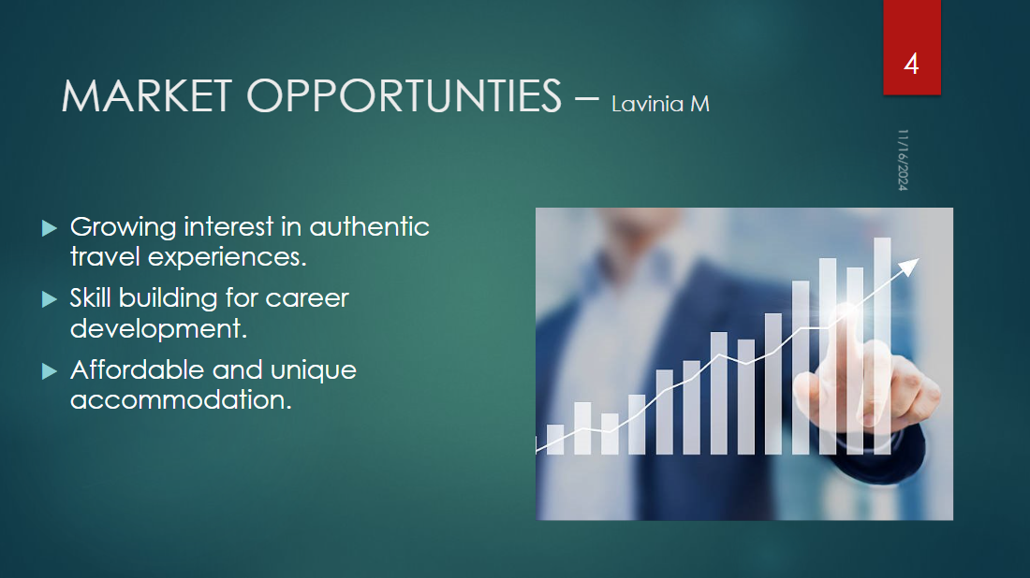
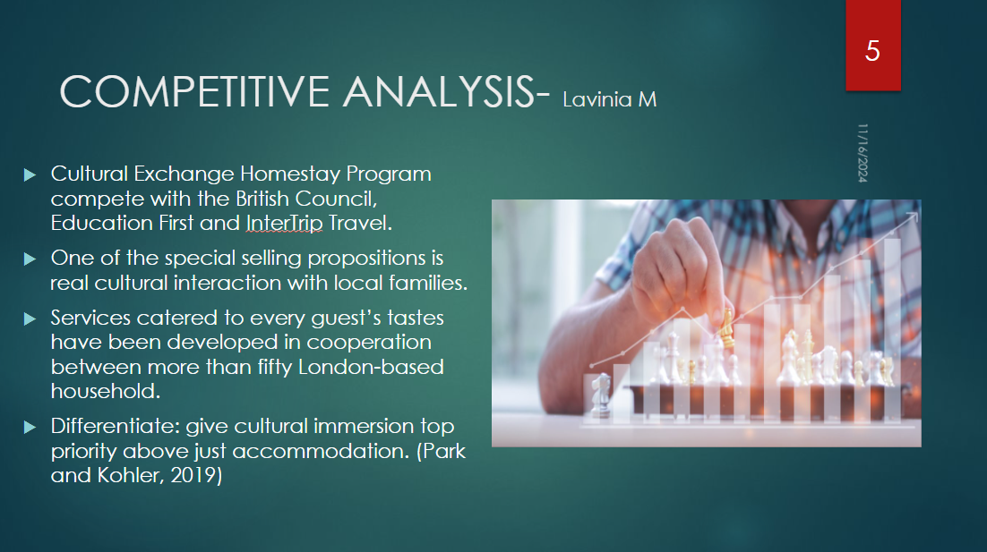
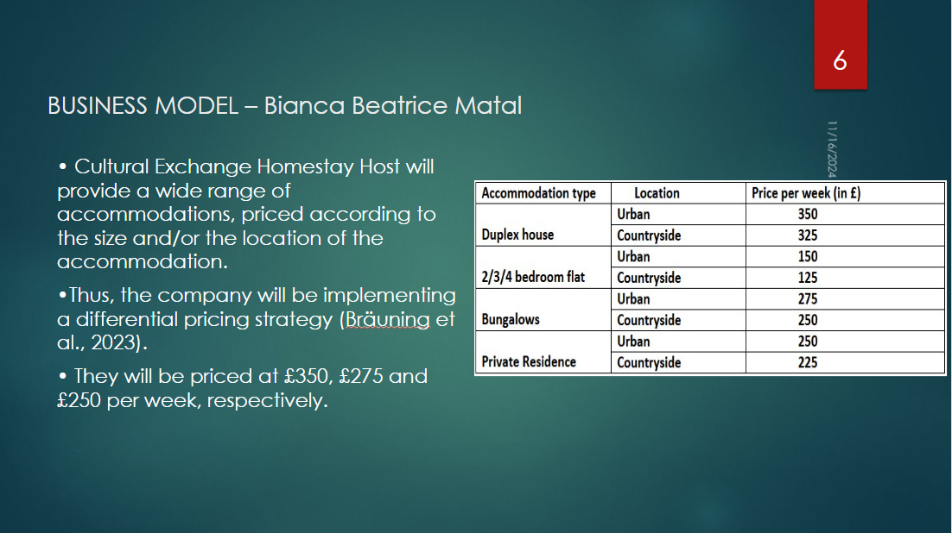
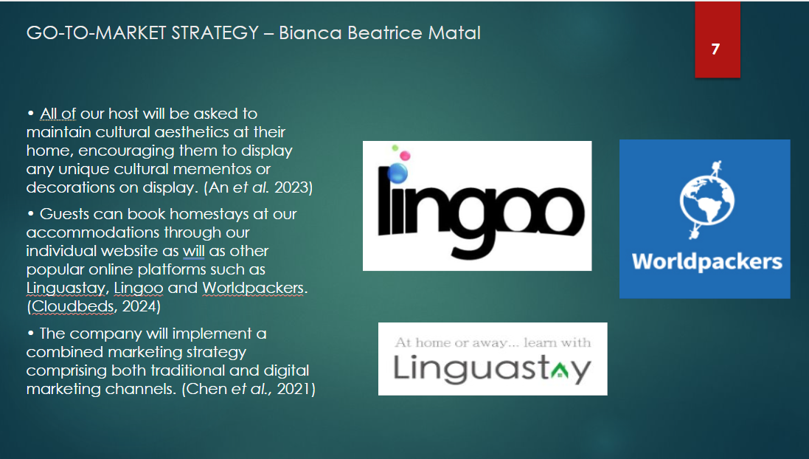

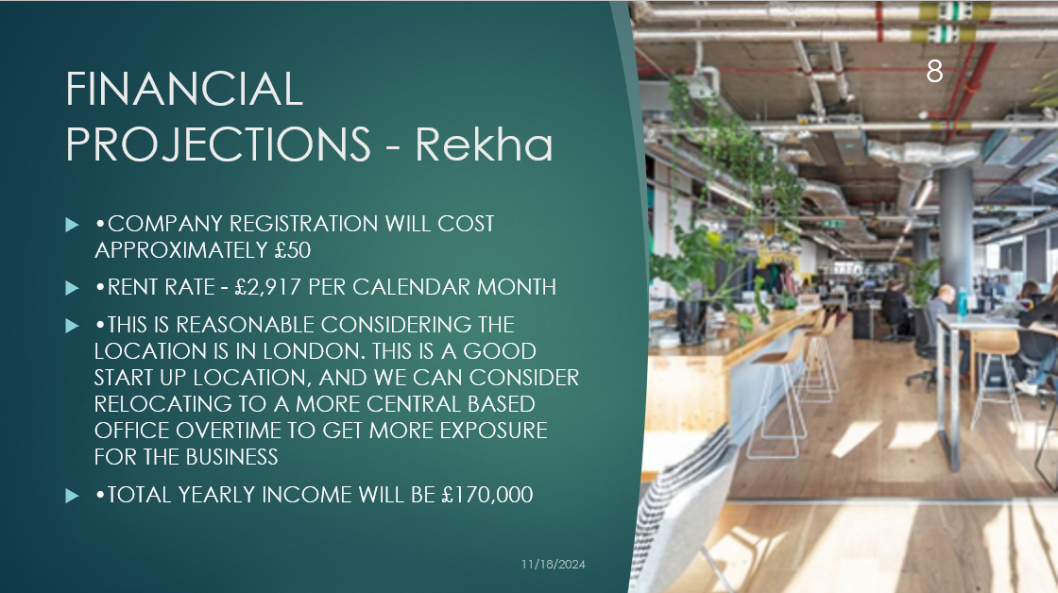
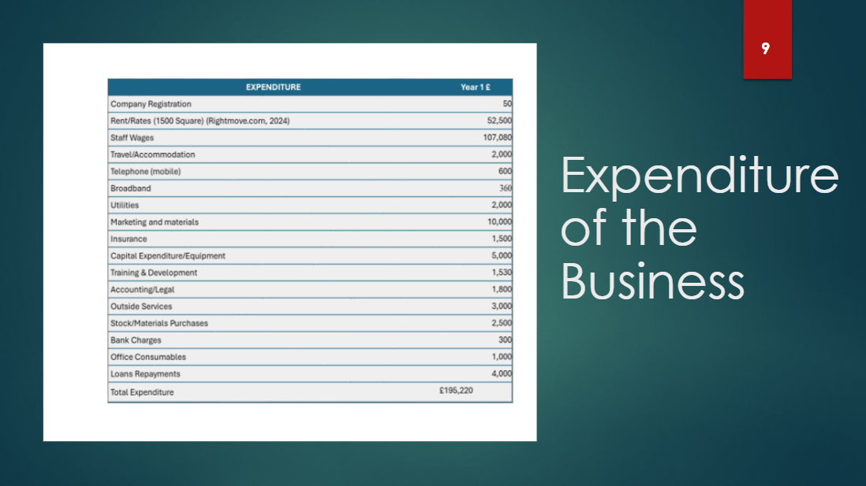

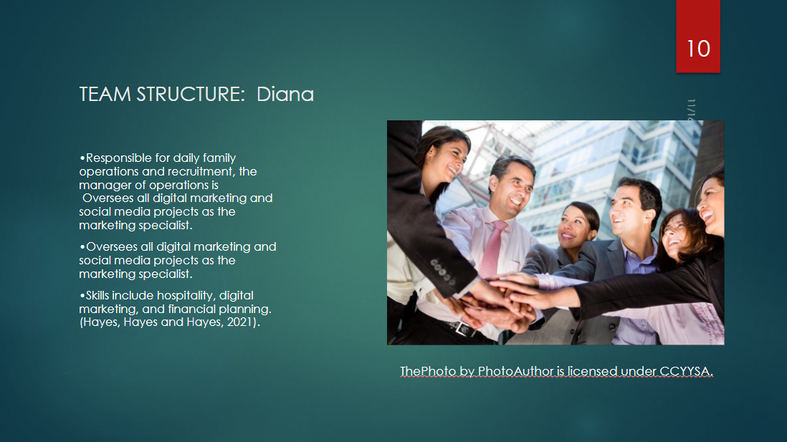
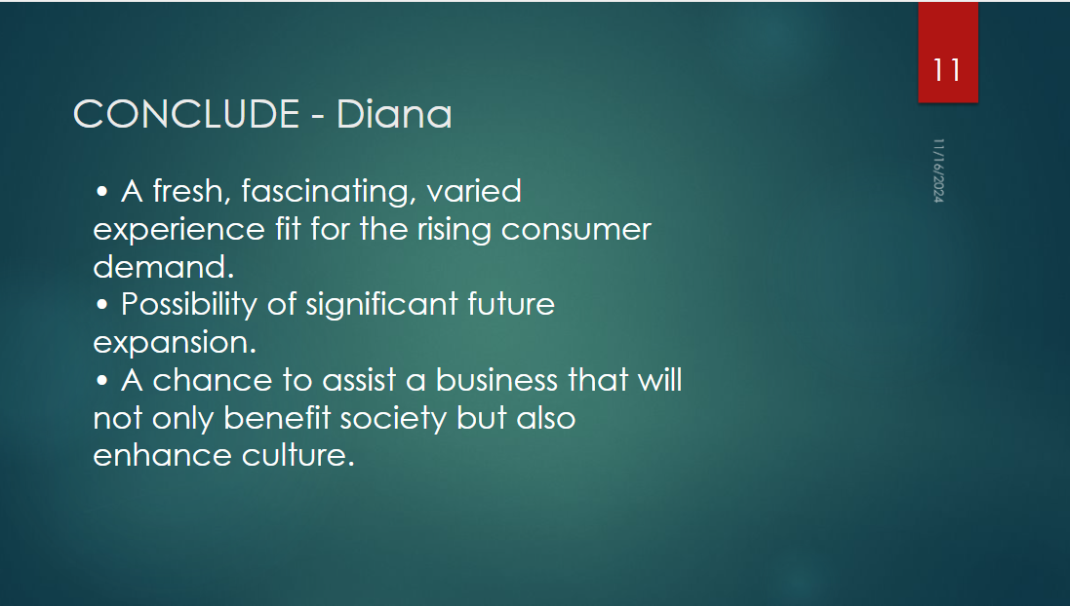

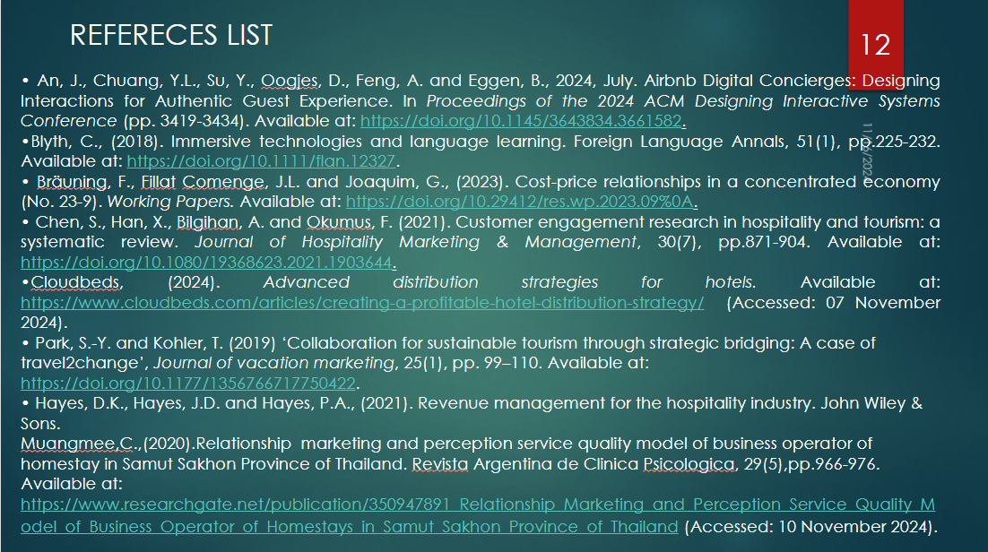


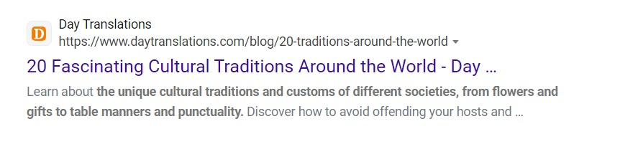

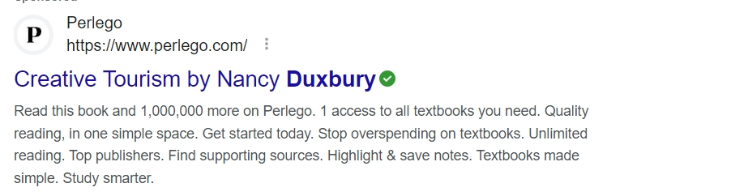



Appendix D – Pricing List

Accommodation type | Location | Price per week (in £)
Duplex house | Urban | 350
Duplex house | Countryside | 325
2/3/4 bedroom flat | Urban | 150
2/3/4 bedroom flat | Countryside | 125
Bungalows | Urban | 275
Bungalows | Countryside | 250
Private Residence | Urban | 250
Private Residence | Countryside | 225

Appendix E: Increasing in international student enrolment

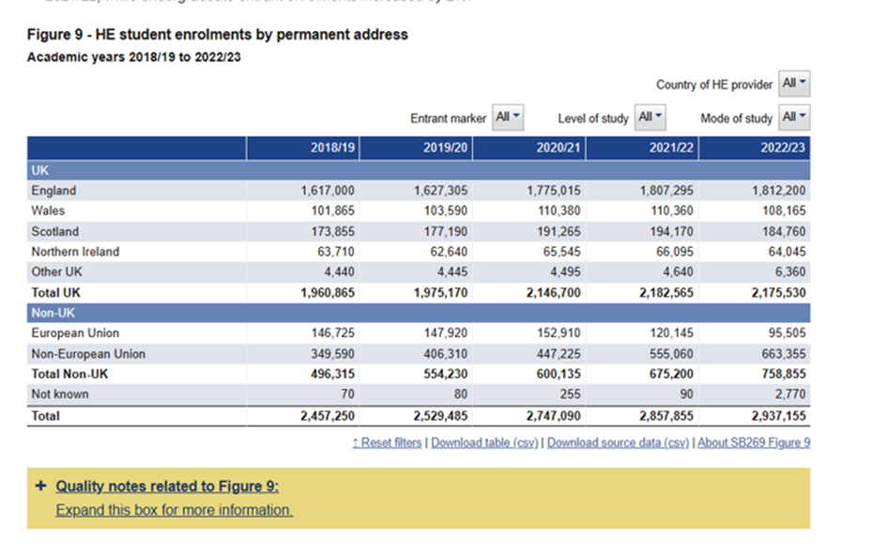

Appendix F: Trends in student UK International Student Growth

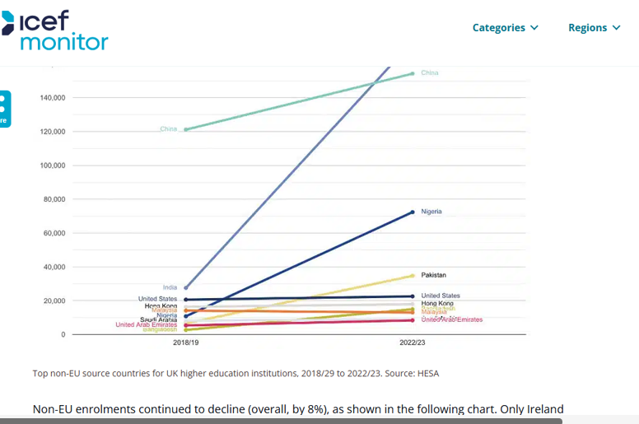

Appendix G: office space to rent

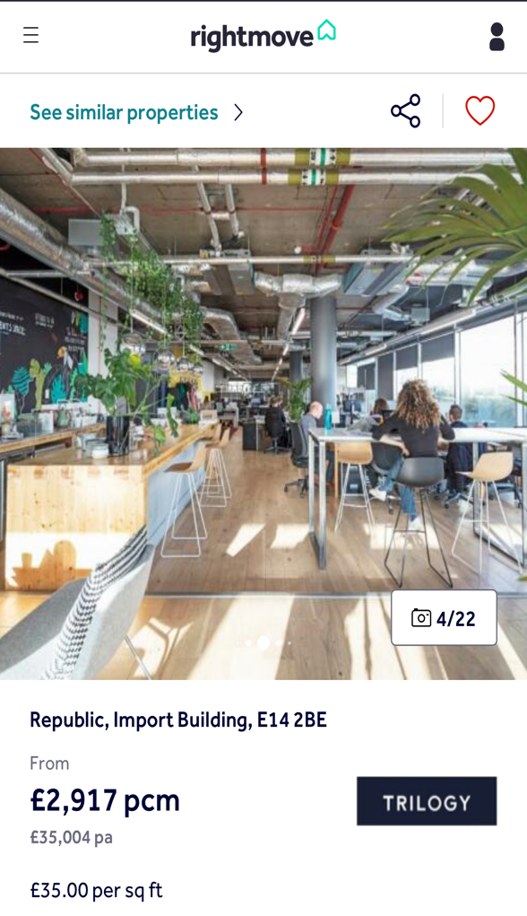

REFERENCE LIST:
An, J., Chuang, Y.L., Su, Y., Oogjes, D., Feng, A. and Eggen, B., 2024, July. Airbnb Digital Concierges: Designing Interactions for Authentic Guest Experience. In Proceedings of the 2024 ACM Designing Interactive Systems Conference (pp. 3419-3434). Available at: https://doi.org/10.1145/3643834.3661582

Bidder. Available at: https://www.utilitybidder.co.uk/compare-business-energy/average-energy-usage-for-businesses

Boukherouk, M., Ed-dali, R. and Dbibirha, Y. (1970) Sharing tourism and its impact on hospitality management in Essaouira: Analysis of the evolution of Booking.com and Airbnb, SpringerLink. Available at: https://link.springer.com/chapter/10.1007/978-3-030-36342-0_12
Bräuning, F., Fillat Comenge, J.L. and Joaquim, G., (2023). Cost-price relationships in a concentrated economy (No. 23-9). Working Papers. Available at: https://doi.org/10.29412/res.wp.2023.09%0A
British Council, 2024 Study and train in the UK. Available at: https://www.britishcouncil.org/study-work-abroad/in-uk (Accessed: 10 November 2024).
Chen, S., Han, X., Bilgihan, A. and Okumus, F. (2021). Customer engagement research in hospitality and tourism: a systematic review. Journal of Hospitality Marketing & Management, 30(7), pp.871-904. Available at: https://doi.org/10.1080/19368623.2021.1903644
Cloudbeds, (2024). Advanced distribution strategies for hotels. Available at: https://www.cloudbeds.com/articles/creating-a-profitable-hotel-distribution-strategy/ (Accessed: 07 November 2024).

D. Zaridis, A., Soldatou, H. and Soldatou, A.-I. (2019) ‘Entrepreneurial strategies and practices for innovation in the hospitality industry’, Tourism & travelling (Online), 2(1), pp. 35–44. Available at: https://doi.org/10.21511/tt.2(1).2019.05. (Accessed: 20 October 2024)

Davari, D., & Jang, S. (Shawn). (2023). Diaspora’s intuitive role as cultural ambassador: toward a new cultural sustainability perspective. Journal of Sustainable Tourism, 32(7), 1332–1349. Available at: https://doi-org.ezproxy.uwtsd.ac.uk/10.1080/09669582.2023.2225802.

Dey, B., Mathew, J. and Chee-Hua, C. (2020), "Influence of destination attractiveness factors and travel motivations on rural homestay choice: the moderating role of need for uniqueness", International Journal of Culture, Tourism and Hospitality Research, Vol. 14 No. 4, pp. 639-666. https://doi.org/10.1108/ijcthr-08-2019-0138 (Accessed: 29 October 2024).

Dong, T. B. (2020) “Cultural Tourism: An Ethnographic Study of Home stay in Briddim Village, Nepal”, The Gaze: Journal of Tourism and Hospitality, 11(1), pp. 10–36. doi: 10.3126/gaze.v11i1.26612.
Duxbury, N.,Bakas,F.E., Vinagre de Castro,T.and Silva, S., (2020). Creative tourism development models towards sustainable and regenerative tourism.

Education First, 2024. All EF programmes (2024) EF United Kingdom. Available at: https://www.ef.co.uk/pg/ (Accessed: 6 November 2024).
Edwards, A. (2024). How Much Does Small Business Insurance Cost - James Hallam. [online] James Hallam. Available at: https://jameshallam.co.uk/how-much-small-business-insurance/ .
Graci, S., (2020). Collaboration and partnership developement for sustainable tourism. In Tourism and Sustainable Development Goals (pp. 232-249). Routledge.
Grand View Research, 2023 Hostel Market Size, Share & Trends Report Hostel Market Size, Share & Trends Analysis Report by Accommodation Type (Dormitory Rooms, Private Rooms, Family Rooms), By Guest Type, By Booking Mode, By Region, And Segment Forecasts, 2024 – 2030. Available at: https://www.grandviewresearch.com/industry-analysis/hostel-market-report/methodology (Accessed: 10 November 2024).

Hesa (2024) UK, 2022/23 - where students come from and go to study. Available at: https://www.hesa.ac.uk/news/08-08-2024/sb269-higher-education-student-statistics/location (Accessed: 10 November 2024).
Hyasat, A.S., AI-Weshah, G.A and Kakeesh, D.F., (2020). Training needs assessment for small businesses: The case of the hospitality industry in Jordan. Geo Journal of Tourism and Geosites, 40(1), pp.20-29.
ICEF Monitor (2024) UK reports record foreign enrolment for 2022/23, ICEF Monitor - Market intelligence for international student recruitment. Available at: https://monitor.icef.com/2024/08/uk-reports-record-foreign-enrolment-for-2022-23 (Accessed: 10 November 2024).

Indeed: Front desk agent salary in United Kingdom. Available at: https://uk.indeed.com/career/front-desk-agent/salaries (Accessed: 09 November 2024).

Iqbal, S. (2021). How to calculate average training cost per employee | HR blog. [online] www.myhrtoolkit.com. Available at: https://www.myhrtoolkit.com/blog/calculate-average-training-cost-per-employee-hr-blog.
Koc, E., (2020). Cross-cultural aspects of tourism and hospitality: A services marketing and management perspective. Routledge.
Kromidha, E, Gannon, M & Taheri, B 2023, 'A profile-based approach to understanding social exchange: authentic tour-guiding in the sharing economy', Journal of Travel Research, vol. 62, no. 2, pp. 324-344. https://doi.org/10.1177/00472875211062616 (Accessed: 02 November 2024)
Lin, B., Wang, S., Fu, X. and Yi, X., (2023). Beyond local food consumption: the impact of local food consumption experience on cultural competence, eudaimonia and behavioral intention. International Journal of Contemporary Hospitality Management, 35(1), pp.137-158. Available at: https://doi.org/10.1108/IJCHM-01-2022-0099
Longley, J. (2020). Average Business Gas and Electricity Bills explained. [online] Utility
Melas, I. (2023) Creating, communicating, and connecting: Digital Technologies in Destination Tourism Management and the new perspectives in Tourism, DSpace Home. Available at: https://hellanicus.lib.aegean.gr/handle/11610/25877?locale-attribute=en_US
Naim (2024) Statistics on international students in UK University, AHZ. Available at: https://ahzassociates.co.uk/statistics-on-international-students-in-uk (Accessed: 9 November 2024).
Rightmove.co.uk. (n.d.). Check out this Office to lease on Rightmove. [online] Available at: https://www.rightmove.co.uk/properties/79597163#/?channel=COM_LET.
Rungraweewan, S., Maneeniam, A. and Waedoko, w., (2022). Green homestay management innovations model for tourism to the next normal. Central European Management Journal, 30(4), pp.648-655.
Sustainability,13(1), p.2. Westcott,m., (2020) Introductia to Tourism.
Youfibre.com. (2024). YouFibre - Full Fibre Broadband - Fibre Broadband. [online] Available at: https://www.youfibre.com/?utm_source=google&utm_medium=cpc&utm_campaign=20721139185&utm_term=youfibre&utm_network=g&gad_source=1&gbraid=0AAAAABq2BkmDIbskPu89smOjiwuhekeNQ&gclid=EAIaIQobChMIvMrbnb3UiQMVgZJQBh3NoRqfEAAYASAAEgJV5PD_BwE (Accessed 11 Nov. 2024).

