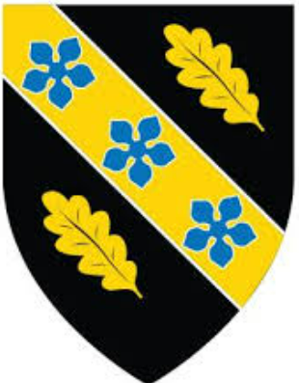
Construction Portfolio
Construction Materials
Isobel Baldwin-Pritchard 2502740

26 March 2026
Contents
Introduction 2
Concrete Framed Building 3
Building Elements 3
Structural frame and foundation: 3
Exterior cladding and façade: 3
Iconic features: 3
Roof and internal structure: 4
Framing Materials 4
Production Process 4
Sieve Analysis 5
Table 5
Conclusion 6
Reference 6

Introduction
This assignment requires the selection of a concrete framed building located in the UK, supported by independent research. The report will examine the building’s original design concept and construction methodology, focusing specifically on the characteristics and performance of its concrete structural frame.
The study will evaluate the framing material in relation to its strength, durability and resistance to climatic conditions at the construction site. It will also compare concrete framing with steel framing in terms of time, labour, programme and cost implications. Further discussion will consider the frame’s ease of assembly and its adaptability to changes in building form and function throughout its life cycle. The report will also address challenges associated with integrating building services within a concrete frame and the strategies used to resolve these issues. Finally, it will explore the specific technical and practical challenges encountered at the building’s end of life, particularly in relation to demolition.

Concrete Framed Building
For this assignment, I will be focusing on the Royal Liver Building completed in 1911 and located on the iconic Liverpool waterfront.

Building Elements
For this build the key elements of this structure are

Structural frame and foundation:
Reinforced Concrete: The core innovation was a concrete-and-steel network of beams and columns that supported the weight of the building, allowing for greater height.
Deep piled foundation: From the top of the Liver Birds that crown each of its two towers, to its base, the buildings stand at a height of 295 feet (90 metres). This was one of the first multi-storey, reinforced concrete, steel-framed buildings in the world, and its revolutionary design means that its granite exterior is simply cladding. The massive weight of the building is supported on concrete piers that were sunk into the bed of the old George’s Dock to a depth of 40 feet.

Exterior cladding and façade:
The architect Walter Aubrey Thomas was well known in Liverpool, having constructed the State Insurance building and Tower Buildings, still, the Liver Building used an innovative form of construction and method of building.
Erected using reinforced concrete, faced with a decorative weather screen of granite, the structure utilised an early form of industrialised building with sand, cement and aggregate. These materials were delivered to the basement, mixed into concrete and then taken to the current working area by electric vertical hoists and a narrow-gauge railway system. In this way each floor was completed on average in just nineteen days.
The Liver Building is known for the exterior is clad or covered in granite. The granite has a pale shade of brown, unlike the white Portland stone used on the Cunard and Port of Liverpool buildings

Iconic features:
When the building was completed, people would describe it as a Skyscraper which technically it was as this being the tallest building in Europe until 1934 and the tallest in the UK until 1961. This building had unusual architectural style with Byzantine elements in the towers and a baroque porch.
The building is crowned by a pair of clock towers with, on the east tower and facing the city, one clock face. On the west tower and overlooking the river, there are faces on three sides. This is so that ships on the river can tell the time from any position. Each clock dial is 25 feet (7.6m) in diameter, and they are set 220 feet above ground.
They are each 2½ feet wider than those on the Big Ben clock tower in London, and each minute hand is an impressive 14 feet long.
Designed by Walter Aubrey Thomas, the building was a revolutionary example of reinforced concrete, designed to be fireproof and structurally sound in a way that influenced future skyscraper construction.

Roof and internal structure:
The design included two 65-foot-square light wells to brighten the interior. The main building had 10 storeys, with four additional stores in each clock tower. The concrete floors were part of the main structure, allowing each floor to be built in about nineteen days. Although the exterior was finished in white granite for weather protection, the reinforced concrete frame carried the building’s weight. The roof reaches 167 ft (50.9 m) and the twin clock towers rise to 322 ft (98.2 m).
Each tower has four 25-foot clock faces made by Gent and Co and is topped with the famous copper Liver Birds, designed by Carl Bernard Bartels. One mechanism controls all four clocks, which began operating on 22 June 1911 to celebrate the coronation of King George V. The domes and spires give the building its distinctive Edwardian Baroque style and were designed to withstand harsh maritime weather.

Framing Materials
During construction of this project reinforcement was installed using steel bars arranged within the formwork to provide structural strength. Once the reinforcement was in place concrete was poured into the mould which was supported by shutters. The concrete was then vibrated to eliminate air pockets and ensure it fully surrounded the steel this process is known as compaction. After pouring, the concrete was left to cure for a specified period to gain sufficient strength. Once curing was complete striking took place during which the formwork was removed.

Production Process
When construction the Royal Liver Building concrete was made by mixing sand, water and coarse aggregate such as river rock or crushed stone along with Portland cement which had been developed in the 1820s and refined by 1900. The process started with dry mixing where the cement and sand were combined first followed by the addition of the coarse aggregate. This was typically done on a wooden platform to ensure the mixture was evenly distributed.
When water was added carefully. Workers often created a crater in the centre of the dry mixture and poured water into it gradually. Laborers then carried out wet mixing by using shovels to turn the materials repeatedly, making sure all the aggregate was thoroughly coated with cement paste. The goal was to achieve a consistent, thick texture similar to oatmeal.
Once mixed, the concrete was placed into wooden forms, also known as formwork and compacted by tamping to remove any trapped air pockets. If reinforced concrete was required, steel rods were inserted at this stage to add strength. Finally, the concrete was left to cure and harden. For large projects, pouring might continue over several days and the curing process could take up to a month to reach full strength.

Sieve Analysis

Table
Original Sample Size: 1250kg
Sieve Size (mm) | Mass(g) | % on sieve | % Passing
125 | 0 | 0 | 100
75 | 0 | 0 | 100
63 | 0 | 0 | 100
37.5 | 120 | 9.6 | 90.4
20 | 137 | 10.96 | 79.44
10 | 143 | 11.44 | 68
6.3 | 105 | 8.4 | 59.6
3.35 | 45 | 3.6 | 56
2 | 130 | 10.4 | 45.6
1.18 | 63 | 5.04 | 40.56
0.6 | 105 | 8.4 | 32.16
0.3 | 102 | 8.16 | 24
0.212 | 109 | 8.72 | 15.28
0.15 | 98 | 7.84 | 7.44
0.063 | 55 | 4.4 | 3.04
To calculate the percentage of sieve, I divided the mass on the sieve by the original sample size and multiplied by 100.
To determine the percentage passing, I subtracted the percentage retained on each sieve from the previous cumulative percentage passing.
Coarse Aggregates: 120 + 137 +143 +105 = 505/1250 = 0.404 = 40.4% coarse aggregate
Fine Aggregates: 45 + 130 + 63 + 105 + 102 + 109 + 98 + 55 = 707 / 1250 = 0.5656 = 56.56%
3.04 by mass

Graph
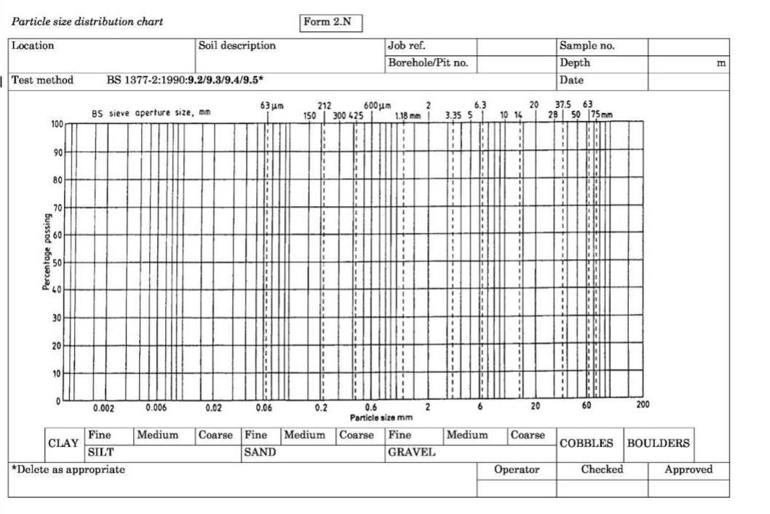

Conclusion
In conclusion, the Royal Liver Building is a key example of early reinforced concrete construction that helped shape modern building techniques. Completed in 1911, it showed how a concrete-and-steel frame with deep foundations could support tall structures while allowing the exterior to act as non-structural cladding.
Its granite façade and efficient, industrial-style construction methods improved building speed and influenced future developments. Combined with its iconic design features, the building demonstrates how engineering strength and architectural style can work together.
As an overall statement it highlights the importance of reinforced concrete in advancing modern construction.

Reference
Building Elements
The Liver Building Birds and Their True Designer: Discover Liverpool
Exterior cladding and façade
The Liverpool View: From the top of the Royal Liver Building - News - University of Liverpool
Hidden Facts about the Liverpool Liver Building and the Liver Birds
Iconic features
The Liverpool View: From the top of the Royal Liver Building - News - University of Liverpool
The Liver Building Birds and Their True Designer: Discover Liverpool
Roof
Royal Liver Building | British Heritage
Royal Liver Building (Liverpool)
Production Process
THE HISTORY OF CONCRETE: CONCRETE THROUGH THE AGES | EasyMix Concrete

