Understanding and Engaging in the Customer Experience
BMSW 5103
Organisation’s Quality Systems and Customer Relationship Management
TM Sidhu 1920725
Lecturer Balendran Kandasamy

Executive Summary:
Customer satisfaction ensures an organization's long-term viability. To develop a great relationship with clients, a periodic check is essential to improve the quality of services and products. Organizations must have a set of rules in place to enhance and evaluate quality to achieve this goal.
In this report Asda is considered and its main goal is to provide high-quality goods and services. In order to improve the quality of products and services provided to clients, Asda conducts research and surveys to identify areas where improvements might be made. People's preferences are being elevated in an effective manner through the development of strategies. Management also use motivational models to improve the efficiency of employees to achieve quality services. Different tools and techniques have been used to analyse not only the organisation as a whole but each product and services as well. The factors that assist Asda in managing their customer relationship management are also discussed and explained.
Some comments and recommendations are made based on the findings that are extracted following the analysis of the research and Asda CRM strategy, where Asda still needs to improve.

Table of Contents

Executive Summary ……………2
Introduction…………….4
critical analysis of the factors that influence Asda quality systems and controls for customers in times of crisis like COVID-19……………5
Maslow's Motivation Theory…………..5
Customer Satisfaction…………..6
SERVQUAL Model…………..6
Customer relationship…………..7
Customer Service…………..7
Customer Engagement…………..8
SWOT Analysis…………..8
PESTLE Analysis…………..9
Porter’s Five Forces…………..10
Marketing Mix…………..12
Customer Relationship Management (CRM) …………..13
Recommendations…………..14
Conclusion…………..15
References…………..16
Appendices…………..17

Introduction:
I am interested to find the Factors affecting Asda quality system and customer management in crisis situations such as Covid 19 and reason behind to choose Asda is my loyalty as a customer and having a friend who is working as a manager.
Asda is Founded in Yorkshire in the 1960s, Asda is one of the UK's finest retailers. Dedicated colleagues serve their customers through online services and store networks, including UK supercentres, superstores, supermarkets, living stores, Petrol stations and depots. Asda have more than 145,000 dedicated Employees serving more than 18 million customers who shop in stores every week., and 98% of UK homes are serviced at www.asda.com. (Asda, 2021)
Competition in the business is very competitive at this time of globalisation, Competitive advantage supports the value of the proposal and support the value of the client that it supports, therefore organisations must plan their strategies effectively to attract the attention of customers. The value of the customer includes the quality of services and product. Providing the best service is maintained with the appropriate strategy that applies to the positive outcome of the business activities, as retaining existing customer is more difficult than acquiring new customers.
Nowadays its very common to analyse customer experience, this help companies manage and design new products and services. The consumer experience focuses on the company’s ability to solve services and problems of the customers. Customer satisfaction is also important, this encourages customers to repeat purchase. SERVQUAL model is part of this report to identify the level of customer satisfaction in Asda.
Covid 19 pandemic has brought changes in human daily life. There are also changes brought by the pandemic in the organisation environment that put undue stress and pressure on all the corporation activities. due to the speed of adaptation to existing challenges, some companies received an advantage from this situation. It indicates how vital it is for stake holders to have the abilities to deal with frequent and unexpected changes. Lockdown in the Europe and all over the world extremely affected the industry. supply chain disruption occurred in many sectors at the beginning of the pandemic. The impact of COVID-19 on business closures and the corresponding increase in unemployment has not yet been thoroughly assessed, and it will be very different among industries (Liebowitz, 2020).
This report focuses on influential factors that demonstrate the ability to maximise customer value of Asda. It also describes efficiency to meet customer requirements. Internal and external factors will be discussed by using SWOT Analysis, PESTLE analysis, porter’s five forces and 7 p’s of Marketing mix. Customer relationship management (CRM) its principle, policies and how an organisation interacts directly with customers for sales and services related processes, forecasting and analysis of customer trends and behaviour is also the aim of this report.
critical analysis of the factors that influence Asda quality systems and controls for customers in times of crisis like COVID-19
Asda’s manager focuses on meeting the demands and requirements of employees and providing the most benefit to them to fulfil their desires. Employees who are happy with their jobs are more likely to perform more effectively to meet customer expectations. Asda employees are dissatisfied, which has a negative influence on customer value and limits their ability to please customers. In this regard, the manager is employing Maslow's motivation theory to encourage employees in a way that will directly increase their performance and meet their needs. The key points of “A Theory of Human Motivation” relate to the five basic needs identified in the text: physiological, safety, love, self-esteem, and self-actualization. (Stoyan, 2017). The theory is based on human psychological demands that must be met at each level of the hierarchy to encourage employees. It is even more surprising that recognition and self-fulfilment are needed for employees to be free to creativity and efficiency.
These needs ranked in order of importance, with physiological needs coming first and self-actualization coming last. The things a person requires to survive, such as food and water, are referred to as physiological needs. These compounds are necessary for survival. When all other circumstances are removed, Maslow argues that a person's basic impulse is to get food and water—nothing else counts.
Physiological needs are met by Asda, but they are no longer a motivating element because, if a person were to lose their employment, the government would meet their physiological needs. Job security is offered at Asda, in that employee who are deemed insufficient, receive an informal warning, three official warnings, and ultimately a week's notice if they do not improve. When every Asda employee receives a "Buddy", their need for belonging will be met then questions and concerns can be discussed privately and confidently. Asda meets people's esteem requirements by hosting events like an achiever’s lunch, where the month's best employee from each department is invited to lunch together. There are also additional things, such as a monthly award for providing the best customer service, employee competitions and departmental competitions, if they have a suggestion for improving Asda, they can tell, which is a scheme that allows all Asda employees to engage in the company's management.
Customer satisfaction is the foundation of Quality Management. Customer Satisfaction is the fulfilment response to a customer experience, or some part thereof (Buttle, 2008). The most frequent method for calculating customer satisfaction is to compare the customer's assessment of an experience, or a portion of it, to their expectations. The ASDA Customer Satisfaction Survey, available at www.TellASDA.com, is an online survey created by Asda to gauge customer satisfaction with their products and services.
COVID-19 has been discovered to have significant effects on a variety of aspects of Asda Superstore, including consumer satisfaction. Given the impact of COVID-19 and the repercussions highlighted, such as panic buying, store closures, and product shortages, retail Supply Chain Management is one of the domains immediately affected by this issue. Consumer satisfaction at the point of sale reflects the effects directly.
Customer happiness is a crucial feature that drives customers to buy items from the same businesses again and again, and it aids in the development of brand loyalty. In this regard, SERVQUAL model is useful in determining the level of customer satisfaction. This concept is linked to determining the perception gap between the expected and received service level. This model is based on five factors (Reliability, Responsiveness, Assurance, Empathy, Tangibles).
At Asda Customers are given surveys with questions based on the five parameters mentioned above in order to apply the SERVQUAL analysis. The analysis is customer-focused, with the goal of highlighting the disparities between consumer expectations and impressions of service. Customers are asked to score questions based on their expectations and perceptions under each of the above criteria. The questions are assessed on a Likert Scale from 1 to 7, with 1 indicating strong agreement and 7 indicating strong disagreement, and the measure of service quality is calculated by subtracting expectation and perception scores.
The above methodology will be used in a study of service quality based on five gaps between consumers' perceived and expected service. Gap 1 depicts the disparity between actual consumer expectations and management's conception or perception of those expectations. Service quality expectations of managers may differ from service quality specifications. Gap 2 demonstrates this misalignment. The third gap is the service performance gap, which can be caused by a lack of training, communication, or preparation on the part of staff who engage with customers. Gap 4 depicts the distinctions between service delivery and customer external communications. Finally, Gap 5 denotes the disparity between consumer perceptions and service expectations. The focus of the investigation is on determining the type of service quality. For each of the ServQUAL components, an average of the perceived and expected values of the service at Asda was generated based on the data obtained. The gap score was derived using these data.
Decisions are always based on the analysis and assessment of data and information gathered from customers after a thorough knowledge of correlational relationships.
Customer relationship is the need for the company to present a consistent image (Bergeron, 2002). To maintain the performance at Asda, manager aim to manage relationships with customers and suppliers, as they always have an impact on the organization's execution. It is critical to manage workplace relationships to secure a company's long-term success. It is never a good idea to overlook human variables such as culture when deciding on a quality standard. To meet quality requirements, it's vital to comprehend customers' perspectives, to provide them with the necessary satisfaction, and to provide them with service quality by building critical understanding of service quality.
Quality is vital, but so is ethics. It is critical to follow ethical guidelines. The term "ethics" refers to a set of rules or ideals that govern behaviour. The products should be ethically sourced and have a low environmental impact, as well as supporting biodiversity and Fairtrade. Asda encourage the use of food products that are less harmful to the environment and ethically sourced so it can build good customer relationship.
Because of the Covid-19 epidemic, businesses have been compelled to retain and create relationships with customers from distance. Asda was faced with the dilemma of increasing sales during a moment of extreme economic distress while also keeping in mind the threats to life and livelihood that had shifted consumer priorities and preferences. Asda has managed customer relationship during the crises by guiding the customers about the changes and keep the customers informed and satisfied by providing regular updates on closings, delays, product changes, and promotions. Social media applications are also transforming the role of online users from passive consumers of information to active participants in creating and sharing information with one another. (Zhan Wang, 2017). During the pandemic Asda use all the social media platforms to build the relations with their customers. Customer service is one of the Asda functions that has been severely damaged by the Covid-19 epidemic.
Customer service must maintain the relationship, acquire information, and improve the process wherever the problem began. Every business's success hinges on its ability to keep customers happy with the goods or services. If consumers are treated well, they will return, resulting in a clear correlation between the workplace's revenue and the number of customers. During the Pandemic Asda’s Customer service severely damaged due to high number of online orders and short member of staff it was difficult to meet the orders. Author of the report leaned form the manager that to cope this situation he changes his strategy to improve customer services. He appointed one member of the staff at the entrance to request customers to download Asda App and use Scan & Go so they don’t need to wait long for payments. There are also handheld terminals available to use this service if in case someone does not have mobile. automation is the key for workflows, swiftly manage and completing customer requests resulted a good customer service. The COVID-19 has posed new challenges for customer engagement, prompting some customers to question their brand loyalty.
Customer engagement is straightforward It refers to how a retailer interacts with current and potential customers, including both person and online. However, in practise things are a little trickier. Due to Covid-19 so many factors to consider, it's easy to see why some retailers are intimidated by the prospect of building a customer engagement strategy. When consumers have a strong emotional connection to a brand, they are more likely to be loyal to it. Asda has decided to build such a bond through regular contacts, which usually take place across various channels, and it has been seen that when the business has established many interactions with a customer, built a successful relationship with them, and gained their loyalty, that customer is more inclined to engage with that brand freely and even suggest it to their friends and family. Customer engagement, in this sense, feeds into customer loyalty.
Asda has adopted the omnichannel strategy, Customers want a personalised experience across all channels as they interact with them than ever before. we use the data to acquire across all these channels to create this kind of experience. such as which products are often purchased together, for example If a consumer is shopping on Asda’s eCommerce platform and adds a Pack of Pasta to their virtual shopping basket, you may display them an automatically produced recommendation for a Pasta Sauce that is frequently purchased with the pasta. Asda will continue to invest in accelerating its omnichannel offer and in the resilience of its supply chain, including sourcing more food from UK farmers and maintaining its commitment to supporting domestic suppliers and small businesses. (Asda, 2020).
To meet customer requirements, internal and external factors play a key role, it is must to keep an eye on the changes inside and outside of the organisation.
SWOT is business strategic tool looks at the general character of the organisation before getting into the specifics of implementation. Detailed SWOT analysis of Asda is examined.
Strengths.
According to the Retail Economics Asda is the 3rd largest retailer in the UK. Asda's performance through the Covid-19 pandemic has demonstrated the fundamental strength and resilience of the business (Saker-Clark, 2020). There are over 630 stores in total. It is largely recognised as the first discount retailer in the United Kingdom to provide customers with the finest value for money.
ASDA sells both its own brand and well-known brands. The company's marketing activities and its products and services have made it possible to reach a wider audience. ASDA is known for its large economy and advanced technology. Customers can use the company's loyalty program to earn reward points for purchasing household items and clothing.
Weaknesses.
Some customers say that ASDA's items are second rate to those of Sainsburys and other comparative superstores. It is not less expensive than budget stores like Lidl and Aldi. In the past, Asda was blamed of forcing employees for a more flexible contract and was extremely controversial. Asda's lack of smaller supermarkets and convenience outlets is a major weakness. Construction of "big box" stores in suburbs and rural regions is strictly regulated in the United Kingdom, as it is in many other European countries.
Opportunities.
Asda has the potential to acquire, combine with, or develop strategic relationships with other global retailers, with an emphasis on expanding its food and non-food sectors. The firm established a number of significant goals for the chain, including passing Tesco to become the UK's "number one" non-food retailer and opening 100 smaller model stores. Online customers growing due to pandemic situation, ASDA has an opportunity to surge its market share. Asda can develop by acquiring other businesses like Focus stores which Asda acquired in 2011. According to reports, the new owners have a variety of initiatives in place to help the company grow.
Threats.
Asda has a number of competitors. Pioneer in the industry is Tesco, whereas main competitor in the industry is Sainsbury's. Morrisons, Waitrose, Aldi, and Lidl. It is additionally critical to note that the rise of autonomous online vendors postures a threat. Claims are another big issue for Asda. It has been penalised by various agencies multiple times in the past for infringing certain restrictions.
PESTEL analysis is also a critical component of strategic planning. Strategic planners at Asda utilise it to examine the macro-environmental issues that affect a company.
Political Factors.
Brexit created a lot of uncertainty. Asda needs to review potential supply chains. It is important to reveal that the later declaration between Britain and the EU made the organizations on both sides idealistic.

Economic Factors
Asda must take into account economic factors such as pay scales. Credit costs, intense competition, manpower, supply and demand, and fuel prices, to name a few. Such financial variables have an impressive effect on the Pricing strategies. People misplaced their business due to the financial lockout in 2020 and purchasing habits have decreased.
Social Factors.
Recognising social factors can offer assistance to present new products and services to the market and helps within the advancement of the company's division plans. Asda already has a great demand for ethnic foods and in response Asda has variety of foods for customers from different ethnic backgrounds.
Technological Factors.
Asda perceives the significance of broadband, phone applications and click and collect services, especially since the use of the technology is increasing after the covid19 situation. Asda is continuously trying to find other ways to use innovation to its advantage.
Environmental Factors.
Since individuals are more mindful of how businesses influence the environment, Asda is improving and reducing its packaging focusing to keep their products fresh for longer. Asda is committed to all packaging being recyclable by 2025.
Legal Factors.
Asda cannot pay less than minimum wage to its employees. Also, employees cannot be dismissed for no reason. In the event that this happens, the employee can file an employment adjudication claim. It should be mentioned that Asda shop floor workers have won the latest round of a legal battle with their employer over equal pay in a ruling has been hailed as a potential “game changer” for more than half a million retail workers (INDEPENDENT, 2019).
Porter’s Five Forces analysis it is also recommended to use to create a clear view of an organization's situation. Using only one technique may result in knowledge and understanding gaps. The Five Forces Model is a strategic management technique that may be used to assess an industry's competitive landscape. The qualities of each of the five forces sketched out within the model help key organisers in deciding an industry's natural benefit potential

Porter’s five forces are
The Bargaining Power of Suppliers
There are more suppliers than the buyers in the industry and this resulted weak force of suppliers bargaining power as the have less control over prices.
Suppliers are not in competition with one other. This means that there are no other options for the goods than those offered by the sellers. Suppliers' bargaining power inside the industry increases.
The Bargaining Power of Buyers
Asda deals with more suppliers than the companies that make the products; buyers, on the other hand, only deal with a few companies and hence have no price control. The buyers' bargaining power has deteriorated.
Within the industry, the buyers' income is low. This means that purchasers are under pressure to buy at low prices, which makes them more price sensitive. As a result, purchasers' purchasing power in the industry is a weaker factor.
The Threat of New Entrants
There are very few competitors in the industry in which Asda operates. This means that no action taken by a business will go unnoticed and existing trade competition within the segment gets to be a weaker drive.
Fixed costs are significant in the industry therefore businesses are required to function at full capacity. This also means that if demand declines, these companies will reduce their forecasting and inside the industry, existing corporate competition gets to be a more grounded force.
The Threat of Substitute Products or Services
There are few substitutes for products produced in the industries. The available alternatives are negligible and are also being produced in low-margin industries. This means that there is no limit to the maximum profit a company can earn in the industry. All these factors weaken the threat of alternative products in the industry.
The available alternatives are of high quality, but much more expensive. Companies that produce within the relative Asda-operated industry sell at the right quality and at a lower price than alternatives. As a result, buyers are less likely to switch to other products. This indicates that the threat of alternative products is low within the industry.
The Rivalry
Asda's has few competitors in the industry. Most of these are also quite large. This implies that businesses in the industry will not make unnoticed advances and existing corporate rivalry becomes a weaker drive.
Just a few rivals have a significant portion of the market. This implies that in order to obtain market leadership, they will participate in competition. Therefore, competition between existing companies has become a stronger force in the industry.
Asda five forces analysis allow Strategic planners understand how the various aspects of each forces affect the profitability of the business. The stronger the strength, the lower the profit margin, Weaker forces have higher profit margins. Based on this, industry profit judgments can be generated and used in strategic planning.
Before conducting a SWOT, PESTLE and Porter’s Five Forces analysis the 7Ps approach is used by Asda to determine their goals. This in-depth analysis of Asda’s marketing mix entails the 7Ps (Product, Price, Place, Promotion, Process, People and Physical evidence) and describes the marketing and business strategy.
Marketing Mix
Product.
Asda products and services are P's first discussion in the marketing mix. From fresh food to frozen food, from grocery to clothing, from entertainment to leisure and many more products are available in Asda. There are services in the financial sector offered by Asda (Insurance, credit cards, foreign exchange, and loans).
Price.
Asda is growing shares much of that has been down to its everyday low pricing (EDLP) strategy (Quilter, 2005). It is committed to providing customers with all food, general products and clotheslines with excellent value for money.
Place.
Asda, work through its online and offline channels. There are over 600 locations in UK and has online presence (www.asda.com). Asda also run Petrol Stations. cloths, and services like food service, banks, hairdressers, and dry cleaners are also available.

Promotion.
Asda use television, newspapers, and social media to communicate with its customers and use different strategies for promotion. 50% sales are very popular. There are other promotional offers available through out the year.
Process.
Asda buys items from its merchants, sorts out them, and places them on racks for clients to buy. Customers choose up their buys and pay at the till or pay at the self-service terminals.
People.
Asda has around 145,000 workforces. There is online and offline training for the development of employees Asda always look after and pay extra to the employees who works beyond their normal time.
Physical evidence.
It refers to the elements of the physical atmosphere that visitors and consumers are exposed to. Website, brochures, logo, and fixtures are few examples.
Customer relationship management (CRM) is required to develop a marketing strategy that are more detailed and targeted to the needs and wants of each customer. Customer knowledge is one of company’s most valuable resources (Kotler, et al., 2009). Direct avenues to the client, such as e-business, call centres, and loyalty programmes, have produced massive amounts of data. Many of these pieces of information are being fed into CRM databases for use in statistical modelling of consumer behaviour. Asda has employed behaviour as a method to establish a successful market segmentation strategy in its business operations. Customers are analysed and grouped into hundreds of segment combinations and variations based on criteria such as age, value, activity, personalities, promotional receptivity, lapse rates, and voucher redemption. Asda researched its competitors and analysed their present conditions in terms of customer data acquired, how it is used, how customer contact is handled across channels to give service, and how the relationship was maintained across numerous product and service divisions.
Asda also conducted stakeholder analysis by group and one-on-one interviews with a variety of personnel from the client organisation to learn about the consumer data that has already been acquired and what the client plans to do with it. Asda also conducted comparable research on several third-party product and service providers whose customer relationships were maintained by someone other than the client company and discovered that user data was acquired on literally dozens of occasions, involving hundreds of thousands of customers. The data was never gathered since the numerous data sources were not coordinated. Asda used several ideas for each of the important features to fix the data disorganisation.
Asda devised a technology architecture that would bring all data sources together in a single data bank while protecting customer individuality and a detailed record of customer relationships. The architecture featured 3rd party and channel integration, as well as making full use of current technologies when possible, resulting in a cost-effective solution. CRM Model for Asda designed and agreed on a data structure after decided on the technological architecture - what data needed to be collected and how it should be stored and modified. Asda also produced a customer-friendly and legally compliant data protection policy on behalf of the client. To collect the customers’ information accurately and legally, adjustments to current customers contact, documents were also examined.
In today's commercial world, it's difficult to practise with current customers whereas moreover generating income by procuring more clients into a circle. Incorporating a CRM system will undoubtedly improve the condition and assist in productively challenging new marketing and company methods. Managers also strive to make the customer's experience unique so that they will return.
During the term I done some case studies given by our lecturer Balendran Kandasamy which help me understand not only the subject but also to understand the importance of CRM in an organisation. (Some class work attached in Appendices)
Recommendations:
Asda's cost-cutting strategy has proven to be quite successful. Asda should be aware of its strengths, weaknesses, opportunities, and threats, and endeavour to maximise current strengths while minimising flaws, seizing opportunities, and being wary of threats.
It should make every attempt to maintain the same level of service and product quality. In order to accomplish this, the company must maintain strong relationships with suppliers in respect of billing and large orders. Despite the fact that Asda contributes to the country's economic development, Government officials have charged the corporation with fines on separate times. This must be avoided if the company's reputation is to be preserved
Asda need to introduce loyalty card like Tesco and Sainsbury’s to build the better customer relationship. This will also help once incorporated in customer relationship management (CRM) system to understand the customer behaviour and their needs and wants.

Conclusion:
This report concluded that the customer is at the centre of everything in a business. A happy consumer is always profitable for the company. It is important to satisfy your customers, and this can be achieved by a good customer relationship management (CRM) system in place. Quality and meeting the desires and needs of customers are extremely important. The different aspects that influence customers' mindsets, such as product, cost, availability, satisfaction, perceived value, and other ethical considerations, must be addressed by the business for customers to return. Customer satisfaction and quality are the most important goals since satisfied consumers bring in more business. Furthermore, in order to succeed in the long run, ethical standards must constantly be met.

References
Asda, 2020. The Issa brothers and TDR to acquire Asda from Walmart. [Online]
Available at: https://asdasupplier.com/news/important-changes/the-issa-brothers-and-tdr-to-acquire-asda-from-walmart
[Accessed 18 08 2021].
Asda, 2021. Company Facts. [Online]
Available at: https://corporate.asda.com/our-story/company-facts
[Accessed 18 08 2021].
Bergeron, B. P., 2002. Essentials of CRM,. New York: Wiley.
Buttle, F., 2008. Customer relationship management: concepts and technologies. 2nd ed. Burlington: Butterworth-Heinemann.
INDEPENDENT, 2019. Asda loses equal pay case against shop floor workers at Court of Appeal.. [Online]
Available at: https://www.independent.co.uk/news/business/news/asda-shopfloor-workers-win-equal-pay-case-court-appeal-gender-a8756221.html
[Accessed 20 08 2021].
Kotler, P. et al., 2009. Marketing Management. Harlow: Pearson Prentice Hall.
Liebowitz, J., 2020. The Business of Pandemics : The COVID-19 Story,. Boca Raton: Auerbach Publishers, Incorporated.
Quilter, J., 2005. Asda. Marketing (London), 20 07, p. 20.
Saker-Clark, H., 2020. Billionaire brothers 'proud' of buying Asda in £6.8bn deal: SUPERMARKETS, London: Solo Syndication, a division of Associated Newspapers Ltd..
Stoyan, s., 2017. An Analysis of Abraham H. Maslow's a Theory of Human Motivation,. London: Macat International Limited.
Zhan Wang, H. G. K., 2017. Can Social Media Marketing Improve Customer Relationship Capabilities and Firm Performance? Dynamic Capability Perspective. Journal of Interactive Marketing,, Volume 39, pp. 15-26.

Appendices:
Appendix1: Staple Case Study
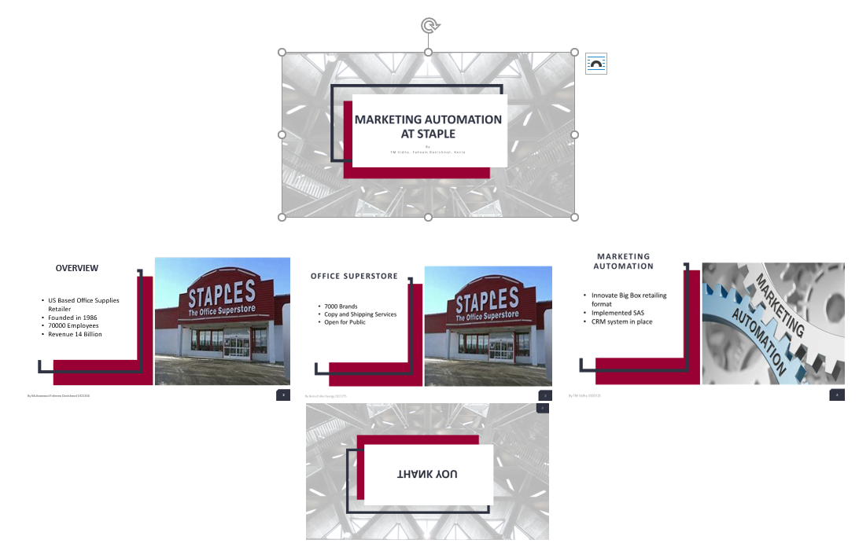

Appendix 2: Shell Case Study
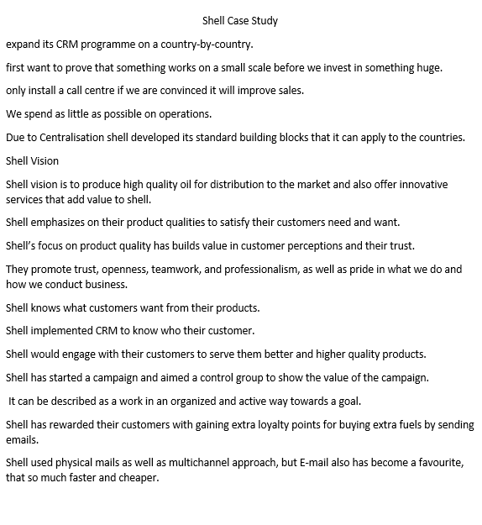
Appendix 3. Enterprise Rent a Car


