John Hughes
1708241
Networking & Cybersecurity

Research Into Cybersecurity Attacks and Penetration Testing for a Virtual Simulated Company Website
2023/2024 Semester One
Ethical Hacking
ACCA7033
Dr Nitheesh Murugan Kaliyamurthy

Submission Date: 15th January 2024
Word Count: 5000
Internal Verifier: Munyaradzi Murira

Contents

Table of Figures 3
Table of Tables 4
List of Acronyms 4
1. Cyberattacks Introduction 5
1.1 The Royal Mail Ransomware Attack (2023) 5
1.1.1 Attack Overview: Method and Impact 6
1.1.2 Attacker Profile and Motivation 6
1.1.3 Victim Response 7
1.1.4 Mitigation Strategies 7
1.2 Microsoft DDoS Attack (2023) 9
1.2.1 Attack Overview: Method and Impact 9
1.2.2 Attacker Profile and Motivation 10
1.2.3 Victim Response 11
1.2.4 Mitigation Strategies 11
1.3 Rockstar Games Grand Theft Auto 6 Leak (2022) 12
1.3.1 Attack Overview: Method and Impact 12
1.3.2 Attacker Profile and Motivation 13
1.3.3 Victim Response 13
1.3.4 Mitigation Strategies 13
2. Simulated Penetration Testing of CPC Virtualised Infrastructure 15
2.1 CPC Testbed Requirements 15
2.1.1 Network Architecture Design 15
2.1.2 Network Implementation 16
2.1.3 Network Infrastructure 17
2.1.4 Contingency Policy 17
2.1.5 Framework Utilisation 18
2.2 Vulnerability Assessment and Penetration Testing 18
2.2.1 Scope 18
2.2.2 Passive Reconnaissance 19
2.2.3 Active Reconnaissance 20
2.2.4 Vulnerability Assessment 22
2.2.5 Exploitation 25
2.3 CPC Test Final Report 31
2.3.1 Executive Summary 31
2.3.2 Recommended Solutions 32
2.3.3 Financial Overview 33
References 35

Table of Figures

Figure 1 Ransomware Attack Process 5
Figure 2 Ransomware Detection Techniques, adapted from [12] 7
Figure 3, Microsoft Attack Timeline, adapted from [15] 8
Figure 4 Anonymous Sudan's Attack Vector Layout 9
Figure 5, SIM Swapping Process, adapted from [23] 11
Figure 6, CPC Network Testbed 14
Figure 7 Oracle VirtualBox Virtual Network 15
Figure 8 Zenmap Intense Scan of Metasploitable2 18
Figure 9 Zenmap Intense Scan of BeeBox 19
Figure 10 Zenmap Intense scan of subnet 19
Figure 11, Nmap Vulnerability Scan of Metasploitable2 21
Figure 12, Nikto Web App Scan of Metasploitable2 21
Figure 13, Searchsploit vulnerability search of mySQL 5.0.51a 22
Figure 14, Nikto Scan of BeeBox port 80 22
Figure 15 Nikto Scan of port 443 23
Figure 16 Searchsploit vulnerability search of MySQL 5.0.96-0ubuntu3 23
Figure 17, Exploitation Targets 23
Figure 18, Metasploit begins backdoor exploit 24
Figure 19, Metasploit payload executed against 10.0.2.8 24
Figure 20, Target Information Displayed 24
Figure 21, User Accounts List retrieved from shell session 25
Figure 22, RSA Privat Keys Obtained from shell session 25
Figure 23, SQL Access failed, ending session. 26
Figure 24, cleanup commands to clear tracks 26
Figure 25, Default Credentials allow for PHP access 27
Figure 26, Metasploit reverse tcp payload requests token 27
Figure 27, Token retrieved from web page source code 28
Figure 28 XSS-reflected GET request from Kali web browser 28

Table of Tables

Table 1 VM IP Address Table 17
Table 2 Open Port Table 19
Table 3, Reconnaissance target table 20
Table 4, Metasploit Remediation Table 30
Table 5, BeeBox Remediation Table 31
Table 6, Remediation Costs Table 31

List of Acronyms

C
CISA
Cybersecurity and Infrastructure Security Agency, 11
CPC
Cureton Pharmaceutical Company, 13
D
DDoS
Distributed Denial of Service, 8
G
GTA6
Grand Theft Auto 6, 11
GUI
Graphical User Interface, 18
I
ICO
Information Commissioners Office, 6
M
MFA
Multi Factor Authentication, 12
N
NAT
Network Address Translation, 14
NCSC
National Cyber Security Centre, 6
O
OSINT
Open-Source Intelligence, 13
R
RaaS
ransomware-as-a-service, 6
S
SDN
Software Defined Networking, 7
V
VPS
Virtual Private Servers, 9
X
XSS
Cross-Site Scripting, 17

Cyberattacks Introduction

Due to the increasing reliance on technology, society is more vulnerable than ever to sophisticated and widespread cybersecurity breaches. The complexity of digital systems, whilst carrying many benefits, has increased the scope and sophistication of attacks. As organisations adopt emerging technologies, the attack surface has grown larger, resulting in proportionately greater consequences.
Cyber-attacks are now a regular occurrence. With technology being embraced through industry 4.0, it is no longer just information systems at risk, but also the global threat to critical infrastructure as industries adapt to the emergence of Internet of Things (IoT), automation and cloud services.
The landscape of cyber-threats has transformed from small-scale attacks to national security threats. This new era of attack groups ranges from individual threat actors to the cyberwarfare of state-sponsored entities, resulting in threats to all aspects of society.
This research delves into three significant cybersecurity breaches to have occurred in recent years. Focusing on attacks of varying characteristics, each case study details the specific nature of the attack and insights gained for future reference.

The Royal Mail Ransomware Attack (2023)

Royal Mail is a key component of the UKs communications infrastructure that has operated in Britain for over 500 years. Their workforce of 150,000 employees helps deliver to over 30 million UK addresses and further destinations overseas [1]. In January 2023, they were subject to a significant cybersecurity incident:

Attack Overview: Method and Impact

In November 2022, dozens of computers and servers were infected with malware at the Royal Mail’s headquarters in London. The attackers were able to access the systems through phishing emails targeting Royal Mail employees. Through this attack vector, a payload known as Emotet ransomware was delivered, encrypting sensitive data from the infected systems [2].

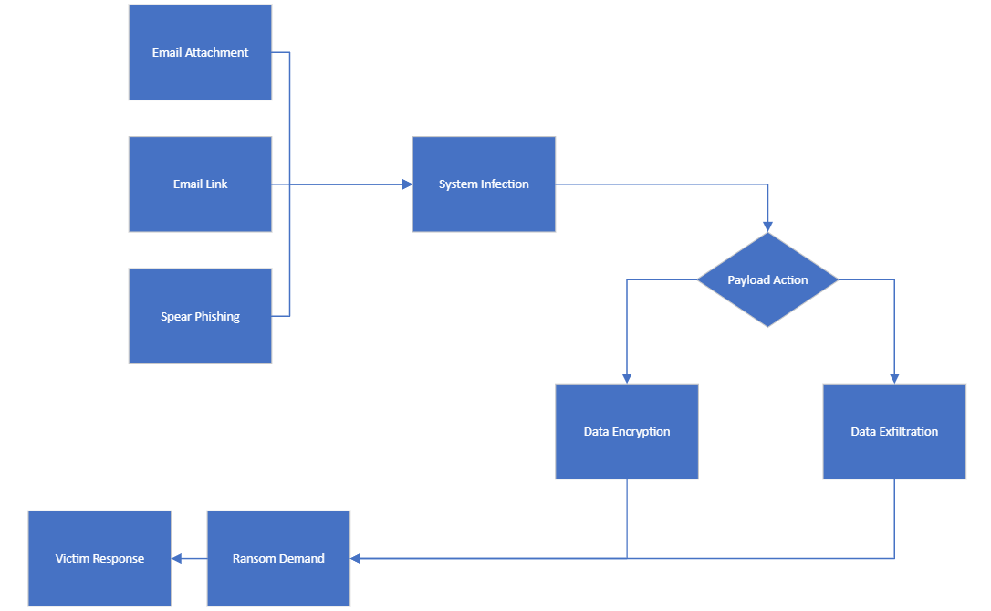
Figure 1 Ransomware Attack Process
The company managed to contain the attack by isolating various systems, allowing domestic services to be maintained. The infection successfully encrypted shipping devices that their Post Office branches used for processing international mail and parcels. With these shipping devices out of service, the company resorted to manually processing the parcels already within their distribution network and temporarily cease further operations beyond the UK [3].
Many small businesses were left stranded by the incident, losing revenue from lack of services and forced to issue refunds for stock held up in the Royal Mail Network [4].
A lasting impact of this attack may be felt nationwide, with the latest information released by Royal Mail’s International Distribution Services reported a revenue drop of 6.5% [5]. This cost will eventually be passed on to the consumer, increasing prices for businesses and their customers.

Attacker Profile and Motivation

The attack was attributed to a sophisticated cybercriminal group known as LockBit, notorious for operating under a ransomware-as-a-service (RaaS) model to extort financial gain from their victims. They employed a double extortion method of encrypting and exfiltrating the data, allowing them to hold the encrypted data to ransom whilst threatening to release it to the dark web. The National Cyber Security Centre (NCSC) reported that LockBit ransomware variants were the most deployed worldwide through 2022 [6].

Victim Response

After isolating the infected systems, Royal Mail began collaborating with cybersecurity experts, including NCSC and the National Crime Agency, UK government bodies for assisting organisations in cyber-attacks. Further to this, the Information Commissioners Office (ICO) was informed of the data theft as a regulatory requirement [7].
The attackers released chat-logs of communications between themselves and Royal Mail, demanding a ransom of $80 million (£67 million), which they calculated as 0.5% of their victim’s revenue. In the face of these demands, Royal Mail stood firm, refusing to pay. During the negotiations, they even attempted to trick the attackers into providing the decryption keys that would allow them to recover their systems. Royal Mail’s ploy was to ask for proof the decryption worked on the pretence of allowing them to ship disrupted medical supplies, whilst actually requesting data that would recover their critical components. It is understood that LockBit’s demands were miscalculated. Payment was never considered as the sum would likely bankrupt Royal Mail’s compromised subsidiary [8].
Financial statements by Royal Mail revealed they spent over £10 million in remediation efforts to their infrastructure. Allocation of these funds was not disclosed, although it is expected to have been divided between cybersecurity upgrades and system rebuilds, since ransomware attacks often render infected systems unusable [9].

Mitigation Strategies

With the attack vector identified as a phishing email, and the execution delivered through means of ransomware, mitigation will focus on these two cyber threats.
According to statistics from IBM’s annual Threat Intelligence report, phishing was the leading attack vector of 2023, accounting for 41% of incidents [10]. The threat of this attack can be mitigated in several forms. Automated tools can be deployed, such as advanced email filtering to detect and block malicious communications before they are received at inboxes. Other real-time threat detection and alert systems may notify a user when they encounter a malicious link, message or website [11].
It is argued that the use of these advanced algorithm and machine learning tools are limited in their ability to identify new permutations and custom-made attacks. Consequently, they are most effective when combined with user training to identify and report incidents. This combined approach not only helps identify and avoid phishing attempts, but also provides input for refining and improving the features of automated tools [11].
Regarding ransomware, IBM also report that the time it takes for attackers to execute the payload from the point of entry has decreased by 94% over the last 5 years. Deployment in 2019 took an average of 60 days, compared with the 2023 average just 3.85 days [10]. This statistic highlights the need for organisations to proactively approach the threat, as by the time a system is infected, it is usually too late to recover the data, even if the ransom demands are met.
The work of Adhirath Kapoor et al describe the Detection avoidance Mitigation (DAM) defence, a theoretical framework that combines a multitude of mechanisms to prevent ransomware attacks. The key features are listed as follows [12]:
- Detection techniques – Automated tools to scan executable files, either statically or dynamically following the flow of code to identify suspicious patterns such as file identification or privilege escalation.
- Avoidance Techniques – As ransomware preys on unpatched vulnerabilities, this can be avoided by regular patches and updates. Non-acceptance of emails from unknown sources would also prevent many forms of attack. Folder-based access control would also avoid sensitive data from being encrypted.
- Mitigation Techniques – utilising Software Defined Networking (SDN) can be implemented to block Command & Control (C&C) server communications, preventing a successful encryption. Another mitigation is the deployment of secure data vaults that maintains file integrity, allowing for post-attack system recovery.

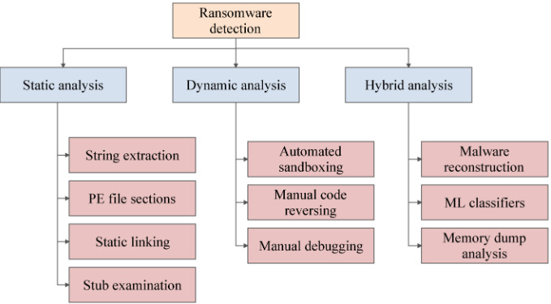
Figure 2 Ransomware Detection Techniques, adapted from [12]

Microsoft DDoS Attack (2023)

In June 2023, tech giant Microsoft received a surge in traffic that primarily targeted their Azure, Outlook, and OneDrive services. This incident was quickly identified as a Distributed Denial of Service (DDoS) attack labelled Storm-1359, temporarily affecting the availability of targeted services [13].
The attack was attributed to the prolific threat-actors Anonymous Sudan, a self-proclaimed hacktivist group that are suspected of being a state-sponsored entity with links to the Killnet group [14].
The attack to Microsoft Services lasted several days. However, the perpetrator’s broader campaign is ongoing at the time of writing. Their attacks cover multiple targets, primarily tech firms such as Cloudflare, OpenAI and PayPal.

Figure 3, Microsoft Attack Timeline, adapted from [15]

Attack Overview: Method and Impact

On June 7th, Microsoft’s Outlook servers were targeted with a DDoS attack that caused intermittent outages for several days. This was followed with further attacks on their OneDrive and Azure services. Microsoft’s assessment of the internally named Storm-1359 attack states that unusual traffic was targeting disruption at the application layer, layer 7 of the OSI model. This was achieved through a combination of techniques [13]:
- HTTP(S) flood attack – Overwhelming the servers with a high volume of HTTP(S) requests, primarily SSL/TLS handshakes from a vast number of internationally distributed IP addresses.
- Cache bypass – Sending requests that bypass the web application’s cache, forcing it to fully process every request. In this case, queries were sent to URLs that forced the frontend to pass on every request instead of serving from cache.
- Slowloris – Establishing unresponsive connections to the target server that are maintained for as long as possible to consume its resources.

Microsoft’s tracking of the event identified the infrastructure involved as rented cloud hardware utilising multiple Virtual Private Servers (VPS) and open proxies combined with DDoS tools. A diagram of the attack is illustrated in figure 4:
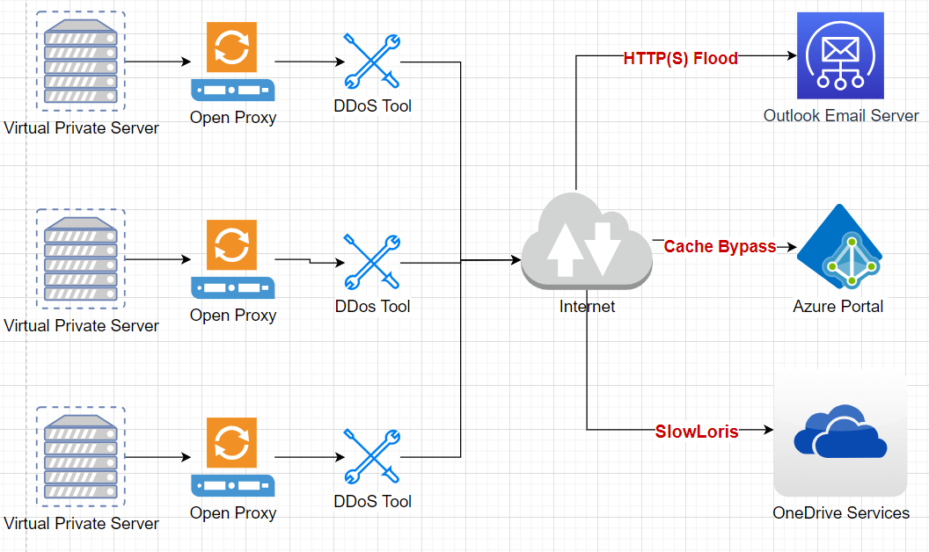
Figure 4 Anonymous Sudan's Attack Vector Layout
Disruption to services lasted several days. At its peak, there were 18,000 reports of outages on Down Detector. Azure was the most severely disrupted, with a reported 77% of users having difficulty accessing the website, 18% experiencing login problems and 6% with server connection issues [15].
Despite the negative publicity, little damage was done to the organisation, issuing a statement that no data was lost during the incident. Share prices were unaffected, rising marginally higher by 0.78% [15].
For Anonymous Sudan, the incident was claimed as a victory due to widespread media attention. The group released statements via its Telegram channel threatening further attacks against US companies, government and infrastructure [16].

Attacker Profile and Motivation

Despite Anonymous Sudan’s claims to be a Sudanese hacktivist group, they appear to have no relation to the nation. Additionally, the cloud infrastructure utilised during their attacks, coupled with the technical sophistication of their methods, extends beyond the average hacktivist group [17].
Such resources are usually seen from state-sponsored hackers, a theory consistent with their ties to the state-sponsored group Killnet. A threat intelligence report by Truesec highlighted their original Telegram statements being in Russian, only to delete these posts and begin posting in basic Arabic, eventually adopting Sudanese dialect. These communications add further weight to the theory of state-sponsored attacks [18].
The attackers self-proclaimed motivation was financially driven. Public demands were made for payment of $1 million in exchange for ceasing attacks and information on how it was performed. This statement was unlikely to be more than a feint, with their real intentions to cause widespread disruption and gain publicity [16].

Victim Response

Microsoft’s initial statement announced the incident as a “technical issue”, whilst their mitigation response was to address the traffic with load balancing processes. They later released a more detailed statement to admit they were victims of a DDoS attack by the Anonymous Sudan group. This also stated that no data was lost or stolen, and damages were contained to temporary service outages [13].
Reacting to the threat of future attacks, it was announced that they had tuned their Azure Web Application firewall to protect from further layer 7 attacks. This specifically involved configuring bot-protection from known threats, blocking IP addresses and limiting traffic from defined regions [13].
Microsoft made no public response to the statements made by Anonymous Sudan, including their demand for $1million payment [16].

Mitigation Strategies

According to Microsoft, various defence mechanisms were already in place for mitigating DDoS attacks. Their strategy was focused on reconfiguring the existing systems by means of load balancing and custom rules to their WAF [13].
Information provided by The Cybersecurity and Infrastructure Security Agency (CISA) states that DDoS defence is enhanced with understanding the network infrastructure and resources before any attack takes place. Particular attention is focused on the following key areas [19]:
- Identify the public facing services and understand their inherent vulnerabilities. Prioritising the most critical assets can enhance the configuration of the WAF.
- Monitor network user traffic to understand the key areas of weakness. Identifying potential network chokepoints will allow for more effective mitigation when deploying load balancing.
- Understanding the defences offered by Internet Service Providers (ISP) and Cloud Service Providers (CSP) can assist in identifying any gaps in their protection. Organisations may alter WAF configurations to cover the limitations in ISP or CSP defences.
- Consider the potential impact a DDoS might have on the network and deploy appropriate network redundancy to mitigate the potential changes to functionality.

Rockstar Games Grand Theft Auto 6 Leak (2022)

On 18th September 2022, video game developer Rockstar Games was subject to a major attack by a British member of the Lapsus$ hacking group that operated under the alias TeaPotUberHacker. Using minimal resources but a strong technical understanding, the attacker managed to steal Rockstar’s intellectual property without access to a PC or laptop. After a spate of high-profile attacks, the hacker’s real identity, Arion Kurtaj, was made public by rival hacker groups, resulting in his arrest. According to a BBC report, he was subsequently placed in police protection in a UK hotel, where he proceeded to execute his attack on Rockstar Games, amongst other targets [20].

Attack Overview: Method and Impact

Kurtaj used a combination of social-engineering and SIM-swapping to steal the source code for the unreleased video game, Grand Theft Auto 6 (GTA6), Rockstar’s flagship product. With his laptop confiscated by police, he instead used simple equipment – an Amazon Firestick, hotel TV and a mobile phone – to conduct the attack by utilising cloud services [20].
Without specific information on how the Firestick was utilised, several assumptions can be made for its use:
- It was modified through accessing root privileges and altering the firmware – a method known as “jailbreaking” [21].
- The Firestick accessed a web browser or shopping app to acquire the mobile phone, an item reported to have been newly purchased [20], for leveraging the cloud services and executing the SIM-swap.

Kurtaj’ attack was initiated by gaining the credentials of a Rockstar employee. The method for acquiring the credentials is unclear, but potentially mirrors a tactic used in the Uber Technologies attack from the same hotel room, where he convinced an employee to provide their user account details by presenting himself as IT staff [22].
With the user account details acquired, he then bypassed Rockstar’s Multi Factor Authentication (MFA) using a method known as SIM-Swapping – contacting the victim’s telecommunications provider and porting the phone number to a SIM-card in his possession, effectively directing all communications to the replacement SIM [23].

Figure 5, SIM Swapping Process, adapted from [23]

Kurtaj then used the credentials to access Rockstar’s systems and navigate through Active Directory security, where he downloaded over 90 videos of the unreleased video game footage and the source code to previous GTA titles that are currently in service. He then leaked the content on social media, quickly going viral across major platforms. Despite the frustration of key product information being revealed, no impact is expected on the video games release, which is estimated to surpass the record-breaking success of its predecessor: GTA5 Online [24].

Attacker Profile and Motivation

Consisting of a small number of teenagers in the UK and Brazil, the volume of attacks by the Lapsus$ group made them one of the most prolific attackers of 2022.
The perpetrator of the Rockstar attack, 18-year-old Kurtaj, has remarkable skills and a strong intent for committing cybercrime. Although the Lapsus$ group are primarily intent on extortion and blackmail, Kurtaj’ motives appear more complex than just financial gain. When convicted for his crimes, he was sadly handed an indefinite hospital order for his severe autism. Kurtaj displays acts of violence and openly states his intention to continue committing cyber-crimes. This intent suggests that he may be a compulsive offender that attacks organisations due to his mental condition [25].

Victim Response

In the immediate aftermath of the attack, Rockstar Games acknowledged the incident as a network intrusion [26]. They were reported to have spent $5million on strengthening their security systems and thousands of hours of admin resources removing the leaked footage [25].

Mitigation Strategies

The primary attack vector in this incident was social engineering based. The survey by Salahdine and Kaabouch lists the following mitigation strategies [27]:
- Educate Employees – The human aspect of social engineering targets the weakest link in network security. Regular training can strengthen this area and identify attacks.
- Limit Information Sharing – Reduce the amount of information shared, particularly with public access that may be used for Open-Source Intelligence (OSINT)
- Verify Unsolicited Contacts – Establish the identity in all communications. In the event where this is not possible, cease contact.

A key factor in executing this attack involved navigating MFA. In the journal by Nader Karim et al, they state that MFA can be strengthened with additional features [28]:
- Voice MFA – Identifies a user by their unique voice patters.
- Physical Security Keys – Involves physical hardware tokens such as key fobs or USB devices to generate one-time user codes.
- Biometrics – Employs unique authentication via fingerprints or facial recognition.

Further to these strategies, the US government agency CISA responded to the Lapsus$ attacks with a series of recommendations at regulatory level to mitigate the specific threats posed as follows [29]:

- Government support for authentication improvements such as Identity Access Management (IAM).
- Strengthen government oversight in telecommunications to prevent SIM swapping.
- Enforce stringent identity verification for SIM swapping.
- Enforce retailer identification checks for SIM card sales.
- Enhance international resources and collaboration for tackling cybercrime.
- Introduce juvenile/youth offender programs for cybercrime prevention and intervention.

Simulated Penetration Testing of CPC Virtualised Infrastructure

Cureton Pharmaceutical Company (CPC) is an organisation working to create vaccines for respiratory viruses. The business requires a strong cybersecurity posture to secure their assets. CPC have extended their Cybersecurity department with a newly formed Red-Team to test the security of their infrastructure.

CPC Testbed Requirements

The chosen design consists of a network of virtual machines hosted by a type 2 hypervisor employing Network Address Translation (NAT). The sandboxed virtualised network provides a safe, scalable environment for a replication of the company’s network.

Network Architecture Design

The network architecture shown in figure 6 was designed as a testbed to meet the needs of the company and suitability of the pen test.

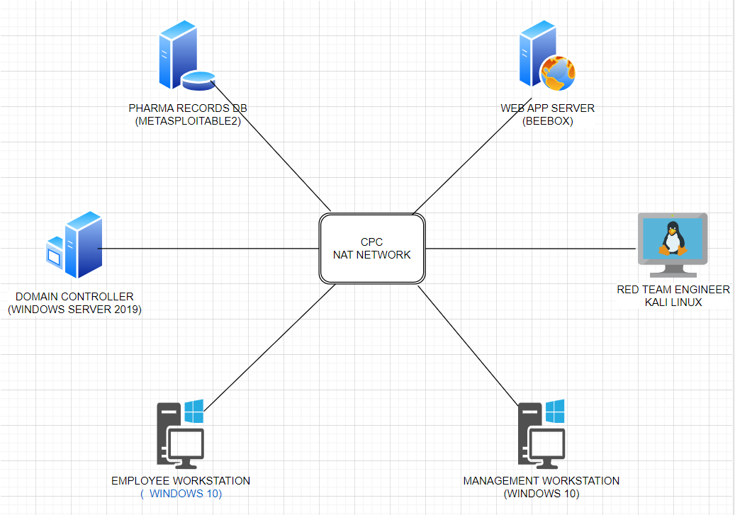
Figure 6, CPC Network Testbed

2.1.2 Network Implementation

Oracle VirtualBox type 2 hypervisor was chosen for constructing the network using the resources shown in figure…

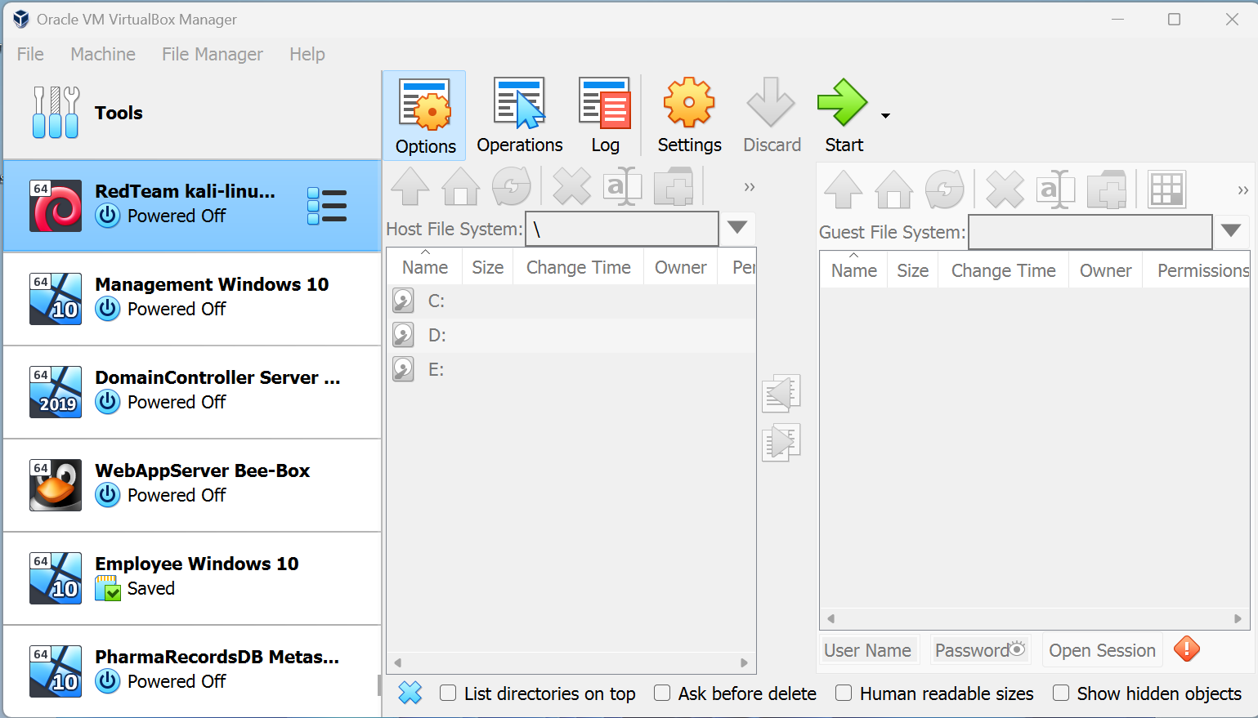
Figure 7 Oracle VirtualBox Virtual Network

2.1.3 Network Infrastructure

CPC NAT NETWORK: Virtualised environment utilising NAT network.
RED-TEAM: Kali Linux distribution for Pen-testing and security auditing.
MANAGEMENT: Windows 10 desktop PC with high privilege access and management tasks.
EMPLOYEE: Windows 10 desktop PC with restricted privileges for typical employee use.
DOMAIN CONTROLLER SERVER: Windows server 2019.
WEB APP SERVER: BeeBox serving as a vulnerable web application server for testing purposes.
PHARMARECORDS: Metasploitable2 simulating a vulnerable database server hosting sensitive records.

2.1.4 Contingency Policy

To establish a safe guide of ethical conduct, a contingency policy was established before executing the penetration testing procedure. The policy details are as follows:

Safe Environment: The use of Oracle VirtualBox provides a controlled, sandboxed environment, effectively isolating the testing activities from real-world networks.
Data Backup & Recovery: Regular backups of all VMs will be maintained to mitigate the risk of critical failures or misconfigurations.
Defined Scope: The testing procedures are restricted to the VMs listed in the virtual network. Any external systems or networks are explicitly excluded from testing. It is acknowledged that virtual environments may not fully replicate real-world environments.
Ethical and Legal Compliance: All testing activities will be for educational purposes only and comply with relevant legal requirements. Only safe and sensible actions will be conducted.
Incident Response Plan: In case of unexpected events, testing activities will be ceased immediately. Assessment of the incident will be initiated for remediation.

2.1.5 Framework Utilisation

The testing approach will incorporate the MITRE ATT&CK and OWASP Top 10 frameworks as guiding principles.
The MITRE ATT&CK will guide the exploitation of specific attack techniques to ensure a comprehensive system assessment by following the MITRE ATT&CK matrix [30].
Concurrently, the OWASP top 10 will provide focus on the most critical web application security risks, such as injection flaws and Cross-Site Scripting (a03:2021) [31].

Vulnerability Assessment and Penetration Testing

The primary aim is for the Red Team to strengthen CPC’s cybersecurity posture by assessing the network for vulnerabilities and offering a form of remediation. This will be conducted under white-box conditions as all information is available to the tester.

Scope

- NETWORK LIMITATION – Testing is confined to the virtualised environment within Oracle VirtualBox, impacting only the VMs within the virtual NAT network. It is established that explicit permission is granted to target all VMs within the CPC testbed.
- ETHICAL BOUNDARIES – All activities will adhere to ethical hacking standards and legal requirements. No harm will be caused to external networks, services, information systems, or users beyond the virtual network.
- DATA HADNLING – Any information, including but not limited to network information, login credentials, vulnerabilities, testing methods, attack vectors and exploits, remain within the confines of the testing environment and are not used for any purpose beyond the scope of this exercise.
- TEST DURATION – The test period is defined as activity between the start date of 1/12/23 to the end date of 29/1/24. Testing beyond the stated timeframe is prohibited.
- USE OF TOOLS – Only established tools within the Kali Linux suite are to be used. Any use of destructive tools is prohibited.
- REPORTING – All findings during the testing process will be documented in a final report detailing vulnerabilities, testing methods and mitigation recommendations.
- POST-TESTING PROCEDURE – Upon completion of this exercise, all VMs will be deleted or restored to their original state, leaving no residual vulnerabilities remaining.

Passive Reconnaissance

In the initial testing phase, passive reconnaissance was aimed at the Metasploitable2 and BeeBox VMs within the network. The primary aim was to gather information that may identify vulnerabilities that are susceptible to OWASP top 10 risks.
According to documentation provided by developers Rapid7, the following known vulnerabilities were identified for Metasploitable2 [32]:
- Apache Tomcat 2.2.8 – Weak default credentials leading to unauthorised access.
- vsFTPd 2.3.4 Backdoor – Potential for remote code execution.
- MySQL 5.0.51a – Vulnerabilities that may lead to unauthorised database access.
- Samba 3.0.20 – Vulnerability that may lead to remote code execution.
According to online sources from ITsecgames, BeeBox is known to have the following issues [33]:
- Web application vulnerabilities that are aligned with the OWASP top 10, including Cross-Site Scripting (XSS) and SQL Injection
- Default user credentials or easily cracked passwords.
- Outdated web services running older versions of Apache, PHP and SQL
The vulnerabilities identified during passive reconnaissance were chosen to make up the scope of the pen-testing stage, assessing the security posture, and demonstrating the impact of exploitation.

Under white box conditions, the IP addresses of each VM are available to the Red Team. They are listed in table 1.
Table 1 VM IP Address Table
Hostname | IP Address | Subnet Mask
Red Team Kali Linux | 10.0.2.4 | 255.255.255.0
Web App Server BeeBox | 10.0.2.5 | 255.255.255.0
DomainController Sever | 10.0.2.6 | 255.255.255.0
Management Windows 10 | 10.0.2.7 | 255.255.255.0
PharmaRecords DP Metasploitable 2 | 10.0.2.8 | 255.255.255.0
Employee Windows 10 | 10.0.2.15 | 255.255.255.0

Active Reconnaissance

To initiate active reconnaissance, Zenmap was chosen to map the CPC network due to its Graphical User Interface (GUI) and clear visual displays. The Metasploitable 2 VM was initially targeted due to its known vulnerability issues.
An intense scan of the 10.0.2.8 target identifies 23 open ports which may lead to potential vulnerabilities. The scan also confirms vulnerable services identified in the reconnaissance stage, such as vsftpd 2.3.4, MySQL 5.0.51a, and Apache 2.2.8.
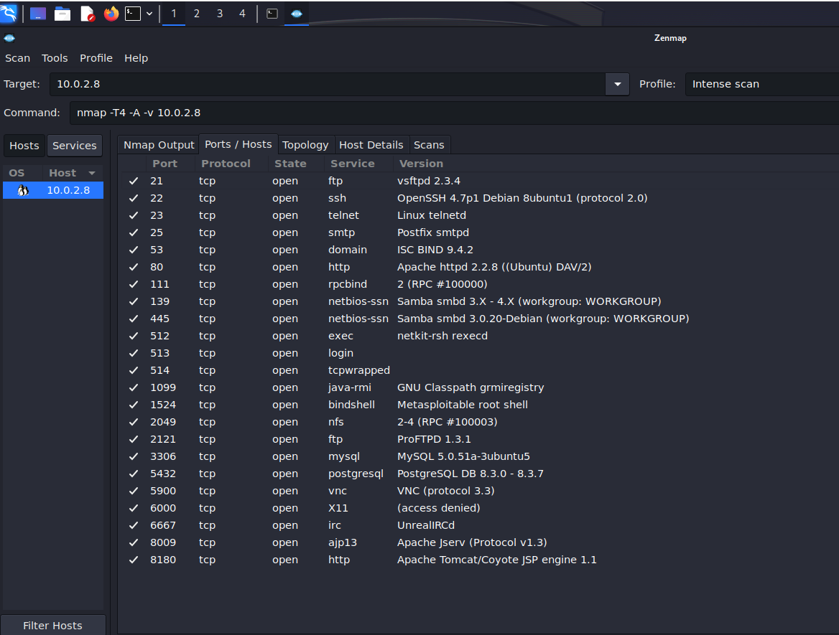
Figure 8 Zenmap Intense Scan of Metasploitable2

The next scan targeted the 10.0.2.5 IP address of the BeeBox VM. The results show 17 open ports, confirming the previously researched presence of outdated service versions and the allowance of anonymous FTP access.
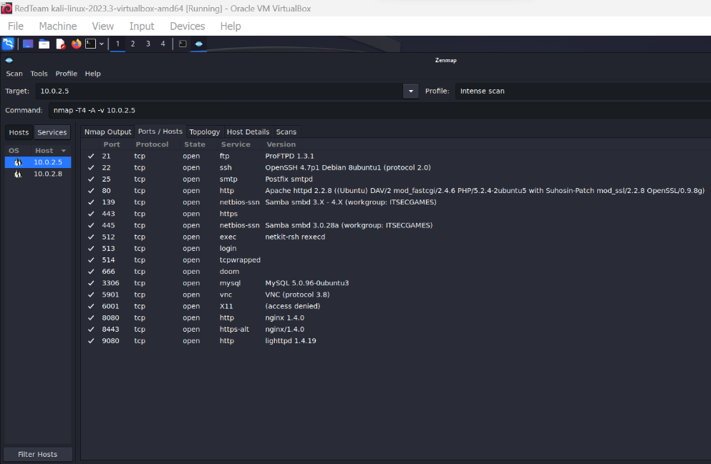
Figure 9 Zenmap Intense Scan of BeeBox
To complete the network mapping, the slash notation is included in the next scan to identify all nodes within the subnet.
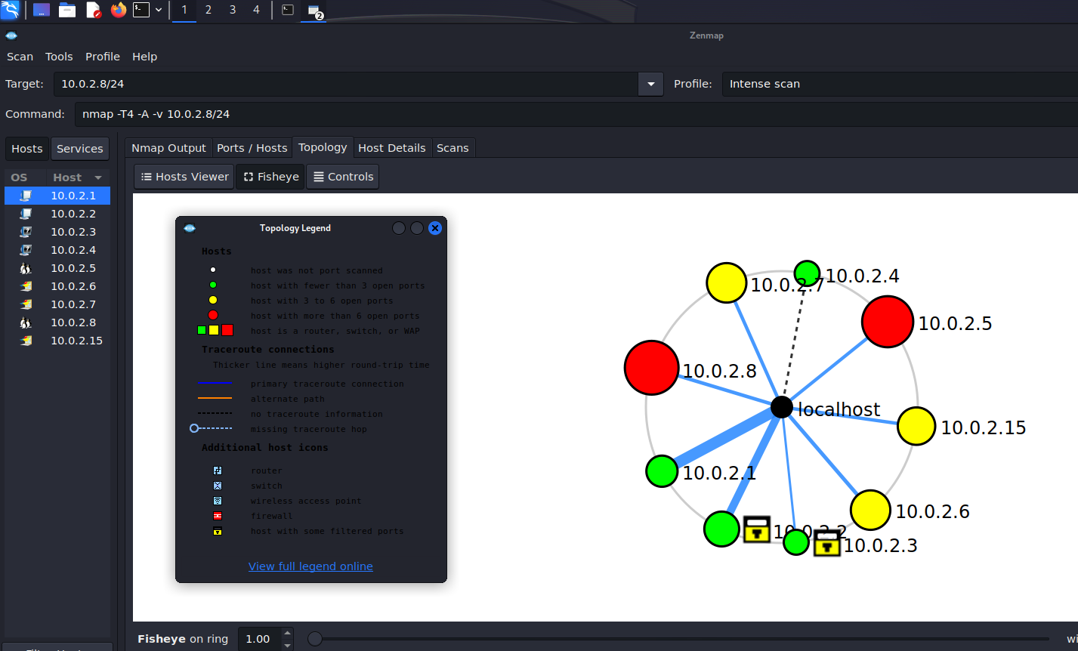
Figure 10 Zenmap Intense scan of subnet

From the resulting topology, an inventory is presented in the following table:
Table 2 Open Port Table
IP Address | Identified Node | Open Ports
10.0.2.1 | Default Gateway | <3
10.0.2.2 | VOIP Phone (97% accuracy) | <3 (Filtered ports)
10.0.2.3 |  | <3 (Filtered ports)
10.0.2.4 | Red Team Kali Linux | <3
10.0.2.5 | Web App Server BeeBox | >6
10.0.2.6 | DomainController Server | 3-6
10.0.2.7 | Management Windows 10 | 3-6
10.0.2.8 | PharmaRecords DP Metasploitable 2 | >6
10.0.2.15 | Employee Windows 10 | 3-6

Vulnerability Assessment

The following ports and services identified during the reconnaissance stage were then targeted for vulnerability assessment using appropriate tools depending on the service.
Table 3, Reconnaissance target table
Hostname | IP | Port | Service | Version | Scan Tool
PharmaRecords DP Metasploitable 2 | 10.0.2.8 | 21 | ftp | vsftpd 2.3.4 | Nmap
PharmaRecords DP Metasploitable 2 | 10.0.2.8 | 80 | http | Apache 2.2.8. | Nikto
PharmaRecords DP Metasploitable 2 | 10.0.2.8 | 3306 | mySQL | MySQL 5.0.51a | Searchsploit
Web App Server BeeBox | 10.0.2.5 | 80 | http | Apache 2.2.8. | Nikto
Web App Server BeeBox | 10.0.2.5 | 443 | https |  | Nikto
Web App Server BeeBox | 10.0.2.5 | 3306 | mySQL | MySQL 5.0.96-0ubuntu3 | Searchsploit

METASPLOITABLE:
The Nmap scan result for 10.0.2.8 port 21 confirmed the presence of a backdoor vulnerability in vsFTPd:
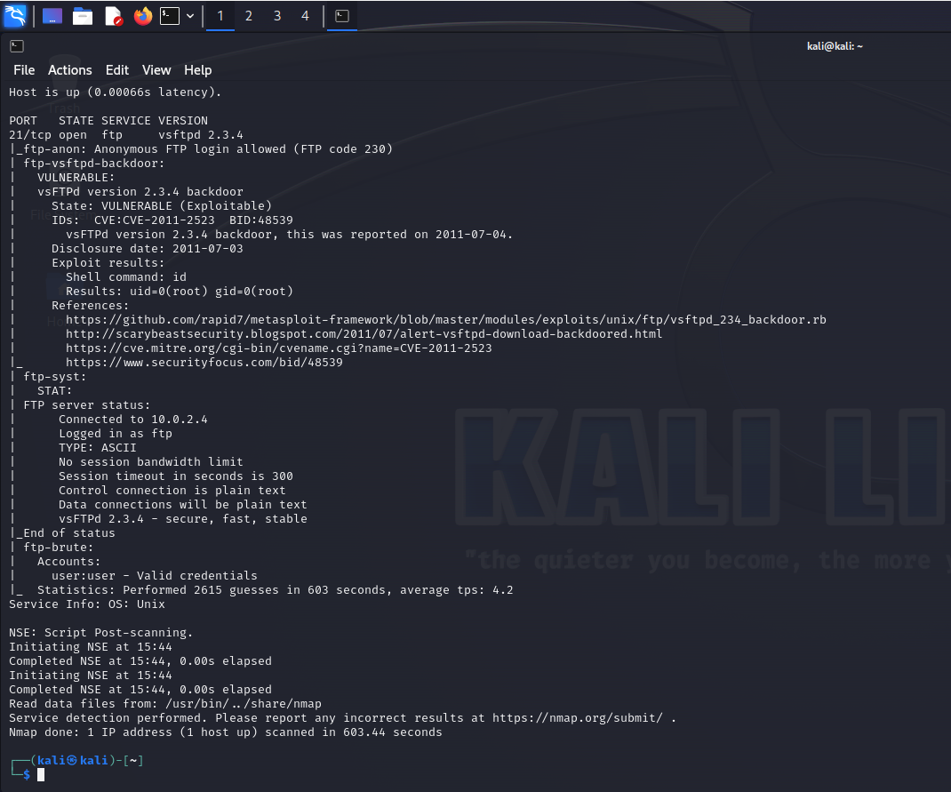
Figure 11, Nmap Vulnerability Scan of Metasploitable2

The Nikto scan of the target server at IP 10.0.2.8 on port 80 has revealed common admin directories, which could be exploited if credential remain unchanged:
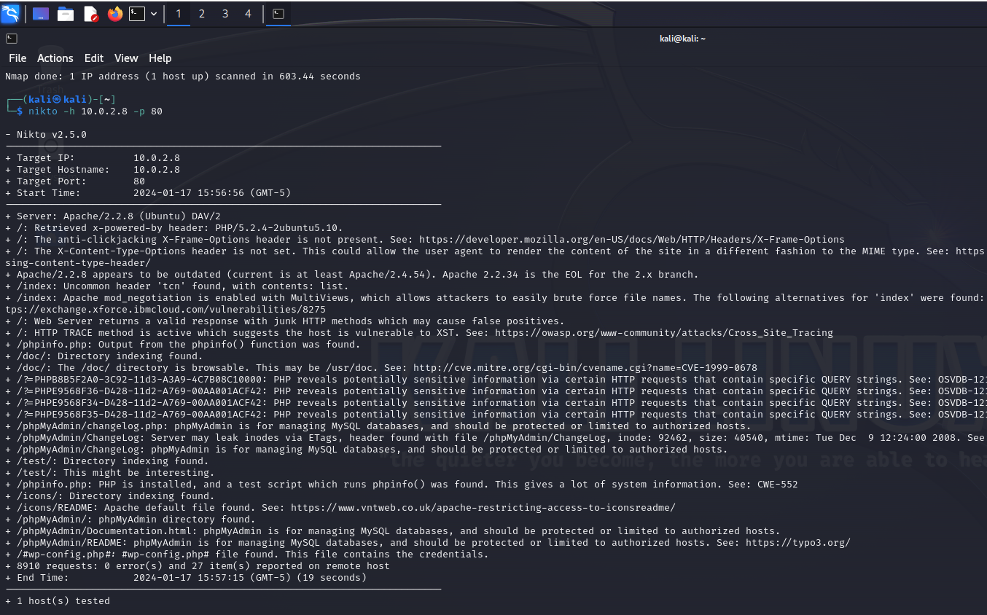
Figure 12, Nikto Web App Scan of Metasploitable2

Searchploit Highlighted the following vulnerabilities in MySQL 5.0.51a:
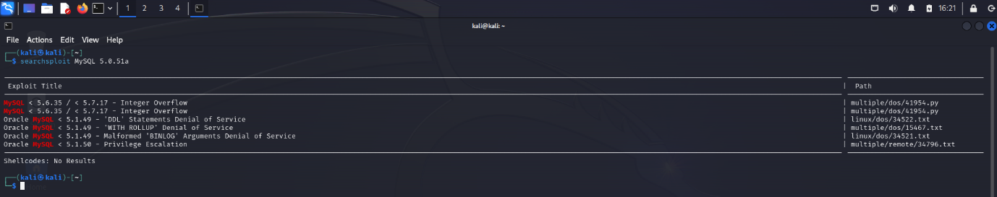
Figure 13, Searchsploit vulnerability search of mySQL 5.0.51a

BEEBOX:
The Nikto scan of port 80 reveals multiple security concerns on the BeeBox server such as outdated software versions, exposed server-status page and publicly accessible phpMyAdmin directory:
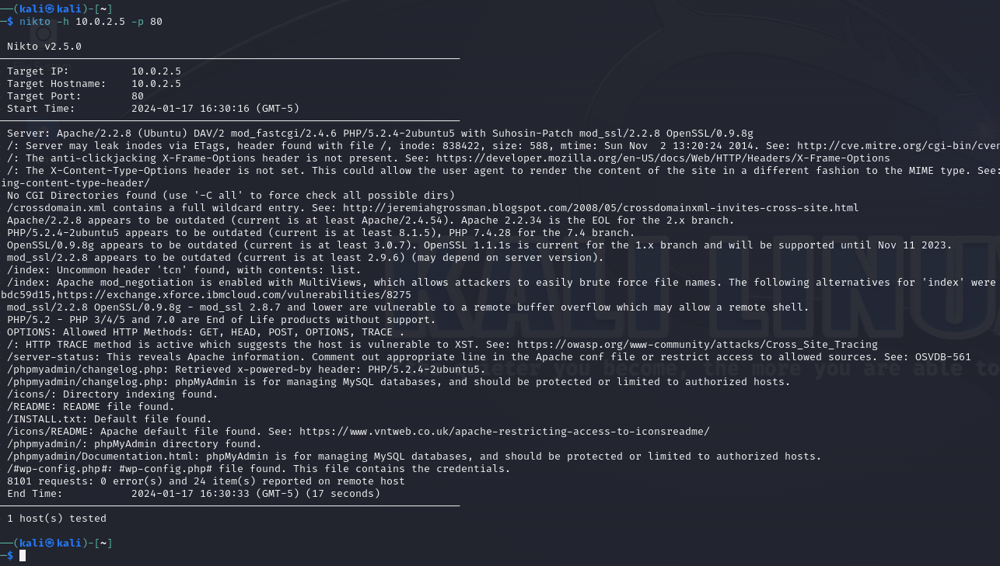
Figure 14, Nikto Scan of BeeBox port 80

Security issues are present on the scan results of port 443. Nikto shows outdated server components and misconfigured http headers:
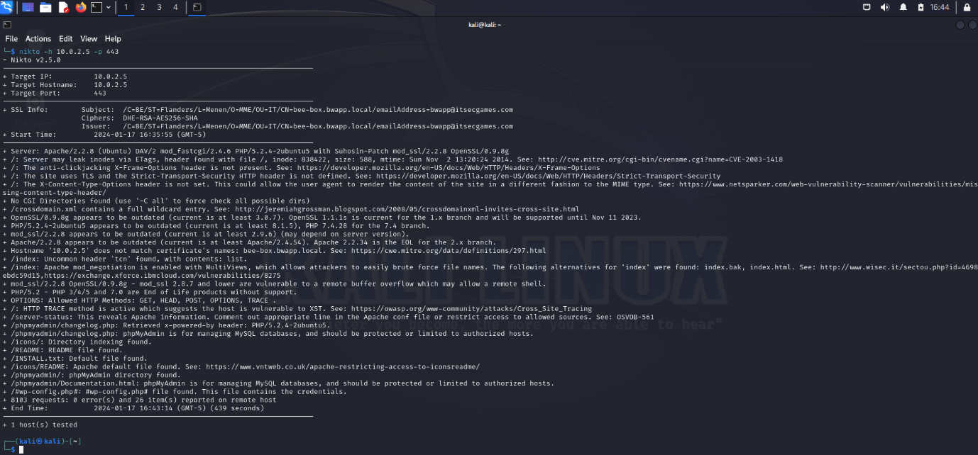
Figure 15 Nikto Scan of port 443

Accordingly, the final scan using Searchsploit raised multiple vulnerabilities with the MySQL 5.0.96-0ubuntu3 database:
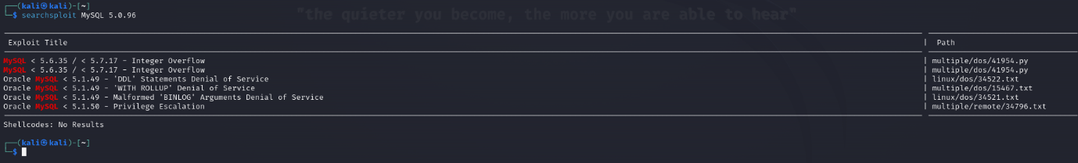
Figure 16 Searchsploit vulnerability search of MySQL 5.0.96-0ubuntu3

Exploitation

For the scope of the assignment, the exploitation stage focuses on one vulnerability for Metasploitable2 and one for BeeBox. They are chosen as follows:

Hostname | IP Address | Port Number | Vulnerability | Tool
PharmaRecords DP Metasploitable 2 | 10.0.2.8 | 21 | vsftpd 2.3.4 Backdoor CVE-2011-2523 | Metasploit
Web App Server BeeBox | 10.0.2.5 | 80 | phpMyAdmin | Metasploit
Figure 17, Exploitation Targets

METASPLOITABLE2:
To begin the exploitation of the targeted vulnerability, Metasploit is launched. The specific vulnerability is entered in a search, resulting in the vsftpd_234_backdoor being identified and executed:
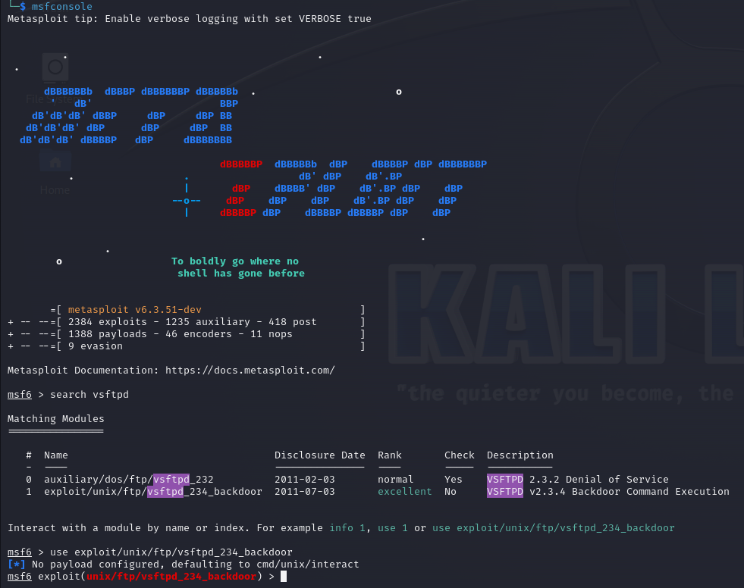
Figure 18, Metasploit begins backdoor exploit

With the exploit executed, the backdoor service successfully targets 10.0.2.8 with an open command shell session and root privileges accessed:
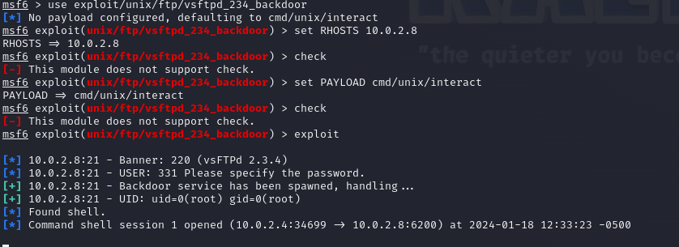
Figure 19, Metasploit payload executed against 10.0.2.8

Within the exploited session, the” uname -a” command is used to display target system information, with the “cat /etc/*-release” command revealing the Ubuntu 8.04 (Hardy Heron) distribution:
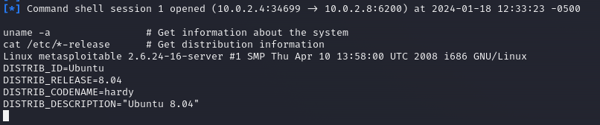
Figure 20, Target Information Displayed

The cat “/etc/passwd” command is used to list the details of user accounts. This information is potentially valuable to a threat actor trying to access within the shell session:
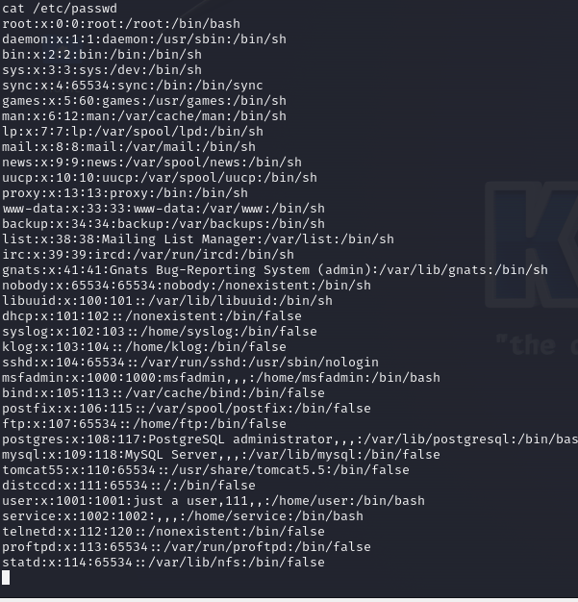
Figure 21, User Accounts List retrieved from shell session

The “cat /home/*/.ssh/id_rsa” retrieves RSA private keys from user directories, potentially allowing a user to gain unauthorised access to user accounts:
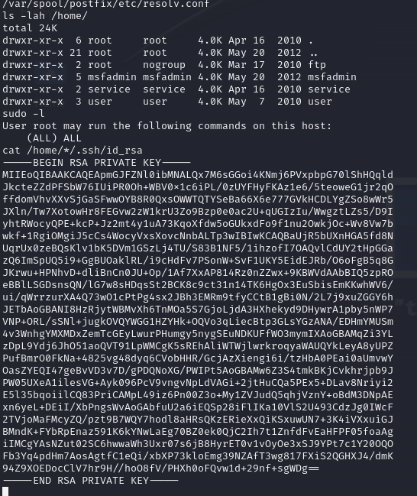
Figure 22, RSA Privat Keys Obtained from shell session

After attempting to access the mySQL service failed, resulting in the shell session becoming unresponsive. The session was closed and restarted:
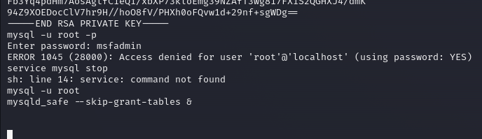
Figure 23, SQL Access failed, ending session.

CLEANUP:
In attempt to cover the tracks, the following commands were used:
- history -c && history -w - Cleared the shell command history to prevent recording of exploitation process.
- echo '' > /var/log/auth.log - Deleted the authentication log file to obscure the evidence of access.
- echo '' > /var/log/syslog - Deleted the system log file to remove traces of the activities.
- rm -rf /var/run/utmp - Cleared the temporary files directory to remove any temporary data left by the exploitation tools.
- cat /dev/null > /var/log/wtmp - Deleted the web server log to hide web access traces.
- cat /dev/null > ~/.bash_history && history -c && exit - Overwritten the bash history file to ensure command history is not recoverable and closed the backdoor session to remove active connections from the compromised system.
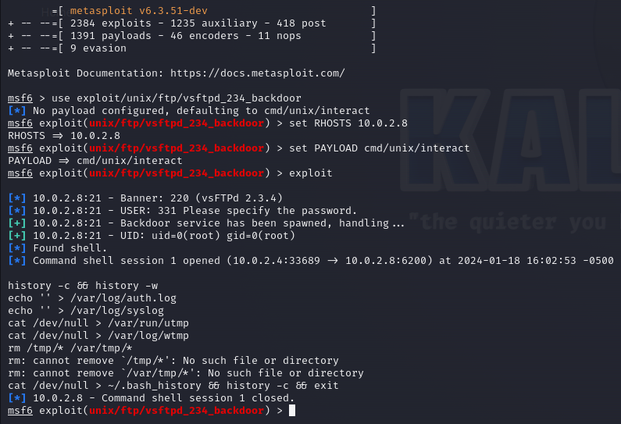
Figure 24, cleanup commands to clear tracks

BeeBox:
Based on the information established in the vulnerability assessment stage identifying basic credentials, access was gained to the phpMyAdmin using the username “admin” with no password set:
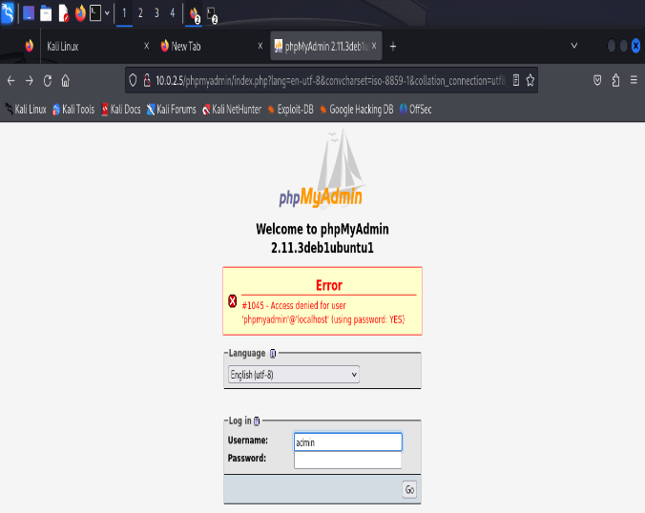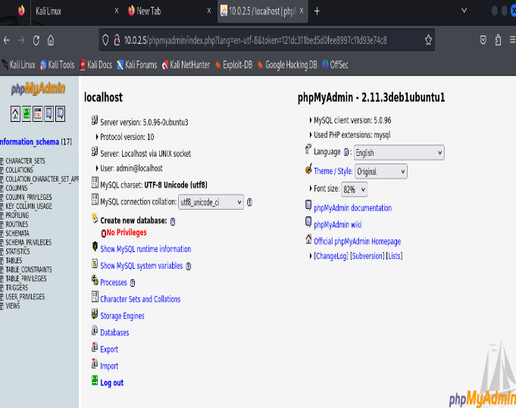
Figure 25, Default Credentials allow for PHP access

Metasploit was chosen to execute a shell session to the phpMyAdmin application. This involved setting the BeeBox IP address with the previously identified credentials, using a reverse_tcp payload from the Kali Linux IP address and port 4444. The exploit failed, with the error message “Couldn’t find token. Is URI set correctly?”
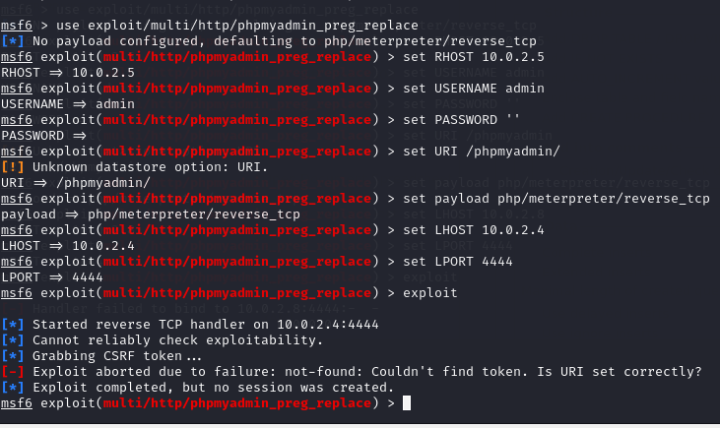
Figure 26, Metasploit reverse tcp payload requests token

With the URI re-checked, an attempt was made to acquire the token from the web page source code within the kali web browser. With the token found, the exploit was reattempted, but still unsuccessful. It is assumed that the inherent security mechanisms within the PHP environment and the target server’s configuration resulted in the failure of the exploit attempt:
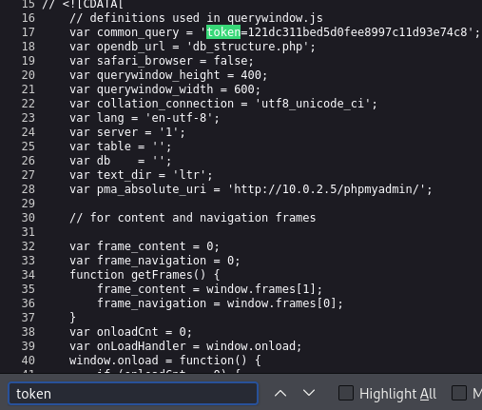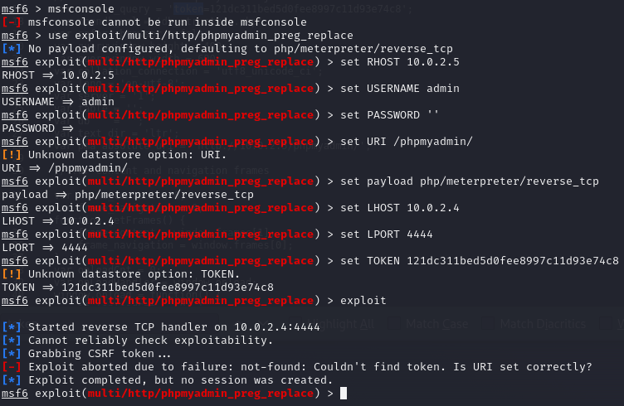
Figure 27, Token retrieved from web page source code

The focus of testing was shifted to the bWAPP web application running on BeeBox. The default credentials were entered from the Kali web browser, accessing a dropdown menu of exploits for the intentionally vulnerable application, with XSS-reflected (GET) chosen. The pop-up box displaying a message. The successful execution of the XSS attack highlights the importance of input validation to prevent malicious redirections that compromise web security:
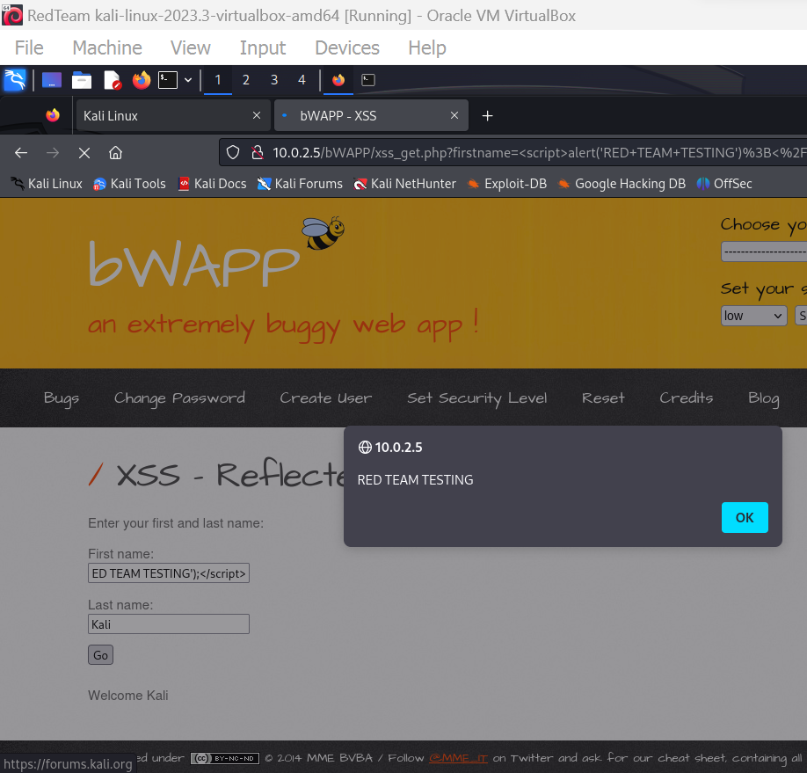
Figure 28 XSS-reflected GET request from Kali web browser

CPC Test Final Report

Testing of the CPC network is concluded with a final report to outline the key findings, recommendations and associated costs of the process.

Executive Summary

Company Details:
Name: Cureton Pharmaceutical Company (CPC)
Location: International
Industry: Pharmaceutical Technology

Test Details:
Date started: 01/01/2024 Date finished: 21/01/2024 Duration: 20 days
Network analysed: Virtual NAT Network ID: 10.0.2.0 Subnet mask: 255.255.255.0
Test status: Completed

Assessment Overview:
This test was conducted internally under white-box conditions as an authorised member of CPC Red Team security. All actions were performed in a controlled environment.
The purpose was to improve the company’s cybersecurity posture by identifying vulnerabilities through the utilisation of MITRE ATT&CK and OWASP top 10 frameworks.
The recommendations included in the Final Report section should be carefully reviewed for implementation to effectively strengthen the CPC network security posture.

Risk Summary:
The test proved the presence of vulnerabilities that compromise the network security. The risks are included but not limited to the following:
The company’s database server (Metasploitable2) was proven to have the vsftpd 2.3.4 Backdoor (CVE-2011-2523) present in its system. Root privileges were accessed via a remote shell session resulting in:
- Retrieved system information and user account details.
- Accessed RSA private keys from user directories.
- Attempted mySQL service access resulted in an unresponsive shell.
The company’s web application server was proven to have default user credentials and XSS vulnerabilities. Exploitation of these issues resulted in:
- Accessed phpMyAdmin using “admin” username with no password.
- Failed exploit attempts on phpMyAdmin with Metasploit.
- Successful execution of a Cross-Site Scripting (XSS) attack on the bWAPP web application.
See section 2.3.2 for recommended solutions.

Conclusion:
The pen-test conducted on the Metasploitable2 and BeeBox virtual machines provided critical insights into the current security posture of these systems.
The vulnerabilities discovered, especially in the BeeBox VM, underscores the relevance of the OWASP guidelines in identifying real-world web application vulnerabilities.
The exercise highlighted the need for regular security assessments to identify and mitigate vulnerabilities before they can be exploited maliciously.

Disclaimer:
This report has been created for the exclusive use of Cureton Pharmaceutical Company. Access to this document, including unauthorised copies, distribution or broadcasting of any subsequent material, is strictly prohibited.
The information in this document is representative of the findings at the time of testing and may not reflect any current changes to the network infrastructure.
Any action taken regarding the results and recommendations of the test/report are at the risk of the acting party and Cureton Pharmaceutical Company. The tester will not be held responsible for any adverse effects.

Recommended Solutions

The following recommendations are made for remediation of each vulnerability.

Database Server (Metasploitable2):
Table 4, Metasploit Remediation Table
Vulnerability | Recommendation
vsFTPd 2.3.4 Backdoor (CVE-2011-2523) | Ensure all services are updated to the latest versions to apply the latest security patches
Apache Tomcat 2.2.8- Weak Default Credentials | Implement password policies and multi-factor authentication
MySQL 5.0.51a | Upgrade to latest version
Samba 3.0.20 | Upgrade to latest version

Web application Server (BeeBox):
Table 5, BeeBox Remediation Table
Vulnerability | Recommendation
Cross-Site Scripting | Upgrade to service that Implements input validation & output encoding
SQL Injection | Upgrade to service that uses parameterised queries and validation of inputs

General security:
- Conduct regular security audits, monthly vulnerability assessments and annual penetration testing to maintain network security.
- Train staff in security practices adhering to security policies.
- Implement access-control and password policies for network systems and services, including multi-factor authentication.
- Utilise network segmentation to reduce the attack surface, limiting damage caused by any security breach.
- Backup data and enforce an incident-response plan to mitigate any security breaches.

Additional Network Infrastructure:
- UTM Firewall at the edge of the network
- WAF Firewall in front of the Web App Server
- Network access control the entry point to the internal network
The revised network architecture may look similar to the example in figure 29:

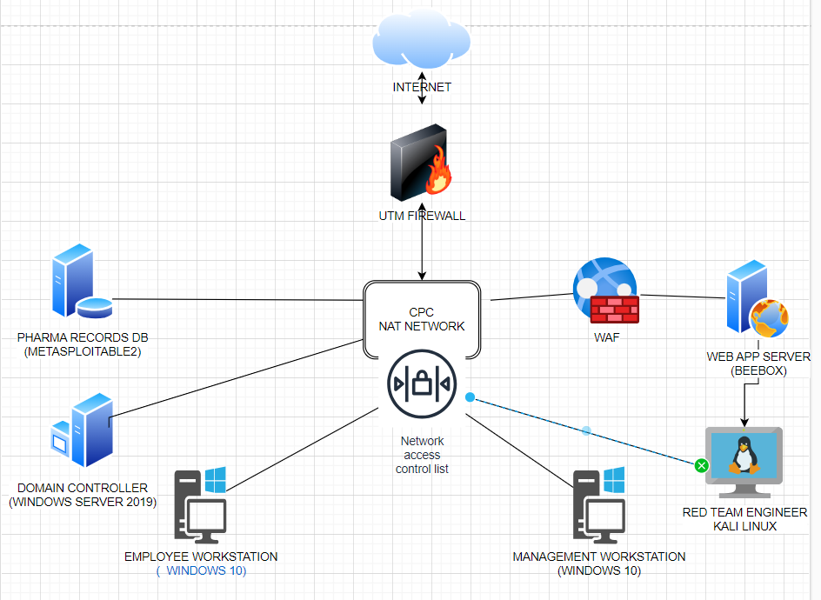

Financial Overview

An hourly rate of £100 per hour is applied to the costs of remediation. In the event of ongoing costs, this will be calculated per annum and included in the listed price.
The costs associated with remediation are listed as follows:

Table 6, Remediation Costs Table
Remediation | Expenses | Cost
System updates and reconfiguration | 30 hours labour | £3000
Changing Credentials and Implementing Password Policy | 5 hours labour | £500
Annual External Security Audit | Annual fee | £20,000
Vulnerability Assessments | £500 per month | £6000
Penetration Testing | Annual fee | £12,000
Staff Training | £100 per staff | £10,000
Network Upgrades | UTM firewall £400, WAF £400, NAC £400 | £1200
Network Segmentation Setup | 15 hours labour | £1500
Multifactor Authentication | £10 per user per month | £12,000
Incident Response Plan | One off fee | £5000
Backup Procedures | Cloud Service Fees | £10,000
Total Cost |  | £81,200

The invoice for the testing is as follows:

From: John Hughes To: Cureton Pharmaceuticals Company
IQ Campus University of Wales, 12 High Street
Swansea Waterfront, Virtual World
SA1 8EW AB12 3CD

Testing Service Breakdown: Cost
Passive reconnaissance – Investigation of VM’s £300
Active reconnaissance – Network/port mapping £400
Vulnerability assessment – Port/service identification £500
Exploitation – Pen-testing of vulnerabilities £500
Cleanup & Remediation suggestions - £200
Subtotal - £1900
Tax - £380
Total - £2280

Please make payment within 30 days of invoice date.
Payable to:
Mr J Hughes
Account no. 12345678
Sort code: 11-22-33

Contact 1708241@student.uwtsd.ac.uk
Tel. 07711223445

References

[1] ‘Royal Mail About Us’. Royal Mail. [Online]. Available: https://jobs.royalmailgroup.com/content/About-Us/?locale=en_GB
[2] L. Fairburn, ‘Royal Mail Ransomware Attack – Part 2’. [Online]. Available: https://www.pentestpeople.com/blog-posts/royal-mail-ransomware-attack-part-2
[3] ‘Royal Mail Ransomware Attack Timeline’. Cyber Management Alliance, Mar. 07, 2023. Accessed: Jan. 22, 2024. [Online]. Available: https://www.cm-alliance.com/cybersecurity-blog/royal-mail-ransomware-attack-timeline
[4] ‘How cyber-attack on Royal Mail has left firms in limbo Published 17 January 2023’. BBC, Jan. 17, 2023. [Online]. Available: https://www.bbc.co.uk/news/business-64291272
[5] ‘INTERNATIONAL DISTRIBUTIONS SERVICES plc RESULTS FOR THE HALF YEAR ENDED 24 SEPTEMBER 2023’. Royal Mail, Nov. 16, 2023. [Online]. Available: https://www.internationaldistributionsservices.com/media/12136/ids-plc-hy-2023-24-results-rns-16-11-23.pdf
[6] ‘NCSC and international partners shine a light on Lockbit ransomware threat’. NCSC, Jun. 14, 2023. [Online]. Available: https://www.ncsc.gov.uk/news/ncsc-international-partners-lockbit-ransomware-threat
[7] ‘Royal Mail tells people not to send post abroad due to “cyber incident”’. BBC, Jan. 11, 2023. [Online]. Available: https://www.bbc.co.uk/news/business-64231473
[8] N. Hare-Brown, ‘Royal Mail Ransomware Negotiation Analysis’. Storm Guidance, Mar. 31, 2023. [Online]. Available: https://www.stormguidance.com/single-post/royal-mail-ransomware-negotiation-analysis
[9] ‘Royal Mail has spent £10 million in remediation costs after LockBit cyber attack’. Nov. 17, 2023. [Online]. Available: https://www.itpro.com/security/royal-mail-has-spent-pound10-million-in-remediation-costs-after-lockbit-cyber-attack
[10] ‘IBM Security X-Force Threat Intelligence Index 2023’. IBM. [Online]. Available: https://www.ibm.com/reports/threat-intelligence
[11] M. L. Jensen, M. Dinger, R. T. Wright, and J. B. Thatcher, ‘Training to mitigate phishing attacks using mindfulness techniques’, J. Manag. Inf. Syst., vol. 34, no. 2, pp. 597–626, 2017.
[12] A. Kapoor, A. Gupta, R. Gupta, S. Tanwar, G. Sharma, and I. E. Davidson, ‘Ransomware detection, avoidance, and mitigation scheme: a review and future directions’, Sustainability, vol. 14, no. 1, p. 8, 2021.
[13] Microsoft Security Response Center, ‘Microsoft Response to Layer 7 Distributed Denial of Service (DDoS) Attacks’, Microsoft, Jun. 2023. [Online]. Available: https://msrc.microsoft.com/blog/2023/06/microsoft-response-to-layer-7-distributed-denial-of-service-ddos-attacks/
[14] ‘What is Anonymous Sudan?’ Cloudflare. [Online]. Available: https://www.cloudflare.com/en-gb/learning/ddos/glossary/anonymous-sudan/
[15] A. Lahiri, ‘Microsoft Azure Users Face Service Disruption Amid Reports Of DDoS Attack’. Benzinga, Jun. 09, 2023. [Online]. Available: https://www.benzinga.com/news/23/06/32799866/microsoft-azure-users-face-service-disruption-amid-reports-of-ddos-attack
[16] M. Parmar, ‘Outlook.com hit by outages as hacktivists claim DDoS attacks’. Bleeping Computer, Jun. 2023. [Online]. Available: https://www.bleepingcomputer.com/news/microsoft/outlookcom-hit-by-outages-as-hacktivists-claim-ddos-attacks/
[17] V. Petkauskas, ‘Anonymous Sudan: neither anonymous nor Sudanese’. Cybernews, Nov. 15, 2023. [Online]. Available: https://cybernews.com/editorial/anonymous-sudan-explained/
[18] ‘Threat Intelligence Report What Is Anonymous Sudan?’ Truesec, Feb. 20, 2023. [Online]. Available: https://downdetector.com/status/windows-azure/
[19] ‘Understanding and Responding to Distributed Denial-of-Service Attacks’. Cybersecurity and Infrastructure Security Agency, Oct. 28, 2022. [Online]. Available: https://www.cisa.gov/sites/default/files/publications/understanding-and-responding-to-ddos-attacks_508c.pdf
[20] J. tidy, ‘Lapsus$: Court finds teenagers carried out hacking spree’, BBC, Aug. 2023. [Online]. Available: https://www.bbc.co.uk/news/technology-66549159
[21] I. Garland, ‘How to jailbreak a Firestick or Amazon Fire TV (the easy way)’. Comparitech, Nov. 10, 2023. [Online]. Available: https://www.comparitech.com/tv-streaming/jailbreak-firestick-amazon-fire-tv/
[22] A. Lopez, ‘Grand Theft Hacker: A Look at The Rockstar Games and Uber Hack’, Cloud Security Alliance. [Online]. Available: https://cloudsecurityalliance.org/blog/2022/10/10/grand-theft-hacker-a-look-at-the-rockstar-games-and-uber-hack/
[23] L. Ilascu, ‘Lapsus$ hackers took SIM-swapping attacks to the next level’. Bleeping Computer, Aug. 11, 2023. [Online]. Available: https://www.bleepingcomputer.com/news/security/lapsus-hackers-took-sim-swapping-attacks-to-the-next-level/
[24] K. Macdonald, ‘Grand Theft Auto 6 leak: who hacked Rockstar and what was stolen?’, The Guardian, Sep. 2022. [Online]. Available: https://www.theguardian.com/games/2022/sep/19/grand-theft-auto-6-leak-who-hacked-rockstar-and-what-was-stolen
[25] J. tidy, ‘Lapsus$: GTA 6 hacker handed indefinite hospital order’. BBC, Dec. 21, 2023. [Online]. Available: https://www.bbc.co.uk/news/technology-67663128
[26] ‘A Message from Rockstar Games’, Sep. 19, 2022. [Online]. Available: https://twitter.com/RockstarGames/status/1571849091860029455?ref_src=twsrc%5Etfw%7Ctwcamp%5Etweetembed%7Ctwterm%5E1571849091860029455%7Ctwgr%5E34f31fc10d7ed572ceafcada23f5cc245e651c3f%7Ctwcon%5Es1_&ref_url=https%3A%2F%2Fwww.gamespot.com%2Farticles%2Fgta-6-leak-rockstar-responds-says-work-will-continue-as-planned%2F1100-6507632%2F
[27] F. Salahdine and N. Kaabouch, ‘Social engineering attacks: A survey’, Future Internet, vol. 11, no. 4, p. 89, 2019.
[28] N. Karim, H. Kanaker, W. Abdulraheem, M. Ghaith, E. Alhroob, and A. Alali, ‘Choosing the right MFA method for online systems: A comparative analysis’, Int. J. Data Netw. Sci., vol. 8, no. 1, pp. 201–212, 2024.
[29] ‘REVIEW OF THE ATTACKS ASSOCIATED WITH LAPSUS$ AND RELATED THREAT GROUPS’. Cybersecurity and Infrastructure Security Agency, Jul. 24, 2023. [Online]. Available: https://www.cisa.gov/sites/default/files/2023-08/CSRB_Lapsus%24_508c.pdf
[30] ‘ATT&CK Matrix for Enterprise’. MITRE ATT&CK. [Online]. Available: https://attack.mitre.org/
[31] ‘OWASP Top Ten’. OWASP. [Online]. Available: https://owasp.org/www-project-top-ten/
[32] ‘Metasploitable 2 Exploitability Guide’. Rapid7. [Online]. Available: https://docs.rapid7.com/metasploit/metasploitable-2-exploitability-guide/
[33] ‘Bwapp Bugs’. itsecgames. [Online]. Available: http://www.itsecgames.com/bugs.htm

