
Programme: MSc Public Health and Social Care in Practice
Module: Quality Assurance and Service Improvements
Module code: LCHS7006
Lecturer: Christopher Mafuva
Assignment Title: Component 2 Service Improvement Report
Case: The Mid Staffordshire NHS Foundation Trust
Student Name: Zakiyabanu Zakirhusen Malek
Student ID:2531983
Table of Contents
1. Introduction 3
2. Main Body 3
2.1. Analysis of the root causes of this issue 4
2.1.1 Fishbone Diagram analysis 4
2.1.2 The 5 Whys 5
2.1.3The Donabedian Model 7
2.2 Strategic planning 8
2.2.1 PESTLE analysis 8
3. Recommendation 10
4. Conclusion 13
References 15

1.Introduction (Case Study: Mid Staffordshire NHS Foundation Trust))
Quality assurance is very important in healthcare because patients depend on the hospital authority to provide safe, effective and compassionate treatment. Patient safety becomes the top priority for the hospital because it does not depend only on the skills of the doctors and nurses. It is also influenced by the staffing level, leadership, organisational culture, communication, and the availability of resources (Goodair and Reeves, 2022). But several areas challenge quality assurance because of poor care that can become a major problem rather than an isolated clinical mistake. The Mid Staffordshire NHS Foundation Trust case is one of the most important examples of healthcare quality failure in England. The serious concern is the standard of care provided by providers especially between 2005 and 2009 (Holmes, 2013). The Francis Inquiry addressed the major problems that involved inadequate staffing, poor leadership, weak governance, and failure to respond effectively, which did not give sufficient priority to patients (Goodair and Reeves, 2022). Different patients experienced problems like inadequate basic nursing care, poor hygiene and failure of communication. Component 1 identifies the chronic nursing shortages with inactive communication and weak clinical governance that discourage staff from raising concerns. The problem and the case remain highly important because the reforms that followed it shaped healthcare regulation. The Current Care Quality Commission (CQC) Fundamental Standards require sufficient numbers of competent staff, effective governance, safe treatment, and appropriate responses to complaints if something goes wrong (Goodair and Reeves, 2024). The Statutory Duty of Candour also requires health care providers to be open and transparent with patients. This report will critically analyse the root causes for poor patient care and patient safety failures at Mid Staffordshire. Fishbone analysis, the Five Whys and the Donabedian model will be used to examine the causes. Along with this, PESTLE will consider the wider strategic environment and, later on, based on PDSA, PDCA, and other aspects, will be applied to develop practical recommendations for sustainable quality improvement.

2. Main Body

2.1. Analysis of the root causes of this issue
The root cause analysis will analyse the poor care at Mid Staffordshire, which cannot reasonably be explained by only one mistake or one professional group. The Francis Inquiry shows that problems were connected through leadership, staffing, governance, organisational culture and operational processes (Holmes, 2013). The root cause analysis will help in understanding the useful discussion by simply asking how the mistake was made and what conditions allowed these failures to continue.

2.1.1 Fishbone Diagram analysis
The fishbone diagram helps in understanding how different aspects are organised in different causes of a quality problem. It also reflects that several weaknesses may contribute to the same outcome. Mid Staffordshire's main outcome is poor patient care and patient safety failures.
People - This is one of the main problems, which was insufficient staffing combined with weakness in leadership. Training and staff support with a low staffing ratio increased the pressure on the existing employees and reduced the time available for patient care (Nwosu, 2024). This remains important in modern healthcare because NHS England explains the evidence-based decision about safety and effective staffing. It also explains the requirements for every organisation (Mannion, 2024). Safe staffing is not simply an HR issue, but it is directly connected with quality control and higher authority.
Resources - The financial pressure affected the workforce and service decisions in the organisation. The trust places considerable importance on financial performance for attaining the foundation trust status (Nwosu, 2024). Financial control is necessary in every publicly funded organisation, but the experience of Mid Staffordshire demonstrates the danger of disconnected financial priorities (Mannion, 2024). Cost reduction becomes more harmful when staffing resources fall back to the level required to deliver safe care.
Methods and Processes - This category identifies the weak point in the incident, complaint management, communication and risk escalation. The warning signals were available, but the information was not constantly converted into improvement (Lord, 2024). This can be seen where complaints should provide organisations with information about the weaknesses in care. This could be done by simply being treated as an administrative problem. The current CQC standard requires providers to investigate the complaint properly and take necessary actions when problems are addressed (Lord, 2024).
Governance - This is a major cause as the senior leaders and the board did not maintain a sufficiently accurate and proper understanding of the experiences of patients. On the other hand, performance information could create a lasting impression of organisational control while serious weaknesses continued in everyday care (Sakdiyah et al., 2022). This analysis demonstrates how unsafe care can result in more interacting causes and problems. It mainly categorises each problem into a specific process.
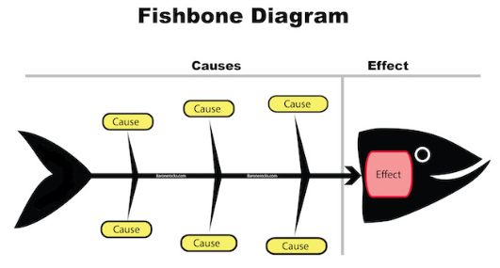
Figure 1: Fishbone Analysis
(Source: GLSS, 2026)

2.1.2 The 5 Whys
The 5 Whys analysis is a simple problem-solving tool that help and individual to find the core problem of an issue. This is also known as a part of the root cause analysis (Setiawan et al., 2024). In the case of Mid Staffordshire, the question begins with a core question: "Why did patients receive poor and unsafe care?" This analysis reflects that the deepest problem and the core issue was not simply of too few nurses. But it was very evident that staffing had a visible cause underneath it: different leadership decisions and weak accountability (Setiawan et al., 2024).
5 Whys | Analysis
Why 1 | Because the patients did not always receive timely, safe and compassionate care.
Why 2 | Because the front-line services had to face staffing pressures, with communication problems and inadequate monitoring of care.
Why 3 | The workforce planning with clinical governance had complaint handling problems. Also, the escalation systems were not strong enough to address and build solutions for the problems quickly.
Why 4 | The organisational leadership placed excessive attention on financial and corporate priorities. This led to a fall in patient and frontline staff attention (Setiawan et al., 2024).
Why 5 | The organisational culture and governance system did not consistently meet the standards of patient care, with transparency and learning at the centre of decision-making.
Table 1: 5 Whys Analysis
(Source: Self-developed)

2.1.3The Donabedian Model
The Donabedian model evaluates healthcare quality through three aspects: structure, process, and outcome. This model also provides another way of understanding the Mid Staffordshire case.
Structure - Structure refers to the conditions and situations within the healthcare sector that have been provided (Kumah et al., 2024). At Mid Staffordshire included staffing shortages, resource limitations, and weak leadership and governance arrangements. All these issues led to the structural weakness that created an environment in which consistent safe care became difficult (McCullough et al., 2023). The current CQC standard requires providers to have enough suitable and qualified component staff to provide stronger support and supervision.
Process - Process is concerned with what actually happens during the care procedure. The problems at the organisation included a lack of communication, poor handling of complaints and an inadequate number of nurses. This led to the failure to carry out effective solutions to the warning signals (McCullough et al., 2023). Poor structures influenced the poor processor like the inadequate staffing increased were cloud and resulted in frequent burnout of the existing employees. While effective leadership reduced the organisation's ability to recognise the core problem, it accelerated the negative reactions of the patient and reduced satisfaction.
Outcome - From the above two processes, the outcome refers to the results experienced by the patients and the organisation (Ghofrani et al., 2024). In this case, the included and acceptable patient suffering, avoidable harm, vah patient experience and a serious loss of public confidence were the main outcomes. This model particularly helped in evaluating the logical relationship between structures, processes, and outcomes (Ghofrani et al., 2024).
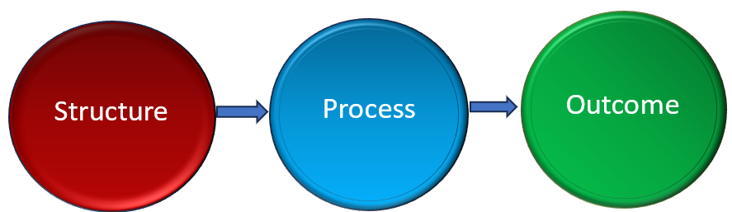
Figure 2: Donabedian Model
(Source: Self-developed)

2.2 Strategic planning

2.2.1 PESTLE analysis
Political Factor: The NHS organisation faces strong political and public expectations concerning patient safety. This also includes transparency and accountability towards the patient and their care (Taylor et al., 2022). The Mid Staffordshire scandal increased the pressure for stronger regulatory compliance and deeper analysis. According to Kendir et al., (2023) greater patient involvement with patient safety became not only a clinical matter but also an important policy concern. This reflects that the NHS organisation has developed new regulations and is trying to improve the services in the healthcare sector (Eljiz et al., 2025). The scandal of neglected patient care not only harmed the reputation of Mid Staffordshire but also damaged a network of authorities as well.
Economic Factor: From the economic perspective, NHS providers must work within financial limits. While facing rising demand and workforce pressure, the case shows that financial sustainability is important (Eljiz et al., 2025). In this manner, savings should not be achieved by reducing safe staffing or essential care. Safe staffing decisions should consider patient need and clinical rather than cost alone. The financial pressure and the scandal together made the case worse to handle (Ilesanmi et al., 2025). It not only impacted the working culture and the goodwill of the hospital but also impacted Mid Staffordshire economically.
Social Factor: Patients increasingly expect dignity, proper care, involvement and openness. Public trust can fall rapidly when organisations appear to ignore complaints. Healthcare providers always remain at the forefront in dealing with patient care and hygiene (Ilesanmi et al., 2025). Failure in handling patient concerns and complaints can become a major drawback for any organisation in question (Martin et al., 2021). The healthcare providers must therefore listen to patients, families and employees and then use their experiences as evidence for improvement (Naci et al., 2025). This will eventually help in the improvement of the services and nursing staff, and also provide a basis for patient satisfaction.
Technological Factor: The digital incident reporting systems, electronic patient records and real-time dashboards also provide several opportunities to detect emerging risks beforehand (Naci et al., 2025). NHS England reported that around 3 million patient safety incident reports in the year 2024 to 2025 showed the scale of information available for organisational learning. It also proves that technology is useful only when managers examine the data and act on warning signals. Using technology for improvement and resolving complaints can become a better approach in handling the organisation's problems (McCullough et al., 2023).
Legal Factor: Healthcare providers now operate under stronger requirements of safe care, staffing, governance and transparency. Regulation 20 of the Health and Social Care Act 2008, and regulations 2014, establish the Statutory Duty of Candour (Quick, 2022). This proves that providers must be open with patients when a notifiable safety incident occurs. It also throws a light on the fact that support, proper care, and services are necessary in handling and improving healthcare services.
Environmental Factor: Hospital quality is also impacted by the physical care environment. A quality service provided to the patient will automatically enhance the environment of the hospital structure (Care Quality Commission, 2025). Whereas neglected behaviour and too much Chaos can give rise to a resentful feeling in the patients, resulting in dissatisfaction. Clean wards, safe equipment, infection prevention and suitable facilities are basic parts of patient care (GOV.UK, 2024). Current CQC fundamental standards mention that premises and equipment are to be clean, suitable and properly maintained.
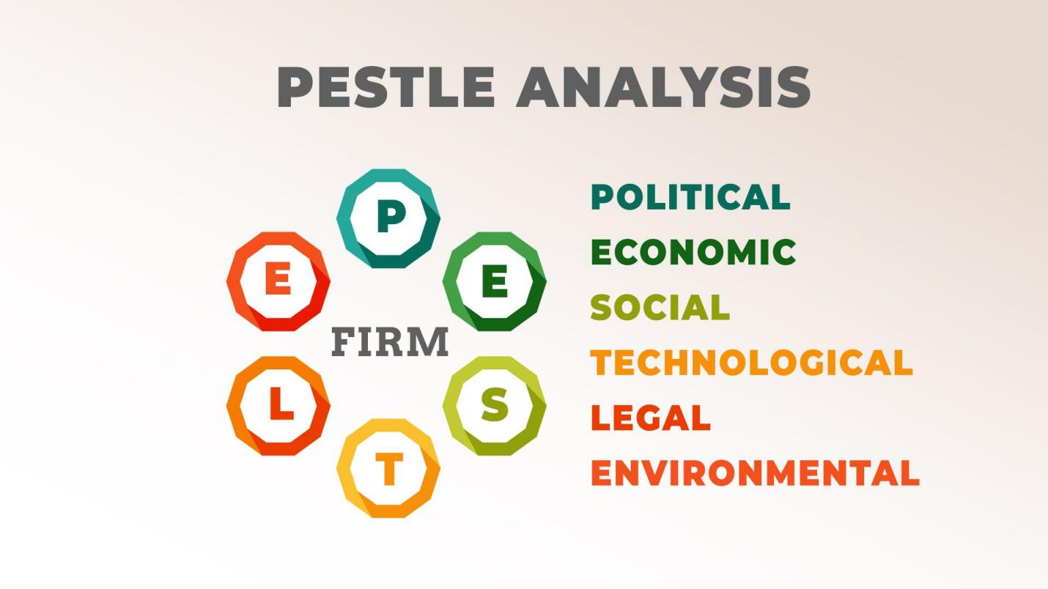
Figure 3:PESTLE factors
Source: (Eljiz et al., 2025)

3. Recommendation
The root cause analysis suggests that the improvement should focus more on safe staffing, stronger governance, open communication, effective incident learning, and continuous monitoring. There should be no single improvement tool that will eventually prove faulty. So a combined approach using PDSA, Lean and Six Sigma frameworks should be applied for improvement. The results indicate that the shortcomings at the Mid Staffordshire NHS Foundation Trust were primarily attributable to the system, therefore necessitating organisation-wide quality initiatives.
Recommendation 1: Firstly, the Trust needs to improve leadership and governance through the Six Sigma approach. The DMAIC strategy of Six Sigma will assist managers in discovering root causes of safety failure, minimizing variations in the process, monitoring key indicators of performance, and improving accountability, which will result in more reliable patient care (Nagadi, 2022).
Recommendation 2: Secondly, it is necessary to enhance employee development through the PDSA cycle. Regular training of employees, skill evaluation, team-based learning, and feedback from clients will help the company to test the changes made and guarantee that its personnel have required degree of competence, thus making sure that an organization can get process-oriented improvements (Bugnitz and Sandberg, 2025).
Recommendation 3: Finally, the company should implement lean principles because their application will lead to a positive patient safety culture, which will be achieved by waste elimination, clinical process standardization, better communication, and improving front-line employees’ participation in improvement activities (Sallam, 2024).
Implementation through PDSA (Plan-Do-Study-Act)
The first recommendation is to introduce ward-level PDSA cycles focused on safe staffing and patient experience. The PDSA explains the plan, do, study and act procedure or cycle that is focused more on developing an organisation's improvement process. This framework helps in understanding how a solution can be planned, then executed (Bugnitz and Sandberg, 2025). Further evaluation is done on the result, and then final steps or decisions can be taken.
Plan: The trust should address different wards with high incident rates. This also includes staffing gaps, patient complaints, delayed care or poor patient feedback (Adams et al., 2018). The baseline measures should include nurse staffing levels, falls, medication incidents, complaints, and patient satisfaction. Proper planning should be done in order to achieve desired results (Bugnitz and Sandberg, 2025). This can be done by focusing on a 360-degree approach, including every minor problem to be addressed.
Do: The improvement should initially be examined in a small number of wards. Actions and activities should include proper staffing arrangements, a safer environment, daily safety measures, and improved clinical handovers (Abuzied et al., 2023). The do procedure is more critical because, after planning, the execution begins for the outcome to be analysed.
Study: After the planning and execution are done, the results should be compared with the baseline data. Staff and patient feedback should also be evaluated because the numerical improvement alone may hide the continuing problems (Abuzied et al., 2023). This process will help in understanding the outcome and analysing the results on the basis of the plan. It will not only improve poor patient care problems, but will also take accountability for how other problems should be resolved with proper measures and action (Barr and Brannan, 2024).
Act: Successful interventions of the plan and outcomes should be adapted and introduced across the departments. If in an intervention phase, it should be revised rather than simply continued (Barr and Brannan, 2024). Acting upon the positive outcome and building new solutions can help the organisation in leveraging the services and patient care.
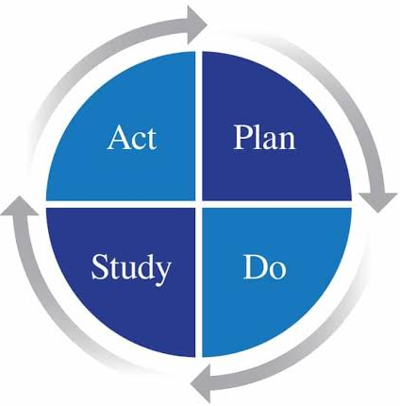
Figure 4: PDSA (Plan-Do-Study-Act)
Source: (Bugnitz and Sandberg, 2025)
Implementation through Lean and Six Sigma
The Lean framework should be applied to eliminate pointless activities or actions that cause delays in patient care. In this case, process mapping can help, as it looks at clinical handover, drug delivery, patient admission and discharge. Process mapping not only evaluates all the activities but also addresses the problems arising in each of the activities. Redesigning steps that offer little clinical value but cause delays is necessary (Sallam, 2024). This can be understood critically, as lean should not be understood as nearly cutting expenses or personnel. The goal of this framework is to minimise waste while maintaining patient safety and value in the healthcare sector (Jasti et al., 2020). By reducing variation and recurring errors in Six Sigma, it can enhance the lean framework. Recurring issues like medication errors, neglected patient care, delayed escalation, and patient falls could be recognised using the DMAIC stages (Nagadi, 2022). According to Al-Rifai (2024), the DMAIC stages involve: define, measure, analyse, improve and control. Mid Staffordshire can first identify the issue, then quantify its occurrences, pinpoint contributing elements, and then implement the proper solutions for the problems.
Therefore, both inefficient processes and quality variation can be addressed by a combined Lean Six Sigma approach (Nagadi, 2022). This approach will help in suggesting the relative solutions to the organisational culture. Employees should be free to provide and voice their concerns without fear of humiliation. This is especially important because one of the main weaknesses found in the organisation was the separation of employee concerns (Barr and Brannan, 2024). NHS organisations must develop speaking channels so that they can hear out the core problems from the employees and pay more attention towards it. This will help them investigate the complaint as part of improvement in the healthcare sector (Shamim and Ruddro, 2023). The healthcare organisation can also be more directly responsible for implementing efficient arrangements for the betterment of the hospital and its services (Barr and Brannan, 2024). This will help in enhancing the quality of governance, which will include patient and family perspectives through the application of the lean framework and 6 sigma rule. Mid Staffordshire's problems can be addressed effectively and can be worked upon.

4. Conclusion
The Mid Staffordshire case reflects that serious failures in healthcare quality rarely result from one problem. The fishbone analysis addressed the weaknesses in the staffing, resources, processes and governance. This provides a clear outlook on why and how the problems are arising. The 5 whys model showed that a deeper problem existed in organisational priorities. The Donabedian model enables understanding how weak structures contribute to poorer care processes. Ultimately, it impacts the working environment in the healthcare sector and patient outcomes. The PESTLE analysis examines the regulation, finances, social and technological areas for the expectations to be considered. Further sustainable improvement requires more than increasing staff numbers or reducing new policies. This has been done and understood by implementing the PDSA, lean framework, and 6 sigma rule. It helped in understanding the continuous learning and accountability the organisation needs to address. While lean and Six Sigma can reduce the existing inefficient processes and variation in care, implementing proper approaches and Solutions can also help in improving the outcomes. The main lesson from the organisation is that financial and organisational performance should never be separated from the fundamental responsibility to provide safe and dignified patient-centred care.

References
Abuzied, Y., Alshammary, S.A., Alhalahlah, T. and Somduth, S., 2023. Using FOCUS-PDSA quality improvement methodology model in healthcare: process and outcomes. Global Journal on Quality and Safety in Healthcare, 6(2), pp.70-72.
Adams, M., Maben, J. and Robert, G., 2018. ‘It’s sometimes hard to tell what patients are playing at’: How healthcare professionals make sense of why patients and families complain about care. Health, 22(6), pp.603-623.
Al-Rifai, M.H., 2024. Lean Six Sigma: A DMAIC roadmap and tools for successful improvements implementation. CRC Press.
Barr, E. and Brannan, G.D., 2024. Quality improvement methods (lean, pdsa, six sigma). In StatPearls [Internet]. StatPearls Publishing.
Bugnitz, C. and Sandberg, K.C., 2025. Creating effective PDSA cycles. Current problems in pediatric and adolescent health care, p.101759.
Care Quality Commission, 2025. Regulations for service providers and managers. Available at: https://www.cqc.org.uk/guidance-regulation/providers/regulations-service-providers-and-managers/health-social-care-act/regulation-20 [Accessed on: 05.08.2026]
Eljiz, K., Derrett, A. and Greenfield, D., 2025. Key lessons for excellent healthcare leadership—a systems lens to drive safe, quality outcomes. International Journal for Quality in Health Care, 37(2), p.mzaf035.
Ghofrani, M., Valizadeh, L., Zamanzadeh, V., Ghahramanian, A., Janati, A. and Taleghani, F., 2024. Adapting the Donabedian model in undergraduate nursing education: a modified Delphi study. BMC Medical Education, 24(1), p.202.
GLSS, (2026). Fishbone Diagram. Available at: https://goleansixsigma.com/cause-and-effect-diagram/?srsltid=AfmBOoqdJppXXp74W5rPSiHTwXd1DwAksHW9hPoxguJu-B9YwXiiHagS [Accessed on: 05.08.2026]
Goodair, B. and Reeves, A., 2022. Outsourcing health-care services to the private sector and treatable mortality rates in England, 2013–20: an observational study of NHS privatisation. The Lancet Public Health, 7(7), pp.e638-e646.
Goodair, B. and Reeves, A., 2024. The effect of health-care privatisation on the quality of care. The Lancet Public Health, 9(3), pp.e199-e206.
GOV.UK (2024). Duty of candour review. Available at: https://www.gov.uk/government/calls-for-evidence/duty-of-candour-review/duty-of-candour-review [Accessed on: 05.08.2026]
Holmes, D. (2013). Mid Staffordshire Scandal Highlights NHS Cultural Crisis. The Lancet, [online] 381(9866), pp.521–522. doi:10.1016/s0140-6736(13)60264-0.
Ilesanmi, D., Lim, P.Y. and Mahmud, A., 2025. A Conceptual Review of Strategic Management Frameworks for Enhancing Hospital Performance. International Journal of Public Health & Clinical Sciences (IJPHCS), 12(5), p.1.
Jasti, N.V.K., Kota, S. and Kale, S.R., 2020. Development of a framework for lean enterprise. Measuring Business Excellence, 24(4), pp.431-459.
Kendir, C., Fujisawa, R., Fernandes, Ó.B., de Bienassis, K. and Klazinga, N., 2023. Patient engagement for patient safety: The why, what, and how of patient engagement for improving patient safety. OECD Health Working Papers.
Kumah, A., Nwogu, C.N., Issah, A.R., Obot, E., Kanamitie, D.T., Sifa, J.S. and Aidoo, L.A., 2024. Cause-and-effect (fishbone) diagram: a tool for generating and organising quality improvement ideas. Global journal on quality and safety in healthcare, 7(2), pp.85-87.
Lord, M., 2024. “Nipping crime in the bud”: local magistracy and the criminalisation of juveniles in Staffordshire and Shropshire c. 1810-c1860 (Doctoral dissertation, University of Birmingham).
Mannion, R., 2024. A statutory public inquiry is not always the most effective vehicle for learning lessons in the NHS. BMJ, 386.
Martin, G.P., Chew, S. and Dixon-Woods, M., 2021. Why do systems for responding to concerns and complaints so often fail patients, families and healthcare staff? A qualitative study. Social Science & Medicine, 287, p.114375.
McCullough, K., Andrew, L., Genoni, A., Dunham, M., Whitehead, L. and Porock, D., 2023. An examination of primary health care nursing service evaluation using the Donabedian model: A systematic review. Research in Nursing & Health, 46(1), pp.159-176.
Naci, H., Murphy, P., Woods, B., Lomas, J., Wei, J. and Papanicolas, I., 2025. Population-health impact of new drugs recommended by the National Institute for Health and Care Excellence in England during 2000–20: a retrospective analysis. The Lancet, 405(10472), pp.50-60
Nagadi, K., 2022. Implementation of green, lean and six sigma operations for sustainable manufacturing. A Review. International Journal of Production Management and Engineering, 10(2), pp.159-171.
Nwosu, N.T., 2024. Reducing operational costs in healthcare through advanced BI tools and data integration. World Journal of Advanced Research and Reviews, 22(3), pp.1144-1156.
Quick, O., 2022. Duties of candour in healthcare: the truth, the whole truth, and nothing but the truth?. Medical Law Review, 30(2), pp.324-347. Available at: https://pmc.ncbi.nlm.nih.gov/articles/PMC9155592/ [Accessed on: 05.08.2026]
Sakdiyah, S.H., Eltivia, N. and Afandi, A., 2022. Root cause analysis using fishbone diagram: company management decision making. Journal of Applied Business, Taxation and Economics Research, 1(6), pp.566-576.
Sallam, M., 2024. Enhancing hospital pharmacy operations through lean and six sigma strategies: a systematic review. Cureus, 16(3).
Setiawan, E., Sulungbudi, M. and Fitriani, K., 2024. Identifying Project Delays in the Engineering Division of a Manufacturing Company: Using the Fishbone Diagram and Root Cause Approach. Jurnal Logistik Indonesia, 8(2), pp.148-161.
Shamim, M.M.R. and Ruddro, R.A., 2023. Applying Lean and Six Sigma in the maintenance of medical imaging equipment manufacturing lines. Review of Applied Science and Technology, 2(04), pp.25-53.
Taylor, V., Scott, H. and Walter, M., 2022. Organisation and management of health and healthcare. In Health studies: An introduction (pp. 323-364). Singapore: Springer Singapore.

