Shannon wallace
1901768
Network operating systems and services-1

Contents
Introduction 2
Installing and setting up servers and clients 3
Installation 3
Setting up network 6
Server 1 6
Client 1 9
Server 2 10
Client 2 13
Firewall 14
Pinging 15
Client 1 and server 1 15
Client 2 and server 2 15
Observational 16

List of figures
Figure 1: screenshot of creating virtual hard disk 4
Figure 2:Screenshot of memory size 5
Figure 3: Screenshot shows client 2 with 20gb 5
Figure 4: screenshot of windows 10 64 bit for client 2 6
Figure 5:screenshot of the server windows 2019(64-bit) 6
Figure 6: screenshot of windows server 2019 7
Figure 7: Selecting windows server 2019 7
Figure 8: Server 1 7
Figure 9: Installation of windows 8
Figure 10:screenshot of client 2 8
Figure 11: screenshot of windows 10 installation on client 2 8
Figure 12: Windows 10 9
Figure 13: Screenshot of client 1 network settings 10
Figure 14: screenshot of ip configuration in Windows 12
Figure 15: Screenshot of servers and clients 13
Figure 16: screen of network settings on server 1 13
Figure 17: screenshot of publicnet 14
Figure 18: screenshot shows extended features are ticked 14
Figure 19: screenshot shows IP addressing 15
Figure 20: Screenshot shows network settings for server 1 - adapter 15
Figure 21: Screenshot of PrivateNet and PublicNet 16
Figure 22: screenshot shows IPV4 properties - ip configuration 16
Figure 23: screenshot of client 2 adapter 1 configurations 17
Figure 24: Screenshot of windows IPV4 configuration for privatenet 17
Figure 25: Screenshot of Network settings on server2 18
Figure 26: screenshot of adapter 2 for server2 18
Figure 27: screenshot of IP configuration for publicnet 19
Figure 28: screenshot of IPV4 configuration - privatenet 19
Figure 29: Screenshot of server 1 and server 2 firewall 20
Figure 30: Client 1 and client 2 firewall 20
Figure 31: Pinging from client 1 to server 1 21
Figure 32: screenshot of pinging. client 2 and server 2 22
Figure 33: example of pinging 26

Introduction
This report provides screenshots on how to set up a Virtual Machine (VM) and provides information about setting up a VM. It has practical work. It provides a brief overview of installation, setting up servers and clients, setting up a network, disabling firewall, and involves pinging the clients and servers.

Installing and setting up servers and clients

Installation
When creating the servers and clients. The server and clients need a file location for somewhere for the VMs to be placed. The virtual machines servers have windows server 2019(64 bit). While the clients VMs have windows 10 (64 bit). The servers had 25gb as figure 1 shows and the clients have 20gb.

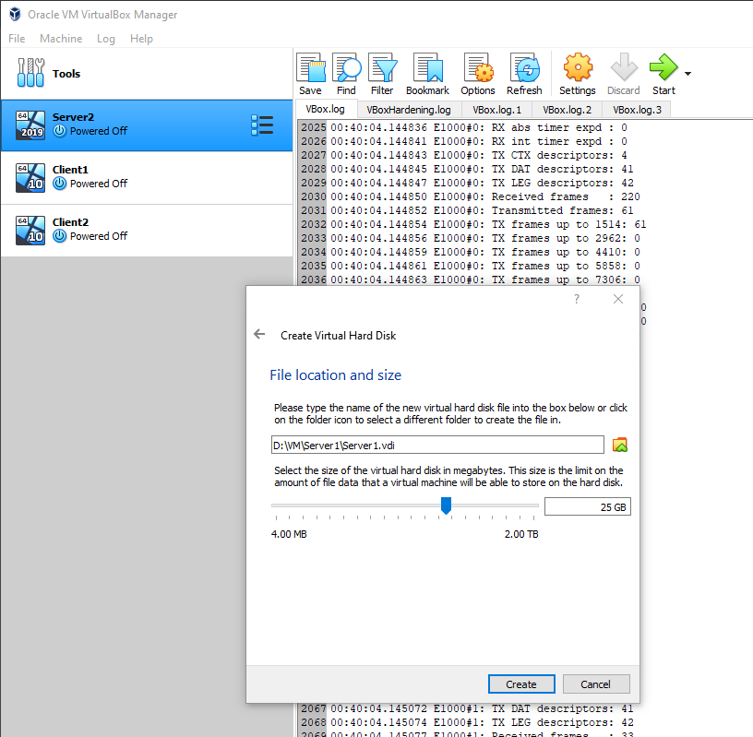
Figure 1: screenshot of creating virtual hard disk

Figure 2 shows the memory size for the virtual machines. All the servers and client all have 4096MB memory size.
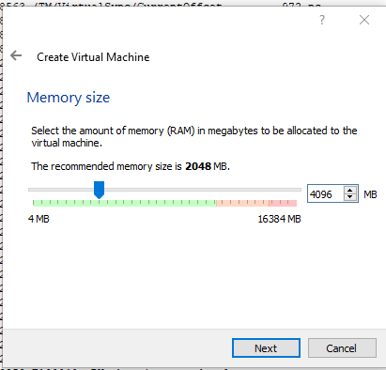
Figure 2:Screenshot of memory size
Figure 3 shows client 2 with 20gb. This was repeated for client 1.
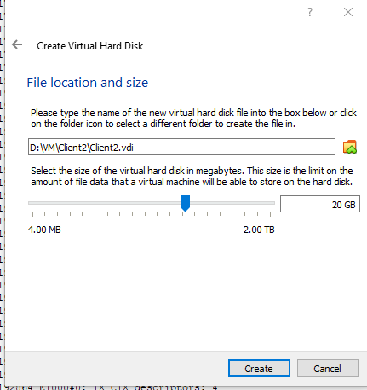
Figure 3: Screenshot shows client 2 with 20gb

Figure 4 shows that client 2 will have windows 10(64bit). This was the same for client 1.
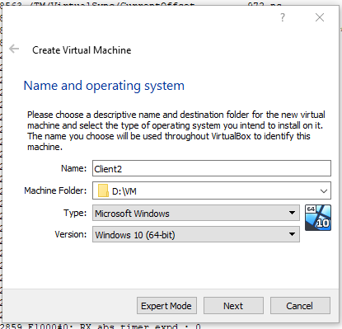
Figure 4: screenshot of windows 10 64 bit for client 2
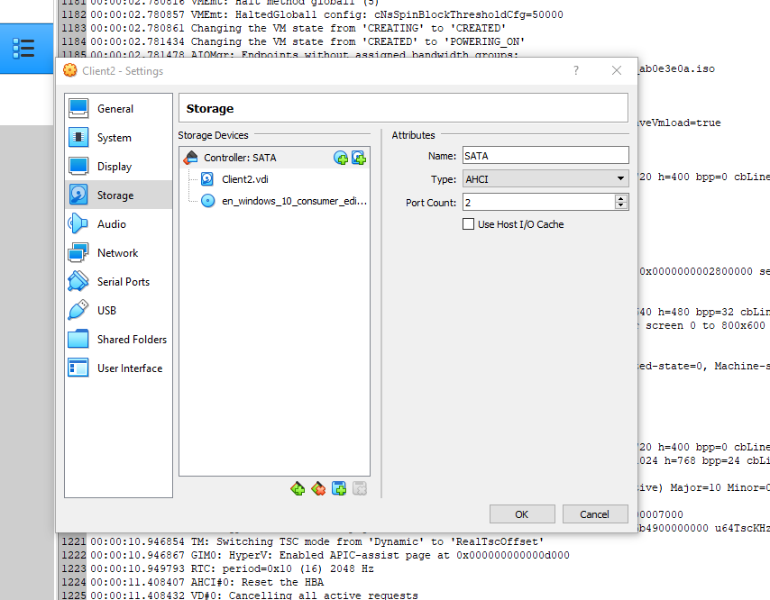
Figure 5 shows creating the server with windows version 2019(64 bit). This was the same for server 2.
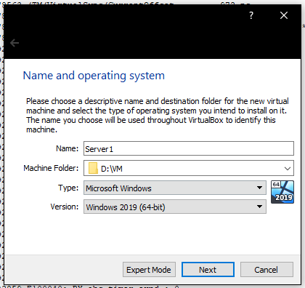
Figure 5:screenshot of the server windows 2019(64-bit)

When creating the servers and client. The servers and clients used VDI which stands for virtual disk installation. The figure 6 shows the windows server 2019 installed on the PC.
The servers were windows server 2019, and then the clients were windows 10. The process for server 2 was repeated for server 1, and then the process for client 2 was repeated for client 1
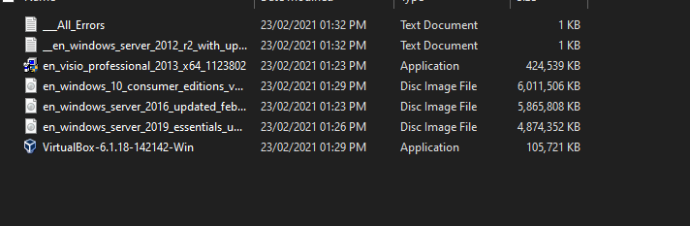
Figure 6: screenshot of windows server 2019
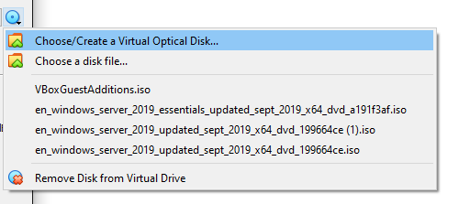
Figure 7: Selecting windows server 2019
The figure 8 shows the installation of windows on server1. Installed windows to server 2, and the clients.
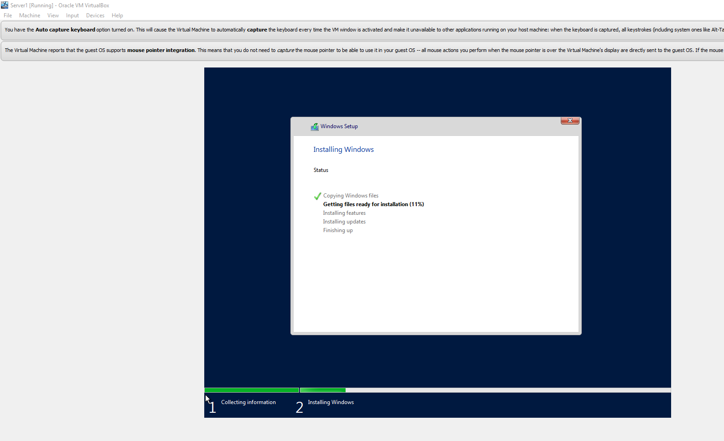
Figure 8: Server 1

Figure 9 shows the full screen of the installation
Figure 9: Installation of windows
The figure 10 shows client 2
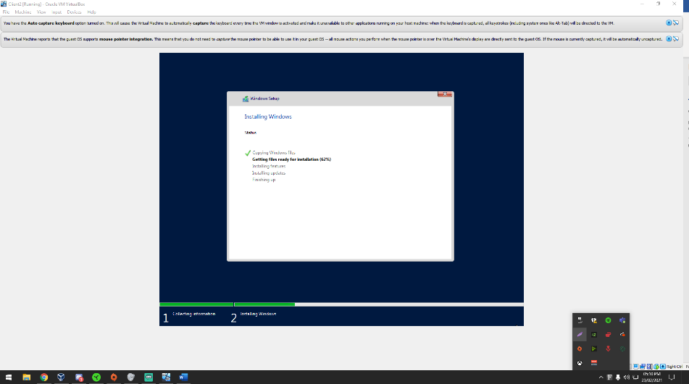
Figure 10:screenshot of client 2

figure 11 shows the installation of client 2.
Figure 11: screenshot of windows 10 installation on client 2

The figure 12 shows the full screen of windows 10 on client 2
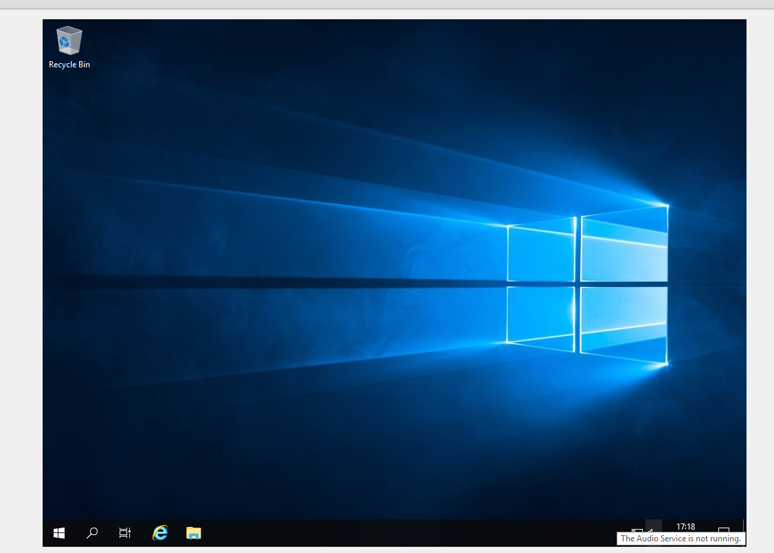
Figure 12: Windows 10

Setting up network

Client 1
Client 1 –
Private NET IP: 192.168.100.1
Client 1 – set up on the private network.
Figure 13 show the settings and then the configuration of the IP address.
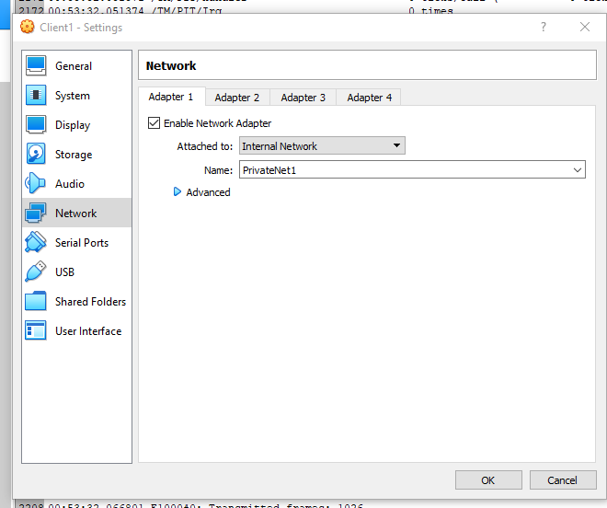
Figure 13: Screenshot of client 1 network settings
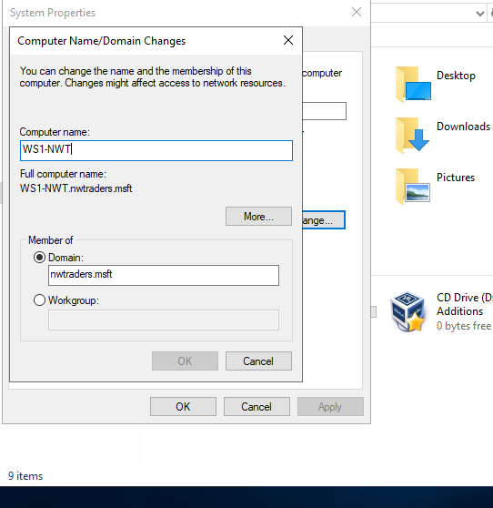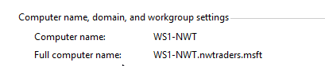
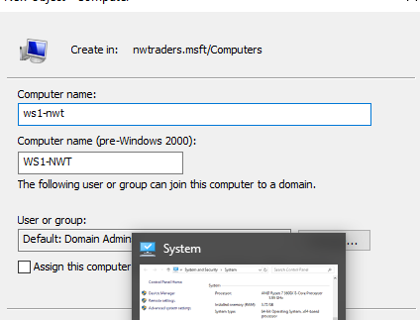

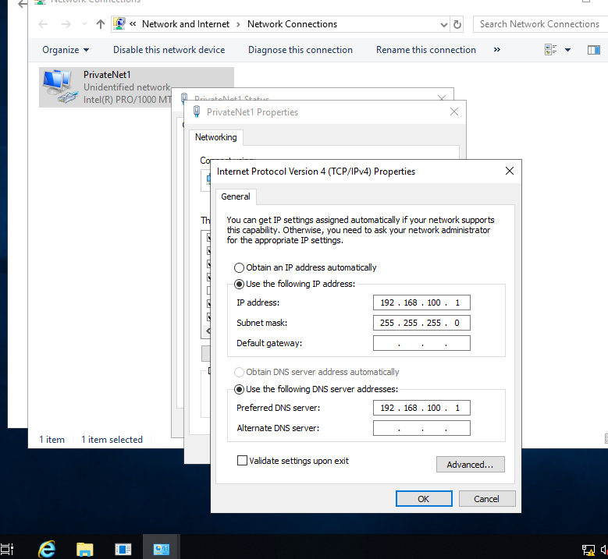
Figure 14: screenshot of ip configuration in Windows

Server 1
Server 1 –
Public Net IP: 192.168.1.100
Private Net IP: 192.168.100.1
Figure 15 shows the servers, and the clients all set up.
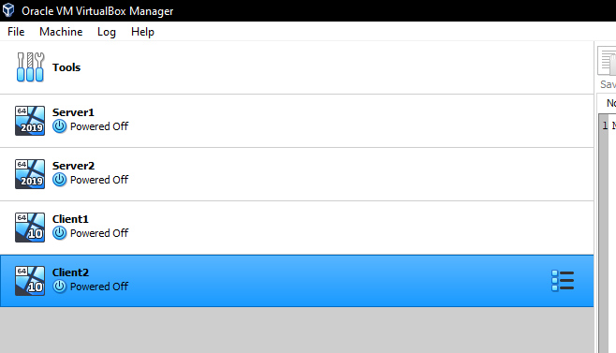
Figure 15: Screenshot of servers and clients
After installation. The servers are going to be configured. To be able to setup a network server. There are settings that need to be changed to be able to set it up. Figure 16 shows the settings for server 1 network settings - adapter 1 Network. This was changed.
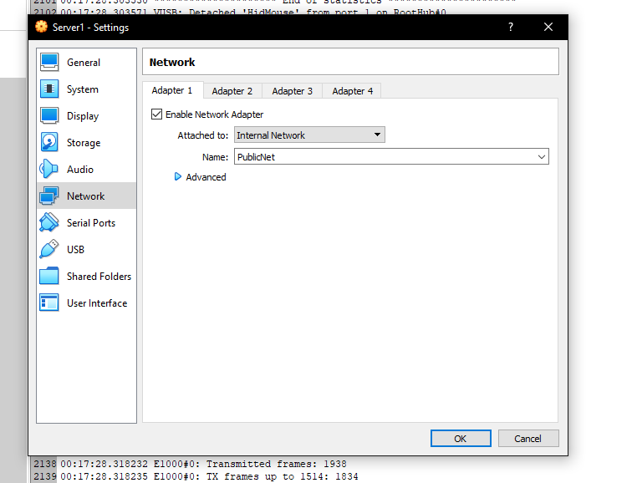
Figure 16: screen of network settings on server 1

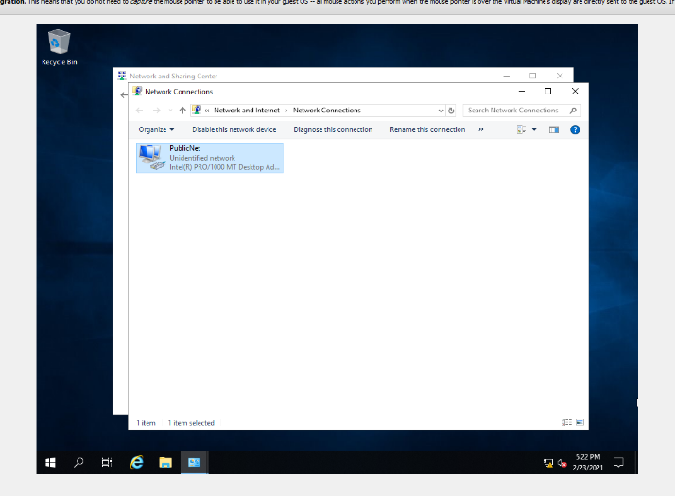
Figure 17: screenshot of publicnet

The clients and servers – had to tick enable PAE/NX and enable nested VT-X/AMD-V
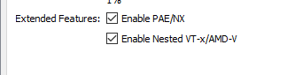
Figure 18: screenshot shows extended features are ticked

After setting up the configuration for the server. It was time to change the IP of the network. This was for Server 1.
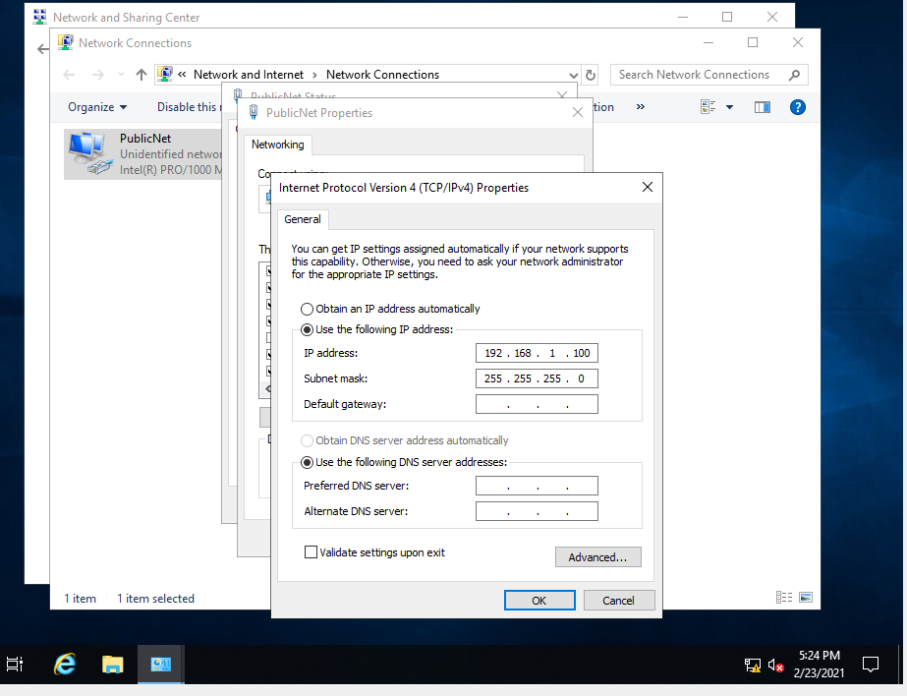
Figure 19: screenshot shows IP addressing

Settings – Server 1 network adapter 2-
Creating a private network. Figure 20 shows that.
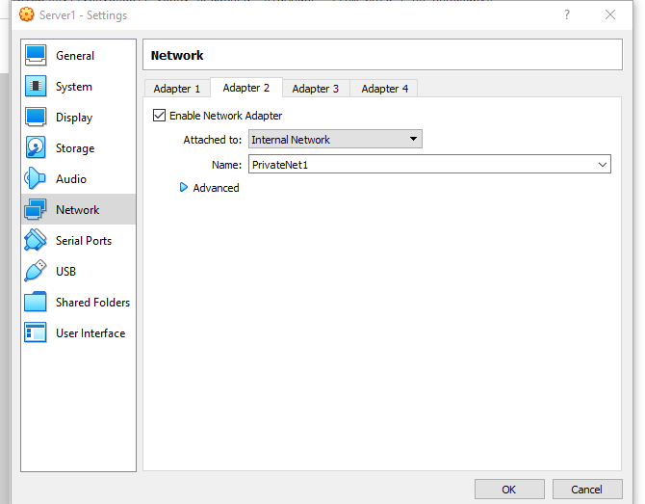
Figure 20: Screenshot shows network settings for server 1 - adapter
Figure 21 shows both of the network that were just created.
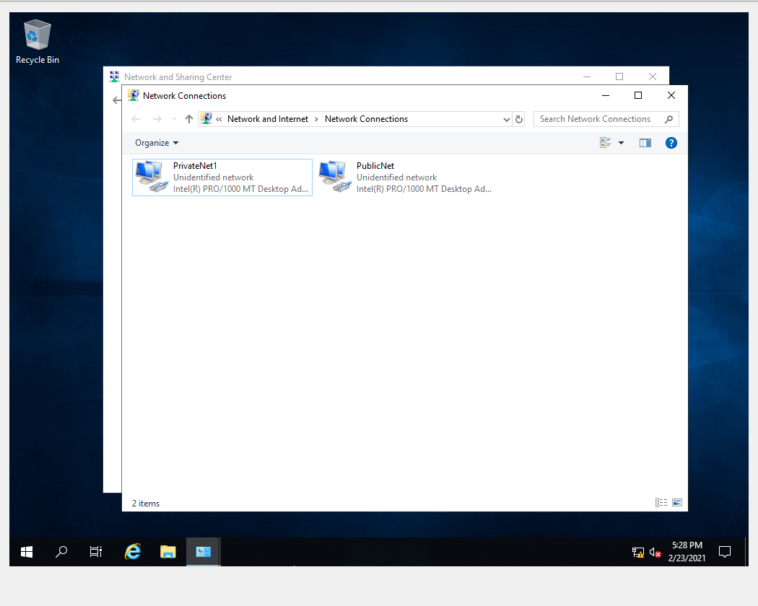
Figure 21: Screenshot of PrivateNet and PublicNet
Figure 22 shows configuration of network by setting the IP.
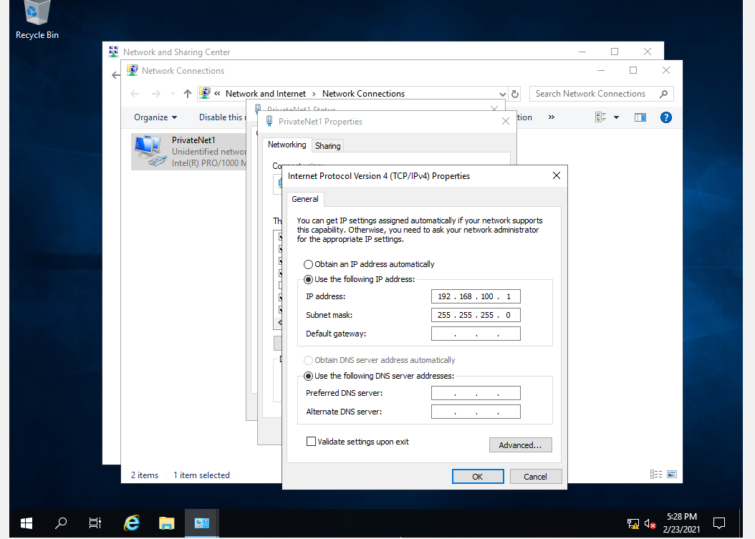
Figure 22: screenshot shows IPV4 properties - ip configuration

Client 2
Client 2 IP:
Privatenet: 192.168.101.2
Figure 23 shows the settings VM and the configuration of the IP address.
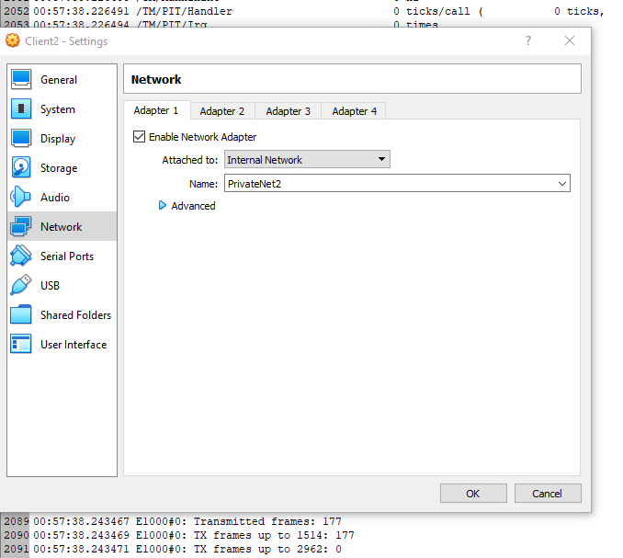
Figure 23: screenshot of client 2 adapter 1 configurations
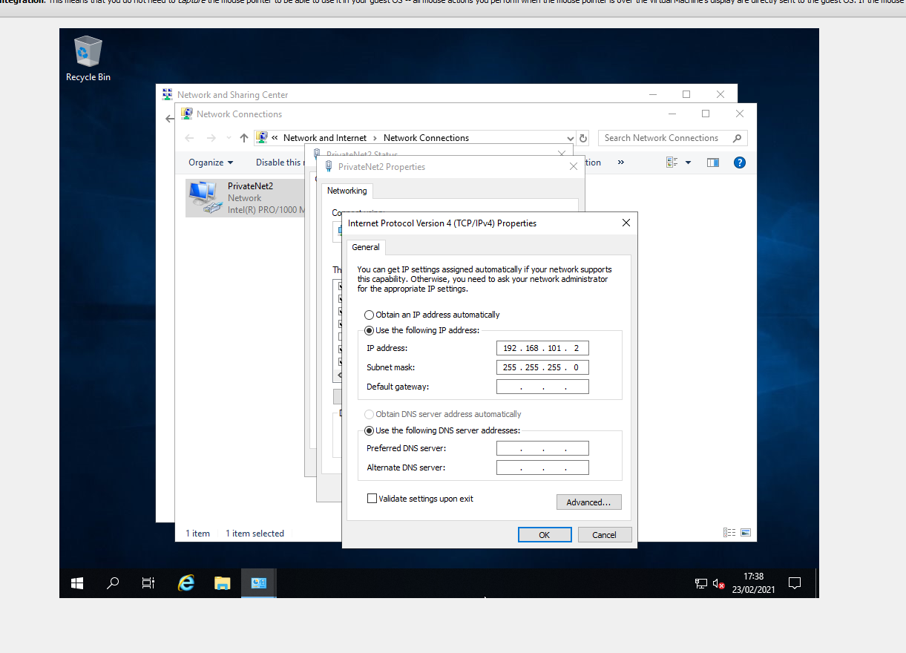
Figure 24: Screenshot of windows IPV4 configuration for privatenet

Server 2
Server 2 - Ip
Private-192.168.101.2
Public- 192.168.1.101
Figure 25 shows the VM settings for server 2. The network adapter set up, and called publicnet, and privatenet
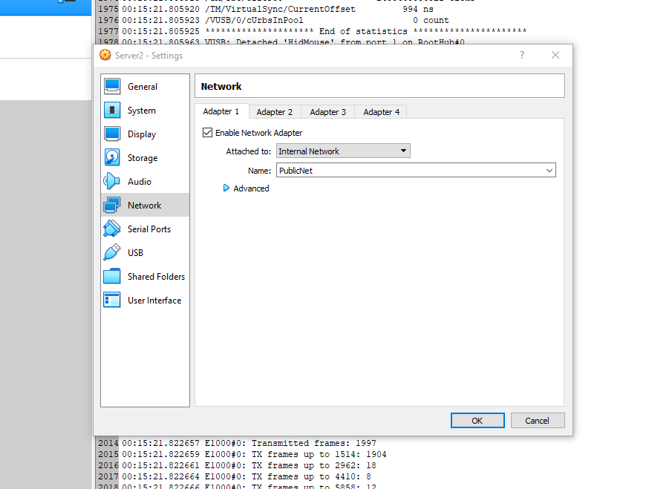
Figure 25: Screenshot of Network settings on server2
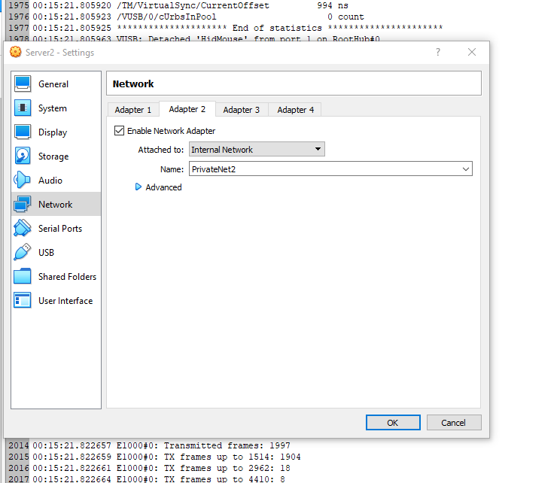
Figure 26: screenshot of adapter 2 for server2

Figure 27 below shows the IP configuration of publicnet and privatenet on server 2.
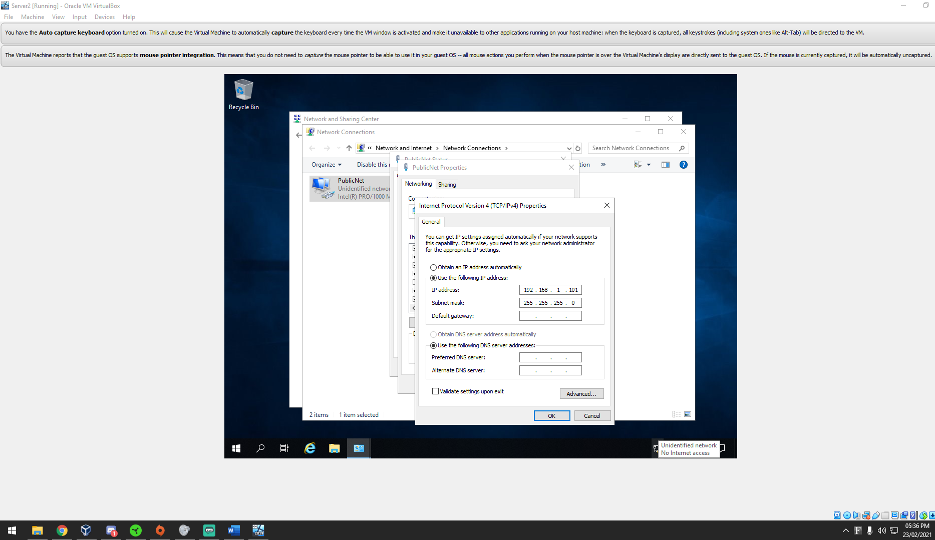
Figure 27: screenshot of IP configuration for publicnet
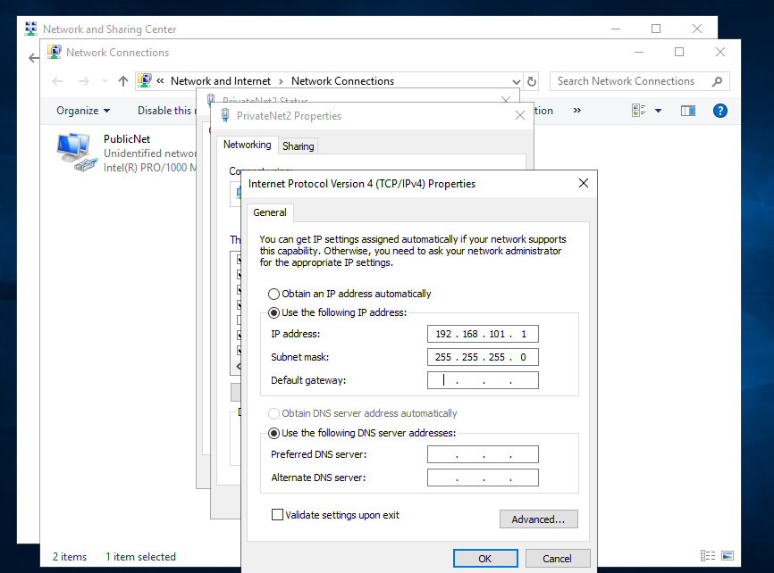
Figure 28: screenshot of IPV4 configuration - privatenet

Firewall
To be able to ping had to turn off the VMs firewalls. Firewall protects against pinging due to traffic on the network. Figure 29 and 30 show that the firewall is turned off for server 1, server 2, client 1 and 2
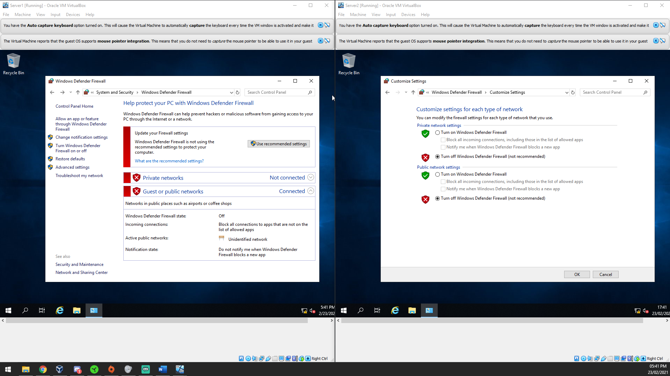
Figure 29: Screenshot of server 1 and server 2 firewall
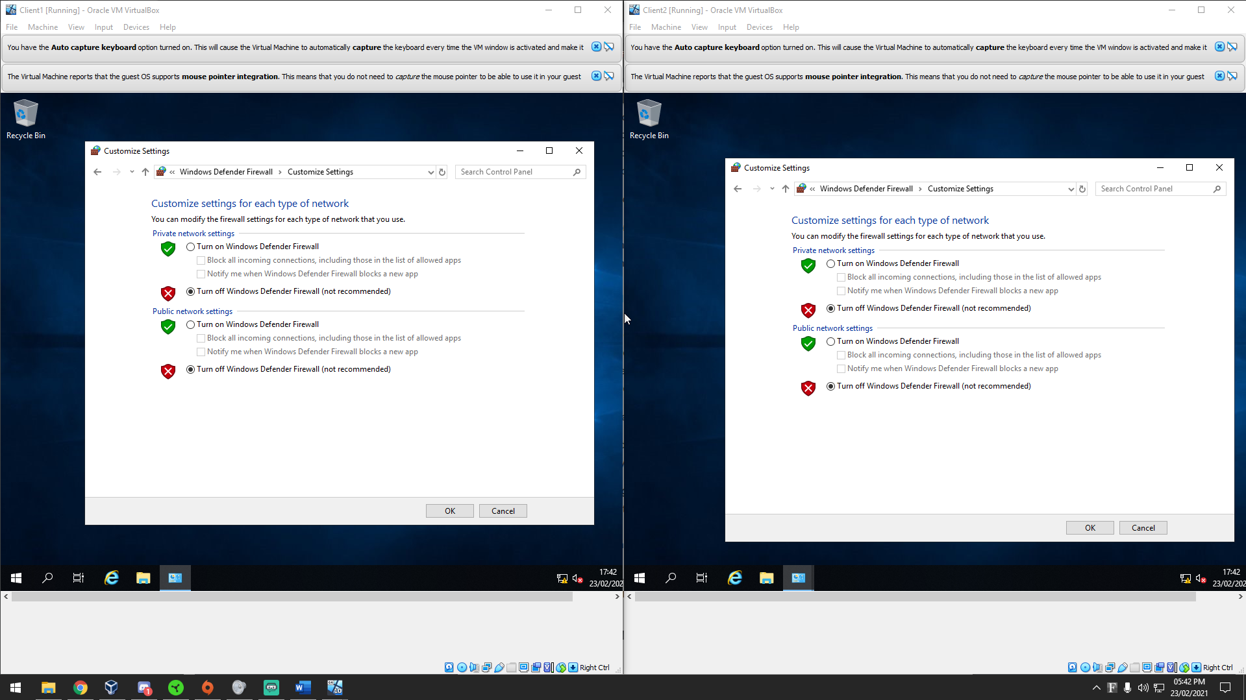
Figure 30: Client 1 and client 2 firewall

Pinging

Client 1 and server 1
Pinging received
Client 1 – Server 1
Private Net – 192.168.100.1

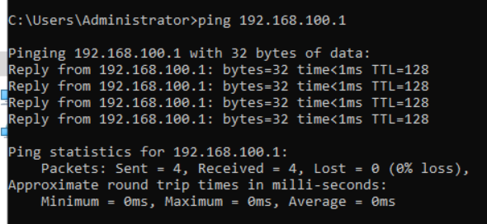
Figure 31: Pinging from client 1 to server 1

Client 2 and server 2
Pinging received
Private net: 192.168.101.2
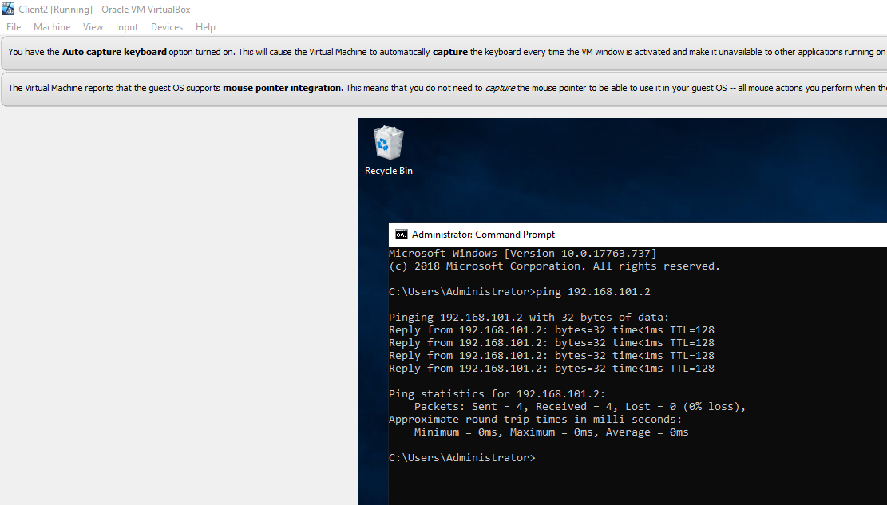
Figure 32: screenshot of pinging. client 2 and server 2

Observational

Hypervisor type 1 and 2

What a hypervisor?
A hypervisor allows one host computer to support multiple guest VMs. It can share resources such as memory and processing. A hypervisor can create and run virtual machines.
“A hypervisor is a software that makes and runs virtual machines (VMs). A hypervisor, sometimes called a virtual machine monitor (VMM), isolates the hypervisor operating system and resources from the virtual machines and enables the creation and management of those VMs.” [1]

Type 1 and type 2 hypervisors
The differences between type 1 and type 2 hypervisors is that hypervisors type 1 runs directly on host machine’s physical hardware and then type 2 hypervisors are installed on top of an existing operating system
The hardware inside the PC matters for type 1 and type 2 hypervisors because it is using physical hardware such as ram, and CPU. This is important to know due to certain motherboards and CPUs don’t support virtual machine.
“Type 1 hypervisors are computer hardware-level hypervisors. Type 1 hypervisors are installed directly on top of the hardware platform” [2]
It is a hardware virtualisation. Type 1 hypervisors require a physical machine or server, hypervisor must be installed, and a guest virtual machine.
Type 1 hypervisor is used by Microsoft. They are also a vendor. They have created Microsoft Hyper-V.
Type 1 hypervisor is often confused for a type 2 hypervisor. The client-servicing operating system is running on a host. The operating system is virtualised and is operating on top of the OS layer of the hypervisor [2].
There are other vendors such as Oracle VM, Citrix Hypervisor, KVM which stands for Kernel-Based virtual machine, and VMware vSphere. These are the most common hypervisors including Microsoft Hyper-V for type 1. They are not free software.
The benefits of type 1 hypervisor are:
- Secure – type 1 hypervisors are more secured because it runs on the physical hardware.
“They run directly on the physical computer hardware without any operating system underneath, they are protected from the errors and weaknesses” [3]
- Good performance – Type 1 Hypervisors are better performance than type 2 hypervisors due to a middle layer. There is no middle layer in type 1 hypervisors.
- Speed- The speed of type 1 is faster due to direct access to hardware.
- Scalability – the scalability is good on type 1 hypervisors.
- Simple Installation – Only if you have the correct hardware supported.
- Independence –Type 1 hypervisors has direct access to hardware along with VM its host.
The drawback of hypervisor type 1 is that it requests a isolated management machine to administer different virtual machines and to control the hardware of the host.
“Type 2 hypervisors are software-level. Type 2 hypervisors are installed on top of an existing operating system. [2]
Type 2 Hypervisor require a physical machine, operating system installed, type 2 hypervisor, and a virtual machine guest(s). Type 2 hypervisors common vendors are VMware workstation player, Microsoft Virtual PC, and sun’s VirtualBox.
The benefits of type 2 hypervisor are:
- Easy management – do not need to install a separate software to manage VMs
- Good for testing – Run multiple virtual machines to test.
- Simple to set up – installed operating system already
The drawbacks of type 2 hypervisor are that it must access computing, memory, and network resources of the host – which is direct access to the physical machine. This would obviously affect the performance of the virtual machine and bring forward security issues.

Significance subnet mask in ipv4 addressing
The significance of the subnet mask in IPV4 addressing is limiting how many devices that can connect to a signal. It also allows user to create sub-networks. This improves performance by splitting up traffic. It allows traffic to go within that subnet.
“Subnetting is important for several reasons. Reduced network traffic, optimized network performance, simplified management, security, and facilitating spinning of large” [4]
These are important due to creating smaller networks that would reduce traffic, network optimization would be improved due to reduce traffic, simplified management this helps to identify and resolve network problem if multiple networks rather than one. Subnetting would improve security due to multiple small networks rather than just one big one.

Cloud computing
Cloud computing is used for multiple services such as servers, storage, databases, networking, software and many more. Cloud computing allow users to save data, or upload data through cloud. This allow the user to be able access data anywhere instead of just one location.
Cloud networking allow users to build networks. Cloud networking works by using cloud-based services. Cloud networking allow users to control and mange network by allowing the users to access anywhere. This increases security and allow monitoring due to cloud computing.
“Cloud networking does not depend on virtualisation, there are multiple cloud structures that are built with virtualised servers. Most network functionalities can reside inside a physical server” [5]
The advantages of cloud computing
- Speed – The speed of cloud computing is extremely fast. It allows the user to get information quickly on their system.
- Back-up and restore data – It are easier to back-up and recovery data.
- Mobility – Accessing data is easily with cloud computing. It allows users to easily access information if not directly wired in.
Cloud computing has different type of vendors for networking, storage, databased and many more. There are many cloud computing vendors. Examples are amazon web services, adobe, drop box, VMware, OneDrive, and Microsoft azure.
The drawbacks of cloud computing are the downtime, internet connectivity and technical issues. These play a major part in cloud computing due to these interrupt user productivity or business. Internet connectivity is important in cloud computing due to access. You cannot access the cloud without internet.

Terminologies
Ping - Pinging is a term used to test if PCs are connected on a network. It is a signal that is sent to a host and it requests a response. It can also test to see how long to get a response from the network. This would allow the user to know if the device is connected to the network and to see if the network is slow.
Pinging on windows is easy. To be able to ping on Windows there is a software called “Command Prompt” and then a command called “Ping” is used to ping the IP address. Figure 33 shows an example of what you type in apart from the IP address. Pinging on Linux and windows are similar. To be able to ping on Linux. Ping needs to be installed on the system example, sudo ping-v and then you type in PING IP ADDRESS
Figure 33: example of pinging
Server management – server management is there to manage servers. It allows users to monitor and manage servers. It allows IT administrators to optimize the performance and health of the servers. There are different types of servers file servers, network servers, web servers, application servers and many more. They all do different things all the servers, but server management allow users to access, keep alerted and to look after the servers.
Firewall – firewall is there to prevent any bad traffic from entering the network. An example would be pinging. The user must turn off firewall to be able to ping due to it sending a signal. Firewall is installed on windows operating system automatically it is built in. Firewall on Linux is also automatically built in. this is to prevent any bad traffic from getting into the network.
PAE/NX – PAE stands for physical address extension. This allow processors to access more than 4gb of physical memory. It allows 32-bit operating systems to access more than 4gb of RAM.
OOBE – OOBE stands for out of box experience. It the start of windows 10 set up. It allows the user to do personal settings such as passwords, privacy settings and allow the user to create user accounts, join wireless network or a network.

References

[1] | Redhat, “What is a hypervisor,” RedHat, [Online]. Available: https://www.redhat.com/en/topics/virtualization/what-is-a-hypervisor. [Accessed 02 03 2021].
[2] | D. Rountree, System Security, Microsoft, 2021, p. 216.
[3] | Admin, “Type-1 and Type-2 hypervisors explained,” VEMBU, 12 December 2019. [Online]. Available: https://www.vembu.com/blog/type-1-and-type-2-hypervisor/. [Accessed 02 03 2021].
[4] | S. N. Sisat, P. .. Bhopale and V. .. Barbudhe, “IP SUBNETTING,” IJECSCSE.
[5] | P. W. R. Y. Siamak Azodolmolky, “Cloud Computing Networking: Challenges and opportunities for innovations,” Research Gate, June 2013. [Online]. Available: https://www.researchgate.net/publication/249325475_Cloud_Computing_Networking_Challenges_and_Opportunities_for_Innovations. [Accessed 3 March 2021].

