Dylan Evans
1701153@student.uwtsd.ac.uk
Abstract
This report will outline the problems with the cycles to share database. The author will discuss how the problems can be solved.
DBMS
Cycles to Share Database

Introduction
This report will outline transactions within the cycles to share database and a solution to distributed database design. The aim of the report is to assist cycles to share with the major problems they are having with their database.

Table of Contents
Introduction 1
1. Performance tuning 3
1.1 Secondary indexes 3
1.2 Transactions 4
2 Distributed database solution 5
2.1 Fragmentation schema 5
2.1.1 Horizontal fragmentation 5
2.1.2 Vertical fragmentation 5
2.1.3 Mixed fragmentation 5
2.1.4 Derived fragmentation 5
2.2 Reconstruction of global relations from the fragments 6
3. References 7

Performance tuning

Secondary indexes
[1] Secondary indexes can be used to organise databases. They are extremely useful when it comes to sorting as you can organise fields in ascending and descending order. For example, if a table were to hold a group of students with a student ID as a primary key, the user could organise the database in a way that the students are ordered by surname this can be done with a secondary index.
The first index in which the author has used is to order accounts by subscription type. This index is useful to see all the Cycles to Share users in the database which are subscribed and all the customers who aren’t subscribed. This is done by creating the secondary index on Status and subscription type in descending order, as shown below:
The second index which the author performed was upon the Rental Bike table on the damage charge and return station. This index was actioned in order to find where the most damaged bikes were being returned out of all of the Cycle To Share stations. This was done by creating a secondary index on the damage charge and return station fields in descending order, as shown below:
The third index in which the author performed was upon the rental table using rental number and customer number fields. This index was used to find out which customers have made the most rentals. This was done by creating a secondary index on the rental number and customer number fields in descending order as shown below:
The fourth and final index in which the author performed was upon the account table using the surname and account number fields. This index was used to order the account table by surname rather than account no as it’s a better way to view the table. This was done by creating a secondary index on the account number and surname fields in descending order, as shown below:
Overall the indexes created by the author will help Cycle to Share to organise their database and to increase the performance of queries as the data will be easier to find when it’s ordered.

Transactions
[2] Transactions are used to run inserts on a database the difference is that when the queries are run within a transaction the insert gets checked for errors predefined by the user, if there are no errors then the transaction will be committed (the inserts will run, and the data inserted into the database). If there are errors the transaction will rollback (the inserts will be cancelled, and no data will be entered into the database)
The within Cycles to Share customers can only rent 6 bikes at a single given time. This must be reflected within the database this can be done by using a transaction. The author did this by using the transaction to insert data into the rental table. The transaction checks to see if the customer has 6 or more rentals. If the customer has less than 6 rentals then the transaction will commit, if there are 6 or more rentals then the transaction will rollback and the customer won’t be allowed to make another rental until they return a bike.
The way in which the author coded the transaction was by selecting the data in the rental table by customer number. Once the data was selected the count function was used to find out how many lines were selected. This number was then stored in a variable and put into an if statement to see if after the insert the number of lines has gone above 6. If this was the case, then the transaction was rolled back. 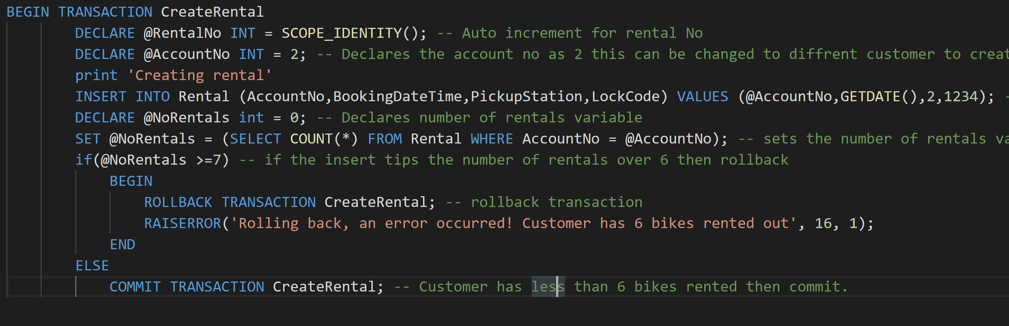
Above is the code for the transaction.

2 Distributed database solution

2.1 Fragmentation schema
[3] Fragmentation is when tables are made up into smaller tables called fragments. Fragmentation is useful when trying to divide information in a table into smaller data sets making it easier to find data. Fragmentation can also help maintain privacy and help to compile with the more recent GDPR. It can help with privacy by fragmenting the table in a way so that only the relevant data is displayed.

2.1.1 Horizontal fragmentation
Horizontal fragmentation is the grouping of tuples (rows) using values from one or multiple fields. For example, in the case of Cycle to Share the database can be horizontally fragmented using the rental table, this can be done by searching for all customers with a yearly subscription as an example.

2.1.2 Vertical fragmentation
Vertical fragmentation is done by grouping attributes from the columns. For example, within the Cycles to Share database the rental bike table could be vertically fragmented by displaying customers and their rental fees. This example is shown in the tables below:
Before Fragmentation
RentalNo | BikeCode | PickupDateTime | ReturnDateTime | ReturnStation | HireCharge | LostLockCharge | DamageCharge | Comments
After fragmentation
RentalNo | Hirecharge

2.1.3 Mixed fragmentation
Mixed fragmentation is combination of both vertical and horizontal fragmentations. This can be done by creating the vertical fragmentation and then creating the horizontal fragmentation from the vertical or by first creating the horizontal fragmentation and then creating the vertical fragmentation from the horizontal.
For example in the case of the Cycle to Share scheme this can be done by vertically fragmenting by customer number in the rental table and then from this creating a horizontal fragment from the pickup station like shown below on pickup station 3:
AccountNo | BookingDateTime | PickupStation | LockCode
1 | 20/03/19 | 3 | 1234
9 | 20/03/19 | 3 | 1234
7 | 20/03/19 | 3 | 1234

2.1.4 Derived fragmentation
Derived fragmentation is combining two tables or relations together. It is easier to make sure that the parent and child are at the same location otherwise the overhead processing will be significantly increased.

2.2 Reconstruction of global relations from the fragments
It must be possible for fragments to be reconstructed into the full table this can be done by using union to reconstruct the horizontal fragmentation and join to reconstruct the vertical fragmentation.

3. References
[1] “Indexes Microsoft Docs.” [Online]. Available: https://docs.microsoft.com/en-us/sql/t-sql/statements/create-index-transact-sql?view=sql-server-2017. [Accessed: 20-Mar-2019].
[2] “Transactions | Microsoft Docs.” [Online]. Available: https://docs.microsoft.com/en-us/sql/t-sql/language-elements/begin-transaction-transact-sql?view=sql-server-2017. [Accessed: 20-Mar-2019].
[3] “Distributed DBMS Design Strategies.” [Online]. Available: https://www.tutorialspoint.com/distributed_dbms/distributed_dbms_design_strategies.htm. [Accessed: 20-Mar-2019].

