Innovative Marketing Strategies For Volkswagen
A Conclusive Report

Student ID: 2132211

Table Of Contents

Table Of Contents 2
1. Introduction 4
2. Company Background 4
3. Communication 4
3.1. Definition Of Communication 5
3.2. Shannon and Weaver’s Communication Model 5
3.3. Integrated Marketing Communication 7
4. New Promotional Strategies for the Volkswagen Group 8
4.1. Online Promotion 8
4.2. Offline Promotion 9
5. Brand and Brand Equity 9
5.1. Brand Equity of Volkswagen 10
Volkswagen Brand Association 10
Volkswagen Brand Awareness 10
Volkswagen Brand Loyalty 10
Volkswagen Brand Element 11
5.3. Keller’s Brand Equity Model 11
Step 1: Brand Identity OR Who Are You? 12
Step 2: Brand Meaning OR What Are You? 12
Step 3: Brand Response OR What Do I Think or Feel? 12
Step 4: Brand Resonance – What Do Feel About You? 12
5.4. Keller’s Brand Equity Model for Volkswagen 12
Brand Salience 12
Performance / Imagery 12
Brand Response 13
Brand relationship 13
6. Customer Journey 13
6.1 Stages of Customer Journey 13
First Step: Awareness 13
Second Step: Consideration 14
Third Step: Decision, 14
Fourth step: Retention 14
Fifth step: ADVOCACY 14
7. Customer Touchpoints 14
7.1. Pre-Purchase Touchpoints 15
7.2. Purchase Touchpoints 15
7.3. After-Purchase Touchpoints 16
8. Customer Journey Map 16
8.1. Strengths and Weaknesses of Volkswagen Customer Journey Map 17
9. The Total Engagement Model 17
10. Conclusion 18
11. Recommendations 19
Reference List 20

1. Introduction
Volkswagen - the people’s car is one of the world’s most famous vehicle brands and this paper evaluates its innovative marketing strategies (VW.com | Official Home of Volkswagen Cars & SUVs n.d.). The aim of this marketing proposal is to see what strategies and tactics a company should adopt to market its product among target-oriented consumers (Brooks 2016). However, marketing analysis is a current situational analysis of Volkswagen that explains the brand’s current positioning through its external and internal analysis of brand equity, Keller's Brand equity model, and customer journey. The paper concludes that Volkswagen features a high competitive advantage and needs to focus on a new targeted population to enhance its market worth.

2. Company Background
Volkswagen – the car of people, is one of the world's most famous brands of vehicles which was founded by German Labour in 1937(The Editors of Encyclopaedia Britannica 2021). The German-based car manufacturer served as the international brand of the Volkswagen Group, headquartered in Germany, Wolfsburg. “Volkswagen” which is also abbreviated as VW, is derived from the two different words of the Germanic language, combing the word Volks and “Wagen” which formed a famous word—Volkswagen. Also, the largest automotive industry market its brand under the slogan: “The People Car” (Volkswagen 2019).

3. Communication
In the Latin language the word “communication” means common which is derived from the word communis. Usually, the common indicates common sharing or common understanding. However, In the English language, the word communication comes from the word communicate which can imply a broader concept of mutuality between two individuals through different forms of writing, gestures, and speaking (Luhmann 1992).

The forms of communication can differ from generation to generation. Like, In the old era, the mode of communication was a drumbeat, pigeon carrier, and smoke signals. On the other hand, with the advancement in digital networks, social media emoji reactions are considered the mode of communication. Despite this mode, the gestures of the person are also a mode of communication like; nodding, raising a hand, etc. Hence it can be verbal and non-verbal (Baraldi 2006).
The world of an individual does not exist without communication, it is of core importance to share the view, thoughts, feeling, needs, and interests with one another for a certain purpose. Communication is a two-way process, which means the participation of two people creates communication (Frey et al. n.d.). One person acts as a sender or vocalist whereas the other person acts as a receiver or the listener. When the sender and receiver start to convey their feelings, ideas, thoughts, and viewpoints, the communication process comes into being.

3.1. Definition Of Communication
So, we can define communication as “The mutual participation of an individual for the purpose of sharing their school thoughts” (phutela 2015).

3.2. Shannon and Weaver’s Communication Model

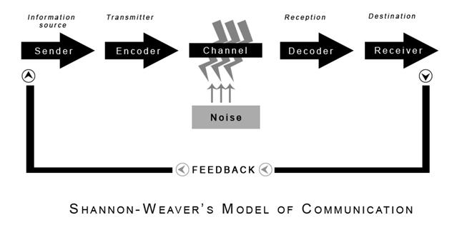
Figure 1: Shannon-Weaver’s Model of Communication. Source: (Communication Theory 2014)

In 1948, Shannon and Weaver proposed the communication model, intending to develop a persuasive flow of communication between the sender and the receiver. The Shannon-Weaver model of communication is considered the “Mother of all the communication Models”, this is also the Human communication model comprising six key modes (Bowman & Targowski 1987). Later, the founder extended the model by adding the modes of “noise” and feedback, which have a direct effect on the process of communication. Finally, the model introduces seven keys concept of the communication model. The seven key concepts of the process include Source, Encoder, Channel, Noise, Decoder, receiver, and feedback. This process works in an integrated manner:
- Source: It is the first and most important mode where the information originated. The major role is the source of information played by the sender that transmits the desired message.
- Encoder: From the source, the message of the sender is converted into signals. For instance, the sender converts the message through speaking – the encoder encodes the “voice” into the signals and then sends it for transmission via cables. The encoder is also known as Transmitter.
- Channel: It plays a very important role in the communication process because it is a medium or pathway that carries the desired information. For instance, In telephone calls wires is the channel of communication.
- Noise: Noise is an interpretation or addition of rough voices that occurred during the transmitting process of communication like; horns, thunders, crowds, etc.
- Decoder: It is the opposite of the encoder. It translates the message into an understandable form for the receiver. For example, software, equipment, and individuals are examples.
- Receiver: Hence, the process goes to its completion because the message reaches its destination, and the receiver receives the message exactly in the same form, in which form it sends by the sender.
- Feedback: The most common example of feedback is the “reply” that the receiver can do after getting the message from the receiver.

3.3. Integrated Marketing Communication
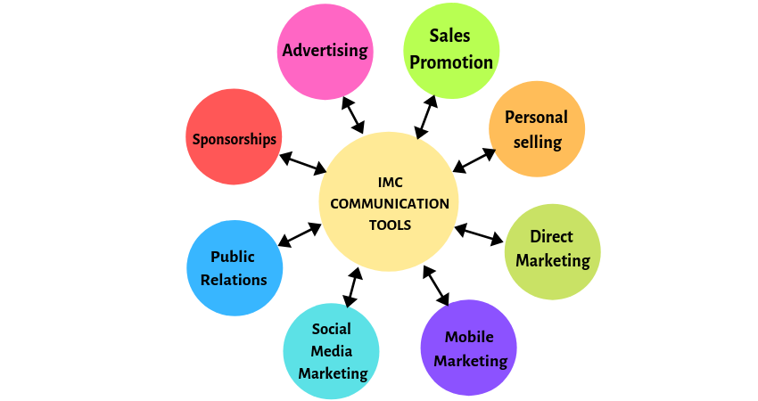

Figure 2: Integrated Marketing Communication. Source: (Taylor 2019)
Integrated Marketing Communications, abbreviated as IMC is a combination of marketing tools that are eight in number including Advertising, Public relations, Sale promotion, Online marketing, Sponsorship, direct marketing, Mobile marketing, and sales promotion (Schultz 1992). These are promotional strategies that work better in the integrated form rather than work in isolation. When these tools promote the brand product with one specific motive, they gain a lot of customers' attention. The approach behind IMC is to design a persuasive experience and spread awareness about the product among the customers so that it holds its strong presence in the market for a long time. Hence more sales mean more profit.

Tools of Integrated Marketing Communications
- Advertising – is a means of communication that companies or businesses use to promote their services or products among their targeted audience. It can be done by advertising through different channels like; print media, broadcast media–television, billboard, etc.
- Personal selling – this includes personal interaction of the brand with the buyer. They also promote and convince them to buy their products.
- Direct Marketing – it is a digital brand imaging by sending the buyer catalogs and other materials via e-mails, text messages, and fax.
- Mobile Marketing – is the cheapest strategy to promote their products among the buyer via sending a message on their mobile phone.
- Social Media Marketing – it is one of the most powerful tools that attract a larger audience toward their brand.
- Public Relations – it is a two-way process of promotional marketing between the organization and the public via press releases, public awareness, and news. It builds a positive image and goodwill for the organization.
- Sales Promotion – it gives the reason to the audience by offering an incentive to the buyer, like; discounts, coupons,price-pack, and low-pricing deals.
- Sponsorships – it creates brand loyalty by using tools of sales promotions and public relations together.

4. New Promotional Strategies for the Volkswagen Group
As Volkswagen has invested in 360 promotions and advertising campaigns, it has promoted each model of its cars individually and even the same as its parent company does. However, the company may use different mediums to market or promote their products like social media (Chris & Gerhard 2016). Apart from digital media, they also use traditional means like newspapers and magazines, event organizations, and roadshows to promote their products.

4.1. Online Promotion
The company used online promotion for its market growth. Online promotion means it uses electronic media like Facebook, Twitter, Instagram, etc. they are promoting their services by developing ads on it.

Volkswagen can use the following promotional strategy for the company to increase brand awareness:

- “Digital Media Inventory” is a great tool for Volkswagen to showcase their brand’s product internationally through interactive media, because it is a solid strategy to create brand awareness globally. So that, the consumers can get the concerning information about the specification of the vehicle, models of the cars, the price of those cars, show alternative colour and their editions along with the cars merchandise and materials designed by Volkswagen for selling in the digital market to create awareness as well as earn a profit.
- Another strategy is to utilize digital coupons that excite and motivate the expectations of the consumers to buy the vehicles that attract them most, giving better deals to the consumers and paving the way to boost the company store's sales rate.

Volkswagen is favorable in promoting its products on social media. It uses social media to produce brand awareness in people. While the social media platforms Facebook and youtube have greater features like sharing and driving brand recognition from that companies can increase their market growth and more followers on their profiles. It creates more attractive videos to upload on their social media platforms and also promotes their services.

4.2. Offline Promotion
It is the traditional way to promote the services of the company. The company uses the newspaper and magazines for its promotions and describes its achievements and its qualities in its ads to influence more customers and enhance its marketing growth. Most people read newspapers and magazines in their free time and do not like to watch digital media like television (Truong et al. 2008).

Volkswagen can use the following promotional strategy for the company to increase its brand awareness:
- The most powerful and delightful strategy that Volkswagen can use for offline promotion is “Multi-sensory Advertising”. Although, Volkswagen is aggressive toward print advertising sing this tactic manipulates the offline promotional, and thus, this will no longer be stagnant. However, an interactive and eye-catching for the consumers in order to influence their behaviors, perception, and judgment through experiencing the right strategy when creating multisensory magazine ads.

5. Brand and Brand Equity
It is also a marketing term used to describe the value of the brand. The brand value depends on the experiences and perception of what the consumer holds for that brand, thus in this way the value of the brand is determined. However, brand equity may be positive and negative. Positive brand equity, If the consumer has good thoughts and perceptions about the brand, the consumer also has urged to buy the products, and hence, more sales take place. On the other hand, negative brand equity is when the sales of the brand go minimal and also the brand reached the point where the pre-consumer advised the new consumer not to buy the product. However, brand equity is developed under the consideration of factors like, Awareness, Recognition, Trial, Preference, and Loyalty.

5.1. Brand Equity of Volkswagen

Volkswagen Brand Association
The world is continuously developing and along with it the automotive industry is also growing. Volkswagen is considered a pioneer in the automotive industry as it has been designed as a fully automatic car, The Sedric is one of the famous brands and the first concept car by the Volkswagen Group which can represent the high-level intelligence in this car.VW groups aim to become exemplary brands for designing a successful enterprise (John et al. 2006). Sedric attracts a lot of consumers as it is designed with new innovative designs and innovative techniques. In addition, it is an autonomous car where the individual touch a button to start the car that talks to its passengers and conveniently drive the passenger to their destination. VW also feels a sense of association with the non-profit organization by providing them with almost 20% share in its parent company (Nilsson & Svensson 2009).

Volkswagen Brand Awareness
In terms of promotion the famous brand Volkswagen has preferred to use the social media platform rather than print media to raise awareness among the consumer, till now it almost used around about 380 brands to publicize and promote its car separately.VW has used powerful promotional tools to create awareness about the brand including; Facebook, Youtube, and Twitter. For an international brand, it is easy to promote its brand on social or online platforms as the world becomes digitized. However, the price of the car depends on the geographical location to which it serves, and the segment of society to whom it is sold, the feature that it offers (Nogueira & Tsunoda 2018).

Volkswagen Brand Loyalty
Volkswagen is the highest multinational industry of the automobile, that sells approximately 34,500 vehicles per day. It also sells its vehicle in different parts of the world including, the USA, Germany, Mexico, Spain, India, China, Africa, and South Africa. Globally, according to the report by Forbes 2000 Volkswagen is ranked 25th number from the largest automobile industries. Volkswagen has become a customer’s favorite because of its brand loyalty as it never compromises on the quality, or performance of the vehicle (Jørgensen, Mathisen & Pedersen 2016).

Volkswagen Brand Element
The logo of Volkswagen is designed with sharp skills in 1938 and was later modified in 2000.
The logo of VW is considered impressive and remarkable. The company’s logo is a simple representation of the company’s initials that was launched in 1938 and has not been modified since 2000. The logo f the Volkswagen company is simply beautiful, and it can catch the consumer itself, As the logo contains two letters V and W that are held together stylishly in a circle. In terms of colour, the colour combination of White and Blue shows a very high-class and elegant look (Feng & Xie 2019). Hence, the brand element also plays a vital role in the promotional market to build up a charm and the standard of the market.

5.3. Keller’s Brand Equity Model
Keller's Brand Equity Model is also called a “Customer-based brand Equity model or (CBBE)” that was proposed by Kevin lame Keller (Kuhn & Alpert 2004). The aim of the Brand Equity Model is to build a strong brand by shaping the product in a way that satisfies the need, beliefs, feelings, and desires of the customers and in return what they think about the products as a consumer. This is called a Keller brand equity model.
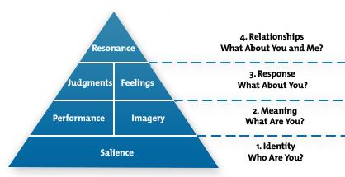
Figure 3: Keller’s Brand Equity Model. Source: (MindTools 2009)
This model has four steps in which the company answered those questions that might be asked by the customer while purchasing a brand (Jalilvand, Samiei & Mahdavinia 2011). These steps follow in order of importance.

Step 1: Brand Identity OR Who Are You?
It is the most important level that must be strong enough because the rest of the features can be placed on it. It plays two major roles.
- To identify the USP (unique selling point) to stand in the marketplace
- Tell the customer about it.

Step 2: Brand Meaning OR What Are You?
The customers will question its features, styles, designs, durability, reliability, price, and customer experience

Step 3: Brand Response OR What Do I Think or Feel?
It describes the customer feedback and review about the product or services of the company.
The responses from the consumer are of two types. One is judgment and the other is feeling. The judgment is made for product quality, credibility, and superiority. While feelings are the fun, excitement security, and social approval by availing the brand products

Step 4: Brand Resonance – What Do Feel About You?
The Keller Brand Equity Model is all about having a good and strong relationship, it is possible when the customer is:
- Loyal to a brand
- Considers its supremacy
- Switch to another when the brand does not meet goals

5.4. Keller’s Brand Equity Model for Volkswagen

Brand Salience
It has a strong and charming brand portfolio as VW Group owns and sells almost 13 automotive brands including, Lamborghini, SEAT, Porsche, SEAT, Audi, Bugatti, Skoda, Volkswagen, Bentley, MAN, Scania and also other commercial vehicles (Romaniuk & Sharp 2004).

Performance / Imagery
The performance of the company is not effective because it lacks empathy with the customers who complained. So, the company should focus on organizing a brief training course for customer service with an intention of improving the company’s response to its customer’s complaints as well as feedback (Keller 2012).

Brand Response
The brand has a quick and friendly response to each and every one including customers and members of the VW groups (Rego et al. 2021).

Brand relationship
The famous brand Volkswagen has a good and satisfying relationship with its parent company as well as with its sponsor (Aggarwal 2004).

Advantages of Keller Brand Equity Model
- It helps the brands to become unique from the Competition
- It helps to create emotional connections with the customers.
- It gives power for better negotiating.

Disadvantages of Keller Brand Equity Model
- It is cost-effective, as promotional activities need heavy investment.
- It needs a heavy invention, in terms of advertising the brand with different strategies and on different channels.

6. Customer Journey
As the name indicates, is the pathway that identifies what the customer is thinking about the brands’ services, Skills, and technologies (Lemon & Verhoef 2016). In short, it is a journey or experience for the consumers from which they go through while buying a brand.

6.1 Stages of Customer Journey

First Step: Awareness
Volkswagen is running a rich social and media mobile advertising campaign for the new design model of Volkswagen CC to promote and raise brand awareness. Also, the company placed the mobile banner advertisement and do promotional activities on the social media websites of the biggest channel CNN and CBS.hence, these mixed promotional activities help the company to create a better brand image (Santana, Thomas & Morwitz 2019).

Second Step: Consideration
Volkswagen is the choice of people because it has done quality works regarding, fuel, energy, design, and styles, In 200 Volkswagen recreate the model of the car because those cars do not meet the standard of emission of fuel (Mangiaracina et al. 1970)

Third Step: Decision,
However, it does not mean that the biggest company has no chance to make a mistake. Volkswagen has taken an excellent decision but sometimes, the right decision also leads to failure. Like same as above emission control device has become a scandal as a result of ineffective decision-making (Bernard & Andritsos 2018).

Fourth step: Retention
Volkswagen always the retention of a great number of its audience because its strategies to retain the customer's needs and desires are based on how the marketing mix has an impact on customer retention at Volkswagen. The sedan Model is an excellent example that retains a lot of customer attention (Magids, Zorfas & Leemon 2015).

Fifth step: ADVOCACY
The public always supports the company and its previous actions or approach for the future.

7. Customer Touchpoints
A customer touch point is the marketing term in which the customer will contact you directly or indirectly with a brand (Roto et al. 2016). It increases the customer journey and is important to influence the customer experience. the interaction between the customer and the brand will be direct such as shopping at the retail store and will be indirect for example reading reviews. During this customer journey, in general, almost every customer touch point is considered to have excessive potential to change perceptions as well as brand loyalty. It has a direct role in the quantitative services of the market such as Net Promoter services. and contribute a lot to customer loyalty and brand perception. the brands that can understand and optimize the customer touchpoints, have high net promoter points, and also more loyal customers (Rosenbaum, Otalora & Ramírez 2017). It can happen within or outside of brand control and maybe happen before, during, and after the purchasing of services and products.
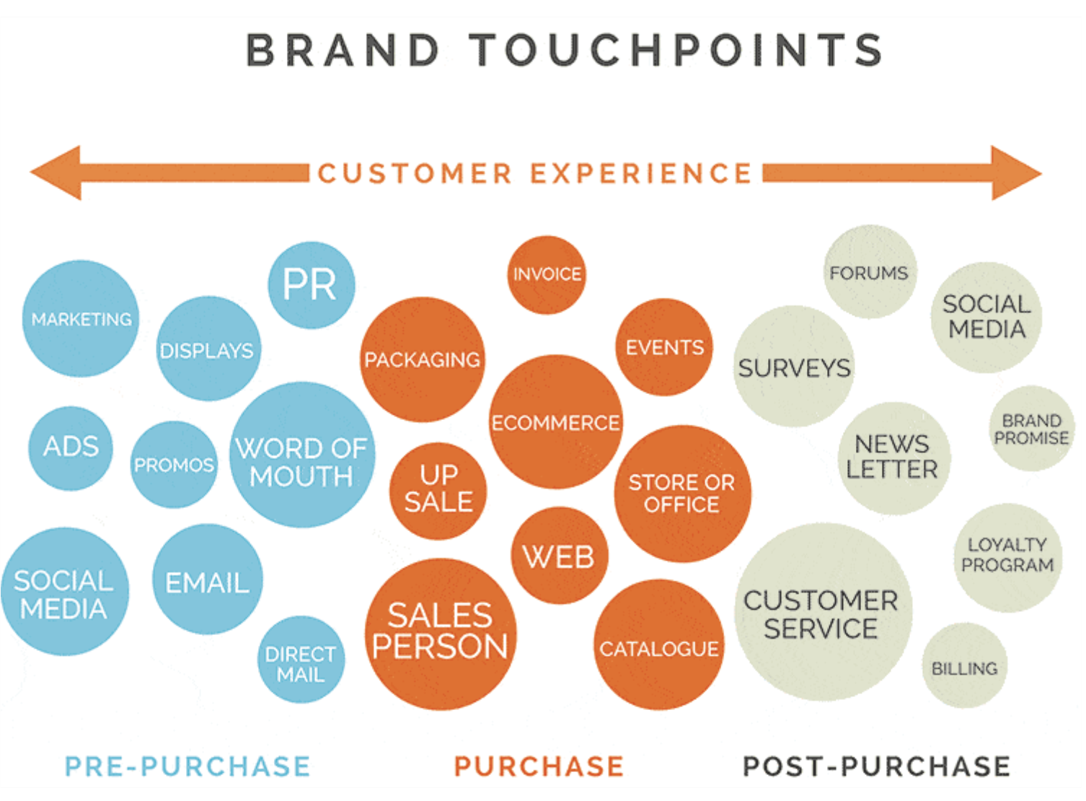
Figure 4: Brand Touchpoints. Source:(Customer touchpoints: Definition & Analytics Guide n.d.)

7.1. Pre-Purchase Touchpoints
Pre-purchase touchpoints are known to produce unknown results. it is the term of the touch point in which companies can communicate before purchasing the product from the customer. the companies communicate with the customer through some channels like social media, the company website, and also through advertising. these touchpoints are very important for crafting a good customer experience (Khanna, Jacob & Yadav 2014).

7.2. Purchase Touchpoints
The interaction of the customer with the business, while they are purchasing the advertising services is called the purchase touchpoints. It’s possibly a significant approach to influence the customer to purchase the best services for life. A few years ago, the main touch point of this is a form of physical purchasing by the customer and now there is much more to consider in the new terms of the touch points for example websites, online stores, and distributors (Herhausen et al. 2019). It is the best touchpoint in the business interest so this part should be smooth as possible for the best customer journey.

7.3. After-Purchase Touchpoints
The after-purchase touchpoints are those when the purchase is made by the customer and the customer journey is over. if the customer purchase is a mistake, the success rate of selling to the customer is lower from 65% to 15% and put down the selling rate of the business. The customer journey becomes more complex while increasing the touchpoints. you should be aware of the touch points and analyze them with the desire to improve the business.

8. Customer Journey Map
The customer journey map, in general, is a marketing tool that helps visualize the customer's point of view that is interacting with the brand. It is considered most critical because it forces the business to check how customers experience the brand and how the business thinks they do. The business can better deliver the product to the expectations when you can better understand the requirements of the customer. According to Morgan, one must consider investing in becoming a well-established and experience-led business to optimize its customer touchpoints (Morgan 2018). By understanding the concepts of the customer journey, different B2B companies can ensure staying a step ahead of their customers with an intention to provide them with great experience as well as quality.
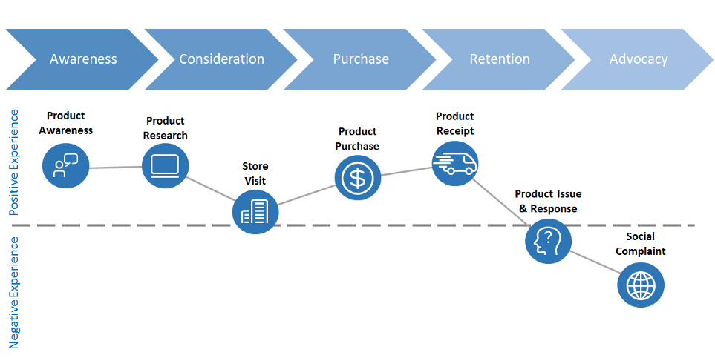
Figure 5: Customer Journey Map. Source:(Visser 2017)

8.1. Strengths and Weaknesses of Volkswagen Customer Journey Map

Strength | Weakness
Quick to respond to new marketing challenges | Misconceptions in brand development
Managing all different points of Interaction customer | Impossible to aline each point
Business partners have high loyalty | Missing expertise in some areas

Table: Strengths and Weaknesses of Volkswagen CSM. Source: (van Viersen, de Bree & de Jong 2019)

9. The Total Engagement Model
In the customer journey map, all the customers are not the same and some of them need more attention and bond to get special attention. There are, considerably, four key factors of the engagement model in the customer journey. The engagement model is better for the development of the business, and it offers high-cost enterprise products (Procci 2015). It defines the way of interacting with the customers such as interactive engagement, two-way conservation, progress journey, and relationship journey. Having an efficient customer engagement model helps the business manage customer relationship throughout the entire customer journey and it improve customer retention and helps in the improvement of the business for the long term.

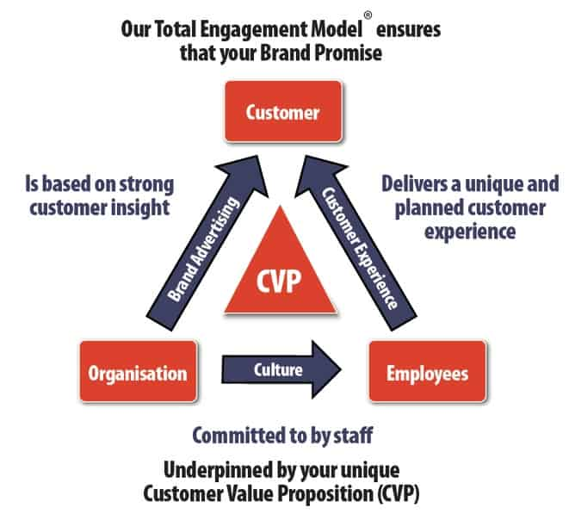
Figure 6: The Total Engagement Model. Source: (Strategy n.d.)

10. Conclusion
Undoubtedly, Volkswagen is a well-known and established brand. The company is still trying to manufacture dynamically-designed and innovative products according to the new generation’s demands and needs. The structured product strategy helps the company to attract customers geographically and internationally. The premium quality car with innovative technology has helped the company to gain a positive brand image which also boosts the brand’s reputation Internationally. The Volkswagen company due to its accurate marketing strategies also helps it to achieve more success.

11. Recommendations
According to the given facts the crisis still occurring, and the strategies of the V.W can probably be revised. And it should move toward the initial plan that appears to be focused on the cooperative culture problem. The company should use new promotional strategies to ensure its development in growth. They should get the highest satisfaction from the customer by planning their new strategies. After discussing the SWOT analysis of the company, it should produce and enhance new marketing strategies outside Europe. The company should improve its product quality and also get new inventions in its product and services to gain good reviews and loyalty from its customers.

Reference List
Aggarwal, P 2004, ‘The Effects of Brand Relationship Norms on Consumer Attitudes and Behavior’, Journal of Consumer Research, vol. 31, no. 1, pp. 87–101.
Baraldi, C 2006, ‘New Forms of Intercultural Communication in a Globalized World’, International Communication Gazette, vol. 68, no. 1, pp. 53–69.
Bernard, G & Andritsos, P 2018, ‘CJM-ab: Abstracting Customer Journey Maps Using Process Mining’, Lecture Notes in Business Information Processing, pp. 49–56.
Bowman, JP & Targowski, AS 1987, ‘Modeling the Communication Process: The Map is Not the Territory’, Journal of Business Communication, vol. 24, no. 4, pp. 21–34.
Brooks, C 2016, ‘Organizing Volkswagen: A Critical Assessment’, WorkingUSA, vol. 19, no. 3, pp. 395–417.
Chris, B & Gerhard, van W 2016, ‘An investigation of the marketing performance measurement practices in Hatfield Volkswagen group’, African Journal of Business Management, vol. 10, no. 6, pp. 131–139.
Communication Theory 2014, Shannon and Weaver Model of Communication, Communication Theory.
Feng, Y & Xie, Q 2019, ‘Ad Creativity via Augmented Reality Technology in Online Video Ads: the Differential Role of Novelty, Message Usefulness, and Ad-Consumer Association’, Journal of Promotion Management, vol. 25, no. 6, pp. 907–933.
Frey, LR, Botan, CH, Kreps, GL, London, B, Toronto, Sydney, Tbleo & Singapore n.d., INVESTIGATING COMMUNICATION AN INTRODUCTION TO RESEARCH METHODS SECOND EDITION ALLYN AND BACON.
Herhausen, D, Kleinlercher, K, Verhoef, PC, Emrich, O & Rudolph, T 2019, ‘Loyalty Formation for Different Customer Journey Segments’, Journal of Retailing, vol. 95, no. 3, pp. 9–29.
Jalilvand, MR, Samiei, N & Mahdavinia, SH 2011, ‘The Effect of Brand Equity Components on Purchase Intention: An Application of Aaker’s Model in the Automobile Industry’, International Business and Management, vol. 2, no. 2, pp. 149–158.
John, DR, Loken, B, Kim, K & Monga, AB 2006, ‘Brand Concept Maps: A Methodology for Identifying Brand Association Networks’, Journal of Marketing Research, vol. 43, no. 4, pp. 549–563.
Jørgensen, F, Mathisen, TA & Pedersen, H 2016, ‘Brand loyalty among Norwegian car owners’, Journal of Retailing and Consumer Services, vol. 31, pp. 256–264.
Keller, PE 2012, ‘Mental imagery in music performance: underlying mechanisms and potential benefits’, Annals of the New York Academy of Sciences, vol. 1252, no. 1, pp. 206–213.
Khanna, M, Jacob, I & Yadav, N 2014, ‘Identifying and analyzing touchpoints for building a higher education brand’, Journal of Marketing for Higher Education, vol. 24, no. 1, pp. 122–143.
Kuhn, K-A & Alpert, F 2004, Applying Keller’s brand equity model in a B2B context: limitations and an empirical test, in J Wiley & P Thirkell (eds), eprints.qut.edu.au, The Australian and New Zealand Marketing Academy, Australia, pp. 1–7.
Lemon, KN & Verhoef, PC 2016, ‘Understanding Customer Experience Throughout the Customer Journey’, Journal of Marketing, vol. 80, no. 6, pp. 69–96.
Luhmann, N 1992, ‘What is Communication?’, Communication Theory, vol. 2, no. 3, pp. 251–259.
Magids, S, Zorfas, A & Leemon, D 2015, HBR.ORG The New Science of Customer Emotions A better way to drive growth and profitability.
Mangiaracina, R, Brugnoli, G, Aless & Perego, R 1970, ‘The eCommerce Customer Journey: A Model to Assess and Compare the User Experience of the eCommerce Websites’, The Journal of Internet Banking and Commerce, vol. 14, no. 3, pp. 1–11.
MindTools 2009, Keller’s Brand Equity ModelBuilding a Powerful Brand, Mindtools.com.
Morgan, B 2018, Motivations for Engaging in Entrepreneurial Activity in the Informal Sector in Sub Saharan Africa, www.diva-portal.org, viewed 30 August 2022, <https://www.diva-portal.org/smash/record.jsf?pid=diva2:1228777>.
Nilsson, I & Svensson, M 2009, The viral makes you aware : how is brand association affected by viral marketing through individual networks, www.diva-portal.org, viewed 30 August 2022, <https://www.diva-portal.org/smash/record.jsf?pid=diva2:294048>.
Nogueira, E & Tsunoda, DF 2018, ‘A Proposed Model for Consumer-Based Brand Equity Analysis on Social Media Using Data Mining and Social Network Analysis’, Journal of Relationship Marketing, vol. 17, no. 2, pp. 95–117.
phutela 2015, The Importance of Non-Verbal Communication - ProQuest, Proquest.com.
Procci, K 2015, ‘The subjective gameplay experience: An examination of the revised game engagement model’, Electronic Theses and Dissertations, viewed 30 August 2022, <https://stars.library.ucf.edu/etd/1169/>.
Rego, L, Brady, M, Leone, R, Roberts, J, Srivastava, C & Srivastava, R 2021, ‘Brand Response To Environmental Turbulence:A Framework And Propositions For Resistance, Recovery And Reinvention’, International Journal of Research in Marketing.
Romaniuk, J & Sharp, B 2004, ‘Conceptualizing and measuring brand salience’, Marketing Theory, vol. 4, no. 4, pp. 327–342.
Rosenbaum, MS, Otalora, ML & Ramírez, GC 2017, ‘How to create a realistic customer journey map’, Business Horizons, vol. 60, no. 1, pp. 143–150.
Roto, V, Väätäjä, H, Law, E & Powers, R 2016, ‘Experience Design for Multiple Customer Touchpoints’, Proceedings of the 9th Nordic Conference on Human-Computer Interaction.
Santana, S, Thomas, M & Morwitz, VG 2019, ‘The Role of Numbers in the Customer Journey’, Journal of Retailing, viewed 14 October 2019, <https://www.sciencedirect.com/science/article/pii/S0022435919300570>.
Schultz, DE 1992, ‘Integrated Marketing Communications’, Journal of Promotion Management, vol. 1, no. 1, pp. 99–104.
Strategy, E n.d., Total-Engagement-Model, Engaged Strategy, viewed 30 August 2022, <https://www.engagedstrategy.com.au/engaged-marketings-proprietary-business-model-becomes-part-of-an-academic-book/total-engagement-model/>.
Taylor, K 2019, 8 Examples of the IMC (Integrated Marketing Communication) Tools, HitechNectar.
The Editors of Encyclopedia Britannica 2021, Volkswagen Group | Overview, History, & Facts, Encyclopædia Britannica.
Truong, Y, Simmons, G, McColl, R & Kitchen, PJ 2008, ‘Status and Conspicuousness – Are They Related? Strategic Marketing Implications for Luxury Brands’, Journal of Strategic Marketing, vol. 16, no. 3, pp. 189–203.
van Viersen, S, de Bree, EH & de Jong, PF 2019, ‘Protective Factors and Compensation in Resolving Dyslexia’, Scientific Studies of Reading, vol. 23, no. 6, pp. 461–477.
Visser, M 2017, Learn Customer Journey Mapping… in 7 Bookmarks, Medium.
Volkswagen 2019, Volkswagen Group, Volkswagenag.com.
VW.com | Official Home of Volkswagen Cars & SUVs n.d., www.vw.com.

