Nusrat Bi
Student Number: 2433266
Module Code and Title: LSCH4009 Professional Development within Health and Social Care
Lecturer: Hajra Mustaqim
Assignment Title: Personal Development Portfolio

Contents page

Health Care Assistant Job Role …………………………………………………….. pp.3-4

Curriculum Vitae ……………………………………………………………………… pp.5-6

Task 1: Personal statement …………………………………………………………. pp.7-8

Task 2: SWOT Analysis ……………………………………………………………… p.9

Task 3: Personal Development Plan (PDP) ……………………………………….. p.10

Task 4: Critical Reflection using Gibbs’ reflective cycle …………………………… pp.11-13

Reference list …………………………………………………………………………. P.14

Health Care Assistant Job Role

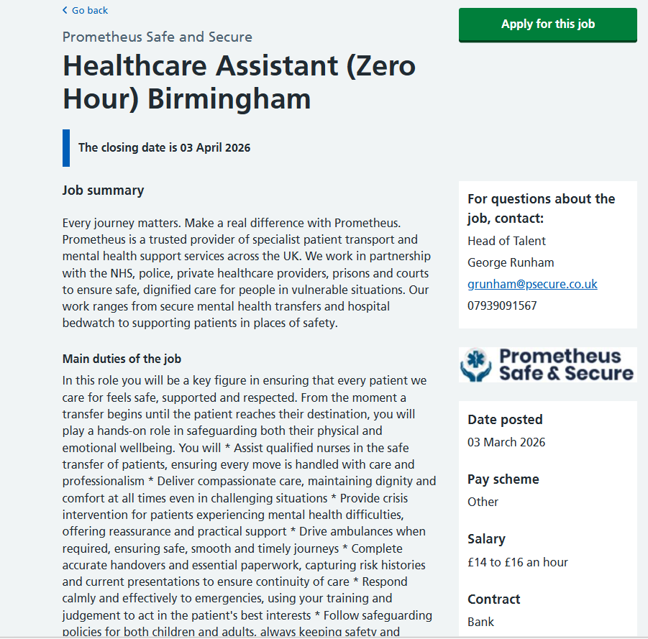

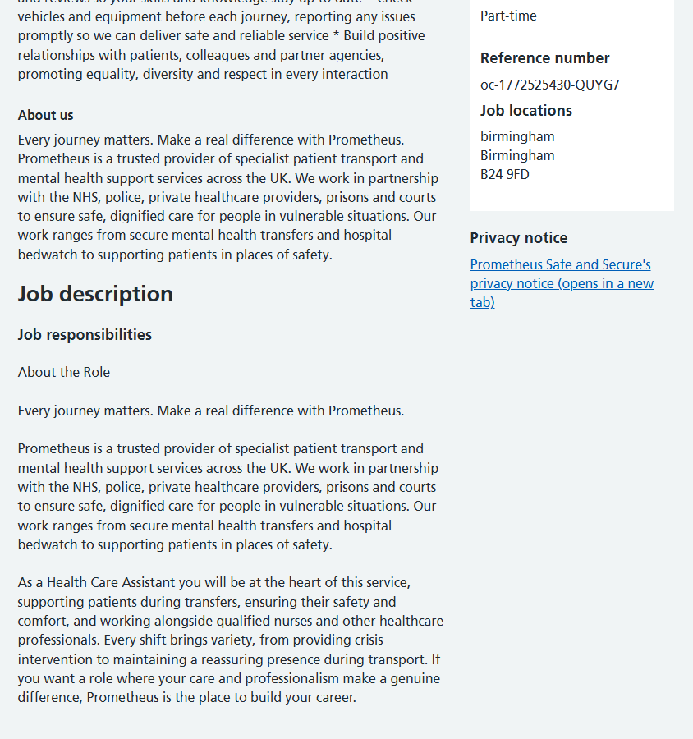

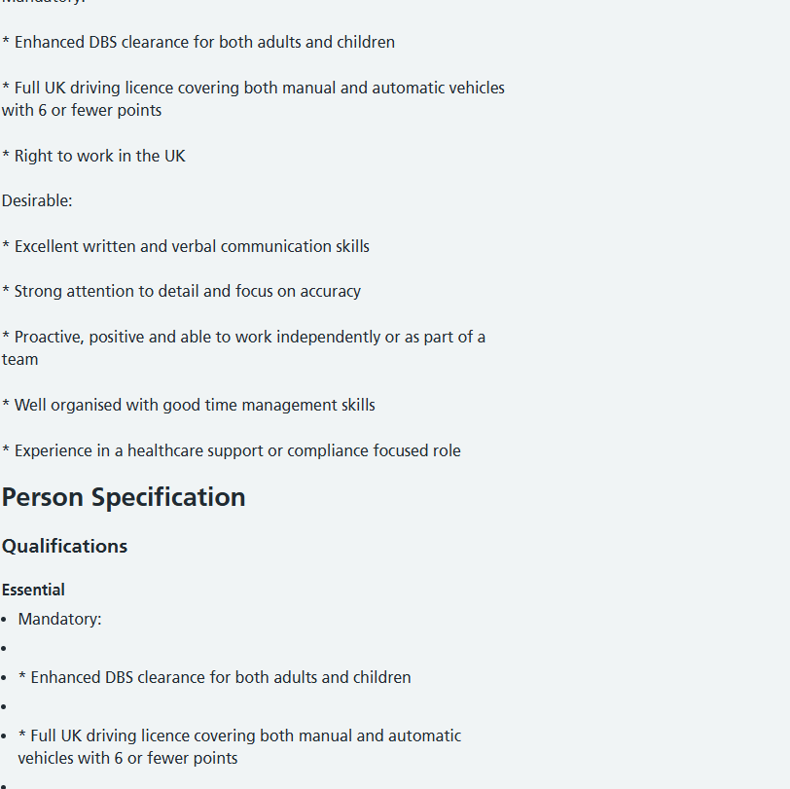

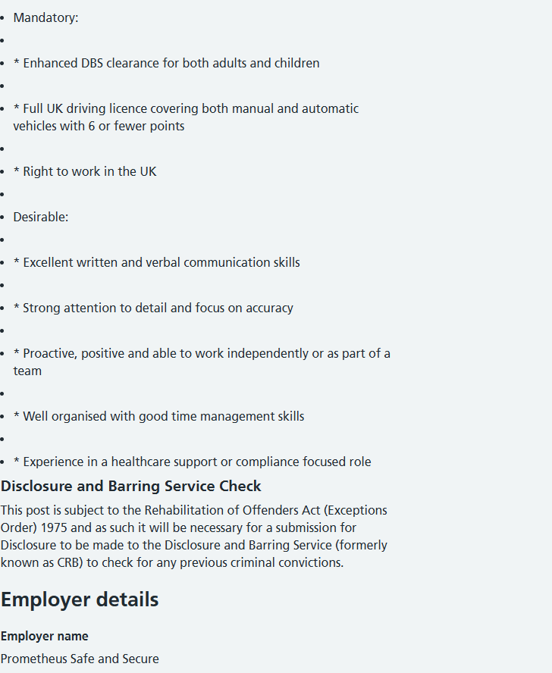

Curriculum Vitae
Name: Nusrat Bi
Address:
Email:
Telephone:

Personal Profile
I am a compassionate, reliable, and motivated healthcare professional with experience working in pharmacy, general practice, and hospital administration environments. I hold a Level 3 NVQ Diploma in Pharmacy Skills and have developed strong communication and organisational skills through supporting patients and healthcare teams in a variety of settings. I am passionate about delivering high-quality, person-centred care that promotes dignity, safety, and wellbeing. I am currently seeking an opportunity within the health and social care sector, such as a Health Care Assistant or Support Worker role, where I can use my experience to support patients while continuing to develop my healthcare career.

Education and Qualifications
Level 3 NVQ Diploma in Pharmacy Skills – Buttercup Training (2019)
BTEC Level 3 Diploma in Pharmacy Skills – Buttercup Training (2019)
Functional Skills Level 2 Mathematics – Buttercup Training (2018)
Functional Skills Level 2 English – Buttercup Training (2018)
Level 2 Award in Customer Service – Buttercup Training (2018)

Professional Development
Safeguarding Adults and Children (2023)
Infection Prevention and Control (2023)
Equality, Diversity and Inclusion (2023)
Confidentiality and Data Protection in Healthcare (2022)

Employment History
Pharmacy Dispensary Assistant
Well Pharmacy, Birmingham (June 2021 – August 2023)
• Prepared prescriptions under the supervision of pharmacists.
• Assisted patients with medication queries and advice.
• Maintained accurate patient records and stock management.
• Worked collaboratively with GP surgeries regarding prescriptions.
Receptionist – GP Surgery
Maplewood Medical Centre, Birmingham (March 2020 – May 2021)
• Managed appointment bookings and patient enquiries.
• Maintained patient records using EMIS Web.
• Supported clinical staff with patient administration.
• Provided a professional and empathetic service to patients.
Hospital Out-of-Hours Receptionist
Sandwell General Hospital (October 2018 – February 2020)
• Registered patients attending urgent care appointments.
• Liaised with medical staff and patient families.
• Managed confidential patient information.
• Worked effectively within a busy healthcare environment.

Achievements
• Successfully achieved Level 3 Pharmacy Skills qualification.
• Developed strong patient communication and healthcare administration skills.
• Demonstrated commitment to continuous professional development.

Key Skills
• Compassionate and caring approach when supporting patients.
• Knowledge of medicines management and dispensing procedures.
• Strong communication skills with patients, families, and healthcare teams.
• Understanding of confidentiality, safeguarding, and data protection.
• Ability to work effectively in multidisciplinary teams.
• Knowledge of infection prevention, health and safety, and patient care practices.
• Strong attention to detail developed through pharmacy and healthcare administration.
• Experience using NHS systems such as EMIS Web and electronic patient records.

Interests and Hobbies
I enjoy supporting my local community, particularly helping elderly neighbours and promoting wellbeing. I am interested in learning more about healthcare and enjoy reading about medical and psychological topics. I also enjoy walking groups and activities that support physical and mental wellbeing.

References
Available upon request.

Task 2 – Personal Statement
I am applying for the role of Health Care Assistant because I am passionate about supporting individuals and contributing to the delivery of high-quality care. My experience working within pharmacy, general practice, and hospital administration has given me a strong understanding of healthcare environments and the importance of providing compassionate, person-centred care. These experiences have motivated me to continue developing my career within the health and social care sector.
I achieved a Level 3 NVQ Diploma in Pharmacy Skills through Buttercup Training, where I developed knowledge of medicines management, patient safety, and healthcare procedures. This qualification helped me understand the importance of accuracy, responsibility, and confidentiality when working with patient information and medication. In addition, I completed Functional Skills qualifications in English and Mathematics, which strengthened my communication and organisational abilities. Alongside my formal education, I have also completed professional training in safeguarding, infection prevention and control, equality and diversity, and data protection, which are essential for safe practice in healthcare environments.
My role as a Dispensary Assistant at Well Pharmacy allowed me to work closely with patients and healthcare professionals on a daily basis. I was responsible for preparing prescriptions accurately, supporting pharmacists, and assisting patients with medication queries. Through this role, I developed strong attention to detail and gained valuable experience in communicating with patients from a range of backgrounds. Many patients required reassurance and guidance regarding their medication, and I learned the importance of listening carefully and responding with empathy and patience.
Working as a receptionist at Maplewood Medical Centre further strengthened my communication and organisational skills. I was often the first point of contact for patients contacting the surgery, which required professionalism, empathy, and the ability to manage sensitive situations. I regularly scheduled appointments, updated patient records using EMIS Web, and supported clinical staff to ensure the smooth running of the practice. This role helped me develop the ability to remain calm and professional while managing multiple tasks in a busy healthcare environment.
My experience working at Sandwell General Hospital as an out-of-hours receptionist provided valuable exposure to the fast-paced nature of hospital care. I supported patients and visitors arriving for urgent appointments and worked closely with clinical staff to ensure accurate documentation and effective communication. This role strengthened my teamwork skills and my ability to work under pressure while maintaining a caring and professional approach.
I believe my personal qualities make me well suited to the role of Health Care Assistant. I am compassionate, reliable, and committed to supporting individuals with dignity and respect. I have strong interpersonal skills and enjoy working as part of a multidisciplinary team to ensure patients receive the best possible care.
In the future, I hope to continue developing my knowledge and practical skills within the healthcare sector while contributing positively to the organisations I work for. I am particularly interested in gaining further experience in patient care and developing my professional skills within a supportive healthcare team.

Task 3 – SWOT Analysis

SWOT Analysis: Health Care Assistant Role
Strengths | Weaknesses
Experience in pharmacy, GP, and hospital environments  Strong communication and empathy skills  Knowledge of medicines management  Attention to detail and organisational skills | Limited direct clinical care experience  Developing confidence in complex clinical situations  Need to build more hands-on patient care skills  Time management when balancing work and study
Opportunities | Threats
Growing demand for healthcare assistants in the UK  Opportunities for further healthcare training  Potential progression into nursing  Access to NHS training and development programmes | Competition for healthcare roles  High workload in healthcare settings  Emotional and physical demands of healthcare work  Financial pressures while studying

Goals | List the actions to complete to achieve the goal | Support/resources needed | Target date | Review date
Gain employment as a Health Care Assistant | Apply for roles, prepare CV and attend interviews | NHS Jobs, Indeed, career guidance | Within 6 months | Review after 3 months
Increase healthcare knowledge | Read healthcare guidance and complete CPD courses | NHS learning resources | Within 18 months | Review every 6 months
Develop patient care skills | Attend training in first aid, manual handling and BLS | Online courses, workplace training | Within 12 months | Review every 6 months
Improve communication and teamwork skills | Work closely with healthcare teams and attend workshops | Mentors and training resources | Ongoing | Review every 6 months
Prepare for future healthcare career progression | Research education opportunities and speak to career advisors | Universities, career support services | Within 24 months | Review annually

Task 3 – Personal Development Plan (PDP)

Task 4 – Critical Reflection using Gibbs’ Reflective Cycle

Description
For the Component 1 assessment, I delivered a presentation on the topic of effective communication in health and social care. The purpose of the presentation was to explain what communication means in healthcare settings, why it is important, and how it supports safe and person-centred care. Unlike typical classroom presentations, I delivered my presentation directly in front of my lecturer rather than a full group of students.
During the presentation, I explained different types of communication used in health and social care, including verbal communication, non-verbal communication, and written communication. I discussed how these forms of communication are used by healthcare professionals when interacting with patients, families, and colleagues (Skills for Care 2020). I also highlighted the importance of communication in supporting patient safety, building trust with service users, and ensuring effective teamwork within healthcare settings (O’Daniel and Rosenstein, 2018).
As part of my presentation, I introduced Michael Argyle’s Communication Cycle, which explains how communication occurs through a process where a message is sent, received, interpreted, and followed by feedback to confirm understanding (Argyle, 2013). I also included a practical example of communicating with an elderly patient who was hard of hearing and anxious about their medication. This example demonstrated how healthcare professionals must adapt their communication style to meet the individual needs of patients.
The presentation concluded by linking communication to person-centred care and explaining how effective communication helps healthcare professionals respect patient preferences, promote dignity, and improve overall wellbeing (NHS England, 2021). After the presentation, my lecturer provided verbal feedback regarding the clarity of my content and my presentation delivery.

Feelings
Before delivering the presentation, I felt nervous because presenting can be challenging, especially when speaking directly in front of a lecturer. I was concerned that I might forget some of the points I had prepared or become anxious during the presentation. However, I also felt reasonably prepared because I had researched the topic and organised my slides carefully.
At the beginning of the presentation, I felt slightly anxious and noticed that my voice was not as confident as I would have liked. However, as I progressed through the slides and explained the key points, I began to feel more comfortable and confident. Because I had practised the presentation beforehand, I was able to follow the structure of the slides and explain the information clearly.
After finishing the presentation, I felt relieved and proud that I had successfully delivered my work, although I also recognised areas where I could improve in future presentations.

Evaluation
Overall, several aspects of the presentation were successful. The slides were well organised and followed a logical structure, which helped explain the topic clearly. I was able to explain the concept of communication within health and social care and link it to professional practice and person-centred care. The use of Michael Argyle’s Communication Cycle helped demonstrate theoretical understanding of communication processes (Argyle, 2013). In addition, the practical example of communicating with an elderly patient helped show how communication skills can be applied in real healthcare situations.
However, there were also areas that could have been improved. At times, I relied too heavily on the slides and could have maintained better eye contact during the presentation. In addition, my confidence at the beginning of the presentation could have been stronger. Speaking slightly slower and projecting my voice more clearly could also have improved the overall delivery.

Analysis
Reflecting on this experience highlights the importance of communication skills not only in healthcare practice but also in professional and academic presentations. Effective communication is considered a key professional skill within health and social care because it supports patient safety, teamwork, and high-quality care (Health and Care Professions Council, 2022). My presentation demonstrated my understanding of the importance of communication in healthcare settings, particularly when interacting with patients who may have specific communication needs.
Furthermore, reflective practice is widely recognised as an important method for improving professional skills and learning from experiences (Cottrell, 2019). By reflecting on my presentation, I was able to identify both my strengths and areas for development. Preparation helped me organise the information effectively, but additional practice focusing on delivery would improve my confidence and engagement with the audience.

Conclusion
Overall, the presentation was a valuable learning experience that helped me develop both my knowledge of communication in health and social care and my presentation skills. I was able to demonstrate an understanding of key communication concepts and provide practical examples of how communication is used in healthcare environments. However, I recognise that improving my confidence and presentation delivery will help me perform more effectively in future presentations.

Action Plan
In future presentations, I will practise my presentation multiple times beforehand in order to become more confident with the content. I will also focus on maintaining better eye contact and engaging more with the audience rather than relying heavily on the slides. In addition, I will work on speaking at a steady pace and projecting my voice clearly to improve the clarity of my presentation. By continuing to reflect on my experiences and seek feedback from lecturers, I will continue developing my communication and presentation skills for future academic and professional situations (Cottrell, 2019).

Reference List
Argyle, M. (2013) Social Interaction: Process and Products. Routledge.
Cottrell, S. (2019) The Study Skills Handbook. 5th edn. Red Globe Press.
Health and Care Professions Council (2022) Standards of conduct, performance and ethics. Available at: https://www.hcpc-uk.org (Accessed: 8 March 2026).
NHS England (2021) Effective communication in healthcare practice. Available at: https://www.england.nhs.uk (Accessed: 8 March 2026).
O’Daniel, M. and Rosenstein, A. (2018) Professional communication and team collaboration in healthcare. Agency for Healthcare Research and Quality.
Skills for Care (2023) Communication skills in health and social care. Available at: https://www.skillsforcare.org.uk (Accessed: 8 March 2026).
World Health Organization (2021) Ageing and health. Available at: https://www.who.int (Accessed: 8 March 2026).

