Children & young people in a digital world: seeing the whole picture (through a Welsh lens)
“It’s not about counting minutes; it’s about the quality of digital interactions and what they displace—sleep, movement, social time.” (RCPCH; AAP)
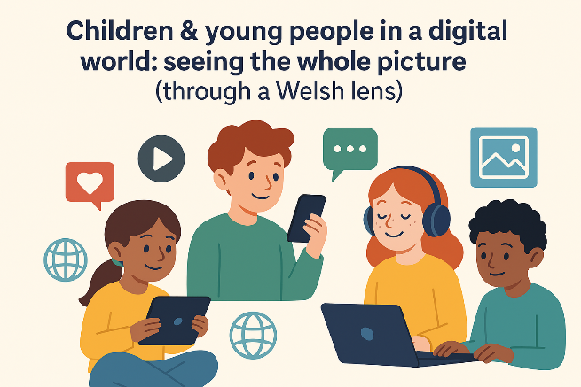
We all know the digital world is where our learners live as much as where they learn. Short-form videos, messages in group chats, and creative posts are woven into daily life. In the UK, almost all 8–17-year-olds go online regularly, creating and sharing their own content—both opportunities and risks (Ofcom, 2024). (Ofcom 2024 report) (Think-Bank summary)

A friendly theory to make sense of it all: Bronfenbrenner’s bioecological model
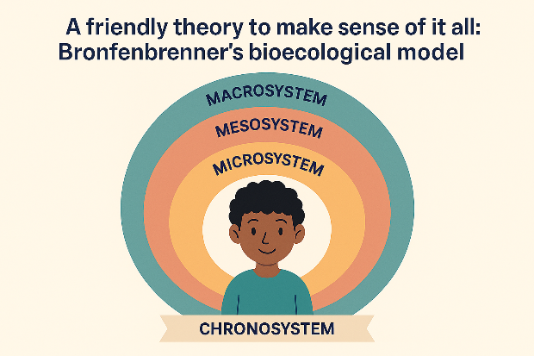
Here’s the helpful bit: Bronfenbrenner explains child development as dynamic interactions between the child and layers of their environment—microsystem (home, class, online communities), mesosystem (home–school–platform links), exosystem (regulators and platform policies), macrosystem (culture and national policy), and chronosystem (time and life transitions). Recent research even recognises virtual microsystems (social media, gaming platforms) as real developmental settings. (SimplyPsychology overview) (Frontiers review)
Why it matters for classrooms in Wales: the quality of proximal processes—the repeated, meaningful interactions learners have in those online spaces—drives growth. So, our job isn’t only to restrict but also to shape those processes through scaffolded, creative, and safe activities.

The upside: learning, creativity, voice
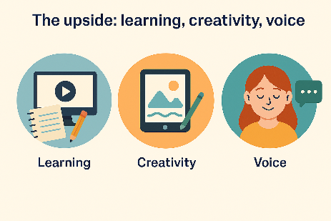
- Learning gains when tech is purposeful. Meta-analysis shows that digital technology can enhance deep learning—especially in blended approaches (offline planning, online production, and structured feedback) —with explicit guidance and collaboration. (Wu, 2023/24) (Hattie, 2023)
- Agency as producers. A substantial share of young people publishes videos or podcasts, building multimodal composition, audience awareness, and (if taught) copyright literacy. (Ofcom 2024) (National College guide)
“Design the digital tasks you actually want learners to repeat—create–review–publish cycles with peer feedback.” (Bioecological proximal processes)

The downside: risk, wellbeing and a lot of headlines
- Harm exposure, mis/disinformation, commerce. Most children will encounter some online risks (bullying, scams, harmful content). KCSIE 2025 explicitly adds misinformation/disinformation to online-safety risk categories—worth tracking even from Wales. (Ofcom 2024) (KCSIE 2025)
- Screen time—nuance beats panic. UK paediatric guidance avoids a universal “safe hour count”, emphasising quality and displacement (sleep, movement, social time), with common-sense routines such as “screens off an hour before bed.” Recent US data link ≥4 hours of non-school daily screen time with poorer sleep and more anxiety/depressive symptoms—proper caution, but context is everything. (RCPCH factsheet & guide) (CDC/NCHS data briefs, 2024–25) (AAP updated guidance, 2025)
- Mental health and social media—mixed evidence. Extensive international analyses from the Oxford Internet Institute find small, inconsistent population-level associations between internet use and psychological harm; researchers still call for better platform data to study mechanisms. (Oxford Internet Institute 2023) (TechCrunch analysis)
Takeaway: apply the bioecological lens—what matters is the fit across home routines, school safeguards, platform design, and developmental timing.

The policy layer: how the macro/exo systems support safety and literacy
- Curriculum for Wales – Digital Competence Framework (DCF). Digital competence is a mandatory cross-curricular responsibility (citizenship, online behaviour/cyberbullying, identity, health & wellbeing). It’s a whole-school endeavour, not an ICT add-on. (Hwb DCF) (DCF guidance)
- UKCIS Education for a Connected World (2020). Eight practical strands (Self-image & Identity, Online relationships, Reputation, Bullying, Managing information, Health & lifestyle, Privacy & security, Copyright & ownership) for progression EY–KS4. (UKCIS framework)
- Online Safety Act 2023 (UK). The strongest protections are for children; platforms must assess risk, enforce age verification, address illegal content, and mitigate harm. Ofcom’s children’s codes (published April 2025) set timelines and measures. (OSA explainer) (Ofcom decisions summary, 2025)

Classroom-ready moves (linked to DCF & UKCIS)
- Reputation & identity (Upper KS2/KS3).
Learners audit their digital footprint, storyboard how a post travels, and co-author a class charter on identity/reputation. (UKCIS: Self-image & identity; Online reputation. DCF: Citizenship.) (UKCIS framework) (Hwb DCF)
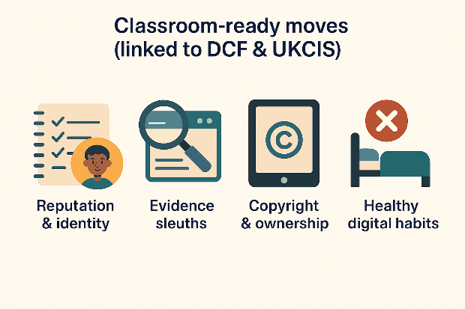
- Evidence sleuths: mis/disinformation (KS3/KS4).
Teach lateral reading, source triangulation, and bias prompts; compare a viral clip with primary data. (UKCIS: Managing online information; KCSIE 2025 risk categories.) (UKCIS) (KCSIE 2025)
- Copyright & ownership through creation (KS2).
Publish a short podcast with Creative Commons music and proper attributions; assess with a rubric including IP/permissions. (UKCIS: Copyright & ownership; DCF: Producing.) (UKCIS) (Hwb DCF)
- Healthy digital habits (FP/KS2).
Co-design class routines: device-free meals, screens off before sleep, movement breaks; explain why—protect sleep, balance sedentary time. (RCPCH/AAP guidance.) (RCPCH guide) (AAP 2025)
- Blended creation cycles (all phases).
Plan, create, review, and publish cycles (offline planning, online production, and peer critique). Evidence suggests stronger deep learning when tech is guided, collaborative, and blended. (Wu, 2023/24) (Hattie, 2023)

What this means for Brynmill Primary (practical, Wales-specific)
1) Make DCF visible in every area.
Map ongoing projects (e.g., inquiry in humanities, science investigations) to DCF Citizenship and Interacting & Collaborating so digital literacy isn’t siloed. (Hwb DCF)
2) Strengthen the home–school “mesosystem”.
Offer parent workshops that share RCPCH’s simple checklist (sleep, movement, mealtimes, co-viewing) and explain the Online Safety Act in plain language—what platforms must do, and how families can use age-assurance and reporting. (RCPCH) (OSA explainer)
3) Embed total communication online.
Extend your in-school total communication approaches into the virtual microsystem—use captions, visuals, symbols and co-regulated routines (“post, pause, check”) in Seesaw/Teams to support learners with ALN to participate safely and meaningfully. (Aligns with DCF Interacting & Collaborating.) (Hwb DCF)
4) Evidence impact, not just compliance.
Collect pupil voice, work samples, and wellbeing notes to show how digital tasks build reasoning, collaboration and safe habits—then iterate. Link lesson studies to the blended cycles that research says work best. (Wu, 2023/24) (Hattie, 2023)

Final thought
The digital world isn’t going away—and neither should our learners’ curiosity and creativity. With a bioecological mindset, Wales’ DCF as our curriculum anchor, UKCIS to shape progression, and the Online Safety Act setting clearer guardrails, we can design the right digital interactions—the ones worth repeating. That’s how we turn online spaces into genuine learning microsystems.

References (selected)
- Ofcom (2024). Children and parents: media use and attitudes report 2024.
<https://www.ofcom.org.uk/media-use-and-attitudes/media-habits-children/children-and-parents-media-use-and-attitudes-report-2024>
- UKCIS (2020). Education for a Connected World.
<https://www.gov.uk/government/publications/education-for-a-connected-world>
- Welsh Government (Hwb). Digital Competence Framework (DCF).
<https://hwb.gov.wales/curriculum-for-wales/cross-curricular-skills-frameworks/digital-competence-framework-dcf/>
- DSIT (2025). Online Safety Act: explainer.
<https://www.gov.uk/government/publications/online-safety-act-explainer/online-safety-act-explainer>
- DfE (2025). Keeping Children Safe in Education 2025.
<https://www.gov.uk/government/publications/keeping-children-safe-in-education--2>
- RCPCH (2019). Screen time guide.
<https://www.solgrid.org.uk/wellbeing/wp-content/uploads/sites/23/2019/01/rcpch_screen_time_guide_-_final.pdf>
- AAP (updated 2025). Screen Time Guidelines.
<https://www.aap.org/en/patient-care/media-and-children/center-of-excellence-on-social-media-and-youth-mental-health/qa-portal/qa-portal-library/qa-portal-library-questions/screen-time-guidelines/>
- Oxford Internet Institute (2023). No “smoking gun” mental health harm.
<https://www.ox.ac.uk/news/2023-11-28-no-smoking-gun-mental-health-harm-internet-landmark-oxford-survey>
- Wu, X-Y. (2023/24). Digital tech & deep learning meta-analysis.
<https://link.springer.com/article/10.1007/s10639-023-12307-1>
- Hattie, J. (2023). Visible Learning: The Sequel.
<https://www.taylorfrancis.com/books/mono/10.4324/9781003380542/visible-learning-sequel-john-hattie>

