University of Wales Trinity Saint David
MSc Cybersecurity and Digital Forensics
Ethical Hacking (ACCA7033)
Connor Michael Anthony Wilson (2011592@student.uwtsd.ac.uk)
Research into cyber security attacks and Penetration testing for a virtualise simulated company Website.



Content Page
Task 1
Glossary – Page 1,2,3
Assignment Breakdown – Page 4
Introduction – Page 4
Methodology for Analysis of Case studies
Research Approach – Page 5
Analysis Tools – Page 5
Selection Criteria – Page 5
Case Study 1: Stuxnet
Stuxnet Case Study – Page 5,6
Case Study 1: Stuxnet Analysis - Page 6,7,8,9
Case Study 1 Stuxnet Lockheed Martin Cyber Attack Model – Page 10
Case Study 2: WannaCry NHS Attack – Page 10,11,12,13,14,15
Case Study 2 Cyber Kill Chain Model – Page 16,17,18
Task 2
Introuduction – Page 19
Network Design – Page 19
Highlighting Initial Vulnerabilities in the network – Page 20
Cpmtogemcu Policy for Pentration Testing – Page 20
Pentest Attack Process – Page 21,22,23,24,25,26,27,28,29,30,31
Conclusion – Page 31
References – Page 32, 33

Glossary
Cybersecurity Attack Case Studies - Detailed examinations of specific incidents where cybersecurity breaches have occurred, used to understand the tactics employed by attackers and to develop prevention strategies.

Scholarly Materials - Academic sources that include peer-reviewed articles, journals, and other educational publications used to support research and analysis.

Prevention Strategies - Methods and techniques proposed to avoid or mitigate the impact of cybersecurity threats and vulnerabilities.

Cyberattack Simulation - A controlled exercise that replicates the actions of a cyberattack on a computer system, network, or virtual environment to test the security and response capabilities of the system.

Virtual Machines - Software-based simulations of computer systems that can run different operating systems and applications like physical computers.

MITRE ATT&CK Framework - A globally accessible knowledge base of adversary tactics and techniques based on real-world observations used for planning security improvements and training.

OWASP Top 10 - A standard awareness document for web application security that represents a broad consensus about the most critical security risks to web applications.

Cyber Kill Chain - A model to outline the stages of a cyberattack from early reconnaissance to the final actions that affect the target.

STRIDE - A mnemonic for security threats in software systems: Spoofing, Tampering, Repudiation, Information Disclosure, Denial of Service, and Elevation of Privilege.

Stuxnet - A sophisticated computer worm discovered in 2010 that targeted industrial control systems used in infrastructure facilities, causing physical, real-world damage to equipment.

Programmable Logic Controllers (PLCs) - Industrial computer systems that monitor inputs from various sensors and make decisions based on pre-programmed logic to control machinery and processes.

WannaCry - A ransomware attack that occurred in May 2017, affecting thousands of computers worldwide by exploiting vulnerabilities in Microsoft Windows operating systems.

EternalBlue - A cyberattack exploit developed by the U.S. National Security Agency that leverages vulnerabilities in Microsoft Windows SMB protocol.

National Health Service (NHS) - The publicly funded healthcare system for England, and one of the four National Health Services for each constituent country of the United Kingdom.

Kaspersky Lab - A global cybersecurity company that provides security solutions and services to protect businesses, critical infrastructure, governments, and consumers around the globe.
etasploit: A popular penetration testing framework that provides tools to exploit vulnerabilities and assess network security.

SMB (Server Message Block) Protocol: A network file sharing protocol that allows applications on a computer to read and write to files and request services from server programs in a computer network.

Crypto ransomware: A type of ransomware that encrypts valuable data on a system, making it inaccessible until a ransom is paid.

Firewall: A network security system that monitors and controls incoming and outgoing network traffic based on predetermined security rules.

Patch Management: The process of managing updates of software patches for computers and network devices, intended to correct security vulnerabilities and other bugs.

NDG (National Data Guardian): A UK authority that ensures the use of health and care information is ethical, and that it respects people's confidentiality.

Cyber Kill Chain: A model developed by Lockheed Martin that describes the phases of a cyber-attack, from reconnaissance to actions on objectives.

MITRE ATT&CK: A knowledge base maintained by MITRE for listing and explaining adversary tactics and techniques based on real-world observations.

SQL Injection: A type of security exploit in which an attacker adds Structured Query Language (SQL) code to a web form input box to gain access to resources or make changes to data.

OWASP (Open Web Application Security Project): A nonprofit foundation that works to improve the security of software through community-led open-source software projects.

Europol: The European Union’s law enforcement agency which assists the EU Member States in their fight against serious international crime and terrorism.

Assignment Breakdown

This assignment is divided into two main sections. The first part comprises a research segment that provides the author with insights into emerging trends and risks through the detailed analysis of three cybersecurity attack case studies. This analysis will be grounded in scholarly materials, offering an in-depth look at how these attacks were executed and suggesting prevention strategies that could be recommended to the affected organizations.
The second part of the assignment leverages knowledge gained from lectures and the research phase to conduct a comprehensive, multi-layered cyberattack simulation on a fictional company. This simulation, executed using virtual machines, will demonstrate an exploit and outline prevention strategies based on the MITRE ATT&CK and OWASP Top 10 Frameworks.

Introduction

In the digital era, where data is as valuable as currency and the integrity of information systems is paramount, cybersecurity breaches have emerged as one of the most formidable challenges facing businesses and organizations worldwide.
Half of businesses (50%) and around a third of charities (32%) report having experienced some form of cybersecurity breach or attack in the last 12 months reported by the UK government in their “Cyber Security Breaches Survey 2024”.[1]
In a report published by IBM, they found that an organisation can be expected to pay an average of £3.4 million for a data breach incident with the highest costs being those in the finical and technology sectors. Only around 51% of the organisations that have experienced a breach plan on increasing their security investments. [2]
With these statics it be understood that cybersecurity is still an issue within many businesses across the United Kingdom with high costs associated with breaches from finical damages or fines that can be issued.
Case studies offer insight on previous incidents so that we can learn from short comings so security techniques can improve to form better standardised practices among cybersecurity professionals around the world. Upon analysing the case studies, we can notice a vulnerability within a systems structure, how it was exploited and how the security incident could be avoided.
Case studies provide an opportunity to reflect on real world incidents, on the timeline of how the incident unfurled, and on the opportunities presented to threat intelligence teams. [3]

Methodology for Analysis of Case studies
Research Approach
My research approach for this assignment will involve different peer-reviewed articles, official reports on cybersecurity attacks and expert analysis. Making use of accredit sources ensure that my information required is reliable will make a good foundation for the practical section of my assignment.
Analysis Tools
To analysis the case studies the writer will be making use of a variety of different cybersecurity analysis models and diagrams such as Cyber Kill Chain or STRIDE. This will allow each case study to be analysed during each stage of the attack so it can be clear what process the perpetrator used to conduct their respective attacks.
Selection Criteria
The criteria for choosing the case studies will be focusing on recency, impact, and diversity of tactics.
The reason for this is that recent attacks will be representative of the current trends within cybersecurity industry. Having knowledge around these recent cases will be more important for my future career and having knowledge around breaches in the past while helpful may not have as much relevancy of the problems that current organisations might face. I
High-impact case studies are crucial in cybersecurity for bridging theoretical knowledge with real-world scenarios, fostering critical thinking, and highlighting emerging threats. They provide invaluable lessons from past mistakes and successes, guiding the development of innovative security measures and strategies, while also enhancing public awareness and education on cybersecurity importance.

Case Study 1: Stuxnet
Stuxnet Case Study
The Stuxnet virus, a sophisticated computer worm, was specifically designed to target and damage the supervisory control and data acquisition (SCADA) systems within Iran's nuclear weapons program. The primary focus of the attack was the Natanz uranium enrichment facility, which housed over a thousand centrifuges. [4]

The virus was introduced through four zero-day vulnerabilities within the network's system. These vulnerabilities were exploited using a malicious payload delivered via a USB drive. Notably, these vulnerabilities could be exploited even on fully updated Windows 7 systems, the leading operating system at the time. [5]

To mitigate future similar risks, implementing policies to disable USB device usage could have been effective. Such policies, enforceable through Active Directory administration, would restrict USB access to unauthorized users, significantly reducing the risk of similar attacks. Additionally, the attack involved placing four different LNK files in the root directory, which directed to a malicious DLL file. When accessed by Windows Explorer, the LNK file triggered the "LoadLibrary" function on the DLL file, executing the malware's main function. [6]

The attack specifically targeted the programmable logic controllers (PLCs) of the centrifuges, which were managed using Siemens Step7 software. The virus caused these centrifuges to operate at unsafe speeds, ultimately leading to their destruction. [7]

Given the critical nature of the facility, it would have been prudent to consider alternative controller software to mitigate risks associated with software vulnerabilities. Establishing a rigorous database to monitor and validate software deployed on company devices could further prevent exploitable vulnerabilities. This case study underscores the importance of avoiding easily exploitable software and enhancing network security to prevent such catastrophic cyberattacks.
Case Study 1: Stuxnet Analysis
In using the MITRE ATT&CK database, it can be understood the techniques used in completing this exploit to gain access to a system. It will be covering the Industrial control system (ICS) as well as enterprise applications. Both were valid in the attack committed in the Case study.
Access Token Manipulation (T1134.001):
Stuxnet attempts to impersonate an anonymous token to enumerate bindings in the service control manager.[8]
Strict access control measures and least privilege principles to limit what resources a token can access when impersonated.
Monitoring and log all access tokens via an endpoint solution can be used to monitor any modifications and impersonations so that unusual activity can be detected.
Account Discovery (T1087):
Stuxnet enumerates user accounts of the local host.[8]
Stuxnet enumerates user accounts of the domain.[8]
Reviewing and updating account permissions to minimize unnecessary access.
Deploy security monitoring tools to detect unusual access patterns or attempts to enumerate accounts.
Application Layer Protocol (T1071.001):
Stuxnet uses Hyper Text Transfer Protocol (HTTP) to communicate with a command-and-control server. [8]
It would be hard to balance this as you would be restricting internet access for an organisation which is normally required to complete work in most jobs nowadays.
However, organisations can take steps to optimize HTTP Headers via configurations for better security. OWASP details configuration options to be used such as Preventing information disclosure via HTTP headers which would prevent any technical information about the web environment being displayed. Within the OWASP Secure Headers Project page, it provides a “Best Practices” tab given example of values to be used.
Included is a snippet of the examples provided by OWASP. Configuring using these settings will help to make the HTTP security for Headers more consistent within a configuration.
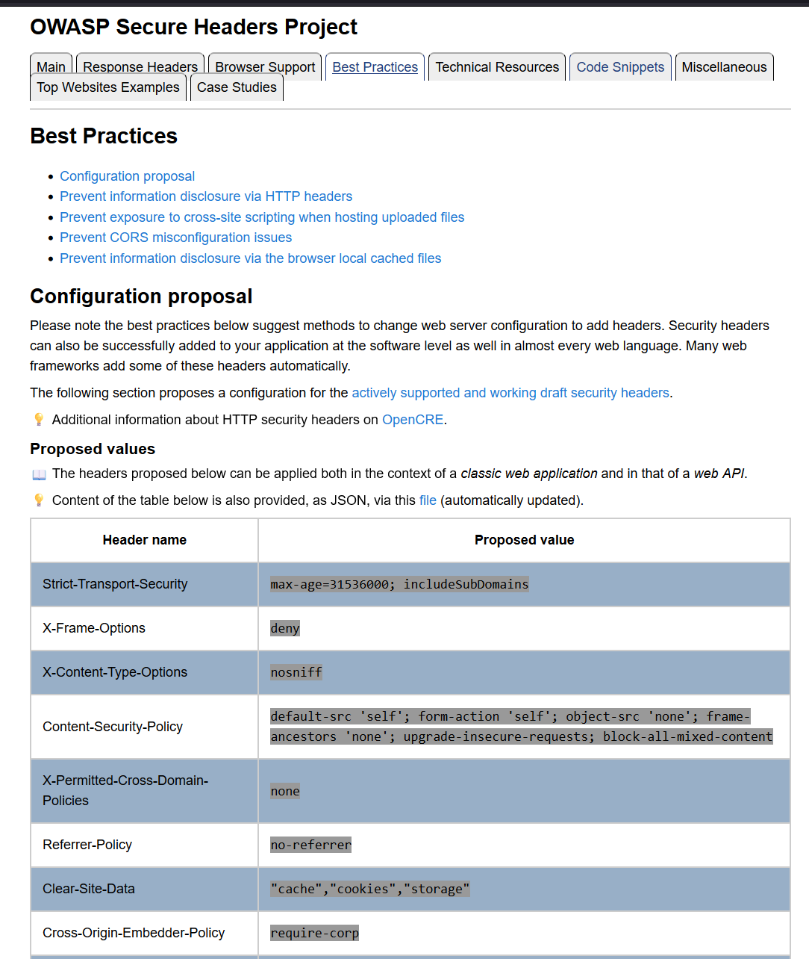
Figure 1 OWASP Secure Headers Project [9]

OWASP also offers a Cheat Sheet Series on security for HTTP Security Response Headers as well as other forms of HTTP security. Given a breakdown recommendation of different configurations for enhanced security.

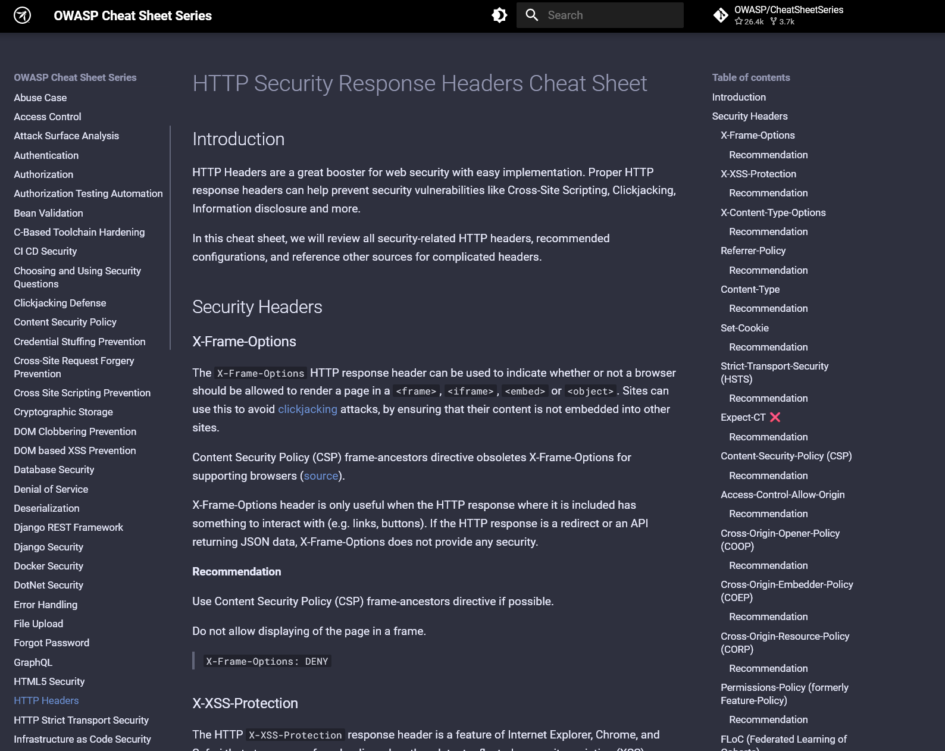
Figure 2 OWASP Cheat Sheet Series [10]
Using the Lockheed Martin “Cyber Kill Chain” cyber-attack model, the author will structure the attack so that is clear what is happening in each step of the attack and the reason why the attack was committed and easy to read format.

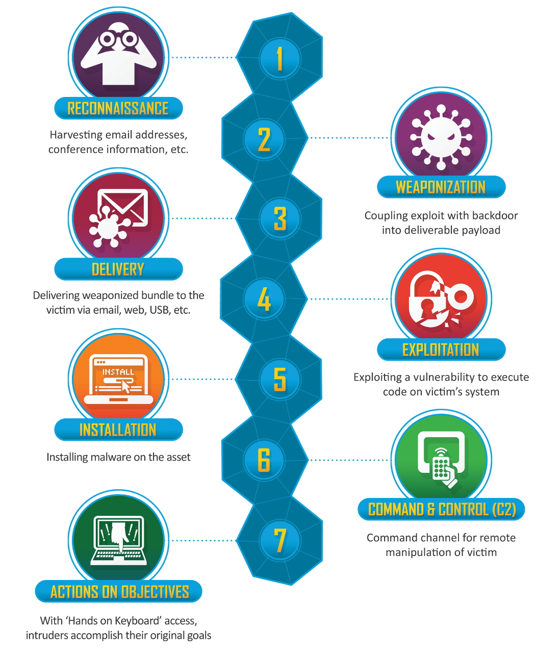
Figure 3 Lockheed Martin Cyber Attack Model. [11]

Case Study 1 Stuxnet Lockheed Martin Cyber Attack Model
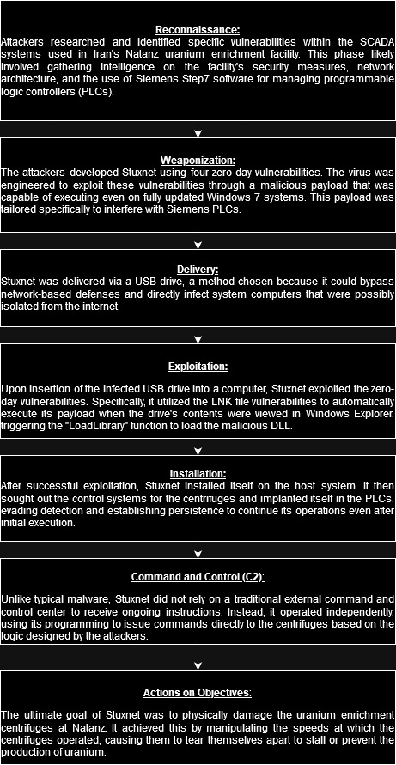

Case Study 2: WannaCry NHS Attack
The WannaCry 2017 ransomware event was a widespread cyberattack that had substantial effects on both organizations and individuals.
In May 2017, the WannaCry ransomware proliferated swiftly, compromising computer systems across more than 150 countries.
The WannaCry cyber-attack commenced on the morning of Friday, May 12, 2017. Within 24 hours, Europol reported that the attack had compromised over 230,000 computers across no fewer than 150 countries. [12]
This attack exploited a vulnerability in Windows, referred to as EternalBlue, which is believed to have been created by the National Security Agency (NSA) and was later disclosed by a hacker Collective known as the Shadow Brokers.
An effected organisations from the WannaCry Attack was the NHS (National Health Service) which is a health service provide throughout the United Kingdom though Wales and Northern Ireland remained unaffected.
The BBC understands about 40 NHS organisations and some GP practices have been hit. The NHS in Wales and Northern Ireland has not been affected. [13]
In a report published by the NHS England, the department details events of the attack as well as information that organisation has learned since the event occurred.
There systems were exploited due to a vulnerability in old unsupported versions of windows XP and Windows 7 as they were not up to date security patches.
Many NHS devices infected were running the supported, but unpatched, Microsoft Windows 7 operating system. Unsupported devices (those on XP) were in the minority of infected devices. [14]
In details released by Kaspersky Lab. It detailed that majority of machines that were affected by WannaCry were running on Windows 7 with a total 98%+ machines running Windows 7.
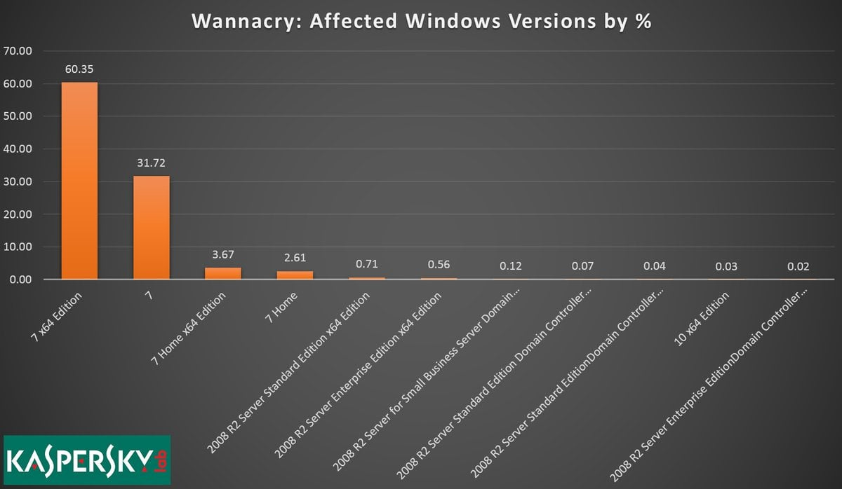
Figure 4 Kaspersky Lab Stats [15]
The WannaCry Worm would only work correctly majority of the time via Windows 7 as it was said to have bugs on other Windows platforms however overtime there was updated versions of the ETERNALBLUE exploit released that could exploit unpatched versions of operating systems up Microsoft Server 2016.
June 2018 a Metasploit module for ETERNALCHAMPION is introduced. This module was much more efficient as it works on all OS’s up to server 2016. [16]
The exploit would be swiftly patched by Microsoft with the Security Bulletin for the SMB Server exploit enabled by ETERNALBLUE being addressed in a critical security patch on March 14, 2017, under MS17-010.
This security update resolves vulnerabilities in Microsoft Windows. The most severe of the vulnerabilities could allow remote code execution if an attacker sends specially crafted messages to a Microsoft Server Message Block 1.0 (SMBv1) server. [17]
Due to the nature of the ETERNALBLUE being able to propagate itself spreading throughout a network, it made so that once one machine had become effected it would certainly affect the whole network.
Malware leveraging the ETERNALBLUE exploit can spread autonomously through networks, significantly amplifying its effects. A notable instance is WannaCry, a type of crypto-ransomware, which was among the earliest and most infamous to employ this exploit for dissemination. WannaCry utilizes ETERNALBLUE to propagate across networks, infecting connected devices and deploying its crypto-ransomware payload. [18]
In the wake of the attack the NHS has taken steps increase their investments in improving the network infrastructure by investing in Firewall technology and other assets to enhance the resilience of their network against future cyber-attacks. As well as device replacement and automation of patch management as well as improved anti-virus protection.
NHS has invested in various areas to strengthen their cybersecurity posture. This includes addressing vulnerabilities in their infrastructure, enhancing network security through firewall upgrades, and bolstering network resilience and segmentation to reduce risks to medical systems. Additionally, improving device security via device replacement and automating patch management, as well as enhancing anti-virus protection, are critical measures. [19]
The NHS has made changes to there leadership to in an NDG review (National Data Guardian for Health and Care’s review) which is the organisations data security, consent and opt-outs. [20]
This was to ensure that there is better security hygiene throughout their different venues.
Ensuring that the 10 information security standards are followed throughout their organisation. This includes, for example, ensuring that CareCERT alerts are actioned, patches are implemented when required and that regular review of firewall configuration and password controls are undertaken. [19]
The 10 information security standards are as follows for the NHS organisation.

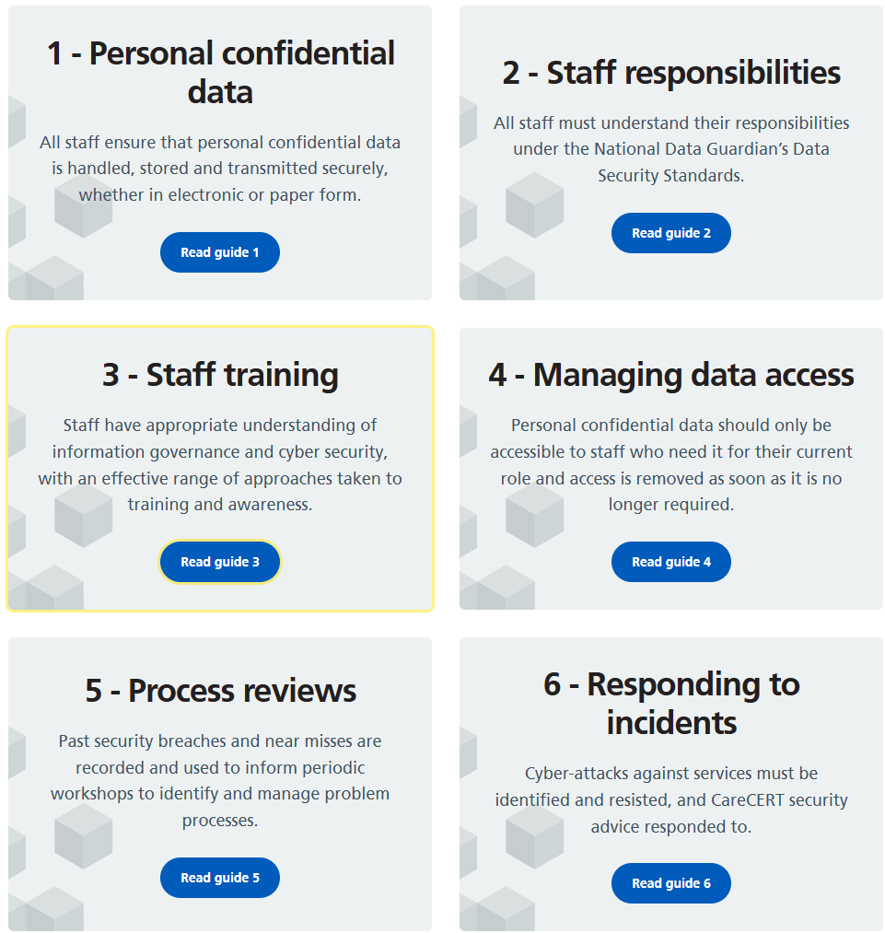
Figure 5 10 information security standards within the NHS [21]
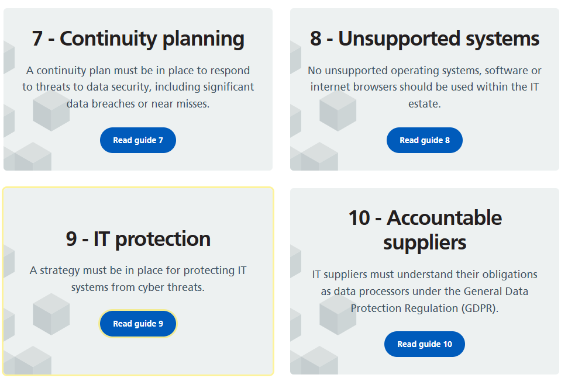
Figure 610 information security standards within the NHS [21]

The NHS organisation had advised that if more substantial firewall solution had been leveraged in their network infrastructure this could have limited the effectiveness of the exploit by limiting the WannaCry attack from spreading to other devices throughout their network.
Whether organisations had patched their systems or not, taking action to increase the security of their network firewalls facing the N3 network would have guarded organisations against infection23.[22]

Case Study 2 Cyber Kill Chain Model

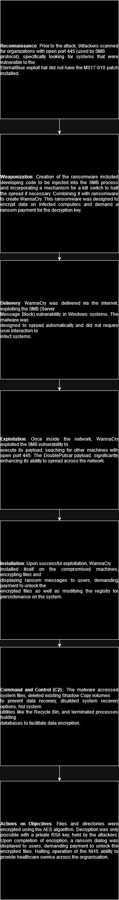

This model outlines the attack process of WannaCry using the Cyber Kill Model by Lockheed Martin.
With Knowledge from the MITRE ATT&CK database to explain the process of the attack when creating this model. [23]

Task 2
Introduction
The author has been tasked with completing a comprehensive Attack simulation on Cureton Pharmaceutical Company (CPC) network which will cover aspects of the design of their network infrastructure, any possible attack vectors that can be identified within the infrastructure.
Network Design
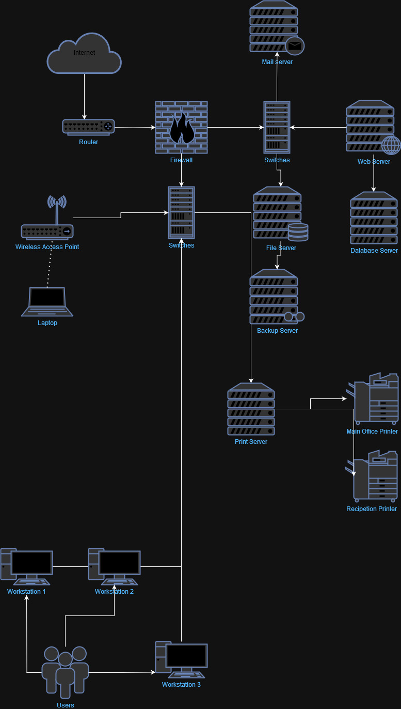
To start out with I will be setting out with a design for CPC network infrastructure with a block diagram. The Diagram will be created during Draw.IO to give a visual representation of what the network will look like.

Figure 7 CPC Network Diagram
Highlighting Initial Vulnerabilities in the network
Before further analysis, the writer will be giving an overview of some of the vulnerabilities that may be apparent within the network infrastructure and then going onto the complete further research into the vulnerabilities that can be enabled as a part of this network infrastructure before completing the assignment.
Initially there is a wireless access point within the network which could be vulnerable to outside threats or possible inside perpetrators that may enter the laboratory facility to exploit network environment of the laboratory.
Contingency Policy for Penetration Testing
Before beginning the process of the penetration testing, this is ensured that any functionality of the organisations system is not affected during the testing period on the organisations infrastructure.
First, an emanation of the network has been created to not effect the running and business function can continue as usual.
In case of any damage that may caused to the systems during the penetration testing, the author has made sure to create images of the test systems. This means that backups can be used to restore the image to ensure consistency in the test environment.
Using an MD5 (message-digest algorithm) can be used to ensure the data integrity of the images that have been created as after a backup has been taken the MD5 hash can be stored and then each time the backup is required the MD5 of the backup can be checked to ensure its data validity.
Ensure that the test environment is isolated from connecting to the organisations network during the test period to make sure that cyber hygiene is maintained and that there is no contamination of the main infrastructure.

Pentest Attack Process:
First of all machines have been configured and setup within the VirtualBox which is the VM (Virtual Machine) manager which is being used to emulate the network environment for the organisation.
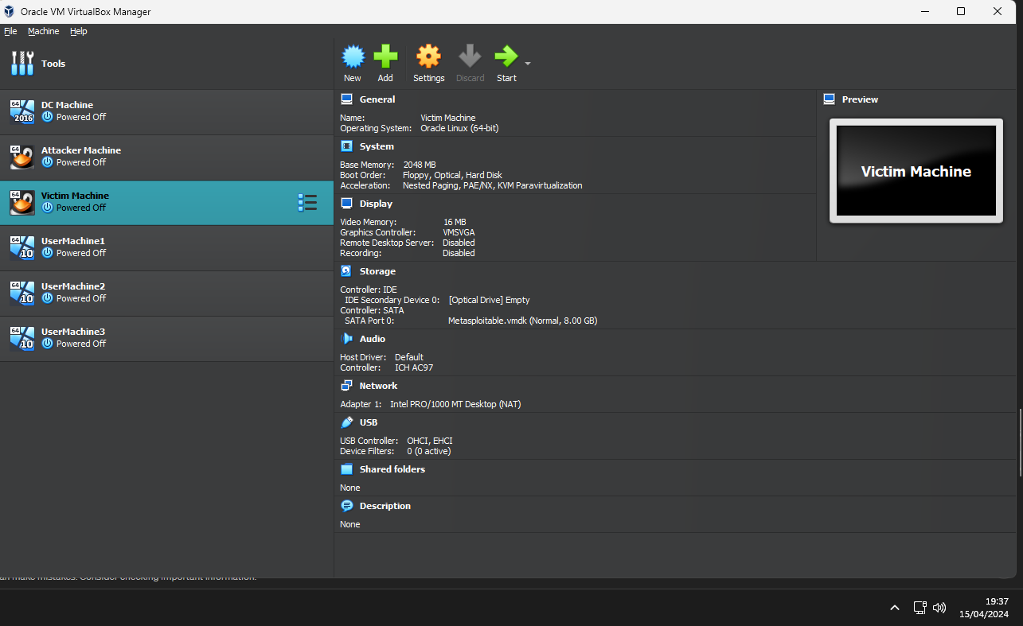
This gives an overview of the different machines with the Domain Controller machine (DC Machine), Usermachine 1,2 and 3 (Windows 10 user machines). Victim machine which is a vulnerable linux machine which is the file server machine and the attack machine which is running Metasploitable which will be delivering the attack onto the Victim Machine.

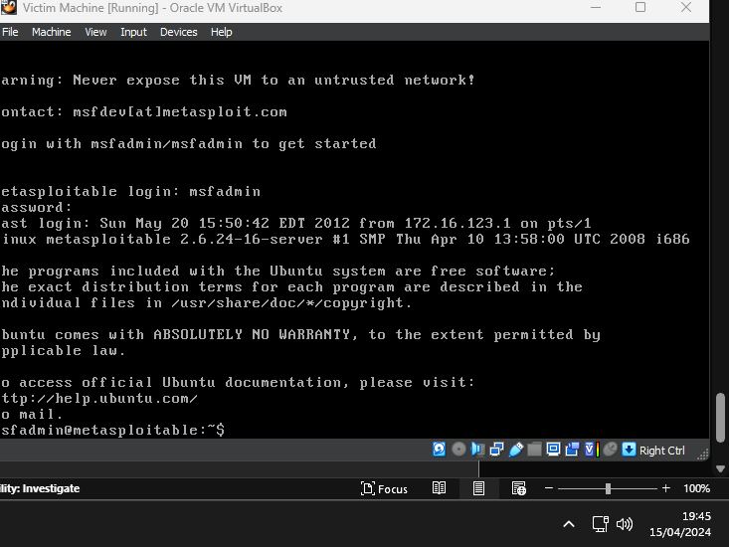
Metasploitable machine has been loaded and login into using the admin login details.
The first step is acquiring the network information of the both machines so that the SQL injection attack can begin.
The IP address of the Metasploitable machine is: 10.0.2.15
The IP address of the Bee-Box machine which is being attacked is: 10.0.2.15
The reason these addresses are the same as they are configured to run locally through my machine without internet access. This is stop the risk of the vulnerable machine from being attacked by outside sources during the demonstration of this attack.
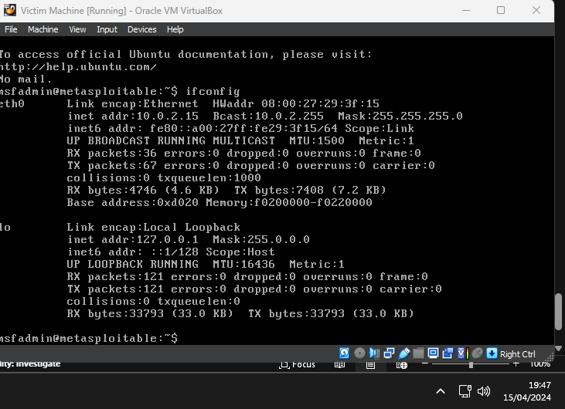
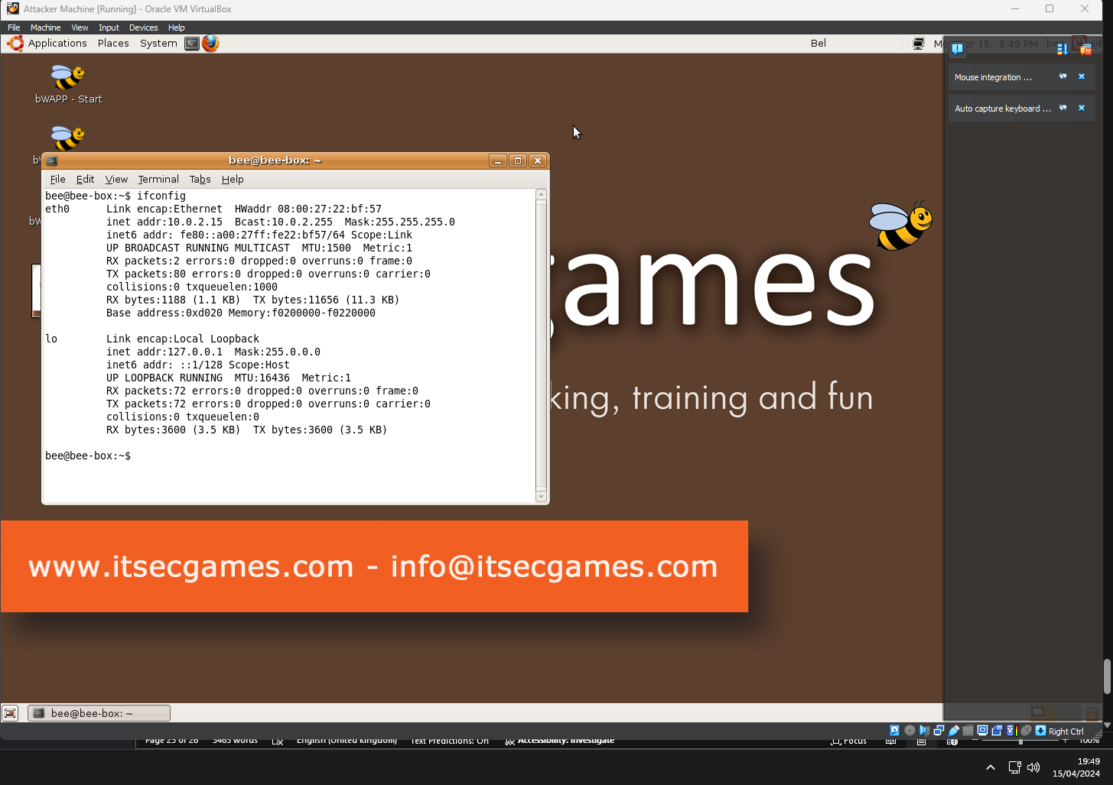

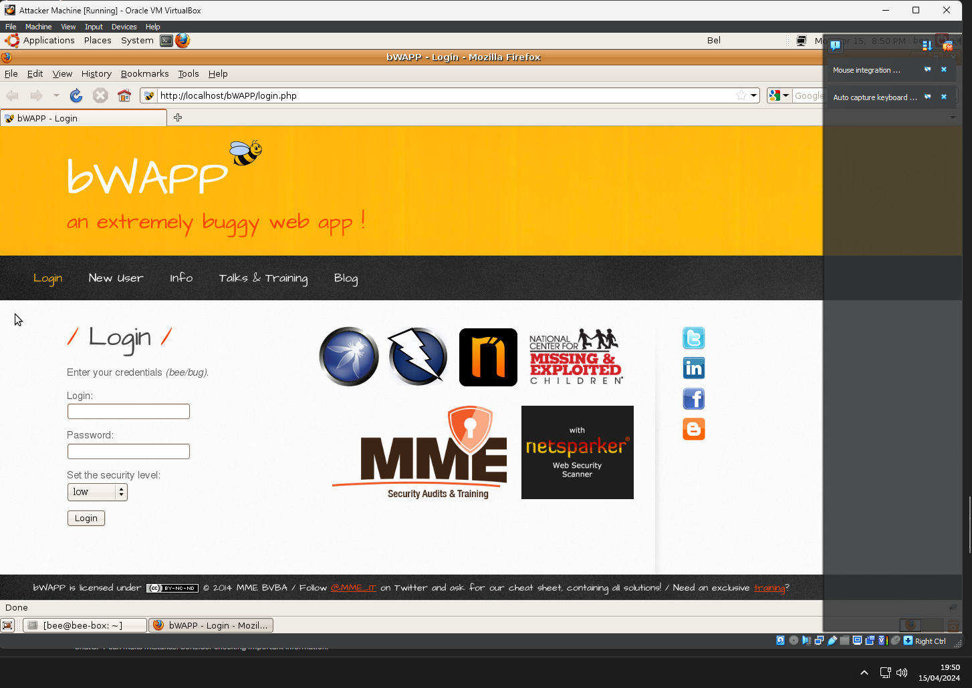
Opening the web browser in the BeeBox Machine loads the login page which needs to be logged into before the exploit can be loaded to the machine.
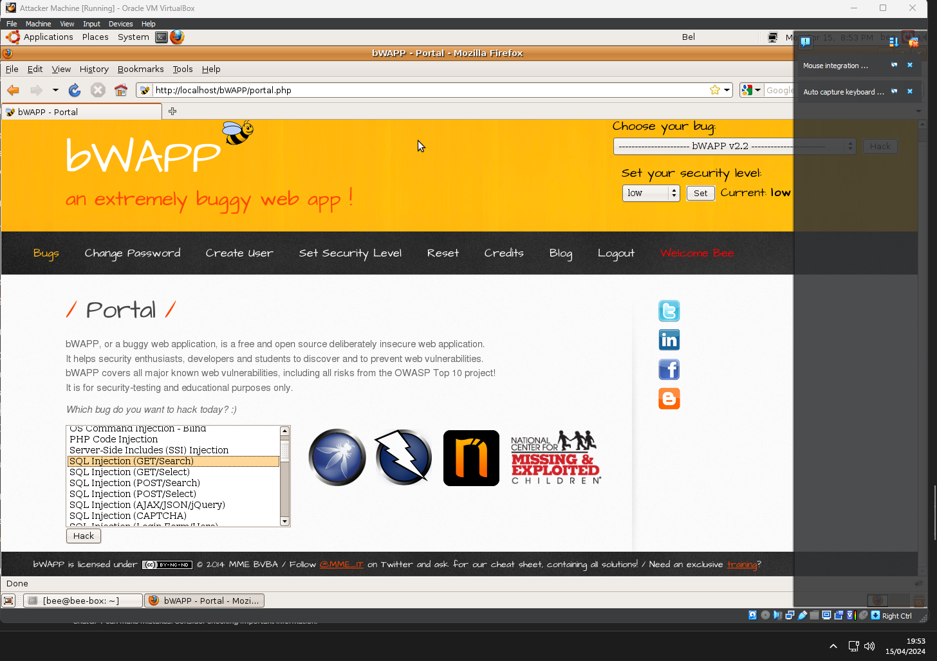
For this particular sample, the author will be using the “SQL Injection (GET/Search)” option from the different SQL Injection options that are available from the vulnerability list within the BeeBox Web Application.
After many attempts of attempting to exploit with SQL Injection via MetaSploitable2. I was unsuccessful. I had attempted to update the packages via CLI in console in MetaSpolitable2 but the packages would not update after some googling it became apparent that the distro that this version of Linux is built on is out of date and no longer supported.

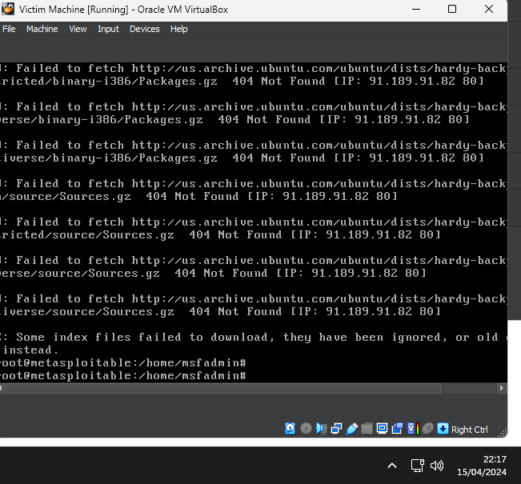

I am going to instead attempt to use MetaSploit via Kali Linux and see if I am complete a different exploit within BeeBox.
Now that metasploit is setup I have load into within the Kali Linux console and entered the following command: search type:exploit platform:php which display a large list of different options that can be used to carry out my SQL injection with different modules for selection.

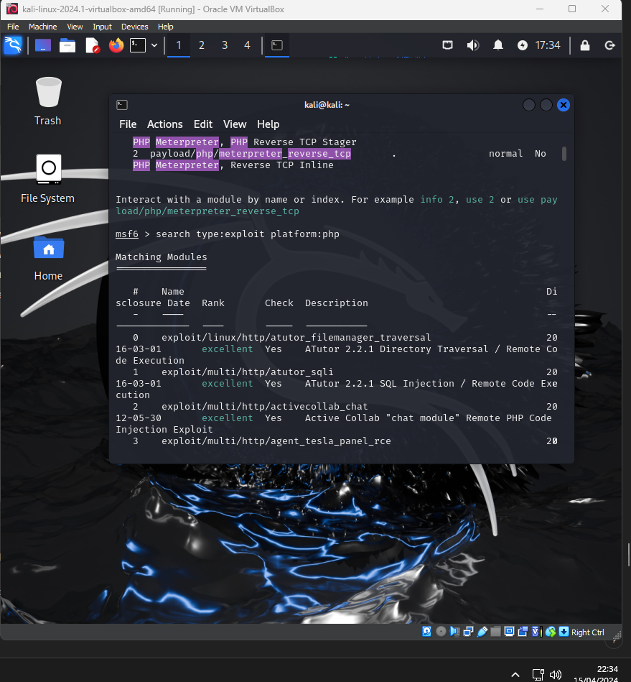
I have selected the following module: search type:exploit platform:php
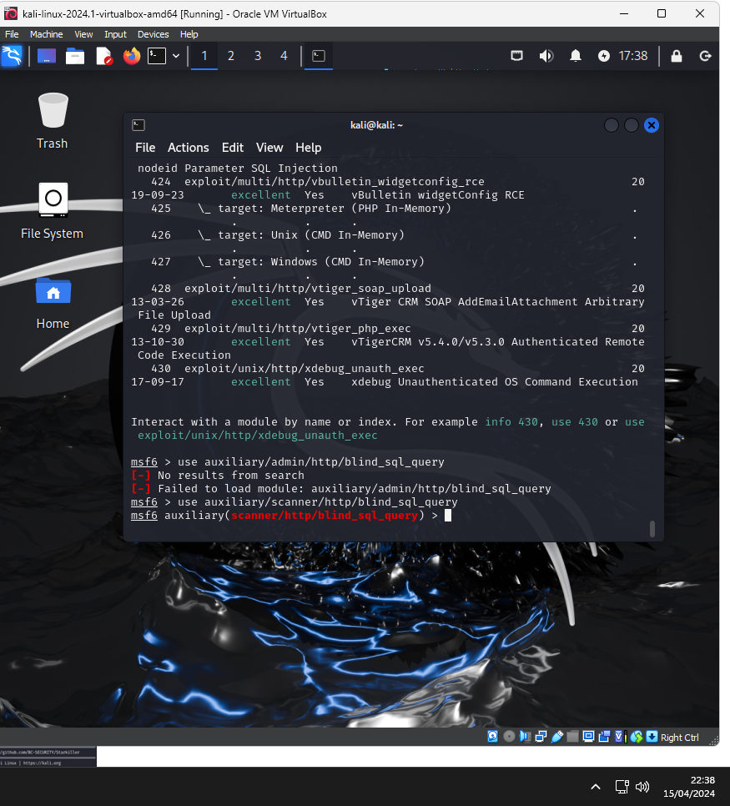
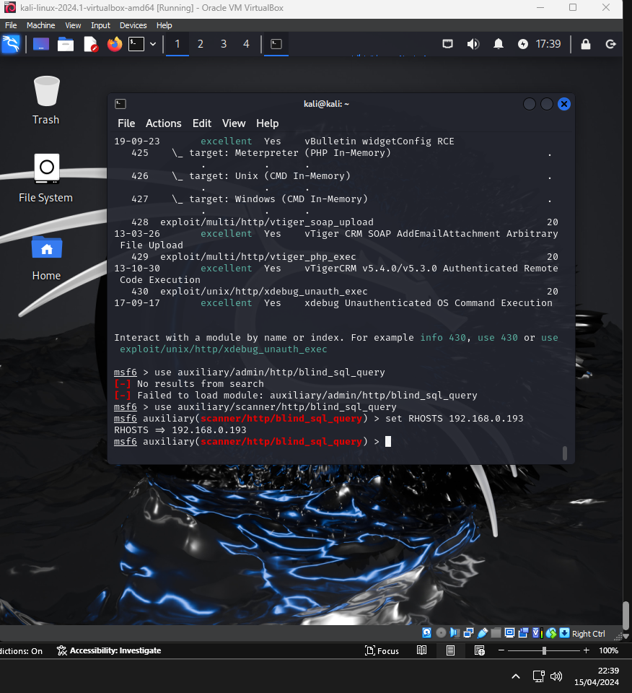

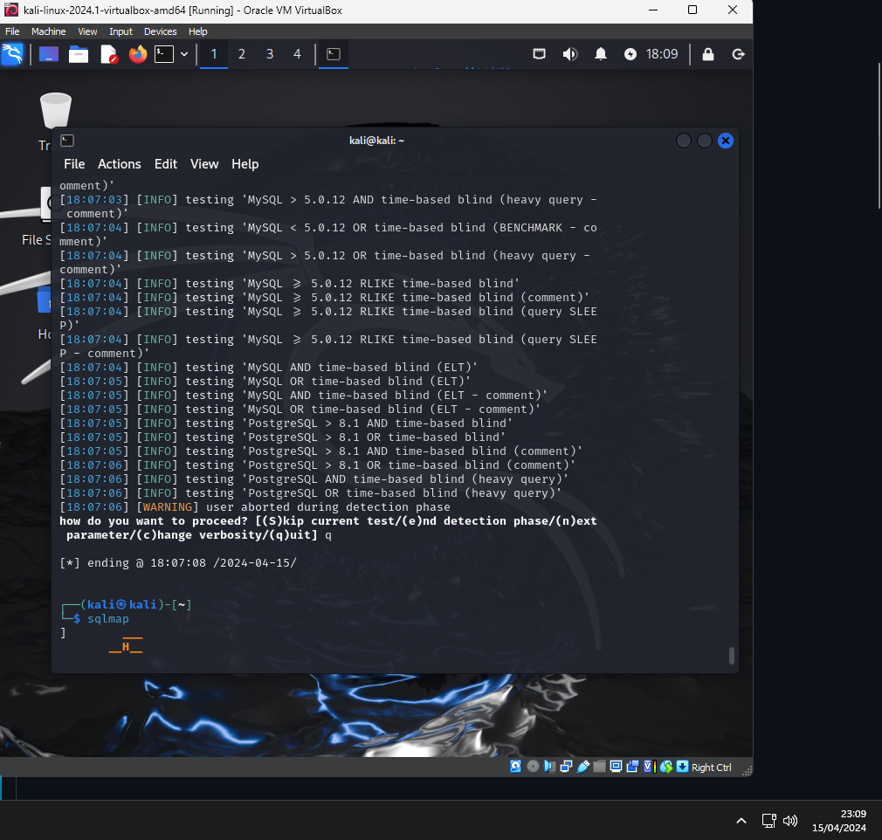
Upon applying the command initially it was being redirected to login page with 302 code but using ignore redirect augment the SQL.

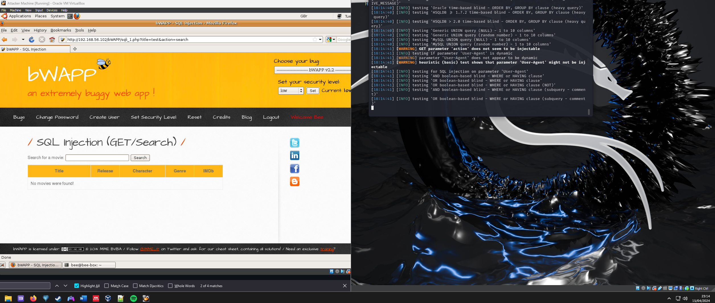
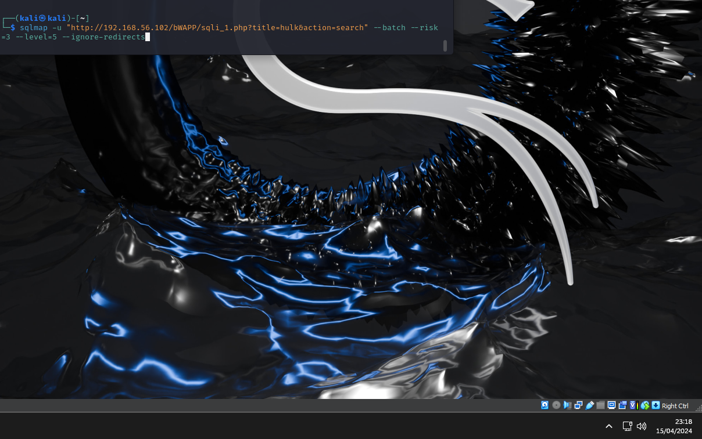
Using the final code that was unsuccessful in injecting the SQL into the browser.
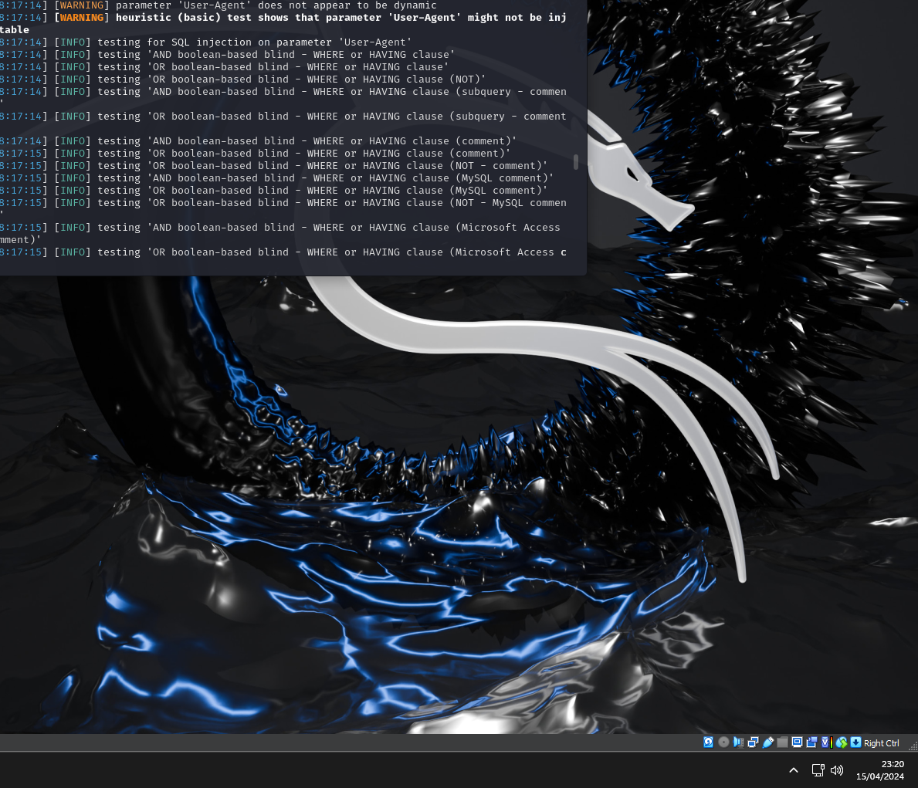
Conclusion
The author had used a variety of tool to attempt to complete an SQL injection but had not succeed with a variety of options that they had used. In a case that the user had been able to breach the security of the Bee-box Machine they would need to implement the best practices that are provided by the SQL Injection Prevention sheet provided by OWASP.

This cheat sheet will help you prevent SQL injection flaws in your applications. It will define what SQL injection is, explain where those flaws occur, and provide four options for defending against SQL injection attacks. [24]

References:
[1] Cyber security breaches survey 2024: technical report - GOV.UK. (n.d.). Retrieved April 11, 2024, from https://www.gov.uk/government/statistics/cyber-security-breaches-survey-2024/cyber-security-breaches-survey-2024-technical-report

[2] IBM Security Report: Cost of a Data Breach for UK Businesses Averages £3.4m. (2023, July). IBM. https://uk.newsroom.ibm.com/24-07-2023-IBM-Security-Report-Cost-of-a-Data-Breach-for-UK-Businesses-Averages-3-4m#

[3] Lee, M. (2023). Case Studies. Cyber Threat Intelligence, 237–276. https://doi.org/10.1002/9781119861775.CH9

[4] Lindsay, J. R. (2013). Stuxnet and the Limits of Cyber Warfare. Http://Dx.Doi.Org.Ezproxy.Uwtsd.Ac.Uk/10.1080/09636412.2013.816122, 22(3), 365–404. https://doi.org/10.1080/09636412.2013.816122
[5] Langner, R. (2011). Stuxnet: Dissecting a cyberwarfare weapon. IEEE Security and Privacy, 9(3), 49–51. https://doi.org/10.1109/MSP.2011.67

[6] Langner, R. (2011). Stuxnet: Dissecting a cyberwarfare weapon. IEEE Security and Privacy, 9(3), 49–51. https://doi.org/10.1109/MSP.2011.67
[7] Pastor-Galindo, J., Nespoli, P., Gomez Marmol, F., & Martinez Perez, G. (2020). The not yet exploited goldmine of OSINT: Opportunities, open challenges and future trends. IEEE Access, 8, 10282–10304. https://doi.org/10.1109/ACCESS.2020.2965257
[8] Stuxnet, Software S0603 | MITRE ATT&CK®. (2020, December 14). MITRE ATT&ACK. https://attack.mitre.org/software/S0603/

[9] OWASP Secure Headers Project | OWASP Foundation. (n.d.). OWASP. Retrieved April 14, 2024, from https://owasp.org/www-project-secure-headers/

[10] HTTP Headers - OWASP Cheat Sheet Series. (n.d.). Retrieved April 15, 2024, from https://cheatsheetseries.owasp.org/cheatsheets/HTTP_Headers_Cheat_Sheet.html

[11] Cyber Kill Chain® | Lockheed Martin. (n.d.). Retrieved April 15, 2024, from https://www.lockheedmartin.com/en-us/capabilities/cyber/cyber-kill-chain.html

[12] Jamieson, A., Petulla, S., & McCausland, P. (2017, May 14). Global Cyberattack Hits 150 Countries, Europol Chief Says. NBC NEWS. https://www.nbcnews.com/tech/internet/after-huge-global-cyberattack-countries-scramble-halt-spread-ransomware-n759121

[13] NHS cyber-attack: GPs and hospitals hit by ransomware - BBC News. (2017, May 13). BBC News. https://www.bbc.co.uk/news/health-39899646
[14] Smart, W. (2018). Lessons learned review of the WannaCry Ransomware Cyber Attack. www.nationalarchives.gov.uk/doc/open-government-licence/

[15] Over 98% of All WannaCry Victims Were Using Windows 7. (n.d.). Retrieved April 15, 2024, from https://www.bleepingcomputer.com/news/security/over-98-percent-of-all-wannacry-victims-were-using-windows-7/

[16] ETERNALBLUE, conducting a history lesson in exploitation | by rootsecdev | Medium. (n.d.). Retrieved April 15, 2024, from https://rootsecdev.medium.com/eternalblue-conducting-a-history-lesson-in-exploitation-fd06a7cf41d5

[17] Microsoft Security Bulletin MS17-010 - Critical | Microsoft Learn. (n.d.). Retrieved April 15, 2024, from https://learn.microsoft.com/en-us/security-updates/securitybulletins/2017/ms17-010

[18] MS-ISAC Security Primer – EternalBlue. (n.d.). Retrieved April 15, 2024, from https://www.cisecurity.org/insights/white-papers/ms-isac-security-primer-eternal-blue

[19]Lessons learned review of the WannaCry Ransomware Cyber Attack. (2018). www.nationalarchives.gov.uk/doc/open-government-licence/

[20] Raza, S., & Hall, A. (2016). National Data Guardian for Health and Care’s review of data security, consent and opt-outs: response from the PHG Foundation.

[21] Data Security and Protection Toolkit assessment guides - NHS England Digital. (n.d.). Retrieved April 15, 2024, from https://digital.nhs.uk/cyber-and-data-security/guidance-and-assurance/data-security-and-protection-toolkit-assessment-guides

[22] Investigation: WannaCry cyber attack and the NHS A picture of the National Audit Office logo. (n.d.).

[23] WannaCry, Software S0366 | MITRE ATT&CK®. (n.d.). Retrieved April 15, 2024, from https://attack.mitre.org/software/S0366/

[24] SQL Injection Prevention - OWASP Cheat Sheet Series. (n.d.). Retrieved April 15, 2024, from https://cheatsheetseries.owasp.org/cheatsheets/SQL_Injection_Prevention_Cheat_Sheet.html

