Synthesize a solution to a potential real-life scenario

Author: Carys Newing 2014825
Module Name: Networks and Cyber Security ACCA4024
School of Applied Computing
Wales Institute of Science and Art
Date of Submission: 07/01/2020

Contents
I. Abstract 4
II. Introduction 5
A. Objectives 5
III. Related Work 5
A. The Current Network 5
B. Threat Actors and Risks 6
IV. Design and Implementation 6
A. System Vulnerabilities 7
B. Proposed Design 7
C. Design Implementation – Showing the Vulnerability 7
D. Design Implementation – Mitigating the Vulnerability 9
V. Mitigations 10
A. Strategies 10
B. Recommendations 10
VI. Conclusion 10
VII. Glossary 11
VIII. Bibliography 12
Appendices 13
Appendix 1 – Network Configuration Diagram 13
Appendix 2– Acceptable Use Policy 15

List of Figures
Figure 1 - Segment of Network map 7
Figure 2 - Tenet Access 8
Figure 3 - Telnet Sniffer Capture 8
Figure 4 - Telnet Plaintext 8
Figure 5 - Switch SSH Configuration 9
Figure 6 - SSH Access from Laptop 9
Figure 7 - SSH sniffer traffic 9

Abstract

Che-Si is a global construction company. Whilst they utilise the latest technologies it has been identified that some routers, switches, and servers have open ports which are at risk of being exploited via sniffing. This is demonstrated and the mitigation strategy of closing unused and unsecure ports has been recommended.

Introduction

Since the ARPAnet was switched on in October 1969 the growth of computer networks and the importance of cyber security has grown and adapted with the advancements in technology. These advancements introduced not only new defensive tools and techniques but new penetration tools and techniques which can be used to infiltrate a network and exfiltrate data or exploit assets.
Over the last 20 years Internet access has become a primary need for many organisations as the majority now have an online presence, however this also opens the organisation up to threats such as malware and hacking and thus the need for Cyber and Network Security has become more prevalent.
Che-Si is a global business that is based in construction which utilises modern technology to provide access to cloud storage as well as communication technology. They also have disaster recovery plans and failovers that are designed to maintain their 24/7 business availability.

A. Objectives

This document aims to evaluate Che-Si's network and propose concepts to improve both the network and cyber security posture of Che-Si’s systems.
Throughout this document, potential vulnerabilities will be discussed, and a demonstration of how it could be exploited and potentially mitigated to remove the threat.
Any mitigations will be recommended this includes changes to the systems or to Che-Si’s current policies, standards, and guidance documents to better improve the security culture and posture.

Related Work

A. The Current Network

Che-Si’s network is a Full-Mesh, Wide Area Network (WAN) as they have sites based around the world which are all interconnected to provide reduced network redundancy and lag Che-Si has provided their employees with laptops and smart phones which allows them to work remotely. Onsite Che-Si has provided static multifunction devices for the scanning and printing of confidential documentation and employees are not permitted to connect their devices to personal or public printers.
Whilst Che-Si has a multitude of devices that are connected via a mixture of Wired and wireless connections, they have considered the use of personal devices in a “Bring your own device” (BYOD) capacity. However, this has been deemed to leave their network prone to cyber-attacks. BYOD can pose a threat to any organisation as they carry an increased risk of the loss of personal and corporate privacy. The major disadvantage of using BYOD is that it requires greater infrastructure and support for the various devices and operating systems used. This could be managed by implementing a mobile application management system to create a secure partition on mobile and desktop devices.
Che-Si currently has a hybrid site which is being integrated with cloud systems as part of an Infrastructure as a Service (IaaS) migration. This integration will provide management of their servers, storage, networks, and any virtualisations of assets such as virtual machines. This is beneficial as it can provide a fail-over should issues be encountered with any of the IaaS assets.

B. Threat Actors and Risks

There are many vulnerabilities, threats and attacks that could occur from allowing the access to Che-Si’s systems from corporate, personal internet devices or public locations. As Che-Si is a global construction company they are at risk of being targeted by many different threat actors;
Hacktivists are deemed to be a low risk to Che-Si as the damage that they would inflict would be to any public facing corporate sites and this is generally in retaliation to any damage that the company causes to animals, the environment or even human exploitation.
As a global construction company, it is deemed that there would be a low risk from Nation States. If they chose to target Che-Si the damage they could do to assets would be high as they have large amounts of funding and tools available for use.
Cyber Criminals possess a wide array or tools and techniques and are deemed to be a high risk to the company as they typically seek financial gain. This could consist of using ransomware, disrupting business services, or blackmailing the organisation with stolen data.
Terrorist Groups are considered a low risk to Che-Si due to the nature of the organisation; this is because terrorists strive for violence and destruction based on their ideals.
Insiders Threats are the greatest risk to Che-Si as they could cause damage through malicious or accidental behaviour. Information Exfiltration is a common threat that could occur, whilst most likely to be from a Data Breach, this could also be done by exploiting systems without having authorised access. The Insider threat is most likely to exfiltrate information by sending it via unsecure methods, this could also indicate abuse of account privileges or account misconfiguration.

Malware of any kind could pose a threat to Che-Si. The delivery method of the malware could be any one or a combination of: downloads, phishing emails, malicious sites, or the connection of unauthorised removable media. BYOD would increase the risk of malware infections as personal devices may not have up-to-date virus definitions or a reputable anti-malware provider. If such devices were joined onto the network or access corporate information, they could introduce malware onto the network.

Design and Implementation

Whilst in the current configuration of Che-Si’s network there are complex elements, there are also some aspects of cyber security that have been neglected or incorrectly set up. Many of the threats mentioned in II. Introduction can be mitigated by utilising the recommended best practises from the National Cyber Security Centre (NCSC) and by working towards industry standard certifications such as cyber essentials and ISO 27001.
The integration with cloud technology to form a hybrid network and the development of Advanced Threat Protection systems can be utilised to monitor and improve the security culture within the organisation.

A. System Vulnerabilities

Che-Si’s current network design, whilst utilising modern techniques and technology, has been identified to have multiple vulnerabilities which pose a risk to the entire network if left unchecked.
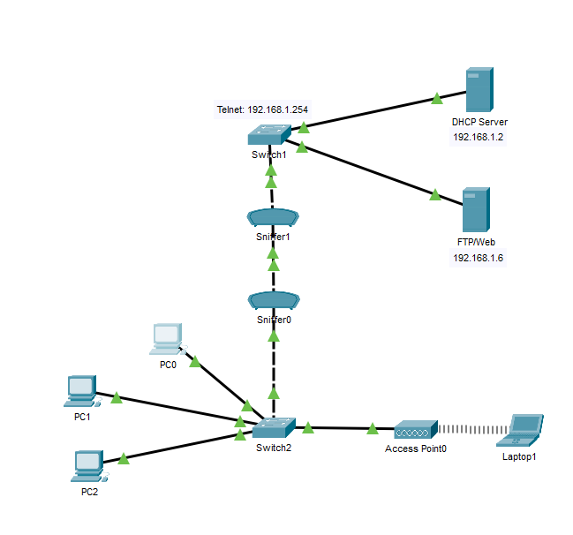
The current network has a visible wireless service set identifier (SSID). Hiding the wireless SSID would force an attacker to sniff for the SSID. This would discourage less skilled attackers but would only be a minor inconvenience for most. To save having users manually entering the SSID information it could be pre-configured on their devices or even pushed out via Group Policy Objects (GPO).
Another vulnerability that has been identified is the use of weak passwords. This could be managed through password audits and complexity requirements in line with the NCSC guidance.
Figure 1 - Segment of Network map
The open and unsecure ports leave the network open to being exploited either through use as a backdoor or for information exfiltration via the use of sniffing devices.

B. Proposed Design
The proposed design focuses on a small section of Che-Si networks and looks to highlight issues when leaving unused ports open and using insecure protocols. The design will use sniffers to identify the insecure transmission of Telnet traffic.
The proposed network design will only focus on a segment of the network to best convey the vulnerabilities that have been identified.

C. Design Implementation – Showing the Vulnerability

For this demonstration, two sniffers have been included in the network design to determine what an attacker would be able to see should they intercept the traffic. A full, easily viewable, network diagram can be found in Appendix A. Figure 1 is a representative of the network diagram.
As Che-Si’s network consists of both wired and wireless devices, the Telnet vulnerability will be shown from PC0 and the wireless laptop to convey that regardless of the connection the data may be at risk.

Using the "telnet 192.168.1.254" command from the prompt of device PC0, it has been able to the wired computer has been able to connect to the router and prompts for a password to be entered as shown in Figure 2.
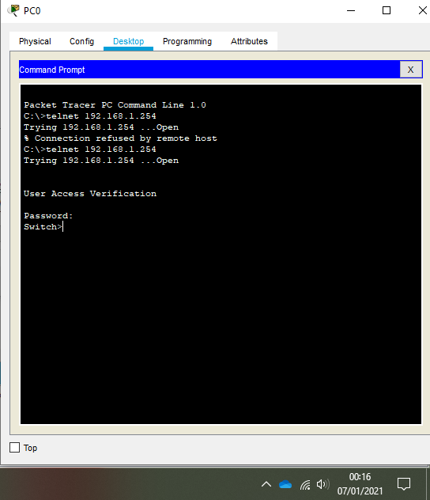
Figure 2 - Tenet Access

When the password has been correctly entered the user is given access to the switch that was navigated to at 192.168.1.254.

The sniffers in the network have detected and recorded the network transactions as shown in Figure 3.
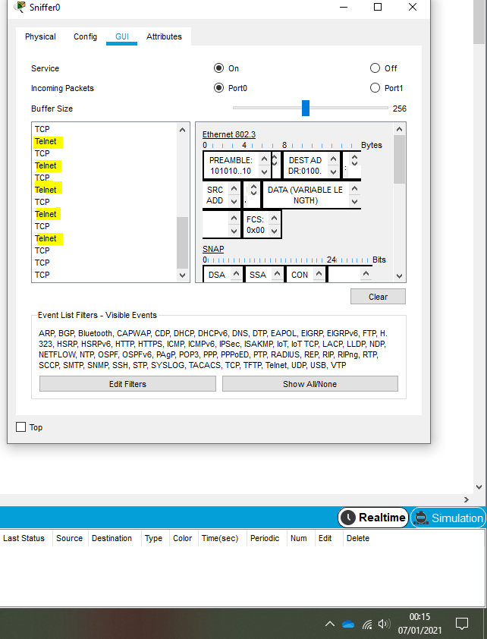
Figure 3 - Telnet Sniffer Capture
The Telnet data capture shows the data transfer of each character in the password entered. To identify the password, each Telnet packet would need to be reviewed. In this case it spells “password”. Figure 4 shows the data capture and the transferred data.
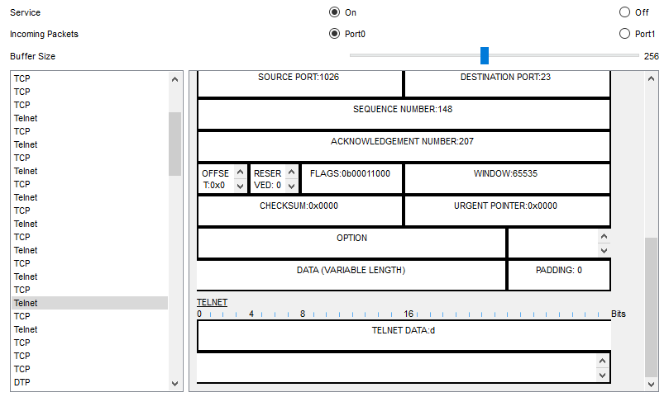
Figure 4 - Telnet Plaintext

D. Design Implementation – Mitigating the Vulnerability

To resolve this vulnerability telnet will need to be turned off on servers, routers, and switches. This can be done through the affected device.
As Telent was enabled on the switch, this has been disabled by using “transport input ssh”. Also, an SSH username and password has been configured. The version of SSH has been set to version 2 using the CLI and a 1024-bit RSA key has been generated to allow for the data to be encrypted.

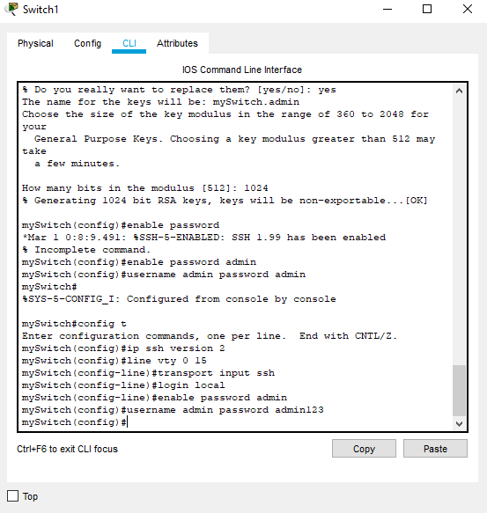
Figure 5 - Switch SSH Configuration

After amending the switches configuration, the Telnet and SSH connection has been tested from the wireless laptop. As highlighted in Figure 6, the laptop has been unable to connect via Telnet but has been able to successfully connect with SSH by using “ssh -l admin 192.168.1.254”.
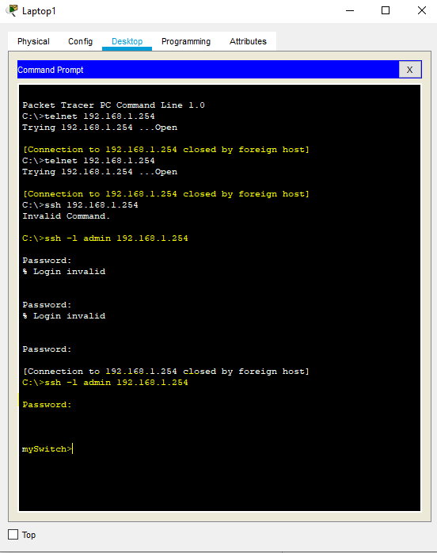
Figure 6 - SSH Access from Laptop
The sniffers have detected some traffic to the switch however the password for the account is no longer transferred using plain text.
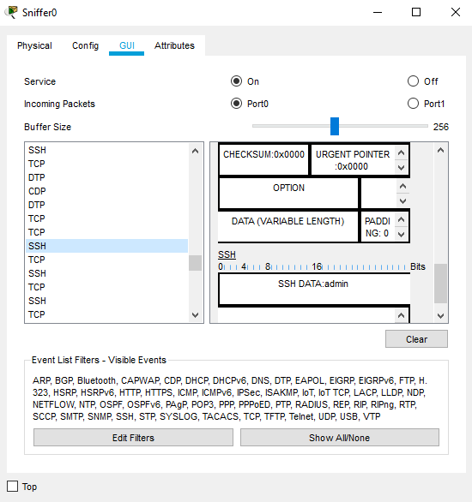
Figure 7 - SSH sniffer traffic

Mitigations

A. Strategies

The cyber and network security measures can be utilised via physical or logical measures both on Che-Si’s sites and at remote locations. Part of maintaining a secure network involves the following of Che-Si’s security goals from their policies being assessed and gaining assurance to ensure the confidentiality, integrity and the availability of its data and systems, as well as ensuring that the system can Authenticate, Authorise and Account for a user’s account.
It is important that any training as well as Policies and Standards are kept up-to-date and are reviewed at least annually. Ensuring compliance can consist of auditing the systems using alerting capabilities and testing employees to identify any gaps in knowledge and to improve the security culture at Che-Si.

B. Recommendations
Following from the vulnerabilities that have been identified in III Design and implementation, and a review of Che-Si’s Acceptable Use Policy (AUP) [see Appendix 2] it is recommend that the following amendments are made to the AUP.
- Unacceptable usage
  - Connecting unauthorised devices such as printers
  - Use of unapproved external USB’s – disabling the use of USB ports for data transmissions
  - Sharing of passwords and accounts
It has also been recognized that Che-Si does not have a Password guidance policy, therefore it is recommended that one is added. It should include guidance such as the use of different passwords for different accounts and is in line with the National Cyber Security Centre’s guidance relating to the strength and complexity of passwords. For technical roles it would also be beneficial if it included details of an approved password manager.
The amendment of their current Web filtering system could be used to prevent users from accessing HTTP sites and could also be used to block access to specific sites or categories of sites and thus allowing for the management of the sites employees could access.

Conclusion

Overall, the network is well designed however there are some system configurations that have been overlooked, resulting in devices being misconfigured on the network. Whilst these issues could be isolated in a manner to prevent unauthorised users or devices from accessing them, it is beneficial to turn any unused and insecure ports off. There are circumstances where this would not be possible due to legacy equipment, however this is not applicable to Che-Si.

Glossary

Access Control Lists (ACL)
Accounting – The ability to monitor activity to ensure compliance and security in a system
Authenticate – To confirm that a user is whom they say they are prior to accessing a system
Authorise – To allow a user the minimum amount of access that they require to perform their role.
Availability – The accessibility of the data and providing that authorised can access it.
Bring your own Device (BYOD) – The use of a user’s personal devices being used for work purposes rather that using corporate issued equipment.
Confidentiality – Ensuring only users authorised to view information can, thus preventing access from unauthorised users.
End Of Life (EoL) – Equipment or Assets that have passed their support lifespan resulting in the physical hardware not being covered and a risk to the organisation.
Group Policy Object (GPO) – A centralised management system fount on Windows computers that can be used to control elements in a user’s account and can be used to deploy new configurations or updates.
Infrastructure as a Service (IaaS) – Where a third party provides the servers and cloud services but has elements such as the applications as well as the choice of Operating system which is decided by the organisation.
Integrity – to ensure that the file is not tampered with and therefore ensures that the data it contains is trustworthy.
Malware – software that is designed to cause damage to an organisation by disrupting business or by providing a hacker with unauthorised access to a computer or network.
Service Set Identification (SSID) – the name of a wired or wireless connection, this can be changed or hidden and is used to differentiate between different internet connections.

Bibliography

Dougeby, “What is Microsoft Intune - azure,” Microsoft.com. [Online]. Available: https://docs.microsoft.com/en-us/mem/intune/fundamentals/what-is-intune. [Accessed: 02-Jan-2021]

“Password policy: updating your approach,” Gov.uk. [Online]. Available: https://www.ncsc.gov.uk/collection/passwords/updating-your-approach. [Accessed: 01-Jan-2021]

Cloudflare.com. [Online]. Available: https://www.cloudflare.com/learning/access-management/what-is-a-business-vpn/. [Accessed: 29-Dec-2020]

“Networking & The Web,” Computerhistory.org. [Online]. Available: https://www.computerhistory.org/timeline/networking-the-web/. [Accessed: 20 -Dec-2020].

Appendices

Appendix 1 – Network Configuration Diagram
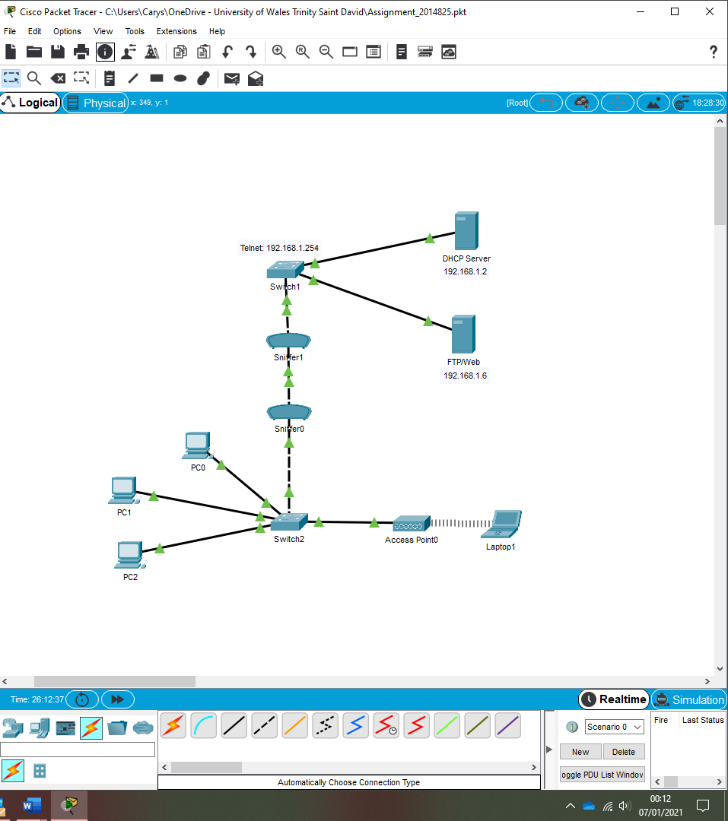
Switch Password: admin
Telnet Password: password
AP WPA2-PSK: Cisco123
SSH Username: admin
SSH Password: admin123

Appendix 2– Acceptable Use Policy

Che-Si Acceptable Use Policy

- Overview
To provide guidance relating to the usage of Che-Si’s assets and how they must be used in the interest of the company. This guidance is in place to protect the assets, clients, and employees of Che-Si.

- Purpose
To outline the acceptable usage of the equipment provided to employees by Che-Si and to raise awareness of any implications that the company could be exposed to because of unacceptable usage.

- Scope
This policy applies to all staff employed by Che-Si and covers the physical, logical, and human assets that are contracted or owned by Che-Si. This includes systems that are managed by third parties which must have been approved through the DPIIA process.

- Policy
Permitted Use
Che-Si offers employees the opportunity to access personal email accounts however this access should be restricted to the employee’s breaks.
Any user that is required to perform scheduled maintenance on systems or the network, must have the appropriate signed off prior to the maintenance being performed. Exceptions may be made in relation to imminent business critical issues.
To access systems, data and applications that are relevant to the employee’s role.

Unacceptable use
The below list is to be used as guidance as it is not limited to the actions listed. For any questions relating to what could be classed as unacceptable use please contact InfoSec. The following activities are prohibited, and no exceptions will be granted
- The participation in illegal activities whilst using Che-Si’s owned resources
- The introduction of Malware onto the network
- Performing any business operations that are not related to Che-Si such as running a business using Che-Si owned equipment
- Running or installing any unauthorised programs or applications
- Sending emails that contain harassment or any profanity.
- Connecting unauthorised devices such as home printers

- Policy Compliance
Compliance with this policy will be verified by the InfoSec team using but not exclusive to audits and business tool reports.
Any exceptions to this policy must be approved by the InfoSec and Legal team in advance.
Any violations of this policy will be subject to an investigation as part of disciplinary action which may in extreme cases result in the termination of employment.

- Related Standards, Policies and Processes
- Admin Code of Conduct
- Auditing and Logging Policy
- Patch Management Policy

