ARC Question Structures

The question starters listed below have been created as examples. The list is not intended to be exhaustive, only initial prompts for the user to gain the vocabulary required for effective reflection.

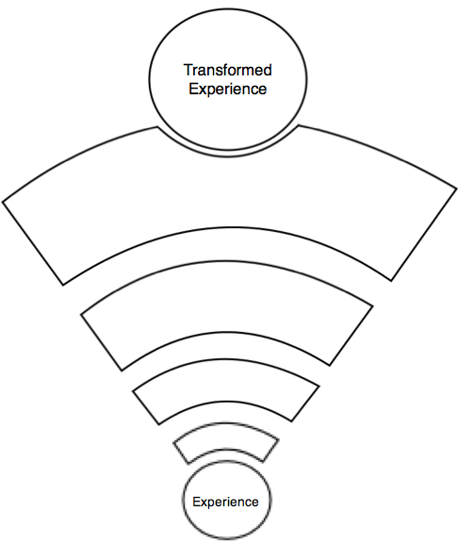
Remember + Understand
Feelings
Evaluate + Analyse
Conclusions
Actions
Connect to theory
Identify causes
Contextualise

Feelings

What are your feelings (initial/reflective) regarding the experience?

Remembering

Can you list…
…the aspects of the lesson that went well?
…the elements of the learning experience that were disappointing?
…any factors that influenced the learning/ experience?
…benefits of the plenary/ main teach out/ introduction?

What happened…
…during the main body of the lesson?
…when learners encountered difficulties?
…during times of transition?

How did…
…the use of resources impact the learning?
…the learners respond to the different phases of the lesson?
…the planned differentiation meet the individual needs of the learners?

Why did…
…learners engage the way they did?
…time become an issue?

Where were…
…the main areas for development in today’s session?

Who was it that…
…drove the learning overall?
…that monitored the learning environment?
…took responsibility for Assessment for Learning?

Understanding

What would be an example of…
…effective teaching and learning during the session?
…high/low motivation during the session?
…excellent pedagogy during the session?

Please explain why…
…the learning could have been more effective?
…you graded the lesson as you did?

Applying for Understanding

Where else would you see…
…specific pedagogy implemented today?
…the class management techniques utilised today?
…the spelling strategies used today?

What questions will you ask…
…senior management within the school?
…your class teacher?
…your university tutor?
…your learners?

Analysing

Why would someone else think that…
…this was an effective/ ineffective session?
…you have developed in your teaching skills?

What would you say to a person who said…
…the learners didn’t move forward in their learning today?
…the learners didn’t meet the learning objectives?
…the use of success criteria was effective?
…the level of work wasn’t appropriate for the learners?
…the learners had clear guidance and instructions?
…the learners had no idea how to be successful?

What are some of the problems…
…learners encountered?
…you encountered?
…support staff encountered?

What was the relationship between...
…your planning and the effectiveness of the lesson?
…the behaviour of the class and their learning?
…the resources prepared and the effectiveness of the learning?
…the grouping of the pupils and their success?

How does…compare with…
…this session…the last session taught?
…the preparation for this session…previous planning?
…pupil achievement today…previous achievement?
…your teaching during this session…previous teaching?

What caused…
…the learning to be effective today?
…disruptions and the children being off task?
…the overall success of today’s session?

Applying for Conclusions and Actions

Can you think of a solution for…
…the main issue with today’s session?
…the behavioural / engagement issues?
…the problems relating to differentiation?
…the transition issues?

Can you outline…
…how you could move the lower/ mid/ high ability forward?
…the next step for the whole class?
…the next steps for specific individuals?

What would you do if…
…this lesson had to be taught again?
…the ICT resources were not available?

How will you use…
…your reflection today to move forward?
…your personal research to improve teaching and learning?
…the feedback from weekly evaluation meetings to improve your pedagogy?

Evaluating for Conclusions and Actions

What is the most important…
…aspect of today’s session to address?
…piece of feedback gained?
…issue to address with regards to children’s learning?

What are the strengths/ weaknesses of…
… the planning and preparation of today’s session?
…your teaching today?
…the learning environment created today?
…your class management today?
…the AfL strategies utilised today?

Do you agree/ disagree with…
…the theory underpinning specific pedagogy you implemented today?
…the feedback given from mentors?

If you could change one thing about…what would it be?
…the activities undertaken today…
…the organisation of the learning environment…
…your teaching today…

Creating for Action

How many ways can you…
…address an issue identified above?
…meet the identified needs of the learners?
…model how to be successful for the learners?
…reward the pupils engaging?

How would you adapt…to create a more effective learning experience?
…planning…
… resources…
… interaction with learners…
…AfL strategies…
… differentiation…

Can you propose and alternative…
…strategy to meet the session’s learning objectives?
…method of AfL to aid learning further?
…Strategy to aid class management?
…system to reward/ support learners?
…strategy to further engage learners?

How would you improve…
…the marking?
…the modeling?
…the differentiation?
…Children’s motivation and engagement?
…pupil love of learning?
…the assessment procedures?

Can you see a possible solution to…
…the timing issue?
…the main issue identified in today’s session?
…the staff management issue?

How will you find out…
…the information needed to move forward?

