A demonstration of understanding, establishment, and development: a reflective report.
Professional career development.

Contents

Cover…….…………….......…….1
Contents………………….......…2
Introduction…………….............3
Main findings…………….......…3
Personal development plan....11
Conclusion………………..........12
References.……………….........12
Appendices.………………........13
Acknowledgements……..........20

Introduction
The intention of this reflective report is to demonstrate an understanding of the topics studied for this module, including:
An understanding of the skills and knowledge which contribute toward working effectively
An understanding of one’s readiness for employment
An understanding of personal strengths and areas for further development
An establishment of one’s employment goals
A development of a personal action plan or development plan.

I’ll be explaining these concepts while demonstrating how their use will allow me to analyse and inform my own learning practices. The nature of the reflection requires me to consider some basic questions. What is self-awareness? Covey (2004, p. 66) defines it as “the ability to think about your very thought process”. What is personal development? Merriam-Webster (2019, merriam-webster.com/dictionary/self-development) defines it as “development of one’s own capabilities or possibilities”. The concepts of readiness for employment and employability are constantly changing to match the changing skills perceived as useful by employers. Professor Mantz Yorke (2006, p. 8) describes employability as “a set of achievements – skills, understandings and personal attributes – that make graduates more likely to gain employment and be successful in their chosen occupations, which benefits themselves, the workforce, the community and the economy”. While the definition provided will remain relatively constant, the skills and attributes referred to are likely to fluctuate wildly depending on which period of history is being discussed. Kelley (2019) alludes to how changes in industrial relations, the rise of the ‘gig economy’ and new technology, including artificial intelligence, will all have influenced the usefulness of certain skills in the workplace.

I will be reproducing the journey I have undertaken while studying this module this term. I shall be illustrating my journey using a variety of methods and strategies. I’ll be examining my goal and using SWOT analysis, conceived by Albert Humphrey (Professional Academy, 2019); the ‘Go M.A.D. Framework’ (Go MAD Ltd., 2019); TOWS matrices, “a tool for situational analysis” (Weihrich, 1982); and a variety of learning styles (including Maslow, Covey, & Myers Briggs) to build to my conclusive Personal Development Plan.

Main Findings

SMART objective.
George T Doran is credited with first using the S.M.A.R.T. acronym for goals and objectives (Project Smart, 2014). SMART stands for Specific, Measured, Achievable, Realistic, Time-bound, with occasional variances e.g. Agreed rather than Achievable, Relevant rather than Realistic. I have composed my own SMART goal to clarify my own hopes and expectations.
My SMART goal:
I intend to achieve a secure, well-paid, office-based job with prospects of advancement by increasing my interview skills and attributes, combining my broad occupational experience with the growth from my forthcoming studies. I intend to bolster my academic qualifications by passing a Certificate of Higher Education (CertHE) within a year, a degree within a year, and gaining a suitable job within six. I will measure my progress by receiving graded reviews on work modules I submit every term for the next 36-48 months.
This objective meets the criteria of being SMART in the following ways:
It sets a specific goal of a particular type of employment (secure, well-paid, office-based).
It is measurable, noting specific achievements along the way (CertHE, degree, graded work modules).
It is achievable, as I am currently undertaking the necessary course aimed for.
It is realistic, as there is a requirement for such roles in the modern workforce, and the qualifications should buttress my previous experience in similar roles.
It is time-bound, describing the detail of timescales involved and remarking on the availability of periodical review of graded modules.

SWOT Analysis
SWOT (Strengths, Weaknesses, Opportunities, Threats) analysis is a strategy used for self-evaluation, starting with internal evaluation of strengths and weaknesses (Professional Academy, 2019). A so-called SWOT matrix is used to represent the four groupings.
I have populated the matrix with applicable examples relating to my own objective.
SWOT matrix
Strengths | Weaknesses
Generally confident demeanour | Shortfall in qualifications
Experienced in a variety of roles | Lack of business knowledge
 | Occasional sense of superiority
 | Lack of application and focus
Opportunities | Threats
Foot in the door of current employer | Competition from other workers
Currently pursuing additional qualifications | Cuts in public service due to austerity

The purpose of constructing the above matrix is to proceed to convert Weaknesses and Threats into Strengths and Opportunities using ‘conversion strategies’. Using the broad strategy of pursuing Higher Education qualifications, I would convert the lack of application, focus, business knowledge, and qualifications into an abundance of focus, application, business knowledge and qualifications. The same strategy ought to similarly convert my sense of superiority into an absence of a sense of superiority, by being forced to confront my academic inferiority. By the same token, the threat of competition from other workers would convert to an advantage over other workers in competition for similar objectives. Matching strategies would be used to convert Strengths into Opportunities. In this case, I’d use the somewhat translucent strategy of exploiting said experience and confidence in interviews for any given jobs applied for.

TOWS Analysis
TOWS (Threats, Opportunities, Weaknesses, Strengths) Analysis use the same words to form a different acronym for a very similar piece of analysis. The perspective is different, starting with an external evaluation of Threats and Opportunities (Van Vliet, 2019) Opportunities and Strengths are grouped with Threats and Weaknesses to produce the following templates for strategies.
Strengths and Opportunities (SO)
Strengths and Threats (ST)
Weaknesses and Opportunities (WO)
Weaknesses and Threats (WT)
Some examples of these strategies as applied to myself would be as follows:
SO: exploiting my confidence to further push at the door of my current employer.
ST: exploiting my experience to avoid cuts due to austerity.
WO: the opportunity to pursue further qualifications should mitigate the weakness of a shortfall of qualifications and due to the nature of the subject, it should also help address the lack of business knowledge.
WT: mitigate weaknesses and convert to strengths using the conversion strategy of academic study thereby eliminating the threat of competition from other workers.

Go M.A.D.
The Go MAD (Go Make a Difference) framework is another tool that can help the user to plan for thinking and achieving success.
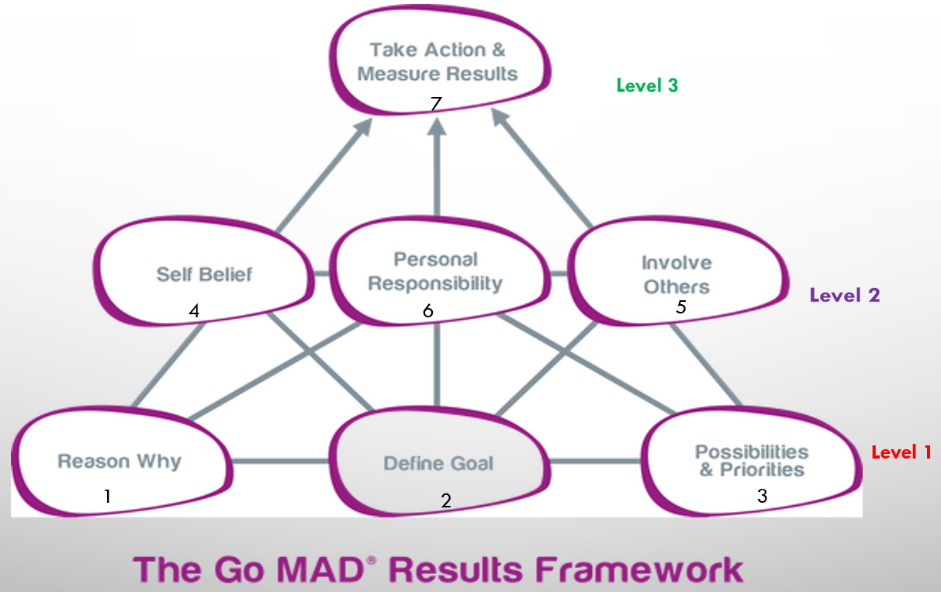
(Go MAD Ltd., 2019)
The framework covers three levels:
- Personal Planning
- Maintaining Momentum
- Making a difference
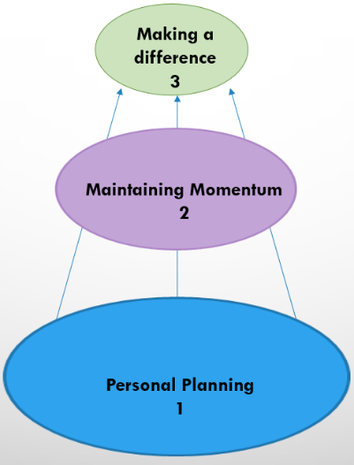
(Go MAD Ltd., 2019)
There are 7 principles to the framework:
Level 1:
- Reason Why
- Define Goal
- Possibilities and Priorities
Level 2:
- Self Belief
- Involve Others
- Personal Responsibility
Level 3:
- Take Action & Measure Results
The first step of completing the framework is to begin with the so-called internal triangle, comprising of steps 1, 2, and 4, found on the left of the framework.
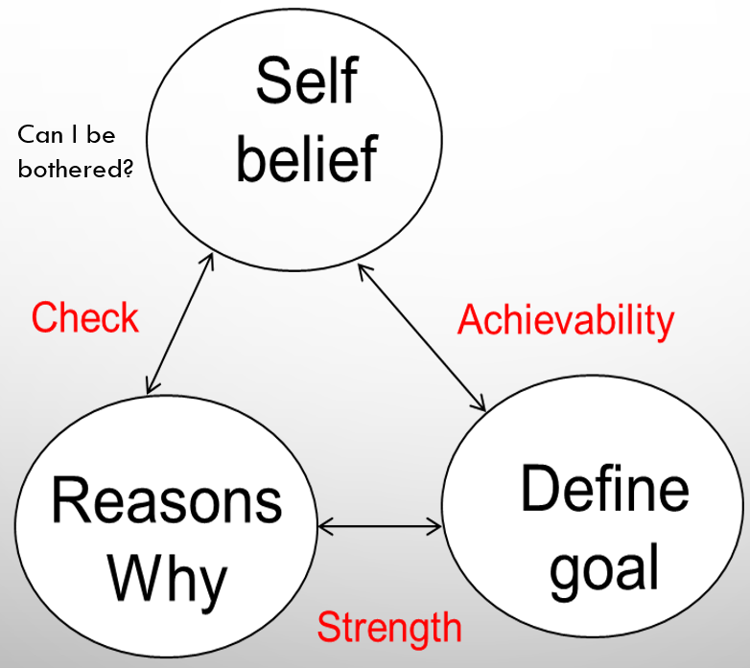
(Go MAD Ltd., 2019)

My own framework is populated as follows:
- I want to earn more money. I want to have better respected qualifications. I want a better job. I want to end decades of underachievement. I want security. I want comfort. I want to learn. I deserve more!

- I intend to achieve a secure, well-paid, office-based job with prospects of advancement by increasing my interview skills and attributes, combining my broad occupational experience with the growth from my forthcoming studies. I intend to bolster my academic qualifications by passing a Certificate of Higher Education (CertHE) within a year, a degree within a year, and gaining a suitable job within six. I will measure my progress by receiving graded reviews on work modules I submit every term for the next 36-48 months.

- I can achieve this goal, as not studying is financially easier than not studying. I have high motivation to achieve it, as my current situation is a constant ordeal. I am certain I have the intelligence and ability to succeed; and have been told so by others. I have a plethora of gruelling experience to back myself up.

Next, the external triangle, on the right of the framework comprising of stages 2, 3, and 5.
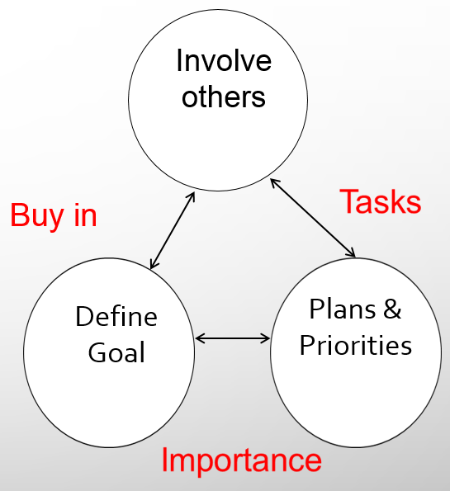
(Go MAD Ltd., 2019)

My versions of principles 3 and 5 are as follows:
- Attend College at every opportunity. Study hard. Learn well. Pass comfortably. Complete and hand in assignments ahead of time. Put learning into practice. Grow as a person. Apply for jobs when time is right. Succeed at ensuing interviews.

- Involve lecturers, and all faculty staff where appropriate. Seek full use of available help. Engage with and learn from teammates & others on the course. Seek encouragement from friends, family and former students where possible.

Finally, principles 6 & 7 are added, my versions of which follow:
- I will take personal ownership of my attempts to reach my goal. I will maintain sufficient discipline to get done what needs to be done. Taking responsibility for a defeat after the fact is easy, and something I am used to. I intend to take responsibility of the success as it happens. I will sacrifice late nights and weekends. I’ll remind myself of my motivation.
- I’ve already started my attempts. I will review each assignment and each term to ensure I’m correctly oriented. I will celebrate each successful assignment and each completed term with a takeaway and some cans. If and when I successfully achieve my goal, I will bask in the associated respect of being a university alumnus; and celebrate with a holiday and buying some festival tickets.

The principles of the framework are connected by links according to the following pattern:
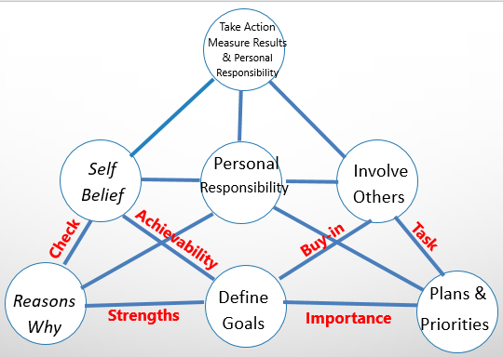
(Go MAD Ltd., 2019)
S- Strengths
I- Importance
T- Task
B- Buy-in
A- Achievability
C- Check
These links (forming the acronym SITBAC) at first glance may appear interchangeable in the framework. However, there is a logic to the placement. The strengths of the individual will bind their goals to their reasoning, and the achievability of their goals bound tightly to their self-belief. Plans and priorities are defined by their importance to the defined goals. The involvement of others buying-in to the defined goal is necessary for said others to be linked by tasks to the plans and priorities. ‘Check’ refers to the need for checking that self-belief is maintained and reasons why are still highly valid.

Learning Styles
Maslow
A.H. Maslow (1943) developed the so-called Theory of Needs. Human needs are arranged in a series of levels of importance. Maslow identified five levels, and using Maslow’s theory, I have identified the second stage (Safety and security) as being most applicable to my own current situation, although I’d claim to aspire to the third stage (Love and belonging). With application, and some success with my employment goal, I’d imagine that I might eventually subscribe to self-actualisation, over time.

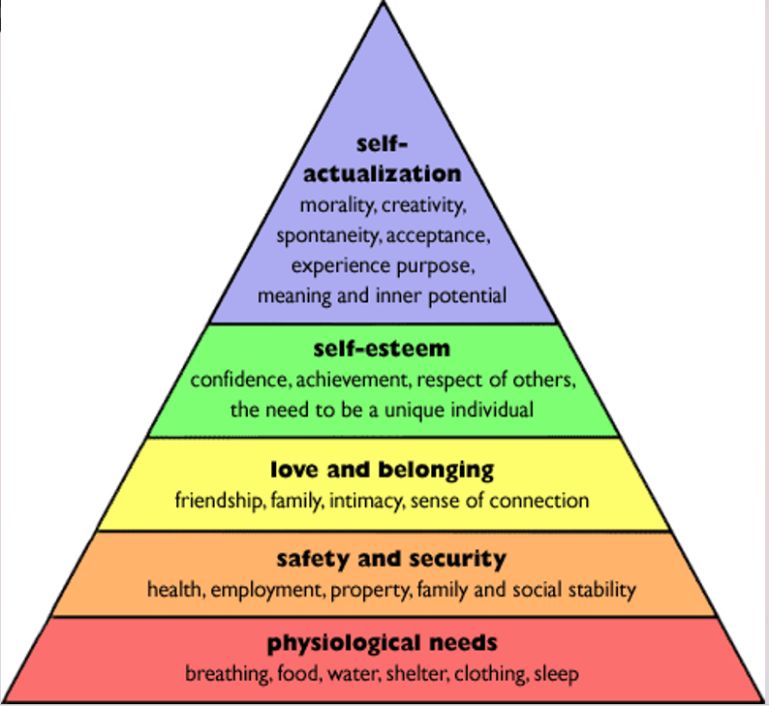
(Maslow 1943)
Covey
Covey (2004) discusses the seven habits of highly effective people. Said habits are as follows:
- Be Proactive
- Begin with the end in mind.
- Put first things first.
- Think win/win.
- Seek first to understand, then to be understood.
- Synergize
- Sharpen the saw.
I have reflected on these and have reasoned that the latter several habits currently apply to me in an extremely limited fashion. The first three habits do seem to be more currently applicable.
Vark
The term VARK is an acronym of the categories of study strategies indicated by the results of the test: Visual, Aural, Read/write, and Kinesthetic. My results were low in Visual and Aural, high in Kinaesthetic, highest in Read/Write. The associated suggestions for beneficial learning styles for my type are to write lists glossaries and definitions, to re-write words again and again, and to organise charts and graphs into statements. (VARK Learn Ltd., 2019)
Honey Mumford
Neugebauer and Evans-Brain (2016, Ch. 5 pp.94-112) suggest that Honey Mumford is the most popular approach to reviewing learning styles. Peter Honey and Alan Mumford based their work on Kolb’s experiential learning theory (The classroom, 2019). My Honey Mumford test output showed low scores across the board, with only the category of Theorist scraping into the moderate level. Activist and Reflector showed Low preference, Pragmatist showed Very Low. Theorists are said to be suited to structure and clarity of purpose. They are more inclined to rationality, with a low tolerance for uncertainty.

Personal Development Plan
Using the results of VARK and Honey Mumford I have created a delicately tailored Personal Development Plan, while being mindful of my needs as according to Maslow and my habits as comparable to Covey. I’ll try to use areas of strength extensively and address areas in need of development.
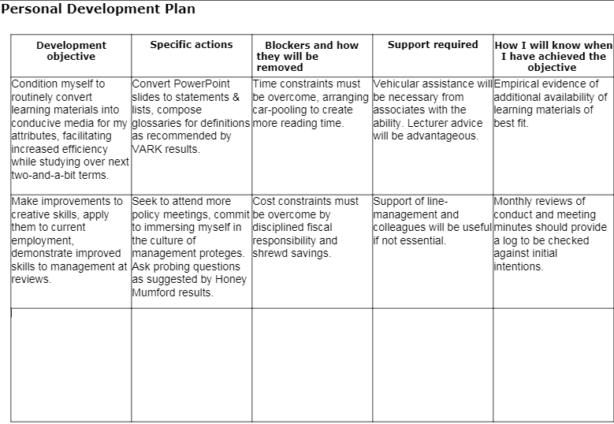

Conclusion
I have considered the purpose of this report and explored the definitions of the related concepts as I see them. My journey has taken me through self-awareness, research into learning, self-reflection, and comparing styles of reflection into a mindscape ready and primed for planning self-development. The experience has altered me, and like the reflective nature of learning, will continue to alter me.
References
Covey, S.R. (2004) The 7 habits of highly successful people. London: Simon & Schuster UK Ltd.
Go MAD Ltd., (2019) gomadthinking. Available at: gomadthinking.com (Accessed 12th November 2019).
Kelley, K. (2019) AI gig economy sets workers and bots on collision course. Available at: searchenterpriseai.techtarget.com/feature/AI-gig-economy-sets-workers-and-bots-on-collision-course (Accessed: 12th November 2019).
Maslow, A.H. (1943) ‘A Theory of Human Motivation’, Psychological Review, 50(4), pp370-96.
Merriam-Webster (2019) Dictionary. Available at: merriam-webster.com/dictionary/self-development (Accessed 9th November 2019).
Neugebauer and Evans-Brain (2016) Employability. London: SAGE.
Professional Academy (2019) Marketing Theories – SWOT Analysis. Available at: https://www.professionalacademy.com/blogs-and-advice/marketing-theories---swot-analysis (Accessed 13th November 2019).
Project Smart, (2014) A Brief History of Smart Goals. Available at: projectsmart.co.uk/brief-history-of-smart-goals.php. (Accessed: 12th November 2019).
The classroom (2019) Honey & Mumford Learning Style Theory. Available at: theclassroom.com/honey-mumford-learning-style-theory-10038576.html (Accessed 12th November 2019).
Van Vliet, V. (2010). SWOT Analysis. Available at: toolshero.com/strategy/swot-analysis/ (Accessed 12th November 2019)
VARK Learn Ltd. (2019) Vark a guide to learning preferences. Available at: vark-learn.com (Accessed 12th November 2019).
Weihrich, H. (1982) The TOWS Matrix - A Tool for Situational Analysis. Oxford: Pergamon Press.
Yorke, M. (2006) Employability in Higher Education: what it is, what it is not. York: The Higher Education Academy.

Appendices
Appendix 1
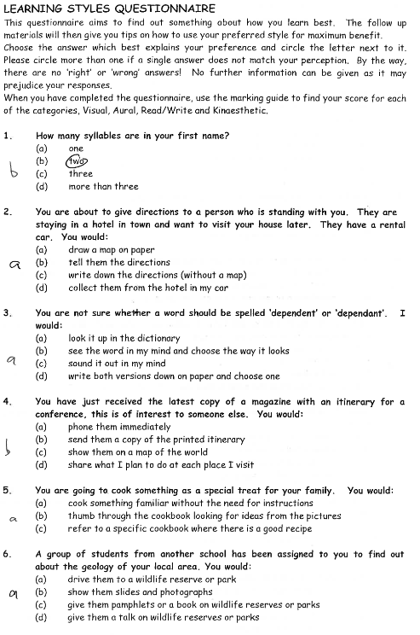

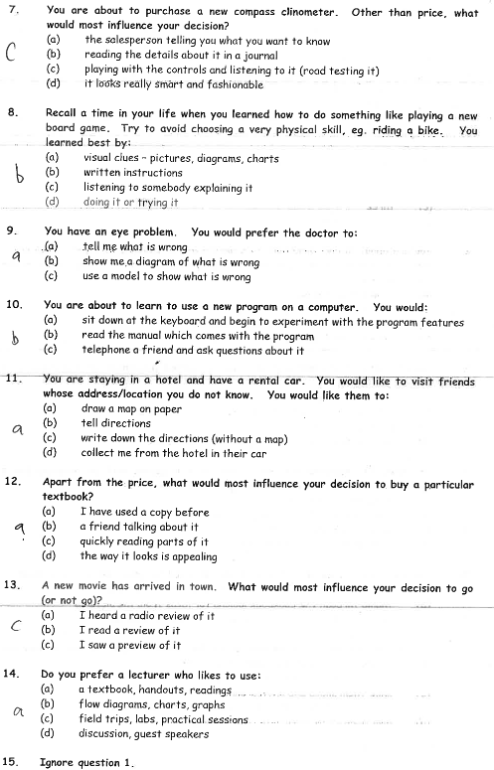

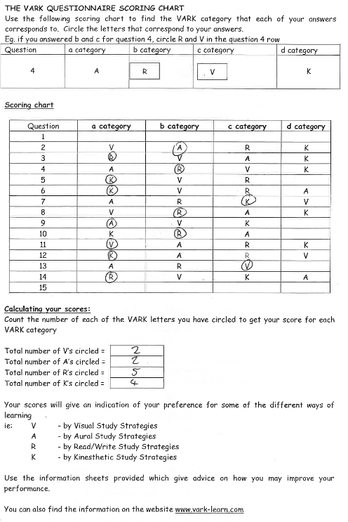

Appendix 2

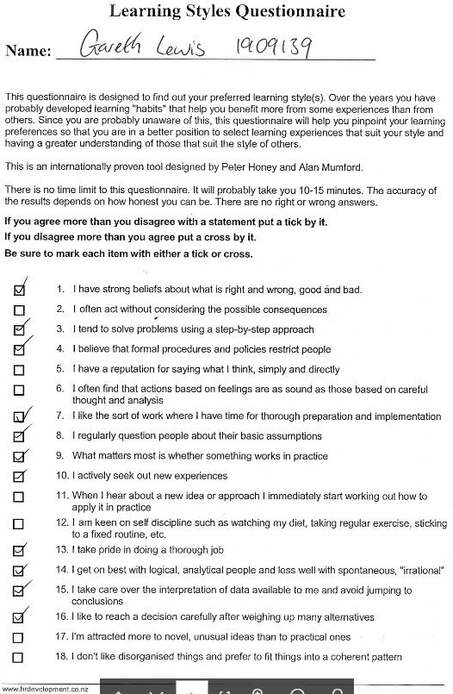

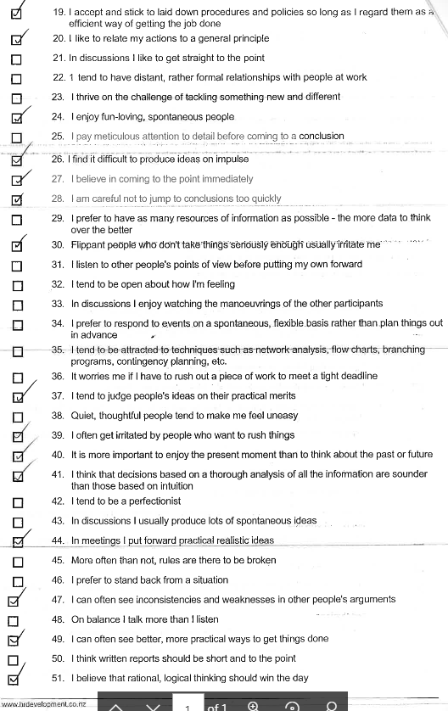

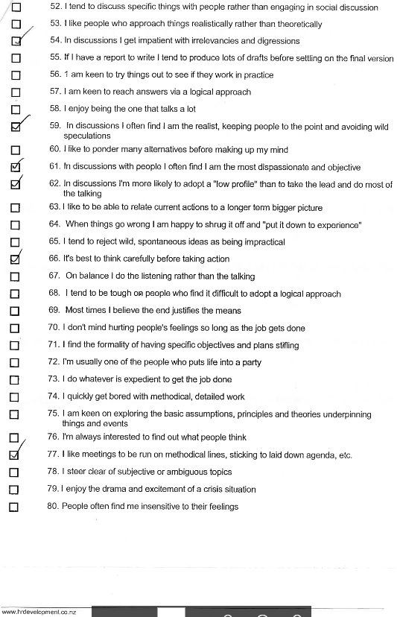

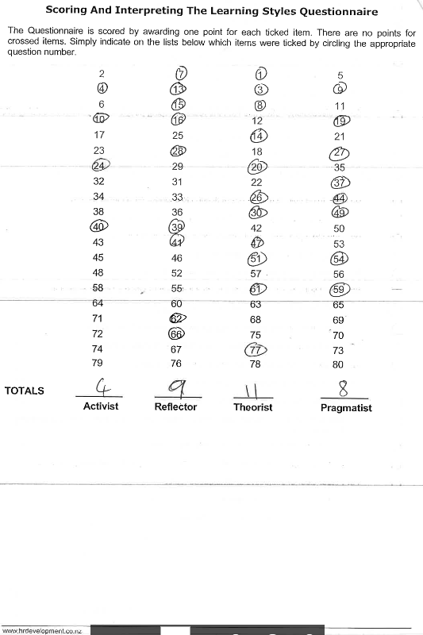

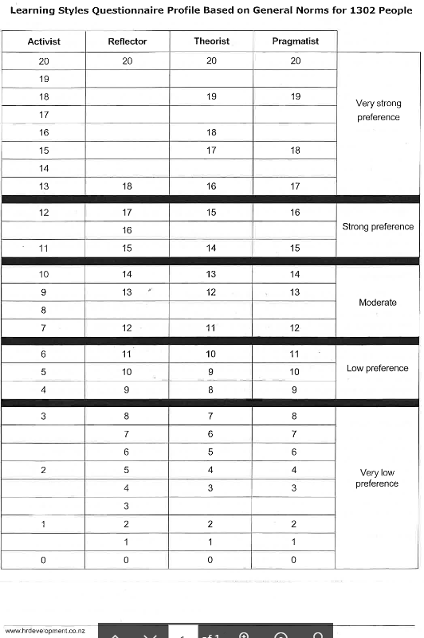
Acknowlegements.
The author acknowledges the invaluable assistance of Shehla Kahn in the study necessary for the completion of this report.

