

Master of Business Administration
Module Code and title:
LCBM7026 International Marketing: Principles and Practices

Assignment title:
International Marketing: Principles and Practices

Lecturer:
Tushara Balendran

Student Name: Ali Akbar Rafsan
Student ID: 2433800

Words: 5455

Date: 17th Dec, 2025
Table of Contents
1. Introduction 4
2. Company overview 5
2.1 BMW Operation in the UK 5
2.2 BMW Operation in China 6
3. Comparison of the Socio-economic context of the UK and China 8
Political factors 8
Economic factors 9
Socio-cultural factors 9
Technological factors 12
Environmental Factors 12
Legal Factors 12
4. STP analysis 14
4.1 STP strategies in the UK 14
4.2 STP analysis in China 15
4.3 Comparative evaluation 16
5. Marketing Mix 18
Marketing mix comparison 20
6. Evaluation of marketing strategy in the UK and China 24
6.1 The performance of BMW in the UK 24
6.2 The Performance of BMW in China 25
7. Ethical issues assessment 27
8. Recommendation 29
9. Conclusion 31
References 32

Table of Figures
Figure 1: BMW 5
Figure 2: BMW’s worldwide automobile sales in FY 2024, by regions (Statista, 2024) 6
Figure 3: PESTEL Analysis (Are, 2025) 8
Figure 4: Hofstede’s Cultural Dimensions comparison (The Culture Factor, 2025) 11
Figure 5: Perceptual Map (Awware, 2022) 16
Figure 6: BMW Car Models 19
Figure 7: BMW Brand awareness by YouGov Brand Index (YouGov, 2024) 25

Introduction
In the contemporary, highly globalised automobile market, efficient global marketing is required to sustain a competitive advantage in a variety of markets. In this report, the marketing approaches of BMW are the object of analysis involving two highly distinct countries, which include the UK, a highly developed, highly controlled one where a consumer oriented on performance, sustainability and advanced technology, and China, the largest international market characterized by high rates of economic growth, fund of technology and a consumer status orientated purchase behaviour. This report is a critical comparison of the strategic adaptations made by BMW in both countries using established marketing frameworks such as the PESTLE analysis, Segmentation-Targeting-Positioning (STP), and the extended marketing mix (7Ps).

Company overview
Bayerische Motoren Werke AG (BMW) is a German luxury car company and motor manufacturer with a global brand name of high-performance cars, powerful engineering and brand equity (SE, 2025). BMW is a luxury carmaker that was founded in 1916 and has expanded to rival other luxury carmakers like Mercedes-Benz and Audi (BMW Group, 2024).
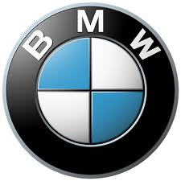
Figure 1: BMW
The BMW Group has the BMW, MINI and Rolls-Royce brands, and a strategic emphasis on digital and electrification (Forbes, 2024). The Group produced approximately 2.45 million vehicles in 2024, but the total sales fell slightly because of the headwind in the major markets such as China and Germany (Investing, 2025). Battery electric and plug-in hybrids constituted approximately 24.2% of all deliveries in the same year, with fully electric BMW models increasing by 13.5% globally (Electrive, 2025).

2.1 BMW Operation in the UK
The UK is a large European market for BMW, with a mature automotive consumer market that is highly conscious of luxury cars and has a growing interest in premium electric car (EV) vehicles (Butler, 2025). In 2024, deliveries in Europe and the UK in particular were resilient, with year-on-year growth recorded in several of the markets, like the UK, where the dispatches in the first half of the year increased (Addyng, 2024). The market of high-end cars in the UK is very competitive. High-performance and quality cars with prestige brands are sought by customers who can afford them. BMW markets its electric models in the UK to help the nation shift to electric cars and comply with more stringent emission regulations. UK laws, including future emissions restrictions and EV subsidies, assist the luxury manufacturers in accelerating electrification (Carsite, 2025). UK retailers and advertisers emphasise customer experience, online interaction and brand legacy to draw in insightful buyers. Europe sold nearly 948,500 BMWs in 2024, and the UK sold nearly 168,800 in 2024, indicating the significance of the market (Bruegel, 2025).

2.2 BMW Operation in China
China is the single biggest market in the world that is served by BMW, comprising almost 29.2% of group sales in 2024 (Statista, 2024).
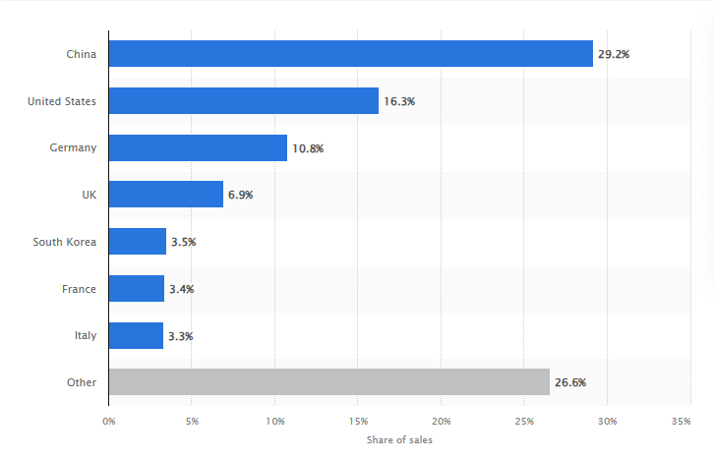
Figure 2: BMW’s worldwide automobile sales in FY 2024, by regions (Statista, 2024)
Although demand has slowed, China is important due to the high number of consumers and the rapid rate of electrification (Forbes, 2024). Over two decades, BMW has been investing in China, and it has had factories in cities such as Shenyang, such as Dadong and Tiexi factories, and collaborated with Great Wall Motor to manufacture electric MINI cars in China (Creemers, 2022). It also has the largest research and development centre outside Germany in China, where it creates digital services, autonomous technology, and EV features that meet local preferences. BMW sold circa 714,530 vehicles in China in 2024, remaining a leader in some of the luxury categories with a 2025 plan on models to consolidate the competitive stance (Padeanu, 2025).

Comparison of the Socio-economic context of the UK and China
The macro environment is examined using a PESTLE framework, which focuses on broad outside forces influencing an organisation or industry. It assists companies in identifying prospects and threats and directs strategic planning, which could be market entry or new product development (Are, 2025).
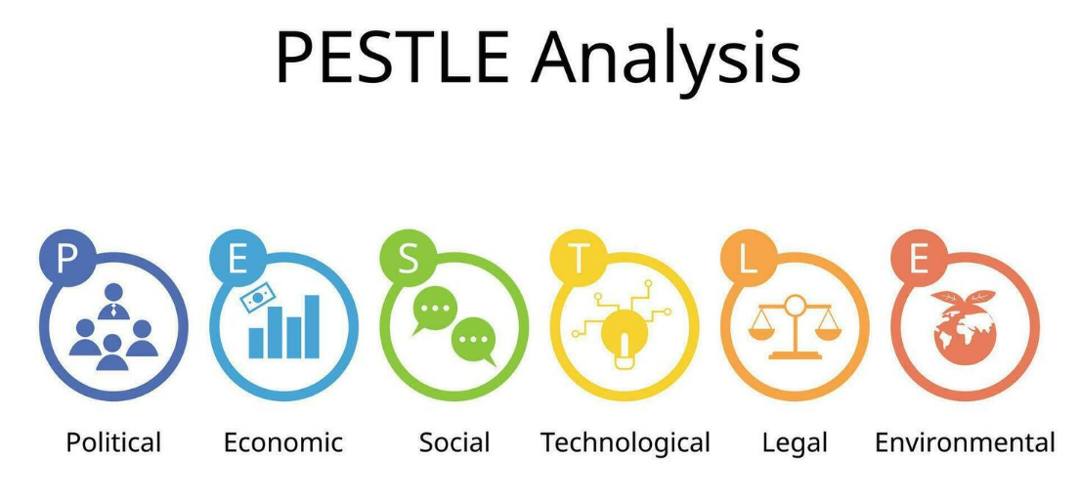
Figure 3: PESTEL Analysis (Are, 2025)

Political factors
United Kingdom: The policy environment in the UK, following Brexit, has generated trade polarity and new industrial activities that directly affect the automotive industry. A legally binding net-zero target to be met in 2050 and a gradual prohibition of new car sales of petrol and diesel cars by 2030 have been established by the government (Bekker, 2025). These regulations drive electrification and offer incentives to EV infrastructure and domestic green production. New electric-car grant in 2025 and company-car taxation are influencing company-car manufacturing strategy and supply chains, and pricing (Chambers, 2025). Such foreseeable regulation pressures imply that BMW will need to change its local marketing and product planning to emphasise EVs more.
China: The political climate of China is associated with operational industrial policy and Chinese directives in strategic sectors like new-energy vehicles (NEVs). Beijing relies on subsidies, dual-credit policies and domestic preferences to increase EV purchases and assist local champions (BRAND MINDS, 2021). Simultaneously, it exerts greater control over foreign companies via joint-venture regulations, information-security guidelines and industrial-planning restrictions. Though the government supports electrification, the repositioning of subsidy programs and increased scrutiny provide both opportunities and regulatory burden to the joint ventures and local operations of BMW (BMW Group, 2025).

Economic factors
United Kingdom: The UK is a mature and high-income market whose consumer purchasing power of high-end goods is relatively stable. Demand for luxury cars can be affected by inflation, exchange-rate variability, and intermittent economic downturns (Briefing, 2021). The automobile industry continues to contribute significantly to the production of jobs and exports, yet the growth of vehicle registrations is very small compared to the emerging markets. The UK market incentives, as well as firm car tax regimes, also influence the fleet and premium-car demand (Callahan, 2022).
China: China is the largest new-vehicle market in terms of volume in the world and is also vital to BMW's world sales (Finnerty, 2025). Blistering urbanisation, growing upper-middle-income incomes, and the electric vehicle sales boom have boosted premium vehicles demand, and recent macroeconomic tailwinds and declining property markets have diminished luxury expenditures (Chau, Zhang and Tang, 2022). China has massive sales potential, though it also entails high local competition and domestic price pressure among local EV manufacturers.

Socio-cultural factors
United Kingdom: The UK customers tend to appreciate individualism, innovation, and real-life, sustainability-focused premium positioning (Du et al., 2024). The British high-end consumers value the engineering heritage, ownership history, and environmental friendliness. Such tastes guide BMW towards driving dynamics and electrified product lines (Cook, 2023). Low uncertainty avoidance and moderate long-term orientation foster the adoption of new technologies in cases supported by brand trust.
China: Chinese consumers are more status-conscious and more long-term oriented in investment and saving behaviour. Buying choices are often influenced by status, technology add-ons and face (China Daily, 2024). The dynamic digital acceptance of the WeChat and Douyin platforms makes experiential KOL-driven marketing particularly effective. Localised services and on-demand digital ownership experiences are also appreciated by the consumers, and therefore, the marketing of BMW in China should preempt prestige, digital convenience, and products that are familiar to locals in China (Clearly Cultural, 2025).
Hofstede’s Cultural Dimension Analysis:
Cultural Dimensions Analysis by Hofstede is a theory of national cultural variations. It determines six dimensions, which are Power Distance, Individualism vs. Collectivism, Masculinity vs. Femininity, Uncertainty Avoidance, Long-Term vs. Short-Term Orientation, and Indulgence vs. Restraint (Masoud et al., 2025). The model assists companies and individuals in cross-cultural interactions through a comparison of societal values in such aspects as hierarchy, self-interest, competition, risk, tradition and gratification (Herring, 2023).
United Kingdom: The United Kingdom has a high individualism (76), low Power distance (35), low uncertainty avoidance (35), moderately high Indulgence (69), and moderate Long-term Orientation (60) (Cook, 2023). Such cultural signs imply that marketing techniques ought to preempt individual selection, invention, competitive benefit, and lifestyle advantages-messages that resonate with the stance of BMW and the driving delight and self-identification (BRAND MINDS, 2021).
China: The Chinese cultural profile is described as focused on Power Distance ( 80), and lower levels of Individualism (43), Uncertainty Avoidance (30), Long-Term Orientation (77), and Indulgence (24) (Ho-him, 2025). In the case of BMW, it means that customers can be motivated by prestige, endorsements of authority and relationship sales, long-term value stories, and a message about status and technological leadership. Therefore, premium status, elite experiences, and long-term quality should be emphasised in marketing (Think Insights, 2022).
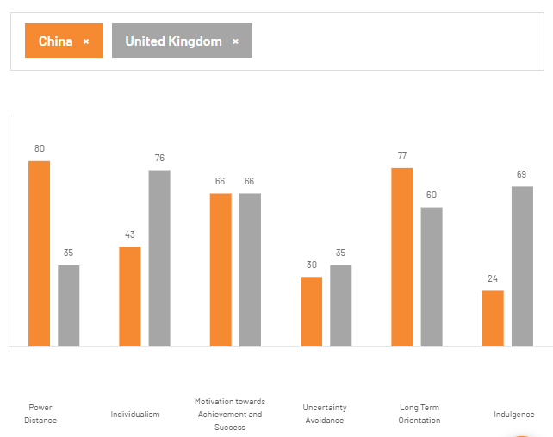
Figure 4: Hofstede’s Cultural Dimensions comparison (The Culture Factor, 2025)
Advantages and disadvantages of Hofstede’s model: The Hofstede framework is a concise, comparative system that helps marketers adapt communication patterns, messaging, and sales methods to national cultures (Frow, 2022). The high-level segmentation and positioning decisions are specific to its use. However, the use of Hofstede presents the problem of excess generalisation and disregard of within-country diversity, regional side-breaking, demographic change, and behavioural change, which happens rapidly, particularly in rapidly changing markets like urban China (Masoud et al., 2025). Hofstede must therefore be used as a guide and not as a mandate in localised research and trial-and-error marketing initiatives (The Culture Factor, 2025).

Technological factors
United Kingdom: United Kingdom trends demonstrate a strong interest in digital and charging infrastructure development, facilitated by huge investment in interconnected services by OEMs, over shows and connection with networks (Hawksford, 2025). Nevertheless, there is unequal coverage of charging in public. There is a policy mandate to meet 2030 targets, along with industrial incentives providing motivation to manufacturers and dealers to provide a digital sales channel and home-charging options (Horatiu Boeriu, 2025).
China: Digital ecosystems, mobile payment and vehicle connectivity dominate the market in China. The quick deployment of charging systems and superapp connections to WeChat and Alipay allows car manufacturers to provide a highly localised digital customer experience (IEA, 2025). The local technological framework and in-car digital services are major competitive battlefields.

Environmental Factors
United Kingdom: These business agendas by the United Kingdom of net-zero and a thriving air-quality mean increased regulation and reputation pressure on automakers to decarbonise products and supply chains (IISS, 2019). The incentives of EV adoption and city low-emission zones create the marketing discourses, which predetermine sustainability and lifecycle emissions.
China: The carbon-peak and carbon-neutrality objectives of China, along with urban subsidies for new electric models, stimulate demand for greener products. However, the ecological footprint of the supply chain and local scrap cycles remains threatening to the reputation of a brand (James Roberts, 2025).

Legal Factors
United Kingdom: The UK has stringent consumer, advertising, competition and personal data protections under UK GDPR and the Data Protection Act 2018 (OECD, 2024). Such regulations influence customer-relationship management, marketing, and after-sales services.
China: The PIPL and data-security framework (DSL) in China establish certain limitations on data flows, telematics in cars, and cloud computing. Original equipment manufacturers need to reorganise their processes and localise certain operations (Partington, 2025). Compliance is thus a fundamental business and marketing issue.
Similarities and Differences: Both markets promote electrification, digitalisation, where EVs and related services are at the centre of the global strategy of BMW. The UK is an established, regulation-intensive market in which consumers are concerned with sustainability and brand heritage (Reid, 2025). China, on the other hand, is a big, status-oriented market, and its digital ecosystems and strong local competition and data and investment regulations are more complicated (Rhodium Group, 2024). Such variations compel BMW to have global brand continuity and adjust product, price, channel, and communication strategies to the specific country.

STP analysis
Segmentation, Targeting, and Positioning (STP) breaks a national market into substantial segments of the market the brand will serve and applies a clear market position to form its product, price, place, and positioning decisions (World, 2025). This section uses STP to BMW to explain how the brand segments both markets.

STP strategies in the UK
Segmentation: BMW in the UK uses conventional customer segmentation. Demographically, it focuses on wealthy professionals between the ages of 30 and 60. Psychographically, it targets its early adopters, driving enthusiasts, those with a keen eye on engineering and a brand heritage, and sustainability-conscious early adopters (Waldersee, 2025). The segments, in terms of behaviour, are performance seekers, corporate fleet buyers and tech-savvy consumers, who cherish connected services. Geographic segmentation is comparatively small since the UK market is small, though urban customers in London and other cities are more interested in EVs due to charging access and Low Emission Zones (Vaz, 2024). BMW products such as 3, 5, 7 series and X SUVs and i-series EVs encompass these segments. BMW Group UK market performance in 2024 indicates that the company was the market leader in the premium market with high EV growth and the ability to segment towards both performance and electrification customers (Usercentrics, 2025).
Targeting: BMW focuses on high-income individuals and company fleet purchasers who value driving dynamic, engineering quality and, more so, electrification. The company aggressively markets EV customers in the UK by training dealers, EV test-drives and marketing sustainable luxury and performance (Trading Economics, 2024). BMW Group UK registration data indicate an increasing number of BEVs, which confirms this approach to targeting. The brand also has distinct products such as MINI and Rolls Royce to strike adjacent style markets (Tian, Wang and Zhu, 2024).
Positioning: Positioning of BMW in the UK combines the heritage of Sheer Driving Pleasure with modern-day sustainability and high technology. Messages that will attract both conventional driving clients and ecologically aware luxury customers focus on engineering, performance and a growing electric line-up of cars (SE, 2025). The UK advertising statistics and brand tracking indicate that BMW remains very conspicuous and positively perceived in relation to competitors.

STP analysis in China
Segmentation: In China, BMW segmentation has been based on technology appetite and status. The main categories comprise high-income, status purchasers in tier-1 and tier-2 urban areas, tech-focused younger workers who value connectivity and in-car digital functions, and a group of NEV buyers who are rapidly increasing and not only demand green credentials and government subsidies (Statista, 2024). The urban concentration is intensive with highly concentrated sales in Beijing, Shanghai, Guangzhou and the key capitals of provinces where the strongest premium demand and charging infrastructure can be found (Reuters Staff, 2024). The segmentation of local tastes and family/chauffeur usage is visible in the localised model mix, which BMW adopted in China as long-wheelbase models, China-specific trims, and locally manufactured EVs through BMW Brilliance (Kang, 2025).
Targeting: In China, BMW targets consumers who prioritise status, technology, and local relevance. It collaborates with BMW Brilliance to manufacture low-cost, country-specific brands among the wealthy population of the country (Dudarenok, 2023). Digital marketing via WeChat, Douyin, and Xiaohongshu, celebrity and KOL endorsement, allows BMW to reach younger and richer crowds. The brand also enhances chauffeur and rear comfort in long-wheelbase models to suit the local taste (Graser, 2018). These attempts are seen through new product launches and continuity in local R&D.
Positioning: BMW positions itself in China as the pinnacle of high status, high technology, and reliability. The brand emphasises domestic quality, tailor-made EVs, and high-quality online services that are connected with Chinese super-apps (Digital Crew, 2020). Social media-specific campaigns are designed, often with local celebrities or KOLs supporting the prestige and cultural appeal. This approach differentiates BMW among established German competitors and fast-growing local NEV manufacturers (Chris Overall, 2024).
Perceptual Map of BMW in the UK
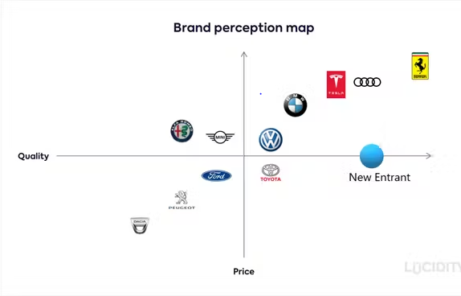
Figure 5: Perceptual Map (Awware, 2022)
BMW in the premium car market of the UK sits in the upper-right quadrant, which associates high performance with a luxury image (Awware, 2022). BMW is perceived to offer better engineering, dynamic handling, and low-tech features in-car, and retains a status of prestige as compared to mass-market and technology-based competitors. BMW is seen as more performance-based and driver-centric than Mercedes-Benz (YouGov, 2024). Innovative brands such as Tesla are regarded as both technology-innovative and not expensive in luxury.

Comparative evaluation
The table below provides a comparative evaluation of BMW’s STP strategies in the UK and China.
Area of comparison | UK | China
Primary segments targeted | BMW primarily serves wealthy individual consumers and corporate fleet clients who enjoy driving performance, high-quality, and more eco-friendly mobility, particularly electric vehicles (Waldersee, 2025). | BMW targets upper incomes, style-conscious urbanites and younger, tech-conscious office workers in tier-1 and tier-2 cities that appreciate prestige, hi-tech capabilities, and electric performance (Xinhua, 2025).
Core targeting tactics | BMW has a dealership-based experiential marketing approach, including test drives, online configurators, and corporate leasing schemes to attract high-end clients and support long-term brand acceptance (Trading Economics, 2024). | Its brand is based on localised manufacturing, models that use China to make them, competitive financing, and high-intensity online marketing on platforms like WeChat and Douyin, which are often anchored by key-opinion-leader marketing (Yougov, 2024).
Positioning emphasis | BMW is positioned as an upscale and sporty brand that integrates sheer driving pleasure with high technology, and growing sustainability and electrification (SE, 2025). | BMW is projected as a high-end global luxury brand promise of long-term value, technological brilliance, and localized premium experiences at the Chinese consumer expectation (Tian, Wang and Zhu, 2024).

Marketing Mix
This section compares the marketing decisions of BMW in the United Kingdom and China based on the 7Ps, how the company is blending product lines, pricing, distribution and messages to respond to local market needs, government regulations and market competition.
Product classification:
The core BMW product lies in exclusive passenger cars and their associated mobility package, which, according to the criteria of marketing, are defined as speciality products that are being bought by buyers based not on pricing sensibility but brand prestige, performance, and technology (BMW Group, 2024). The other complementary sub-brands, such as MINI, Rolls-Royce, and after-sales services, as well as features that are digitally delivered, including ConnectedDrive, BMW Charging, are also included in the portfolio (Frow, 2022).
Product depth
The depth of models is various, as many different types of engines, types of trim, wheelbase, powertrain (ICE, PHEV, BEV), and equipment packages make up a dizzying number of SKUs that fit the local consumer market and local tax systems (BMW Group, 2024). As an example, a longer-wheelbase 5 Series and trims customised exclusively to China demonstrate a more rigorous SKU customisation in China than in the UK (Ho-him, 2025).
Product width:
At the international level, BMW has a wide product line that covers compact models (1/2 Series), core sedans (3/5/7 Series), and SUVs (X family), performance models (M models), and electrified models (i3 legacy, i4, iX, iX1, iX3), and lifestyle products and financial services (LBB Editorial, 2022). BMW has deployed the majority of its worldwide families in both the UK and China, but has diversified the model mix and feature set to meet the local taste (Padeanu, 2025a).
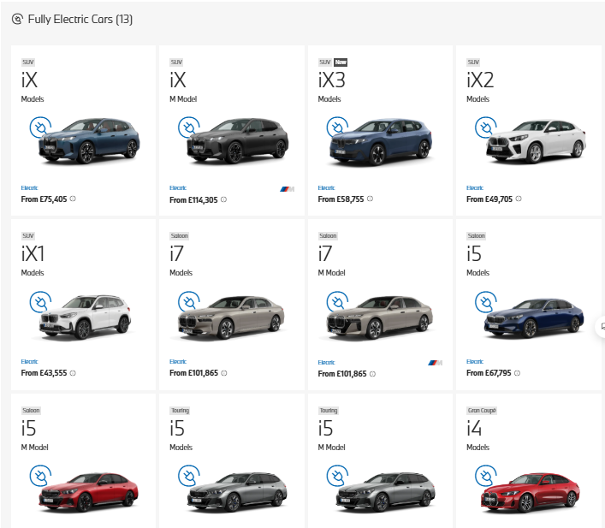
Figure 6: BMW Car Models
Product dimensions:
Core products: Mobility is at the centre of its core product, and it is presented in the form of safe, performance and premium cars that provide a high-quality driving experience and a comfortable feeling (World, 2025).
Packaging: Physical attributes, including exterior design, interior quality, and long-wheelbase options, and digital features, including in-car software or China-specific apps and services, are all covered under packaging (Padeanu, 2025b).
Auxiliary features: The auxiliary offerings cover warranties, BMW Financial Services, subscription plans, connected services, and dealer experience packages, which include personal delivery and VIP events (Addyng, 2024). Digital packaging has become more important than ever with the recent emphasis on Neue Klasse roadmap products, which are software-defined.

Marketing mix comparison
Although BMW has a consistent premium brand image, the company varies the seven Ps of product, price, place, promotion, people, process, and physical evidence to fit the UK and China markets, considering the local policy, consumer motives, and competitive strategies (Dudarenok, 2025).
Product
In the UK, BMW represents a well-balanced approach to the use of ICE, PHEV, and BEVs, which will speed up the introduction of BEVs. Marketing focuses on momentum, technology of tradition and the shift to electrification and is consistent with the 2030 petrol/diesel phase-out. BMW Group UK has noted high BEV market share in 2024, with the i4 and iX in model launches trailed by dealer experience centres (Bruegel, 2025).
In China, BMW markets its cars in a different way, including long-wheelbase sedans and China-specific EVs manufactured under Brilliance (BBA). It combines the local digital capabilities and voice assistants (Creemers, 2022). Localisation of production increases local content and facilitates quicker product cycles that are responsive to the Chinese market. By 2024, China's shipments were over 700,000 vehicles, with an obvious emphasis on BEV expansion despite recent weaknesses in the market (Carsite, 2025).
Price
The pricing of BMW in the UK is based on its high-end positioning and the influence of company-car taxes, including Benefit-in-Kind taxes, which apply to corporate leasing and pricing messages (Butler, 2025). Consequently, BMW facilitates finance deals and corporate offers with list prices. EV incentives are lower than in earlier years, meaning that the emphasis is on the total cost-of-ownership instead (Electrive, 2025).
In China, BMW competes with local brands of NEV, which tend to set lower prices than European competitors. BMW employs local pricing, attractive financing, trade-in promotions, and joint-venture price advantages to remain competitive and maintain positioning on premium trims (Dieselnet, 2016). Its demand is also driven through frequent promotions and subscription models.
Place
BMW has balanced franchised dealerships, certified pre-owned stores, and an expanding online direct-to-consumer channel in the UK, allowing clients to build cars, finance, and obtain cars without physical contact. BMW UK has emphasised its investments in omnichannel retail (Forbes, 2024). Urban experience centres and regional dealerships continue to be important in terms of test drives and service.
Distribution in China is very digital and omnichannel. BMW retails via the BBA dealer network, brand flagships in tier-1 cities and official T-mall or JD accessory chain (Leggett, 2025. Superapps like WeChat Mini Programmes and Douyin shops are integrated with sales. Local partners deal with last-mile delivery and after-sales services, and joint-venture plants reduce supply chains (Padeanu, 2025).
Market Entry: BMW first penetrated the UK by exporting and subsequently by creating manufacturing and assembly plants, including the Oxford MINI, and a well-established dealer network (SE, 2025). It runs in the UK as a direct market country with wholly owned sales and marketing. The brand has been strengthened by the historical production and its network of dealers.
In China, BMW uses a long-term joint venture, BMW Brilliance Automotive (BBA), to address regulatory needs and localisation of production, R&D, and supply chains (Are, 2025). The JV allows local production, fast response to the market and custom products. BMW has renewed the JV agreement until 2040, which indicates strategic dedication (Bekker, 2025). The model also enables adherence to local data and investment regulations.
Promotion
UK advertising emphasises brand legacy, pleasure-engineering, and green technology by using televisions, online marketing, experiential activities, motorsport association, and targeted CRM with very rich customers and fleet managers (BMW Group, 2025). BMW UK embraces BEV incentives and dealer EV programmes as well.
In China, promotional campaigns involve exploiting temporally resonant campaigns, such as the Lunar New Year, and cooperating with key opinion leaders, viral content on platforms like Douyin, and strategic platform choices, which help to quickly reach the target audience and convert it into profits (Briefing, 2021). BMW China also utilises short video and live streaming, along with campaigns led by local artists, to attract younger buyers and then convert that online interest into a visit to the showrooms (Callahan, 2022).
People
The UK people strategy of BMW is based on the trained dealership sales teams, training of service staff in electrification, and corporate account managers to support fleet sales (Cook, 2023). BMW spends a lot of money on training its dealers to provide a standardised high-end customer experience.
In the Chinese market, sales staff often take the role of relationship managers and are assisted by digital sales assistants and key opinion leaders (Chau et al., 2022). BMW then uses some local teams and collaborates with domestic agencies to provide customers with culturally suitable services at flagship stores and dealer points of contact.
Process
In both markets, this brand embraces lean digital buying platforms, online configurators, and matters with built-in after-sales. Nonetheless, in China, in-app service booking, payments, and livestream commerce services show more transaction-focused and fast interactions than the more appointment-based dealer experiences in the United Kingdom (Du et al., 2024). OTA software provisioning and subscription services are the new elements of processes in both countries.
Physical evidence
BMW's physical representations feature showrooms, test-drive routes, service centres, and branded events. In the UK, the focus lies on fully-immersive showrooms and electric-vehicle centres, whereas in China, full-line brand stores in the centres of cities, as well as surrounding paintings of shopping holidays, provide concrete high clues and help to create local contact (Finnerty, 2025).
Advantages and Disadvantages of Marketing Mix
The marketing mix allows BMW to broaden its brand across countries and allows localisation at the level of products, involvement of the joint ventures' production process in China, and omnichannel selling in the United Kingdom, thus increasing relevance and responsiveness (Herring, 2023). Experiential and online promotion campaigns also strengthen brand equity and speed up the penetration of battery-electric cars.
The added complexity of managing a diverse set of SKUs and the large network of dealerships swells the cost structures (Horatiu Boeriu, 2025). Local new-energy-vehicle entrants in China lead to aggressive competition that would squeeze margins and cause quick adaptations to price and feature offerings (IEA, 2025). At the same time, regulatory and tax reforms, including the United Kingdom rules regarding the company cars and Chinese data/protection rules, drive continuous adjustment and can undermine the effectiveness of standardised offers.

Evaluation of marketing strategy in the UK and China
This part examines the effectiveness of marketing strategies of BMW in the United Kingdom and China by comparing the sales, market share, distribution, brand awareness and digital activities.

6.1 The performance of BMW in the UK
The UK marketing strategy is quite effective for BMW, particularly in the high-end market. In the UK, the registrations of the top three premium car brands according to the BMW Group Annual Report 2024 include BMW, Mercedes-Benz, and Audi (Hall, 2025). According to SMMT, BMW is estimated to have about 10-12% of the UK market in the premium market, which reflects good brand loyalty and marketing to the high end of the market (SMMT, 2025).
The electrification drive of BMW also showed good outcomes. In 2024, BMW was one of the largest sellers of premium EVs in the UK (Bekker, 2025). The UK BEV registrations rose annually, and models such as the i4 and iX performed well. BMW Group UK has more than 130 authorised dealers around the country, offering extensive physical presence and after-sales service all over (Investing, 2025).
Brand awareness scores solidify the effectiveness of the strategy. YouGov BrandIndex UK continually places BMW at the top of the list in terms of brand consideration, perceived quality, and corporate reputation among high-end car buyers (YouGov, 2024).
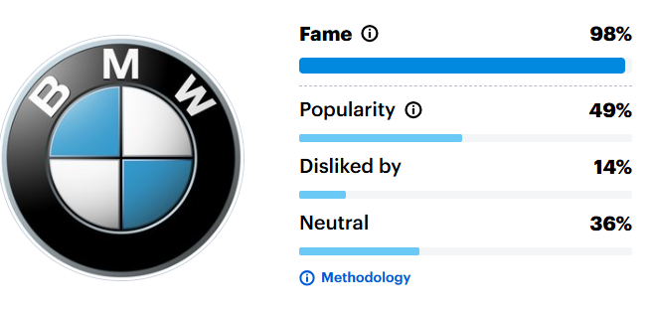
Figure 7: BMW Brand awareness by YouGov Brand Index (YouGov, 2024)
Online interaction is high as well. The Instagram and YouTube pages of BMW UK have high engagement rates compared to competitors, with the help of experiential campaigning, EV-education, and sponsorships (Hootsuite Inc, 2025). Generally, the UK marketing of BMW supports its sustainability-based, performance-based, and premium positioning.

6.2 The Performance of BMW in China
China is the most strategically critical market for BMW, but its performance is more ambivalent in terms of stiff competition. According to the BMW Group Annual Report 2024, China was recognised as contributing approximately 30% of total world sales with more than 700,000 vehicles sold despite slower macroeconomic growth (Co, 2025). According to CAAM and Statista data, BMW is ranked among the leading foreign premium brands in China, alongside Mercedes-Benz (Kang, 2025).
The BMW joint venture, BMW Brilliance Automotive (BBA), operates two huge production facilities in Shenyang. It also maintains over 600 dealerships in China that provide extensive penetration of BMW (Reuters Staff, 2024). BMW uses localised marketing approaches, including long-wheelbase models and China-related EVs, to remain relevant among status-seeking customers.
BMW China has great execution with regard to digital engagement. Millions of people follow the brand on WeChat, Weibo, and Douyin (Think Insights, 2022). Key opinion leaders (KOLs) result in high views through and interaction rates. However, the expansion of its market share is strained by the presence of ambitious domestic EV brands such as BYD and NIO (Tian et al., 2024). This indicates that although BMW marketing is good, aggressive competition limits overall performance gains.

Ethical issues assessment
The section will consider the main ethical concerns associated with the marketing mix of BMW in the United Kingdom and China, covering sustainability claims, data use, fairness in prices, and responsible promotion.
Environmental and Sustainability Ethics
BMW also promotes electrification and sustainability in the UK and China; it is associated with holding concerns about greenwashing. The firm records reduced lifecycle CO₂ emissions and increased battery electric vehicle sales (Greenly, 2023). However, its future popularisation of high-emission performance vehicles can corrupt its environmental assertions. The standard of environmental statements required by UK advertising insists on clarity and an evidence-based nature, which increases reputational risk in case BMW exaggerates the level of influence (Norton Rose Fulbright, 2023). The fast development of EVs in China poses the threat of battery sourcing, recycling, and upstream environmental impacts. BMW addresses these risks through supplier codes of conduct and programmes to reduce its environmental impact through the circular economy, but with limited external monitoring (Shipley, 2023).
Data privacy and digital marketing ethics
BMW prolifically employs connected car data and digital environments, with potential ethical issues arising in China. The Personal Information Protection Law (PIPL) of China and the Data Security Law regulate the collection and use of customer data by BMW via in-car systems and superapps (Reid, 2025). In the UK, BMW has to adhere to the UK GDPR, which enforces strict consent and disclosure conditions in CRM and targeted advertising.
Pricing and promotional ethics
In both markets, premium pricing is ethically fair. Nevertheless, the competitive nature of the EV market in China compels unattractive discount pricing and financing terms that threaten to undermine transparency and consumer confidence (World, 2025). BMW considers its ethical risks with compliance schemes and ESG reporting, although constant attention is necessary due to the increased digitalisation and sustainability marketing (BMW Group, 2024).

Recommendation
This section offers strategic recommendations to enhance the effectiveness of BMW in its international marketing, particularly in the UK and China.
Deepening electric-first and sustainability-led positioning
BMW must invest in an electric-only storey to shed transitional rhetoric that continues to offer high-emission sports vehicles (World, 2025). In the UK, it needs to reinforce lifecycle sustainability claims, including production, use and recycling, to comply with tougher ASA regulations and fulfil environmentally conscious consumer needs. Local EV-manufacturing, battery recycling, and long-term carbon-neutral strategies should be prioritised in China, enabling BMW to compete on equal terms with local NEV brands (Transport and Environment, 2019).
Enhancing digital ecosystem localisation
BMW needs to reshape specific market digital ecosystems rather than a global approach. Greater involvement with WeChat, Douyin, and in-car local applications in China would increase engagements and conversions, particularly among its younger premium consumers (Padeanu, 2025a). In the UK, developing a data-transparent CRM with subscription-based services would enhance the level of trust and long-term client participation and meet UK GDPR requirements (OECD, 2024).
Refining premium value communication under price pressure
With the intensifying competition, especially in China, BMW needs to shift its messages to not just price and incentives, but the overall ownership value, which comes in the form of software updates, resale value and after-sales quality (Reid, 2025). In the UK, the corporate fleet marketing needs to use to its advantage the favourable EV tax breaks and ownership-cost comparisons in order to ensure that it does not lose its market share (Greenly, 2023).
Strengthening ethical and governance transparency
BMW needs to market its ethical standards, as it has created data-privacy protection, responsible supply chain, marketing, and advertising. Effective ESG narration will protect brand equity and differentiate BMW as a responsible and premium brand in these two markets (BMW group, 2024).

Conclusion
. The report critically analyses the marketing of BMW in the United Kingdom and China, demonstrating how the world's premium brand responds to varied macroeconomic and cultural environments. The analysis demonstrates that BMW has been successful in localising STP strategies and marketing mix without altering its premier identity. BMW in the UK is focused on performance, sustainability and corporate fleet marketing, which is also matched to the mature consumer expectations and regulatory pressures. Joint-venture production, digital ecosystems and positioning based on status allow BMW to operate in the largest automotive market globally, localisation in China. However, rising competition and moral focus imply that BMW has to reinforce electric-first messages, digital openness and accountable marketing conduct in order to achieve long-term international competitiveness.

References
Addyng (2024). What Challenges Does the UK Automotive Industry Face in 2024? – addyng. [online] Addyng.com. Available at: https://addyng.com/what-challenges-does-the-uk-automotive-industry-face-in-2024.php? [Accessed 14 Dec. 2025].
Are, M. (2025). The Electric Car Scheme. [online] The Electric Car Scheme. Available at: https://www.electriccarscheme.com/blog/evs-eligible-for-the-electric-car-grant? [Accessed 14 Dec. 2025].
Awware (2022). Perceptual map: how-to, types and tools. [online] awwaredigital. Available at: https://awware.co/blog/perceptual-map/ [Accessed 15 Dec. 2025].
Bekker, H. (2025). 2024 (Full Year) Britain: Best-Selling Car Brands in the UK - Car Sales Statistics. [online] Best-selling-cars.com. Available at: https://www.best-selling-cars.com/britain-uk/2024-full-year-britain-best-selling-car-brands-in-the-uk/? [Accessed 15 Dec. 2025].
BMW Group (2024). BMW Group maintains BEV growth path in challenging market situation in 2024. [online] BMW Group PressClub. Available at: https://www.press.bmwgroup.com/global/article/detail/T0447427EN/bmw-group-maintains-bev-growth-path-in-challenging-market-situation-in-2024?language=en [Accessed 15 Dec. 2025].
BMW Group (2024). Introducing The BMW Group. [online] BMW Group. Available at: https://www.bmwgroup.com/en/company.html [Accessed 14 Dec. 2025].
BMW group (2024). NEW SALES AND MARKETING STRATEGY. [online] Bmwgroup.com. Available at: https://www.bmwgroup.com/en/news/general/2021/marketing-strategy.html? [Accessed 15 Dec. 2025].
BMW Group (2025). BMW Group posts third-quarter sales growth. [online] BMW Group PressClub. Available at: https://www.press.bmwgroup.com/global/article/detail/T0453185EN/bmw-group-posts-third-quarter-sales-growth?language=en [Accessed 14 Dec. 2025].
BRAND MINDS (2021). What is Hofstede’s cultural dimensions theory? UK vs China, a comparison - BRAND MINDS. [online] BRAND MINDS. Available at: https://brandminds.com/what-is-hofstedes-cultural-dimensions-theory-uk-vs-china-a-comparison/? [Accessed 14 Dec. 2025].
Briefing, C. (2021). The PRC Personal Information Protection Law (Final): A Full Translation. [online] China Briefing News. Available at: https://www.china-briefing.com/news/the-prc-personal-information-protection-law-final-a-full-translation/? [Accessed 14 Dec. 2025].
Bruegel (2025). A smart European strategy for electric vehicle investment from China. [online] Bruegel | The Brussels-based economic think tank. Available at: https://www.bruegel.org/policy-brief/smart-european-strategy-electric-vehicle-investment-china? [Accessed 14 Dec. 2025].
Butler, E. (2025). Euronews.com. [online] euronews. Available at: https://www.euronews.com/business/2025/04/10/bmws-china-sales-drop-to-lowest-level-in-five-years-at-start-of-2025? [Accessed 14 Dec. 2025].
Callahan, J. (2022). How will the dual-credit policy help China boost new energy vehicle growth? - International Council on Clean Transportation. [online] International Council on Clean Transportation. Available at: https://theicct.org/china-dual-credit-policy-feb22/? [Accessed 14 Dec. 2025].
Carsite (2025). BMW Group UK Achieves Record-Breaking Sales in 2024 with Continued Electrification Success – Car Site. [online] Carsite.co.za. Available at: https://carsite.co.za/bmw-group-uk-achieves-record-breaking-sales-in-2024-with-continued-electrification-success/? [Accessed 14 Dec. 2025].
Chambers (2025). Data Protection & Privacy 2025 - China | Global Practice Guides | Chambers and Partners. [online] Chambers.com. Available at: https://practiceguides.chambers.com/practice-guides/data-protection-privacy-2025/china/trends-and-developments? [Accessed 14 Dec. 2025].
Chau, V.S., Zhang, R. and Tang, L. (2022). Insights on measuring China’s new national culture from leaders of the Fourth Industrial Revolution. Journal of General Management, 49(3), p.030630702211170. doi:https://doi.org/10.1177/03063070221117090.
China Daily (2024). EVs fuel BMW’s lead in China. [online] Chinadaily.com.cn. Available at: https://www.chinadaily.com.cn/a/202401/10/WS659decf9a3105f21a507b77b.html? [Accessed 14 Dec. 2025].
Chris Overall (2024). BMW Group UK Leads the Premium Segment in 2024 with Strong Electric Growth. [online] BMW Group PressClub. Available at: https://www.press.bmwgroup.com/united-kingdom/article/detail/T0447261EN_GB/bmw-group-uk-leads-the-premium-segment-in-2024-with-strong-electric-growth?language=en_GB [Accessed 15 Dec. 2025].
Clearly Cultural (2025). Power Distance Index – Clearly Cultural. [online] Clearlycultural.com. Available at: https://clearlycultural.com/geert-hofstede-cultural-dimensions/power-distance-index/? [Accessed 14 Dec. 2025].
Co, M. (2025). China - New car sales in 2024 by OEM, model, vehicle type. [online] MarkLines Automotive Industry Portal. Available at: https://www.marklines.com/en/statistics/flash_sales/automotive-sales-in-china-by-month-2024? [Accessed 15 Dec. 2025].
Cook, T.B. (2023). The United Kingdom: Its Cultural Dimensions and Cultural Values. [online] TBC Culture Hub. Available at: https://www.tbcculturehub.com/post/the-united-kingdom-its-cultural-dimensions-and-cultural-values? [Accessed 14 Dec. 2025].
Creemers, R. (2022). China’s emerging data protection framework. Journal of Cybersecurity, 8(1), pp.1–12. doi:https://doi.org/10.1093/cybsec/tyac011.
Dieselnet (2016). Emission Standards: China: New Energy Vehicle (NEV) Policy. [online] Dieselnet.com. Available at: https://dieselnet.com/standards/cn/nev.php? [Accessed 14 Dec. 2025].
Digital Crew (2020). Douyin, The New WeChat in China - Digital Crew. [online] Digital Crew. Available at: https://www.digitalcrew.agency/douyin-is-a-popular-app-among-the-youth-in-china-an/? [Accessed 15 Dec. 2025].
Du, J., Liu, X., Shepotylo, O. and Shi, Y. (2024). Unbound: UK Trade post-Brexit Centre for Business Prosperity. [online] Available at: https://www.aston.ac.uk/sites/default/files/2024-09/Full%20Report.pdf? [Accessed 14 Dec. 2025].
Dudarenok, A. (2023). 2023 Brand Guide To WeChat, Douyin, Xiaohongshu And Other Top Chinese Social Platforms. [online] Jing Daily. Available at: https://jingdaily.com/posts/chinese-social-media-xiaohongshu-douyin-wechat-weibo [Accessed 15 Dec. 2025].
Dudarenok, A. (2025). What Is Viral Marketing? How China Turns Content into Massive Reach. [online] Ashley Dudarenok. Available at: https://ashleydudarenok.com/what-is-viral-marketing/? [Accessed 15 Dec. 2025].
Electrive (2025). BMW increases electric sales to 368,523 EVs in 2024 - electrive.com. [online] electrive.com. Available at: https://www.electrive.com/2025/01/13/bmw-increases-electric-sales-to-368523-electric-cars/? [Accessed 14 Dec. 2025].
Finnerty, J. (2025). GRIDSERVE | The future of electric vehicles in the UK: Policy and market trends. [online] GRIDSERVE. Available at: https://www.gridserve.com/the-future-of-electric-vehicles-in-the-uk-policy-and-market-trends/? [Accessed 14 Dec. 2025].
Forbes (2024). BMW Group. [online] Forbes. Available at: https://www.forbes.com/companies/bmw-group/ [Accessed 14 Dec. 2025].
Frow, J. (2022). The Oxford Encyclopedia of Literary Theory.
Graser, S. (2018). 15 years BMW Brilliance Automotive: BMW Group strengthens commitment to China. [online] BMW Group PressClub. Available at: https://www.press.bmwgroup.com/global/article/detail/T0285823EN/15-years-bmw-brilliance-automotive%3A-bmw-group-strengthens-commitment-to-china?language=en [Accessed 15 Dec. 2025].
Greenly (2023). Complying with the Advertising Standards Authority (ASA) rules - Greenly. [online] Greenly.earth. Available at: https://greenly.earth/en-gb/blog/company-guide/complying-with-the-advertising-standards-authority-asa-rules? [Accessed 15 Dec. 2025].
Hall, R. (2025). Conservatives would end 2030 ban on new petrol and diesel cars. [online] the Guardian. Available at: https://www.theguardian.com/environment/2025/dec/14/conservatives-would-end-2030-ban-on-new-petrol-and-diesel-cars? [Accessed 15 Dec. 2025].
Hawksford (2025). Understanding China’s Personal Information Protection Law (PIPL). [online] Hawksford.com. Available at: https://www.hawksford.com/insights-and-guides/china-pipl-compliance-guide? [Accessed 14 Dec. 2025].
Herring, A. (2023). UK automotive needs cross-party consensus on industrial strategy. [online] Pinsent Masons. Available at: https://www.pinsentmasons.com/out-law/analysis/uk-automotive-needs-crossparty-consensus-on-industrial-strategy? [Accessed 14 Dec. 2025].
Ho-him, C. (2025). Luxury car sales in China weaken as its economy slows. [online] AP News. Available at: https://apnews.com/article/luxury-cars-china-economy-europe-a1f4f55f2989082a2a533ab891f75408 [Accessed 15 Dec. 2025].
Hootsuite Inc (2025). Social Media Trends 2025. [online] Social Media Trends 2025 | Hootsuite. Available at: https://www.hootsuite.com/research/social-trends?srsltid=AfmBOoos4jsfs_MPNiok9gqg7F0TViTyvAxUo87xhfMvF8Neeab1oVjE [Accessed 15 Dec. 2025].
Horatiu Boeriu (2025). BMW UK Leads Premium Market with Record Electric Vehicles Sales in 2024. [online] BMW BLOG. Available at: https://www.bmwblog.com/2025/01/14/bmw-group-uk-2024-premium-market-electric-growth/? [Accessed 14 Dec. 2025].
IEA (2025). Trends in electric car markets – Global EV Outlook 2025 – Analysis - IEA. [online] IEA. Available at: https://www.iea.org/reports/global-ev-outlook-2025/trends-in-electric-car-markets-2? [Accessed 14 Dec. 2025].
IISS (2019). The EU’s approach to tariffs on Chinese electric vehicles. [online] IISS. Available at: https://www.iiss.org/publications/strategic-comments/2024/10/the-eus-approach-to-tariffs-on-chinese-electric-vehicles/? [Accessed 14 Dec. 2025].
Investing (2025). BMW Q1 2025 slides show electric vehicle momentum amid China sales slump. [online] Investing.com. Available at: https://www.investing.com/news/company-news/bmw-q1-2025-slides-show-electric-vehicle-momentum-amid-china-sales-slump-93CH-4128232? [Accessed 14 Dec. 2025].
James Roberts (2025). UK industrial strategy settles some automotive nerves. [online] Autovista24. Available at: https://autovista24.autovistagroup.com/news/uk-industrial-strategy-settles-some-automotive-nerves-but-challenges-remain/? [Accessed 14 Dec. 2025].
Kang, L. (2025). China NEV sales at record 1.596 million in Dec, CAAM data show. [online] CnEVPost. Available at: https://cnevpost.com/2025/01/13/china-nev-sales-dec-2024-caam/? [Accessed 15 Dec. 2025].
LBB Editorial (2022). How BMW China Gave Us Nothing but Sheer Joy | LBBOnline. [online] Lbbonline.com. Available at: https://lbbonline.com/news/how-bmw-china-gave-us-nothing-but-sheer-joy? [Accessed 15 Dec. 2025].
Leggett, D. (2025). BMW Group 2024 sales dragged down by China drop. [online] Yahoo Finance. Available at: https://finance.yahoo.com/news/bmw-group-2024-sales-dragged-122033979.html? [Accessed 14 Dec. 2025].
Masoud, R., Liu, Z., Ferianc, M., Treleaven, P. C., and Rodrigues, M. R. (2025, January). Cultural alignment in large language models: An explanatory analysis based on hofstede’s cultural dimensions. In Proceedings of the 31st International Conference on Computational Linguistics (pp. 8474-8503).
Norton Rose Fulbright (2023). Greenwashing: what is the guidance for advertisers? [online] Nortonrosefulbright.com. Available at: https://www.nortonrosefulbright.com/es-419/knowledge/publications/6bbd657f/greenwashing-what-is-the-guidance-for-advertisers? [Accessed 15 Dec. 2025].
OECD (2024). OECD Economic Surveys UNITED KINGDOM. [online] Available at: https://www.oecd.org/content/dam/oecd/en/publications/reports/2024/09/oecd-economic-surveys-united-kingdom-2024_82b39666/709e70b8-en.pdf?.
OECD (2024). Responsible business conduct. [online] OECD. Available at: https://www.oecd.org/en/topics/responsible-business-conduct.html [Accessed 15 Dec. 2025].
Padeanu, A. (2025). China Is Still BMW’s Largest Market Despite Sales Slump. [online] BMW BLOG. Available at: https://www.bmwblog.com/2025/03/24/china-largest-bmw-market-2024/? [Accessed 14 Dec. 2025].
Padeanu, A. (2025). BMW’s China-Only iX3 Long Wheelbase Emerges Ahead of 2026 Launch. [online] BMW BLOG. Available at: https://www.bmwblog.com/2025/11/14/bmw-ix3-long-wheelbase-china-testing-2026/? [Accessed 15 Dec. 2025].
Padeanu, A. (2025). EVs Had A 17.4% Share In BMW Group Deliveries In 2024. [online] BMW BLOG. Available at: https://www.bmwblog.com/2025/03/16/bmw-group-electric-vehicle-share-2024/? [Accessed 15 Dec. 2025].
Partington, R. (2025). UK economy shrank unexpectedly before budget, data shows. [online] the Guardian. Available at: https://www.theguardian.com/business/2025/dec/12/uk-economy-shrank-unexpectedly-before-budget-data-shows? [Accessed 14 Dec. 2025].
Reid, G. (2025). Driving Compliance: Car Tech & Data Protection in the UK & EU. [online] Punter Southall Law. Available at: https://puntersouthall.law/insights/driving-compliance-car-tech-data-protection-in-the-uk/? [Accessed 14 Dec. 2025].
Reid, G. (2025). Driving Compliance: Car Tech & Data Protection in the UK & EU. [online] Punter Southall Law. Available at: https://puntersouthall.law/insights/driving-compliance-car-tech-data-protection-in-the-uk/? [Accessed 15 Dec. 2025].
Reuters Staff (2024). FACTBOX German carmakers most exposed to Chinese counter-tariffs. Reuters. [online] 12 Sep. Available at: https://www.reuters.com/business/autos-transportation/european-carmakers-exposed-any-chinese-retaliation-eu-tariffs-2024-06-13/ [Accessed 15 Dec. 2025].
Rhodium Group (2024). Terms and Conditions Apply: Regulating Chinese EV Manufacturing Investment in Europe. [online] Rhg.com. Available at: https://rhg.com/research/terms-and-conditions-apply-regulating-chinese-ev-manufacturing-investment-in-europe/? [Accessed 14 Dec. 2025].
SE, A. (2025). BMW automotive group - Global performance review. [online] Autodoc.co.uk. Available at: https://www.autodoc.co.uk/info/bmw-automotive-group-global-performance-review? [Accessed 15 Dec. 2025].
Shipley, V. (2023). Connected vehicles – new regulatory guidance highlights the importance of data protection laws in the design process. [online] Venner Shipley. Available at: https://www.vennershipley.com/insights-events/connected-vehicles-new-regulatory-guidance-highlights-the-importance-of-data-protection-laws-in-the-design-process/? [Accessed 15 Dec. 2025].
SMMT (2025). UK New Car Registration Data - Latest Figures & Statistics | SMMT. [online] SMMT. Available at: https://www.smmt.co.uk/vehicle-data/car-registrations/? [Accessed 15 Dec. 2025].
Statista (2024). Key automobile markets of BMW Group 2024| Statista. [online] Statista. Available at: https://www.statista.com/statistics/267252/key-automobile-markets-of-bmw-group/? [Accessed 14 Dec. 2025].
Think Insights (2022). Hofstede’s Cultural Dimensions. [online] Think Insights. Available at: https://thinkinsights.net/leadership/hofstedes-cultural-dimensions? [Accessed 14 Dec. 2025].
Tian, J., Wang, P. and Zhu, D. (2024). Overview of Chinese New Energy Vehicle Industry and Policy Development. Green energy and resources, 2(2), pp.100075–100075. doi:https://doi.org/10.1016/j.gerr.2024.100075.
Trading Economics (2024). United Kingdom Full Year Gdp Growth - 2021 Data - 2022 Forecast - 1949-2020 Historical. [online] tradingeconomics.com. Available at: https://tradingeconomics.com/united-kingdom/full-year-gdp-growth [Accessed 14 Dec. 2025].
Transport and Environment (2019). Campaigning for cleaner transport in Europe | Transport & Environment. [online] Transportenvironment.org. Available at: https://www.transportenvironment.org/ [Accessed 15 Dec. 2025].
Usercentrics (2025). The UK GDPR: an overview. [online] Consent Management Platform (CMP) Usercentrics. Available at: https://usercentrics.com/knowledge-hub/uk-gdpr-compliance/? [Accessed 14 Dec. 2025].
Vaz, R. (2024). A New Machine to Change the World? The Rise of China’s New Energy Vehicle Industry and its Global Implications. [online] Tricontinental: Institute for Social Research. Available at: https://thetricontinental.org/wenhua-zongheng-2024-2-china-new-energy-vehicle-industry/? [Accessed 14 Dec. 2025].
Waldersee, V. (2025). German premium carmakers’ sales battered in China and Germany amid slowdown. Reuters. [online] 13 Jan. Available at: https://www.reuters.com/business/autos-transportation/bmw-group-annual-sales-fall-weak-demand-china-germany-2025-01-13/.
World, A. (2025). BMW Group maintains BEV growth path in challenging market situation in 2024 | Automotive World. [online] Automotive World. Available at: https://www.automotiveworld.com/news-releases/bmw-group-maintains-bev-growth-path-in-challenging-market-situation-in-2024/? [Accessed 15 Dec. 2025].
World, A. (2025). BMW Group shows positive sales development in second quarter of 2025 | Automotive World. [online] Automotive World. Available at: https://www.automotiveworld.com/news-releases/bmw-group-shows-positive-sales-development-in-second-quarter-of-2025/? [Accessed 14 Dec. 2025].
Xinhua (2025). Interview: R&D, innovation in Chinese market drive global technological advance, says BMW board member - People’s Daily Online. [online] People.cn. Available at: https://en.people.cn/n3/2025/0304/c90000-20284201.html? [Accessed 14 Dec. 2025].
YouGov (2024). BMW popularity & fame | YouGov. [online] Yougov.co.uk. Available at: https://yougov.co.uk/topics/travel/explore/brand/BMW? [Accessed 15 Dec. 2025].
Yougov (2024). Hyundai, Audi and BMW have the highest Ad Awareness amongst all automakers in the UK in 2024. [online] Yougov.com. Available at: https://yougov.com/en-gb/articles/49784-hyundai-audi-and-bmw-have-the-highest-ad-awareness-amongst-all-automakers-in-the-uk-in-2024? [Accessed 15 Dec. 2025].

