Christin Joy

Digital Era

Marie Grundzova (2410573)

Student Strategies

Introduction

We engage students in the activities in the strategy to ensure they have impact on higher education regulation. It is tailor engagement to ensure students can shape work and evaluate student engagement practice. approach to student engagement is shaped by student engagement, co-created with student panel. begin every engagement with a clear understanding of the purpose of engagement and how this aligns with the role (“Building a culture of student engagement: our priorities for 2022-23”)

What Is Student Strategy?

“In any endeavor, having a strategy means having a plan.” (“College Help: What Is Student Strategy? | Student Strategy Blog”) For students and parents, knowing how to prepare for college is more important now than it has ever been. College costs are at record highs, and four-year graduation rates are shockingly low, which makes being prepared and making good decisions paramount to a student earning a college degree. The traditional definitions of “college preparedness” can quickly break down once the student enters the higher education system, and even students who earned high GPA’s, had top ACT, and SAT scores during high school could have problems. This is because the skills needed for college are not always summarized by these predictors of college success. (“College Help: What Is Student Strategy? | Student Strategy Blog”) A re-definition of college preparedness is needed, one that is based on what real-life college students face. "Student Strategy” means that you have an effective plan for college. (“College Help: What Is Student Strategy? | Student Strategy Blog”) You understand that just picking a school based on its popularity, there are many well-known factors for college success and potential problems that most people have never heard of. An effective Student Strategy means making effective decisions. Based on your research to give a high probability of student success.

They are also based on what is best for you, what will help you to be prepared for the realities of higher education and beyond and not based on what the crowd is doing. times to graduate, with an average of only 52% of students graduating even after six years. Nearly All parents and students that are work with during high school no one ever told them about the state of higher education in the U.S. Currently: The graduation rates, with only 36% of students on average finishing a bachelor’s degree in four years. College has become increasingly expensive, both due to tuition costs and parents having to pay for additional years. An effective Student Strategy intends to reduce graduation times, and therefore costs, to students and families. Having an effective “Student Strategy” means that you have an effective plan that goes beyond the conventional thinking about college. Think of it as a “College success plan” that can increase the likelihood of a student doing well in college and prevent mistakes. (“College Help: What Is Student Strategy? | Student Strategy Blog”) It should also serve an educational function, since

too often students and parents are not informed of key issues during high school. work with students who are in college, could focus is on the realities of that level. Having an effective Student Strategy means knowing what lies ahead so that good decisions can be made to minimize problems and maximize student success. (“College Help: What Is Student Strategy? | Student Strategy Blog”) They have a condition that can affect their studies, and choosing the right college can make the difference between continuing reliable performance and not graduating. Students with a disability can be placed on academic probation, suspended, or even dismissed from their college, regardless of whether they have a disability. “Setting goals is the most important thing you can do in your life.” (“Importance of Setting Goals Essay - 608 Words - Bartleby”) Without goals you are going to have no direction, no ambition to be successful, no drive to stay in school, and you would have trouble finding a career that will provide for you. When planning for success you must make good choices on the path you are going to choose. The wrong path will put you somewhere that is going to take you off track of your goals. For example, it can lead you to get lazy, partying (“How This Course Has Affected My Development as a Students”)

too much and skipping school. You must stay on top of schoolwork and not fall behind. (“How This Course Has Affected My Development as a Students”) The SMART system stands for specific, measurable, attainable, relevant and time bound. (“An Effective Approach to Setting Business Development Goals - Team) The first step in setting a goal is it should be specific. The more concrete a goal is, the more likely you are to achieve it, and you need to begin by answering the who, what, where, why and how to help avoid goals that are too general. The second step is goals should be measurable. You need to set up concrete criteria for your goal by choosing specific dates, numbers, or milestones to help you stay on track. (“Smart Goals - 1339 Words - Bartleby”) As an illustration. The third step is goals should be attainable. It is good to dream and challenge yourself, but goals should also relate to our personal strengths and abilities. (“Smart Goals - 1339 Words - Bartleby”)

Conclusion

The most important realization that a student can make in their hunt for success and personal growth is that there is no such thing as the correct chronological order of reaching success but rather what are the correct steps and attributes. Success is a word that can be defined in multiple ways depending on the individual being asked. The definition could either consist of personal experience or from what they have observed and learned in the past. (“Student success - Bartleby”) Most students, especially those in define their success by going to college and earning a degree in a high paying career. “A successful student should have a specific purpose or aim in life.” (“How Students Improve Student Success - 1050 Words - Bartleby”) It could either be attending a four-year university, community college or simply in grade school
Individuals who want to succeed will take that extra step. Sometimes these students are involved in sports, extracurricular activities, school, leaderships and so on, leading to a full plate. This could sometimes lead to a lack of motivation for wanting to do any academics because they have pushed themselves to the max. Being overwhelmed is not something the student should achieve but rather excited in wanting to do more. In fact, students become more successful when he or she finds something that motivates him or her to go every day to university, sit down for several hours and seek answers to the questions their teachers and colleagues pose,” which benefits them in
many ways. That said, self-motivation is an attribute needed to accomplish schoolwork. The teacher or supervisor will not be there holding
the student's hand, guiding them through everything because they have surpassed that.

Even though students have challenging times because of diversity after decades they have many education opportunities, students should
regulate their style of living because of the health issues that could come eventually, time management will help students survive throughout the courses, and character strengths will increase positive achievements in life. (“The Importance of Students Success in College - 1444 Words - Bartleby”) Academic success has always been on the student and what he or she believes to be right. Some students are more hardworking than others, which is why they can achieve their goals. (“Student success - Bartleby”) These are the students you see coming after school to get help with homework, constantly asking questions and trying to get help from others that do understand the material. Many believe that it is always the student and the effort they put into their academics that determine their future and the success they deserve. (“Student success - Bartleby”) After going through various sources and collecting data from different pieces of writing the only conclusion that was possible to reach was that success is determined by not only the student but the environment. “As dreadful and time consuming of an activity homework may be, I highly recommend it.” (“Homework Student Success - 1077 Words - Bartleby”) In a microscopic lens, most

Students hate homework because it is annoying, time-consuming, and mean, who enjoys it? However, on a macroscopic scale, homework is extremely advantageous and beneficial to a student's success. (“The Vital Importance of Homework - 680 Words - Bartleby”) Homework provides exceptional decision-making skills and repetition which develops students prioritizing skills like putting homework before friends or their phone. Another skill that develops from completing homework is learning real-time management skills that are crucial to the future and reside hand in hand with college preparation. With given

circumstances, self-discipline also progresses. “Whether you juggle sports, a job, family matters, or extracurriculars, everyone must manage their time efficiently or homework does not reach satisfaction.” (“Homework Student Success - 1077 Words - Bartleby”) A student that struggles with bad time management may battle with unfinished or blank homework, skipping breakfast in the morning trying to finish it which causes ripple effects throughout the day, drowsiness in the morning trying to stay up late to complete homework, missing the bus from staying up so late, developing habits of procrastination, and turning assignments in late. Many students find problems with managing their time, especially me. would not consider myself terrible with time management, it is more the decision-making aspect that battle with. When spend time together with friends before I do my homework, am stuck trying to complete it at 11 PM. Though did have a strong knowledge of students, particularly due to the small size of my class, having a detailed record to which to refer and create feedback helped to deepen this understanding and the quality of feedback.

Reference:

Bartleby research. (2022). student strategy. [Online]. Bartleby research. Last Updated: 2022. Available at: Bartleby research.com [Accessed 6 March 2025].
Jeffery Ludovici. (2024). student strategy. Jeffery Ludovici. 1(1), pp.20-30. [Online]. Available at: Jeffery Ludovici
Google scholar
USA. (2016). LinkedIn. [Online]. LinkedIn. Available at: linkedln.com
google. (2022). student strategy. [Online]. google. Last Updated: 2022. Available at: google.co.uk
Microsoft bling. (2024). student strategy. [Online]. Microsoft bling. Last Updated: 2024. Available at: microsoftbling.com

Presentation

STUDENT STRATEGY
MARIE GRUNDZOVA 2410573

STRATEGIES TO CONSIDER

- Explicit instruction
- Differentiated instruction
- Lecture based Learning
- Summative and formative assessments
- Deliberate practice
- Solving skills
- Group learning

STUDENT STRATEGY
Student strategy means that you have an effective plan for college or university,
You understand that just picking a any based on its popularity because your guidance counselor gave some names or places where you could get in or approach higher education.
• The simplest way of describing learning styles is to say that they are different methods of learning or to understand latest information such as Visual,Auditory,Read/Write.


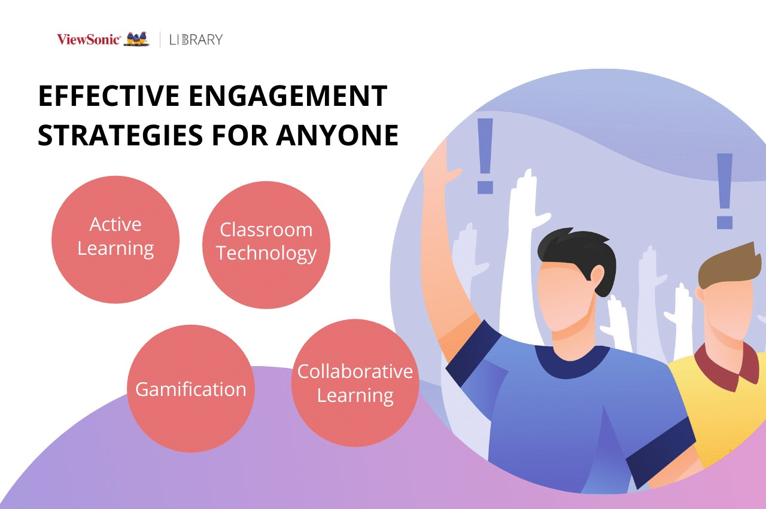
SUCCEED
hand writing out design plans
- Develop yourself everyday
- Set the bar high
- Create structure
- Inspire students
- Be transparent

The end

