Analysis and Simulation of a centrifugal clutch
Stress Analysis and Dynamics (ACMA5010)

November 11, 2024
UNIVERSITY OF WALES TRINITY SAINT DAVID
Carissa George

Executive summary 3
1. Task A 3
1.1. Centrifugal clutches 3
1.2. Historic development 3
1.3. Materials 3
1.4. Application 4
1.5. Operations 4
1.6. Frictional lining material and Judder 6
1.6.1. Frictional lining material 6
1.6.2. When does frictional lining occur? 7
1.6.3. Judder 7
2. Electromagnetic clutches 8
2.1. Current application 9
3. Centrifugal clutches VS electromagnetic clutches- the advantages and disadvantages 9
Task B 10
Q1) 10
Q2) 11
Q3) 12
Q4) 14
Q5) 15
Q6) 16
Q7) 16
Q8) 18
4. Bibliography 19
5. Lists of figures 22
6. Appendices 23

Executive summary
In this report, it looks into the historic development of centrifugal clutches leading to current electromagnetic clutches which is used in modern automation of manufacturing processes, and mathematical questions based on a centrifugal clutch.

Task A

1.1. Centrifugal clutches

1.2. Historic development
Numerous clutch mechanisms have been invented and utilised to control the energy transmitted in automobiles and manufacturing prior to centrifugal clutches becoming widely used (Yousef, 2023). In 1936, Armstrong Siddeley introduced the centrifugal clutch (Figure 1) to automobiles. Furthermore, Armstrong Thomas Fogarty was also recognised for establishing the centrifugal clutch which is used in small motor applications worldwide (MechStudies, 2021).
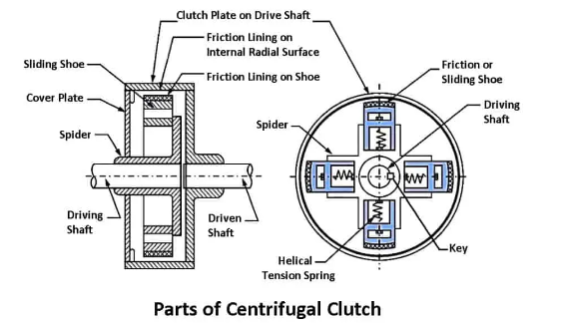
Figure 1 - Centrifugal clutch (Yousef, 2023a)

1.3. Materials
To guarantee maximum efficiency performance and durability, centrifugal clutches are manufactured from a range of materials, individually selected for it’s specific mechanical properties and characteristics.
The following are examples of which materials the components can be manufactured from:
- Due to the outcome of the inner/outer drum, the design is to tolerate high levels of rotational RPM speeds where a frictional force is generated during the engagement, which is typically produced from steel or cast iron (Cope, 2021).
- Plates are produced from either steel or aluminum due to the unique properties of these materials, depending on the performance goals the manufacturer aims to achieve. Steel is highly durable and can withstand significant wear and tear. It is also known for its excellent heat resistance, maintaining outstanding performance under extremely high temperatures. On the other hand, aluminum is a good thermal conductor, which allows it to dissipate heat quickly. Additionally, aluminum is lightweight, making it effective for performance-oriented applications (Jason, 2024).
- To maintain the tension the force is required to engage and disengage the clutch, springs are typically made from steel containing a high level of strength of its mechanical property (Yousef, 2023).
- The shoes are usually constructed from either aluminium or steel, as the drum is protected with a friction material such as a ceramic composite (Cope, 2021).
- To withstand the centrifugal forces during operation, the spider is often constructed from steel (Yousef, 2023).

1.4. Application
A centrifugal clutch's primary function in small applications is to automatically engage and disengage the engine's power to the driven shaft. Without the need for manual clutch control, this automatic operation makes it easier to operate compact cars and machinery (Yousef, 2023).

Centrifugal clutches can be commonly found in various applications such as GoKart, chainsaw, conveyors, sawmills, snowmobiles, motorbikes (Thomas, 2022), (Purvis, 2023) (Team, 2019).

1.5. Operations
A centrifugal clutch has a two force factor, a rotational motion applied with centripetal forces which allows the clutch to engage and disengage (MechStudies, 2021), (Yousef, 2023). Figure 2 represents a demonstration of a centrifugal clutch in motion:
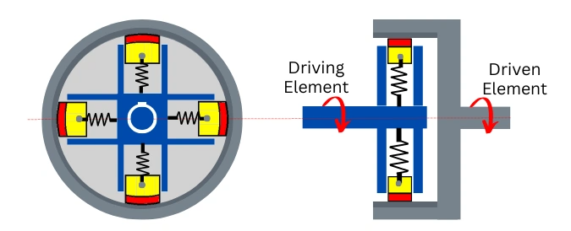

Figure 2- Centrifugal clutch - engaged. (Pratik,2020)

The rotating clutch shoes encounter centrifugal force as the motor’s RPM becomes greater, pushing the shoe outward. This force causes the shoe to press against the inner drum, engaging the pivot with the outer drum. In the moment the shoes and drum emerge another force is created, friction. Transmitting power from the motor to the shaft as a result of the clutch drum spinning (Yousef, 2023).

When the motor’s RPM declines the centrifugal force is reduced which disengages (Figure 3) the driven shaft instantly removing the rotational motion energy, and the shoes come inwards of the spider, which slows the transfer of the power (MechStudies, 2021c), (Toulas, 2018).

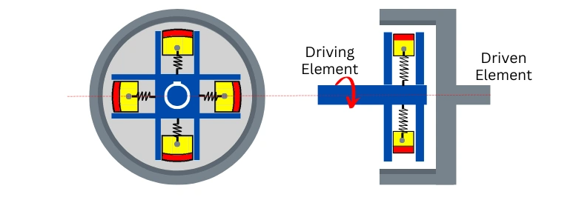

Figure 3 - Centrifugal clutch - Disengaged. (Pratik,2020)

Centrifugal clutches might contain two to six shoes that are symmetrically poisoned. Depending on the manufacturer's requirements to achieve their results, manufacturers may examine the spring’s length and strengths to ensure that they can control the expansion in accordance with the RPM speed. To maintain engagement it is ideal to optimize the motor’s torque range to enable the manufacturer to obtain points of engagement and disengagement. It is suggested by (Toulas, 2018) that not all centrifugal clutches are suitable for all types of motors, therefore, manufacturers must optimize in order to achieve the greatest result (Toulas, 2018).
Centrifugal clutches can be commonly found in various applications such as GoKart, chainsaw, conveyors, sawmills, snowmobiles, motorbikes (Thomas, 2022), (Purvis, 2023) (Team, 2019).

1.6. Frictional lining material and Judder

1.6.1. Frictional lining material
A centrifugal clutch's frictional lining materials are specialised parts made to transmit torque by providing the required frictional force while supporting smooth engagement and disengagement. These components have a major impact on the clutch's lifetime and its purpose. The following are a few of many significances of material relating to frictional lining:
- Made from fibres of ceramic and additives, ceramic materials are ideal for high-performance applications and can tolerate high temperatures.
- Organic Materials: Often found in the automotive industry in vehicle clutches, these materials are constructed up of fibres, resins, and additives which offer smooth engagement.
- Semi-Metallic Materials: a combination of metallic additives and fibres that deliver a balance between durability and performance.
(Virmani, Madhogaria and Baskar, 2021), (Rohan Ramesh et al., 2021).

According to (Clutchfix Ltd, 2024), it is recognised for its expertise in the clutch and flywheel market, providing a variety of goods with over 40 years of expereince and knowledge. High mechanical durability and reliability across a range of temperatures are key characteristics of their friction materials, primarily the HD1 material, which is ideal for applications such as centrifugal clutches (Clutchfix LTD, 2016).
The coefficient of friction, which is a characteristic of the lining material, may be used to describe the frictional force (N) in a variety of ways. The following instance of dry friction (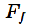) also known as Coulomb Friction (Baker and Haynes, 2023), equation is shown below:
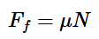

According to the Coulomb friction equation, the normal force—which is the force operating perpendicular to the contacting surface—is proportional to the frictional force. The friction coefficient is often less than one and is always more than zero (0><1), (Baker and Haynes, 2024), (Abdel-Aal, 2018).

1.6.2. When does frictional lining occur?
A centrifugal clutch's frictional lining is activated during the engagement phase, which is controlled by engine speed. The frictional line appears:
When the engine starts, the shoes experience an increase in centrifugal force as engine speed rises. The shoes migrate outward when the centrifugal force surpasses the spring force keeping them together at a specific engine speed. The inner surface of the drum comes into touch with the shoes' exterior surface, which is lined with friction. The Frictional Force is caused by the torque transmission from the driving element to the driven element is made possible by the frictional lining. The clutch shoes and drum rotate together when the engine speed increases because of the increased contact force between the frictional lining and the drum (Yan et al., 2023), (Li, Huang and Lin, 2015).

1.6.3. Judder
According to a case study conducted by SAE Internals (Mohire, Kapse and Tendulkar, 2019), a company. A centrifugal clutch's judder, often referred to as clutch chatter or shudder, is a problem in which the driver feels vibrations while engaging the clutch. The following are some of the numerous variables that may contribute to clutch judder:
- Friction Lining Contamination: Unbalanced engagement due to oil or grease on the friction linings might result in judder.
- Heat Damage: If the clutch overheats, the friction linings may sustain irreversible damage that might result in judder.
(Rohan Ramesh et al., 2021), (Li, Huang and Lin, 2016)

Electromagnetic clutches
Centrifugal clutches are examples of classic traditional clutch types; electromagnetic clutches (Figure 4) are believed to be more recent in their development (Jaber, 2024). The clutch is constructed from modest structural components, involving a rotating shaft that attaches to the machine's driveshaft and a stationary coil in a shell. (Flemming, 2009). The friction discs and cooling ring work together to accomplish the transmission. An electromagnetic clutch's friction discs are essential for transmitting torque.(Jaber, 2024) In the pump housing , a set of permanent magnets is positioned around the rotor to drive it. The current action will drive the cooling ring forward to a specific position, transferring torque at a slower pace to the pump. (Shapiro, 2009), (Vranish, 1994), (Eitel, 2002).
The direct drive happens when the solenoid valve is activated. The armature plate, which is pressed against the rotor by the magnetic field, allows the rotor to have a direct connection to the shaft and, consequently, the pump wheel. The coil is usually formed from copper wire, and must to be energised by powering on the electric circuit, which will cause current to flow through it and create a magnetic field (Krafft, Wolf and Faller, 2007).

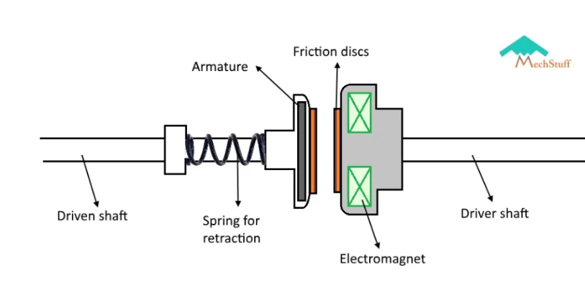
Figure 4 - Electromagnetic clutch (Mechstuff, 2019)

The design is navigated to achieve the precise control over the engagement and disengagement they provide over power transmission and their complex structure (Jaber, 2024). An electrical signal is used to activate or deactivate an electromagnetic coil, which permits highly accurate control. An electromagnetic clutch is an electrical device that uses electromagnetic forces produced by its energising coil to regulate power and rotation (T.K. Hareendran, 2023), (Li, Zheng and Wang, 2014) (Neville and Kashy, 2018).

Current application
The capacity of electromagnetic clutches to precisely manage power transfer makes them an important component of the indurstries worldwide. The following are some significant uses:
Automotive Industry: Power steering, air conditioning systems, and hybrid car drivetrains all employ electromagnetic clutches to regulate when power transmissions are connected and disconnected.
Electronic clutches are used in aeroplanes to effectively regulate power transmission.
Medical Technology: Electromagnetic clutches satisfy the requirements of medical technology, which requires accuracy, safety, and reproducibility (KEB, 2022). MRI machines, the accuracy, precise control in motion and operator is the reason the clutch is utilized in this type of industry (Chen and Steckner, 2017).

Electromagntic clutches can be found in wind turbines, the clutch is a good common practice in how it is used in application due to the control connection between the turbine blades and the generator (Vinothkumar Kolluru, 2017).

Centrifugal clutches VS electromagnetic clutches- the advantages and disadvantages
When comparing the advantages and disadvantages of centrifugal clutches and electromagnetic clutches, it becomes evident that the choice depends on the specific requirements of the manufacturing application. The centrifugal clutch stands out for its cost-effectiveness and accessibility in the market, being both affordable and easy to obtain (Crane, 2003). As cited by Masoud Moghani and Kermani (2016)it is suggested, a significant disadvantage of the electromagnetic clutch is its higher production cost due to advanced technology.
The centrifugal clutch also benefits from low maintenance requirements thanks to its simple structure, whereas the electromagnetic clutch necessitates a regular maintenance schedule. Furthermore, the straightforward design of the centrifugal clutch makes it easy to understand and maintain (Crane, 2003), while the electromagnetic clutch, with its intricate design, demands more sophisticated operation and maintenance (Hardy, 1951), (Gaunt, 1971). The centrifugal clutches provide less accurate engagement control than electromagnetic clutches (Biru1142 and Biru1142, 2019), and because of frictional contact during engagement, a centrifugal clutch is prone to wear and strain (Engineering Designer, 2023).
In conclusion, when selecting the appropriate clutch for the application, it is important to consider the advnatages and disadvantages before hand due to the nature of design, manufacturing and end goal of the outcome of what is trying to be achieved.

Task B

Q1)
Given values from question:
- Radius, r = 95mm
- Clearance distance, x = 9mm
- Wall thickness, t = 4mm

Convert from mm to m
- Radius, r = 95x10⁻³ m
- Clearance distance, $x$ = 9x10⁻³ m
- Wall thickness, t = 4x10⁻³ m
Find the diameter, $d$ of the outer drum:
Equation:
$d$ = (r+t+ $x$) x2
Substite values into equation:
$d$ = (95x10⁻³ + 4x10⁻³ + 9x10⁻³ ) x2
$d$ = 216x10⁻³m

Q2)

Given values:
- Mass, m = 275 grams
- Radius, r = 95mm
- Spring stiffness, k = 7.5kN/m
- Clearance distance, $x$ = 9mm

Convert to SI units:
- Mass, m = 0.275kg (/1000)
- Radius, r = 95x10⁻³m
- Spring stiffness, k = 7.5x10³ N/m
- Clearance distance, $x$ = 9x10⁻³m

Determine the engagement speed:
Equation:
k $x$ = m x ω² x r

Rearrange equation to get angular velocity, ω:
ω = $\sqrt{\frac{kx}{mr}}$

ω = $\sqrt{\frac{\text{7.5}\text{ x}\text{10}\text{3} \text{ x }\text{9}\text{x}\text{10}\text{-3} }{\text{0.275 x }\text{95}\text{x}\text{10}\text{-3}}}$
ω = 50.83 rad/s

Convert from rad/s to RPM:
Equation:

RPM = rad/s x ($\frac{60}{2π})$
RPM = 50.83 x ($\frac{60}{2π})$
RPM = 485.39RPM

Answer rounded to the nearest whole value:
485 RPM

Q3)
Given values:
- Mass, m = 275 grams
- Radius, r = 95mm
- Clearance distance, $x$ = 9mm
- Speed, N = 550 RPM

Convert to SI units:
- Mass, m = 0.275kg (/1000)
- Radius, r = 95x10⁻³m
- Clearance distance, $x$ = 9x10⁻³m

Convert speed from RPM to rad/s:
Equation:
ω = $\frac{2π \text{x} N}{60}$

ω = $\frac{2π \text{x} 550}{60}$

ω = 57.6 rad/s

Find the total radius, r:
r_{total} = r + $x$
r_{total} = 95x10⁻³ + 9x10⁻³
r_{total} = 104x10⁻³m
Find the total force, $F$:
$F$_{total} = m x ω² x r_{total}
$F$_{total} = 0.275 x (57.6)² x 104x10⁻³
$F$_{total} = 94.9N

Find the tension of spring:
$F$_{spring} = k x $x$
$F$_{spring} = 7.5 x10³ x 9x10⁻³
$F$_{spring} = 67.5N
Find the radial force, $F$:
Equation:
Radial force, $F$ = total force – tension of spring
= 94.9 – 67.5
Radial force, $F$ = 27.4N

Q4)
Given values:
- Mass, m = 275 grams
- Radius, r = 95mm
- Clearance distance, $x$ = 9mm
- Speed, N = 550 RPM
- r_{total} = 104x10⁻³m (workings shown in Q3)

Convert to SI units:
- Mass, m = 0.275kg (/1000)
- Radius, r = 95 x10⁻³m
- Clearance distance, $x$ = 9x10⁻³m
- Speed, N = 57.6rad/s (workings shown in Q3)
Find the centrifugal force, F_{c}:
$F$ _{c} = m x ω² x r
= 0.275 x 57.6² x 104x10⁻³
$F$ _{c} = 94.9N

From Q3 we know of the following:
- Tension of the spring = 67.5N
- Radial force = 27.4N

27.4 x 0.35 = 9.59N

Find the torque value:
$T$ = $F$ x r
$T$ = 9.59 x 104x10⁻³
$T$ = 0.99Nm

Find the total torque value across all shoes:
Torque_{total} = torque x number of shoes
Torque_{total} = 0.99 x 4
Torque_{total} = 4N/m

Q5)

Refer to appendice for the background data into the graph.

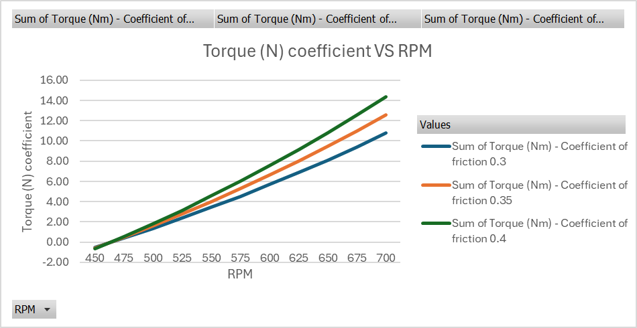
Q6)

From the graph, as the RPM increases the torque of coefficient of friction 0.4 appears to rapidly increase to a value of 14.34N/m.
Refer to appendice for the background data into the graph.

Q7)
Given values:
- Mass of drum, m = 750 grams
- Diameter of drum, $d$ = 216x10⁻³m
- Maximum possible transmitted torque determined from point 6 = 14.34Nm

Convert to SI units:
- Mass, m = 0.750kg (/1000)
Find the radius, r of the drum:
$r= \frac{d}{2}$
r = $\frac{216x\text{10}\text{-3}}{2}$
r = 108x$\text{10}\text{-3}$m

Find the moment of inertia:
Equation:
$Ι= \frac{1}{2} x m x r^{2}$
$= \frac{1}{2} x$ (0.750) $x$ (108 x10⁻³)²
$Ι=$ 4.374x10⁻³kg/m²

Find the angular acceleration, $α$:
$α= \frac{T}{Ι}$
Whereas:
$Ι=$Moment of inertia
$T=$ Torque

From point 6 we know, the maximum possible transmitted torque determined = 14.34Nm
$α=\frac{14.34}{4.374x\text{10}\text{-3}}$
$α=3278.5 rad/s$

Q8)
Given values:
Driven shaft diameter, $d$ = 17.5mm
Find the Radius, r:
$r= \frac{d}{2}$
$r= \frac{17.5}{2}$

Radius, r = 8.75x10⁻³m

- Braking force = 500N
- Moment of inertia of drum, $Ι$ = 4.374x10⁻³kg/m²
Find the braking force:
Equation:
$T=F x r$
$=$500 $x$ 8.75x10⁻³
$T=4.375$Nm
Find the difference in torque:
Driving torque – braking torque

From point 6 we know, the maximum possible transmitted torque determined = 14.34Nm
14.34 – 4.375 = 9.965Nm

Find the angular acceleration, $α$:
$T= α x I$
Rearrange to get angular acceleration, $α$ :
$α= \frac{T}{I}$
$α=\frac{9.965}{4.374x\text{10}\text{-3}}$
$α=$2278.23rad/s²

Bibliography
Abdel-Aal, H.A. (2018). Surface structure and tribology of legless squamate reptiles. Journal of the Mechanical Behavior of Biomedical Materials, 79, pp.354–398. doi:https://doi.org/10.1016/j.jmbbm.2017.11.008.
Baker, D.W. and Haynes, W. (2023). 9.1.1: Dry Friction. [online] Engineering LibreTexts. Available at: https://eng.libretexts.org/Bookshelves/Mechanical_Engineering/Engineering_Statics%3A_Open_and_Interactive_(Baker_and_Haynes)/09%3A_Friction/9.01%3A_Friction/9.1.01%3A_Dry_Friction [Accessed 7 Nov. 2024].
Baker, D.W. and Haynes, W. (2024). Engineering Statics Open and Interactive. [online] Available at: https://engineeringstatics.org/pdf/statics.pdf [Accessed 8 Nov. 2024].
Biru1142 and Biru1142 (2019). Be Curious. [online] Be Curious. Available at: https://becurious.co.in/clutches-working-advantages-disadvantages-and-application/#disadvantages [Accessed 8 Nov. 2024].
Chen, X. and Steckner, M. (2017). Electromagnetic computation and modeling in MRI. Medical Physics, 44(3), pp.1186–1203. doi:https://doi.org/10.1002/mp.12103.
Clutchfix LTD (2016). About us | Clutchfix. [online] Clutch-fix.co.uk. Available at: http://clutch-fix.co.uk/about-us/ [Accessed 6 Nov. 2024].
Cope, L. (2021). Understanding Clutches: Types, Functions, and Applications. [online] Engineer Fix. Available at: https://engineerfix.com/mechanical/clutches/a-complete-guide-to-clutches/#google_vignette [Accessed 1 Nov. 2024].
Crane, N.B. (2003). Compliant Centrifugal Clutches: Design, Analysis, and Testing - ProQuest. [online] www.proquest.com. Available at: https://www.proquest.com/openview/0b556c866ea3a0db8bfe748cf20382a5/1?pq-origsite=gscholar&cbl=18750&diss=y [Accessed 2 Nov. 2024].
Eitel, E. (2002). StackPath. [online] www.machinedesign.com. Available at: https://www.machinedesign.com/motors-drives/article/21828254/electromagnetic-brakes-and-clutches [Accessed 2 Nov. 2024].
Engineering Designer (2023). How Does A Centrifugal Clutch Work? What Are The Pros And Cons? - Engineering Designer. [online] www.engineeringdesigner.co.uk. Available at: https://www.engineeringdesigner.co.uk/how-does-a-centrifugal-clutch-work-what-are-the-pros-and-cons/ [Accessed 4 Nov. 2024].
Flemming, F. (2009). Friction and megnetism. The basics of EM clutches and brakes. [online] MachineDesign.com. Available at: https://ogura-clutch.com/downloads/editorials/The%20Basics%20of%20Electromagnetic%20Clutches%20and%20Brakes.pdf [Accessed 3 Nov. 2024].
Gaunt, A. (1971). Clutches. Palgrave Macmillan UK eBooks, pp.17–24. doi:https://doi.org/10.1007/978-1-349-01197-1_2.
Hardy, E.J.R. (1951). The magnetic fluid clutch. Students Quarterly Journal, 22(86), p.51. doi:https://doi.org/10.1049/sqj.1951.0064.
https://www.facebook.com/pratik.ambukar.9 (2020). Centrifugal Clutch: Working, Diagram, Application, Advantage. [online] Mech Content. Available at: https://mechcontent.com/centrifugal-clutch/ [Accessed 2 Nov. 2024].
Jaber, S. (2024). Electromagnetic Clutch Design: Simulate and Optimize. [online] SimScale. Available at: https://www.simscale.com/blog/electromagnetic-clutch-design-simulate-and-optimize/ [Accessed 3 Nov. 2024].
Jason (2024). Clutch Plates: A Comprehensive Exploration. [online] Springfield Gearbox Repairs Specialist Centre Cape Town. Available at: https://www.springfieldgearbox.co.za/clutch-plates-a-comprehensive-exploration/ [Accessed 1 Nov. 2024].
Krafft, R., Wolf, A. and Faller, W. (2007). Electromagnetic Water Pump Clutch: Working Principle, Design Strategies and Applications for Heavy-Duty Vehicles. SAE technical papers on CD-ROM/SAE technical paper series. doi:https://doi.org/10.4271/2007-01-4260.
Li, T.C., Huang, Y.W. and Lin, J.F. (2015). Studies on Centrifugal Clutch of Frictional Lining Materials. Key Engineering Materials, 642, pp.39–44. doi:https://doi.org/10.4028/www.scientific.net/kem.642.39.
Li, T.-C., Huang, Y.-W. and Lin, J.-F. (2016). Studies on centrifugal clutch judder behavior and the design of frictional lining materials. Mechanical Systems and Signal Processing, 66-67, pp.811–828. doi:https://doi.org/10.1016/j.ymssp.2015.06.010.
Li, Z., Zheng, J. and Wang, J. (2014). Proceedings of the ASME International Mechanical Engineering Congress and Exposition - 2013 - : presented at ASME 2013 International Mechanical Engineering Congress and Exposition, November 15-21, 2013, San Diego, California, USA. New York, N.Y.: American Society Of Mechanical Engineers.
Masoud Moghani and Kermani, M.R. (2016). Design and development of a hybrid Magneto-Rheological clutch for safe robotic applications. International Conference on Robotics and Automation. doi:https://doi.org/10.1109/icra.2016.7487474.
MechStudies (2021). Centrifugal Clutches – Definition, Parts, Types, Working, Application. [online] www.mechstudies.com. Available at: https://www.mechstudies.com/centrifugal-clutches-parts-types-working/ [Accessed 1 Nov. 2024].
Mechstuff (2019). Types of Clutches | Animations & Diagrams. [online] MechStuff. Available at: https://mechstuff.com/types-of-clutches/ [Accessed 9 Nov. 2024].
Neville, F. and Kashy, E. (2018). Electromagnetism. In: Encyclopædia Britannica. [online] Available at: https://www.britannica.com/science/electromagnetism [Accessed 2 Nov. 2024].
Purvis, B. (2023). Clutchless snickers: KTM working on centrifugal clutch and auto shift for range of big twins. [online] Motorcyclenews.com. Available at: https://www.motorcyclenews.com/news/new-tech/ktm-automatic-gearbox/ [Accessed 2 Nov. 2024].
Rohan Ramesh, M., Atharva Ravindra, K., Ashok, B. and Kannan, C. (2021). Optimizing thermal performance of a dry rigid clutch by varying groove pattern and friction material. Materials Today: Proceedings, 46, pp.7459–7467. doi:https://doi.org/10.1016/j.matpr.2021.01.130.
Shapiro, J. (2009). StackPath. [online] www.machinedesign.com. Available at: https://www.machinedesign.com/archive/article/21831719/the-basics-of-electromagnetic-clutches-and-brakes [Accessed 2 Nov. 2024].
T.K. Hareendran (2023). Electromagnetic Clutch - ElectroSchematics.com. [online] ElectroSchematics.com. Available at: https://www.electroschematics.com/electromagnetic-clutch/ [Accessed 2 Nov. 2024].
Team, T.B. (2019). Advantages and Disadvantages of Centrifugal Clutches. [online] BLM Automatic Clutch. Available at: https://www.centrifugalclutches.com/blog/advantages-disadvantages-centrifugal-clutches/ [Accessed 2 Nov. 2024].
Thomas, D. (2022). How A Snowmobile Clutch Works: (Explained). [online] Fun In The Yard. Available at: https://funintheyard.com/how-a-snowmobile-clutch-works/ [Accessed 2 Nov. 2024].
Toulas, B. (2018). How does a Centrifugal Clutch work? What are the pros and cons? - Mechanical Engineering. [online] Mechanical Engineering. Available at: https://mechanical-engineering.com/centrifugal-clutch/ [Accessed 2 Nov. 2024].
Vinothkumar Kolluru (2017). Design and fabrication of Electromagnetic clutch for wind turbine. [online] IJSRD - International Journal for Scientific Research & Development|. Available at: https://www.academia.edu/106825229/Design_and_fabrication_of_Electromagnetic_clutch_for_wind_turbine [Accessed 5 Nov. 2024].
Virmani, K., Madhogaria, T. and Baskar, P. (2021). Design optimization of friction lining of a clutch plate. Materials Today: Proceedings, 46, pp.8009–8024. doi:https://doi.org/10.1016/j.matpr.2021.02.775.
Vranish, J.M. (1994). Electromagnetic brake/clutch device. [online] Nasa.gov. Available at: https://ntrs.nasa.gov/citations/19940019496 [Accessed 3 Nov. 2024].
Wang, T., Lv, H. and Wang, X. (2024). Development of an electromagnetic energy harvester for ultra-low frequency pitch vibration of unmanned marine devices. Applied Energy, [online] 353, p.122072. doi:https://doi.org/10.1016/j.apenergy.2023.122072.
Yan, Z., Li, H., Lei, H., Xie, M. and Wang, L. (2023). Study of the Judder Characteristics of Friction Material for an Automobile Clutch and Test Verification. Chinese Journal of Mechanical Engineering, 36(1). doi:https://doi.org/10.1186/s10033-023-00864-y.
Yousef (2023). Centrifugal Clutch: Diagram, Parts, Working & Uses [PDF]. [online] The Engineers Post. Available at: https://www.theengineerspost.com/centrifugal-clutch/ [Accessed 1 Nov. 2024].

Lists of figures
Figure 1 - Centrifugal clutch (Yousef, 2023a) 3
Figure 2- Centrifugal clutch - engaged. (Pratik,2020) 5
Figure 3 - Centrifugal clutch - Disengaged. (Pratik,2020) 5
Figure 4 - Electromagnetic clutch (Mechstuff, 2019) 8

Appendices

Q5) background data part 1:

Q5) background data part 2:

Q6) background data part 1:

Q6) background data part 2:

Q6) background data part 3:

