Name: Morgan Jones
Student number: 1706863
Module: (ACDA5005)
Course: Electronic Engineering

Table of Contents
Name: Morgan Jones 1
Introduction 3
What is Internet of things 3
What is smart home or building? 4
How to create a smart home 5
What are smart home products? 5
Do smart devices connect to each other? 6
Smart TVs 7
What is a smart TV? 7
Smart TV issues 7
Smart alarm clock 8
Smart alarm clock issues 8
Smart doorbell 9
Smart doorbell issues 9
Summary 9
References 10

Introduction
This report will cover internet of things, smart devices, and smart homes/building, how you can make a smart home, what the different types of smart devices and their security issues.

What is Internet of things
Internet of things (IoT) is a network of devices connected via the Internet and can collect and exchange data. “Examples of what can fall into the scope of Internet of Things include security systems, thermostats, cars, electronic appliances, lights, alarm clocks, speaker systems, vending machines. An example of how this works is that a businesses can use IoT applications to automate safety tasks such as alert the appropriate authorities when a fire extinguisher is blocked [1].”
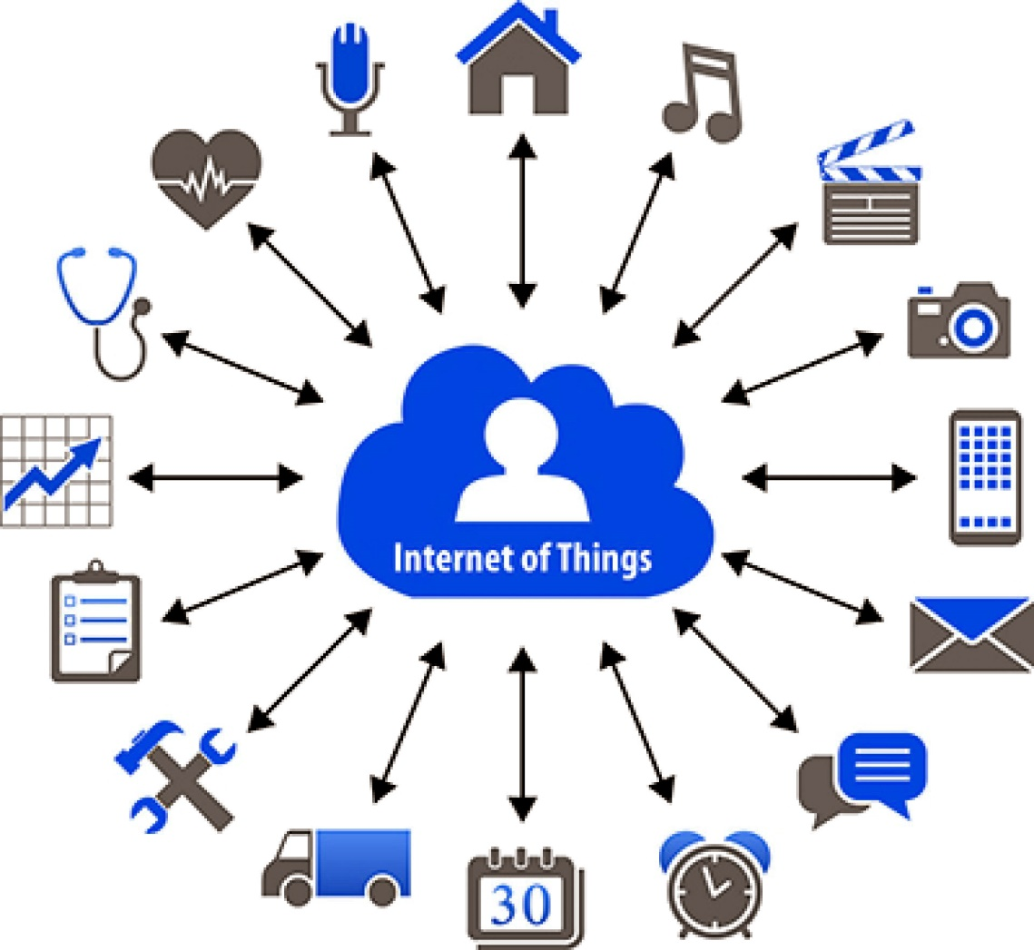
Figure 1 diagram of IOT [2]

What is smart home or building?
A smart home is a house that uses objects and devices that can access the internet to allow remote monitoring and management of appliances and systems, such as doors and windows. “The term 'smart home' is used to describe a house that contains a communication network that connects different appliances and allows them to be remotely controlled, monitored and accessed, according to the Department of Trade and Industry.” [3]
Using the objects and devices inside and outside the house you can control and view what is happening at home, even when at work by using a smartphone or computer. For example, if you have a dog and want to guarantee they are safe and secure, you can install cameras that makes it possible view your pet. [3]

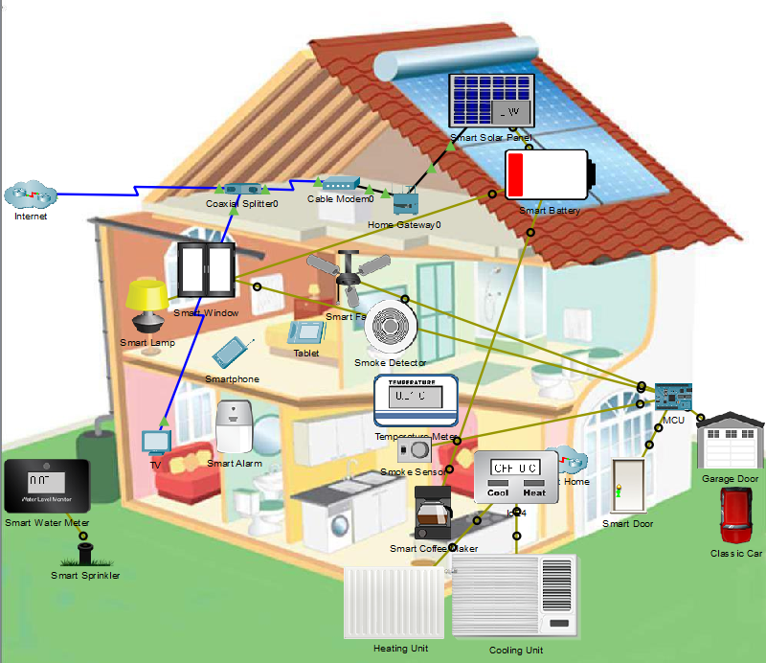
Figure 2 an example of a smart home [4]

There will also be a change in the cost of your bills for example heating or water, meaning you do not waste money by accidentally leaving the heating on when you leave the house. By checking your heating, water and electricity helps reduce the risk of an unforeseen large bill. [3]
Smart homes can also safeguard the more vulnerable individuals in a society for example the sick or elderly. “Certain devices can activate an alert if a person fails to take their pills, falls over or is behaving erratically [3].”

How to create a smart home
You can create a smart home by fitting a network that allows you to link your appliances and devices, you can buy specific products that connect to your personal device like a phone. [3]
One of the device you use is a voice assistant an example of this is the Amazon Echo and Google Home. Another device that can be used is a smart thermostat that lets you to set the heating temperature and the hours the heating is on an example is for the heating to come on after being out in cold and windy weather which can be done by using your phone. [3]

What are smart home products?
For viewing your home, security cameras connected to your wi-fi network lets you view video from the cameras wherever you are in the world. These cameras can have the ability to detect motion which allows you to be alerted if there is movement when the system is active. [3]
For viewing your front door you have devices like the Ring Video Doorbell where you can “see, hear, and speak to anybody that is at your door from your smartphone, tablet or PC. Install the doorbell and app which lets you to get alerts when a someone comes to your door [3]”. An example of this is when you are expecting a delivery and it is delivered when you are not at home you can tell the person delivering where to place the delivery.

Another product that can be used is a voice activated system like “Google Home and Amazon Echo these are both voice-activated personal assistants that allow you to search the web, listen to news, get traffic updates and more while you go about your daily household activities [3].”

Do smart devices connect to each other?

Smart devices work in tandem. The Nest system which includes a thermostat and a smoke/carbon monoxide detector, an example of how this works is if the detector detects a carbon monoxide it will send a signal to thermostat to turn the heating off.
One of the more popular smart devices is a smart assistant that answers to voice commands. An example of this is the Amazon Echo which lets you speak to Alexa and, will also try to do what you ask. “Alexa and Google Home also work with other smart devices made by other companies. Using their voice, Ford owners can lock/unlock their car doors, Philips Hue users can dim their home lights or Nest owners can adjust the thermostat temperature [3].”

“However not every system works together if you get a Nest thermostat, it will not work with Hive’s door sensors. However there is a way around this because of a free service called If This, Then That (IFTTT) which allows you to set up automated rules that combine smart devices from with apps and information, like weather reports or your phone’s location. IFTTT works even if devices aren’t designed to work together: your smart heating can switch on when you leave the office; or switch off if there’s an open window [3].”

Smart TVs

What is a smart TV?
While TVs have been around for decades, the older versions do one thing receive a signal from an antenna, cable or another A/V source which means you can only view films and shows and not have access to the internet or to apps like Now TV or Netflix whereas the more modern tv’s can access the internet, have voice control, have screen share capabilities and have access to many application like Spotify, YouTube and Amazon prime. [5]
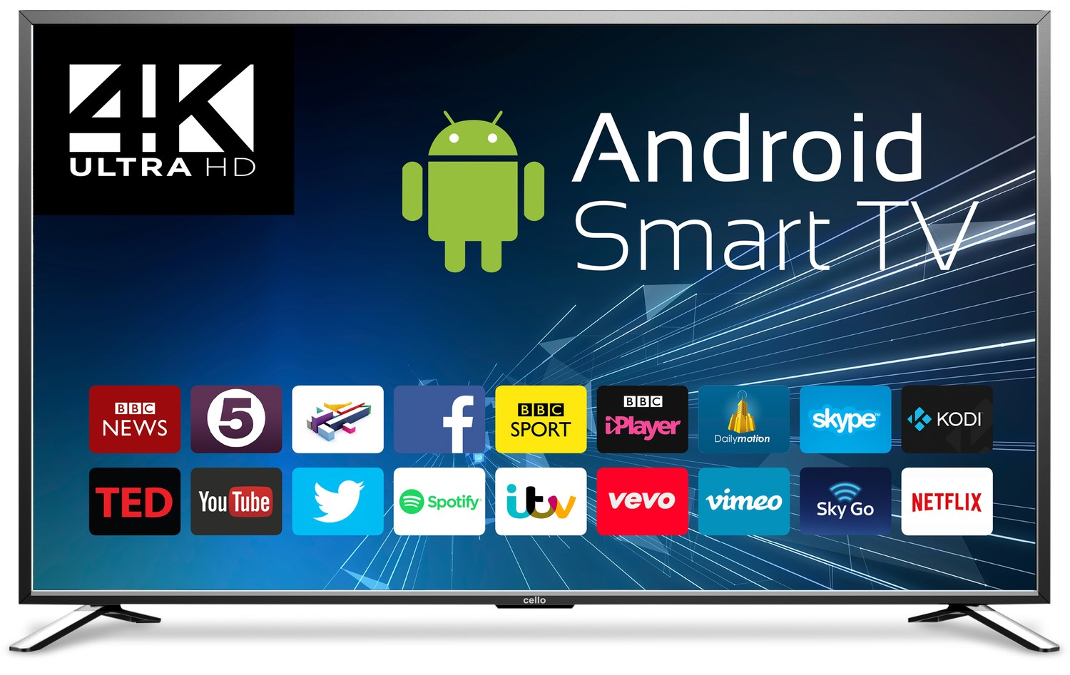
Figure 3 A smart tv with some of the apps [6]

Smart TV issues
Just like a computer smart tv’s are to being hacked and having viruses meaning that if someone hacks into a smart TV linked to the internet and can steal things like passwords or other personal information. Companies can also gather information about you and your habits from a smart TV exactly the same way as when you conduct business on a computer or phone however the majority of the data is limited to viewing information and what apps you use which may not seem that big of a deal but the
main issue is your security isn't that great at keeping other hackers out. There also the issue of a inserted camera which gives a view of the room the tv is in and smart speakers which are always on and listening even when not in use. [5]

Smart alarm clock
A smart alarm clock is any alarm clock that has a minimum of one smart feature. There are a many ways a clock can be classified as smart. [7]
Firstly, can it link to your home network then it is a smart alarm clock. The clock can could be set so that when your alarm goes off another smart device activates .For example, maybe your alarm rings and the lights come on, or maybe your blinds are opened. [7]
an alarm clock can have a smart assistant like Alexa which makes it smart. “These types of devices are nearly the same as an Amazon Echo the difference is, they look like clocks instead of smart assistant speaker hubs [7].”
An alarm with add-ons not usually found on a clock. “Sunrise alarm clocks, for example, wake you up with a glow of soft light, meant to mimic the rising sun, and slowly get brighter. Vibration alarms are smart, too. They’re excellent for people who don’t want to wake their partner with an alarm, as well as people in the deaf and hard of hearing communities [7].”
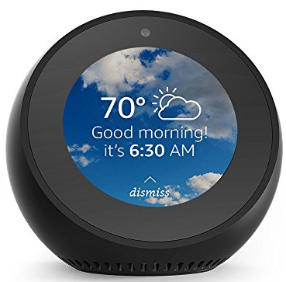
Figure 4 Amazon Echo Spot [7]

Smart alarm clock issues
The issues concerning the smart alarm clock vary depending on the type of clock you have an example of this is that if the clock is connected to the internet then it is at risk of being hacked and a clock that has a smart assistant like a Alexa will listen to what is being said around it even though it is not in use.

Smart doorbell
A smart doorbell is a doorbell that links to the internet and also alerts you when a person is at your door. It activates when a person presses the button of the doorbell or with its motion sensors. The smart doorbell lets the homeowner use your phone via an app to view and speak using the doorbell's camera and microphone. There are some doorbells which allow you to open your door remotely. [8]
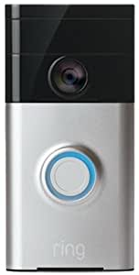
Figure 5 Ring doorbell [9]

Smart doorbell issues
The main issue is that the doorbell is hackable meaning that someone could intercept the owner's wi-fi credentials, giving hackers unrestricted access to the network and possibly other devices on it. There is also the concern that the any data collected by companies will be given out an example of this is amazon giving peoples data by Ring doorbell to the police. [10] [11]

Summary
In summary all smart device are susceptible to hacking and other means of illegally accessing your data. There is also a chance that the companies that are allowed to collect your data may misuse it. [12]

References

[1] | “Internet of Things (IoT) Definition,” [Online]. Available: https://www.webopedia.com/TERM/I/internet_of_things.html. [Accessed March 2020].
[2] | “How IoT Works – 4 Main Components of IoT System,” [Online]. Available: https://data-flair.training/blogs/how-iot-works/.
[3] | L. Stevens, “What is a smart home,” BT, 3 December 2018. [Online]. Available: https://home.bt.com/tech-gadgets/internet/connected-home/what-is-a-smart-home-11364214165664. [Accessed March 2020].
[4] | “Explore the Smart Home.pka,” [Online]. Available: https://moodle.uwtsd.ac.uk/pluginfile.php/351853/mod_folder/content/0/Explore%20the%20Smart%20Home.pka?forcedownload=1. [Accessed March 2020].
[5] | B. Westover and J. R. Quain, “Smart TVs: Everything you need to know,” tom's guide, [Online]. Available: https://www.tomsguide.com/uk/us/smart-tv-faq,review-2111.html. [Accessed March 2020].
[6] | “Cello C86SFS4K 86" 4K Ultra HD LED Android Smart TV,” [Online]. Available: https://www.appliancesdirect.co.uk/p/c86sfs4k/cello-c86sfs4k-85-inch-led-tv.
[7] | J. Duffy, “Wake up happier with one of these smart alarm clocks,” dailydot, [Online]. Available: https://www.dailydot.com/debug/smart-alarm-clocks/. [Accessed April 2020].
[8] | J. Lee, “What Is A Smart Doorbell, And Which Should You Buy?,” [Online]. Available: https://www.makeuseof.com/tag/what-is-a-smart-doorbell-and-which-should-you-buy/. [Accessed April 2020].
[9] | “Ring 88RG000FC100 HD Video Doorbell, Wi-Fi Enabled,” Amazon, [Online]. Available: https://www.amazon.co.uk/dp/B00N2ZDXW2?psc=1&slotNum=1&th=1&linkCode=g12&imprToken=QKphDX9rxuK4m5Lb0X7Weg&creativeASIN=B00N2ZDXW2&tag=mak044-21.
[10] | “Amazon Ring: Police tie-up criticised by anti-surveillance campaigners,” BBC, 1 August 2019. [Online]. Available: https://www.bbc.co.uk/news/technology-49191005. [Accessed May 2020].
[11] | “Ring doorbell 'gives Facebook and Google user data',” BBC, 28 January 2020. [Online]. Available: https://www.bbc.co.uk/news/technology-51281476. [Accessed May 2020].
[12] | “SmartHomeDeﬁnitionandSecurityThreats,” [Online]. Available: https://ieeexplore-ieee-org.ezproxy.uwtsd.ac.uk/document/7195812. [Accessed May 2020].

