Student Name: Petronela Gabriela Uruioc
student number: 1914742 | Lectuer Name Rexon nting
WORKPLACE CULTURE AND ITS IMPACT ON ORGANISATIONAL EFFICIENCY
module code: bmsw5105

Executive Summary
This report has been portrayed the workplace culture and its impacts on organization efficiency. It has been discussed the workplace culture of the company ASDA in the UK. It has been analyzed the external environment of this company by using PESTLE analysis and porters five forces model completely. It has been mentioning the changes in the culture and business environment due to COVID-19. Further, it has provided the ethical dilemmas of ASDA and its resolution strategy effectively.

Table of Contents
Introduction 2
Aim 2
Introduction of the organization 2
Business Environmental Analytical Tools 3
Evaluation of organizational environmental and organizational analysis 4
PESTLE Analysis 4
Porter's Five Forces Model 6
Key drivers for changes in the business environment 9
Workplace culture using cultural web 10
Organization present culture and its efficiency in achieving financial and non-financial performance 12
Ethical Dilemma and identification of two ethical dilemmas faced by the organization 13
Resolving strategy 14
Conclusion 14
Reference List 15
Appendix: Questionnaire 18

Introduction
The business environment and market are changing with each passing day. The competition level in the market is also getting raised day by day. In order to compete with this growing competition, organizations need to focus on the performance of their employees. As the entire performance of an organization completely depends on the presentation of its employees. Employees' performances help to raise the production of their company and make the product completely different from others so that their organization gives tough competition to their competitors. In order to raise the performance of employees, proper workplace culture is very crucial. In proper culture, employees work more comfortably and are able to give their hundred percent to their company.
The development of a proper environment in the workplace mainly helps the employees to perform harder in a correct way to fulfill the organizational goal. It highlights that workplace culture greatly influences organizational efficiency. It has been found that the pandemic citation changes the entire work culture in an organization. Work from home is the new work culture for everyone to continue their work in the lockdown period (Holford, 2019). This report mainly analyses the business analytical tools correctly and will evaluate organizations based on environmental and analytical techniques. It also assesses the workplace culture of the organization and analyzes ethical dilemmas faced by the organization. Further, it provided a resolution strategy to improve the performance of the organization.

Aim
The main aim of this report is to analyze the external environment factor along with COVID-19 and ethical dilemmas that affect the organizational culture and performance accordingly.

Introduction of the organization
This report is going to analyze the performances of the ASDA, as in the past I have been working in this organization for a very long time. As an employee, I know the working culture of this organization very well compared to other organizations. This is the main reason behind the choice of this organization, particularly for this report. ASDA is one of the most popular supermarket chains in the UK. It was founded in 1949 and founded by Peter and Fred Asquith (Corporate.asda.com, 2021). This company is very much focused on the needs of their customers and tries to fulfill all their demands correctly. It sells various products like “groceries, food products, and drinks, clothing, health and beauty products, household goods, electrical products, electronics, music and video products, toys, and baby products”. It sells its products both online and offline accordingly.
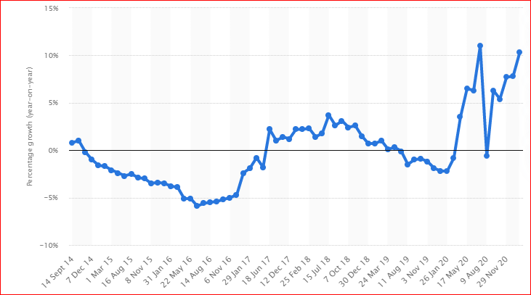
Figure 1: ASDA sales growth
(Source: Statista, com, 2021)
This figure shows that the sales growth of this company in earlier 2020 is decreased largely due to the pandemic situation. The outbreak of COVID-19 affected the country UK drastically. But this company again raised its sales growth up to 10.3 percent up to February 2021 (Statista, com, 2021). This company used social media platforms well to promote its products worldwide. It added innovation and creativity to their products to raise the sailing rate of the product accordingly. This company has a total of 631 stores in the UK (Corporate.asda.com, 2021). It used the latest technology to raise their production better than previous and give tough competition to the rival company well.

Business Environmental Analytical Tools
Business environmental analysis is a systematic process, it helps to analyze the environmental factors in the business. The business environment is changing with each passing day. As per the views of Jyoti and Rani (2017), organizations need to understand this changing environment and modify their business strategy according to the changes correctly. Otherwise, organizations cannot compete with these changes and competition levels in the market. Decision-makers need to change their business according to this environment and help the organization along with their employees to adopt these changes accordingly.
The impact of this analysis helps the organization to identify further problems or takes advantage of this analysis completely. Through these tools, ASDA company is able to know the business environment and market completely. According to Diamantidis and Chatzoglou (2019), there are various business analytics tools that help to understand the environmental factors in the business properly. This report mainly used Pestle analysis for environmental analysis and Porter's five forces model as an organizational analysis technique. Pestle analysis helps to identify the external environment of the company ASDA accurately. It helps to analyze the political, economic, social, technology, legal and environmental factors properly (Bienhaus and Haddud, 2018). On the other hand, Porter's five forces is another business analysis model that mainly helps this company to understand the factors that are affecting the profitability in a specific industry correctly. It helps to formulate an accurate competitive strategy to remain competitive in the market.

Evaluation of organizational environmental and organizational analysis

PESTLE Analysis
In order to increase the performance of this organization environmental analysis is very crucial. Pestle analysis helps to understand the external environment accordingly. The pestle analysis of the ASDA Company is taken under consideration to show the impact of the framework on the company.

Factors | Description | Impact
Political Factor | - The political condition of the UK is in the stable position  - Democracy is ensured by the government | Positive
Economic Factor | - The UK is one of the richest countries in Europe  - The GDP rate is in a stable position also (Statista.com, 2021) and the unemployment rate of this country is 4.34% (Statista.com, 2021) | Positive
Social Factor | - The UK has a diverse population  - All the citizens in this country are well educated and give respect to each other custom | Positive and Negative
Technological Factor | - This country is one of the leading innovative countries in this world  - People are inclined to used modern technology | Positive
Legal Factor | - Equality Act 2010 depicted that, all the people in this country have an equal right and there are no chances of discrimination based on any factors accordingly (Gov.UK, 2021)  - Employee Act 1996 ensures that all the employees have the right to share their views or perspective regarding the ongoing operations in their organization (Legislation.gov.uk, 2021) | Positive and Negative
Environmental Factor | - Government is active and takes initiatives to protect the environment  - People are aware and take responsibility to protect their mother nature well | Positive and Negative

Table 1: PESTLE Analysis
(Source: Ramdhani et al., 2017)
Discussion: External Factors of the UK play a major role in managing the business operation of ASDA effectively. Stable political conditions help this company to expand its business effectively. The growing GDP of this country makes this company more stable in the UK. The unemployment rate in the UK is also decreasing day by day and ASDA gets an opportunity to raise the number of customers with each passing day. The social factors give both positive and negative factors to this company. Roscoe et al., (2019) stated that, as, people are well educated and therefore all give value to each product of ASDA. On the other hand, people are well-checked all the products of ASDA and therefore, this company needs to maintain good gradation in their all items completely. Technological factors give a positive impact only as ASDA is completely able to use the latest technology to raise their production better than previous (Lewis and Wescott, 2017). Similarly, by the use of modern automation, ASDA gives their product a unique design and that makes their product completely different from others and able to sakes their product online during the lockdown period due to COVID-19. This helps ASDA to give tough competition to their competitors accordingly.
Similarly, people also liked to use modern automation and all are able to handle all this latest automation well. Therefore, ASDA is completely able to use technology in their product. This country is very strict in its legal factors and all the organizations in this country need to follow this legal act appropriately, otherwise, the government will take serious action against the breaking of rules accordingly. Jiang et al., (2017) opined that environmental factors give both positive and negative factors. It indicates that this company has to follow the environmental policies to protect the environment accordingly. Similarly, this company has to manufacture products in such a way that it does not pollute nature and this company also focused on reducing carbon emission effectively.

Porter's Five Forces Model
On the other hand, organizational analysis is also very crucial to understand the performances of this organization. In this respect, Porter’s five forces model is one of the essential techniques that helps to determine organizational analysis completely (Hamza et al., 2021). It also helps to determine the competitive landscape of this industry accordingly. This five forces model has been described below:
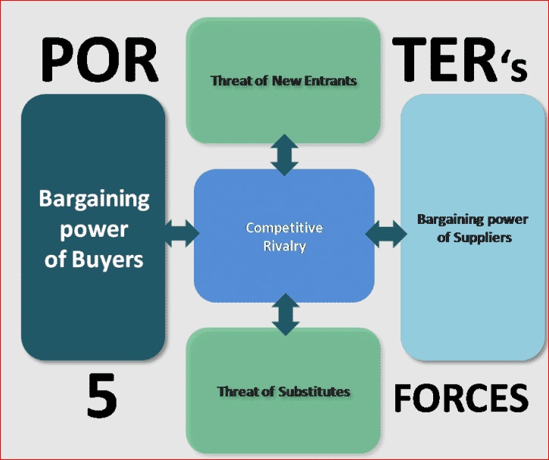
Figure 2: Porter's Five Forces Model
(Source: Felipe et al., 2017)
The threat of new entrants: This force mainly indicates the chances of new entrants in the industry. ASDA belongs to the retail industry and it provides information regarding the threat of new entrants in this industry completely. The impact of this factor is weaker for the company ASDA. In order to enter, the retail industry needs a large amount of capital and for that reason, the chances of entry of new entrants are relatively lower. Similarly, in this pandemic situation, the arrangement of this large amount of capital is not possible for an individual, as the financial crisis is getting raised in these circumstances. As per the views of Felipe et al., (2017), similarly, differentiation in products makes the products completely different and unique from others. This helps the organization to give tough contesting to their competitors. This company also adds innovation and creativity to its products and creates strong brand identification. It helps this company to retain their customer permanently and reduces the switching of customers to other brands completely.
Bargaining power of suppliers: Organizations build an effective and good relationship with their suppliers to compete with the growing competition well. According to Al Zefeiti et al., (2017), suppliers supply all the raw materials to the organization and through that, the organization is completely able to fulfill the demands of their customers. ASDA also sells a variety of products and therefore, the role of suppliers is crucial for this company, as all of them have to supply all the resources to this company. It highlights that the power of suppliers for this company is relatively higher. The supplier easily switches to another retailer, if all of them provide a large amount of price for the resources completely.
Bargaining power of buyers: Customers or purchasers are an integral part of this organization. The profit rate of this company completely depends on the sailing rate of their products. It has been found that customers purchase their products from the stores which give excellent service to them. It includes good graded products with relatively lower prices effectively (Nikpour, 2017). ASDA follows these facts correctly and gives a variety of products to their customers. It gives excellent offers to each product and sells only good quality products. This makes their customers stick to this particular brand of products and makes the power of buyers weaker accordingly.
The threat of substitution: This factor is a very important factor, as stronger this factor can reduce the profit rate of this company. But it has been found that the threat of substitute products in this company is relatively higher (Kundu and Lata, 2017). As there is a huge competition and rival companies in the UK belong to this retail industry. It highlights that the chances of substitution are very high. On that, ASDA focuses to reduce this threat and follows proper pricing strategy for their products.
Competitive rivalry: The competition level in the retail industry in the UK is relatively higher. Tesco, Sainsbury is one of the big rivals of ASDA. Both this company holds a large market share and raises the opposition level in the market with each passing day. It clearly highlights that competitive rivalry for this company is much higher. In the words of Mohelska and Sokolova (2018), every organization in the retail industry in this country follows the latest technology, strategy and innovation to make their product different from others and that mainly raises the competition level largely. All the rival companies aim to raise the customer retention rate and focus on switching customers from other brands to their particular brands well. It highlights that ASDA needs to follow proper administration in their organization to remain competitive in the market.

Key drivers for changes in the business environment
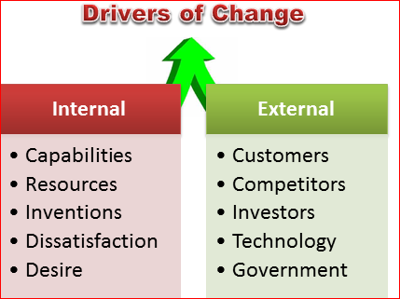
Figure 3: Drivers of Change
(Source: Horak et al., 2018)
The business environment is changing a lot and for that, organizations need to cope up and become active regarding this changing environment in their business. It clearly indicates that for the growth of the business globally change is very crucial. According to Horak et al., (2018), there are both external and internal drivers for changes in the business environment. ASDA follows these changes a lot to compete with this growing opposition accordingly. Organizations need to develop their capabilities by adding innovation and creativity in their both existing and new products. It helps to attract new customers a lot. In this respect, this company needs to follow the Diffusion of Innovation theory, it gives accurate ideas regarding innovation. Customers are the main asset of this company.
The sailing rate of each product completely depends on the purchaser. According to the theory of customer satisfaction, ASDA needs to satisfy all their clients well, it helps them to create a loyal relationship with their customers accordingly. The UK is one of the leading innovative countries and for that, technological advancement in this country is up to the mark. For that, ASDA needs to implement modern automation in their organization well and give proper training to their all employees well. Pawirosumarto et al., (2017) stated that, so, all of them are completely able to handle all this new technology well. Similarly, Industry 4.0 is the latest automation that also needs to be implemented by ASDA in their organization effectively. The competition level in the market has increased largely and the number of new competitors is coming into the market wisely. For that, according to the theory of market analysis, the external environment in this business is changing rapidly.
As per the views of Horak et al., (2018), in order to cope up with this growing opposition, this company needs to follow the marketing mix theory accurately. It helps this company to set the price of their products by following an accurate pricing strategy. ASDA uses good quality resources or raw material, to make their product high graded only. The reputation of this company in the market is completely based on the quality of their products only. On the other hand, according to Tomaskovic-Devey and Avent-Holt (2019), the proper promotional strategy needs to be followed well by ASDA. It helps to raise the branding value of each item well and promotes their product globally. This driver mainly helps to improve the performances of this business more progressively than previous.
As per the views of Tomaskovic-Devey and Avent-Holt (2019), stakeholders and investors are one of the important drivers that mainly help this company to raise their business both nationally and internationally through their investment. According to the theory of stakeholders, ASDA has to maintain good and loyal relations with all its stakeholders properly. According to Havens et al., (2018), another important driver is to check all the government policies accordingly. As the legislative changes and all the latest policies give an impact on business. These drives for the change are accurately related to the operation or business that is mainly followed by ASDA completely. This company needs to focus on giving the best customer service or experience to its purchasers. For that, this company needs to follow an omnichannel marketing strategy. Through that, employees of this organization are able to meet their customers and know their needs for the product completely. This ultimately improves the performance of the company accordingly.

Workplace culture using cultural web
Proper workplace culture is very crucial, as the performance of an individual worker completely depends on the culture of their company. Accurate culture gives comfort to their employees and all of them give good output to this company. ASDA focuses on maintaining proper culture in their organization and for that, follows Hofstede's cultural theory accurately. As per the views of Havens et al., (2018), this theory gives proper guidance of all the dimensions regarding the culture perfectly. This company gives value to both customers and employees accordingly. It tries to fulfill all their needs correctly. The maintenance of proper culture helps this company to raise its business globally. It helps this company to recruit fresh talents from the international market and helps these talented employees to manage themselves in a completely new culture.
On that, ASDA gives training and development classes to all its employees, so that workers coming from different backgrounds easily adapt themselves to this new culture. Managers are also able to easily communicate with fresh talents during their recruitment for this company well. According to Oyemomi et al., (2019), the recruitment of talented ones from different international markets helps this company to know the needs and demands of their customers. According to that, this company modifies their product and raises the brand value of their product in the international market also. In this respect, the cultural web is an effective tool that helps to map the entire culture of ASDA completely. It provides various aspects that influence the culture of an organization effectively.
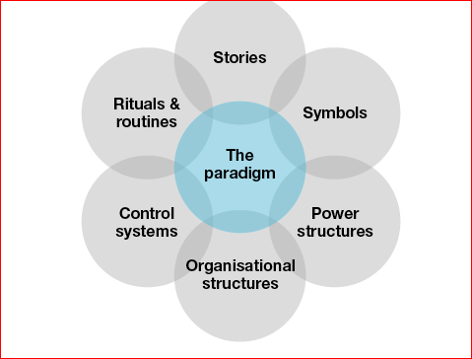
Figure 4: Cultural Web
(Source: Oyemomi et al., 2019)
This figure clearly shows that this web includes a total of six elements. All these elements greatly influence the culture of ASDA completely. On that, this organization focuses on the element of stories completely. This organization describes all its products both new and existing on its websites and gives accurate information regarding this aspect completely to its customers (Van Der Lippe and Lippényi, 2020). This company also used a logo for their company and made this logo the identity of their organization completely. People are completely able to identify the name of this organization after seeing this logo in their products. This company also focuses on its organizational structures also. ASDA follows a formal hierarchical structure in their company and there are various departments in their organization. It mainly helps them to manage all employees in various departments correctly (Elsbach and Stigliani, 2018). Hierarchy balances and manages all the ongoing operations and guides their employees in the correct direction well.
This structure mainly helps this company to fulfill all the aims and goals of ASDA completely. On the other hand, it focuses on power structures accurately. It gives power to all managers and HR to monitor the performances of all team members accurately. This company also sets norms or rules and regulations for each employee, so that all the employees follow these rules during working with this company. The Control system is another important aspect and gives a great impact on workplace culture. According to Gochhayat et al., (2017), the leaders of this company follow transformational leadership theory completely. On that, leaders discuss with their all employees before taking any decision regarding the ongoing operation of ASDA. By that, the employees are completely able to share their views with their leaders.
In the words of Aksoy (2017), on the contrary, leaders monitor their performances strictly and give them guidance to improve their performances well and maintain the deadline of each task well. The development of proper control systems in an organization is very important, as it helps the company to raise the efficiency of their workers better than previously. In this way, ASDA maintains its workplace culture accurately. In this pandemic situation, work culture has changed a lot and work from home is the new work pattern accordingly. Employees lost their motivation and efficiency towards their performances due to this changing environment. ASDA follows motivational theories to give motivation to their employees effectively.
[Refer to Appendix]

Organization present culture and its efficiency in achieving financial and non-financial performance
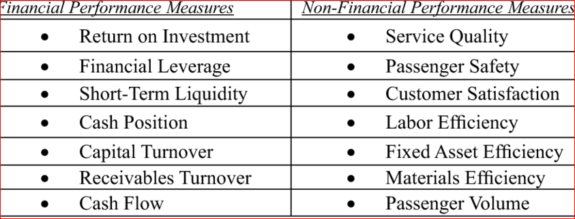
Figure 5: Financial and non-financial performances
(Source: Bruijl, 2018)
Organizational culture plays a crucial role in achieving good financial and non-financial performances. Both these performances give an idea regarding the profit rate of the organization. Similarly, by the analysis of both these performances, this company is able to know the entire expenses of this organization completely. The role of organizational or workplace culture is very important in this context. As good performances of an employee depend on the culture and in contrast, the company’s profit rate depends on the presentation of their worker. The workplace culture of ASDA has been described in the previous part already and based on that, both of their performances have been analyzed. As per the views of Perera (2017), key performance indicator (KPI), is monitored both of these performances accurately. On that, the profit rate of this company is relatively higher, as the sailing rate of this company is raised with each passing day. Innovative design in their products and best customer services help in their facts correctly.
It also checks the number of resources and their cost monthly and ensures that the use of excessive resources is completely avoided by their employees. It helps to reduce the excess cost of this company and all of them used this extra cost for expanding their business well. According to Jung (2018), non-financial performances mainly check the customer retention rate of this company. On that, ASDA maintains good relationships with all purchasers and gives them complete values properly. It raises their number of customers day by day. The non-financial performance also checks the performances of employees completely. As this company maintains proper culture, the performances of their employees are improving day by day and all of them are completely able to fulfill the demands of their purchasers on time. Bieńkowska et al., (2017) stated that, on the contrary, ASDA maintains their supply chain accurately and that helps to raise their both performances effectively.

Ethical Dilemma and identification of two ethical dilemmas faced by the organization
An ethical dilemma is a problem that mainly describes during the decision-making process between two possible but unacceptable options from an ethical perspective. There are four different types of ethical dilemma and that is “truth vs loyalty, short-term vs long-term, individual vs community, and justice vs mercy”. It has been found that ASDA faced some ethical dilemmas and this study mainly discussed two dilemmas accordingly.
- There is huge discrimination between the workers in ASDA. Female workers mainly faced this issue and implicated that, this company does not give equal opportunity in comparison to their male workers (Chikeleze et al., 2017). Female workers do not get an opportunity to become leaders and handle the team members, as this position is only occupied by the male workers in this organization. Similarly, in the same designation, the number of wages is not the same in their workers. For that, female workers are discriminated against based on their gender completely. It is the first dilemma that is mainly faced by this organization.
- Another important dilemma, that is mainly faced by this organization is that this company gets a middle rating from ethical consumers for their animal testing. ASDA had a fixed cut-off date for the ingredients of their own household and cosmetic products accordingly. Similarly, they continue to sell their brands known to test on animals. But this company has no proper animal testing policy.

Resolving strategy
ASDA has to focus on this fact and try to solve their ethical dilemma, otherwise, it decreases the reputation of this company from the market. Their brand value is decreased rapidly and it harms their business effectively. This organization needs to set a norm that, there are no chances of discrimination based on any fact according to the theory of gender equality. All the employees are being judged based on their talents only and the designation, responsibility has been given by the company to their workers based on their annual performances and hard work only (Prasad, 2020). It helps the workers to only focuses on their performances instead of discrimination completely. On the other hand, this organization needs to focus on the animal testing policy and develop this system in their internal management correctly to resolve the ethical dilemmas accurately.

Conclusion
Thus, it can be concluded that this study mainly focuses on the workplace culture and its impacts on the efficiency of the organization ASDA. It also describes the changes of cultures in this pandemic situation. Further, it provides information regarding the external environment ethical dilemmas that affect the organizational culture and performances.

Reference List
Aksoy, H., 2017. How do innovation culture, marketing innovation and product innovation affect the market performance of small and medium-sized enterprises (SMEs). Technology in Society, 51(4), pp.133-141.
Al Zefeiti, S.M.B. and Mohamad, N.A., 2017. The Influence of organizational commitment on Omani public employees’ work performance. International Review of Management and Marketing, 7(2), pp.151-160.
Bienhaus, F. and Haddud, A., 2018. Procurement 4.0: factors influencing the digitisation of procurement and supply chains. Business Process Management Journal.
Bieńkowska, A. and Ignacek-Kuźnicka, B., 2017, September. The Dilemma Of Knowledge Management In An Organization. In CBU International Conference Proceedings (Vol. 5, pp. 192-197).
Bruijl, G.H.T., 2018. The relevance of Porter's five forces in today's innovative and changing business environment. Available at SSRN 3192207.
Chikeleze, M.C. and Baehrend Jr, W.R., 2017. Ethical leadership style and its impact on decision‐making. Journal of leadership studies, 11(2), pp.45-47.
Corporate.asda.com (2021), Overview of the Company, Available at: https://corporate.asda.com/our-story/company-facts [Accessed on: 12/08/2021]
Diamantidis, A.D. and Chatzoglou, P., 2019. Factors affecting employee performance: an empirical approach. International Journal of Productivity and Performance Management.
Elsbach, K.D. and Stigliani, I., 2018. Design thinking and organizational culture: A review and framework for future research. Journal of Management, 44(6), pp.2274-2306.
Felipe, C.M., Roldán, J.L. and Leal-Rodríguez, A.L., 2017. Impact of organizational culture values on organizational agility. Sustainability, 9(12), p.2354.
Gochhayat, J., Giri, V.N. and Suar, D., 2017. Influence of organizational culture on organizational effectiveness: The mediating role of organizational communication. Global Business Review, 18(3), pp.691-702.
Gov.uk (2021), Equality Act 2010, Available at: https://www.gov.uk/guidance/equality-act-2010 [Accessed on: 12/08/2021]
Hamza, P.A., Othman, B.J., Gardi, B., Sorguli, S., Aziz, H.M., Ahmed, S.A., Sabir, B.Y., Ismael, N.B., Ali, B.J. and Anwar, G., 2021. Recruitment and Selection: The Relationship between Recruitment and Selection with Organizational Performance. International Journal of Engineering, Business and Management, 5(3), pp.1-13.
Havens, D.S., Gittell, J.H. and Vasey, J., 2018. Impact of relational coordination on nurse job satisfaction, work engagement and burnout: Achieving the quadruple aim. JONA: The Journal of Nursing Administration, 48(3), pp.132-140.
Holford, W.D., 2019. The future of human creative knowledge work within the digital economy. Futures, 105, pp.143-154.
Horak, S., Arya, B. and Ismail, K.M., 2018. Organizational sustainability determinants in different cultural settings: a conceptual framework. Business Strategy and the Environment, 27(4), pp.528-546.
Jiang, W., Zhao, X. and Ni, J., 2017. The impact of transformational leadership on employee sustainable performance: The mediating role of organizational citizenship behavior. Sustainability, 9(9), p.1567.
Jung, B., 2018. An Ethical Dilemma and Unethical Behavior of Information Sharing by Information Asymmetry Level. Journal of Digital Convergence, 16(7), pp.131-144.
Jyoti, J. and Rani, A., 2017. High performance work system and organisational performance: Role of knowledge management. Personnel Review.
Kundu, S.C. and Lata, K., 2017. Effects of supportive work environment on employee retention: Mediating role of organizational engagement. International Journal of Organizational Analysis.
Legislation.gov.uk (2021), Employee Act 1996, Available at: https://www.legislation.gov.uk/ukpga/1996/18/contents [Accessed on: 12/08/2021]
Lewis, L.F. and Wescott, H.D., 2017. Multi-generational workforce: Four generations united in lean. Journal of Business Studies Quarterly, 8(3), p.1.
Mohelska, H. and Sokolova, M., 2018. Management approaches for Industry 4.0–the organizational culture perspective. Technological and Economic Development of Economy, 24(6), pp.2225-2240.
Nikpour, A., 2017. The impact of organizational culture on organizational performance: The mediating role of employee’s organizational commitment. International Journal of Organizational Leadership, 6, pp.65-72.
Oyemomi, O., Liu, S., Neaga, I., Chen, H. and Nakpodia, F., 2019. How cultural impact on knowledge sharing contributes to organizational performance: Using the fsQCA approach. Journal of Business Research, 94, pp.313-319.
Pawirosumarto, S., Sarjana, P.K. and Gunawan, R., 2017. The effect of work environment, leadership style, and organizational culture towards job satisfaction and its implication towards employee performance in Parador Hotels and Resorts, Indonesia. International Journal of Law and Management.
Perera, R., 2017. The PESTLE analysis. Nerdynaut.
Prasad, L.M., 2020. Principles and practice of management. Sultan Chand & Sons.
Ramdhani, A., Ramdhani, M.A. and Ainissyifa, H., 2017. Conceptual framework of corporate culture influenced on employees commitment to organization. International business management, 11(3), pp.826-830.
Roscoe, S., Subramanian, N., Jabbour, C.J. and Chong, T., 2019. Green human resource management and the enablers of green organisational culture: Enhancing a firm's environmental performance for sustainable development. Business Strategy and the Environment, 28(5), pp.737-749.
Statista.com (2021), Percentage change in sales at Asda in Great Britain compared to a year earlier from September 2014 to February 2021, Available at: https://www.statista.com/statistics/386700/asda-sales-percentage-change-great-britain-uk/ [Accessed on: 12/08/2021]
Statista.com (2021), GDP rate of the UK, Available at: https://www.statista.com/statistics/281734/gdp-growth-in-the-united-kingdom-uk/ [Accessed on: 12/08/2021]
Tomaskovic-Devey, D. and Avent-Holt, D., 2019. Relational inequalities: An organizational approach. Oxford University Press, USA.
Van Der Lippe, T. and Lippényi, Z., 2020. Beyond formal access: Organizational context, working from home, and work–family conflict of men and women in European workplaces. Social Indicators Research, 151(2), pp.383-402.

Appendix: Questionnaire
Q. 1. What is your age?
- 20-35
- 35-50
- 50-65
Q.2. What is your gender?
- Female
- Male
Q.3. What is your employment status in your company?
- Full time
- Part time
Q.4.Do you believe that, your organizational culture gives you best environment to performing task?
- Agree
- Strongly agree
- Neutral
- Disagree
- Strongly disagree
Q.5. Do you agree that there is a relationship between the workplace culture with organizational efficiency?
- Agree
- Strongly agree
- Neutral
- Disagree
- Strongly disagree
Q.6. Do you agree that, COVID-19 changes the entire culture of worker and it creates an impacts in your performances?
- Agree
- Strongly agree
- Neutral
- Disagree
- Strongly disagree
Q.7. Do you agree that, ethical dilemma affects the culture of the organization?
- Agree
- Strongly agree
- Neutral
- Disagree
- Strongly disagree

