

DIGITAL DEGREE APPRENTICESHIP
SOFTWARE ENGINEERING

CHANGEMAKERS

CREATIVITY AND VALUE CREATION

ACCA5033

NICHOLAS ALDOUS
2237649

Table of Contents

TASK 1 - PROJECT MANAGEMENT 3
Project Management & Planning 3
Project Scope 3
Technologies and Resources 3
Project Timeline & Schedule 4
Constraints 4
Development Method 5
Gantt Chart 5
Conclusion 5
Project Design 6
Design 6
Requirements Specification 6
User Interface Designs 12
TASK 2 - INNOVATION 14
Analysis of Nothing Technology Limited 14
PEST Analysis 14
SWOT Analysis 14
Development, Deployment, Maintenance and Evolution of the Exam Concession System within a Large Organisation 15
Development 15
Deployment 15
Maintenance 15
Future Improvements 16
TASK 3 - REFLECTION AND CONCLUSION 17
Project Reflection 17
Conclusion 18
Bibliography 19
Appendix 20

TASK 1 - PROJECT MANAGEMENT

Project Management & Planning

Project Scope
The goal of this project is to develop and implement an Exam Concession Management System that replaces the current Microsoft Access solution used by the University of Wales Trinity Saint David. The small administrative team (3–5 staff members) currently faces issues such as inadequate system performance, data integrity challenges and limited scalability. The new system will modernise the workflow and enhance data security enabling users to efficiently record, manage and report exam concession cases.
The proposed solution will be a web-based platform built using modern technologies, including .NET Core MVC for the backend architecture, HTML and CSS for the frontend design and Microsoft SQL Server for data management. The system will integrate with the University's student management system (Tribal SITS) to retrieve and validate student information and connect to term time exam data. Overall, the platform will improve access to data, enable staff collaboration and strengthen reporting processes.

As part of the project, existing data from the Microsoft Access system will be migrated into a new SQL Server database. This will require careful mapping of existing tables, data cleansing and validation to ensure consistency and integrity while keeping the current system available to avoid service interruption.

The project development cycle will run for approximately 6 months, split into defined milestones.

Technologies and Resources
The following technologies and resources will be applied to deliver the project:

- Frontend: HTML5, CSS
- Backend: ASP.NET Core MVC (C#)
- Database: Microsoft SQL Server
- Authentication: OAuth2.0 or Single Sign On (SSO)
- Tools: Visual Studio 2022, GitHub, UWTSD hosting
- Project Management: Azure DevOps Agile
- Hardware Requirements: Development Laptop or PC with adequate processing power
- Access: Authorisation to UWTSD internal servers (SQL Server Management Studio) and UWTSD student management system (Tribal SITS).

Project Timeline & Schedule
The project development cycle will run for approximately 6 months which will be split into defined milestones.

Month | Weeks | Tasks
1 | 1-4 | Requirements gathering, stakeholder consultation and current system analysis
2 | 5-8 | Finalising scope, writing user stories, designing database schema, setting up framework
3 | 9-12 | Backend development and database integration
4 | 13-16 | Frontend development, user interface prototype and backend integration
5 | 17-20 | Internal testing, bug fixing, staff user testing, feedback collection
6 | 21-24 | Final refinements, data migration, documentation and deployment

Constraints
- Time
The project is limited to a 6 month development window. Consistent progress is essential to ensure the project stays on track and aligns with academic deadlines.

- Staff Availability
The small administration team might have limited availability to explain the current system in detail and to test and feedback on the new system. Arranging meetings and reviews will require flexibility and efficiency.

- Budget
All software, tools and platforms must be open source, free or licensed through the University.

- Security & Compliance
The system must strictly follow GDPR and the University’s internal data protection policies, especially as it handles sensitive student information.

- Usability
Since the system will be used by non-technical staff it must be intuitive, require minimal training and offer clear navigation with helpful user guides and documentation.

Development Method
An Agile development approach will be adopted, specifically the Scrum framework which supports a flexible, step by step progress. Scrum is a lightweight Agile framework that breaks work into short, manageable cycles called sprints. It’s ideal for this project as it allows for regular feedback, changes in priorities and continuous improvement.

The project will run within regular 3 week sprint cycles, with progress reviewed at the end of each sprint. During these reviews, the management team will be updated on overall progress, key developments, issues and next steps. The Azure DevOps Kanban will be utilised to manage tasks, track sprint progress and stay organised [1]-[2].

Gantt Chart
The project schedule has been visualised using a Gantt chart, which is a widely used tool in project management that displays tasks, durations and their timeline. These charts help monitor progress and allocate time efficiently [3].

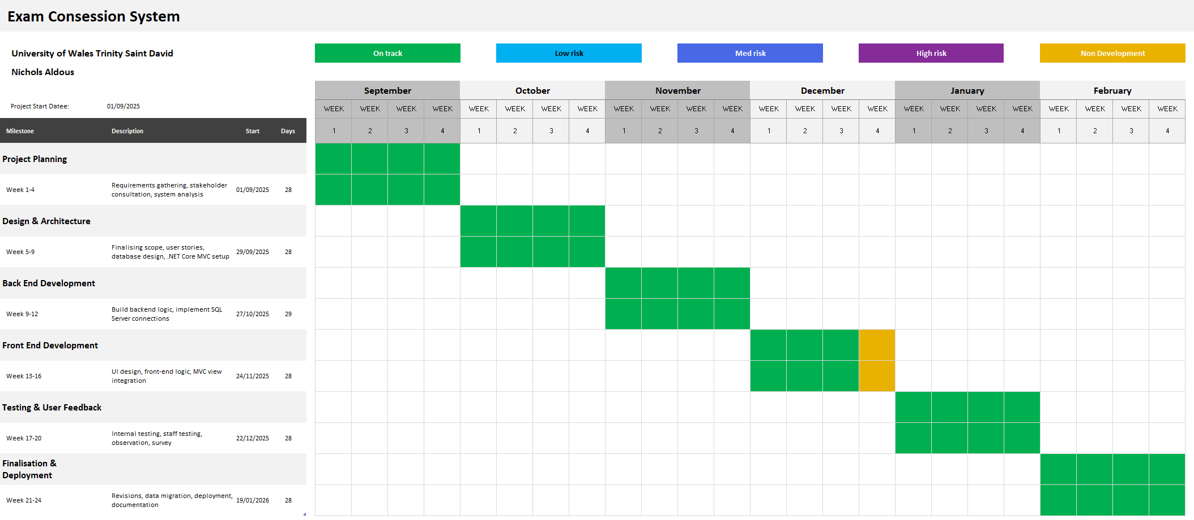

Fig 1. Exam Concession Project Gantt Chart

Conclusion
Thoughtful planning, along with an Agile development approach will create the foundation for delivering a secure and user-friendly web system to manage exam concessions. By maintaining a clear schedule, a well-defined scope and realistic constraints the solution will meet the requirements of the internal team while remaining scalable for future growth.

Project Design

Design
Design plays a vital role in ensuring the system is functional, user friendly and aligned with project goals. For the development of the Exam Concession System, two primary design items have been developed – A Software Requirements Specification Document and User Interface Design Examples. These items guide development and provide a foundation for evaluating progress and user expectations.

Requirements Specification
A comprehensive Software Requirements Specification document has been written to clearly define the project’s functional and non-functional requirements which include –

- System Overview and Purpose
Replacing the current Microsoft Access system with a secure, scalable and user-focused web solution.

- Product Scope and User Characteristics
Targeting academic staff with attention to intuitive usability which requires minimal training.

- Detailed Requirements
Covering functional operations such as student search, concession creation and timetable report generation.

- Data Migration
Legacy data from Microsoft Access will be migrated to SQL Server, ensuring continuity, integrity and improved reporting capability.

- Quality Attributes
Including performance expectations, data security and system availability.

- External Interfaces
The use of SQL Server, .NET Core MVC and institutional login integration.

The requirements specification ensures that all stakeholder expectations are captured clearly and provides a blueprint for structured development.

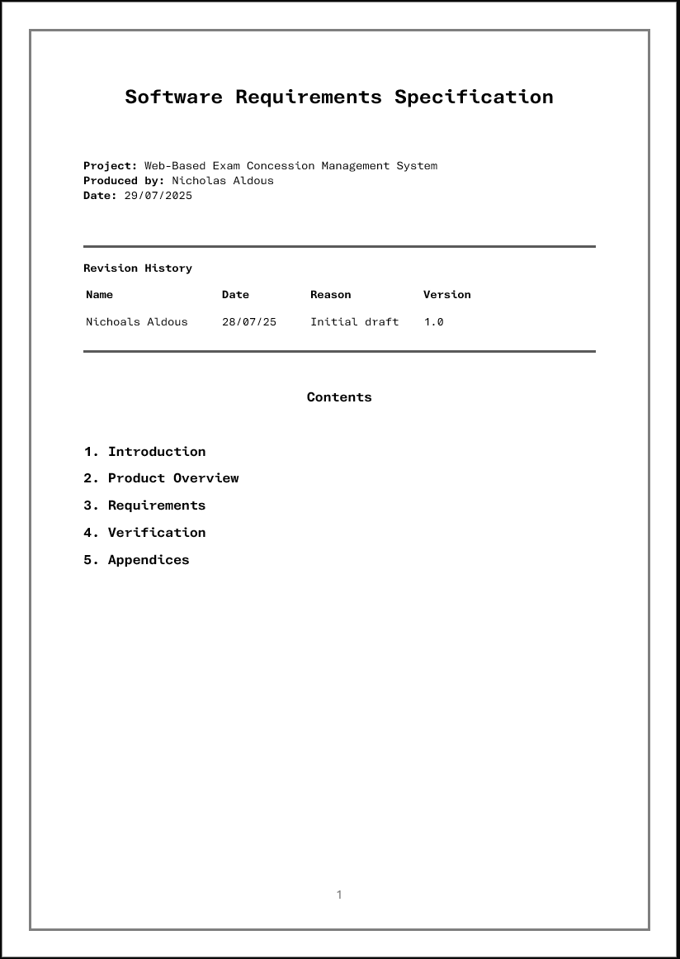

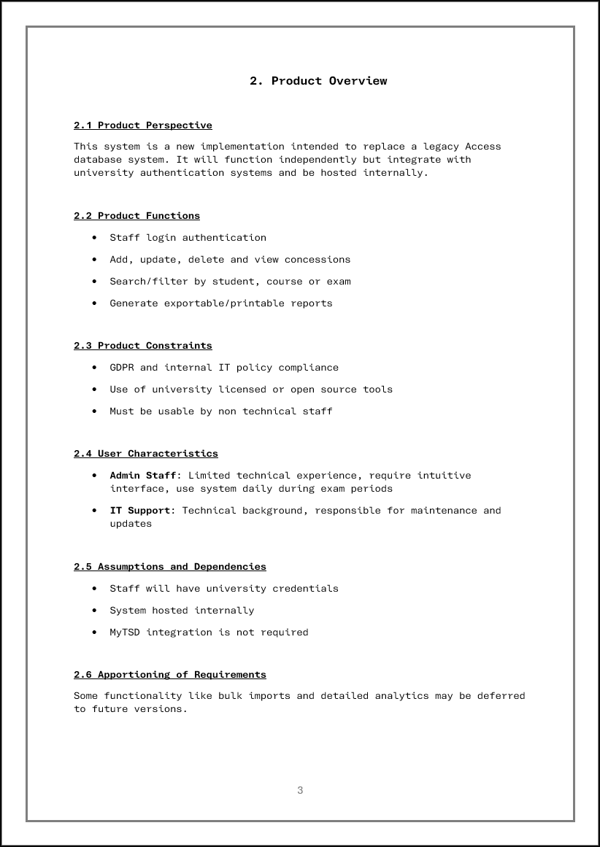

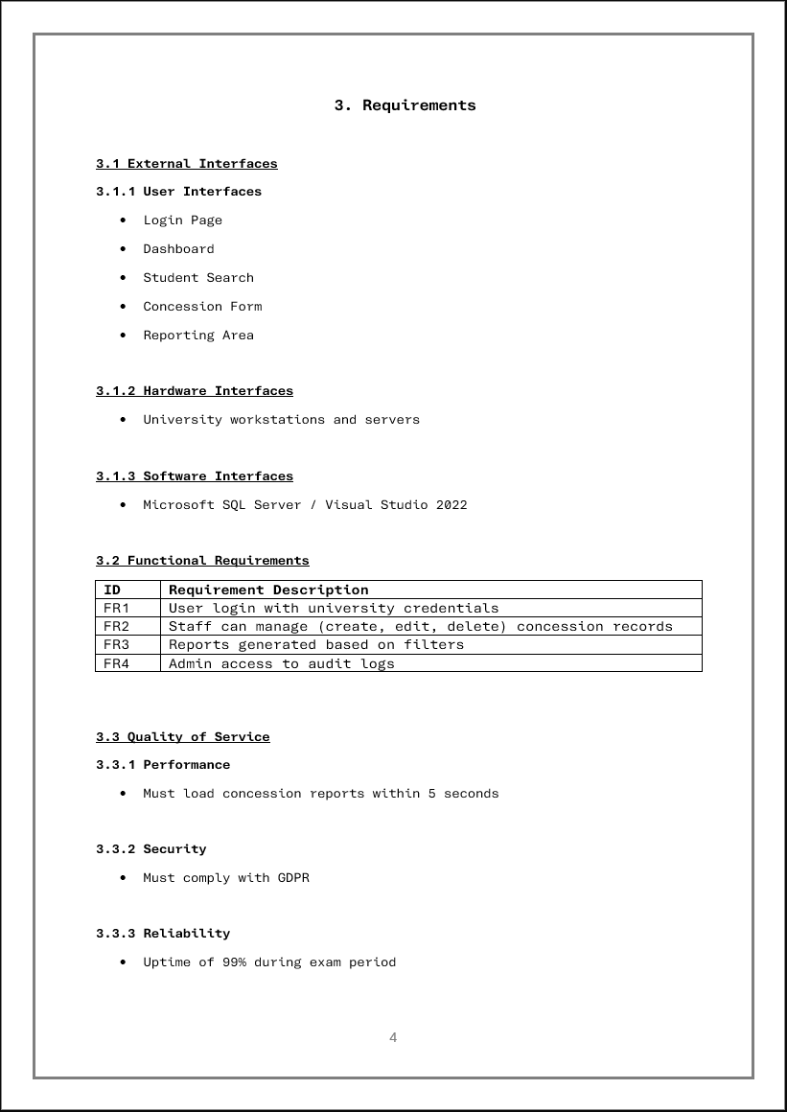

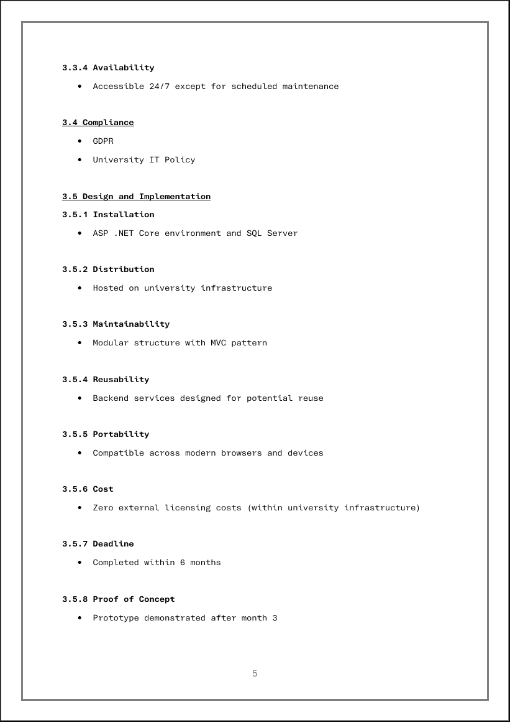

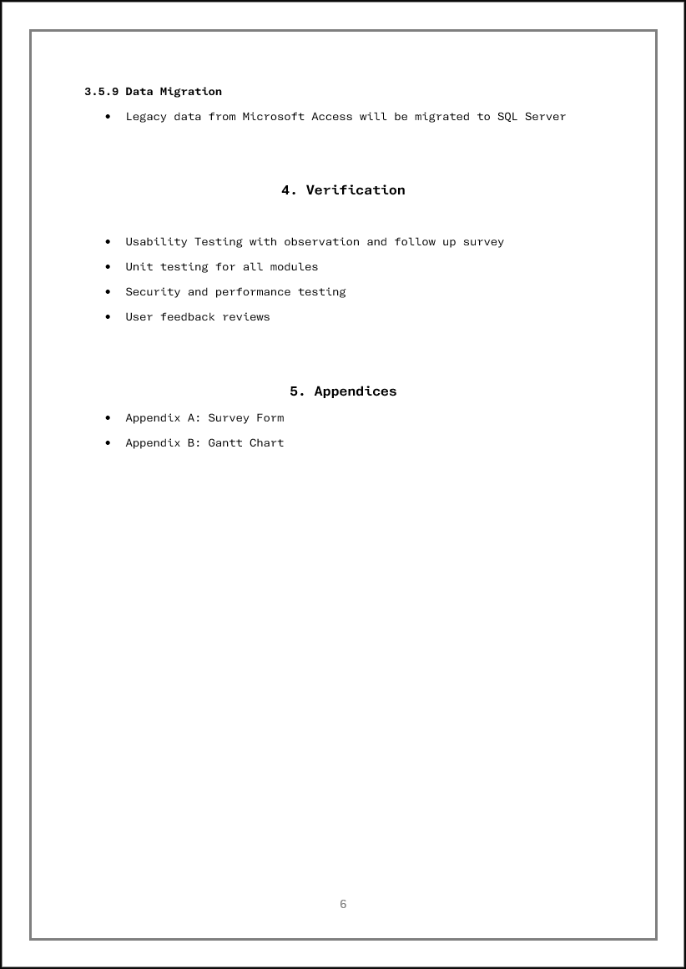

Fig 1. Exam Concession System Software Requirement Specification (1-6)

User Interface Designs
To visualise the system’s front-end interface, two designs have been created using Adobe Photoshop –

- Log-In Page
Styled to match the University’s MyTSD system, promoting consistency and user familiarity. It includes institutional branding, dedicated log-in control panel and accessibility considerations.

- Main Dashboard Interface
Showing the layout post-login, it features several interactive containers including Exam Concession, Student Search, Reporting and Support. There is also an in-tray panel which features upcoming exams and their allocated students.

These wireframes help validate user expectations early in the process and guide development in creating a layout that aligns with institutional standards. Matching the current MyTSD design ensures seamless integration with staff workflows and reduces the learning curve.

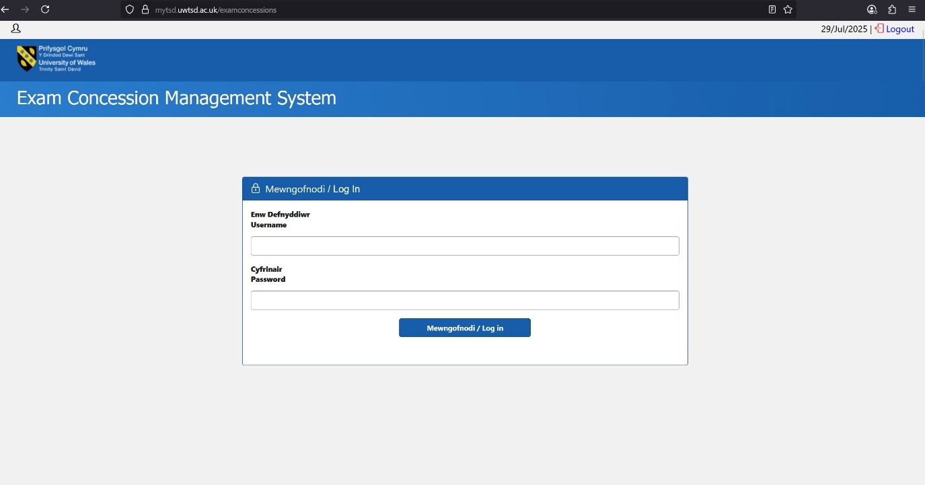

Fig 2. Exam Concession Management System: Log-In Page Design

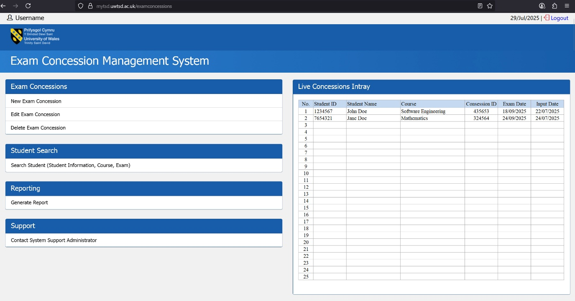

Fig 3. Exam Concession Management: Dashboard Design

TASK 2 - INNOVATION

Analysis of Nothing Technology Limited

PEST Analysis
Political - Nothing Ltd operates globally and is impacted by trade regulations, import/export restrictions and technology bans. An example would be the US-China tensions disrupting chip manufacturers. Also, as a UK-based company, Brexit had an influence on parts sourcing and distribution timelines [4]-[5].

Economic - As a startup company in a volatile market, Nothing Ltd must navigate inflation, component shortages and competitive pricing against market leaders such as Apple and Samsung. Their pricing strategy must balance innovation with affordability [6].

Social - There is growing demand for minimalist tech design, sustainability and a transparent brand identity which are areas where Nothing Ltd excels. Their products are designed to appeal to a younger, tech-conscious demographic that values aesthetics and ethical consumption [7].

Technological - The development of the Nothing Ltd Android Operating System skin (Nothing OS) shows a commitment to differentiated user experience. However, staying up to date with Android changes and ensuring long term software support presents challenges for the smaller technology brand [8].

SWOT Analysis
Strengths - Unique transparent hardware design, strong branding and leadership under Carl Pei. Fast-growing community with strong and innovative marketing.

Weaknesses - Limited market share, hardware availability constraints and reliance on Android updates.

Opportunities - Expansion into other product ranges (earbuds, smart watches), software innovation through Nothing OS and leveraging direct-to-consumer sales.

Threats - Competition from dominant brands, supply chain risks and negative impact from slow software updates or bugs.

Legal and Ethical Considerations - Nothing Ltd must comply with data protection laws like the General Data Protection Regulation (GDPR) and ensure transparency in how user data is handled within Nothing OS. They also need to consider open-source licensing obligations and intellectual property protections in both design and software. Ethically, ensuring sustainable materials and fair labor practices is vital to align with their brand promise [9].

Development, Deployment, Maintenance and Evolution of the Exam Concession System within a Large Organisation

If the Exam Concession Management System was to be implemented within a large academic institution such as the Massachusetts Institution of Techology (MIT) the development, deployment and maintenance of the system would need to be reliable, scalable and secure. The system must work well for a wide range of users while remaining easy to maintain and improve.

Development
The system would be developed using the latest version of .NET Core MVC, along with Microsoft SQL Server databases. These technologies are secure, widely supported and work well in enterprise environments. A development method called Agile Scrum would be adopted, where work is broken into smaller steps called ‘Sprints’ and reviewed every three weeks to gather feedback and then adjust the system as required.

Azure DevOps would be used to manage tasks, test progress and track issues. The source code would be stored and managed using GitHub, which would also support version control. Developers would write unit tests for the code as it’s written, following Test-Driven Development (TDD) to find issues early within development. The tool Selenium would be utilised to test how the system works from a user’s point of view [10]-[11].

Deployment
To perform within a large organisation, the system would be deployed using Microsoft Azure, which provides cloud hosting with strong security and backup options. Alternatively, the University’s internal servers could be adopted if they are sufficient.

Single Sign On (SSO) would let staff log in using their University credentials to enhance security. A CI/CD (Continuous Integration/Continuous Deployment) process would allow updates to be made quickly and safely, without causing downtime. Deployment scripts and environments would be set up to ensure consistency [12].

Maintenance
Once the system is live, it would be monitored using tools such as Azure Monitor to track usage, discover errors and check on the system’s performance. Automatic backups would be set up and updates would be scheduled at quiet times to avoid interruptions.

ServiceNow would be implemented to track support tickets and or internal help page would be available for staff to support system use. Regular updates would be made to ensure the system’s security is up-to-date and includes new features that optimise usability and performance.

Future Improvements
The system could expand by adding features such as automatic emails, a reporting dashboard, or better filtering options. The modular design means parts of the system could be updated or added without rebuilding everything and prevent interruption. If the University adds more campuses or locations, the system could handle the growth by using role-based access control (RBAC) to give permissions to different staff members [13].

Regular feedback from users will be gathered through surveys and feedback forms. This helps keep the system aligned with what staff need and ensures that the system is continually improving.

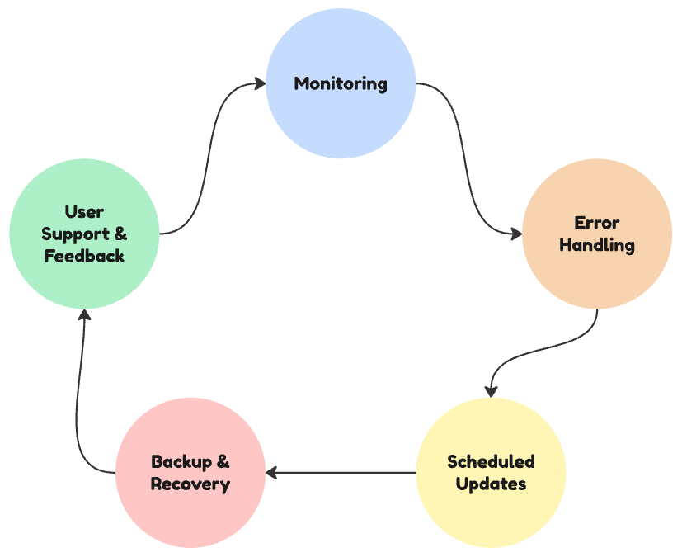

Fig. 4 Maintenance Lifecycle Flow Diagram

TASK 3 - REFLECTION AND CONCLUSION

Project Reflection

Developing the Exam Concession Management System has provided a chance to build useful, technical and professional skills that apply to real software development. The project covered all stages of the development cycle from planning and design through to deployment, with a focus on backend development using ASP.NET Core MVC, frontend design using HTML/CSS and database implementation using SQL Server.

One of the key goals was to improve my software development and project planning skills. This included learning C# programming, gathering system requirements, writing technical documentation and managing tasks using Azure DevOps. Working in an Agile environment, with three-week sprints made the process more flexible and helped to ensure the system met real user needs.

I gained practical experience in testing, user interface design and documentation. Creating wireframes and Software Requirements Specification (SRS) supported a clear development plan and helped match the design to user expectations. These real-world tasks offered theory and practical valuable learning.

Importantly, the system aims to make a positive impact on University staff and students. By replacing the outdated Microsoft Access database with a more secure and reliable web platform, the system improves how exam concessions are managed. This helps staff save time and reduces the chance of making mistakes, while ensuring that students are supported across the exam period.

Several challenges were addressed during the project. Migrating data from the Access database to SQL Server carried the risk of data loss or inconsistency. This was managed with a structured approach, including data backups, validation and testing to protect the integrity of the records.

Another issue was the small size and availability of the admin team. With limited time for training or testing, the system had to be simple to use and testing tasks had to be concise. Surveys and testing activities were designed to be efficient and respectful of their time.

Security and privacy were also key concerns. As the system handles sensitive student data, GDPR compliance and safe access were priorities. Staff are assigned different access permissions based on their roles and only essential information is stored to minimise risk.

The system is built using scalable technologies, so it can be expanded or adapted for future University requirements. Ongoing maintenance and feedback will help the platform stay relevant and useful long term.

In summary, the project has provided strong technical experience and created a system that improves University processes. With further development, it has the potential to benefit more staff and students across the institution.

Conclusion

This project has provided me with a valuable opportunity to design, develop and reflect on a real-world web-based system that solves a specific problem within a University environment. The Exam Concession Management System has allowed me to explore the full software development lifecycle from generating the idea and researching best practices to producing designs, technical documentation and implementing solutions using industry standard tools and methods.

Throughout the journey, I’ve enhanced my technical skills in backend development, frontend design and database integration. I have also developed soft skills such as planning, stakeholder communication, project management and user-testing. Agile development methods and tools assisted in staying organised and to make steady progress across each stage of the project.

The system not only meets an internal need but also contributes positively to educational fairness by helping staff manage exam concessions more easily and efficiently. I also learned how to plan for data migration, handle ethical and legal considerations and reduce project risks through careful planning and testing.

Looking forward, this system has the potential to be scaled to integrate with other departments or other Universities. With further development, user training and support, it could grow into a widely used internal platform.

Overall, this project has been a great learning experience, helping to build my confidence and practical skills needed for real-world software development while contributing a meaningful solution to a real problem.

Bibliography

[1] K. Schwaber, Agile Project Management with Scrum. New York: O’Reilly Media, Inc., 2009.

[2] R. S. Pressman and B. R. Maxim, Software Engineering : A Practitioners Approach, 9th ed. New York, Ny: Mcgraw-Hill Education, 2019.

[3] Microsoft, “Start planning visually with Gantt charts,” Microsoft 365, 2025. https://www.microsoft.com/en-us/microsoft-365-life-hacks/organization/visual-planning-gantt-charts

[4] digital doughnut, “Brexit Effects On The Mobile Market,” Digital Doughtnut, 2017. https://www.digitaldoughnut.com/articles/2017/january/brexit-is-already-saturating-the-mobile-market

[5] R. Whittington, K. Scholes, D. Angwin, P. Regner, and G. Johnson, Exploring Strategy: Text and Cases, 11th ed. Harlow, England: Pearson, 2017.

[6] T. L. Wheelen, J. D. Hunger, A. N. Hoffman, and C. E. Bamford, Strategic management and business policy : toward global sustainability. Upper Saddle River: Prentice Hall, 2018.

[7] Designlabb, “The Story of Nothing - Designlabb | Brand Design Agency - Medium,” Medium, Sep. 16, 2024. https://designlabb.medium.com/the-story-of-nothing-8458180049ee

[8] C. Hall, “Nothing has eyes on its most ambitious project yet,” T3, Nov. 05, 2024. https://www.t3.com/tech/phones/nothing-has-eyes-on-its-most-ambitious-project-yet (accessed Jul. 29, 2025).

[9] Nothing Technology Limited, “PRIVACY POLICY – NOTHING TECHNOLOGY,” Nothing, 2023. https://nothing.tech/pages/privacy-policy (accessed Jul. 29, 2025).

[10] 352 Dev Ops, “What is Test Driven Development (TDD)?,” Agile Alliance |, Dec. 06, 2015. https://agilealliance.org/glossary/tdd/

[11] BrowserStack, “Selenium: Definition, How it works and Why you need it,” BrowserStack. https://www.browserstack.com/selenium

[12] Henry van Merode, Continuous Integration (CI) and Continuous Delivery (CD). Apress, 2023.

[13] D. Ferraiolo, D Richard Kuhn, and R. Chandramouli, Role-based access control. Boston: Artech House, 2007.

[14] M. Cohn, Succeeding with agile : software development using Scrum. Upper Saddle River, Nj: Addison-Wesley, 2019.

Appendix

Link to Gantt Chart
https://drive.google.com/file/d/1wO25cVyW7zubhTRkgKdPwfO6oDjll5_y/view?usp=drive_link

Link to Software Requirement Specification
https://docs.google.com/document/d/1AJF73AnYkJmN4ECxi8mdJhRcCM3kA8fX/edit?usp=drive_link&ouid=100484526482929115189&rtpof=true&sd=true

Link To Wireframe Design #1
https://drive.google.com/file/d/1Dxpzp2H6w1dWswWgTOJoyDHLrdDMBnSe/view?usp=drive_link

Link To Wireframe Design #2
https://drive.google.com/file/d/1RjwZzf9MKVJuWivdrT7r6JK_Je7PEEfm/view?usp=drive_link

