Customer Relationship Management Emerging Themes
PART 1 Report

AMINA BEGUM
Student Number: 2118505
BA Leadership & Management
Managing The Customer Experience BMSW5103
Lecturer: Kingsley Omeihe

Executive Summary

The effectiveness of customer touchpoints has made a significant difference in the profitability of Cazoo, an online I.T. company that sell and buy cars. As an online business they have created many touchpoints which they are able to monitor to help them manage the customer experience and develop the service. This report has examined several touchpoints, including social media platforms, TV commercial, website, and sports sponsorship. Cazoo has spent a lot of time increasing the brand recognition via commercials and sports sponsorship, which has gained them support from paid marketing. Although they had a great start in the first years, it has declined in current times.

The customer experience can be viewed by two perspectives, the firm’s perspective, and the co-creation perspective. Customers at Cazoo are influenced by the co-creation, which is other actors or customers who leave their feedback or suggestions regarding the company. The total customer experience at Cazoo can be reviewed on Trust Pilot, in which it was suggested that there are mixed views regarding customer experience. This report found that the lack of human interaction can have an impact on I.T. businesses, especially when customers are buying services which require high quality in terms of product. In the event of problems, customers are all too eager to resolve these issues as soon as possible, unfortunately, customer reviews at Cazoo revealed they were unable to efficiently resolve issues. To ensure the quality of their brand and product they must show they are continuing to improve their services. The recommendations made are to incorporate more face-to-face opportunities and increase efficiency of training given to their staff to support customers, so they can provide great customer service. It was also found that any issues should be addressed as soon as possible so customers do not leave negative reviews.

In part (b) of the report the customer experience of two other companies; Monzo and Deliveroo, has been examined from the firm's perspective and co-creation perspective. It was concluded in the findings, regardless of the advantages that these companies offer, the co-creation perspective can impact how customers view the services offered. Although Deliveroo had many advantages regarding their offerings, customers were unhappy at how it was delivered. Unfortunately for Deliveroo this could weight a heavy loss considering how much effort they put into adding value to their services.

Within the findings of this report, it is recommended that these organisations should incorporate Total Quality Management so that all staff are taking part in the managing and customer experience process.

Table of Contents

Executive Summary 2
Introduction 3
PART 1 (a) Customer Experiences at Cazoo 4
1. Overview of the organisation 4
2. Customer Experience 5
3. Customer Touchpoints 6
3.1 Customer Touchpoints at Cazoo 6
4. The two major perspectives of customer experience 8
4.1 Customer experience at Cazoo 9
5. Brand Experience at Cazoo 10
6. Discussion and Recommendations 11
PART 1 (b): Critical Review on Customer Experience at two I.T. firms; Monzo and Deliveroo 13
1. Overview of organisations 13
2. Customer Experience 14
3. The two major customer experience perspectives 15
3.1 Firm’s Perspective at Monzo and Deliveroo 15
3.2 Customer/Co-creation Perspective at Monzo and Deliveroo 17
4. CONCLUSION 18
REFERENCE LIST FOR PART 1 (a) 19
REFERENCE LIST FOR PART 1 (b) 22

Introduction

Customer experience is critical to the sustainable growth of a business, a positive experience promotes loyalty, customer retainment and brand recognition (Peppers and Rogers, 2016). It has been defined in many terms but also referred to as a ‘service exchange’ which ultimately leads to the customer experience (Lemon and Verhoef, 2016). The effective designing and managing of customer touchpoints can improve the quality of the customer experience received throughout all aspects of the buyer’s journey. Part 1 (a) of this business report has been conducted to identify the customer experience of a leading I.T organisation ‘Cazoo’, to assess the importance and suitability of their customer touchpoints and the customer and brand experience received by their customers. A discussion regarding their impact on customer relationship management (CRM) will be included together with recommendations on how Cazoo can manage their customer relationships for a better future for the business. Part 1 (b) will look at the two major customer experience perspectives; customer/co-creation perspective and the firm's perspective at two I.T. companies, Monzo and Deliveroo, and how the concepts can shape the future of IT businesses drawing on a critical review of both.

PART 1 (a) Customer Experiences at Cazoo

1. Overview of the organisation

Cazoo was founded by British entrepreneur Alex Chesterman in 2018 (Cazoo, 2023), who is also the founder of the online UK property market Zoopla and Love Film the online DVD rental service. He does not refer to himself as an innovator but a ‘copycat’ and is inspired by spotting opportunities to improve the consumer experience (Lewis, 2021). The used cars market was the largest retail market at 500 billion pounds across the UK and European Union in 2019 (Statista, 2023). Cazoo launched an online marketplace for used cars in 2019, offering customers a new and convenient way to rebuy cars online using a multi-payment system. They buy used cars and fully reconditions them before offering them for sale on their website. It had become a market-leading brand which includes Premier league football sponsorship and due to the scale of its operation and promise of quick delivery to their customers, has been likened to Amazon (Metcalf, 2022). Since its quick rise and growth within 3 years it has since had to cut down its workforce due to ‘unpredictable economic conditions’ and has recently scaled back its EU (European Union) operations solely operating from the UK (The Guardian, 2022).

Figure 1. Cazoo brand picture

Source: Cazoo (2023)

2. Customer Experience

The concept of customer experience was introduced in the 1980s by Holbrook and Hirschman (1982) and was defined as a whole event that is experienced by a person during the transactions and the consummation of products and services. Lemon and Verhoef (2016) suggest that there is a difference between the customer touchpoint and the customer experience, and that the touchpoint is part of the journey of how the customer moves across different points including their individual motives and goals at each touchpoint. However, they went on to explain that the customer experience is the multidimensional construct focusing on the cognitive, emotional and behavioural responses of a customer's interactions with a firm.
It is important to satisfy a customer's experience by placing a strategy which is focussed on the type of customer a business is targeting. The idea of Customer Relationship Management (CRM) facilitates this relationship building by managing customer interactions and data, it is the ‘Top-down’ view where a strategy is based on keeping the customer the core focal point strategizing to keep profitable customers (Ellis, 2010). CRM allows for businesses to understand their target customers using data from previous or current customers to create a better experience (Lemon and Verhoef, 2016).

3. Customer Touchpoints

Touchpoints are individual contacts between the organisation and the customer at distinct points in the experience, whether direct or indirect. As described by Maechler et al, (2016) it is a way customers interact with the business and its offerings through individual transactions. An indirect encounter could be via Facebook comments and is out of the brand’s control whereas the direct touchpoint would have been actively created by the business to reach its audience. Touchpoints can occur prior, during or after the use of the service. Throughout the duration of the customers journey, the customer may encounter multiple touch points within that organisation which is known as the ‘corridor.’ These touchpoints are what the customer feels and connects with which influences how the individual views the brand. As quoted by Honeywell CEO,
‘With every customer contact and whenever we represent Honeywell, we have the opportunity either to strengthen the Honeywell brand or to cause it to lose some of its lustre and prestige’ (Esch et al, 2014, pp 427-448).
A case study assessing the specific customer touchpoints and the importance for customer satisfaction had concluded that not all touchpoints are relevant and that the ones which involve human interaction were found to be important (Aichner and Gruber, 2017, p131).

3.1 Customer Touchpoints at Cazoo

Within Cazoo, it is identified that social media is used to promote engagement with their product and services. It is common for influencers on social media to hashtag a brand and create content for the brand to generate interest (See Figure 2). This touchpoint is effective as the content maker can be of any genre but reviews their experience or product on their platform to advocate for Cazoo reaching a wide range of customers, promoting brand awareness and becomes part of the customer journey (Yakhlef and Nordin, 2021). Multiple touchpoints can be encountered by customers whilst navigating the Cazoo website, which welcomes visitors to read or view articles on latest car news as well as viewing cars for sale (Cazoo, 2023).

Figure 2.

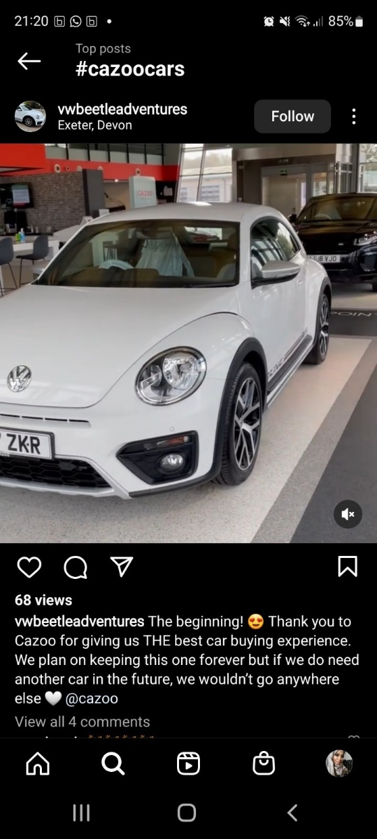
Source: Author

Other customer touchpoints identified at Cazoo:

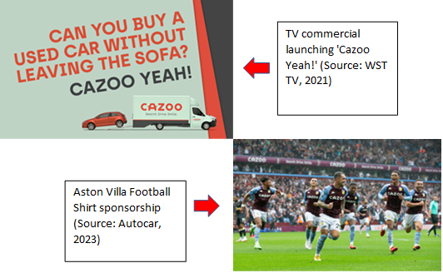
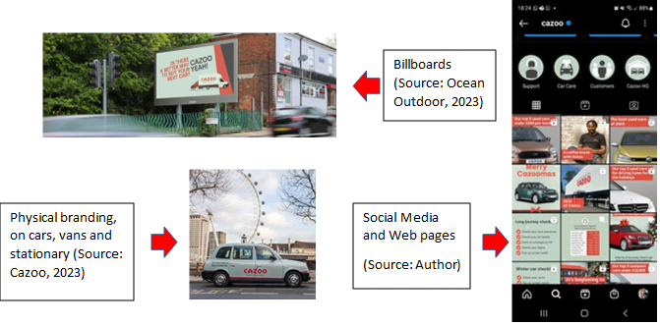

4. The two major perspectives of customer experience

Customer experience can be seen from two perspectives, the ‘firm’s perspective’ and the ‘customer’ or ‘co-creation perspective’. The firm’s perspective focusses on the designing and implementing of touchpoints to create an experience (Berry et al, 2002). The co-creation perspective has been illustrated by Chandler and Lusch (2015) as how different actors contribute to or influence a customer's experience through the co-construction of the experience. The interaction between the customer and the other actors is based upon the value proposition to engage in a service. Value proposition is not always the same for every person; what one person may value a product another customer may not. According to Pynnonen et al, (2011) value is not always in the product but in services they provide. Only by understanding and knowing what customers need and want can a firm create a value in the customers eyes. This value can be in the quality of a product; products, services and relationships which are free of defects (Pryor et al.,1998).

4.1 Customer experience at Cazoo

At Cazoo, customers can be influenced by the co-creation which are the online bloggers, social media chat forums and reviews. Trust-pilot is an online review company where anybody who has ever received a service can rate their experience with a given company. Cazoo has been rated 4.6 stars out of 5 from over 32,000 reviews (Trustpilot, 2023). This can be assumed that the overall customer experience of Cazoo is very good – excellent, but their low rated reviews from customers are related to the lack of communication regarding issues with the car and returns procedure (See appendix 1). Meyer and Schwager (2007) suggested that customer problems need to be acknowledged and resolved in a timely manner, as not to lose the value of their purchase.

The firm’s perspective at Cazoo is the designing of the touchpoints, especially the web browser which is where the customer can view and buy the services. During the pre-purchase stage, the customer can gain information regarding products and services via their website (Cazoo, 2023) which highlight the advantages of buying from them (see Table 1) (see appendix 2 and 3). They aim to offer more than their competitors (see Table 2) giving reassurance, complete transparency and car buying confidence (see Table 1). During the purchase stage the customer can navigate the website easily and hassle free, allowing for a seamless sale. The after-purchase stage is an important part of any purchase as the customer still needs the reassurance that the company has their best interest in mind, they offer a smooth hand over of the car from an experienced representative so the customer can feel positive about the purchase.

Table 1.
Advantages of buying from Cazoo
View detailed photography and data of cars
300-point checks on all cars (see appendix 2)
No hidden fees
Paint guard protection for extra cost (see appendix 3)
Easy to view and filter searches
Purchase using multiple options
Buy/Finance/Subscribe/Part-exchange
After purchase welcome email
Customer support – online live chat service
FAQs page
Cazoo car quality assurance
7-day moneyback guarantee
90-day warranty
Source: Author

Table 2.

Offering | CAZOO | CARWOW | CARVANA
Brand leadership | √ | √ | √
Online only retail | √ | √ | √
Digital finance | √ | X | X
In-house servicing | √ | X | X
Subscription | √ | X | X
UK and EU | √ | X | √
Source: Author

5. Brand Experience at Cazoo

At Cazoo, their initial focus was to impact their customers interest through brand recognition, using multiple channels to market the business. One of their featured campaigns was ‘Cazoo Yeah!’ which launched in January 2022 (Marketing Week, 2023) celebrating how great it feels to buy a used car from Cazoo. The rule of 7 suggested by marketing site Brittany Hodak (2023) implies that it would take 7 brand interactions before a customer will buy. Brand recognition plays a vital role in gaining loyal customers and can also influence how likely customers would use a product, as in the case study by Sultan et al (2019). They undertook comparative research of 2 well-known brands, Coca-Cola, and Pepsi to understand the perception of consumers regarding these two competitors and why they stay with a brand even though there is market pressure of other brands. They concluded that if there is a positive perception regarding a brand then there is a high possibility of gaining loyal customers.
Cazoo’s success factors lies in their brand marketing which has added value to their product by influencing customers and generating the feeling of wanting the product when exposed to the brand. Cazoo had gained 69% of brand awareness nationally in the UK and were able to significantly grow within their first 12 months (Rogers, 2022). As a football shirt sponsor for Aston Villa and Everton the brand has reached a large target audience in the UK. Media commercials gained them recognition from customers instilling a sense of loyalty, trust, credibility, and confidence.

6. Discussion and Recommendations

The company has spent a lot on gaining recognition and prestige for their brand, however one of their biggest weaknesses is the lack of interaction physically and not offering customer care and support efficiently after sales. This can leave a negative feeling, impacting customer attitudes and behaviours regarding the experience (emotions and thoughts) and future expectations from the company, so the firm must keep up with what customers are saying regarding their experiences and look to make changes where necessary. They may consider literary theories such as Crosby’s Cost of Quality model (1979) to produce quality service. One point argued by Crosby was that businesses should pay attention to the customers' requirements and conform to that. According to Crosby, you should spend money to ensure quality of services as it would cost more money if you do not. This is particularly important for Cazoo as although they are an IT based company, they still can manage the customer experience face to face especially during the handover of the car and post-sale support where there can be human interaction. Cazoo should spend on training their after-sales staff on better customer service and make improvements to their return's procedure. The online access to their market is convenient and has become the most popular ways to buy however, Cazoo can create a touchpoint which is more interactive, such as holding kiosks/pop-up shops in shopping centres and other sites to connect with customers.

PART 1 (b): Critical Review on Customer Experience at two I.T. firms; Monzo and Deliveroo

1. Overview of organisations

Monzo Ltd was founded in 2015 and is a digitally run app-based mobile bank which provides its customers with Master Card debit card (Monzo, 2023). Their net revenue was 154.2 million GBP in 2022. They do not own branches/stores and their ‘FAQ’ section on their website confirms that they invest the money they save from not operating physical network of branches into better service and new features that people want.

Figure 2. Brand Image

Source: Monzo (2023)

Deliveroo was founded in 2013 in London, England, and is now operating in several countries across the globe (Deliveroo, 2023) with a revenue of 1.824 billion GBP for the year ending 2021 (Market line, 2023). Food delivery apps have become popular, and the market size continues to grow (Net Solutions, 2023). According to Deliveroo (2023), not only do they serve the consumers but also the restaurants, grocers, and the riders. They are driven by technology, connecting riders, restaurants, and customers to deliver best-in-class logistics service.

Figure.3 Brand Image

Source: Deliveroo (2023)

2. Customer Experience

Having outstanding customer experience is important if businesses want to stand out from their competitors. Customer experience is the customers purchase journey through a business and is the multidimensional construct which looks at the cognitive, emotional, behavioural, sensorial, and social responses of a customer towards a firm’s offering (Lemon and Verhoef, (2016) (See Figure 1). According to Meyer and Schwager, (2007) the customer’s expectation must meet the experience they receive for the experience to be a ‘delight’. To optimise the experience of their customers, businesses collect data through surveys and targeted studies at different ‘touchpoints’ of the customers journey and then create fulfillable expectations (Schwager and Meyer, 2007).
Figure.1
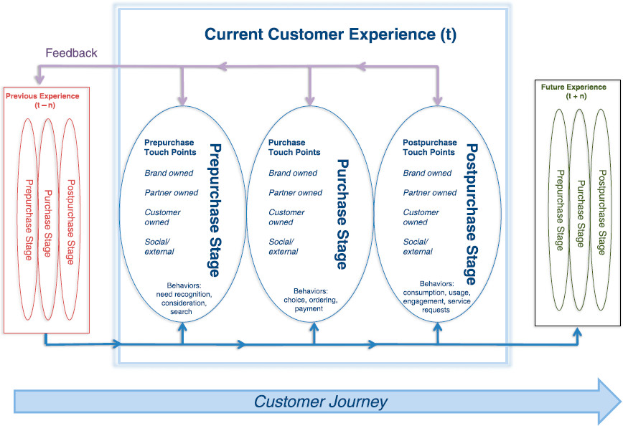
Source: Lemon and Verhoef (2016)

3. The two major customer experience perspectives

The customer experience from the firm’s perspective is to add value for the customer. This can be by solving a problem through their offering or fulfilling a need to the customer which the customer is willing to pay a reasonable price for (Pynnonen et al., 2011). The co-creation perspective is the customers interaction with other actors in the eco-system that can shape the experience (Schmitt, 2011). The co-creation is the cognitive outcome of a customer's experience (Ahn et al, 2019), customers share their interactions regarding experiences or ideas with other customers or service providers. The importance of the interaction of the consumer in co-creation would differ depending on motives and personalities (Fuller, 2010). The customer expectations in terms of co-creation benefits contribute to the overall experience, Berry et al, (2010) suggests that customers with diverse needs and expectations should be considered during the designing of these environments. A study by Verleye (2015) looked at the characteristics of the co-creation environments and found that environments which had higher technologization and connectivity have better experiences such as online communities. By creating multiple environments to engage customers in the co-creation, there would be a benefit for the firm.

3.1 Firm’s Perspective at Monzo and Deliveroo

MONZO: The customer experience at Monzo is designed around the smartphone. The firm’s perspective is to maximise profits by creating and maintaining value for the customer (O’Cass and Ngo, 2011). Monzo have used this approach by looking at what people want. They are continually building Monzo by taking suggestions for features, testing the app and getting feedback to create an app for everyone (Monzo, 2023). Their innovation of having one app with access to all banking operations for a customer solves problems in a digital era where people prefer contactless banking especially during the onset of Covid-19 pandemic (Strohm, 2022). Monzo are also taking responsibility towards holding high standards of ethical activity by supporting their own employees to making simple changes by working in partnership with charities and organisations to campaign for changes that matter to them (Monzo, 2023) (see appendix 4). They have a feature on their app which allows customers to block gambling transactions, taking into consideration and advocating for those that are likely to have money problems (see appendix 5). From their perspective according to their website they want to support all customers, allow accessibility and provide financial inclusion.

DELIVEROO: They have created value to their consumers by providing the best availability, selection, experience, brand and value according to their website, all by using their mobile-app or website. The founder of Deliveroo, Will Shu, was a very first rider and worked full-time during the first year and still completes deliveries today (CNBC, 2018). This enabled him to understand the pressures faced by riders and adjust the model where necessary. Deliveroo aims to support their partners (restaurants and grocers) with the tools to grow their businesses and are pioneering through innovation, ultimately delivering a great experience to the end consumer (Corporate Deliveroo, 2023). They use Facebook, YouTube, Twitter and paid media as a form of initial or pre-purchase stage touchpoint. Figure 4 suggests that Deliveroo has significant more advantage than disadvantages but unfortunately their customer reviews regarding experience is very poor (Trust Pilot, 2023) (see appendix 7).
Figure.4 Table of advantages and disadvantages

 | Pros | Cons
Monzo | Premium customers can save money on their phone and travel insurance.  Offering cashback at certain places.  Contactless Mastercard | Paying a fee to add cash into your account.  Cheques would need to be mailed.  No branches available.  You can only use your phone to do banking.
Deliveroo | Convenience of ordering food to your door.  Regular discounts and offers not available when buying in instore.  Discover new restaurants.  Avoid weather delays.  The app offers in-app searches, easy ordering and tracking system with reliable and fast delivery and responsive customer-care (see appendix 6). | Wait times.  Costly as there is a fee to buy and for delivery.  Not always consistent.  Inconvenience of rectifying orders.
Source: Author

3.2 Customer/Co-creation Perspective at Monzo and Deliveroo

MONZO offers their customers the ability to follow them on twitter, providing customers with information with issues and problems. This gives customers the trust and transparency of what they offer. Customer service can be accessed through their app anytime which makes it easy to communicate. The ‘help’ section offers resources on all things related to Monzo. Customers can also share the ‘golden ticket’ with others, which is to share an offer which fast-tracks a customer referral so they can recruit a new customer.

DELIVEROO customers get a variety and selection foods delivered to them. These customers can share their thoughts on the driver who delivered the food, giving ratings for the food and restaurant which builds a customer-to-customer interaction. This helps to shape the customer experience and individuals can use this knowledge to start using this firm.

4. CONCLUSION

The firm's perspective enables firms to design the product to the vision they have and constantly updating and reviewing these enables tech companies to continue to add value. In the case of Monzo, their approach is to tap into the emotions of their customers, showing them that they care for their customers well-being. Deliveroo have succeeded in their venture through offering a wide range of foods and flavours at convenient reach. Both have been successful so far, but Deliveroo has shown better reaction towards making changes to the customer needs as well as to environmental changes, adding greater value for the customer.
The co-creation perspective is a great way for businesses to leverage new customers. Firms can gain a monetary advantage especially if the product/service created provides high value to the customer. Customers of Monzo and Deliveroo have been sharing their experiences through social media voices to spotlight the company. However, not all interaction has been positive and hence any negativity may have impacted the quality perceived by the customer such as the ‘bad’ customer reviews for Deliveroo.
Incorporating Total Quality Management (TQM) where everyone in the organisation is involved in the quality processing of services and products can be a plan for Deliveroo, they can ensure that riders and restaurants are offering synchronised efforts in maintaining customer experience at high standards. It is important for organisations to offer alternative solutions as innovation for the future will require businesses to interact with customers to enable optimum customer experience.

REFERENCE LIST FOR PART 1 (a)

Aichner, T. and Gruber, B (2017) Managing Customer Touchpoints and Customer Satisfaction in B2B Mass Customisation: A Case Study. International Journal of Industrial Engineering and Management 8(3) pp131-140.

Autocar (2023) Autocar.co.uk Available at: https://www.autocar.co.uk/opinion/business-dealers/inside-industry-cazoos-spectacular-stock-market-drop

Berry, L. Carbone, P. and Haeckel, S. H. (2002), “Managing the Total Customer Experience,” MIT Sloan Management Review, 43 (3), 85–89.

Brittany Hodak (2023) What is a brand touchpoint and why are they important? Available at: https://brittanyhodak.com/what-is-a-brand-touchpoint-and-why-are-they-important/ (Accessed 2nd February 2023).

Cazoo (2023) About us. Available at: https://www.cazoo.co.uk/about-us/ (Accessed: 2nd February 2023).

Crosby, P.B. (1979) Quality is free McGraw-Hill Book Company. New York/NY/USA.

Ellis, N. (2010) Business to business marketing: Relationships, networks and strategies. Oxford University Press.

Esch, F.R., Klein, J.F., Knörle, C. and Schmitt, M. (2014) Customer Touchpoint Management für Corporate Brands umsetzen. Corporate Brand Management: Marken als Anker strategischer Führung von Unternehmen, pp.427-448.

Holbrook, M.B. and Hirschman, E.C. (1982) The experiential aspects of consumption: Consumer fantasies, feelings, and fun. Journal of consumer research, 9(2), pp.132-140.

Lemon, K.N. and Verhoef, P.C. (2016) ‘Understanding Customer Experience Throughout the Customer Journey,’ Journal of Marketing, 80(6),69-96. https://doi.org/10.1509/jm.15.0420

Lewis, J. (2021) ‘Cazoo’s Alex Chesterman: “I’m not an innovator, just a copycat”’ Money week 24th April. Available at: https://moneyweek.com/economy/people/603138/cazoo-alex-chesterman-profile (Accessed: 12th February 2022).

Maechler, N., Neher, K. and Park, R. (2016) ‘From touchpoints to journeys: Seeing the world as customers do.’ McKinsey & Company, pp.1-10.

Marketing Week (2023) How Cazoo disrupted the used car market Available at: https://www.marketingweek.com/masters-awards-cazoo-disrupted-market/ (Accessed 2nd February 2023).

Metcalf, M. (2022) ‘Lesson Learned From The Rise & Fall of Cazoo’ Latana 23rd September Available at: https://latana.com/post/cazoo-deep-dive (Accessed 12th February 2023).

Meyer, C. and Schwager, A. (2007) Understanding customer experience. Harvard business review, 85(2), p.116.

Oceanoutdoor (2023) Oceanoutdoor.com Available at: https://oceanoutdoor.com/product/digital-48-sheet/?site_selected=97331

Peppers, D. and Rogers, M. (2016) Managing customer experience and relationships: A strategic framework. John Wiley & Sons.

Research gate (2019) Image Available at: https://www.researchgate.net/figure/McKinseys-7S-Hard-and-Soft-Strategies_fig1_336143426

Rogers, C (2022) ‘Cazoo switches from brand to performance in bid to ‘realign’ business’ Marketing Week 8th June Available at: https://www.marketingweek.com/cazoo-switches-brand-to-performance/ (Accessed: 2nd February 2022).

Statistica (2023) New and used car sales in the United Kingdom between 2004 and 2021. Available at: https://www.statista.com/statistics/299841/market-volumes-of-new-and-used-cars-in-the-united-kingdom/ (Accessed: 2nd February 2023).

Sultan, K., Akram, S., Abdulhaliq, S., Jamal, D. and Saleem, R. (2019) A strategic approach to the consumer perception of brand on the basis of brand awareness and brand loyalty: A comparative analysis of Coke & Pepsi brands in Erbil KRI. International Journal of Research in Business and Social Science (2147-4478), 8(3), pp.33-44.

The Guardian (2022) Cazoo to abandon business operations in EU and cut 750 jobs Available at: https://www.theguardian.com/business/2022/sep/08/cazoo-to-abandon-its-business-operations-in-europe-and-cut-750-jobs (Accessed: 19th February 2023).

WSTtv (2021) WST.tv.com Available at: https://wst.tv/how-to-watch-the-cazoo-players-championship/ (Accessed: 12th February 2023).

REFERENCE LIST FOR PART 1 (b)

Ahn, J., Lee, C.K., Back, K.J. and Schmitt, A. (2019) Brand experiential value for creating integrated resort customers’ co-creation behavior. International journal of hospitality management, 81, pp.104-112.

Berry, L. L., Bolton, R. N., Bridges, C. H., Meyer, J., Parasuraman, A. and Seiders, K. (2010), "Opportunities for innovation in the delivery of interactive retail services", Journal of Interactive Marketing, 24 (2) 155-167

CNBC (2018) The CEO of $2 billion food start up Deliveroo still helps out with deliveries. Available at: https://www.cnbc.com/2018/04/23/deliveroo-ceo-will-shu-i-still-do-deliveries-once-every-two-weeks.html (Accessed: 24th February 2023).

Corporate Deliveroo (2023) Corporate.Deliveroo.co.uk (Accessed: 24th February 2023).

Füller, J. (2010) Refining virtual co-creation from a consumer perspective. California management review, 52(2), pp.98-122.

Lemon, K. N. and Verhoef, P. C. (2016) ‘Understanding Customer Experience Throughout the Customer Journey,’ Journal of Marketing, 80(6),69-96. https://doi.org/10.1509/jm.15.0420

O'Cass, A. and Ngo, L.V. (2011) Examining the firm's value creation process: a managerial perspective of the firm's value offering strategy and performance. British Journal of Management, 22(4), pp.646-671.

Pynnönen, M., Ritala, P. and Hallikas, J. (2011) The new meaning of customer value: a systemic perspective. Journal of Business Strategy.

Schmitt, B. (2011) Experience marketing: Concepts, frameworks and consumer insights. Foundations and Trends® in Marketing, 5(2), pp.55-112.

Strohm, M. (2022) Digital Banking Survey: How Americans prefer to Bank. Forbes 8th March. Available at: https://www.forbes.com/advisor/banking/digital-banking-survey-2022/ (Accessed: 24th February 2023).

Trust Pilot, (2023) Deliveroo reviews. Available at: https://uk.trustpilot.com/review/www.deliveroo.co.uk. (Accessed: 5th March 2023)

Verleye, K. (2014), "Designing service interfaces for customer engagement in the creation of value", in J. Kandampully, Ed., Customer experience management: Enhancing experience and value through service management. Kendal Hunt Publishing Company, Dubuque, USA, pp. 73-97
Verleye, K. (2015) The co-creation experience from the customer perspective: its measurement and determinants. Journal of Service Management.

APPENDICES

1.
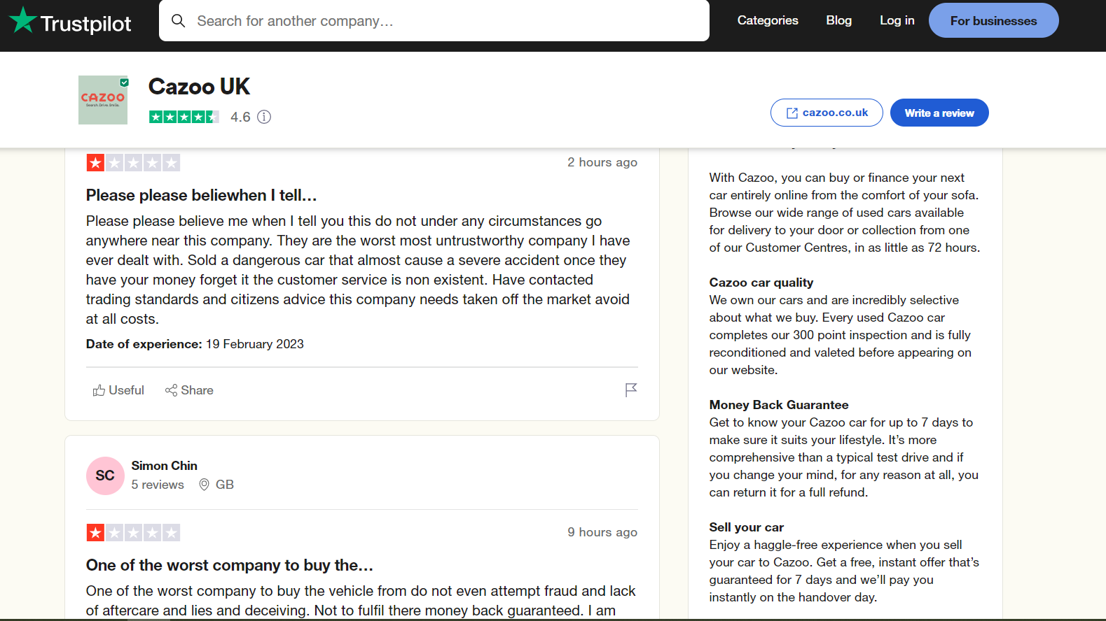

2.
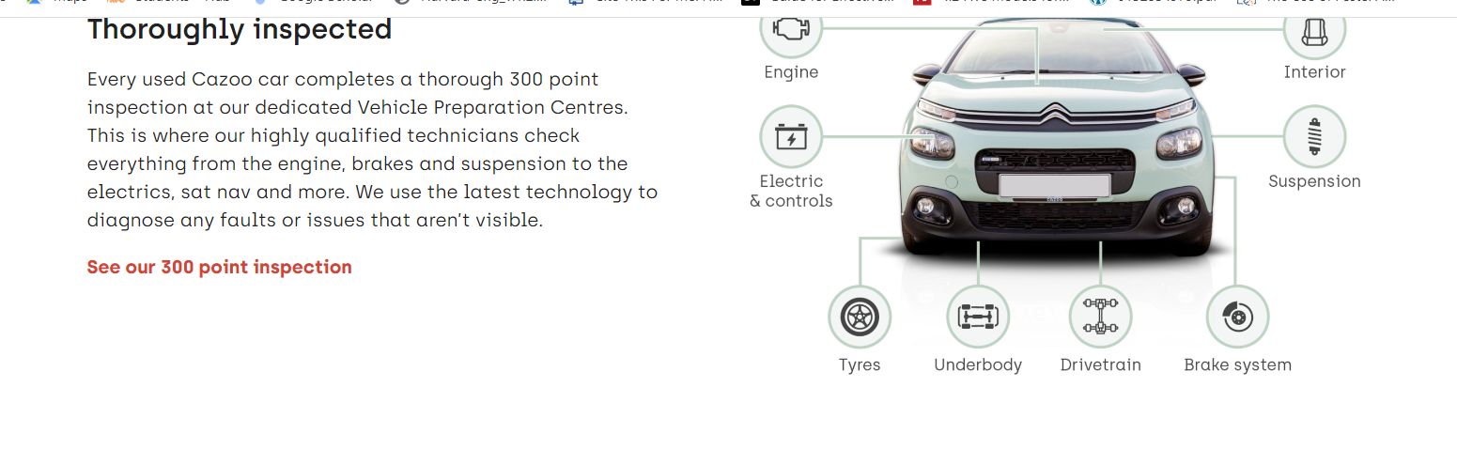

3.
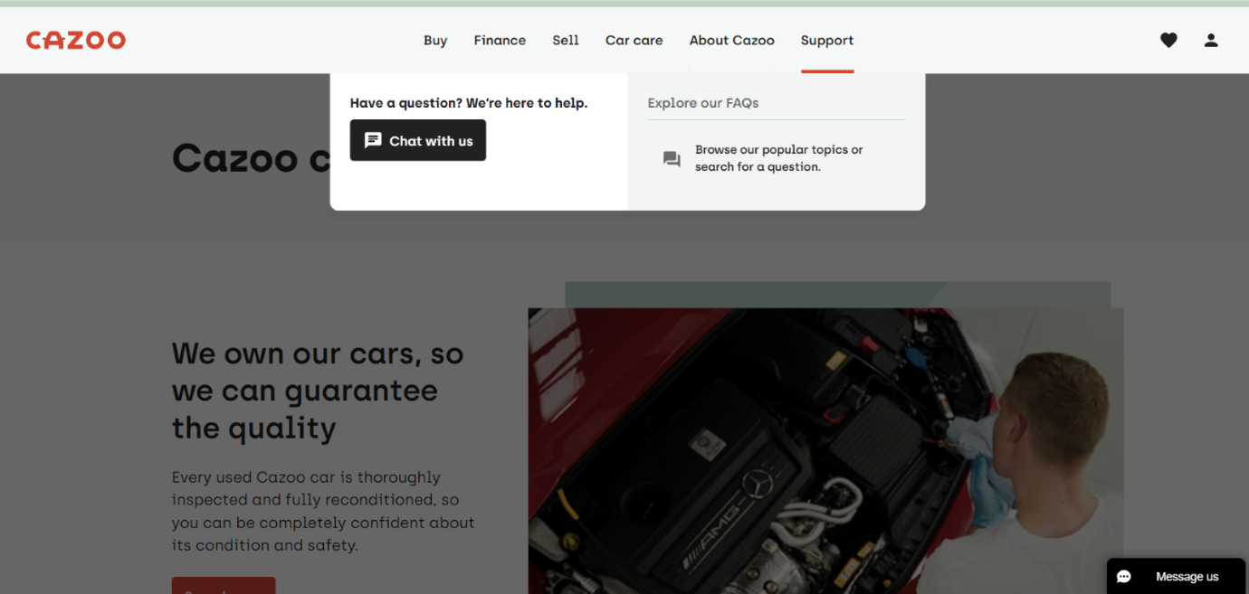
4.
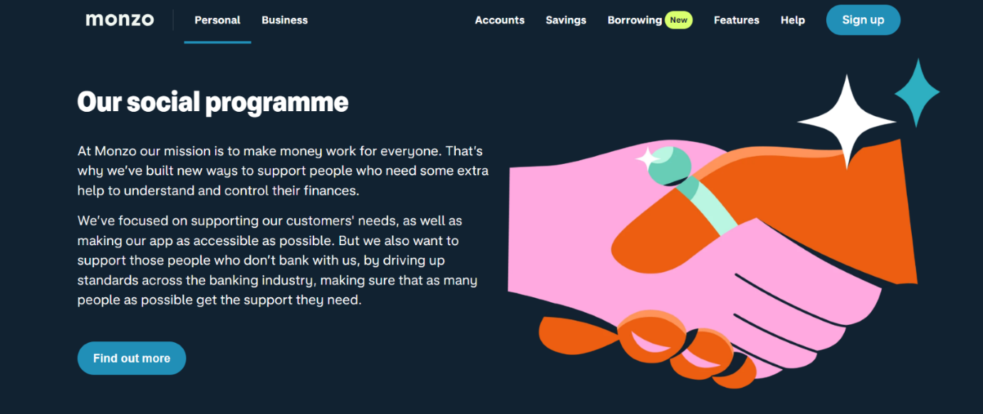
5.
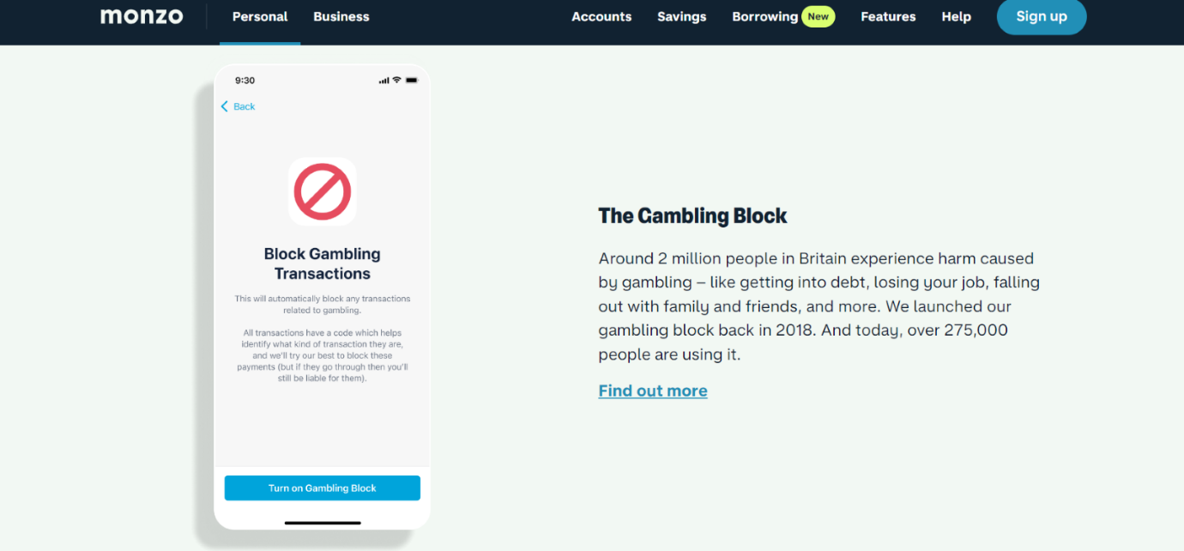
6.
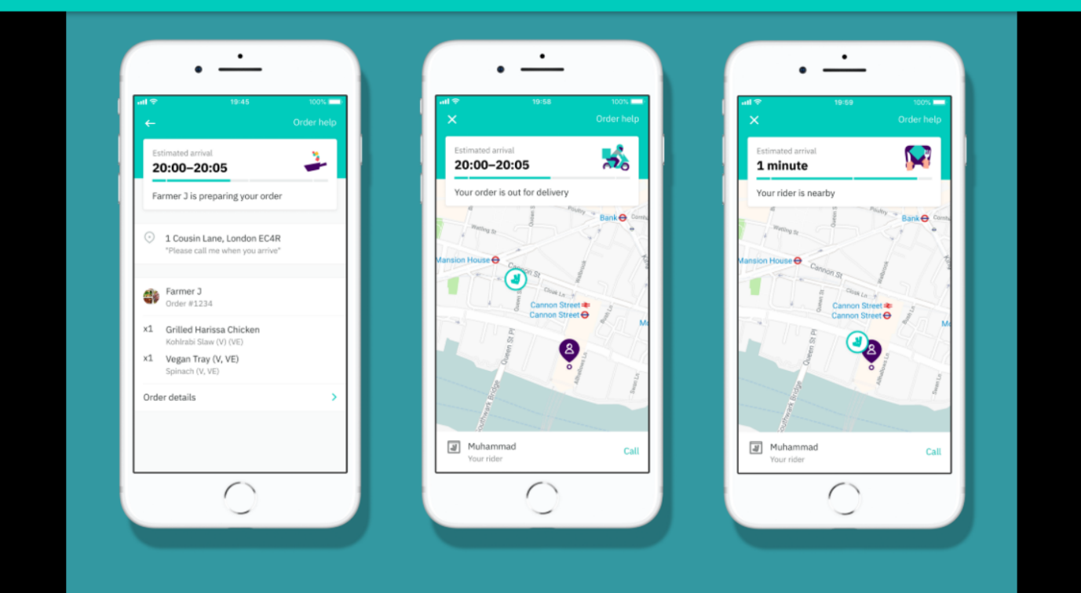
7.


