Contents
Main Body 1
External environmental analysis. PESTEL 1
Porter’s 5 Forces 3

In a fast moving world and high competitivity the Global Business Environment is seen like centre of economic health and economic expansion. The Global Business Environment is defined as environment in different countries with exogenous factors that come from environment in which company is registered that are affecting company decision making regarding resources an company capabilities. The Global Business Environment can be divided in macroenvironment and microenvironment. On one side macroenvironment incudes the social, political, technological, legal, economical and environmental factors. On other side microenvironment includes the buyers, suppliers, substitutes, new entrants in market and competitors. (Chibba M., 2012)
Global Business Environment have a big importance in business world. Because it fundamentally influence the business activities, the market in which business is operating, workforce and other essentials wedges. Also profit and business well-being is directly related to micro and macro environment conditions. Behind of all this when a business is making hiss strategic planning, he needs to take in account all likely changes in global business environment. An error in measure how it will affect business in different circumstances and at different stages of business can lead to wrong decisions and actions in preventing or preparing for those consequences as result business can have big losses or even a crash. (Brooks, 2010, p.5)
In this assignment is an overview of Global Business environment and how it affect businesses. First of all I want to mention that I have explained above what is Global Business Environment and why it is so important. Secondly I want to highlight that further I will use PESTEL and after Porter’s 5 Forces. I will explain key definitions of each framework and their elements giving examples at each stage. After I will select two factors and through examples I will show how it impacts positively and negatively Barclay’s Business.
Barclays is a British universal bank from Banking Financial Service Industry which was founded on 17 November 1690 in London, UK. It operates as two divisions first one is Barclays UK and second one is Barclays International. Today Barclays is operating over 40 countries and have approximatively 85,000 employees. Las year in 2021 Barclays had a revenue of £21.940 billion. Barclays main products are: Retail Banking, Commercial Banking, Investment Banking, Wholesale Banking, Private Banking, Wealth Management. (Barclays, 2022) (Wikipedia, 2022)

Main Body

External environmental analysis. PESTEL
For instance External Environment is not purely natural or ecological environment, when we talk about it from a different perspective like business for example it get a total different definition. The concept of externa environment enclose the totality of external environmental forces that can in a way to affect the activity of business. (Brooks, 2010 p.3)
One of the most used framework today to analyse external environment is PESTEL Framework. This analysis can help the business to anticipate some threats and opportunities, and also give to the user a certain overview on its weaknesses that give a opportunity to remove them and avert an wrong decision. (Oxford College of Marketing, 2022) PESTEL is an acronym used to describe the main factors that a company should take in account when take a decision.

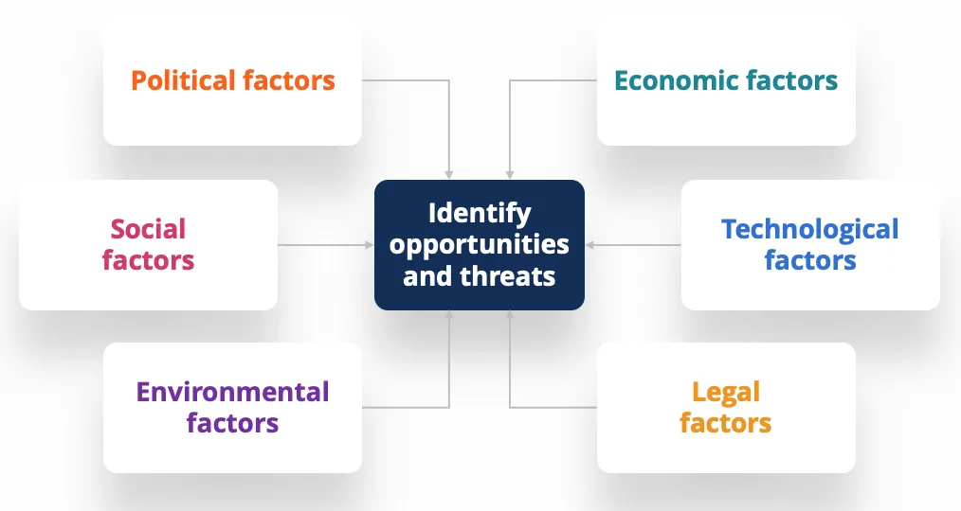 https://corporatefinanceinstitute.com/resources/knowledge/strategy/pestel-analysis/

- Political & Legal Factors
This are government actions and policies which give birth to laws. A certain criterium for this is political stability and legal, because a country that don’t have this stability cant give a healthy macroenvironment. For Barclays from this perspective is verry important this aspect for example some of Political and Legal factors tat can affect their company is: Industry safety regulations in financial sector for creating a branch in which safety regulations are respected and also adapt the branch in case of regulations changes, minimum wages and also overtime that employee can have, data protection laws because Barclays have a lot of personal information about their clients like their income, address, names, on what they how they spend money, their loans and et al.

- Economical Factors
Some of weight indicators are GDP that show the total monetary value of all goods and services that a country have accrued in one year, also inflation that affects money value, interest rates, GNP and others, type of economic system and his stability.

- Social Factors
Social factors are a bit more difficult that others to determine because here is about people. This include peoples beliefs, values and attitude, lifestyle and demographic trends. Ones that are directly affecting Barclays are: skill level of people because a lot of aged people don’t now how to use online banking and don’t know how to operate with a lot of banking services, people beliefs there still are people that don’t believe in making purchasing online because they are afraid that can lose their money also they tend to store rather money at home than in a bank account.

- Technological Factors
Business landscape offer today a big range of technology implementing and automatization, technology is fast moving and evaluating. Every business should know how technology could affect their business through factors like : cyber security, technology infrastructure, technology impact on product that they offer for example if tomorrow will appear a new bank machines that work with metal bank cards cause they are more durable and they are not accepting plastic cards. Then Barclays will need to update its bank cards.

- Environmental Factors
This factors are directly relating with ecological needs of environment and natural resources an pollution. All companies need to be aware and accord importance to Corporate Sustainability Responsibility because nowadays this is verry important because the awareness grade of pollution in the world. Businesses need to careful hoe they conduct processes like: recycling, disposal waste, carbon footprint, stewardship of natural resources, waste management in financial sector.

Porter’s 5 Forces
The Porter Five Forces is framework that dissociates strategic decision-making from simply focusing on the current competition. The Porter Five Forces analysis's can help Barclays to establish a durable competitive advantage in the international money centre banks industry. In addition utilising the Porter`s 5 Forces to forge a strategic position in the Foreign Money Centre Banks market, the ability to look for attractive opportunities across the whole financial industry.

Competitors
Porter's Five Forces Lesson one tests the number and strength of your competitors. How many opponents do you have? Who are they and how does the quality of their products and services compare to yours?
In a fiercely competitive industry, companies attract customers by offering steep discounts and launching high-impact marketing campaigns. However, it may be easier for suppliers and buyers to go elsewhere if they feel they are not getting a good deal from you.
On the other hand, when the competition is minimal and no one else is doing what you are doing, you are likely to enjoy tremendous competitive power, as well as substantial profits.
Note that Michael Porter developed the Quadrangle
model based on competitor behaviour and you can read more about it in our related article.
New players in the foreign money centre banking industry bring new ideas and ways of doing things, putting pressure on Barclays by lowering prices, cutting costs, and offering consumers new value propositions. To maintain its competitive advantage, Barclays must overcome all of these challenges and erect strong barriers.

2. Supplier strength
Supplier strength is determined by how easily your
suppliers can raise their prices. How many potential suppliers do you have?

How unique is the product or service they offer? And how much will it cost to switch from one provider to another?
The more suppliers you have to choose from, the easier it is to switch to a cheaper alternative. Conversely, the fewer sellers there are and the more you can count on them to help you, the stronger their position and the more likely they are to charge you. This can affect your profits, for example, if you are forced into expensive contracts.
3. Purchasing power
If the number of buyers is small relative to the number of suppliers in an industry, they have what is called "purchasing power". This means they may find it easier to switch to new, cheaper competitors, which can ultimately drive down prices.
Think about how many buyers you have. What is their order size? How much will it cost them to switch from your products and services to your competitors' products and services? Are your buyers strong enough to make your terms?
When you deal with just a few
savvy customers, they have more power. However, your power increases if you have more customers and less competition.
Assessing how to price your products to attract the customers you want and
protecting your brand takes a lot of skill. To learn more, check out our article
on Kotler's Pricing Strategy

4. Threat of Substitution
Your customer can find another way to get what you give, something similar. For example, if you offer a bank services people can find a bank that offer the same services but chiper that automates a critical process, people can replace it by performing the process manually or outsourced.
Easy and cheap substitutions can weaken your position and threaten your profits.
5. Threats of Recovery
Your position may be affected by everyone's ability to enter the market. If you spend little money and effort to enter the market and compete effectively, or if you have little protection for your key technologies, competitors can quickly enter the market. your. and weaken your position.
However, if you have strong and durable barriers to entry,
you can maintain an advantageous position and gain a reasonable advantage.
Is it relatively easy for a new competitor to gain a foothold in your industry or market? How much will it cost and how regulated is your industry? New entrants come and go often? Or is the industry dominated by a few big guys?
How to use Porter's Five F

References
- Chibba M., (2012), “Global Business: Origins, Viewpoints and Six Cornerstones”, Global Policy Accessed at: https://www.globalpolicyjournal.com/sites/default/files/Chiba%20- %20Global%20Business%2009.12.pdf

- Brooks I., Weatherston J. and Wilkinson G. (2010), The International Business Environment, 2nd Ed. Publisher: Pearson Prentice Hall

- Barclays (2022). Available at: https://home.barclays/ (Accessed : 14th July 2022)

- Wikipedia the Free Encyclopaedia (2022) Barclays. Available at: https://en.wikipedia.org/wiki/Barclays (Accessed : 14th July 2022)

- Oxford College of Marketing (2022) What is a PESTEL analysis? Available at: https://blog.oxfordcollegeofmarketing.com/2016/06/30/pestel-analysis/ ( Accessed : 14th July 2022)

- CFI (2022). Available at: https://corporatefinanceinstitute.com/resources/knowledge/strategy/pestel-analysis/ ( Accessed : 14th July 2022)

