

LEVEL 5

SEMESTER 1

MODULE CODE: SHSS5081
PEDEGOGY OF PLACE: SUSTAINABLE OUTDOOR EDUCATION
aSSESSMENT TYPE: aSSIGNMENT
Assessment/Component: 1

COMPONENT WEIGHTING: 30 %

WORD COUNT: 1000 WORDS

MODULE TUTOR: Denise Leonard/Graham Harvey
Portfolio
Undertake two days (approximately equivalent to16 hours) of volunteer work in a project directly connected to conservation. Link this with field experiences and write a reflective journal on your experience and how this has contributed to your knowledge and understanding of sustainability in an Outdoor Education context. You must also provide a full account of your placement including photographs completed timesheets and other placement related paperwork.

SUBMISSION DETAILS:
Date: 3pm 10/01/2020
Portal: Turnitin

School of Sport, Health & Outdoor Education

Assessment Feedback Sheet

Student No./Name:
Module: Pedagogy of Place; Sustainable Outdoor Education
Module Code: SHSS5081

Personal Evaluation – to support your academic progress please complete the section below BEFORE submitting your work.
What do you consider to be the best aspects of this work? |  | Learning to share more of my knowledge
Which aspects do you consider could have been improved in this piece of work? |  | Understanding how to lay it out
What have you found most satisfying whilst undertaking this submission? |  | Helping a community
ASSESSMENT CRITERIA | Learning  Outcomes | GRADE
ASSESSMENT CRITERIA | Learning  Outcomes | Poor  < 20% | Weak  20-29% | Unsatisfactory  30-39% | Satisfactory  40 – 49% | Good  50 – 59% | Very Good  60 – 69% | Excellent  70 – 84% | Exceptional  85– 100% | %
Evaluate how conservation volunteering within a chosen organisation might contribute towards sustainability. | 2  4 |  |  |  |  |  |  |  |  | 30%
Reflect on the link between conservation, sustainability and wider outdoor education principles. | 3  4 |  |  |  |  |  |  |  |  | 30%
Organise and undertake voluntary work in conservation with evidence from log book/ diary, photographs and relevant paperwork. | 1 |  |  |  |  |  |  |  |  | 30%
Range and quality of sources of information. Referencing accuracy. | All |  |  |  |  |  |  |  |  | 10%
It is expected that students will present work that is proof read and follows the School Reference Guide and Assessment Checklist. Therefore a range of 0 – 10 marks will be deducted for non-completion of any of the points on the checklist below.

Placement Portfolio

This essay will be evaluating my time undergoing a voluntary position based around conservation and the wider narrative around the importance of voluntary conservational work. The organization in which I chose to do my placement was the National Park. I was working with multiple park rangers in the aim of creating an exhibition. This exhibition was based in Oriel y Parc (A National Park centre) and the project was to create a pollinating garden with a beehive being the centre piece. I will be evaluating the importance of outdoor educators getting involved with communities to introduce them to environmental issues and the impact that this can have.

Oriel y parc is a national park gallery and visitors centre. When we arrived, I was introduced to the other park rangers that were there and the different roles that they have. There was then a meeting regarding an exhibition that the oriel y parc rangers are creating. This exhibition is a pollinator garden, the purpose of a pollinator garden is to provide sufficient food being nectar and pollen as well as providing a safe environment for pollinators, bees in particular. The reason for this pollinator garden was specifically aimed at providing information for the visitors on how they can help provide a safe space for pollinators within the comfort of their own gardens. This is a pressing matter as the population of bees has been drastically decreasing year by year. The past decade within the United Kingdom bees have decreased in population by a third. Bees are crucial to the agricultural production of food with bees pollinating around a third of all food eaten. Spreading this message to the visitors who come to see the exhibit is a duty as an outdoor educator. As outdoor educators, the national park rangers have vast knowledge about the environment and the wildlife within. Spending the majority of their time in the outdoors, they will have a greater understanding of the complications that surround wildlife. The importance to act as a role model for the general public in living a more sustainable life should be of great importance. The National park rangers frequently work with the public, cohesively running educational programmes with schools, guided walks and much more.

With people volunteering with the national park and other like-minded organizations, they could potentially become more environmentally conscious. Volunteer work regarding conservation could build a greater understanding regarding certain issues with the environment. When creating the pollinator garden, I learnt about different challenges that pollinators face such as the destruction of their habitat, pesticides and global warming. This has led me to expand my knowledge of the area and try to become eco-friendlier for pollinators. It is a simple way to potentially make people think more about their actions and possibly positive impacts that they can have going forward. As a broader narrative volunteering opens up opportunities for greater participation in a community for environmental sustainability. As an outdoor educator the natural world is your workplace and your passion, however much you know will not help unless you try to share your knowledge. Jackson (2005) states, “human beings are social creatures. In spite of our best efforts at independence and individuality, we learn by example, and model our behaviours on those we see around us”. This shows the importance on environmental advocates such as national park rangers. The national park is an organization that aim to preserve, promote and share the natural environment. The National park rangers frequently work with the public, cohesively running educational programmes with schools, guided walks and much more.

United Nations Volunteers issue brief (2015) states, “Volunteerism has been a key driver of the global environmental movement, mobilizing communities all over the world to help address environmental problems”. Volunteering is a great way for people to help make a movement in environmental change where without volunteering that option may not be there. Not everybody can have a job in which everything they do is sustainable or eco-friendly, but volunteering allows you to combat issues that matter to you. During my placement with the national park I have learnt how important it is to share your knowledge. It is not just local people who will be seeing the exhibition, St. Davids is a popular tourist location. There will be many different people from many different places whether they are surrounded by nature in the place they live or if they live in the middle of a city.

The more people that volunteer for conservation projects, the more the organisations that run the projects can expand. Expanding these organizations will mean that they can do more projects and reach even more people. As well as helping the organization, the individual volunteers learn valuable skills and improve their knowledge which could benefit them through life. The more people getting involved, the more people will be spreading the word about conservation efforts because they’ll talk to friends, family and co-workers about these organisations. The more people that get involved in conservation projects, the bigger the environmental impact.

In conclusion, my time with the national park was insightful and fascinating. Before I thought that expanding my knowledge around environmental issues was the most valuable contributor. However, now I understand that there is power in numbers. What use is my knowledge if it is just me who is going to be using it, I need to make more of an effort to spread information to those who may be less knowledgeable around certain topics. There is a great importance for more people to be contributing their time if possible to voluntary positions for environmental matters that are important to them.

Word count - 940

Appendices

Log book

Day 1 was an introduction
I was picked up by Ian Meopham (Park Ranger). He drove us to Oriel y Parc which is a nation parc centre. He gave me a tour around and introduced me to different members of the team. We went into a meeting room and explained that they are hosting an exhibition on conservation. The exhibition will be a pollinating garden, there will be a beehive within and multiple flowers surrounding. We later spent the day evaluating the land where the garden would be and the work that would need doing. We spent time choosing which flowers would be best appropriate for the display accounting for the type of soil and time of year that the exhibition would be (January 26th). After this we discussed the layout of the exhibition evaluating the landscaping that needs doing and the design.

Day 2 getting dirty.
I was picked up by Ian again and went to Oriel y Parc. We discussed with Nigel (Oriel y Parc maintenance ranger) our plan and the equipment we need. We then went to Porthgain where the national parc have a storage centre. We picked up multiple pieces of landscaping equipment. We then ventured to back to Oriel y parc to start working. We spent many hours digging up turf and making the soil ready for planting. Once we had finished this we went to a florist by Abereiddy. We discussed what we were doing and discussed the type of flowers we would like for the arrangement.
I was unable to finish the project within the allotted time period, but I will be going back to help them finish the project in time. I am really looking forward to continuing work with the Nation park under a voluntary position. I feel I have learnt things that I would not necessarily have thought about during my 16 hours with the park and I am excited to have an open mind and continue on my learning journey.

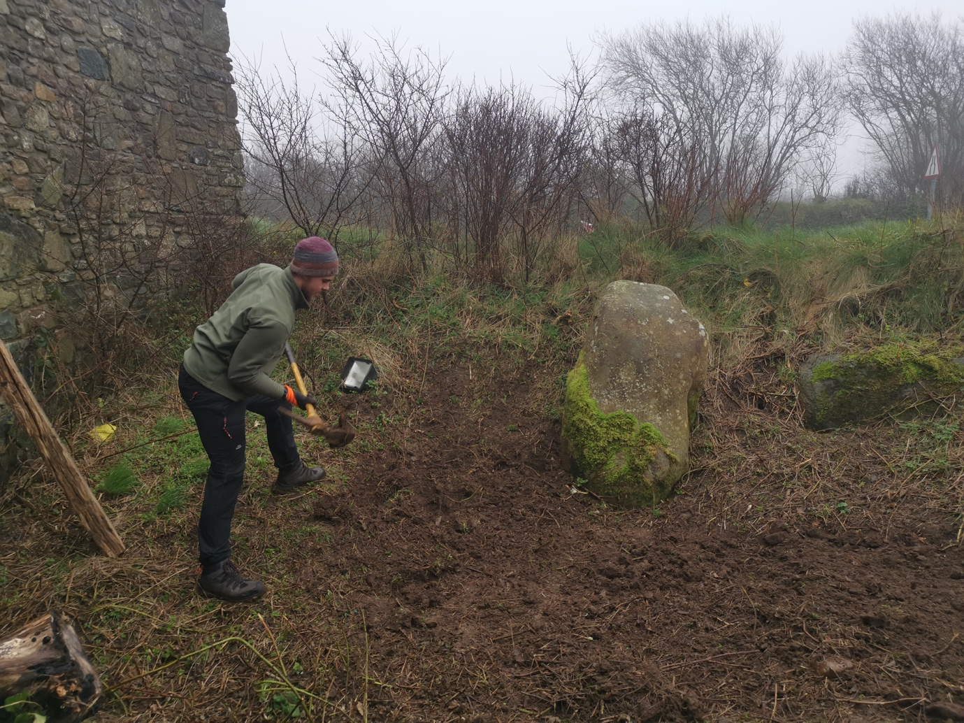
Pictures from preparing the garden.
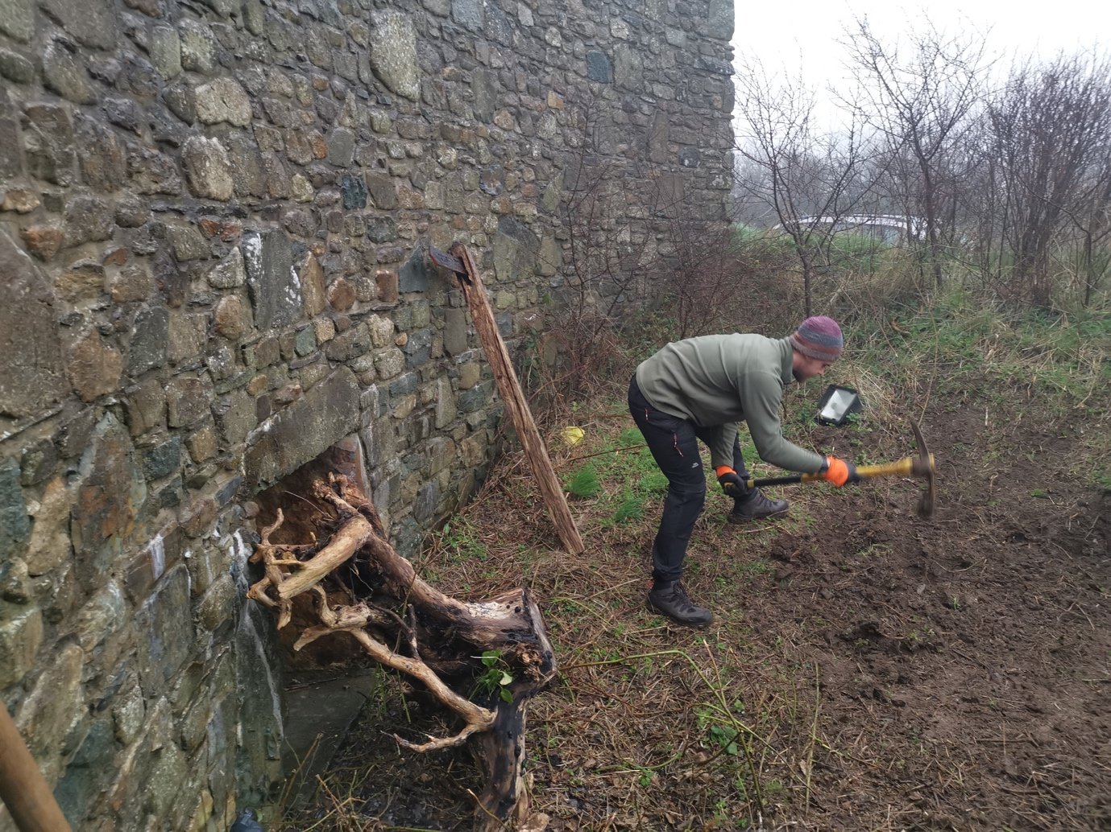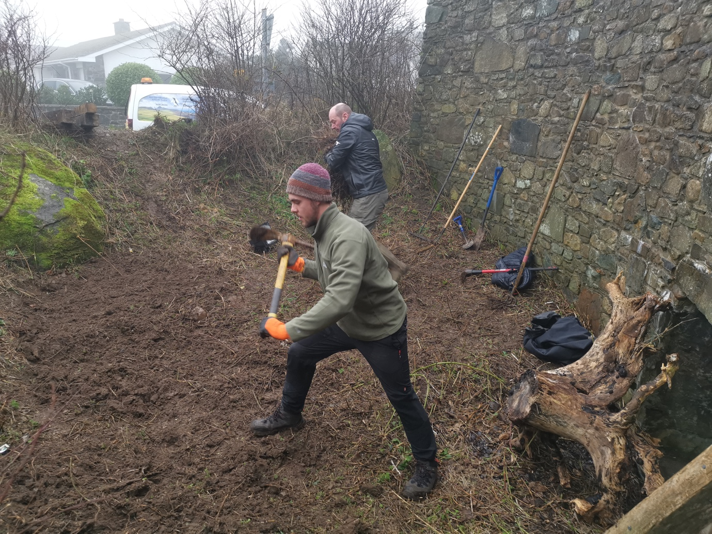
Reference list.

The Bees in Decline. (2019). Causes. [online] Available at: http://sos-bees.org/causes/ [Accessed 2 Jan. 2020].

Jackson, T. (2005). Motivating Sustainable Consumption. [online] Surrey: Sustainable Development Research Network. Available at: http://sustainablelifestyles.ac.uk/sites/default/files/motivating_sc_final.pdf [Accessed 2 Jan. 2020].

Prince, H. (2016). Outdoor experiences and sustainability. Journal of Adventure Education and Outdoor Learning, [online] 17(2), pp.161-171. Available at: https://www.tandfonline.com/doi/full/10.1080/14729679.2016.1244645 [Accessed 3 Jan. 2020].

UNV (2020). [online] Sustainabledevelopment.un.org. Available at: https://sustainabledevelopment.un.org/content/documents/120020443_UN%20Volunteers%20POST-2015%20Brief%20-%20Environmental%20Sustainability%20and%20Volunteerism%20WEB.pdf [Accessed 2 Jan. 2020].

