Effective Team Working and Communication BMSW4002
Lecturer: Navami Leena
Student: Laura Iacob
Student number: 1907861

Contents

Introduction 3
Types of communication 4
Verbal communication 4
Nonverbal communication 4
Relevant theories 6
Shannon and Weaver model 6
Berlo model 7
Schramm model 9
Culture and intercultural communication 10
Communication in organisations 10
Conflicts and strategies 11
Conclusion 13
References 14

Introduction

Communication - is the ability to share information with people and understand what information and feelings are transmitted by others. Communication can take place in many forms including gestures, facial expressions, signs, voice (tones, inflections), in addition to written and spoken communication. Communication, a smiling face, a gesture of approval, indicates that the listener is interested in what we say and encourages us to continue.
Communication objectives:
1. To be received (heard or read);
2. Let us be understanding;
3. To be accepted;
4. To provoke a reaction (a change of behaviour or attitude).
Communication is a process of relationship, of construction of social life. Each person has their own reference system and each one expresses his or her thoughts differently. Even if we meet two people who want to convey the same message, they will express this message differently. Negative attitudes can be considered as communication barriers. They can limit the quality of the communication process.
Interpersonal communication takes place within certain parameters. It is very important that the verbal relationship between two persons takes place at the same level. Most of the times we are put in the situation where we have to communicate with people who are not on the same level with us.

Types of communication

Communication is a process composed of a series of elements. Verbal communication is just one component of this process. The non-verbal component refers to gestures, pitch, mimics, body language.

Verbal communication
Verbal communication is a form of communication that allows one to enter into direct communication with another person regardless of whether it is a dialogue or a simple monologue.
Verbal communication is a positive action that has a direct connection with the personality of the person who initiates the communication process and if the interlocutor responds also by verbal communication, the personality characteristics and of the dialogue partner can be observed.
In other words, each participant in the communication process puts his or her fingerprint so that the persons concerned can be easily identified.
The communication through the verbal language that is, the transmission of messages directly to an interlocutor is called verbal communication.
This form of communication is based on saying the words with the intention of directing the message to a caller, which is why it is also called direct communication.

Nonverbal communication
We can define nonverbal communication as the whole of behaviours and characteristics that convey meanings without using words / language. It has a powerful impact because sometimes the slightest glance, a warm tone can convey undeniable messages about ourselves.
So much of what we can find out about people's thoughts and feelings is not necessarily based on listening to words, what they actually say, but on observing body language. Sometimes words are useless, because in certain situations just a simple gesture is enough to say everything. So, we can track the facial expressions, observe how people move and what gestures, notice their posture and eye contact. All these behaviours sometimes convey extremely much information, much clearer and sufficiently visible about people, in much more efficient and even subtle ways.
Non-verbal communication is extremely important for people who do not have language skills but also the other way around, such as children who can speak without words or people with certain neurological problems and who cannot use language, as well as if they can use but the language does not speak the same language and depends only on nonverbal behaviour in order to be understood.
Non-verbal communication:
- face expression: a smile, a frown;
- gestures: movement of the hands and body;
- body position: the way we sit, standing or sitting;
- orientation: if we stand face to face or with the back;
- eye contact: whether we look at the interlocutor or not, as well as the time interval;
- body contact: a light beating on the back;
- head movement: approval - disapproval;
- the external appearance: uniform, choice of clothing;
- nonverbal aspects of speech: tone, voice intensity, loudness or speed of speech;
- nonverbal aspects of writing: handwriting, accuracy and general visual appearance.

Relevant theories

Shannon and Weaver model

The generic model of communication in information theory, proposed in 1949 by Shannon and Weaver, can be summarized using the following scheme:
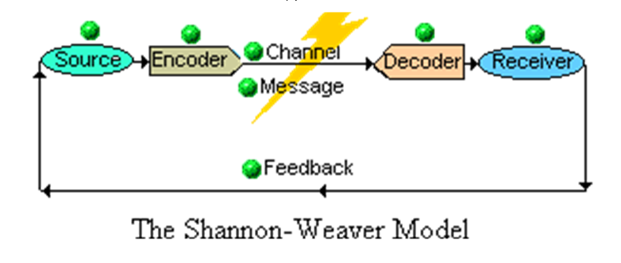

This model can be summarized in a few words: The source decides which message to transmit, via the transmitter, the message is sent on a channel to the receiver.
For example, telephone communication we have:
- Source: the person talking on the phone
- The channel: the telephone line
- The signal: the electric current
- Transmitter and receiver: telephone devices.
Instead, in a conversation, the structure of communication is different:
- Source: the voice chords of the interlocutors
- The channel: the air
- Signal: sound waves
- The transmitter: the mouth
- The receiver: the ear
The noise is any received signal that does not belong to the source, or whatever makes the initially transmitted signal more difficult to accurately decode.
According to this model of representation of the communication process, we notice that the focus falls on the message and the way it is transmitted, as well as how the code in which the message is transposed can influence its quality along with the background noise that can damage the information contained in the message. However, it is very important an element that is found in this representation, respectively the response (feedback) that the initiator of the communication wants to obtain from the receiver after the communication process.

Berlo model

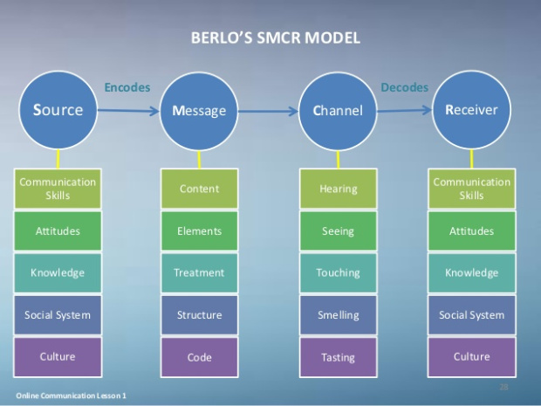

Berlo's model highlights the psychological nature of communication. It focuses on different components, including attitudes, intentions and specifies the conditions for an efficient transmission.
The SMCR represents the source (S), the message (M), the channels (C) and the receiver (R).
The source wants to transmit something. His ideas, needs, intentions to communicate and use the symbols needed to produce a message depend on:
a) Communicative ability: skills for coding the message (knowing how to write), the ability to decode the event (knowing how to see), the ability to rationally analyse a situation, according to objectives (to know, for example, to convince) .
b) Attitudes, which constitute the predisposition to act in different situations (negative, authoritarian, hesitant, positive attitude).
c) His knowledge in relation to the treated subject, with the recipient.
d) The social and cultural system.

- The message consists of elements and has a structure.
- The channel is represented by the five senses.
- The receiver has the same characteristics as the source, influencing communication.

In Berlo's conception, communication is a dynamic and continuous process between two persons who can be separated and simultaneously, and transmitter, and receiver. It is a linear and sequential model, not realizing a dynamic relationship between the different elements of the model.

Schramm model
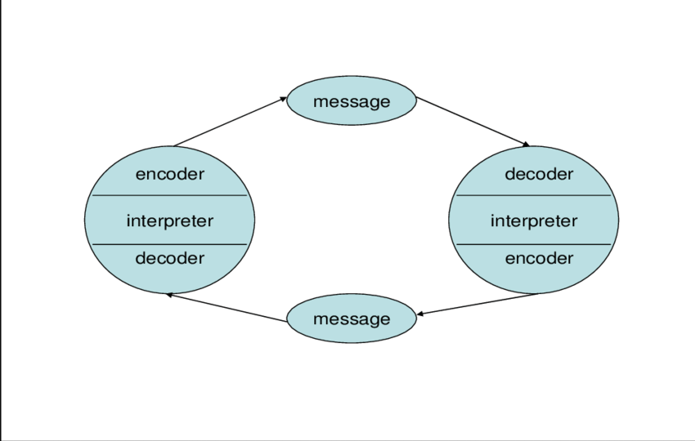
Communication is a continuous, circular process, where the roles of communicator and recipient, or communicator and recipient, change with each intervention. With every message. And from here until the circular model of communication was only a safe step.
Wilbur Lang Schramm proposed in 1954 a new model of communication that is noticeable through its circular component. Coming in response to the linear model, Schramm notices a simple truth in appearance, but is able to influence the theories that followed, namely that one cannot talk about communication that begins at one point and ends at another, like a road. one-way
It is not a transmitter and a receiver, but interchangeable roles, where the communicator successively performs coding, interpreting and decoding messages.
The advantages of this model, first of all, communication is centred on the idea of permanent feedback, breaking the barrier between transmitter and receiver, and talk about dynamic roles, understanding the importance of semantic interpretation and noise.

Culture and intercultural communication

The term culture is used in different meanings, with different connotations depending on the specificity of the discourse, and the scientific field of reference. The socio-psychological acceptance of the term broadly refers to the set of:
- the system of values ​​and beliefs existing within the community
- social, legal and moral norms on which the society is based, and whose transmission stops in the socialization process
- customs and traditions specific to a certain community
-the model for interpreting reality (comprising both mythological and mythogenetic elements, religious beliefs, but also the "scientific truths" that were received and became the members of the community
Interculturality is the relationship of continuous interaction and cooperation of various cultural, ethnic, religious groups, etc. (of all categories of minorities). The relationships determined are cultural exchange and interconnection in the context of caring for maintaining the specificity of each community. Interculturality in the educational process, it does not mean first of all else, but it means above all else. Otherwise it means a new paradigmatic opening of the horizon of thought, towards the factual experience of social reality.

Communication in organisations

Communication is one of the most important activities of an organization. Fundamentally, relationships develop as a result of communication, and the functioning and survival of organizations is based on effective relationships between individuals and groups. Moreover, organizational capabilities are adopted and developed through "intense communication and social processes" .
Communication helps individuals and groups to coordinate their activities in order to achieve their goals and is vital in socializing, decision making, problem solving and management change.
Internal communication also provides employees with important information about their job, the organization in which they work, the external environment or information about their colleagues. Communication can help motivate employees, build trust, create a common identity or increase personal involvement; it provides individuals with a way to express their feelings, share their hopes and ambitions, and celebrate and recall their achievements. Communication is the way in which individuals and groups understand their organization, what it is and what it represents.
Internal communication is a complex and dynamic process, but previous models focused on transmitting messages in one direction.

Conflicts and strategies
Conflicts can occur in any organization. Human skills can effectively participate in conflict resolution. The manager of any organization must have the leadership skills, so that the problem can be resolved permanently, without affecting the relations between the employees. For the positive outcomes of conflicts, the designed strategies should be effective, through negotiation and communication.
In any organization, conflicts are considered beneficial because there is an opportunity for personal and organizational growth. After conflict resolution, productive and creative social relationships are strengthened. Conflicts are necessary for the organization, because it stimulates innovative thinking, for their proper management, negativity must be avoided.
Each supervisor must have the leader skills; negotiation is the best way to deal with conflicts, in negotiations both sides, understand the problem correctly and solve it by mutual contract. The leader does not have to be aggressive; he should accept and respect everyone in his team. He should never make assumptions and should get feedback from employees.
Techniques for relating to negative people:
When you are in a position to communicate with a person who develops a negative attitude, it is important to have certain techniques that will help you maintain your optimism and not be affected by the negative state of the other person:
- Keep your state of optimism.
Regardless of the mood of the interlocutor with whom you conduct the conversation, try not to be affected and maintain your optimism.
- Propose other approaches
People who adopt a negative attitude do not intentionally and deliberately do so. They react to events in their lives. You can propose other variants to approach the problems, suggesting even possible solutions.
- Facilitate the elimination of negativism
When you talk to a difficult, closed, negative person, try to create a communication space full of positive energy that will facilitate the elimination of negative thoughts.
- Create enthusiasm
You can try to ask the negative people questions about their goals. When you open a discussion that will focus on their dreams, these people will turn their attention to the goals they have to accomplish, leaving the negativity behind. Try asking them questions so you can create enthusiasm.
- Do a good deed
Try to do a nice thing for the negative people. Think of something that will change their attitude and give them the opportunity to be grateful. Regardless of the degree of negativity of the person you communicate with, this person will appreciate a good deed.
- Offer optimism
Do not let the caller create a negative state. Show an optimistic attitude and set an example for those who do not have the power to observe the beautiful things around them.

Conclusion

I have presented some methods to increase the effectiveness of communication. It is very easy to make general comments about the benefits of an 'open communication climate' or the importance of egalitarianism in communication. But we must recognize that the communication difficulties that arise often reveal more serious organizational problems, for which there are no simple solutions. It would be too simplistic to say that all we need is better communication and that this would be easy to achieve. However, there are many practical things we can do to improve the way we communicate every day. Although we each form our own style of communication, we can refine ourselves by reflecting on the behaviour we adopt, the way it is perceived by others and the many ways we communicate our information to others, without even thinking about it.
After studying this, I learned about: analysing communication interactions with those around you; understanding how communication is influenced by organizational conditions; understanding the nature and characteristics of the different communication channels; developing a strategy to improve the effectiveness of the way you communicate.

References
Bonaccio, S., O’Reilly, J., O’Sullivan, S. and Chiocchio, F. (2016). Nonverbal Behavior and Communication in the Workplace. Journal of Management, [online] 42(5), pp.1044-1074. Available at: https://journals.sagepub.com/doi/abs/10.1177/0149206315621146 [Accessed 13 Nov. 2019].
Coffelt, T., Grauman, D. and Smith, F. (2019). Employers’ Perspectives on Workplace Communication Skills: The Meaning of Communication Skills. Business and Professional Communication Quarterly, [online] 82(4), pp.418-439. Available at: https://journals.sagepub.com/doi/abs/10.1177/2329490619851119 [Accessed 1 Dec. 2019].
Gartmeier, M., Gebhardt, M. and Dotger, B. (2016). How do teachers evaluate their parent communication competence? Latent profiles and relationships to workplace behaviors. Teaching and Teacher Education, [online] 55, pp.207-216. Available at: https://doi.org/10.1016/j.tate.2016.01.009 [Accessed 1 Dec. 2019].
Jia, M., Cheng, J. and Hale, C. (2016). Workplace Emotion and Communication. Management Communication Quarterly, [online] 31(1), pp.69-87. Available at: https://journals.sagepub.com/doi/abs/10.1177/0893318916650519 [Accessed 15 Nov. 2019].
Karanges, E., Johnston, K., Beatson, A. and Lings, I. (2015). The influence of internal communication on employee engagement: A pilot study. Public Relations Review, [online] 41(1), pp.129-131. Available at: https://doi.org/10.1016/j.pubrev.2014.12.003 [Accessed 6 Dec. 2019].
Stich, J., Tarafdar, M. and Cooper, C. (2018). Electronic communication in the workplace: boon or bane?. Journal of Organizational Effectiveness: People and Performance, [online] 5(1), pp.98-106. Available at: https://doi.org/10.1108/JOEPP-05-2017-0046 [Accessed 7 Dec. 2019].



