Student’s Name: Cristina Elena Draghici
Student Number: 2018557
Professor’s Name: Dale Clarke
Course Name: Financial Management for the Hotel Industry ( BMIH5007/BMIH5002)
Date: 30/05/2022
Analysis Of the Financial Statements of Hilton Hotel 2019 And 2020
Introduction
As the senior manager at Hilton Worldwide Holdings, the report is addressed to the chief executive officer encompassing the horizontal ratios for 2019 and 2020 and discussion on the trends seen in the ratios and actual changes in the balance sheet and income figures. The second part of the report outlines the importance of using ratios in the analysis for decision making and the last section of the report provides an investigation of the limitations of the ratios and why one would need to understand the ratios and their fluctuations especially in hotel management. This report is therefore divided into 3 sections.
a. The horizontal ratios and trend analysis for the financial years 2019 and 2020

Financial analysis can be achieved through vertical, horizontal and ratio analyses, according to Franklin, Patty and Dixon (9). The horizontal analysis shows the trend between two years, 2019 and 2020, while the ratio analysis focuses on different categories like profitability, liquidity, solvency, and efficiency (Kimmel, Jerry and Donald 21). Figure one shows that the overall financial performance of Hilton Worldwide holdings incorporation decreased between 2019 and 2020. According to the trend analysis in Figure 1, all the components of the income statement had a negative trend, save for the interest expense whose positive trend also indicate a negative effect on the firm. The most affected was other income which the company had received $82,000 in 2019 but that reduced to negative (376,000) in 2020, indicating 559% decline (Figure 1). The interest expense, which is the interest the company pays on the debt facilities, also increased by 4% from 414,000 to 429,000 between 2019 and 2020 (Figure 1). These changes in the income statement reduced the net income significantly to a negative value of (715,000) from 80,000 and could have been caused by changes in the consumption of the company's products because of COVID-19 pandemic that disrupted the hotel and hospitality industry significantly (Linxi 7). For example, because of a decline in sales by 54%, the company's overall gross profit decreased by a significant 6% despite the cost of goods sold reducing by 7% (Figure 1).
Concerning the changes or horizontal analysis of the balance sheet, it is evident that the company’s combination of assets, and liabilities and stockholders’ equity had a different trajectory compared to the income statement. For example, the company’s current assets increased by 101% because of a significant increase in accounts receivable, while the non-current assets, which are fixed assets, decreased by 2% (Figure 2). This decline however led to an overall increase in the total assets by 12%. Concerning the liabilities, the company managed to reduce its current liabilities by settling the pending current bills by 15%. However, the current liabilities increased significantly by 26% raising the total liabilities by 18% which is higher than the change in total assets which was at 12% (Figure 2). Their stockholder’s equity decreased significantly by two or 9% implying that their shareholders were not interested in the company's shares or had lost confidence in its direction as the impact of the pandemic and other supply chain disruptions affected the multinational corporation operation (Zeng 12).

Figure 1: The Horizontal Analysis and Trend for Income Statement
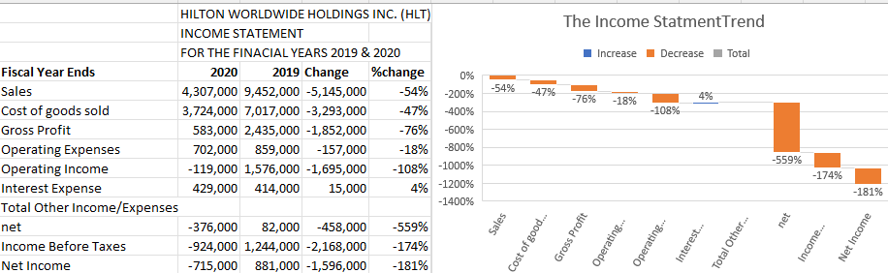
Source: Yahoo Finance, Hilton Worldwide Holdings Inc. (HLT). 2022
Figure 2: The Horizontal Analysis and Trend for Balance Sheet
Balance Sheet 2019 & 2020
2020 2019 Change Change%
Current Assets 4,202,000 2,093,000 2,109,000 101
Non – Current Assets 15,810,000 12,558,000 3,252,000 26
Total Assets 16,755,000 14,957,000 1,798,000 12
Current Liabilities 2,431,000 2,871,000 -440,000 -15
Non – Current Liabilities 15,810,000 12,558,000 3,252,000 26
Total Liabilities 18,241,000 15,429,000 2,812,000 18
Common Stock 3,000 3,000 0 0
Retained Earnings - 6,732,000 - 5,595,000 -1,137,000 20
Total Stockholders Equity -1,490,000 -482,000 -1,008,000 209
Total Liabilities and Stockholders 16,755,000 14, 957,000 1,798,000 12

Source: Yahoo Finance, Hilton Worldwide Holdings Inc. (HLT). 2022
Ratio Analysis
The financial ratios used to analyse the financial position of Hilton Worldwide incorporation, as indicated in figure 3, are liquidity, solvency, efficiency, and the profitability (Warren 25).
The liquidity ratios show the ability of the company to settle all the short-term financial obligations as and when they fall due (Rao 13). The quick ratio analysis shows that between 2019 and 2020, the company had a 114% improvement in its liquidity position while the current ratio which involves the nonliquid current assets like inventory, indicates that the company had a significant increase of 137% in its liquidity position between 2019 and 2020 (Figure 3). The times interest ratio however declined by negative 120% but the overall liquidity position indicates that the company was better off in 2020 than 2019 with regards to its liability position (Alameri 19).
The second category of ratios that is important in determining the financial position of the company is a solvency ratio. These ratios analyse the ability of the company to meet its long-term financial obligations as and when they fall due (Schroeder, Richard, Myrtle, Clark, and Jack 45). The debt-to-equity ratio shows that the company had more debt in 2020 than 2019, thus the decline by 62%; but its overall equity to total assets improved significantly by 176% even though equity itself declined over the two periods. The debt ratio, which determines the overall solvency of the company, increased by 6% indicating that the firm needs to make immediate decisions on how to improve on its debt ratio. It can do this, for example, by reducing its reliance on the long-term debt and encouraging more investors to buy shares.
The efficiency ratios are also important because they indicate the ability of the company to convert total assets or equity into sales (Easton 49). From the efficiency ratios calculated in figure 3, Hilton Worldwide incorporation was more efficient in 2019 than 2020 because both the accounts receivable turnover and asset turnover ratio declined by 25% and 59% respectively (Figure 3). The company should improve these efficiency ratios by working on measures that can improve on the cash conversion cycle, for example, through innovation that would make it easier for customers to settle their bills electronically (Hasanaj, Petrit and Beke Kuqi 17).
That last category that provides a sense into the financial position and performance of the company is the profitability ratios. Profitability is important because it aligns with the profit maximisation and wealth maximisation aims of the company and it is linked directly with the dividend that shareholders get (Easton 18). Decline in profitability ratios therefore indicate poor overall financial performance that could lead to the companies collapse in the foreseeable future. As can be seen from the figure three calculations below, the company's gross profit margin declined by 49% , while its return on assets declined by 172%, and the return on equity declined by 126% (Figure 3). The return on assets and return on equity measure the net income as a percentage of the average total assets and total equity. The calculations in Figure 3 indicate that it is vital for Hilton Worldwide Inc. to make decisions such as increasing the non-current assets and splitting shares to entice more shareholders because as it stands, the company does not generate enough net income from its assets and equity. The decline in the gross profit margin is also a worry to today's stakeholders like the employees whose earnings, in the form of salaries and wages, are redacted from the gross profit.
Figure 3: The Financial Ratios
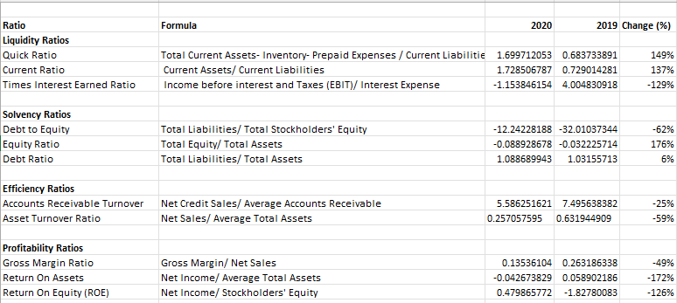
Source: Yahoo Finance, Hilton Worldwide Holdings Inc. (HLT). 2022
b. The importance of using ratio analysis for decision making
The financial ratios help in decision making in many ways. First, financial ratios can be used to validate or disapprove the investment, operating, and financing decisions of a firm because they summarise the financial statements into comparative figures and can help the management to value the financial position of the company (Subalakshmi, Grahalakshmi and Manikandan 4). The second importance is in simplifying the complex accounting statements. The financial ratios breakdown the financial data into simpler ratios which explained the solvency, liquidity, financial efficiency and profitability, and long-term position of the company in a summary form, thus helping to make quick decisions in the business. For example, the financial ratios on liquidity show the overall ability of the company to meet all the short-term obligations as and when they fall due. The other importance of financial ratios is identification of the problem areas within the company which helps in making informed decisions based on clear priority. For example, if a company’s liquidity ratios are above 1.0 while the solvency ratios are poor (below 1.0), this can easily portray that the problem area is on the management of long-term liabilities of the company. The financial ratios can also be used to conduct comparison with other firms or the overall industry, thus helping that organisation to better understand its fiscal position in the in the economy (Nufus 430).
Using financial ratios to conduct financial analysis is also important for planning and future forecasting of the firm. For example, the trend analysis of the financial ratios can help in making critical decisions if tools like excel forecasts are used to predict the changes or possible changes in the next two to three years (Mayes 15). Besides, these ratios can help identify the financial and business risks that face the company and therefore informed decisions to help in countering such risks can be made by the management. There is also specific importance of the financial ratios. For example, the profitability ratios of the company help the management to make decisions about the overall profitability based on their gross profit margin and net income margin while the efficiency ratios help the company to determine its level of operation and the overall decisions surrounding its ability to convert assets and equity into income. The financial ratios are also used to communicate with the external stakeholders who may not have the financial understanding of the complicated statements or the financial literacy to derive specific kinds of information from the financial statements (Alameri 29). For example, the creditors would only be interested in understanding the liquidity position of the company and therefore ratios would be much simpler than having to go through the entire financial statements.
c. The limitation of ratios and why it is important to understand ratios and their fluctuations
Even though ratios are useful in understanding the financial position of a corporation like Hilton Worldwide incorporation, it does have many limitations and is therefore important to understand their fluctuations and such challenges. The first limitation is that it does not consider the size of the business but diverts the attention of stakeholders to the figures only. This can lead to wrong conclusions especially if the users of the financial ratios do not understand the scope of the business or the industry in which the business operates (Mayes 16). The second limitation is that the financial ratios do not consider the contingent liabilities which depends on external factors that may or may not happen such as litigation matters; this implies that financial ratios may be inaccurate should such contingent liabilities happen (Alameri 49). Another limitation of this financial ratios is that they do not incorporate uniform accounting policies because companies reporting depreciation based on straight line method will report different net income from those using declining balance method yet the formula for calculating financial ratios that incorporates net profit remains the same (Kadim, Nardi Sunard and Husain 860). This implies that the financial ratios do not incorporate the impact of accounting policies, thus the comparison of financial ratios between companies that use different accounting policies will therefore be biased. Besides, the financial ratios are susceptible to creative accounting because profitability and liquidity ratios can be significantly affected by slight shift in business model like from LIFO inventory methods to FIFO inventory method.
Considering that financial accounting is historical, the use of financial ratios has the limitation of only relying on historical figures, thus, the information given may not be relevant when a business has changed its model (Easton 27). Besides, the financial ratios do not consider the impact of inflation in the economy and therefore an increase in sales is reported on account of inflation even though in actual sense, the net revenue may have remained constant over the period of analysis. It is also a limiting factor that the financial ratios do not consider the impact of market conditions and fail to capture the impact of seasonality which all affect the financial position of the company. The other limitations of financial ratios are that; they can be used for window dressing, they ignore the price level changes cost by ignoring qualitative aspects of the firm, they do not show solutions to their firm’s problems, and causes the problem of aggregation which does not give a true picture of the overall financial position of a firm (Franklin, Patty, and Dixon 45).

Works Cited
Alameri, Mouza, et al. "Financial Analysis of Hilton Holdings." Available at SSRN (2021).
Easton, Peter Douglas, et al. financial statement analysis & valuation. Boston, MA: Cambridge Business Publishers, 2018.
Franklin, Mitchell, Patty Grayvbeal, and Dixon Cooper. Principles of Accounting, Volume 1: Financial Accounting. 2019.
Hasanaj, Petrit, and Beke Kuqi. "Analysis of financial statements." Humanities and Social Science Research 2.2 (2019): p17-p17.
Kadim, A., Nardi Sunardi, and T. Husain. "The modeling firm's value based on financial ratios, intellectual capital and dividend policy." Accounting 6.5 (2020): 859-870.
Kimmel, Paul D., Jerry J. Weygandt, and Donald E. Kieso. Financial accounting: tools for business decision-making. John Wiley & Sons, 2020.
Linxi, Xu. "The Digital Transformation Strategy of Hilton During COVID-19." 2021 International Conference on Financial Management and Economic Transition (FMET 2021). Atlantis Press, 2021.
Mayes, Timothy R. Financial analysis with Microsoft excel. Cengage Learning, 2020.
Nufus, Khayatun, et al. "Analysis of Financial Performance: Case Study of PT. X Employee Cooperative." Utopía y praxis latinoamericana: revista internacional de filosofía iberoamericanay teoría social 10 (2020): 429-444.
Rao, Peddina Mohana. Financial statement analysis and reporting. PHI Learning Pvt. Ltd., 2021.
Schroeder, Richard G., Myrtle W. Clark, and Jack M. Cathey. Financial accounting theory and analysis: text and cases. John Wiley & Sons, 2019.
Subalakshmi, S., S. Grahalakshmi, and M. Manikandan. "Financial Ratio Analysis of SBI [2009- 2016]." ICTACT Journal on Management studies 4.01 (2018): 2395-1664.
Warren, Carl S., Christine Jonick, and Jennifer Schneider. Financial accounting. Cengage Learning, 2020.
Yahoo Finance, Hilton Worldwide Holdings Inc. (HLT). 2022. Accessed Online from Hilton Worldwide Holdings Inc. (HLT) Balance Sheet - Yahoo Finance
Zeng, Li. "Analysis of Hilton Worldwide Hotel Group’s Transnational Operation Strategy." Academic Journal of Business & Management 3.11 (2021).

