How a school develops one aspect of its SDP: a report that critically reflects on the actions, impact and evidence base

Introduction
A school development plan, sometimes referred to as the school improvement plan, is a working document that plans the actions in place for school improvement (Welsh Government, 2022). The main purpose of school improvement is to aid education settings to give pupils the best learning experiences and outcomes possible no matter their socio-economic background or circumstance, in order to achieve a high standard and aspirations for all (School improvement guidance: framework for evaluation, improvement and accountability. Welsh Government). The school that was researched was an English medium primary school in Wales. The school is made up of 225 students who are between the ages of 3 and 11. The school had a below average free school meals eligibility, but an above average intake of students with additional learning needs (ESTYN, 2022). There are reported to be no students who speak Welsh at home. Within the school’s development plan there were four goals presented. These are:
- To improve standards in Numeracy, with a focus on reasoning.
- To enhance pupil voice opportunities within the school.
- To further develop robust monitoring processes to include effective assessment, with a focus on the five principles of progression.
- To continue to support all groups of learners, in line with the Additional Learning Needs transformation.
(Halfway Primary School SDP, 2023)
This research focuses on the point “to enhance pupil voice opportunities within the school”.

Literature review
School development is the use of strategic planning to create positive change towards a school’s vision. Strategic planning has been defined as the analysis of a school, the environment, and the formulation of a set of key strategic objectives to enable a school to realise its vision (Davies & Ellison, 1997). The school development plan and strategic planning of a school is evaluated during Ofsted and EYSTN inspections, however what these evaluative organisations define strategic as being, unfortunately has not been defined in their inspection guidelines (Bennett et al, 2000). When creating a school development plan it is important to identify the stakeholders involved with the vision of the school. A stakeholder is a person, group, or organisation who have an interest in the decision making and the activities of an organisation (Barney, 2023). The stakeholders involved in the school development planning process can be those within the school environment, such as teachers, higher management, and students, or those outside of the school environment such as the governors, parents, and county council representatives. It is important that everyone is considered when implementing change within the school environment and that the school development plan incorporates the voice of all involved. It is key that a school develops a collaborative work culture in order to sustain the improvement of the school (Hopkins et al 1994). In order to become an organisation that provides a quality education for its students, a school needs to focus on development. There is to be a priority for schools to develop through the utilisation of the available manpower of an organisation and strategic planning (Yikici & Altinay, 2018)
However, it is argued that as the educational environment is becoming more complex, the solution cannot be detailed school development plans and that with the new demands of the environment, so should come new solutions. Davies and Ellison (1998) have proposed a new system that they state will allow schools to respond to current demands without overburdening them with having to develop “more and more detailed planning matrices”. Mintzberg (1994) pegged the term “strategic planning” to be considered an oxymoron that prevents strategic thinking. Davies and Ellison (1998) believe that strategic planning is only effective when it comes to predictable and controllable elements within the planning processes. With the new expectations on schools, it may not be rational to expect predictability with the new dynamic environment we are in. It has been suggested that strategic planning concerns maintaining a strategic fit that emphasises “trimming ambitions to match available resources” (65), or “leveraging resources to reaching seemingly unattainable goals”. A growing number of research is coming to light to suggest that this approach to strategic planning is revealing more “about todays problems than tomorrows opportunities” (Hamel and Prahalad)(66). Boisot (1995) has identified four basic types of response that examine strategy and the inability to have control within the rapidly changing environment. It is suggested that in order for strategic planning to be successful the organisation needs to assume there will be turbulence. Due to this it has been suggested by Davies and Ellison (1998) that school planning needs to happen over a longer period than the current 1-2 years, and instead extend over 5 years in order to have time to plan for turbulence and changes in plans. This strategy is a similar concept as that proposed in Mintzberg’s emergent strategy, which allows the blurring of lines between planning and strategy.

Developing an action point
A school needs to be dynamic to the needs of the stakeholders within its network (MacGilchrist et al, 1995). Schools will prioritise a select amount of development points in each plan (Hargreaves et al, 1989), as discussed previously, the school whos’ development plan is being examined was able to identify four points to focus on. These four points are all equally as important as the others and are only numbered for ease of organisation and reading (School Deputy Head, 2023). As shown in the diagram below, in order to create a school development plan the organisation must first have a vision of the next steps in developing the education setting. Visions for the school can be created through new legislation, such as the Additional Learning Needs transformation which is requiring schools to create Individual Development Plans and Individual Behavioural Plans for students (Welsh Government, 2022). Another way in which a school vision can be introduced in through external assessment, such as ESTYN reports.
The organisation researched has recently had their latest ESTYN report which highlighted their goal to improve standards in numeracy and to develop more effective assessment (ESTYN report, 2022). Lastly, staff can self-evaluate through the use of assessment for learning, learning walks, or team reflection. This will then lead to planning and making changes to practice. Self-reflection is continuous throughout the process of implementing change in order to monitor the effectiveness of the changes. Research has shown that “effective self-evaluation will emphasise the importance of effective self-evaluation being focussed on evaluation for improvement, rather than to satisfy external accountability.” This means that school improvement should be motivated by their values and their responsibility to create an environment that promotes student learning. Organisations should not be pressured or motivated by external factors, such as competition between institutions. It is also important that staff see self-evaluation as a meaningful practice to create organic improvement within the school, rather than an audit of their practice (Llwyodraeth Cymru, 2022)
.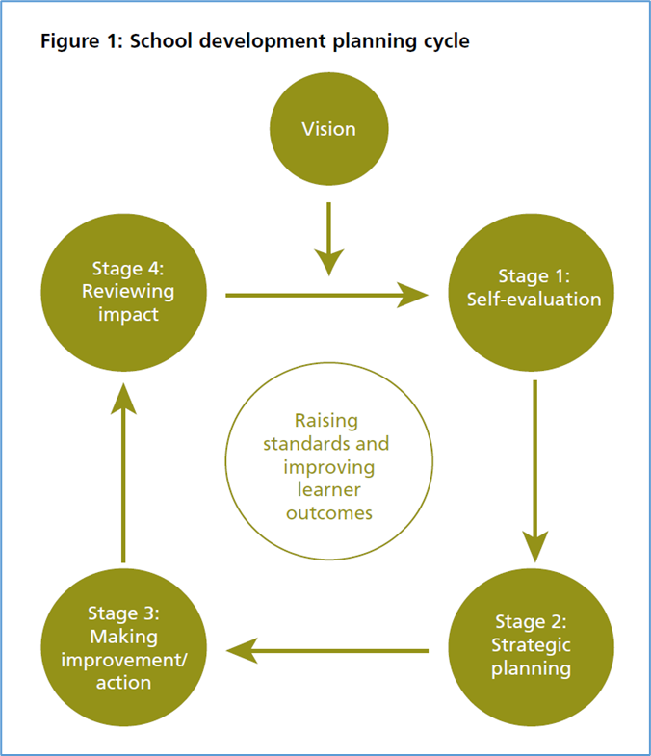
Once the organisation has evaluated their progress towards achieving and implementing their vision, strategic planning can commence. The strategic planning can be seen within the School Development Plan. All plans for evaluation, monitoring, and new action points will be documented, and the school development plan will also mention which staff members are taking the lead for different priority points throughout the year. This is then implemented and edited throughout the year to see the progress made on each point throughout the year.
The way in which a school undertakes the development of its school development plan has been suggested to be a mirror of its culture (MacGilchrist et al, 1995). It is argued that staff need to be involved and feel ownership over the school development plan in order for this to be successful. The importance of staff involvement in the school development plan was researched by Bennet et al (2000), and it was found that in schools where the school culture was more divided and staff were less involved in the planning and instead delegated to, these schools did not implement their vision as effectively. This was seen to be because staff did not feel confident in their knowledge of the plan, or why the points were being chosen to be implemented and were instead following the vision blindly, by using their own interpretation. Another issue that was explored by Bennet et al (2000) was the question of whether school need long term goals or if these are a hinderance to the dynamic nature of a school, especially schools in areas of high deprivation. It was decided that the use of a school development plan is a dynamic way in which schools can react to its stakeholders and environment and change priorities where needed.

Reflection and evaluation
In order to implement this action point, the school has been creating opportunities for students to be heard in various parts of their educational journey. Students have completed the Emotional Literacy questionnaire, which showed that although a high percentage of students had a positive perception of school, this percentage was lower than the previous years score (reference for the emotional literacy review). Due to this, wellbeing has been made a focus for the school moving forward. Students are going to complete their PASS and bully buster survey, this will help the organisation gage more on student wellbeing and attitudes towards school.
Within the classroom, the school has also introduced “Everyone Plans in Class”. This will give all learners a chance to decide on the context for learning. This will be implemented through discussions and KWHL grids, KWHL grids focus on “what I know”, “what I want to know”, “how I will find out”, and “what I have learnt” (School Development Plan, 2023). The school is aiming to focus on the “H” so that students can discuss how they would like to learn and what learning styles work best for them. By engaging students in the learning and how to learn, it is hoped that not only wellbeing will be increased but also student achievement. This can be seen to link to the four purposes, through being ambitious capable learners who can explain ideas and concepts they are learning about and who set themselves high standards and seek and enjoy challenges (Welsh Government, 2022).
Outside of the classroom environment, the school has also introduced learner groups in order to enhance student voice in various areas. The school provides a Digital Learners group, which aims to promote online safety within the school. The Eco school group, which provides learners the ability to be a part of creating a school that is ethically informed. Criw Cymraeg promotes the usage of the Welsh Language within the school, and allows students to learn about and promote their heritage throughout the school. The Healthy Schools group meet up in order to come up with ideas on how to promote healthy lifestyles to those in school. Lastly, there is a school council who meet up and discuss various issues and policies that come up within the school (School development plan, 2023). These groups were disrupted due to Covid-19 causing all meetings to be online or in Covid bubbles, this meant that student voice opportunities were lessened. However, this academic year has seen the continuation of the regular in person group meetings, which aims to improve the student voice within the school. Students within these groups are able to influence decisions and activities for the group, such as helping create child friendly policies and coming up with group mascots (Conversation between Kyla Greenwood and Deputy Head)
The school has created a concise method that can be seen implemented throughout the school and throughout the learner’s education journey. Learners are able to have their voice heard both within the school and through networking opportunities outside of the school. In order to further enhance student voice and wellbeing, the school could use Maslows Hierarchy of Needs (Maslow, 1987).
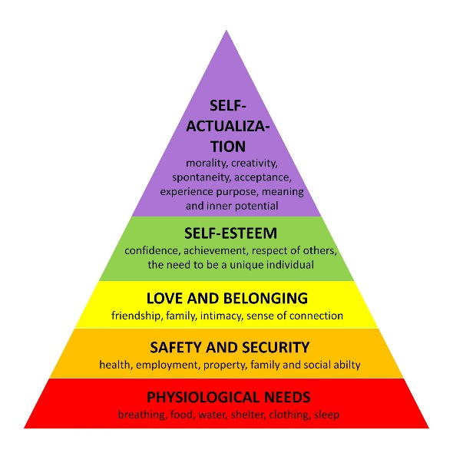
Student voice can cover various parts of this model, such as gaining safety and security through the use of emotional literacy surveys, or love and belonging by creating a sense of connection and belonging within groups in the school. Students self-esteem can go through students being able to feel confident enough to give their opinions and feel like a valued unique household. However, although student voice can help students reach self-actualisation throughout the fulfilment of needs further down the pyramid, it is important to note physiological needs, which need to be fulfilled before someone is able to prioritise needs higher in the pyramid. Due to the cost of living crisis and the Covid-19 pandemic, a growing number of students will be worried about having food available, having their clothes ready for school and having a stable home to go home to (Student Minds, 2023).

Conclusion
To conclude, this research has showcased the importance of being a reflective practitioner who self-evaluates their practice, alongside having a clear plan on how to meet a goal (Smyth, 1989; Shandomo, 2010). A whole school approach to change (Poulou, 2007) is an essential part of an educational setting creating necessary alterations to the school environment. Due to this it can be seen as fundamental that all practitioners are up to date with the school development plan and what the long and short term aims for the school are. Alongside this, this research also shows the importance of student voice within the school. When students are heard and able to influence their environment, they will grow into more confident adults, and engage more in their studies. Lastly, it is important to be aware of the socio-economic standing of the students that are being taught in the school as the needs they are hoping to fulfil are going to be different to the needs of those who are able to have their food and shelter needs met. Going forward, practitioners should not only reflect on the goals stated on their school development plan but also focus on ensuring that students feel safe to be themselves and be heard when giving their opinion.

References

Broadhead, P., Cuckle, P., Hodgson, J. and Dunford, J., 1996. Improving primary schools through school development planning: Building a vision, exploring the reality. Educational Management & Administration, 24(3), pp.277-290.
Conversation between Kyla Greenwood and deputy headmaster of Halfway Community Primary School, 2023
Davies, B., 1998. Strategic planning in schools: An oxymoron?. School Leadership & Management, 18(4), pp.461-473.
Halfway Community Primary School, School Development Plan, 2023
Hargreaves, D.H. and Hopkins, D., 1994. Development Planning for School Improvement. Cassell, 387 Park Avenue South, New York, NY 10016-8810 (hardback: ISBN-0-304-33101-5; paperback: ISBN-0-304-33103-1)..
Lewis, W.A., 2004. Development planning. Routledge.
Llwyodraeth Cymru (2022) School improvement guidance: impact assessment
Maslow, A. and Lewis, K.J,. 1987. Maslow’s hierarchy of needs. Salenger Incorporated, 14(17). Pp 987-990.
Poulou, M. 2007. Social resilience within a social and emotional learning framework: The perceptions of teachers in Greece. Emotional and Behavioural Difficulties, 122: 91–104.
Shandomo, H.M., 2010. The role of critical reflection in teacher education. School-University Partnerships, 4(1), pp.101-113.
Smyth, J., 1989. Developing and sustaining critical reflection in teacher education. Journal of teacher education, 40(2), pp.2-9.
Student Minds. (2023) Cost of living, Student Minds. Available at: https://www.studentminds.org.uk/cost-of-living.html (Accessed: April 10, 2023).
Welsh Government,. 2022. Written statement: Aln reform in Wales, GOV.WALES. Available at: https://www.gov.wales/written-statement-aln-reform-wales (Accessed: April 13, 2023).
Yıkıcı, B. and Altınay, F., 2018. The importance of strategic planning and humanpower in school development. Quality & Quantity, 52, pp.509-520.

