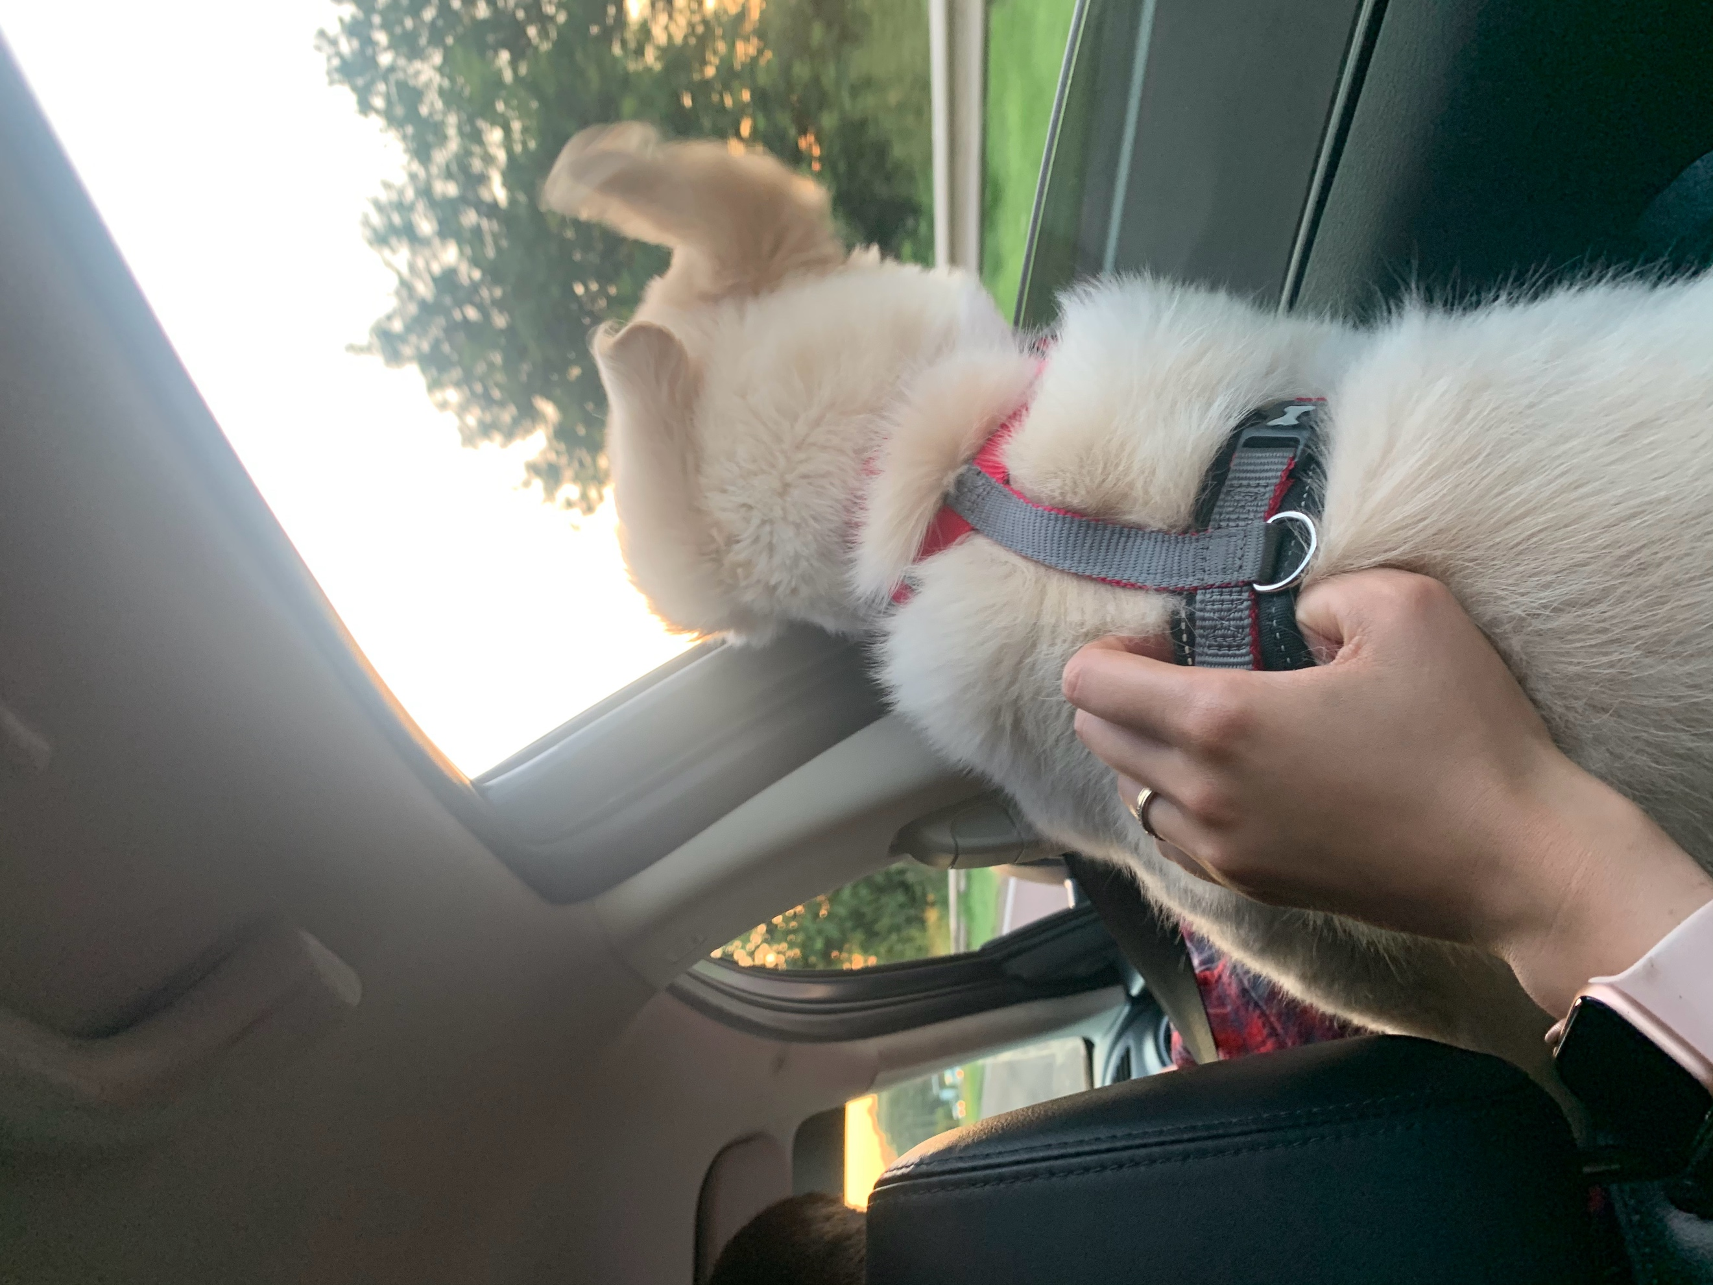  Project Management Plan  Uber Pets | Module code: BMSW 5104- Managing Projects in the Workplace  Bianca Suleap (1918286)  Lecturer name: Daminabo Pokubo

Table of Contents
Introduction: 1
Project-what it is: 1
Project management- what it is: 1
Stakeholder analysis: 2
Stakeholder analysis applied to Uber Pets: 2
Work Breakdown Structure (WBS) 3
Uber Pets- Work Breakdown Structure 4
Costs/resources use: 5
Gantt Chart: 6
UBER PETS GANTT CHART: 7
Project Network 7
UBER PETS PROJECT NETWORK: 9
Why is UBER PETS using a Project Network? 12
Risk Assessment: 12
Risk Assessment-UBER PETS: 12
Conclusion: 14
1. Bibliography 15

Project Management Plan
Uber Pets

Introduction:

This report's objective is to introduce a new, necessary product to the market. This is an expansion of the Uber App, entitled Uber Pets. Why Uber Pets? There are currently a few businesses offering pet taxi services, but the most of them have received negative reviews due to a lack of drivers, poor customer service, or employers who lack the funds necessary to build their businesses and provide poor services.
Uber is already willing to invest in a new project, and it has the funds and skilled personnel to make it a success.

“Project success is measured as the ability to complete the project according to desired specifications and within the specified budget and the promised time schedule, while keeping the customer and stakeholder happy.” (Globerson & Zwikael, 2002). Both project planning and project execution must be correctly executed for the project to be successfully completed.

Our team created a project management strategy to assist you in comprehending why mankind needs this app and why it is the smartest new product that Uber could offer.
The project Management team examined every part of the project, stakeholder analysis, the work breakdown structure, costs of the project, a project schedule and the risk assessment.

Project-what it is:

A project may be characterised as a collection of tasks that have a strongly outlined beginning and finish. Here are also included the tasks that are not repetitive, that are subject to resource limits, and culminates achievements at the conclusion. These tasks are processes that must be accomplished in order the project to be considered successful. Time, money, personnel, and materials are all examples of resource constraints. It is impossible for a project to be duplicated since the final service or product given is always distinct from any other.

Project management- what it is:

Project management is the procedure of organising, prioritising, and controlling processes and resources in order to achieve a set goal within the restrictions of time, resources, and budget. Depending on its complexity, a project plan may be as basic as a list of jobs with their start and completion dates scribbled on a piece of paper, or it can be as complicated as one including an enormous numbers of activities and resources and a requirement of millions for the budget.

Stakeholder analysis:

A stakeholder analysis is conducted with the goal of determining who is investing in the organisation and what importance the organisation has for them. As part of a stakeholder analysis, the company will be able to identify the groups of people that have a stake in the success or failure of their firm. When it comes to using stakeholder analysis in the disciplines of policy development, management, and project implementation, it has evolved into a tool or a combination of tools with a variety of goals in its application.

Using stakeholder analysis in project management, organizations will raise the probability of project success by guiding their concepts, planning, and execution, or by using it as part of an assessment process before, through the process, or after the project is completed.

Stakeholder analysis applied to Uber Pets:

The analysis will be conducted by the analysis team. Since perspective is essential, especially when it comes to qualitative data analysis and quantification, a collaborative approach may result in a more accurate analysis.

Table 1
Stakeholders/  Authority | Description of the stakeholder | How will the Stakeholder contribute to the project? | Influence | Impact
Travis Kalanick-  Founder | He is the most important advisor for Uber, he is the one who approves the new strategies within the company.  When it comes to corporate money, he is the first person who comes to mind. | He will provide his approval to all revisions to the project as well as any new recommendations that are made to go along with the project ’s objectives.  During the project, he will validate any financial adjustments, as well as any financial choices that are made. | High | High
Dara Khosrowshahi-  CEO | The CEO is one of the primary advisors on the project. | The financial measures recommended by the project manager are approved by the CEO and the rest of the management team. | High | High
Project Manager | Creates a proposal of the project management plan and presents it to all the stakeholders. | Monitors all project processes and provides updates to the project's overall management at each of the project's major milestones. | High | High
Project Management Team | They have a critical impact on the project management plan as the project management team are the ones who carry out the project’s plan. | They execute the project manager's instructions and confirm that the project management plan is followed while implementing the project's strategy. | High | High
Uber Pets  Drivers | They're a key player in putting the project's new plans into action. | Drivers will be employed to carry out the plans, and as such, they are required to market the business's strong reputation. | High | High
Uber Pets  Customers | Customers are the driving force behind the program's development. | During the project's implementation stage, customers will offer feedback on the final result. | High | Medium
IT Department  Team | It Department has a major impact on the project development as they are the ones who are creating the new app. | The IT department must create the interface of the app, to develop a new Logo for the app | Medium | High

Work

Work Breakdown Structure (WBS)

“WBS is used to describe the scope of the project, increase estimates, control project implementation and also to ensure project completion more accurately. “(Supriadi, et al., 2018) The work breakdown structure is a hierarchical framework used to divide down a large project into manageable sections. The construction of a work breakdown structure (WBS) is the responsibility of the project manager.

There are three reasons to adopt a work breakdown structure (WBS) in business projects. The first reason is that WBS aids in more carefully and precisely defining and organising the project's scope. The second reason to use a work breakdown structure (WBS) in business projects is to aid in the assignment of roles, distribution of resources, supervision, and management of the project. The third reason is that using a work breakdown structure (WBS) provides for more accurate cost, risk, and time estimation since the project management can work their way up from the level of the individual jobs to the level of the whole project. (Devi & Reddy, 2012)

Uber Pets- Work Breakdown Structure

Table 2
PROJECT | PHASE | TASK
 | - INITIATION | 1.1.1. Create the project plan  1.1.2. Submit the project plan  1.1.3. Project plan approved.
UBER PETS | - PLANNING | 1.2.1. Determine the scope of the project  1.2.2. Form the Project's Team  1.2.3. Plan Team Meetings  1.2.4. Create the project plan  1.2.5. Setting up a budget  1.2.6. Deliver the project's plan  1.2.7. Obtain the necessary approvals for the project plan.
 | - EXECUTION | 1.3.1. Monitoring on the progress of the project on a regular basis  1.3.2. Designing the app  1.3.3. Action plan for the system  1.3.4. Testing the app  1.3.5. Designing the interface requirements of the system  1.3.6. System configuration
 | - CONTROLLING | 1.4.1. Completion of implementation  1.4.2. Risk Management  1.4.3. Update project management plan.
 | 1.5. Closing | 1.5.1. Maintenance of the system  1.5.2. System’s testing  1.5.3. Creating accurate test plans  1.5.4. Creating a training strategy  1.5.5. Applying training strategy

Costs/resources use:

Defining the scope of the project from the beginning is an effective method of outlining the project aspects and ensuring consistency and stability with the project goals. As a project manager, completing projects on schedule, within budget, and with the desired quality is a major challenge.

The Uber Pets app is the major focus of the company's strategy. The project management team estimates an hourly rate of £16 based on the estimated costs of developing an app like Uber Pets. The Uber Pets app is projected to have a development cost of over £400000 due to the program's complexity and user feedback. A budget of more than £500000 has been set aside to cover any risks and uncertainties that may arise throughout the course of the project.

Gantt Chart:

“Projects are economically important, both as direct value-earners and as means of carrying out organisational change.” (Maylor, 2001) There is a perception that Henry Gantt's performance bar charts have been given a breath of fresh air by integrating them with a feeling of certainty, regardless contradictory evidence.
The Gantt chart is among the most commonly used instruments for project planning and management in today's world (WBS) is a hierarchical division or fragmentation of a project or significant activity into consecutive levels, with each level being a tighter reduction of the previous one. The work breakdown structure (WBS) is the foundation for most of project planning. Gantt charts are excellent for showing progress on projects by showing how long things will take. This might be a graphic display of previous accomplishments and/or catastrophes but can also represent a display of forecasts for the future in terms of scheduling. Moreover, the use of a Gantt chart encourages the project manager to exercise extreme responsibility for the project instead of sharing responsibilities with the project management team for scheduling the activities.

UBER PETS GANTT CHART:

Table 3

Figure 1

Project Network

When it comes to current engineering project management, knowing how to prepare and implement a plan is a key skill to have. Planning stage in a project becomes represents the primary strategy for mitigating expected risks. The normative procedures and methodologies that are utilised in managing projects have been created in the context of engineering and operations research. (Hellgren & Stjernberg, 1995) are describing the project network as a collection of relationships in which no one actor has the power to serve as the official authority for the whole network. The network is accessible when there are no defined conditions by which the network's boundaries may be recognised and regulated. Furthermore, if the network is temporally constrained, continuously evolving, and rebuilt from one project to another.
Project Network of Uber Pets:

Table 4
UBER PETS PROJECT NETWORK:  Project | Sub-activity | Sub Sub-activity | Number of weeks
Uber Pets | 1.1. INITIATION | A- Create the project plan | 24
 |  | B- Submit the project plan | 2
 |  | C- Project plan approved | 2
 | 1.2. Panning | D- Determine the scope of the project | 3
 |  | E- Form the Project's Team | 4
 |  | F- Plan Team Meetings | 3
 |  | G- Setting up a budget | 2
 |  | H- Deliver the project's plan | 1
 |  | I- Obtain the necessary approvals for the project plan. | 1
 | 1.3. Execution | J- Monitoring on the progress of the project on a regular basis
 |  | K- Designing the app | 16
 |  | L-. Action plan for the system | 4
 |  | M- Testing the app | 20
 |  | N- Designing the interface requirements of the system | 8
 |  | O- System configuration | 10
 | 1.4. Controlling | P- Completion of implementation | 10
 |  | Q- Risk Management | 12
 |  | R- Update project management plan. | 8
 | 1.5.Closing | S- Maintenance of the system | 4
 |  | T- System’s testing | 12
 |  | U- Creating accurate test plans | 2
 |  | W Creating a training strategy | 10
 |  | Y- Applying training strategy | 5

In this table every Sub Sub-activity has a letter as a symbol to facilitate a better understanding of the following table and diagram.

Table 4
Activity | Predecessor | Duration(weeks)
A |  | 24
B | A | 2
C | A, B | 2
D | A | 3
E | B, C | 3
F | E | 4
G | A | 3
H | C | 2
I | H | 1
K | A | 1
L | I, K | 16
M | K, L | 4
N | I,M | 20
O | M | 8
P | O | 10
Q | O. P | 12
R | Q | 8
S | P | 4
T | S | 12
U | T | 2
W | O,P | 10
Y | W | 9

Table Project Network 2:

This table illustrates the letter corresponding to each activity, the predecessor of the activity and also the duration( weeks) of each activity.

Figure 2
F

E
B
B

START
H
I
L
C
A

D

G

N
M

K

U
S
T
P

O

R
Q

Why is UBER PETS using a Project Network?

A project network serves as a foundation for planning equipment and staff of the Uber Pets project. It also serves as a foundation for budgeting and cash flow management. A project network will display actions that are vital to the network's operation and will also identify actions that cannot be postponed without causing a stoppage in the network's operation.

Risk Assessment:

Almost every element of life entails some level of danger. How individuals respond to danger is highly dependent on their level of understanding it. In their work (Mark, et al., 2004) states that risk represents the possibility of difficulties and issues arise while completing a project activity.
Based on (Dikmen , et al., 2008) journal, risk management is concerned with identifying uncertainties, predicting the repercussions of unpredictable actions, developing countermeasures. Finally, depending on real results and hazards identification, the process of risk assessment will continue the identification and evaluation and responses generating processes all through the life cycle of the project in order to guarantee the project's goals are met.

Risk Assessment-UBER PETS:

Table 5
Risk | Importance  Impact | Likelihood  Probability
Energy blackout | H | L
Implementation of the new software problems | H | M
Developing the software taking longer than expected | M | M
Software evaluations are a failure. | H | L
Not having enough IT engineers | H | L
Project Manager Team Member Resigns | H | M
Unclear Communication | H | L
Delays | L | H
Founds unavailable | H | L
Exceeding budget | M | M

There are three categories in this table: risk, importance/impact, and likelihood/probability. Three degrees of importance and influence are classified under the Importance and Impact category: H(high), M(medium), and L(low) (low).

Table 6
Risk | Impact | Probability
R1 | 3 | 2
R2 | 2 | 2
R3 | 3 | 1
R4 | 3 | 1
R5 | 3 | 2
R6 | 3 | 1
R7 | 1 | 3
R8 | 3 | 1
R9 | 2 | 2

The risk assessment table contains the risk factors, their impacts on the project (where 1 represents a low risk, 2 represents a medium risk, and 3 represents the greatest risk), as well as the probability that the risk will manifest within the project.

Risk Assessment Chart:

Figure 3

Conclusion:

Project planning is critical in guiding stakeholders, investors, departments, and also the project manager through the many stages of a project's lifecycle. Planning is required in order to establish set outcomes, eliminate risks, prevent schedule delays, and, eventually, provide the agreed-upon item, function for the customer.
The Uber Pets plan project will need a Stakeholder Analysis, a Work Breakdown Structure, an examination of the Cost/Resources Planning, a Gantt Chart, a Project Network, and a Risk Assessment in order to
function successfully.

Bibliography

- Cerezo-Narvaez, A., Pastor-Fernandez, A., Otero-Mateo, M. & Ballesteros-Perez, P., 2020. Integration of Cost and Work Breakdown Structures in the Management of Construction Projects. Applied Sciences, 10(4), pp. 1-33.

- Coyne, C., 2016. Benefits of a Stakeholder Analysis. The Membership Management Report, 12(4), p. 8.

- Devi, T. & Reddy, V., 2012. Work Breakdown Structure of the Project. International Journal of Enjeneering Research and Applications, 2(2), pp. 683-686.

- Dikmen , I. et al., 2008. Learning from risks: A tool for post-project risk assessment. Automation in Construction, 18(1), pp. 42-50.

- Gambrill , E. & Shlonsky, A., 2000. Risk Assessment in Context. Children and Youth Services Review, 22(11), pp. 813-817.

- Geraldi, J. & Lechter, T., 2012. Gantt charts revisited A critical analysis of its roots and implications to the management of projects today. International Journal of Managing Projects in Business, 5(4), pp. 578-595.

- Globerson, S. & Zwikael, O., 2002. The Impact of the Project Manager on Project Management Planning Processes. Project Management Journal, 33(3), pp. 58-65.

- Hellgren, B. & Stjernberg, T., 1995. DESIGN AND IMPLEMENTATION IN MAJOR INVESTMENTS A PROJECT NETWORK APPROACH. DESIGN AND IMPLEMENTATION IN MAJOR INVESTMENTS , 11(4), pp. 377-394.

- Kumar, P. P., 2005. Effective Use of Gantt Chart for Managing Large Scale Projects. a Publication of the American Association of Cost Engineers. Cost Engineering, 47(5), pp. 14-21.

- Mark, W., Cohen, P. E. & Glen, R. P., 2004. Project Risk Identification and Management. AACE International Transaction.

- Maylor, H., 2001. Beyond the Gantt Chart:Project ManagementMoving on. European Management Journal, 19(1), pp. 92-100.

- National Research Council, 2001. Science AND DECISIONS Advancing Risk Assessment. 2nd ed. Washington: The National Academies.
- Nieto-Morote, A. & Ruz-Vila, F., 2010. A fuzzy approach to construction project risk assessment. International Journal of Project Management , 29(2), pp. 220-231.

- Semour, T. & Hussein, S., 2014. The History Of Project Management. International Journal of Management & Information Systems, 18(4), pp. 233-240.

- Supriadi, L. S. R., Wiesesatama, B. & Latief, Y., 2018. Development of work breakdown structure (WBS) dictionary for road construction works. IOP Conference Series: Earth and Environment Science, 195(1), pp. 1-8.

- Xia, L., Wen-ping, W., Sui-cheng , L. & Yi , S., 2006. The Discussion on the Network Plan Technique That Is Used to Arrange Duration of Project. 2006 International Conference on Hybrid Information Technology , 1(1), pp. 569-572.

- Zsuzsa, V. & Ruairi, B., 2000. A stakeholder analysis. Health Policy and Planning, 15(3), pp. 338-345.

