eCommerce

(M5X01030)

Assignment 2 - Report

Lecturer: Susan Maw

Riaz Khan – P150731

Contents
1. Introduction 3
2. Website Design Tools 3
2.1. Wix Website 6
3. Monetary Transactions 12
4. Marketing Metrics 14
5. Conclusion 15
6. References 16

Introduction
Emrys Plum, a local plumbing engineer, three years ago decided to start his own business which he named ‘Plumrite’. With the help of his son and daughter they were able to complete small jobs. Since then the business has grown rapidly and now employs six additional workers and also a part time office administrator.
With the rapid growth of the business Emrys is finding it difficult to keep up with some of the work that has been booked. Emrys feels that a new computer-based system is the solution to this problem. At the moment the businesses use a standalone computer to keep up with orders of stock, invoices, and scheduling of work, all of this work is done manually. The writer feels that the implementing a new computer system would be a very good idea. With the increased demand of work, it would be in the best interest of Plumrite to start using a new system. Bringing in a new system can increase productivity as scheduling can be done faster, stock can be organised more neatly, and invoices can also be sent and received in a timely manner. The new system can also motivate the admin staff as it is something new to learn since joining the business. The only downside to this is that the set-up cost may be expensive, and someone would need to be hired to maintain the system. Emrys’ daughter has offered her time to work on the proposed new system.
Along with the new administration system Emrys is also considering other ideas such as an e-commerce site. This site would be used to provide information to viewers such as products and services available, times of operation, background of the business and additional information such as reviews and contact information. The writer has been asked to create an e-commerce site which will fulfil all of the said needs, the site will also include e-payment so that customers can be straight from the website.

Website Design Tools
To build the e-commerce site the writer has a number of options to choose from. There are many site building tools online that are free to use and he also has the option to write his own code. To help him decide what he will use to create the e-commerce site the designer will evaluate some of the options available and then using his evaluation will decide what he is going to use.
One tool that can be used is Wix[1]. Wix is an online tool that has no register charge and is free to use. Users can create a free account and make very neat and professional websites by starting from nothing or using the hundreds of templates available.
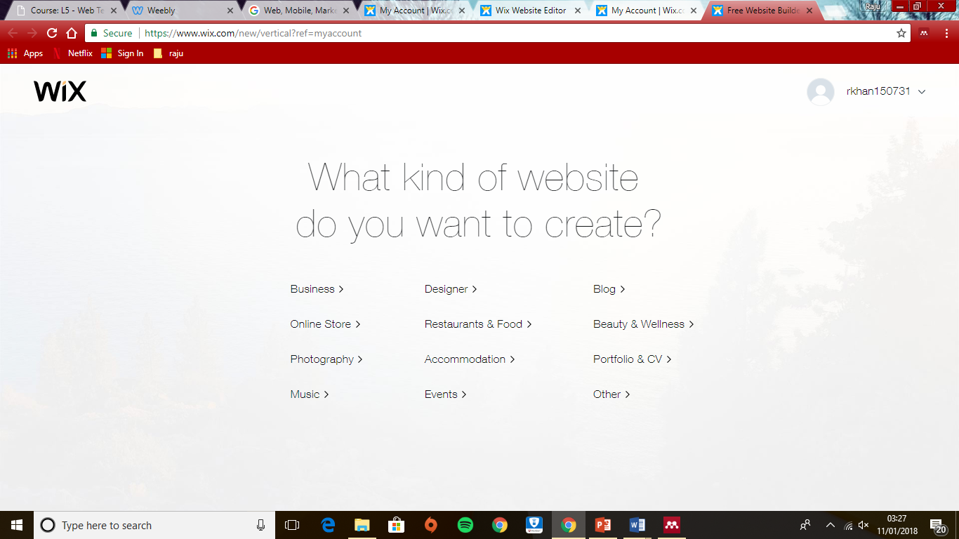

Users also have the options of asking a few questions and have an app called ‘Wix ADI’. This application on the website which is free to use will automatically create the website for the user, once the website has been created the user can then put on the final details. Millions of people around the world use this builder for many different uses such as blogging, online stores, information sites and much more. One advantage is that is very easy to use, and tutorials are available when starting.

Some features such as custom domains and web analytics can only be accessed by upgrading to the premium options which can be inconvenient for those who are starting out and would like to see their e-commerce results with early customers. Another disadvantage to be considered is the mobile view. As well as editing the desktop view, the user would also need to edit the mobile view. This could use up time if they wanted the site to look the same on both platforms.
Another tool that can be used is Weebly[2]. This site builder is very similar to Wix in that it is free to register and use. For businesses who are starting out, this tool would be very useful as it uses a drag and drop editor. Different options are available on the side tool bar which the user can just select and drag to the required page. The site offers over 60 templates to choose from, this can be seen as a low amount to competitors such as Wix and Squarespace.
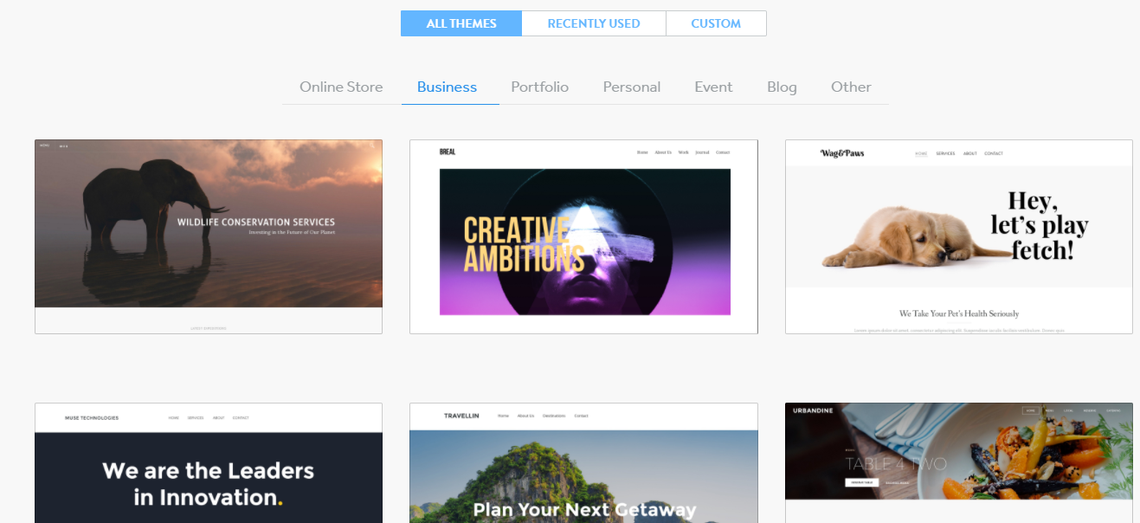
Webcreate[3] tells us that Weebly offers tremendous advantages of creating a store such as:
. Adding store information like name, address, contact details, etc.
. Adding products to the store such as images, details, and prices.
. The store also allows you to set up payment options such as credit/debit cards. PayPal is also available to add. This feature is only available if you upgrade to a paid subscription.
One disadvantage of using Weebly is that a premade template must be chosen. The user does not get the option to start from the drawing board. This may be inappropriate for businesses who are looking to stand out from the competition, many business users use Weebly to create their e-commerce site.
Another option for the designer is to write his own code. Coding is available to use in Wix and Weebly but a software that the writer can use that doesn’t require an internet connection (to design) is Visual Studio.
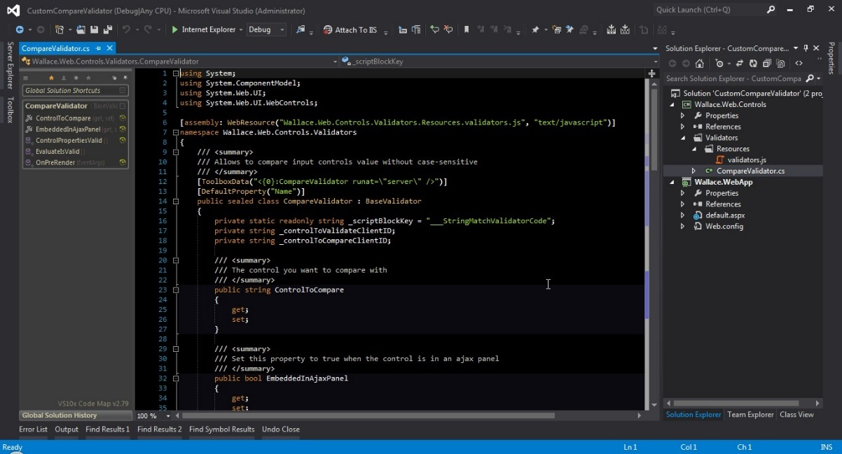
Some advantages of coding are explained in a blog by Hugo Di Francesco, on quora.com[4].
By using your own code, you are most likely going to know how everything works. If a mistake is made while creating a website, then the designer will be able to track back to the last step and look for ways to try and resolve the problem. Updating and maintaining the website will also be easy as the code will not need to be re-arranged, this can also be seen as a cheap option as the only thing you’ll spend money on is the application. No subscription is required to use coding. Although a developer may need to be hired to maintain the site.
If the writer codes the website this means that less problems are likely to occur. As mentioned before, changes will be easy to make, and problems will be easy to solve. There are millions of developers around the world who will have probably done the same thing as you before, if a mistake is made then it has probably been noted down somewhere. Tutorials and documents regarding coding will be vastly available.

Wix Website
After evaluating some tools to create the site for Plumrite, the writer has decided to use Wix. He has chosen Wix because he has previous experience with the site builder and finds it easier to use compared to using Weebly or writing his own code. There are a number of ways that he can create the e-commerce site and a majority of the features for the B2B element are available to use.
On the website the writer has created a welcome page, catalogue page, a contact us page and a review page. He has also added a shopping cart with a debit/credit card payment option for those who would like to buy certain products online for their own use. The writer has chosen only this type of payment for now as Plumrite is only recently establishing themselves online. Once they have gotten used to how things work then they may want to consider adding further payment methods to keep up with trends, try and gain more customers or try increase online viewership in general.

Home page/About us
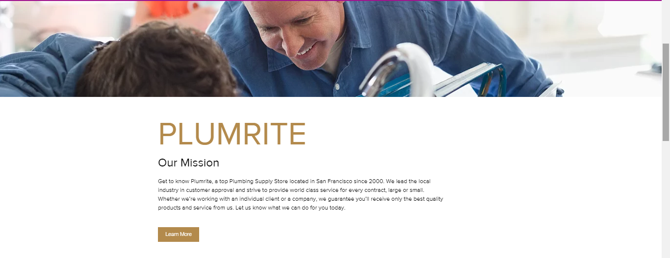
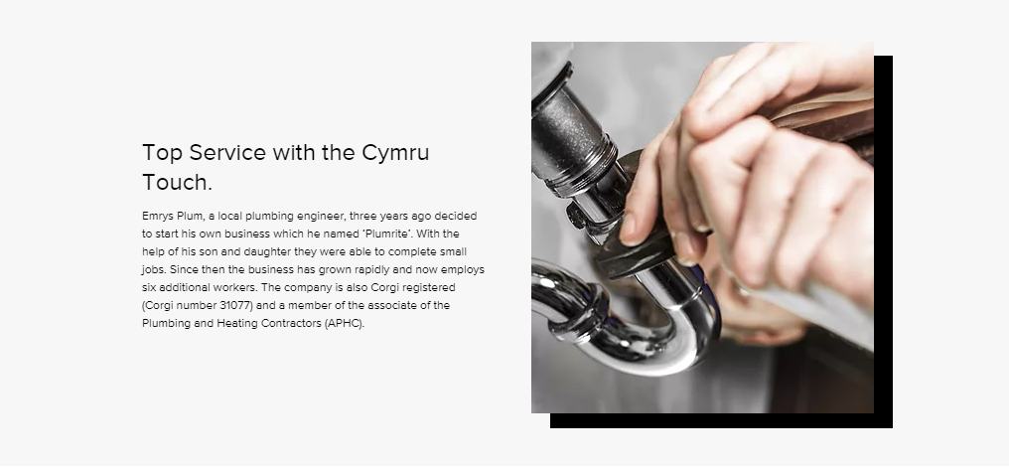
Products Page
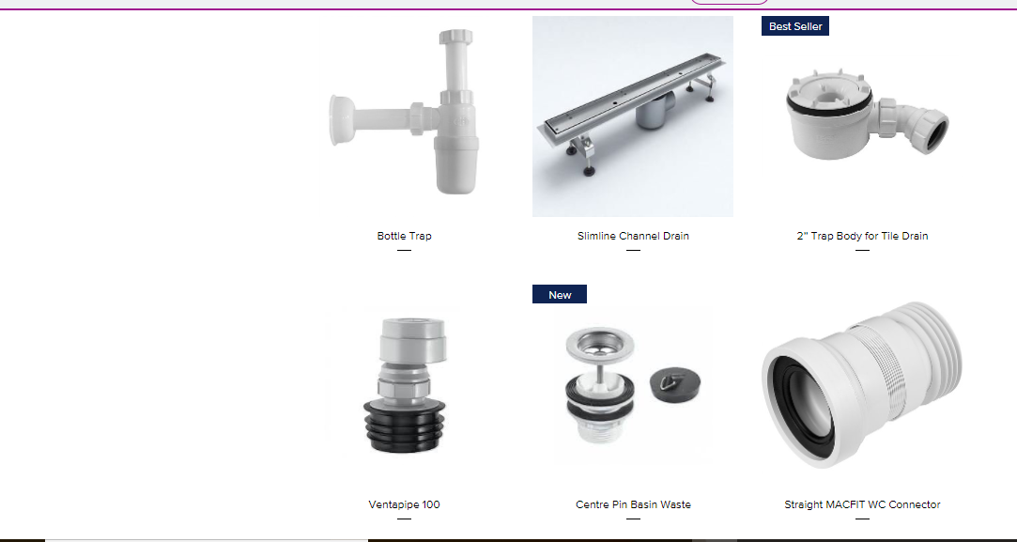
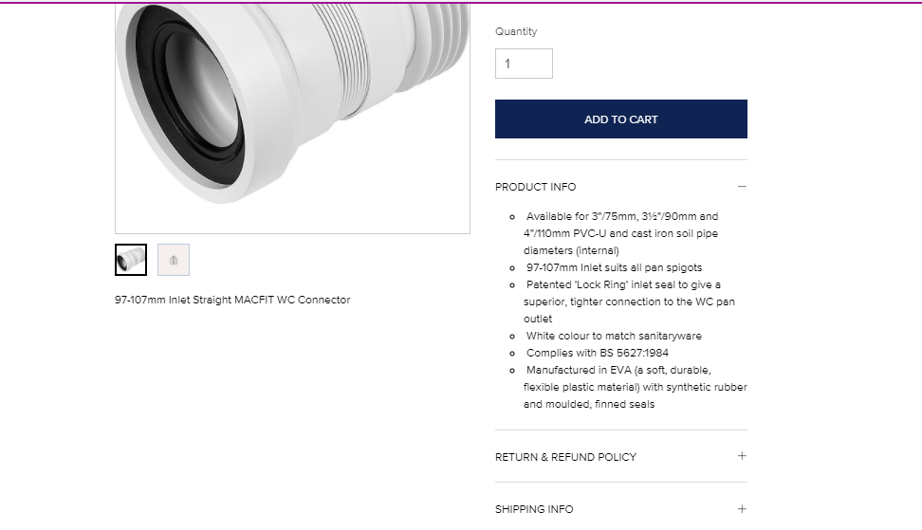
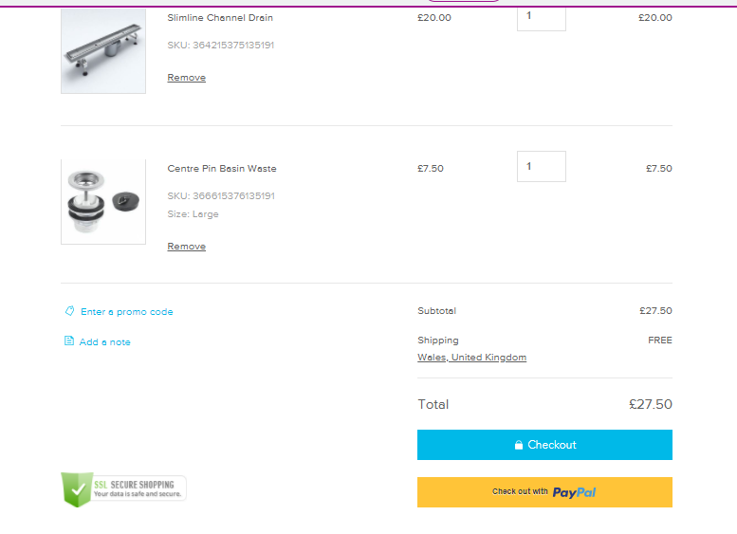

Book Online
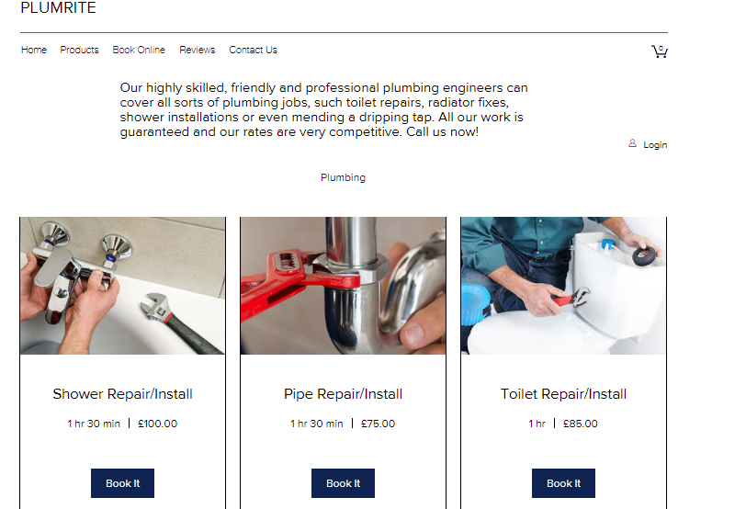

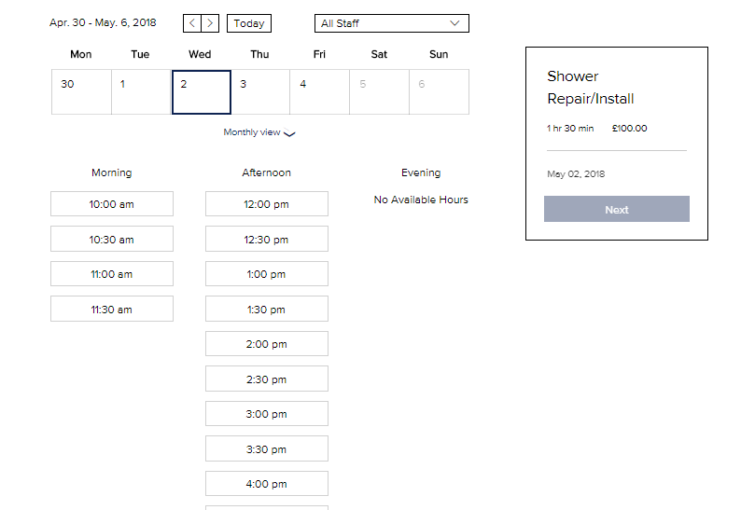
Reviews
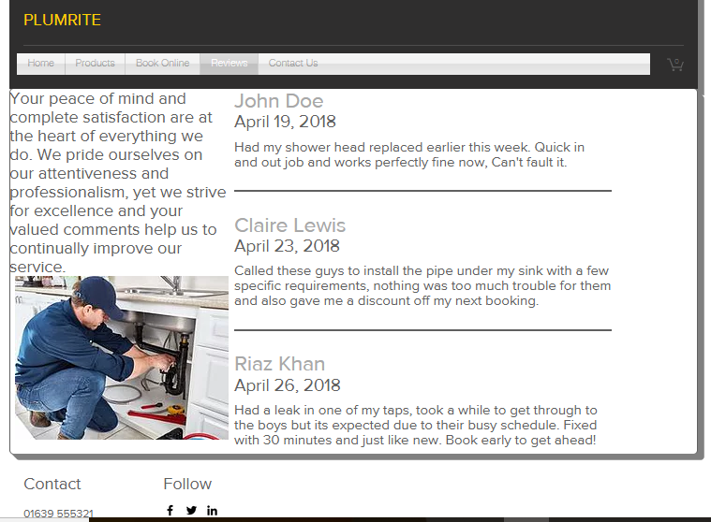

Contact Us
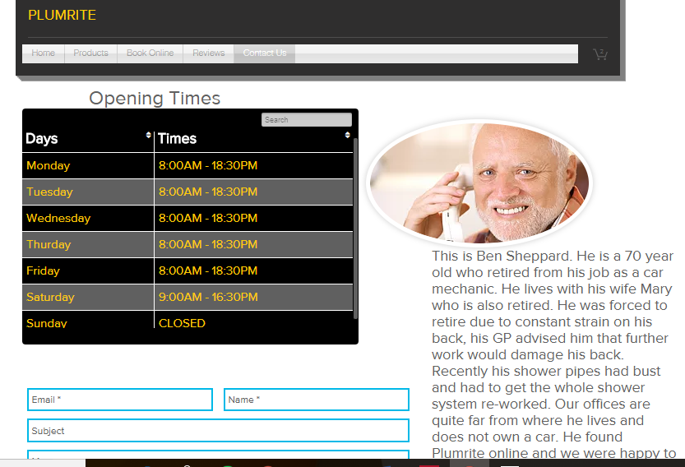
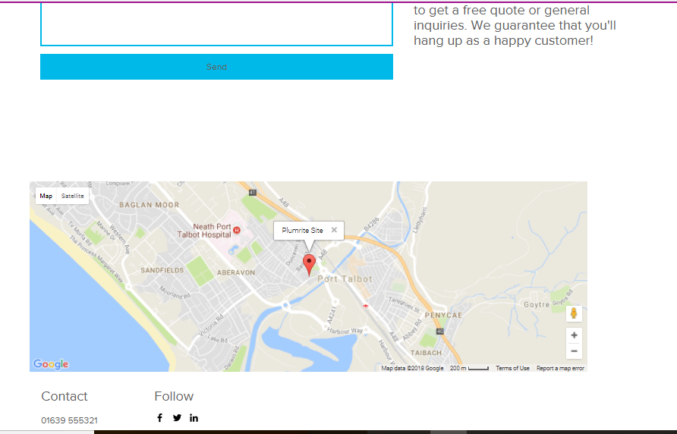

Search Engine Plan
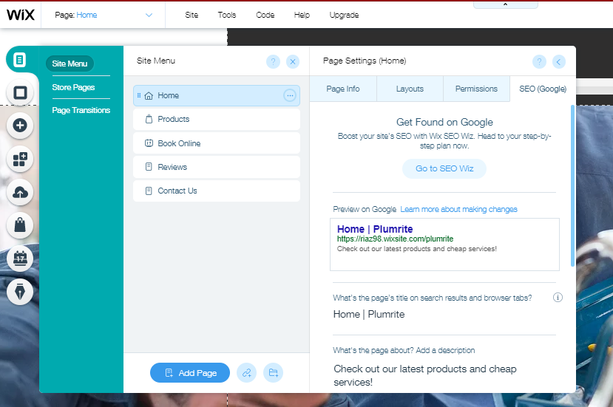
The writer has also edited the search engine optimisation for Plumrite. This way users who are in the area who search for plumbing related terms can have Plumrite on the top of their search results.

Monetary Transactions
As well as using debit and credit card there are also other payment methods that the writer could have used. A blog post on segmentify.com[5] outlines a few payment methods and transaction tools that are used in e-commerce around the world.
The most common type of payment methods in e-commerce are:
Bank transfers: Some e-commerce websites ask their customers to pay for the product or service by bank transfer, this is simply when money is sent from one bank account to another. This method is usually faster and safer than most methods, this is also free to do. Transfers are normally made by using an International Bank Account Number.
E-Wallets: Having an E-wallet is very essential for those who prefer safe and fast transaction. This allows for someone to store many credit cards, debit cards and bank account information in a secure place. Once signed in, payments are made very quickly as all of the information required is already filed in.
Cryptocurrencies: Cryptocurrencies, while fluctuating in value is a rapidly growing interest among people around the world. Many owners of cryptocurrencies spend hours a day on saving and mining any type of crypto currency that they can in the hope that one day it will make some physical cash. With that being said, some business has had to keep up with trends and to do so they have started accepting with currencies such as bitcoin which has become very popular in recent times.
A case study written by a blogger names Kevin suggests that Bitcoin has helped many businesses with online sales. One example that he spoke about was an online booking service called CheapAir.com[6].
Case study taken from thebigcoin.io[7]
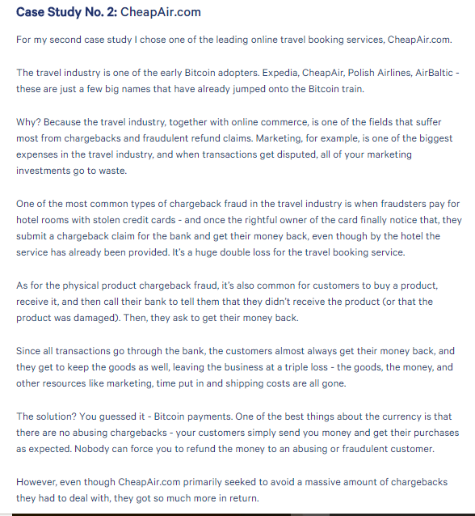
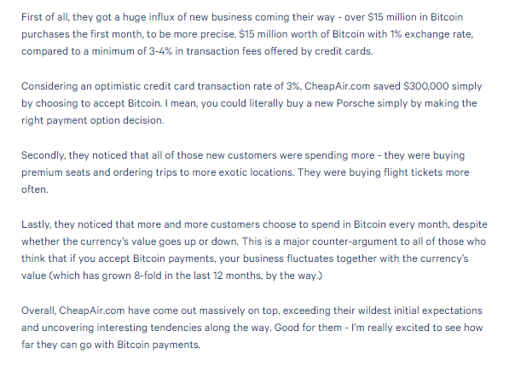
This case study explains that businesses that operate online, like CheapAir.com suffer from problems such as fraudulent transactions. Payments being made with stolen credits is the best example for this. Once the rightful owner notices that a payment has been made without their permission they often resort to making a claim. Once the claim has been made the victim gets their money back and the business is left at a loss.
Bitcoin payments can be seen as the solution to this problem. This case study explains that there is no chargeback when paying with Bitcoin. The customers send the Bitcoin payment and receives the product or service, no claim can be made by anyone and refunds cannot be requested by fraudulent customers.

Some useful tools that businesses can use are:
. Bitpay – As mentioned earlier, cryptocurrencies are becoming a regular form of payment. A tool that is used by businesses today is Bitpay. Crunchbase.com[8] tells us that the business has made over $100 million from leading investors, including Sir Richard Branson and Index Ventures. This is available to download from the Apple store and Android play store. Some sites that accept Bitcoin are Shopify, Microsoft, and CheapAir (As mentioned earlier).
. PayPal – This is probably the most popular form of e-payment which is available on most, if not all e-commerce sites. PayPal is the perfect example of an E-wallet. It offers 24/7 security to keep all of your stored information safe against theft. It also allows you to link your credit or debit account information so that if you are looking to make a payment(s), you will not have to check of there is enough money in your account. Money can be sent or received in a matter of seconds by having access to simple information such as a friend’s email address or a family member contact number. PayPal could prove to be very useful to Plumrite who have stated that demand for their service is growing with the business. As they grow in the future their one of their main aims will be to work as quickly and efficiently as possible.

Marketing Metrics
Online Metrics in e-commerce can act as factors that can be measured by business owners. These factors can then be assessed on how affective they are. Plumrite will want to make it an important job to check how they e-commerce site is doing once its published. By checking their metrics, they may be able to identify which pages of the site need to be changed or even removed, they may also be able to consider their advertising channels and assess where more of their viewership is coming from (social media, TV adverts, general browsing).
Klipfolio[9] suggests that these are some important metrics that should be regularly monitored:
. Return on Marketing Investment – This Metric is measured by calculating the total revenue made from the campaign (in this case the e-commerce site) against the amount that was invested, the expenses it took to create the website. If more money is gathered compared to what was invested, then this is a sign that the campaign has done well.
. Search Engine Optimisation Traffic – This relates to the number of users that visit a website through a link from a search engine. “Using a Web analytics program, a website’s overall search engine traffic can be segmented to show the percentage of search engine traffic for individual Web pages or site sections.”
As explained by techopedia.com[10], a high volume of search engine traffic is a good sign. This means that the site is good enough to reach a high search rank which then results in views.
. Social Media Traffic – This metric is used by businesses to measure how many views counts the site has received from people who have clicked on the link through social media platforms. Social media marketing campaigns focuses on creating content that is good enough for users to share across all social media sites.
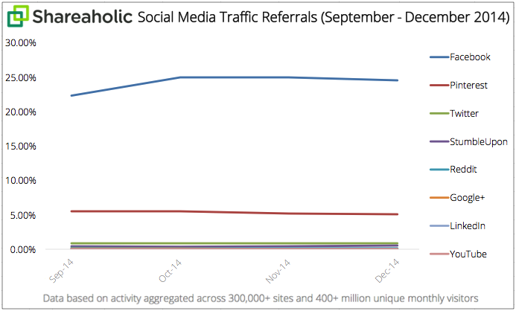
Figure 1: Social Media Traffic 2014 from Shareaholic[11]
This blog post from 2014 states that “Social media drove 31.23% of social media traffic to sites”. If we were to consider the fact that there are over 7 billion people around the world to date, then that percentage would equate to around 2 billion users. That is a lot of traffic to be shared around millions of websites. To this day social media is widely used and is still a growing tool that some people rely on. Using social media could prove very useful for Plumrite as they can gain different types of customers through various social media networks.

Conclusion
After being told by Emrys what he needed to do, the writer analysed to of the most used web builders around the world, Wix and Weebly. He also considered the use of coding to create the e-commerce site. After weighing up the pros and cons the writer decided to use Wix as he has used it before and found it easy to use. Using Wix he created a site that met all of the requirements such as a product catalogue to view online, e-payment and reviews for new and current customers to look at. The writer also discussed monetary transaction methods such as Paypal and Bitpay which could be considered as future additions. The writer also discussed the importance of using market metrics in order for businesses that operate online to succeed. Social trafficking can be used to find out which social media platform consumers use to find out about Plumrite. SEO can also be used so that the website can reach the top pages of a search engine list such as Google or Bing.

References
[1] “Create Your Free Website | Wix.com.” [Online]. Available: http://www.wix.com/professionalwebsite/hiker-uk?experiment_id=cake_34826457%5E62&utm_campaign=af_top10bestwebsitehosting.com&utm_medium=paid_referral&utm_source=affiliate. [Accessed: 11-Jan-2018].
[2] “Weebly Website Builder: Create a Free Website, Store or Blog.” [Online]. Available: https://www.weebly.com/uk?c=mkt_w_nwk:Affiliate_cat:NaturaInt_type:top10_camp:NI-UK_ag:2-3_subid:DdccY7BEPk. [Accessed: 11-Jan-2018].
[3] “Weebly Review 2018, How To Build A Weebly Site | WebCreate.” [Online]. Available: https://www.webcreate.io/website-builders/weebly-review/?f=17&pl=4. [Accessed: 26-Apr-2018].
[4] “What are the benefits of coding a website from scratch or learning web developing languages in the first place when there are many tools/builders such as Dreamweaver, Squarespace, WordPress, etc.? - Quora.” [Online]. Available: https://www.quora.com/What-are-the-benefits-of-coding-a-website-from-scratch-or-learning-web-developing-languages-in-the-first-place-when-there-are-many-tools-builders-such-as-Dreamweaver-Squarespace-WordPress-etc. [Accessed: 26-Apr-2018].
[5] “7 Payment Methods for Your ECommerce Store | Segmentify.” [Online]. Available: https://www.segmentify.com/blog/7-payment-methods-e-commerce-store/. [Accessed: 26-Apr-2018].
[6] “Cheap Airline Tickets, Airfares &amp; Discount Air Tickets | CheapAir.” [Online]. Available: https://www.cheapair.com/. [Accessed: 27-Apr-2018].
[7] “3 Case Studies on How Bitcoin Payments Helped Boost Online Sales | TheBigCoin.” [Online]. Available: https://www.thebigcoin.io/blog/3-case-studies-on-how-bitcoin-payments-helped-boost-online-sales. [Accessed: 27-Apr-2018].
[8] “BitPay | Crunchbase.” [Online]. Available: https://www.crunchbase.com/organization/bitpay#section-overview. [Accessed: 27-Apr-2018].
[9] “The top 10 most valuable metrics for marketing managers | Klipfolio.com.” [Online]. Available: https://www.klipfolio.com/blog/metrics-marketing-managers. [Accessed: 26-Apr-2018].
[10] “What is Search Engine Traffic? - Definition from Techopedia.” [Online]. Available: https://www.techopedia.com/definition/27981/search-engine-traffic. [Accessed: 27-Apr-2018].
[11] “Report: Social Media Drove 31.24% of Overall Visits to Sites.” [Online]. Available: https://blog.shareaholic.com/social-media-traffic-trends-01-2015/. [Accessed: 27-Apr-2018].

