Cloud Computing Administration

[Student’s Name] Marios Soulka

Table of Contents
Introduction 3
Cloud computing background 3
Available public cloud providers 5
Best Option Public Cloud service provider for Global Learning Institute 5
Literature Review 7
Background review of Microsoft Azure 7
Azure Total Cost Ownership (TCO) 7
Using the Azure Calculator for GLI 8
Azure File Storage 12
Implementation of Azure Storage for GLI 14
Azure database options 16
Azure SQL database 16
Azure Database for MYSQL 20
Azure Database for PostgreSQL 23
Azure SQL database vs. Azure database for MYSQL vs. Azure database for PostgreSQL 25
Recommended Azure database 26
Azure Back-up Options 28
Azure back-up option for File shares 28
Azure back-up for database option 30
Azure Site Recovery 32
References 33

Introduction

Cloud computing background
Cloud computing is a model of delivering computing services over the internet. These services include servers, storage, databases, networking, software, analytics and intelligence. Organizations are opting for cloud computing instead of maintaining physical data centers or serve which are expensive to install and maintain. Cloud computing allows the companies to access storage on-demand from a cloud provider, which manages the underlying infrastructure.
Cloud computing offers the users on-demand self-service where the user is provided the resources they need automatically without requiring human interaction with each service provider. Cloud computing services offer brand network access to users through standards mechanisms thus supporting a wide range of devices. Cloud computing is becoming common and serves multiple customers using a multi-tenant model. The service provider offers different physical and virtual resources dynamically assigned according to customer needs and demand. Cloud computing resources can be quickly scaled up or down based on the customer needs and the workload, making it flexible for various user needs. Cloud computing automatically controls and optimizes resource usage by leverage a metered capability like the bandwidth, processing and storage.
There are several types of cloud services that organizations choose based on their user needs. First is the Infrastructure as a Service (IaaS) which provides virtualized computing resources over the internet. IaaS cloud computing services include virtual machines, storage, and networks with examples being Amazon Web Services (AWS), Microsoft Azure, Google Cloud Platform (GCP). The second type of cloud computing is the Platform as a Service (Paas). This cloud computing, infrastructure offers hardware and software tools over the internet for application development. It enables developers to build applications without worrying about underling infrastructure. PaaS services include the Google App Engine and Microsoft Azure App Services. The third types of cloud computing service are the Software as a Service (SaaS) technologies which delivers software applications over the internet on subscription basis. The users can access software applications without managing the underlying infrastructure and include the Salefsforce, Microsoft Office 365 and Google Workspace [1].
Cloud computing services can be deployed through public Cloud which is shared across multiple organizations like the AWS, GCP, and Azure. The cloud computing services can also be deployed through private clouds which are dedicated to a single organization, either on-premises or hosted by a third party. The private cloud offers greater control over the security and data management. The cloud computing services can also be deployed through the hybrid model which combines both public and private clouds to allow data and applications to be shared between them, thus providing better flexibility and optimization of existing infrastructure, security and compliance [2]
Cloud computing offers great cost efficient to organizations b eliminating capital expenses of being hardware and software and setting up and running on-site data centers. Cloud computing also offers scalability, unlike the physical data storage infrastructure. Businesses are able to scale up as their computing needs increases or scale down when the demand decreases, thus offering flexibility and cost savings during scaling up or down. Cloud computing also runs on a worldwide network of secure data centers, thus proving high performance and reliability. Cloud computing offers great security to organizations through data encryption, identity management and regular security updates. This makes it hard for the organization to be hacked or to loose valuable data to third parties or cyber criminals. Cloud ensures data protection and business continuity through backups, redundancy and geographic diversity.
However, cloud computing has a few disadvantages which can expose the business to risks. The organizations can lose private and confidential data following unauthorized access and failure to comply with the regulations. This can lead to huge financial losses and damage of reputation of the organization. Cloud computing is also prone to downtimes as it relies on the internet thus any outages in Internet can lead to downtimes of the services and thus not being reliable for accessing critical applications and data. Organizations may also find it difficult to migrate from one cloud provider to another due to differences and lack of compatibility in platforms and services.

Available public cloud providers
There are several public cloud services that compete at the top tier offering a broad range of computing needs. The major cloud computing providers are Amazon Web Services (AWS), Microsoft Azure, Google Cloud Platform (GCP), IBM Cloud, Oracle Cloud, Alibaba Cloud ad Tencent Cloud. These companies offer cloud storage services, databases, networking, artificial learning and machine learning services. Security, computing services and DevOps. These services offer other specializes services based on their core business like cloud media services for Tencent Cloud, big data and analytics services for Oracle Cloud and Google Cloud Platform. The cloud services enable businesses and developers to build, deploy and manage applications on a global scale with varying degrees of control, flexibility and security.

Best Option Public Cloud service provider for Global Learning Institute
Global learning Institute can use Microsoft Azure as the best option based on its needs. Microsoft Azure is a robust cloud platform that offers a comprehensive set of tools and services suitable for an educational institution. Microsoft Azure offers specialized services and solutions tailored for the education sector. This includes tools for managing student information, creating virtual classrooms and facilitating online learning. Microsoft Azure will also offer Global Learning Institute access to Microsoft education hub which is a suite for educational tools like Office 365 for Education that includes Teams for collaboration, OneNote for note-taking and SharePoint for content management [3].
Microsoft Azure also allows flexibility to Global Learning Institute to scale its resources based on demand. For instance, the organization can scale up during peak seasons when there are more students and courses in session to offer adequate storage resources and computing infrastructure. Microsoft Azure can also allow the institute to deploy educational applications, websites and virtual labs using Azure’s scalable virtual machines or App services which can also be scaled up or down on demand. Microsoft Azure will also provide the Global Learning Institute with global reach. Azure has a vast network of data centers across the globe, which ensures that the institute can deliver content quickly and reliably to students anywhere in the world. As a result, the institution can offer distant learning to students who are spread across the world and ensuring they have access to all learning resources as the students who are physically in the Institution’s premises. Azure will also ensure that the Institute meets international and industry-specific compliance standards like GDPR, FERPA for education and ISO/IEC 27001 which is crucial for protecting student data and maintain the integrity of educational content. Microsoft Azure will also provide the organization with integrated artificial intelligence and analytics tools to create personalized learning experiences for the learners. This can allow the institution to tailor educational content to meet individual student needs. Azure also offers cognitive services which can enhance online learning platforms with features like language translation, speech recognition, and sentiment analysis, making the learning environment more interactive and inclusive. This will enable the organization be able to take global students with various language preferences and needs and offer them personalized learning experiences. Azure will also offer the Global Learning Institute data analytics tools which will allow the organization to analyze student data, performance, course effectiveness and other critical metrics for the organizations management purposes. Microsoft Azure uses Power BI and Azure Synapse Analytics which are powerful emended tools for analytics and management tools.
Microsoft Azure will provide the organization with cost-effective computing services. Azure has a flexible pricing model where the organization can choose to Pay as You Use for the resources the use only, without needing the whole Azure package thus saving on cost. Additionally, azure allows the clients to use some free services like the free credits and free modes when the institution does not have a budget for subscription [4].

Literature Review

Background review of Microsoft Azure
The Azure provides an array of services in various categories that GLI can leverage from these are:
- Compute
- Databases: Azure PostgreSQL database, Azure SQL database, Azure database for MYSQL
- Networking services: Azure Load balancer, Azure DNS service
- Storage services: Azure Blob storage
- Machine and AI

Azure Total Cost Ownership (TCO)
Azure Total Cost Ownership is a valuable tool that is designed to assists companies and organizations estimate their cost savings which they can achieve by moving from an on premise structure to Microsoft Azure structure. This allows a company to compare the cost of running one infrastructure in Azure cloud platform with cost of running it on premise.
Majorly, the azure calculator assists an organization in understanding three major costs. First is the compute costs. In this case the Azure calculator assists an organization in computing the costs of virtual machines that are the VMs or what are known as containers on the Azure platform. Using the TCO calculator an organization is able to get billing per second of the VMs utilized by the organization. Second using the TCO an organization is able to estimate the storage costs that is the costs of storing data or information in various storage solutions like the Azure Files or the widely known Azure Blob storage [5]. Third is the database costs which is the costs of managed databases like the Azure MYSQL database, the cosmos database, and the Azure SQL database. Forth, the TCO assists in calculating the network costs that is the costs for data transfer, the Azure network services, and the VPNs. Lastly, the calculator assists in calculating the additional costs, in this case the additional costs is the licensing and support costs.
There are various benefits which comes with the Azure TCO calculator. First is the costs savings. The TCO calculator assists in quantifying the potential savings which includes the facility costs, maintenance costs, and the hardware costs. Second benefit is the reduction of risks. Second the Azure TCO calculator comes with flexibility and scalability. With the TCO one is able to scale up and down resources. This means that GLI can scale down resources based on their demand. This ensures that they only pay for the resources that they only use. Lastly, TCO comes with costs efficiency; this means that GLI can be able to use the TCO calculator to manage resources effectively during the preliminary phase of migration [6].

Using the Azure Calculator for GLI
Step 1: Data input
The first step is inputting the details of the current on premise infrastructure. This includes the number of servers, types of workloads. Also in here one is required to input the storage to be used, the require network bandwidth, and some other metrics. Lastly, one is required to input associate facility and labor costs. For this case is as shown by figure one shown below
Figure 1: GLI TCO data input
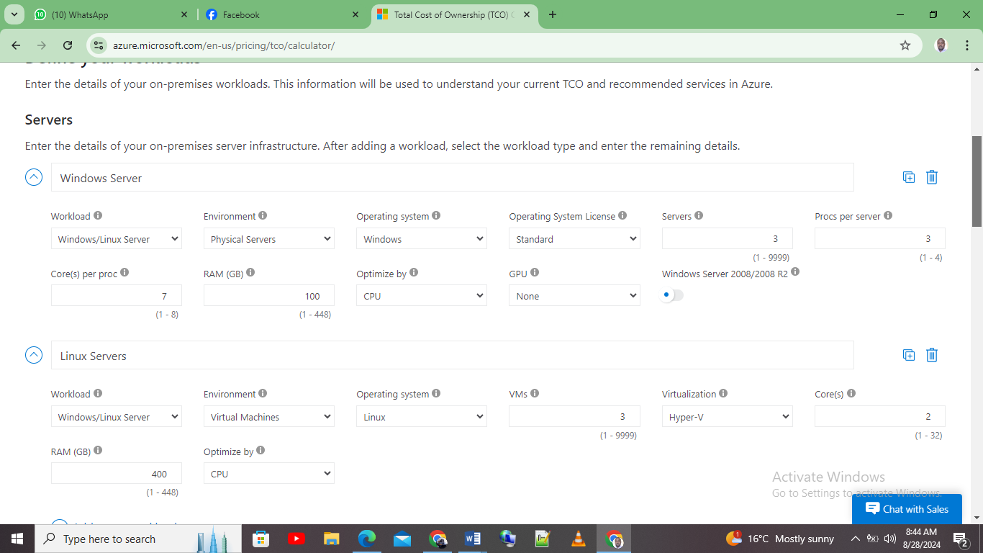
Step 2: Customization
In here one is required to customize assumptions such as power usage and the server utilization rate. This is as shown by figure 2 below
Figure 2: Usage customization
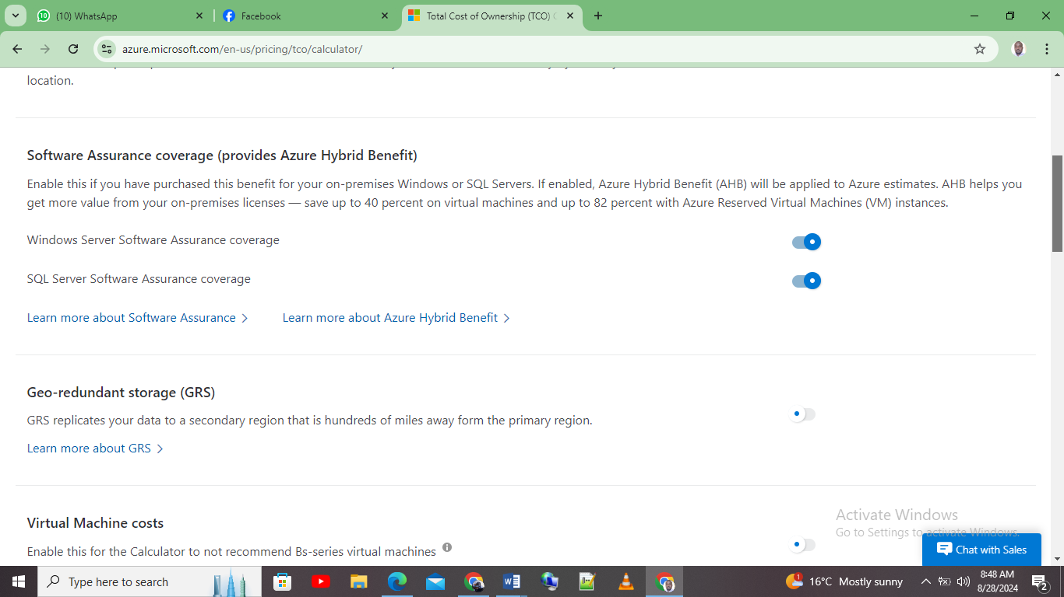
Step 3: Results
The last step is providing a detailed report showcasing the potential costs savings which is usually broken down into categories like networking, storage, and compute. For the GLI case it is as shown by figure three below. From the figure 3 below the potential, saving for the organization over five years is estimated to be 140,0003 dollars
Figure 3: GLI potential savings from the TCO calculator
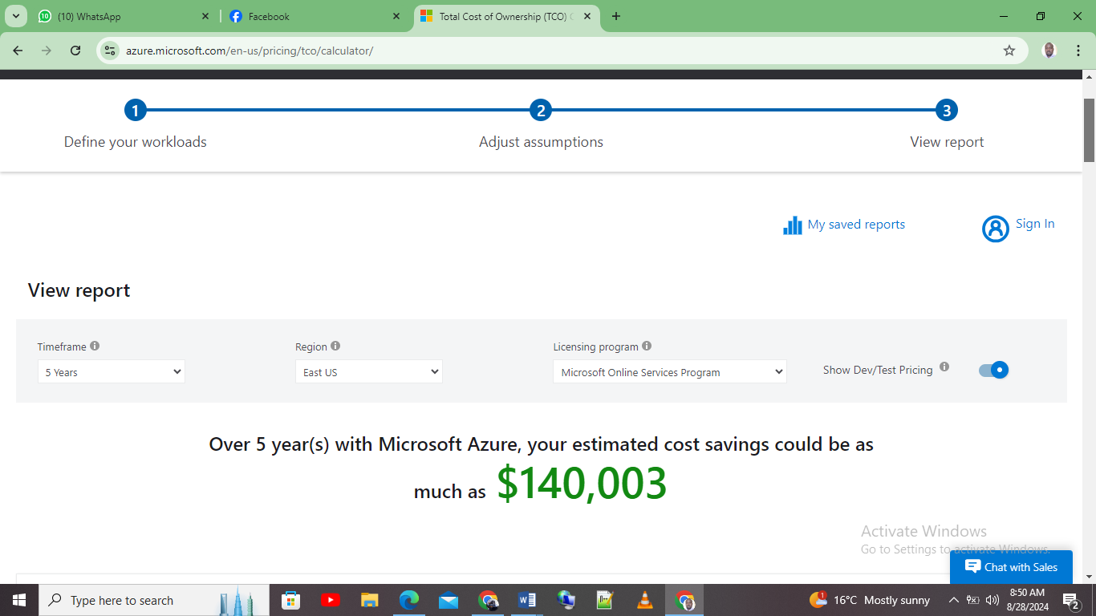
Figure four below compares the cost for hosting GLI infrastructure on Azure platform and using on premise infrastructure, for over a period of five years. As shown by the figure the cost on Azure platform is 792,934 as compared to on premise which is estimated to be 932,937 for a period of five years. Figure five shows the total breakdown of the costs.
Figure 4: Azure platform vs on premise
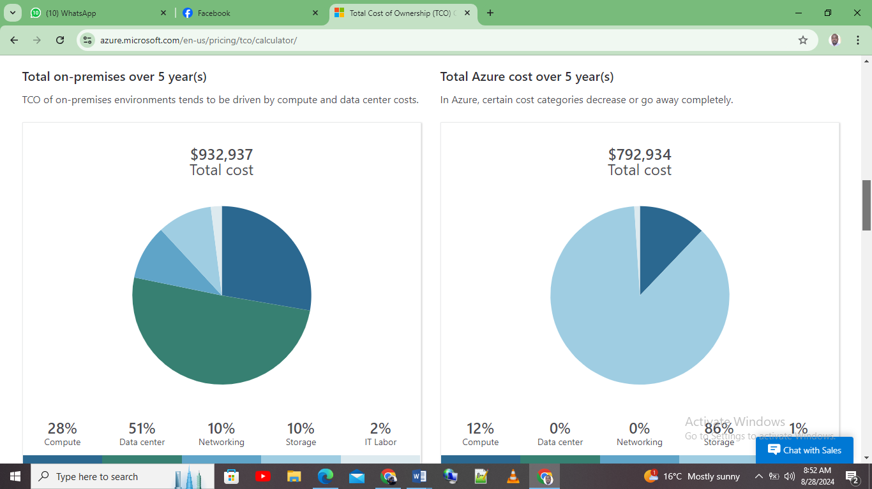
Figure 5: Total breakdown of the costs
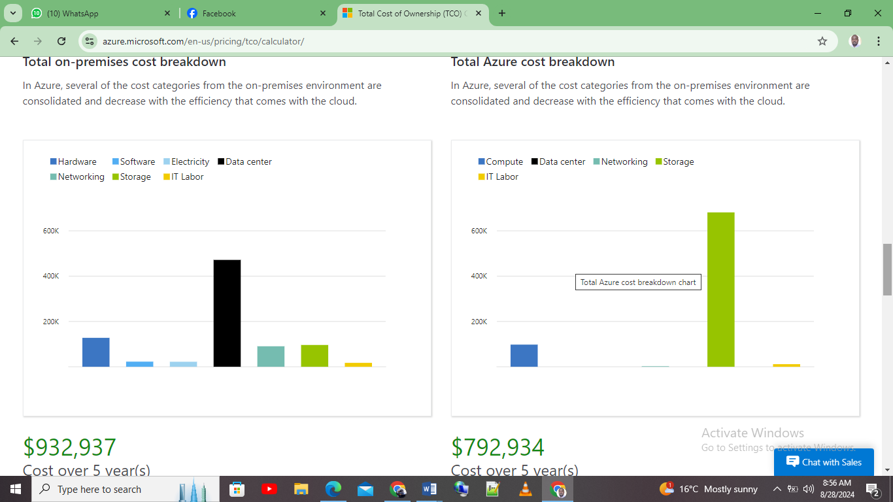
This means that Azure cloud platform is the best as compared to On premise for GLI institute

Azure File Storage
First, Azure File Storage is one of services offered by Microsoft Azure platform. The service allows an organization to manage and store files in Azure cloud platform with same accessibility and familiarity like a traditional on premise server. Specifically, the service is supported by SMB commonly known as SMB protocol. This enables a seamless integration with the current existing systems and applications. For GLI, moving to Azure File Storage option can offer several advantages [7].
First Azure File storage comes with flexibility and scalability. This means that the service provides an unlimited storage capacity. This allows GLI to scale as needed. With this feature in means that the GLI institution can easily accommodate the growing demand of its students and other users without necessarily worrying about its physical storage constrains or any form of hardware upgrades required. This feature is important for institution as it enables them to handle huge or what are known as peak workloads during student enrollment periods or when the institution is launching courses.
Second feature is that the service comes with high availability and offers redundancy. The Azure platform ensures high data availability with built-in features. This means that files are stored across various data centers within a certain region. This in turn protects GLI data from any form of power outages, any potential disruptions, and hardware failures. Also, Azure offers what is known as geo-redundant storage (GRS) options, replicates info to other Azure regions which further enhances disaster recovery capabilities. This feature or resilience is essential for GLI as it ensures a continuous access to administrative systems to the staff members and the institution course materials to the student even in unforeseen incidents.
Third feature is that Azure integrates seamlessly with other Azure services like the Azure Site recovery and the Azure back-up. This form of integration allows the organization to implement a disaster recover technique and at the same time implement a robust Back-up mechanism. This ensures that information or data is protected and its recoverable in case of any form of accidental deletion or cyber-attack.
Forth, Azure file storage comes with security. Some of the security features which comes with Azure File storage are encryption here data at rest is encrypted using the AES-256 encryption method. Data on transit is encrypted using the SMB 3.0 encryption or using the HTTPs standard. This ensures that is always secure during transfer. Also the service allows one to manage access to folders or files using the group based access control or the identities. This ensures that only the authorized users can access the files or can modify the files. Lastly, is that the service allows an advanced threat protection via the Azure defender. This means through the Azure defender one is able to monitor unusual activities via any form of unauthorized access attempts [8].
Some of the security measures and best practices for GLI via Azure Filer storage are; first is configuring the Azure File storage via VNet commonly known as Virtual Network service endpoints. This restricts access to file shares from a certain VNet. Also, GLI can use the Azure Private link to establish a private connection to the Azure File storage. This ensures data traffic remains only within the Azure network.
Second, GLI needs to take advantage of the Azure Active Directory commonly known as AAD. This enforces a multi-factor authentication for accessing the Azure File storage. This adds another later to the security of Azure File storage

Implementation of Azure Storage for GLI
Step 1: Navigating via the Azure File Storage for GLI
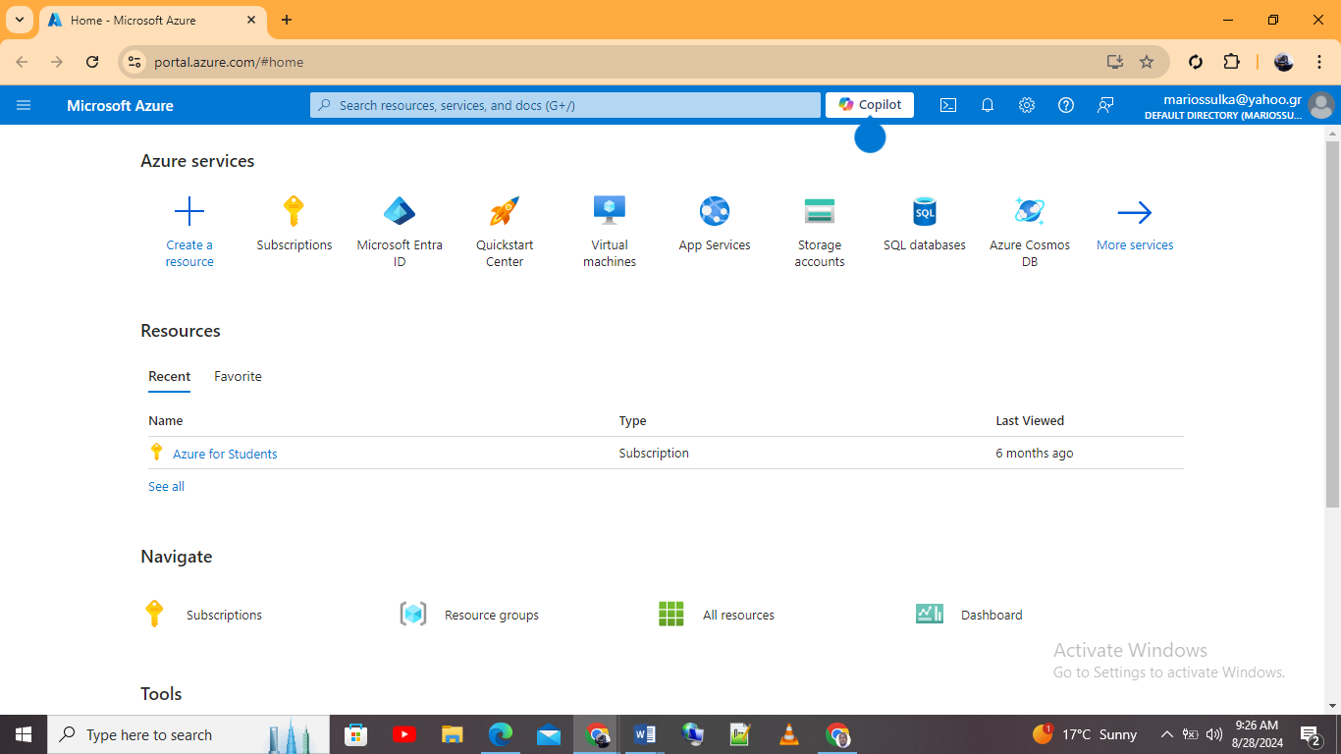
Step 2: Selecting storage account
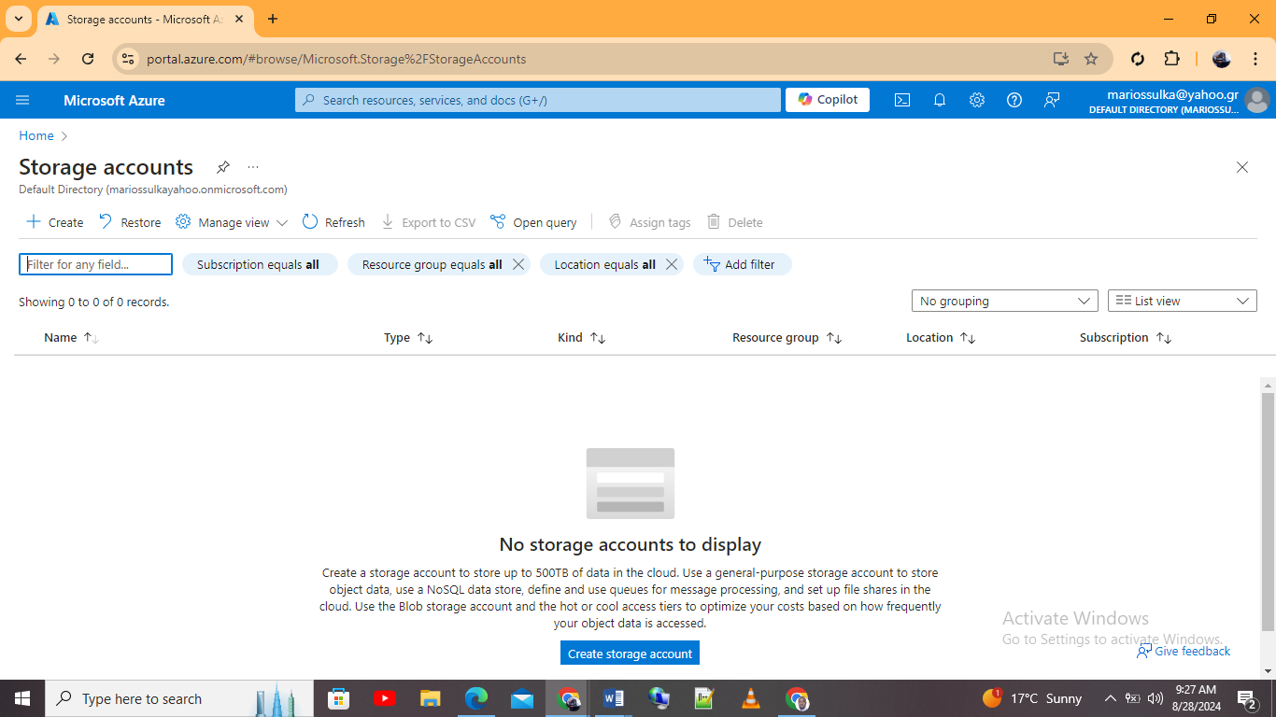
Step 3: Creating Azure File storage
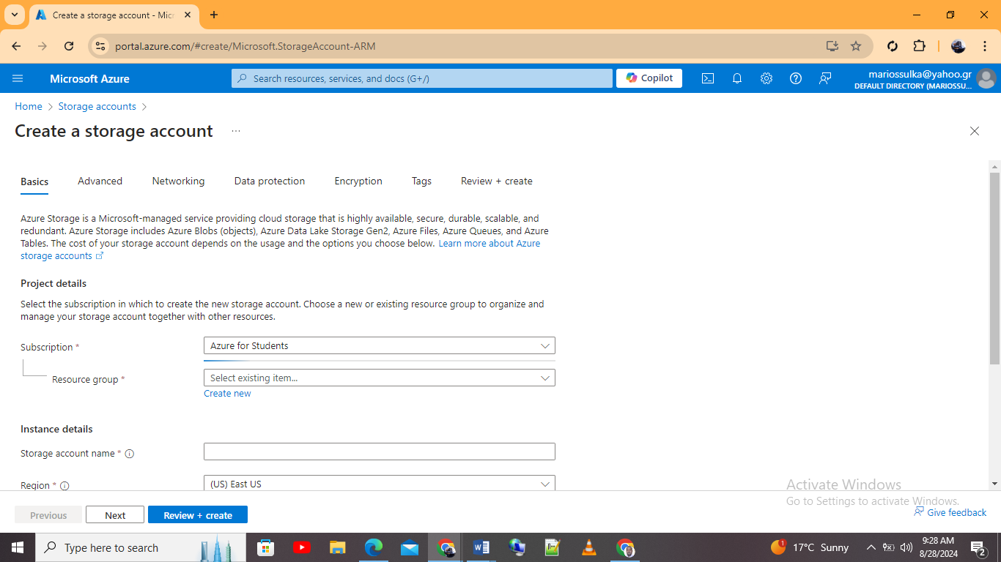
Step 3: Created Azure File storage
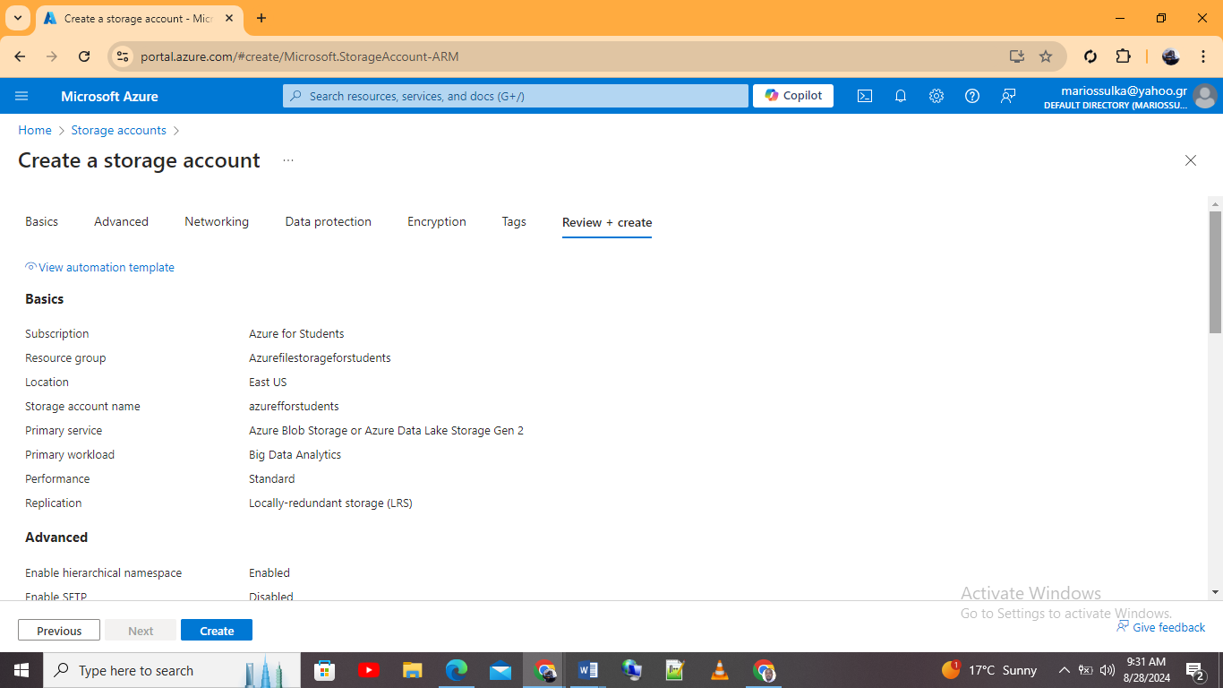
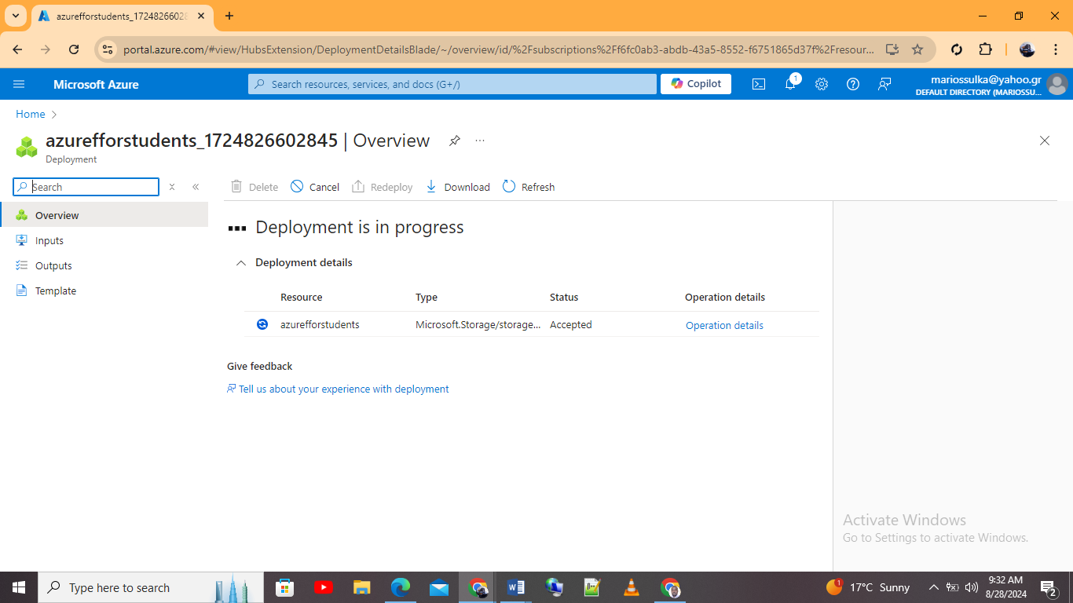

Azure database options
There are three major databases that one can utilize in the Azure platform. These are the Azure SQL database, Azure MYSQL, and Azure PostgreSQL solutions.

Azure SQL database
The Azure SQL database is widely known as relational database service. The database is built on Microsoft Azure Service Engine. Second, the database offers a wide range of features which are mainly designed to meet the need of the current modern cloud applications. This in turn makes it versatile option for organizations such as the GLI which is shifting from an on premise platform to a cloud platform. Specifically, the Azure SQL database is mainly optimized by Microsoft for high availability, security, and scalability. This in turn will enable GLI to efficiently manage their data while at the same time reducing their administrative overhead which is mainly associated with the traditional database management.
There are four major features of the Azure SQL database. First is the Platform is fully managed service. The database is a PaaS that is Platform as a Service. This means that Microsoft handles the back-end management which includes monitoring, back-ups, and patching. This in turn will reduce GLI’s IT staff with workload. This will assist the organization in this case to focus on more important aspects of their infrastructure. Also, the Azure SQL database has in built database such as active geo-replication, point-in-time restore, and automated back-ups. This ensures that GLI database is always recoverable and available in case of an incident [9].
Second important feature is the scalability. This is one of the standout features of the Azure SQL database. The ability to scale both horizontally and vertically. In this case GLI can opt for a variety of pricing tiers based on performance and standard. Also, the service supports elastic pools thereby allowing GLI to manage various Azure SQL databases with varying needs in performance under one budget. This type of flexibility ensures that the SQL database is able to grow based on the needs of the organization.
Third most important feature is high availability and disaster recover. The Azure SQL database provides built-in high available SQL database via its always on technology. This ensures that the SQL database remains operational even during hardware failures. Additionally, the Azure SQL database replicates various regions. This ensures that the database is available any time even in the event of power outages which in turn ensures minimal disruption.
Lastly is security, the Azure SQL database offers various advanced security features to protect data. First is data encryption via the TDE mechanism. This type of encryption ensures that data is protected at rest. Also, the TDE encryption ensures the Azure SQL backups and logs are always protected. Second type of encryption is the access control; the Azure SQL allows a fine grained access control thereby enabling GLI to manage database access based on user permissions and roles. Lastly, the Azure SQL database includes advanced threat protection capabilities. This ensures a continuous monitoring of the database. Also, it ensures that database is protected from attacks like SQL injection.
Implementing Azure SQL database for GLI
Step 1: Log onto to the Azure dashboard platform
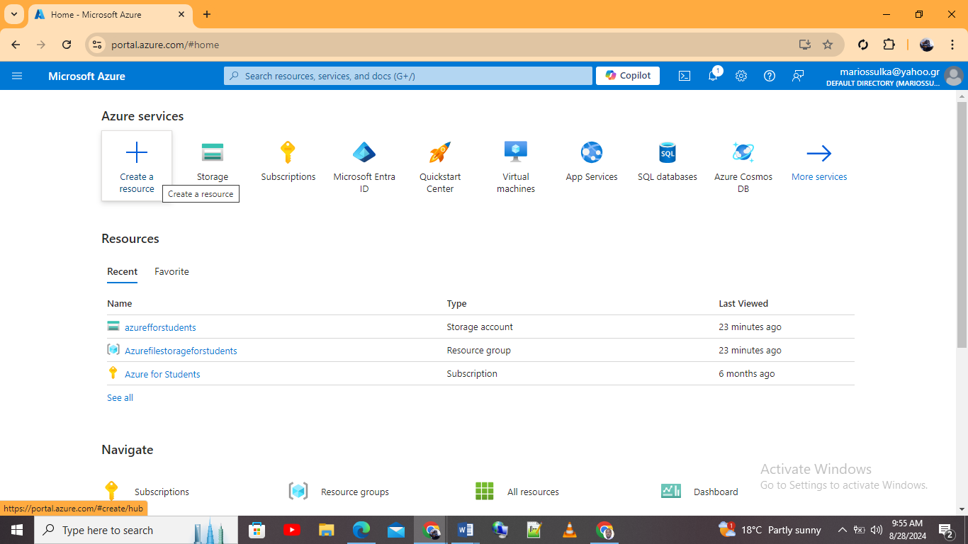
Step 2: Create Azure SQL database
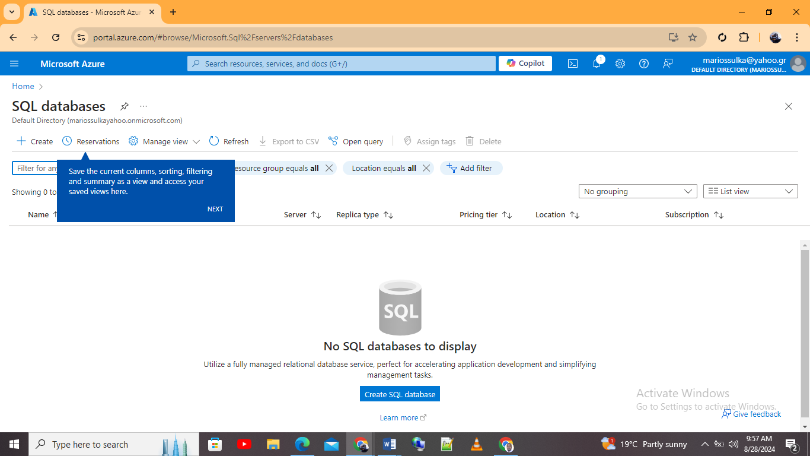
Step 3: Created Azure SQL database
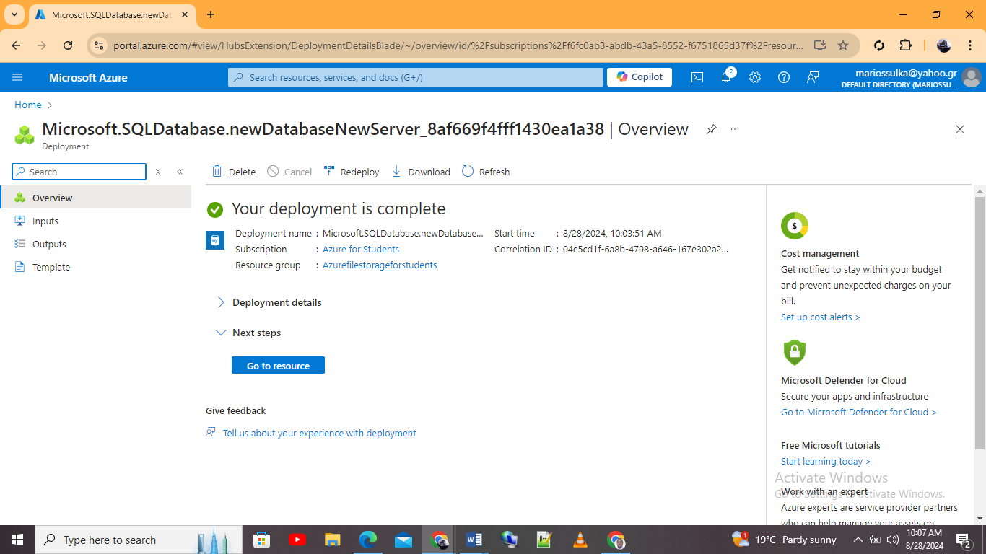

Azure Database for MYSQL
This is the second major type of Azure database commonly known as Azure database for MYSQL. First the Azure database for MYSQL also has the fully managed database feature. This allows one to run the database on cloud. It is a built on the community edition which offers a range of features like good performance, reliability, and flexibility. For organization like GLI which might have an existing MYSQL database or might want to take advantage of the MYSQL open source ecosystem, the Azure database for MYSQL can present a better option as compared to the rests.
Some of the important features of this database include; first is a fully managed service. This means that Microsoft is able to handle the routine database management tasks like scaling, updating or patching, backups, and monitoring. This in turn allows the GLI organization team to focus on other essential tasks like deployment of applications rather than maintenance of the database. Additionally, other services like automatic back-ups and ensuring that data is recovered in times is failure is also available. Second, important feature is scalability Azure database for MySQL comes with scalability. This means that the database is designed to scale up more as one demand increases. The platform supports both horizontal and vertical scaling. The vertical scaling in this case means adjusting the compute resources such as the memory and vCores. The horizontal scaling in this case means providing a flexibility to handle all the database workloads.
Third most important feature is ensuring high availability with no added configuration that is required. Also, the database replicates data across various availability zones within a certain region. This ensures that the database remains operational event in the event of hardware outages or failures. Lastly, is that the database comes with various security features. First data at rest is always encrypted using the AES-256 encryption standard. On the other hand, data in transit is encrypted using the SSL/TLS encryption standard. This ensures that sensitive information or data is always protected. Other security features with this database are advanced threat protection which assists in continuous monitoring of the database. Also it integrates with other features like AAD commonly known as Azure Active Directory. This allows a centralized identity management thereby enabling enforcement of MFA and the RBAC access controls [10].
Implementation of Azure database for MYSQL
Step 1: Logging into the Azure MYSQL database
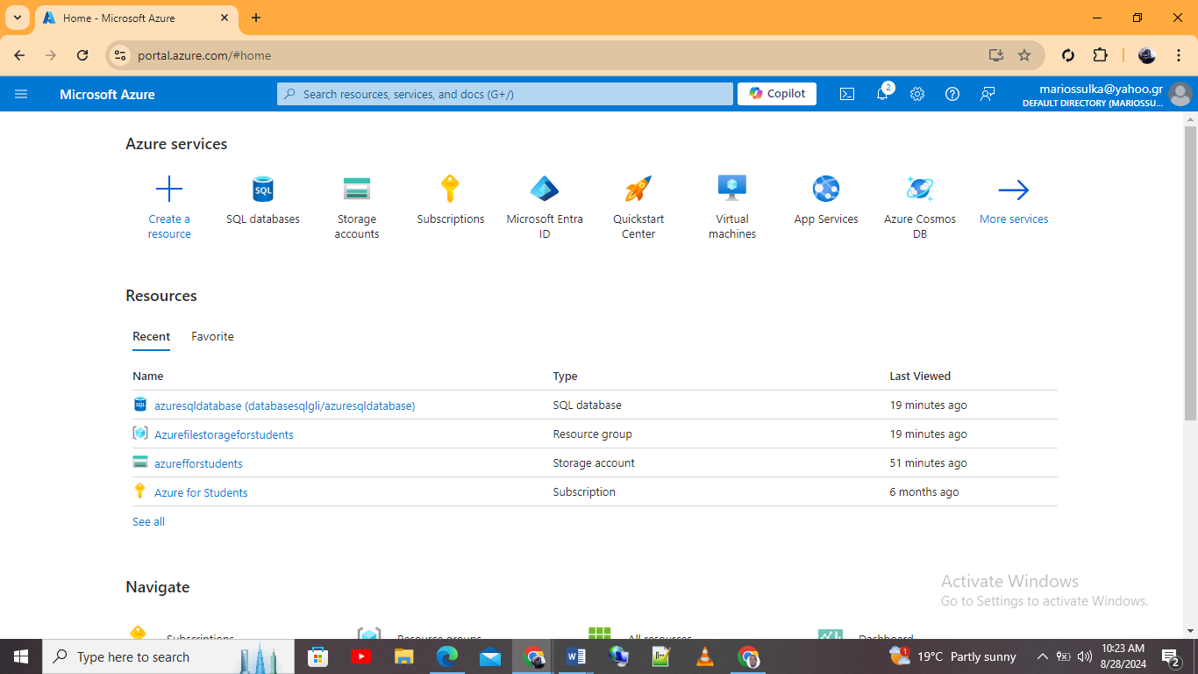
Step 2: Creating Azure database for MYSQL
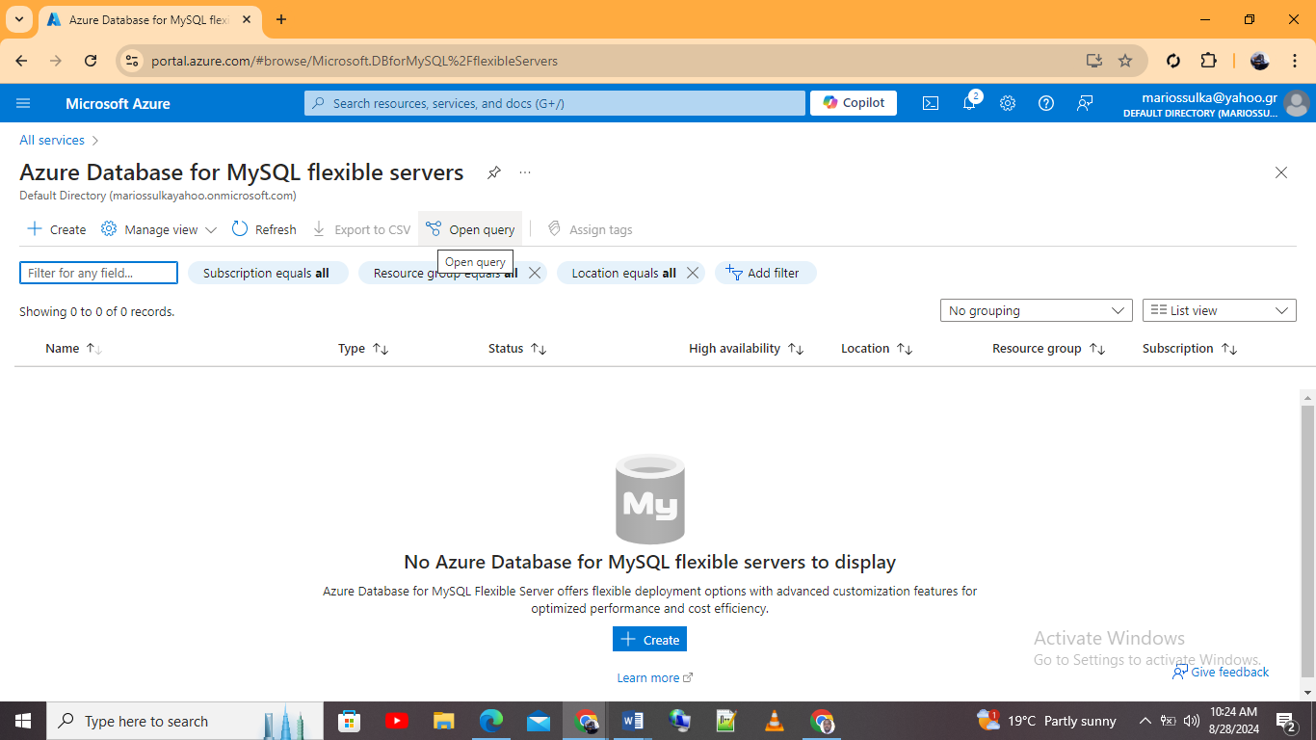
Step 3: Deployed Azure database for MYSQL
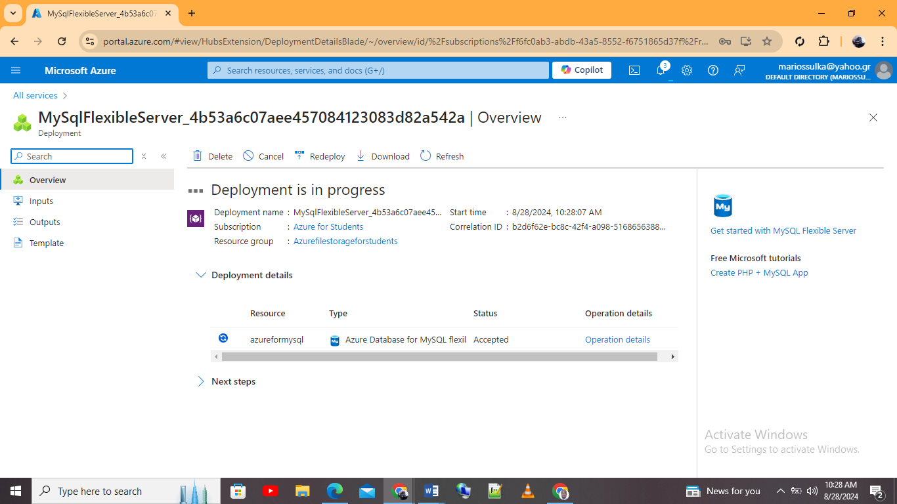

Azure Database for PostgreSQL
Just like the Azure SQL database, Azure database for PostgreSQL is also a fully managed database service. This is done by Microsoft. Also, the database is built an open-source relational database system. It offers high security, scalability, and availability. This in turn enables an organization to deploy PostgreSQL databases in the wide area network or cloud without the overhead of managing the underlying IT infrastructure. For organizations like GLI which might rely on data-sensitive applications for both students and the administrators and which might require a robust data integrity, the Azure database for PostgreSQL might present an ideal solution.
Some of the major features of this type of database include; first a fully managed service. This means that Microsoft offers the normal routine dataset maintenance. This in turn enables GLI to focus on other important features of the database. Also the database contains automatic back-ups. Second, important feature are scalability and high availability. This means that the database is designed to provide a high available database which us built in an automated failover mechanism and one which is highly redundant. Also, the database can be configured across various mechanism to ensure a continuous operation event in the times of failures. Scalability is another feature which allows the database to scale vertically by increasing storage and compute resources. Also it scales horizontally by adding what are known as read replicas to distribute workloads [11].
Lastly, the database comprises of advanced features which enables one secure important data for an educational institution like GLI. Some of the security features include data encryption for data which is at rest using the current industry standard like the AES-256 type of encryption. Also data on transit is encrypted using the SSL/TLS protocols. This ensures that GLI data remains secure both during transmission and when stored.
Implementation of Azure database for PostgreSQL
Step 1: Creating Azure database for PostgreSQL
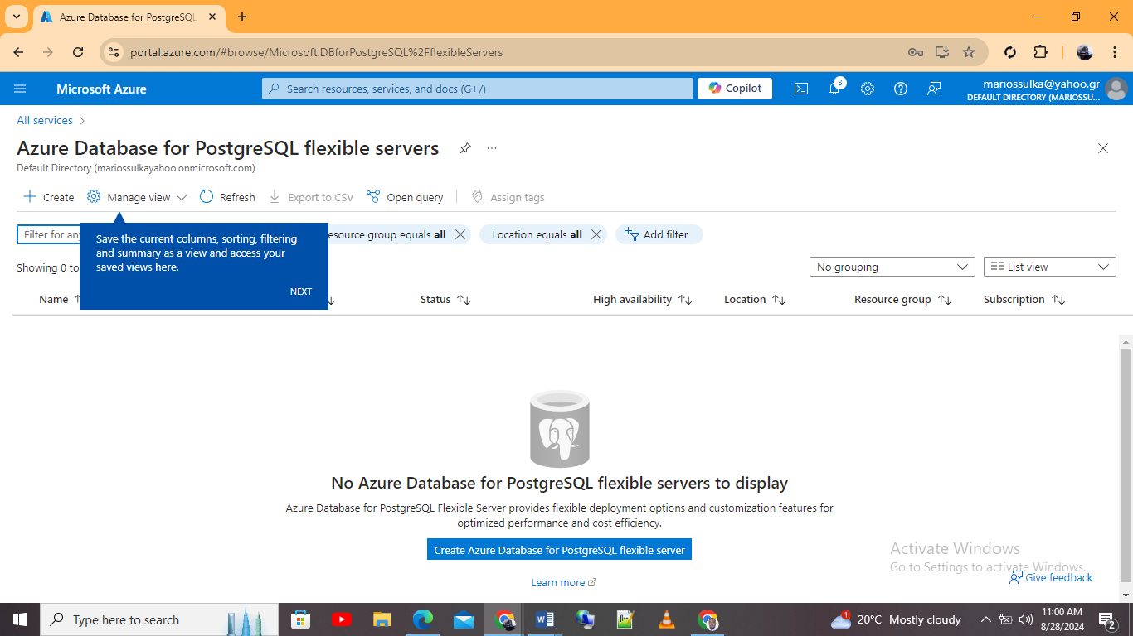
Step 2: Created Azure database for PostgreSQL
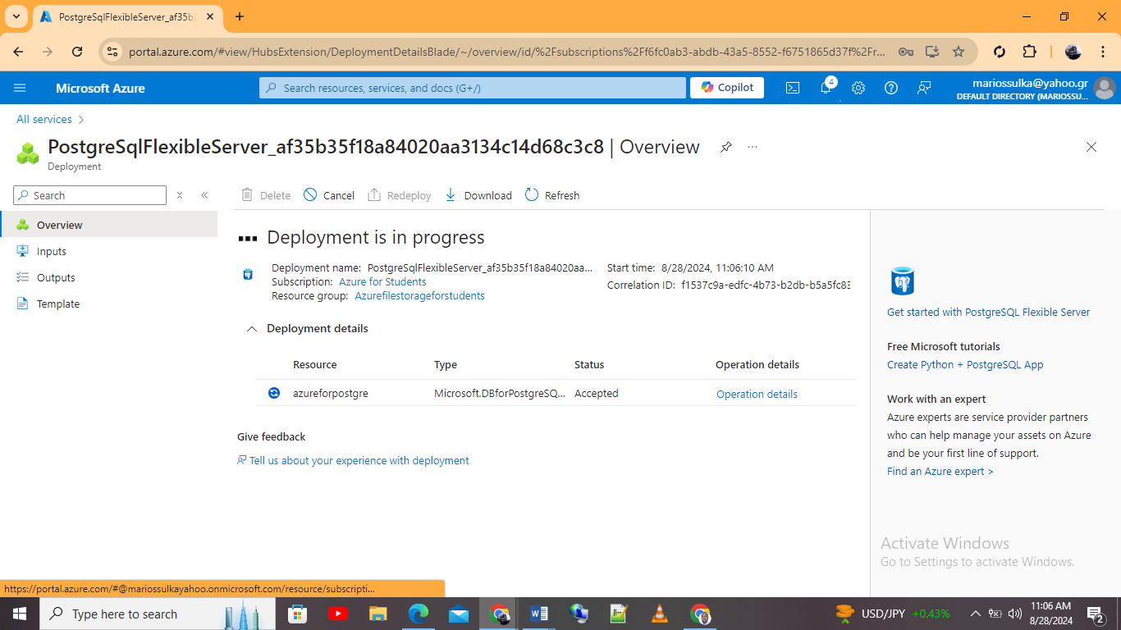

Azure SQL database vs. Azure database for MYSQL vs. Azure database for PostgreSQL
Criteria | Azure SQL database | Azure database for MYSQL | Azure database for PostgreSQL
The database engine | Microsoft SQL server which is proprietary | It is an open-source MYSQL | An open-source PostgreSQL
Available deployment options | Managed instance,  A single database, and Elastic Pool | Flexible server, hyper-scale, and single server | Hyper-scale, flexible server, and single server
Use cases | Data warehousing analytics, OLTP | Web applications, management systems, and web applications | Complex queries and data warehousing
Compatibility | Fully compatible with Azure SQL and SQL server | Compatible with MYSQL apps and tools | It is compatible with the PostgreSQL tools and the applications
Scalability | Able to scale vertically and horizontally | Able to scale vertically and horizontally | Able to scale vertically and horizontally
Data types supported | Standard SQL data types supported | All MYSQL data types are supported | Postgre SQL data types like XML and JSONB
VNet integration | Yes it is supported | Yes it is supported | Yes it is supported

Recommended Azure database
A review of GLI requirements
As stated from the organization description, GLI is a medium sized organization which is currently facing various issues with their current on premise IT infrastructure. Some of the major listed issues are maintenance costs, processing capacity, a limited storage, and hardware failures. Additionally, the organization supports online certifications and courses. This means that a scalable, robust, and secure database is needed.
Given the stated issues, it is important to have in place a database which aligns with the organization operational requirements, future growth and within the required budget. Each of the above three Azure databases offers distinct advantages and caters for certain use cases.
The Azure SQL database is specifically suited for data warehousing, business intelligence applications and transactional workloads. Also this type of database offers other Azure services like Azure Factor and PowerBI. However, some of the limitations which comes with this type of database are; being more expensive even with simple applications. This means that licensing cost can be concern especially if the organization in this case, GLI has a limited budget [12].
The Azure database for MySQL is an open-source database which is mainly used for web applications, e-commerce platforms, and content management systems. As compared to Azure SQL database it is a more effective type of database. It can be an ideal choice if GLI is running web applications only. However, the database is not ideal for running applications which holds sensitive data. Additionally, the database lacks advanced features like being able to process JSONB data types or the geospatial data.
Lastly, the Azure database for PostgreSQL is widely known for its compliance standards, extensibility, and robustness. The database is fully managed and support complex queries and advanced data type like XML data, PostGIS data, and JSONB. The database is ideal for applications which require complex data operations like learning management systems, geographic information systems, and student information systems. Additionally, the database is able to handle heavy workloads which makes it more powerful and versatile than the other two options.
Best Azure database option- Azure PostgreSQL option
From the three Azure databases, the best database option is the Azure database for PostgreSQL database. This is because the database supports more advanced data types. For example, GLI can have full-text data types or geospatial data types. This aligns with the current GLI need of requiring a more versatile database which is able to handle diverse data workloads. Second, the database supports more advanced optimization features like intelligent query processing. This means that GLI will be able to handle concurrent transactions efficiently without compromising performance. Lastly is that the database comes with various advanced security measures like VNet and identity management

Azure Back-up Options
One of the essential elements for GLI is configuring retention policies and back-up schedules. This ensures that the organization can recover all its information and data in the event corruption or deletion. In the Azure platform, Azure back-up options are offers to manage back-ups for both Azure database and Azure File share.

Azure back-up option for File shares
This provides an easy way to back-up File shares. This is as shown by the implementation shown below
Step 1: Creating a recovery service fault
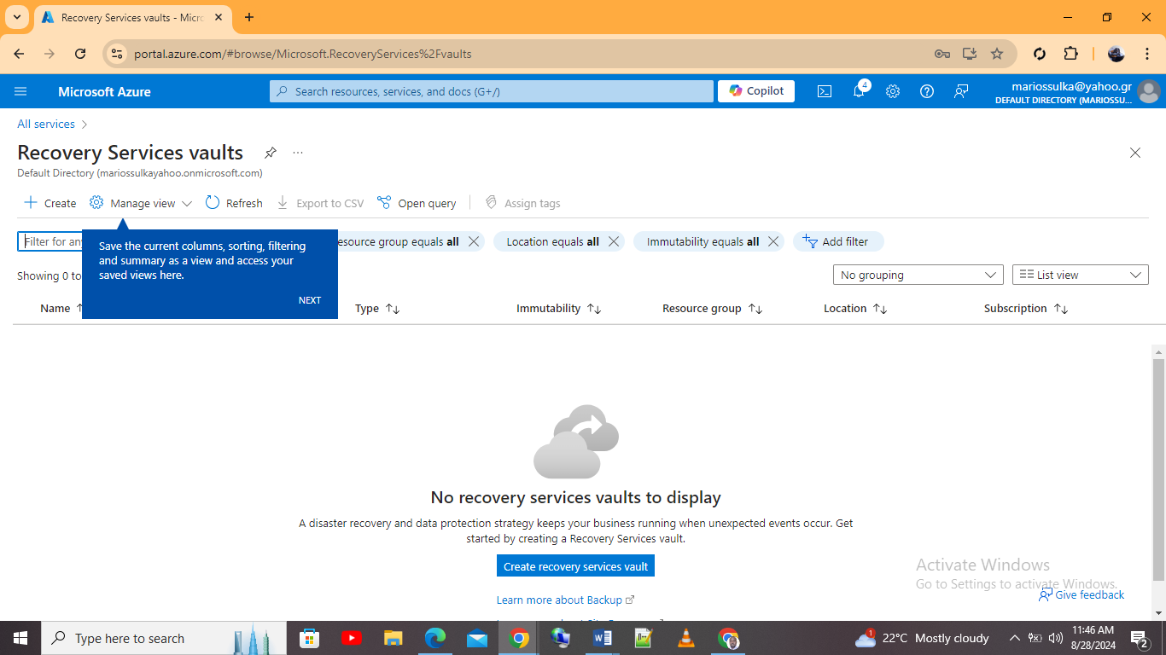
Created recovery service fault
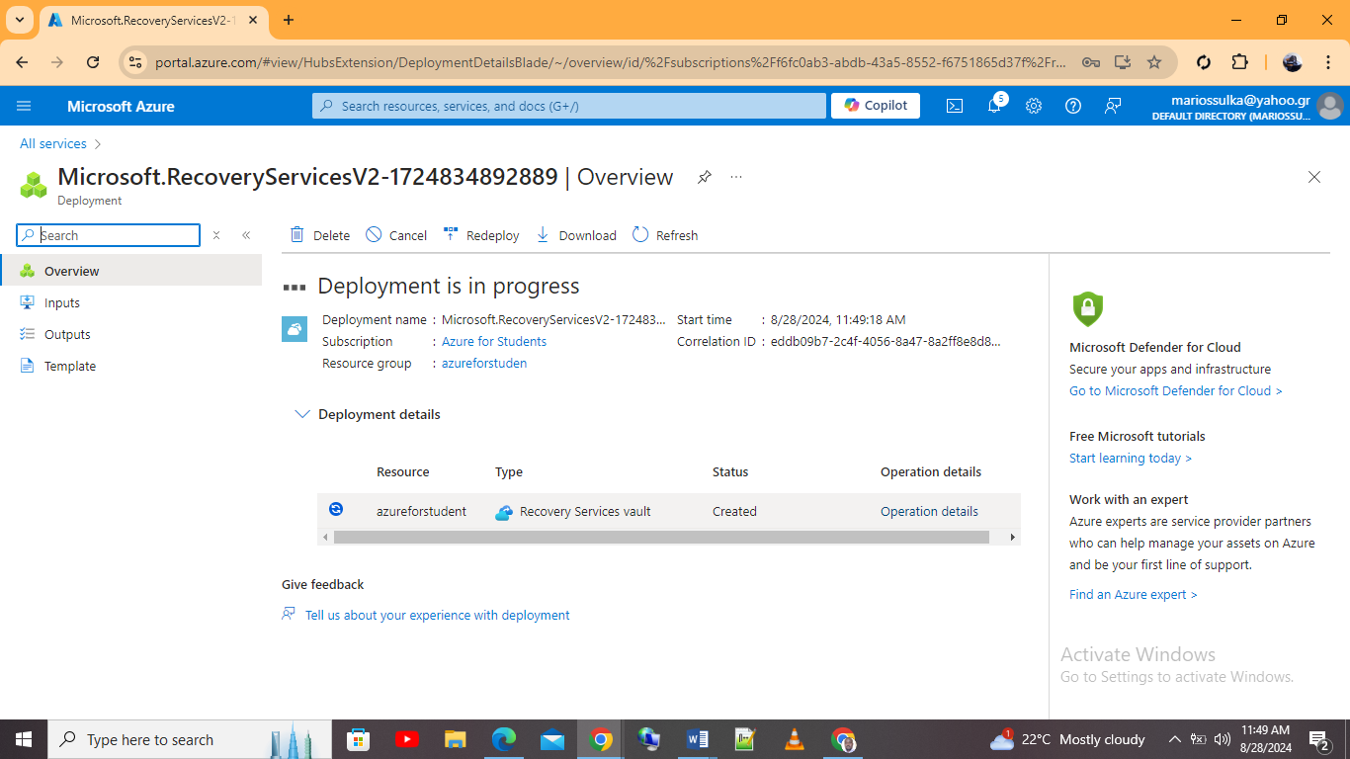
Step 2: Creating back-up vaults
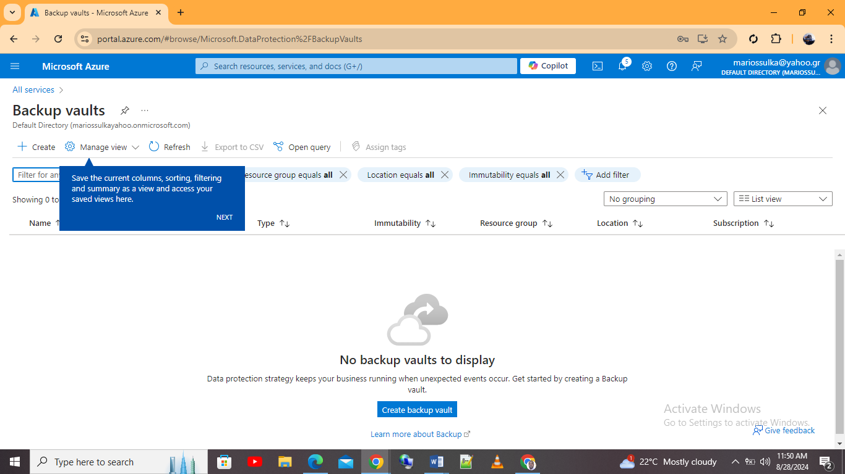

Step 3: Back-up for Azure files
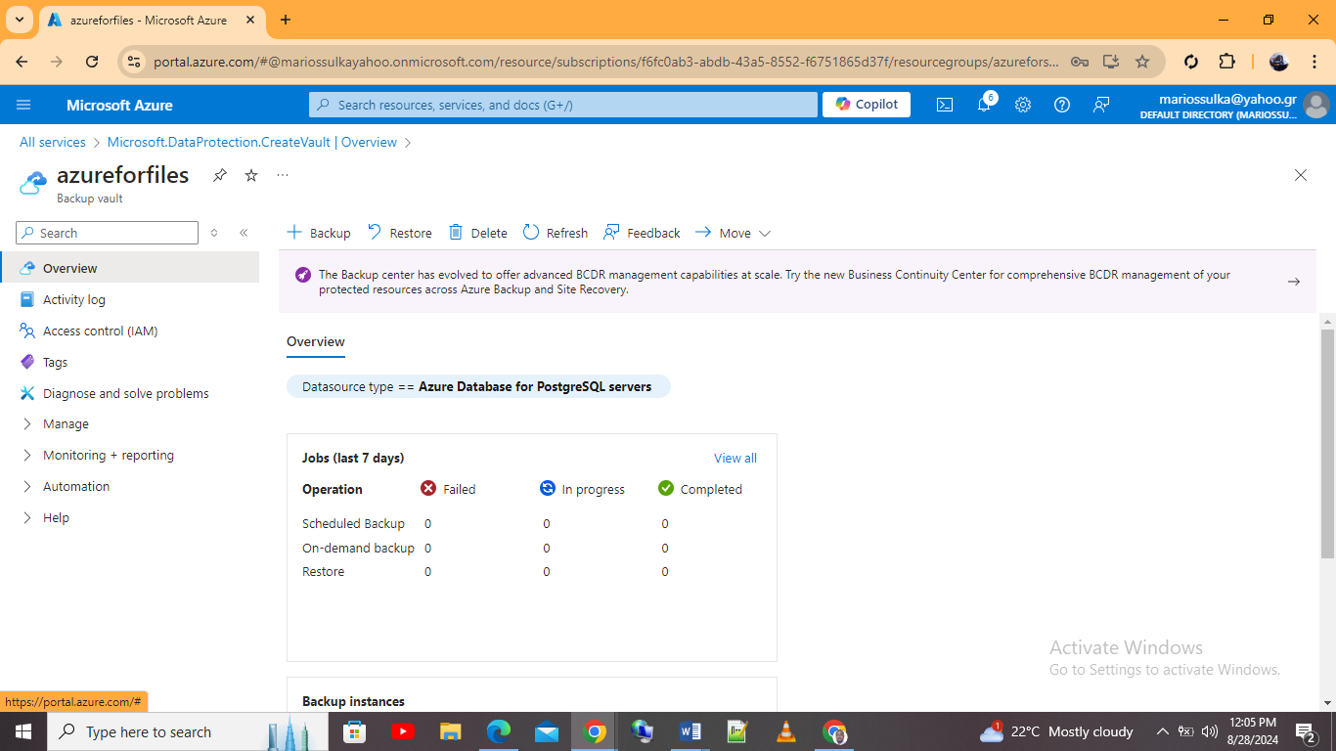

Azure back-up for database option
Another Azure back-up option available is the Azure back-up for databases. This is a type of Azure back-up which supports recovery for Azure databases. In this case the GLI organization can configure this back-up directly from the database service or via the recovery service fault. This case showcase how to carry the back-up via the Azure database for MySQL database service as shown by the below steps and screenshots
Step 1: Configuring Azure MySQL database back-up
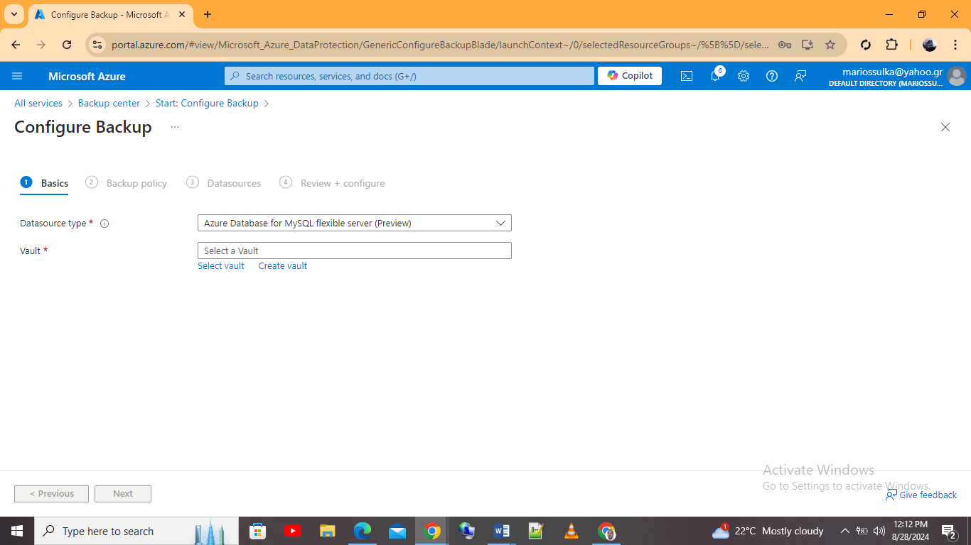
Selecting the database to back-up
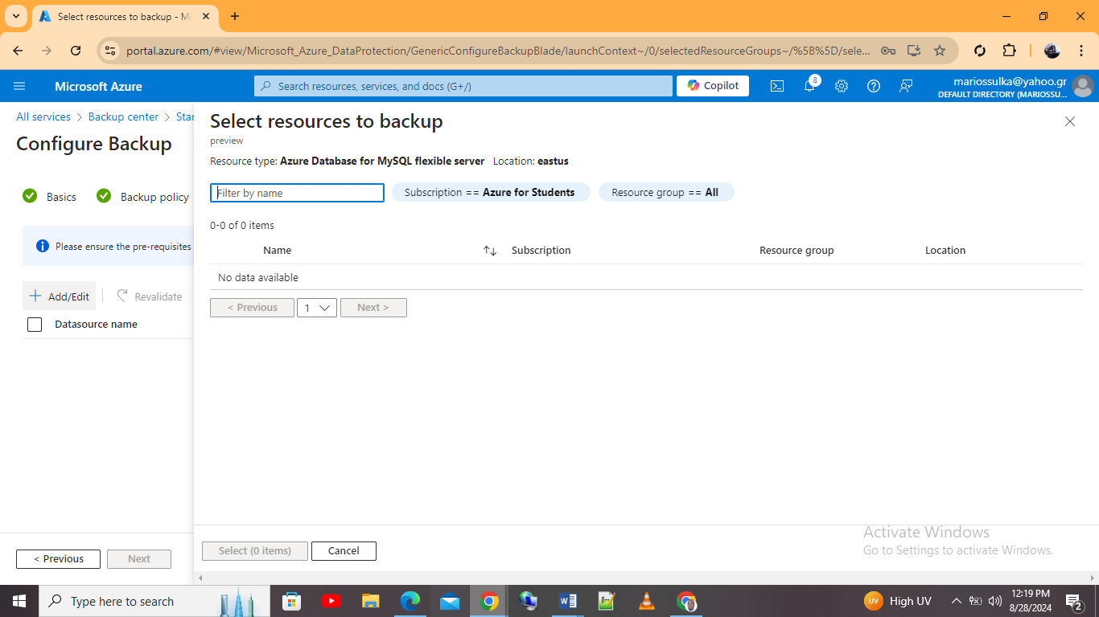

Azure Site Recovery
As indicated in this case, GLI is reliant on online education platforms; this means that the organization infrastructure needs to unexpected outages or any form of disaster. One of the feature which the organization can implement in the Azure platform is the Azure Sire recovery commonly known as ASR. This feature provides a robust disaster recovery process which ensures continuity and one which protects GLI’s databases and storage systems. Also, it ensures a minimal downtime and a rapid recovery process.
Specifically, ASR feature is three to ensure business continuity by replicating workloads running on virtual and physical virtual machines. Also the feature enables a seamless failover to the replicated site thereby allowing operations to continue with a minimal interruption. Also the feature supports Azure to Azure and on premise to Azure [13].
For GLI organization, ASR provides the following capabilities which are geo-replication which replicates Azure File shares to a secondary region. This in turn ensures that in case a primary region experiences an outage, then data or information is available in the secondary region. This minimizes data loss. Lastly ASR allows configuration of policies which are back up and which determine how frequent back-ups are taken. This in return ensures that the organization is able to recover data from various points in tine

References
- Heinrich, “AIS Electronic Library (AISeL) - Hawaii International Conference on System Sciences 2023 (HICSS-56): A Total Cost of Ownership Model for Cloud Computing Infrastructure,” Aisnet.org, 2023. https://aisel.aisnet.org/hicss-56/os/enterprise_system_integration/2/
- Valiramani, “Microsoft Azure Compute,” Google Books, 2022. https://books.google.com/books?hl=en&lr=&id=ftfPEAAAQBAJ&oi=fnd&pg=PR3&dq=Azure+Calculator+&ots=FkZZtpinAC&sig=_TatULCGnMm4Rd4vs0bTYA5XJf8 (accessed Aug. 28, 2024).
- S. Buchanan and J. Joyner, “Azure Management Insights,” Apress eBooks, vol. 1, no. 2, pp. 39–72, Dec. 2021, doi: https://doi.org/10.1007/978-1-4842-7768-3_3.

- Michalski, Damaschke, and Klaffenbach, “Implementing Azure Solutions,” Google Books, 2017. https://books.google.com/books?hl=en&lr=&id=zHc5DwAAQBAJ&oi=fnd&pg=PP1&dq=Azure+Calculator+&ots=Yeu7xy0pTo&sig=mG0-2uYlBvxgkr5F-kPcSNchNkM (accessed Aug. 28, 2024).
- Waly, “Learning Microsoft Azure Storage,” Google Books, 2017. https://books.google.com/books?hl=en&lr=&id=EEBPDwAAQBAJ&oi=fnd&pg=PP1&dq=Azure+Calculator+&ots=pmxeJz3QOM&sig=xzLfq6DSWKEper6DM5fIt0haHHI (accessed Aug. 28, 2024).

- P. Mazumdar, S. Agarwal, and A. Banerjee, “Microsoft Azure Storage,” Apress eBooks, vol. 2, no. 1, pp. 35–52, Jan. 2016, doi: https://doi.org/10.1007/978-1-4842-2083-2_3.
- R. Ramakrishnan et al., “Azure Data Lake Store,” Proceedings of the 2017 ACM International Conference on Management of Data, May 2017, doi: https://doi.org/10.1145/3035918.3056100.

- Jennings, “Cloud Computing with the Windows Azure Platform,” Google Books, 2024. https://books.google.com/books?hl=en&lr=&id=KkwsRbTzkKQC&oi=fnd&pg=PR9&dq=Azure+File+Storage&ots=X7OO6dNVRm&sig=lQNupf-3uYoMBS5AfPqOm5gqK1k (accessed Aug. 28, 2024).
- M. Copeland, J. Soh, A. Puca, M. Manning, and D. Gollob, “Understanding Azure Storage and Databases,” Apress eBooks, vol. 1, no. 2, pp. 177–201, Jan. 2015, doi: https://doi.org/10.1007/978-1-4842-1043-7_7.

- J. R. Guay Paz, “Introduction to Azure Cosmos DB,” Microsoft Azure Cosmos DB Revealed, vol. 1, no. 2, pp. 1–23, 2018, doi: https://doi.org/10.1007/978-1-4842-3351-1_1.

- Vallarapu, “Beginning PostgreSQL on the Cloud,” Google Books, 2018. https://books.google.com/books?hl=en&lr=&id=iVNSDwAAQBAJ&oi=fnd&pg=PR5&dq=Azure+Database+for+PostgreSQL&ots=WC6p_UKy3T&sig=BM2ShuLrF14_P4r0-66dTa6x_7E (accessed Aug. 28, 2024).

- P. Antonopoulos et al., “Constant time recovery in Azure SQL database,” Proceedings of the VLDB Endowment, vol. 12, no. 12, pp. 2143–2154, Aug. 2019, doi: https://doi.org/10.14778/3352063.3352131.

- B. Chakraborty and Y. Chowdhury, “Introducing Azure Site Recovery,” Introducing Disaster Recovery with Microsoft Azure, vol. 1, no. 2, pp. 43–79, 2020, doi: https://doi.org/10.1007/978-1-4842-5917-7_2.

