

Undergraduate assignment feedback form
(to be completed by marker)

Student Name: Sophie Rossiter

Module Code: CSPB 4001  Module title: Persuasive language | Student number:1707327
For completion by marker:
Comments:

Marker’s signature: |  | Date:
Provisional mark:
NB. All marks are provisional until confirmed by the final examination board.

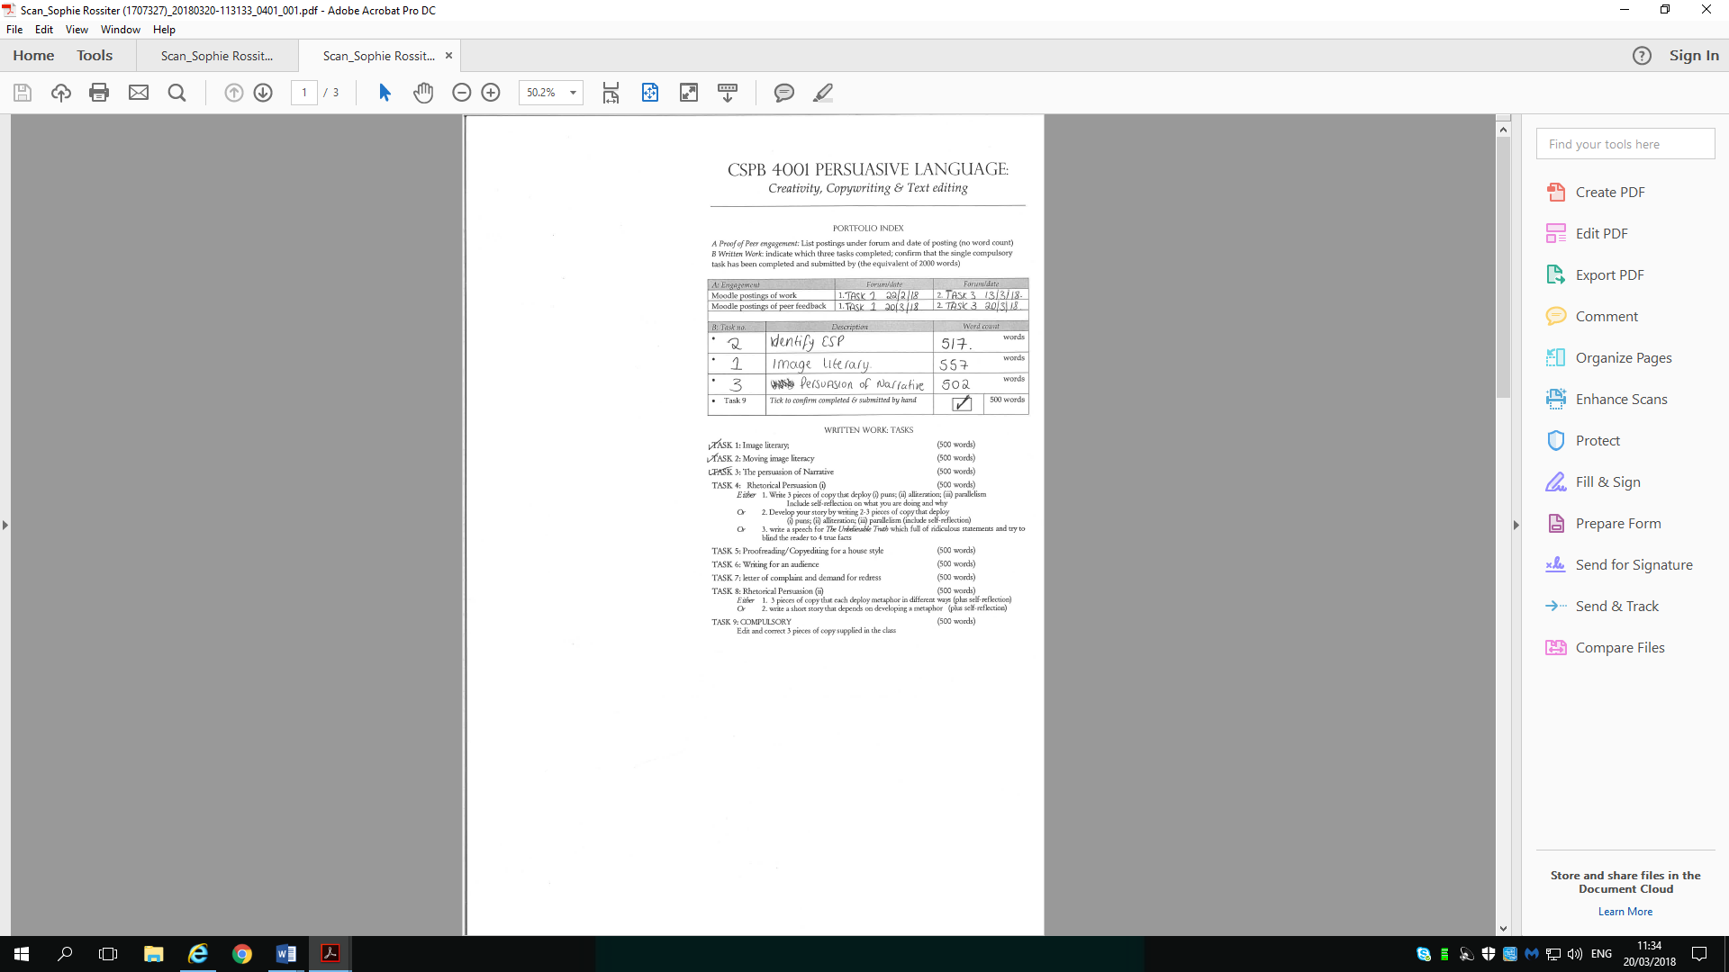

CSPB4001
Assignment 2 – Moving Image Literacy
Identifying the Emotional Selling Proposition (ESP)
St Johns Ambulance First Aid Course
Published: April 2014 in Australia
https://www.youtube.com/watch?v=HMUvDx9WlUQ

To identify the ESP of an advert, three questions need to be asked;
- What atmosphere does it attempt to create?
The atmosphere of this advert is heart breaking. It pulls at your heart instantly. It shows a young boy playing while (presumably) mum is sat nearby. He is confident in the water and is enjoying himself. She is happy for him to be playing there, it’s clear that it isn’t the first time he has done this. It then creates panic and heart break as the boy hits his head and unfortunately there is nothing his mum can do to help save him. If you have first aid, then you can avoid the atmosphere altogether. The fact that they have a swimming pool, have a large, comfortable house and demonstrate that they are a caring family through the warm interaction between the mother and child. They don't look time constrained or harassed. This speaks volume to who it is aimed at. The pool is clean and secluded so there are no threats from the outside world, just the threat of not knowing first aid.

- Which attributes or qualities are linked to the brand or product?
St Johns Ambulance is a well known service world wide. They offer first aid training and are linked to first responders. You can usually find them at most well organised out door type events and are linked to a lot of charity events. It is a positive organisation that only encourages goodness.
- How does it attempt to manipulate our emotion?
This advert not only attempts to manipulate our emotion but succeeds triumphantly. It is easy to relate to as no parent would ever want to go through the scene showed on the clip. It is heart breaking to think that if your child or any child for that matter had an accident and you were unable to help them through first aid that you could essentially lose them, where-as if you have just take a first aid course then there is a higher chance of helping the said child.
It is something that will stay in your head and possibly haunt you, it is the type of advert that would make you think twice. I know personally that after watching this advert I am already looking into retaking my first aid course.
I don’t think the mother in this video is purposefully neglecting to watch the child, an accident like that can take seconds, and it is not possible to watch someone at every second. It is very emotional and extremely effective.
It makes you empathise with the woman in the video, and imagine what you would do in her position. It is one of the most effective pieces of advertising I have seen.
Showing affluent family home and them still not being able to do anything shows that money doesn’t help as it can happen to anyone. It speaks to such a wide audience.

Persuasive Language:
Creativity, Copywriting and Text Editing (CSPB4001)
TASK 1: Image literary

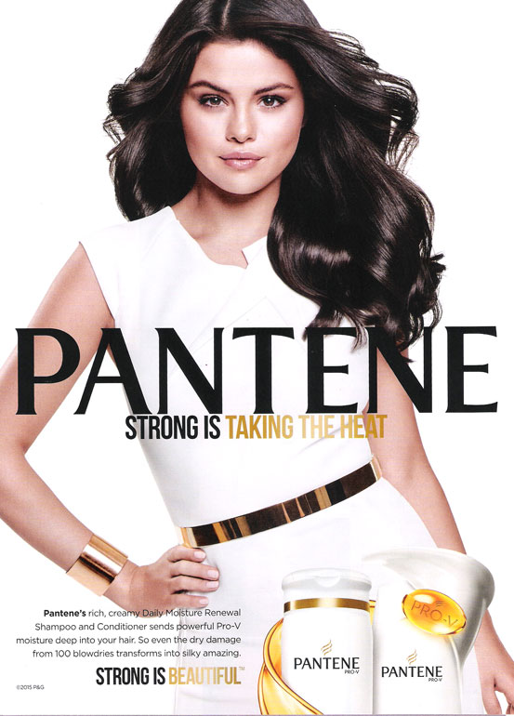
I have chosen a celebrity endorsed advert as I find these are usually more effective. This particular advert is for Pantene shampoo and conditioner.
Using Selena Gomez as the ambassador for this brand of shampoo has a positive effect as she has really great hair, and as self-image is big right now, most people take pride in their appearance, even if it is just making sure your hair is clean.
Obviously, just from using this shampoo your hair will not look like the advert, her hair has been styled, her makeup professionally applied and her wardrobe far more exceptional than your average female, but its relatable as most women under the age of 30 will have heard of her and or seen her on screen/in magazines.
The text on the advertisement is also persuasive, it states that your hair will become ‘silky amazing’ which is something that most people would love to have used as words describing their own hair.
This shampoo and conditioner set will combat damage caused by heat, i.e.; blow drying and straightening, which as a female, you are aware of the consciences that come with every day damage.
This product will make your hair look stronger and healthier, will make you ‘beautiful’ and ‘strong’ both positive and uplifting to a female. The hair used in the advert is a very healthy brown hair, which corresponds the tones of the advert. Its screaming beautiful hair which is what a lot of females aspire to have. It is a very natural colour enhancing the shampoo to more women.
I find this advert personally persuasive, I recognise Selena Gomez, I recognise the brand, I like the simple gold and white colour theme. The focus is on the hair, so the basic colours add to the beautiful colour and shine on her hair. This advert would quite possibly stand out in my head when going to buy shampoo at the supermarket. It focus’ on the health benefits instead of fragrance. I also appreciate the subtle link between her dress and jewellery and the bottles, they are matching which will only help with their advert as if you remember how great she looks, next time you are in the supermarket you will instantly notice the bottles on the shelf as appose to the bright coloured brands.
If it were to combat specific anxieties, I would assume it is trying to build confidence so on a level it could achieve this (if the product works as well as stated) and could really benefit people who have low self-esteem.
Buying this product would overall have a positive effect. It is the sort of thing that you could recommend to a friend who has heat-damaged hair, as it is so common to use heated products in this day and age that we do rely upon shampoo and hair treatment to counteract the damage we cause. This is also relayed in the image as she is taking the heat in a sleeveless dress, the defence is in the bottle/dress with little else needed.
In conclusion, I think I would try the product from the advert, and next time I am in a supermarket I will most definitely remember this advert as the bottles look similar to Selena’s outfit. Her white dress with the gold detail is almost identical to the shampoo bottle.

Persuasive Language:
Creativity, Copywriting and Text Editing (CSPB4001)
TASK 3: The persuasion of Narrative
Q. Develop a persuasive Conspiracy theory and promote it online (negative enchantment)
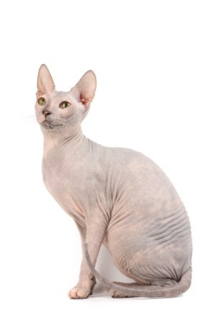

Cats are secretly alien spies sent to earth to transmit information ready for an invasion from a new world. Due to an increase in stray cats it’s clear that the aliens are closer than ever to completing their mission.
Cats may seem cute and cuddly, but their lack of voice box has heightened speculation on the species, with scientists coming back with no answers for the noise they make.
“A rhythmic, repetitive neural oscillator [in the brain] sends messages to the laryngeal muscles, causing them to twitch at the rate of 25 to 150 vibrations per second (Hz). This causes a sudden separation of the vocal cords, during both inhalation and exhalation - the unique feline vibrato.
"Opera singing for cats," is what animal behaviorist Karen L. Overall, VMD, PhD calls it. But the purr is usually so low-pitched that we tend to feel it as much as hear it.”

It has already been hinted at during the episode of Fututama, That darn Katz where the cat fully admits being an alien spy. It is time we took notice and started banning the creatures from our homes as they are interfering with our devices and channelling information with every ‘purr’ that we hear.
We may have been side-tracked with the feline’s ability to lower blood pressure in humans but its time we took a different view on the pesky animals. How many other pets can survive and thrive so well in the wild? It is no wonder the aliens chose a cat though, as it has managed to blend into society dating back as far as the Egyptian times back when Cleopatra took a liking to them. We have gone from a Sphynx with no fur or whiskers with a great likeness to aliens to a variety of cute and cuddly versions, all of whom we willingly welcome into our homes giving the aliens free reign to our information.
Every time your cat enters a box seemingly too small for it to sit in, we may beam with excitement and tell our friends, but the furry aliens are waiting to be beamed back to their land, they are mistaking cereal boxes for the mothership and we are blinded by their cuteness.
It is time we stood up for our dogs, they’re not assholes who just refuse to get along with the felines, they have seen them reporting back to their leaders when we aren’t looking, please I urge you to put your cat outside for the last time, lock your cat flap then cover it over, for your safety and for the safety of the rest of the world, we must not let the cat win. They may have nine lives to our one but we must take a stand! It is time the cat didn’t land on its feet.

https://pets.webmd.com/cats/features/why-cats-purr#1
https://www.youtube.com/watch?v=whRgzBcrcVg
https://pets.thenest.com/cats-lowering-blood-pressure-humans-8509.html
https://www.google.co.uk/search?q=cats+are+secretly+aliens&source=lnms&tbm=isch&sa=X&ved=0ahUKEwiMh6WTpOrZAhWB3KQKHY9BCbcQ_AUICigB&biw=1438&bih=686&dpr=0.95#imgrc=gkILzpwtu6uvCM:

