

Programme Master of Business Administration
Module: MARKETING MANAGEMENT
Module code: LCMB7024
Title: Marketing Environment Analysis
Word Count: 2635
Lecturer: Dian Mayasari

Student Name: Vaishnavi Vasantrao Patil
Student ID: 2504969
Submission Date- 24th October 2024

Contents
1 Introduction 3
2 Macro Marketing Environment (Task-1) 3
2.1 Technological Factors- 4
2.1.1 Global Technological Trends 4
2.1.2 Opportunities and Threats for The North Face (Pioneer) 4
2.1.3 Opportunities and Threats for Columbia Sportswear (Followers) 5
2.1.4 Comparative Summary- Technological Factor 5
2.2 Socio-Cultural Factor- 6
2.2.1 Global Socio- Cultural Trends- 6
2.2.2 Opportunities and Threats for The North Face (Pioneer) 6
2.2.3 Opportunities and Threats for Columbia Sportswear (Followers) 6
3 Strategic Responses- (Task 2) 7
3.1 Overview of Pioneer and Follower Strategy 7
3.2 Strategic Response to Socio- Cultural Factors 7
3.3 Strategically Adjusting to Technological Aspects 8
STP Analysis: 9
7Ps of the marketing mix: 10
4 Conclusion: 12
5 References 12

1 Introduction
The purpose of this report is to critically analyse the ways in which macroenvironmental factors impact the strategic marketing management of two well-known outdoor apparel companies, The North Face and Columbia Sportswear. The North Face is recognised as a trailblazing brand known for technological innovation and premium positioning, while Columbia is a follower brand that successfully adapts established technologies to reach a wider, budget-conscious audience. Despite being in the same competitive industry, these brands handle marketing differently.
Because it enables companies to anticipate external changes that may affect long-term profitability, competitiveness, and demand, macro marketing environment analysis is essential to strategic marketing management. To identify external opportunities and risks that are beyond their control but are crucial for strategic decision-making, marketing professionals employ frameworks such as PESTEL (Political, Economic, Social, Technological, Environmental, and Legal). A thorough understanding of these external factors can help businesses stay competitive, develop proactive plans, and align marketing objectives with environmental realities.
The report is divided into two main sections. Task 1 closely examines the risks and opportunities that Columbia and The North Face encounter due to advancements in Socio Cultural and technological contexts. Task 2 then evaluates how these companies strategically react to the identified elements using relevant marketing theories and models to keep their competitive edge in the global outdoor apparel market.

2 Macro Marketing Environment (Task-1)
The macro marketing environment is made up of uncontrollable external factors that have an impact on how businesses create strategies, compete in markets, and stay competitive over the long run. The PESTLE framework (Political, Economic, Socio-Cultural, Technological, Legal, and Environmental) is commonly used to analyse these external factors. Even though every element has strategic implications, this paper concentrates on technological and sociocultural players because of their growing impact on market dynamics, consumer expectations, and innovation pathways (Kotler & Keller, 2016). The global market for outdoor gear has expanded dramatically as more people look for healthier lifestyles and sustainable consumption patterns. In 2024, global sales were projected to reach $23 billion, with a 5-6% yearly growth expected (Statista, 2024). This sector is impacted by sustainability regulations, technological developments, and societal shifts that value diversity, well-being, and ethical consumption (McKinsey & Company, 2024). A division of VF Corporation, The North Face (TNF) is a pioneer in this industry, producing cutting-edge performance technology and upscale designs. McKinsey & Company (2024) claims that Columbia Sportswear (CSC) uses a market follower strategy, leveraging established technologies to offer practical products to a larger spectrum of cost-conscious customers. Understanding macroenvironmental factors is crucial for strategic marketing management since they enable companies to anticipate opportunities and lower risks.

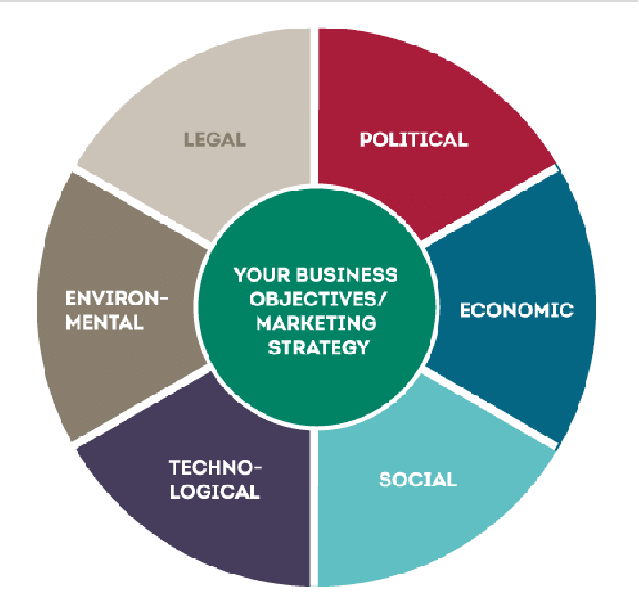

Figure 1. The six components of PESTLE analysis

2.1 Technological Factors-

2.1.1 Global Technological Trends
Rapid automation, digitalisation, and sustainability-driven R&D are all transforming the outdoor clothing market. Emerging technologies that enhance breathability and weather protection include nanotechnology and smart textiles. Additionally, 3-D design and digital twin tools streamline prototypes, reducing costs and material waste. The expansion of e-commerce and AI-powered analytics allow businesses to customise the customer journey, while sustainable manufacturing innovations like waterless dyeing and recyclable textiles support environmental goals (McKinsey, 2024; Forbes, 2024). These technological advancements offer the industry's companies both strategic and operational opportunities.

2.1.2 Opportunities and Threats for The North Face (Pioneer)
As a pioneer, TNF could use cutting-edge technologies like Future light and ThermoBall Eco to bolster its market dominance and sustainable credentials (VF Corporation, 2024). 3-D virtual sampling speeds up product development and helps achieve environmental goals (Business of Fashion, 2024). Furthermore, production planning and premium customer experiences are improved by omnichannel integration and AI-enhanced forecasting (Forbes, 2024). However, because rapid copying shortens the duration of technical advantages, it threatens TNF (Rogers, 2003). High R&D expenses put additional strain on finances, and reliance on specialised suppliers like Gore-Tex may reduce operational flexibility. TNF uses the Diffusion of Innovation concept to take on early-adopter risk while earning reputational benefits. By claiming that its patented technologies, sustainability expertise, and brand equity are valuable and difficult to replicate, the Resource-Based View preserves uniqueness in the face of copying pressures (Barney, 1991).

2.1.3 Opportunities and Threats for Columbia Sportswear (Followers)
CSC can reduce R&D costs while maintaining the reliability of its products' performance by utilising proven technologies like Omni-Heat Infinity and Out Dry Extreme (CSC, 2024). Growth in digital marketing and e-commerce further increases accessibility (Statista, 2024), and partnerships with technology providers optimise supply chains and spread innovation risk (Gartner, 2024). However, reliance on licensed or outdated technologies may limit distinctiveness, and mid-market margins restrict investment in radical innovation (IBIS World, 2024). In terms of dynamic capabilities, CSC excels at spotting and quickly adopting tested technologies, transforming its reputation as a follower into cost-effectiveness and operational agility (Teece, 2007). Its technology strategy prioritises process optimisation over innovation, which supports a broad market focus.

2.1.4 Comparative Summary- Technological Factor
Aspect | The North Face (Pioneer) | Columbia Sportswear (Follower) | Implication
Focus on innovation | Adoption of established technology | Pioneers drive innovation, while followers democratise it | Proprietary technology through rigorous R&D
Competitive logic | Differentiation through performance & sustainability | Cost efficiency and scalability | Distinct routes to competitive advantage
Key theories | RBV; Diffusion of Innovation | Dynamic Capabilities | —

2.2 Socio-Cultural Factor-

2.2.1 Global Socio- Cultural Trends-
Sociocultural factors are causing a shift in consumer expectations for outdoor apparel. Growing ethical and environmental concerns are driving demand for sustainable products. Outdoor recreation is also encouraged by the growing popularity of wellness-focused and experiential lifestyles. Diversity and inclusivity movements also demand gender-neutral and adaptive clothing, even as social media activism intensifies scrutiny of corporate authenticity and ethical standards (Vogue Business, 2024; Nielsen IQ, 2024). These trends increase the risk of reputational harm even though they offer brands the opportunity to emotionally connect with consumers.

2.2.2 Opportunities and Threats for The North Face (Pioneer)
By linking its brand to environmental action, adventure, and exploration, TNF strengthens its aspirational character (McKinsey & Company, 2024). Initiatives such as The Explore Fund support purpose-driven marketing strategies and involve communities (VF Corporation, 2024). Its clientele is also increased by the rise in female involvement in outdoor sports. However, if sustainability promises are exaggerated, TNF could be accused of greenwashing due to increased transparency demands (Harvard Business Review, 2023). Trends towards inclusivity may clash with premium pricing, and audiences may become polarised by activist efforts. While Maslow's hierarchy says purchases meet esteem and self-actualization requirements, TNF's story combines adventure with identity and self-expression, as explained by Consumer-Culture Theory (Arnould & Thompson, 2005). This highlights the significance of authenticity in maintaining emotional brand equity.

2.2.3 Opportunities and Threats for Columbia Sportswear (Followers)
Using inclusive sizing, community partnerships, and affordable sustainable lines, CSC positions itself as a family-friendly, wellness-focused, and approachable brand for outdoor recreation (CSC CSR, 2024; Statista, 2024). Aspiration and affordability are balanced by its "masstige" branding (Deloitte, 2024). However, cost-conscious consumers may prioritise money over ethics (PwC, 2024), and fads driven by fashion may overshadow CSC's practical designs (WGSN, 2024). By emphasising inclusivity and value orientation, CSC fosters cultural resonance through relatability rather than elite positioning.

3 Strategic Responses- (Task 2)

3.1 Overview of Pioneer and Follower Strategy
To gain a competitive edge, businesses employ a range of strategic management techniques. Pioneer strategies include being the market leader and introducing novel products, concepts, or technologies. First-mover advantages like greater pricing power, customer loyalty, and brand recognition are often the outcome of these tactics (Lieberman & Montgomery, 1988). Pioneers face greater risks in R&D and innovation.
To adopt or imitate innovations made by trailblazers is the aim of a follower strategy. Followers can use market insights from early adopters and benefit from lower R&D costs, as they often target larger or more cost-sensitive markets (Lieberman & Montgomery, 1988). The North Face is a shining example of a trailblazing strategy in the outdoor apparel industry thanks to its investments in state-of-the-art technology, upscale branding, and creative goods. Columbia Sportswear is an excellent illustration of a follower strategy since it uses proven technologies, streamlines operations, and concentrates on price.

3.2 Strategic Response to Socio- Cultural Factors
Sociocultural trends have a big impact on consumer choices in the outdoor apparel market, particularly when it comes to lifestyle, sustainability, and inclusivity.
The North Face (Pioneer)
- Strategy: To appeal to wealthy, socially conscious clients, emphasise sustainability and adventure.
- Product Development: Sustainable material usage, circular design, and repair programs are all in line with eco-friendly trends.
- Marketing: The "Never Stop Exploring" campaign appeals to sociocultural values of exploration, well-being, and environmental awareness by promoting outdoor adventure as a way of life.
- Customer engagement: Increases social impact and brand credibility by collaborating with influencers and environmental organisations.
Columbia Sportswear (Follower):
- Strategy: Provides affordable, useful outdoor clothing to a wider range of mid-market consumers.
- Product Development: To appeal to socially concerned consumers without charging exorbitant premium prices, recycled materials and energy-efficient production methods are used.
- Marketing: Reliability, affordability, and family-friendly outdoor activities are highlighted in functional, inclusive advertising that appeal to popular sociocultural values of practicality, accessibility, and wellbeing.
- Adaptability: Quickly reacts to market sociocultural trends, such as growing demand for eco-friendly clothing or informal outdoor activities.

3.3 Strategically Adjusting to Technological Aspects
Product performance, sustainability, and customer satisfaction are all impacted by technological innovation.
The North Face (Pioneer):
- R&D Investment: With a focus on sustainability and performance enhancement, VF Corporation has made a substantial investment in new technologies.
- Technological Initiatives:
- Digital twin technology for sustainable product design and rapid prototyping.
- Collaborations with Intel and GORE-TEX for innovative performance and water-resistant materials.
- Omnichannel Customer Experience: This strategy blends virtual reality (VR) in-store experiences, physical shopfronts, and mobile apps to enhance customer interaction and brand engagement.

Columbia Sportswear (Follower)

• Adoption of Technology: Successfully integrates tried-and-true technology into their product lines, including Omni-Heat reflective lining and waterproof breathable fabrics.
• Process Innovation: Reduces expenses by using technology to optimise manufacturing and supply chain operations.

• E-commerce Optimisation: By customising online purchases, AI-powered recommendation systems increase customer satisfaction and conversion rates.

Analysis of the Resource-Based View (RBV):
• The North Face: Has distinct, difficult-to-copy technological skills that give it a long-term competitive edge (Barney, 1991).
• Columbia: Makes use of operational effectiveness and flexibility to react swiftly to consumer demands and technological advancements.

Application to Pioneers and Followers:
Through creative products, state-of-the-art materials, and a strong global brand identity, pioneers like The North Face benefit from long-term distinction. The company's emphasis on high-performance outdoor clothing and continuous innovation enable it to command premium pricing, long-term market leadership, and customer loyalty, despite the fact that significant R&D investment carries a higher short-term risk.
To compete in established markets, followers (Colorado Sportswear, Patagonia) rely on cost leadership and operational efficiency. These businesses place a high priority on competitive pricing, effective production, and small-scale product improvements. This strategy limits the ability to achieve the same level of long-term financial sustainability and brand distinction as pioneers, despite ensuring stability and market presence.

Aspect | The North Face (Pioneer) | Columbia Sportswear / Patagonia (Followers)
Emphasis on Tactics | Differentiation | Hybrid and Cost Leadership
Core Focus / Products | Innovative materials, superior branding, unique/creative products | Small-scale product improvements, operational efficiency, competitive pricing
Innovation & R&D | High investment in product innovation and R&D | Focus on process optimization; modest investment
Brand Positioning | Upscale, practical outdoor apparel | Dependable and conveniently available outdoor apparel
Customer Loyalty | Strong brand loyalty due to unique products | Moderate loyalty; price-conscious clientele
Short-term Performance | High volatility due to innovation risk | Reliable and consistent performance
Long-term Sustainability | High, driven by differentiation and brand power | Moderate; constrained by less distinct market positioning
Risk Level | Increased systematic risk due to market uncertainty and innovation | Decreased; consistent and efficient operations

STP Analysis:
• Segmentation: Columbia targets more general mainstream segments, whereas The North Face targets premium, speciality sectors.
• Targeting: The North Face focusses on high-performance adventure consumers who are socially concerned. Columbia caters to consumers who are family-oriented and cost-conscious.
• Positioning: Columbia prioritises usability, affordability, and inclusivity, while The North Face sets itself apart with premium quality, innovation, and lifestyle branding.
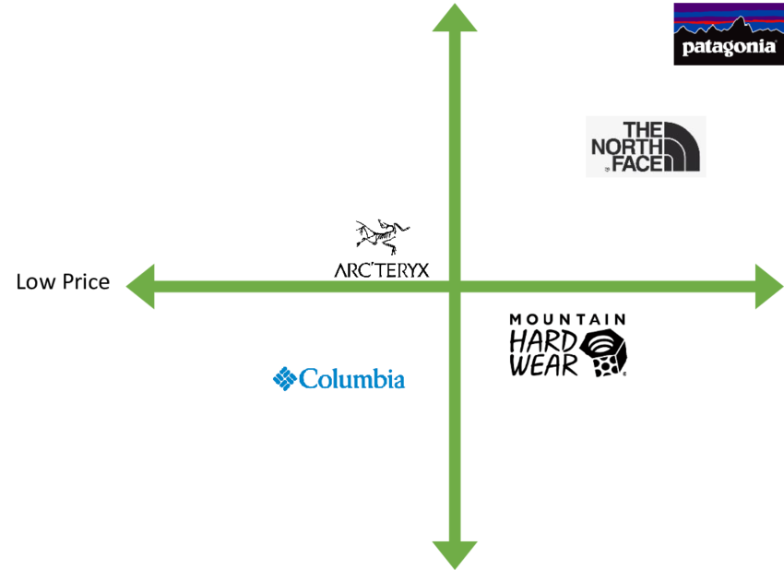
Figure 2 Brand positioning perception map Source (Qiviut & co, 2018)

7Ps of the marketing mix:
Marketing Mix Element | The North Face (Premium, Technical) | Columbia (Mid-market, Functional)
Product | specialised, high-performance equipment made for extreme sports like rock climbing and mountaineering. The brand places a strong emphasis on durability, exclusive innovations, and partnerships with luxury labels like Gucci. | Sportswear that is practical, reasonably priced, and adaptable for a variety of daily wear and activities. renowned for inventions like the Omni-Heat insulation system.
Price | Its reputation for high-quality materials, technical expertise, and innovative designs is reflected in its premium pricing. For instance, its upscale Summit Series is far more costly than the majority of Columbia equipment. | In general, more affordable and available to mid-market customers. Competitive pricing is offered, along with regular specials and discounts.
Place | Omni-channel distribution consists of agreements with upscale shops, independent retail locations, and an e-commerce website. The goal of the customer-focused strategy is to provide a "point of difference" on the company's website. | extensive distribution via its own retail locations, online sales, and a vast network of athletic goods merchants, department shops, and marketplaces. For the typical consumer, accessibility and wide availability are given top priority.
Promotion | uses intense advertising campaigns with extreme athletes and influencers to appeal to a younger, more fashion-conscious audience. Fashion trends, performance, and exploration are highlighted in the messaging. | use a more traditional and approachable marketing approach, occasionally incorporating a light-hearted or tongue-in-cheek tone. The company markets itself as dependable for "whatever" outdoor conditions are, and emphasises the advantages of its technologies, such as Omni-Heat.
People | cultivates a brand-focused culture with enthusiastic staff members and athletes who support the outdoor exploration purpose. Those who are serious about their equipment and outdoor activities are the target audience for customer service. | upholds a customer-first mentality, but on a bigger corporate scale, leading to more uniform interactions amongst employees. The emphasis is on being useful and having functional knowledge for a larger clientele.
Process | a digital-first strategy and a streamlined supply chain to meet consumer demands. Throughout its manufacturing process, the company prioritises performance and innovation while utilising cutting-edge technologies. | a focus on scalable procedures and effective operations to satisfy the needs of a mass market audience. The company uses an open supply chain to keep an eye on its production standards.
Physical Evidence | Through interactive digital content and sustainability-related educational displays, flagship stores—like the one featured in a Mood Media case study—are intended to strengthen the brand's identity. The purpose of product packaging is to convey the distinctive quality and value of the brand | The uniformity and broad appeal of retail spaces represent the brand's approachable and practical essence. emphasises visibility in a variety of retail environments, including both its own stores and those of other partners.

4 Conclusion:
Technology and sociocultural variables have a big impact on outdoor clothing firms' strategic choices. The North Face uses cutting-edge technology to produce inventive, high-performance goods and engaging consumer experiences, while also using sociocultural themes like sustainability, wellness, and adventurous lifestyle to strengthen premium differentiation. By focussing on process optimisation, implementing established technologies effectively, and creating accessible, socially conscious products that appeal to a wider range of consumers, Columbia Sportswear responds to the same macro factors.
These methods are reflected in marketing strategies: Whereas Columbia prioritises cost, usefulness, and diversity, The North Face places more emphasis on influencer relationships, experiential marketing, and premium positioning. This comparison emphasises how followers rely on flexibility, agility, and operational efficiency, whereas pioneers rely on uniqueness and creativity.
All things considered, technological and sociocultural factors propel ongoing strategic alignment, influencing competitive positioning, customer interaction, and product development. Both Columbia and The North Face preserve market relevance, exhibit adaptability, and establish long-term competitive advantages by proactively reacting to these outside forces. Their methods show that long-term success in the fast-paced outdoor clothing sector requires strategic reactions to macroenvironmental conditions.

5 References
- Barney, J. (1991) Firm resources and sustained competitive advantage. Journal of Management, 17(1), pp. 99–120.
- Business of Fashion (2024) Sustainable innovation in performance wear. Available at: https://www.businessoffashion.com/
- Columbia Sportswear Company (CSC) (2024) Corporate Responsibility Report. Available at: https://www.columbia.com/
- Deloitte (2024) Masstige marketing trends in the apparel industry. Available at: https://www.deloitte.com/
- Forbes (2024) Technology trends shaping outdoor apparel manufacturing. Available at: https://www.forbes.com
- Gartner (2024) Supply chain innovation and technology adoption in apparel manufacturing Available at: https://www.gartner.com/
- Harvard Business Review (2023) The dangers of greenwashing in fashion. [Online] Available at: https://hbr.org/
- IBISWorld (2024) Global outdoor clothing manufacturing industry report. Available at: https://www.ibisworld.com/
- Kotler, P. and Keller, K. L. (2016) Marketing Management. 15th edn. Pearson Education.
- Lieberman, M. B. and Montgomery, D. B. (1988) First-mover advantages. Strategic Management Journal, 9(S1), pp. 41–58.
- McKinsey & Company (2024) The State of Fashion 2024: Wellness, Technology and Sustainability. Available at: https://www.mckinsey.com/
- Nielsen IQ (2024) Consumer insights: sustainability and outdoor lifestyle trends. Available at: https://nielseniq.com/
- PwC (2024) Global consumer intelligence series: Apparel sustainability gap. Available at: https://www.pwc.com/
- Rogers, E. M. (2003) Diffusion of Innovations. 5th edn. Free Press.
- Statista (2024) Global outdoor apparel market size 2024Available at: https://www.statista.com/statistics/
- Teece, D. J. (2007) Explicating dynamic capabilities: the nature and micro foundations of (sustainable) enterprise performance. Strategic Management Journal, 28(13), pp. 1319–1350.
- VF Corporation (2024) The North Face sustainability and innovation report Available at: https://www.vfc.com/
- Vogue Business (2024) Inclusivity and sustainability in the outdoor fashion market. Available at: https://www.voguebusiness.com/
- WGSN (2024) Outdoor fashion consumer forecast 2024–2025. Available at: https://www.wgsn.com/

