Understanding and Engaging in the Customer Experience
BMSK5003

Hena Begum
UWTSD

Executive Summary
This is a report which has been requested by the Chief Executive Officer of Marketing Week an online journal. The CEO and the team are currently researching ‘the influence of ethical trading and sustainable resources and the impact of the quality and the customer relationship’.

Contents
Executive Summary 1
1.0 Terms of Reference 4
2.0 Procedure 5
3.0 Findings 6
3.1 Ethics 6
3.2 Sustainability 7
3.3 Quality 8
3.4 Impact on CRM Systems 9
3.4.1 Impact on CRM system 9
3.4.2 Impact on Ethic in CRM system 9
3.4.3 Impact on Sustainability in CRM system 9
3.4.4 Impact on Quality in CRM system 9
3.5 Organisational CRM Systems 10
3.5.1 Marks and Spencer Ethics 10
3.5.2 Marks and Spencer’s sustainability 10
3.5.3 Quality of CRM system 10
3.5.4 Barclays Bank CRM ethics 11
3.5.5 Barclays Banks CRM sustainability 11
3.5.6 Quality of CRM 11
3.6 CRM System gaps 12
3.6.1 Marks and Spencer Ethical Gaps 12
3.6.2 Marks and Spencer sustainability 13
3.6.3 Barclays CRM gaps 13
3.6.4 Identify the gaps in CRM 14
3.6.5 Compare the Gaps in CRM 14
4.0 Conclusion 14
5.0 Recommendations 14
6.0 Appendices 16
Appendix 1 16
Appendix 2 17
17
Appendix 3 17
Appendix 4 18
Appendix 5 M&S circular economy over the years 18
Appendix 6 19
Appendix 7 19
7.0 Acknowledgements 21
8.0 References 21
9.0 Bibliography 24

1.0 Terms of Reference
Report has been requested by the Chief Executive Officer of Marketing Week an online. The date of the request was on 27th February 2019. The Purpose of the report is to outline the impact on ethics, sustainability, quality and the customer relationship management system in organisations.

2.0 Procedure
The procedure for preparing the report is an undertaking of secondary research study about ethics, sustainability and quality within M&S and Barclays Bank. The sources of information used includes books about corporate responsibility and quality, newspapers and news reports that cover sustainability and ethical issues within M&S and reliable websites written by credible authors.

3.0 Findings

3.1 Ethics
According to Brown University (2019), Ethics is standard of behaviour to decide on acts toward a range of situations. Ethics is also concerned with the way of making decisions on law, morality and religion for example: -
- Law; The difficult time designed on enforcing standard, slow to address problem.
- Morality; Ethic interchangeably while reserve the morality between morality and ethic basis on good reason on something is moral.
- Religion; Ethic decision-making but not away address the range of choices (Brown University, 2019).

Managerial focuses within ethics take on a practical view on social and expectation business. In the workplace ethics this is referring to business ethics, justice and fairness towards any issue that arises. An organisation needs to be efficient with shareholders, employees, government, customers, local communalities and global are resonate it the dimension in business social relationships (Archies & Bucholtz, 2015).(P2

Ethical value is a core role to build the sustainable in the organisation and social and right direction to reflect on corporate purpose. Ethics polices governance and the values on polices provide a framework in organisational culture and decision making. Ethics defines the organisation in how they apply values to business behaviour. This progresses into how the customer is treated fairly, employees treated with respect and dignity, and suppliers are paid on time. It also extends to acknowledge their social responsibility and the environment (Back, 2017).

The illustration in appendix 1 provides a framework of ethics and behaviour at work with an ethics code to map out enhancement of the organisation. The employees are provided with guidance to ensure consistency in the organisation.
According to Encyclopedia.com (2019), Normative theory is a statement or hypotheses on what is right or wrong in society it considers its forms of explanation to evolution. A way to develop moral reason to ethical dilemmas process to deal situation in different areas. (See appendix 2 for a further brief explanation of Normative ethic theory.)
Therefore, ethics is a core principle, value and rule which enhances the decision-making towards law, morals and religion of individuals or to the organisation, to be able to proceed and sustain what is good or bad/ right and wrong. By applying the ethical value, it is beneficial to the organisation in valuing the customer, employee, society and the environment to help the planet. Normative is an action of right and wrong that is good or bad of a normal rule or standards.

3.2 Sustainability

“Sustainability has been defined as that which ‘meet need of the present without compromising the ability of future generation to meet their own needs.’ When this definition appeared in 1987 nobody predicted that it would be change management system.” (kiyment, 2017)

Sustainability is referred to as meeting the world’s growth and needs environmentally, economically and socially. Many organisations have core value for interacting with environmental responsibility at the same time as making profits to ensure the financial sustainability as well as social and environmental (Micheal & Alan, 2011). A corporation has to relate to commercial needs by identifying challenges and having the ability to be effective to provide assurance to the investors and stakeholder (Micheal & Alan, 2011).
Sustainability is a purpose for the organisation to strive towards and deliver. A commitment to sustainability also helps ensure that the goals are sustainable growth, shareholder satisfaction and organisational efficiency.

Sustainability is about meeting the present needs without compromising the ability of future generations to meet their needs. There are three main pillars of sustainability. These are; social, environmental and economic. The pillars are sometimes referred as people planet and profit.

- Social sustainability; Organisation to function to define a social harmony indefinitely, endemic poverty, social wellbeing and low education rate on symptoms a system is social unsustainability.
- Environment; Is to support and natural resource and also receive a low priority to solve.
- Economic sustainability; Economy support the economic production. (Thwink.org, 2014)

Sustainability has influence on the behaviours and mind-sets of customers. Customers have growing concerns about environmental degradation and social inequalities. This led to customers being aware of the impact of consumption and production has on the environment, and on the potential of future sustainability (Muller, 2014).
The illustration in appendix 3 a framework to understanding of McKinsey’s 7s framework is a tool to map out 7-element strategy, structure, systems, shared value, style, staff and skill. Structure on organisation to analysis to able assess and monitor any changes to organisation internal sustainability situation.

3.3 Quality

The definition of quality relating to manufacturing, processes and service industries is as follows: -
- Meeting the customer’s need.
- Customer satisfaction. Fitness for use.
- Conform to requirements.
- Degree of excellences at an acceptable price” (Abbul, 2013).
“The International Organisation for Standardisation (ISO) defines quality as the totality of characteristics of an entity that bears on its ability to sagittate or implied need” (Abbul, 2013).
Quality is involved in management circles and is applicable to product, process and services (Mar, 2013). Quality is allowing the organisation to perform better for stakeholders. From services, system improvement, product and process, quality in these areas can enhance the organisation’s effectiveness and allow them to pursue excellence to keep on improving (IRCA, 2019).
Total Quality Management (TQM) is a quality improve the methodologies in the service oriented and customer-based industries. TQM refers to customer practices which is to improve quality and promote process improvement.
Feature customer supplier interface external and internal customer and supplier to commutate quality this is importing to acknowledge the organisation culture is effective to the fundamental and structure of total quality management. Organisation culture is effective to the fundamental and structure of total quality management.

Phillip Crosby’s method of ‘Zero defects and right first time’ was to reduce any mistake and to get it done in the right manner. Crosby believes management is a prime responsibility for worker quality to manager to follow the four absolutes of management are; -
1. Quality prevention.
2. Quality conformance.
3. zero defects.
4. Quality measured monetary term.
Illustration of Crosby’s 14 steps of improvement quality in appendix 4.

Crosby 14 steps program is to enhance in organisation progress towards quality. Build communicate with organisation department and employee to accomplish the desired result of quality for customer satisfaction by applying the 14 steps to guild the management to accomplish quality satisfaction right first time and to repeat the method again.

3.4 Impact on CRM Systems

3.4.1 Impact on CRM system
According to Infor Entrepreneur (2019), customer relationship management (CRM) is based on strategy to learn about customer behaviour and needs to develop a relationship between organisation and customers by using the customer details to adapt the business to the customer. Some of the impacts of a CRM system are to have a better relationship with existing and new customers. By identifying the specific requirements to enhance customer satisfaction, it can help the organisation to grow in the marketplace and to improve profitability (Entrepreur, 2019)

3.4.2 Impact on Ethic in CRM system
According to Markgrat (2018), collecting customer data can be linked to ethical issues for CRM. For example, medical histories, credit card details and other details are collected in a secure environment and transmitted data back securely. The data is safely held in the organisation’s database. The ethics behind the principles is that the customer’s data belongs to the customer and are able to withdraw from the program. However, in organisations, security of data has a high function to enhance the ethical importance to protect the customer identity. It must also ensure the accuracy of the data submitted and organisation must ensure that customer information is not misused or used without the customers’ consent. (Bert, 2017)

3.4.3 Impact on Sustainability in CRM system
According to Customer Think (2017), customer satisfaction is a core role in creating sustainability and profitability in an organisation. CRM systems enhance sales and the provide different requirements to improve customer loyalty. CRM measures the customer database for an accurate sale and marketing opportunity. This allows for sustainability and growth, using analysis to improve relationships between sales and marketing. Organisation efficiency is when sales and marketing teams work together to work towards and achieve a common goal. Each department must keep track of other departments within the organisation for strategy and growth. (Hassan, 2017)

3.4.4 Impact on Quality in CRM system
According to Business.com (2019), Poor quality can impact on problem with productivity using low quality part can cause back down and slow down product. Impact on organisation profitability is when employee engaged with working environment as a team the work environment run smoothly in emphasize the goal. A well-designed CRM allows access critical sales data from a mobile device to help employees access data anytime. (Rohit, 2018) CRM is a tool to map TQM to focuses and monitor and control processes the aim is to enhance performance overall and minimise any defaults and to increase efficiency and revenue. CRM impact on ethic on personal detail issue, sustainably in relationship with employee a d customer and Quality of the production to be efficient and effectively.

3.5 Organisational CRM Systems

3.5.1 Marks and Spencer Ethics
Marks and Spencer(M&S) brands is leading the ethical standards of the strategy of Plan A commitments tackle from low wages to animal welfare in the company's extensive supply chains. Actions of M&S gaps in CRM. people, environment and animals etc. M&S Best Rating on supply chain management in the ethical consumer. But they have been issues reported by investigation by The Guardian and Reporter Brazil, that a supplier to M&S (JBS, one of the world's largest meat processing companies), purchased cattle from a farm in Brazil for using workers as modern-day slaves. farm on discovered the alleged link to labour abuses. M&S retailers have sold tinned corned beef produced by JBS.
In 2016, Marks and Spencer failed in the supply chain after one of its dairy suppliers had allegedly "broken animal welfare laws by keeping calves in cramped conditions". The vegan pressure group Animal Equality UK was said to have revealed that calves aged 6 months were kept in pens designed for animals up to 8 weeks old at its supplier. M&S has apologised and pledged the dairy farms would meet with RSPCA Standards. (Marks and Spencer, 2019)

3.5.2 Marks and Spencer’s sustainability
M&S has been criticised over the sustainable fish. Research has shown that in 2017 Marks and Spencer had only 13% of its wild seafood range certified by MSc, less than 1/3 of the wild fish it sold. (Marks and Spencer, 2019) M&S product are made exclusively for M&S also has comparable with the market. M&S reputation for quality, sustainability and innovation to build a long-term relationship with suppliers. All suppliers support and are committing to deliver Plan A, with the M&S routine audits carry out to supplier to ensure the expectation on food and safety. (Marks and Spencer, 2019) Plan A sustainability program for M&S is in achieve progress on social and environment. M&S 2020 sustainability target on focusing on areas and challenges for come in years on issue on carbon, energy efficiency, recycling wastes etc, (edie.net, 2015)

3.5.3 Quality of CRM system
Marks and Spencer has a hierarchical structure whereby the decisions are made by the CEO. However, the organisation follows a framework on ethics and values, which for part of the organisation’s policy and decision-making process. Within the organisation, there is a commitment to embed a culture of ethics to support the communication & engagement, training and reinforcement, thereby creating responsible values and behaviour. Another framework used by Marks and Spencer is Phillip Crosby’s 14 steps of program, allowing the company to establish management commitment to evaluate the quality and profits. Employees are given supervisors and training to encourage the fixing of defects and to identify actions needed. Training is given to create and understanding of the next step of achievements through having regular meetings and being ready to circulate the 14 steps over again to improve and innovate.

3.5.4 Barclays Bank CRM ethics
Barclays success serve the underline of weakness as well as strength of British banking and has changed from retail banking to investment banking. (Augar, 2010) It is one of the British with a strong history of innovation and global investment bank.
The values set out by Barclays drive the behaviours of the business. These values are respect and value for the contributions of the people who work for the organisation; integrity, meaning that the company acts fairly and ethically for customers and clients; excellence in using skills and resources to deliver sustainable results for customers.
The behaviours of the organisation as a whole, link in to the values of the company. One of the behaviours is building trust with colleagues and partners. This is important for CRM because it means colleagues and partners can trust the company to get help and support. Another behaviour of Barclays is to challenge action and behaviours that go against the values and ethics of the company. This helps with CRM because it outlines the company's beliefs and values, which can increase custom from those with similar values and attitudes. Barclays take the time to understand the needs of clients and customers. This is a behaviour across the whole of the organisation, regardless of role. Understanding the needs of customers is an essential part of CRM because it allows the company to sell what the clients need. Barclays are committed to finding ways to positively impact all of the communities that interact with the organisation. The benefit of this is that it helps the community, which leads to a happier community and people appreciate that a company has taken the time to do something nice for them. This could encourage more people within the communities to back with Barclays as they have already established that link within the community.

3.5.5 Barclays Banks CRM sustainability
The behaviours of Barclays help to build a "sustainable, strong and profitable business for the long term and adding value to our business relationships and the broader communities in which we live and work" (p.9) (Barclays, 2019). Barclays ensure that the reputation of the business is protected and enhanced. The brand focuses on long-term stock market value and sustainable growth instead of short-term profits. On top of this, the organisation also ensures that all information about the business that is available publicly and internally is honest, clear, accurate and up to date. This is important for sustainability of the company to build trust between customer and business. allowing it to remain profitable and building a loyal customer base. in order to make more sustainable decisions for the business, Barclays identify how actions of the company can impact on the decision making and the work environment. The company is also aware of any potential impacts on the environment and society this helps the company to achieve sustainability goals.

3.5.6 Quality of CRM
Barclays bank’s framework follows normative ethics to determine good and bad, and right and wrong acts. By acting fairly and ethically towards customers, Barclays builds on trust respect and values. This is also achieved by using Mckinsey 7’s framework to build on shared values and society between competitive and corporate responsibility. There are systems in place to work together with employees and clients, and give back to communities to build a relationship to connect within the organisation. Staff also build a trust with the organisation.

3.6 CRM System gaps

3.6.1 Marks and Spencer Ethical Gaps
M&S is moving forward and tacking issue form animal welfare to low wage and supply chain to standards the ethical commitment to create a fair workplace by placing the Plan A action these has been positive overwhelming of 25% energy efficiently, 34% cuts on Waste on sustainability the of raw material to develop the health product range this has taking the ethical trade to next level. £50m funds to providing capital for supplier to introduce new working way pursue the ethical side. To train 500,000 workers in right and support the disadvantaged worker and producers. The positive evidences are in Kenya where tea producer and value of packing source also in Warangal and India 20,000 help to improve the living of farmer and better cotton. (Lynn, 2012) The fashion industry is one of the biggest polluters in the world to compare leading fashion brands and see which companies are putting people and the planet before profit. (consumer, 2019)

3.6.2 Marks and Spencer sustainability
Plan A has made demonstrable business in 2010/11 by delivering 70m in net benefit and M&S plough back in to sustainability work. M&S helps supplier reduce dependency on fossil fuel and protecting biodiversity, vulnerable systems and environmental right of community as the policies for sustainable souring of cotton, fish, soy, wood, leather, palm oil, coffee, coco and beef. Face to Face annual meeting conference with supplier for dedicated guidance, website tools and opportunity for supplier to share progress. (Lynn, 2012) According to Retail Gazette (2019), M&S has been criticised for works right by following the factories in development countries. M&S active declaration regards to the fair labour. In 2010 M&S ‘Plan A pledge’ was designed to implement a process for suppliers to be able to work fair living wage. The brands profit from consumers buying the ethical credentials, and its vital M&S to apply and follow with ensures that living wage is paid to all the workers as a M&S spokesperson said; “However, we are committed to ensuring our cost prices remain high enough to pay a fair living wage, training workers in financial literacy and worker rights, and playing our part in collaborating with other brands and governments to improve the sector” (Gallagher, 2016)
In appendix 5 an illustration on how M&S measure Plan A product attribute.
M&S facing the challenges from robust to credible approach action to make product more sustainable. M&S has been criticised on the unfairness of working standard with the structure of Plan, A as a guild line to accomplish the issue for moving towards a better future for customer, employee shareholder and suppliers. Plan A is business plan to target customer, employee supplier engagement to be the most sustainable retailer with in the principle, inspiration, in touch and innovation.
In appendix 6 of retails participation in sustainability and ethical scheme and action. The director Mike Barry of sustainable business at M&S is “engaged” retailers an illustration

3.6.3 Barclays CRM gaps
Barclays created a social media presence by posting tweets, updating Facebook and adding content to YouTube. This was done to encourage customers to engage with the organisation. However, instead of engaging on the company’s social media platforms, Barclays customers were using other social media pages to discuss the business, making complaints and recommendations, but as they were not engaging with the company directly, the customers did not receive answers or responses from Barclays (Barclays, 2019).
Barclays identified this gap in communication and designed a social CRM platform that “integrates social media gives access to the same level of insight associated with more traditional channels, plus the ability to use social tools for communicating internally” (Barclays, 2019).
Barclays use social CRM so that the customer can be the focus of the organisation by using the preferred communication channel of the customers. This allows Barclays to engage and with customers and give individual responses on the platform that the customer whilst still being able to track and manage communications on a global scale. This encourages customers to view the organisation as one that listens and responds across multiple channels (Barclays, 2019).

3.6.4 Identify the gaps in CRM
Analysing the research between both M&S in the retail organisation, and Barclays Bank in the Services Organisation, both industries have the same ethical belief on customer satisfaction and trust. In terms of sustainability, M&S and Barclays both sustain the values to build loyalty to customers to improve the service provided. The Barclays brand focuses more on long-term in the stock market and sustainable growth rather than short-term profit. M&S is dedicated to the Plan A to build a long-term relationship with supplies and customers. However, the CRM systems are always improving to increase production and the quality of the existing products and services.

3.6.5 Compare the Gaps in CRM
Both organisations use the normative ethics model, believing in acting fairly in what is good or bad for customers and the organisation, applying moral beliefs. This a good practice in building the brand to thrive. Both organisations also apply Crosby’s model to improve efficiency in CRM systems. TMQ model and the framework of Mckinsey 7’s are also used, applying the strategic plan tool by the organisations to achieve success all over.

4.0 Conclusion
This report has highlighted the ethic, sustainability and quality in CRM system in organisation focusing on framework to result to acknowledge the important of customers and the organisation needs and satisfaction for the organisation to thrive in the brand both M&S and Barclay rely on CRM system for quality success by achieving the command goal to customer loyalty, employee loyalty, diversity innovation and transparent within in the organisation.

5.0 Recommendations
The recommendation toward this report to implement the CRM system in the organisation allows to be efficient and effective with a framework of Phillip Crosby, Normative ethics, business ethics and Mckinsey 7’s frameworks.
M&S has placed in progress plan A structure to improve overall aspect of the organisation by 2025 and so far, the organisation is more success by improve the weakness of quality. M&S is known for the quality products, M&S brand for innovation, this allow M&S to survive throw the competitive market.
Barclay also identify on how the origination is to act on the impact work environment and is aware of potential impact on society and environment to achieve sustainability in the goals with accurate and updated information about the organisation.

6.0 Appendices

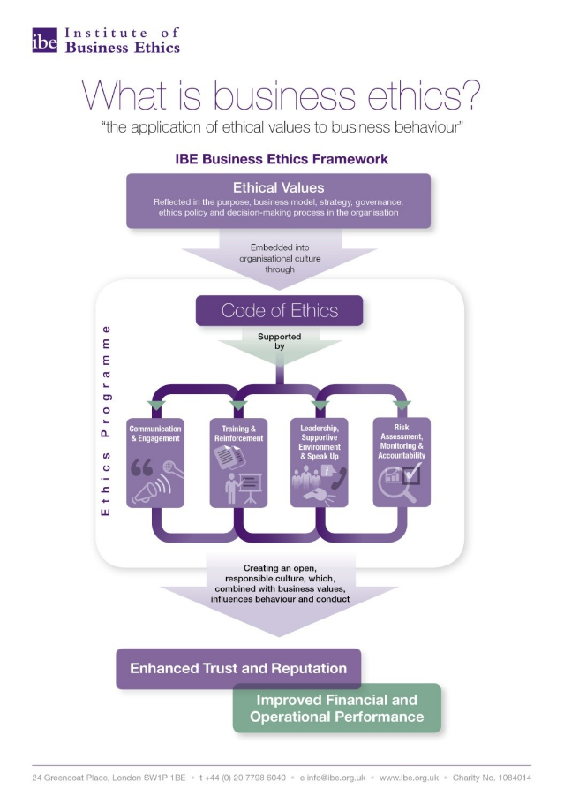
Appendix 1

(Institute of Corporate Responsibility and Sustainability , 2019)

Appendix 2
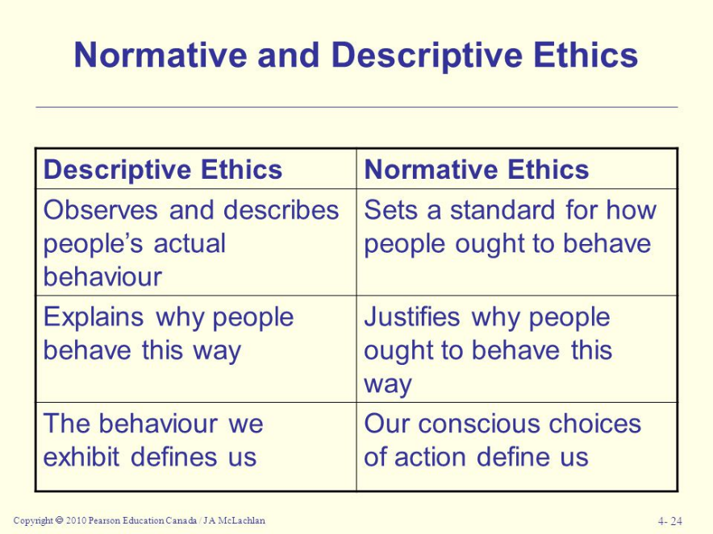

(Encyclopedia.com, 2019)

Appendix 3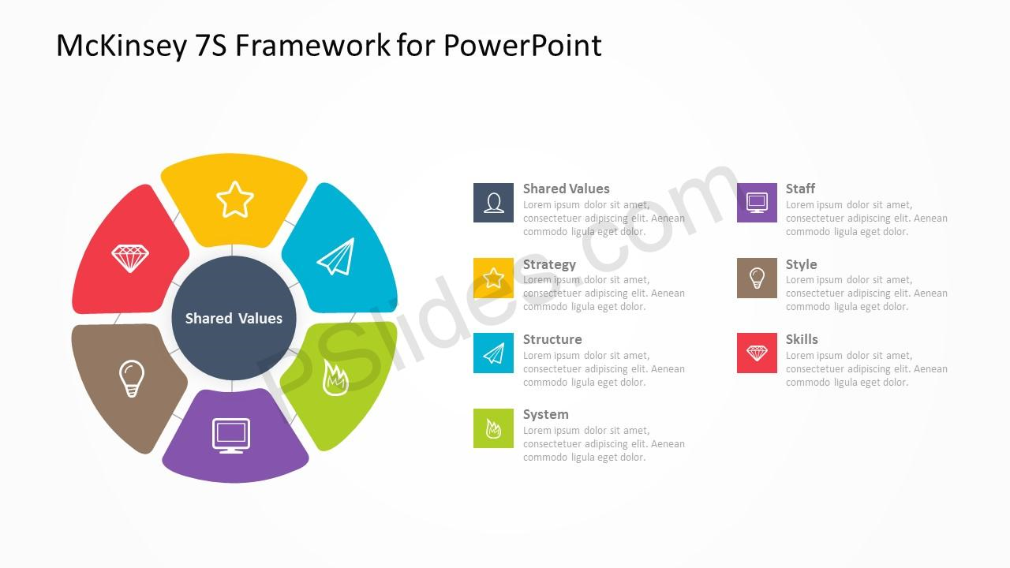
Mckinsey 7s Framework (2019)

Appendix 4
Illustration of Phillip Crosby 14 steps program of TQM: -
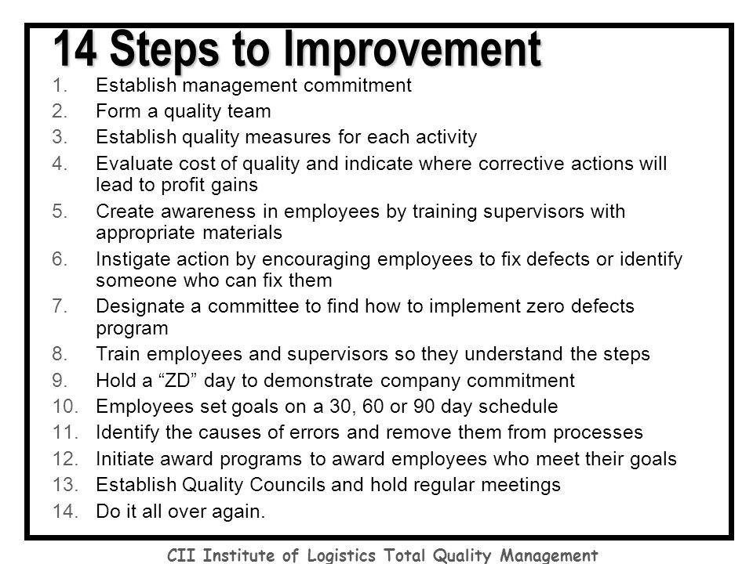

Appendix 5 M&S circular economy over the years

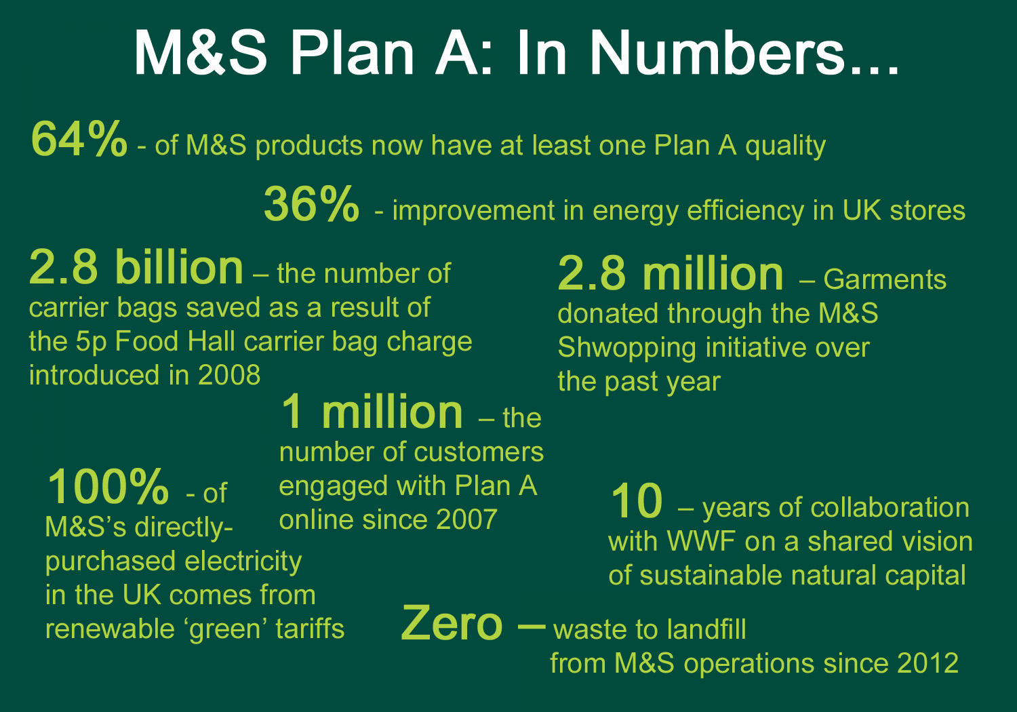
(Marks and Spencer, 2019)

Appendix 6
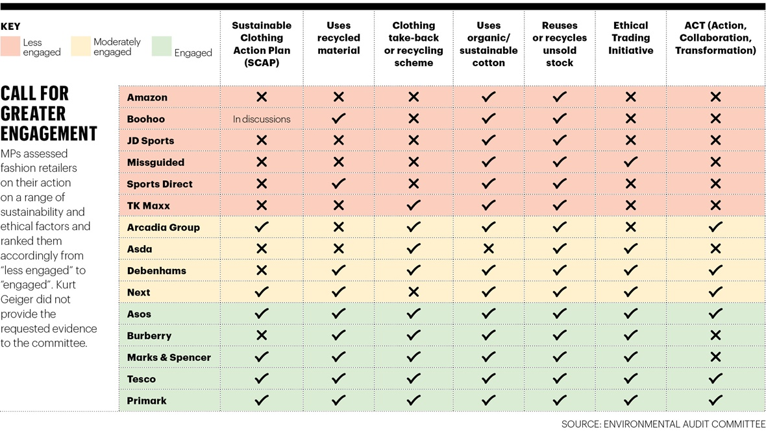

Appendix 7
Identify and measure Plan A

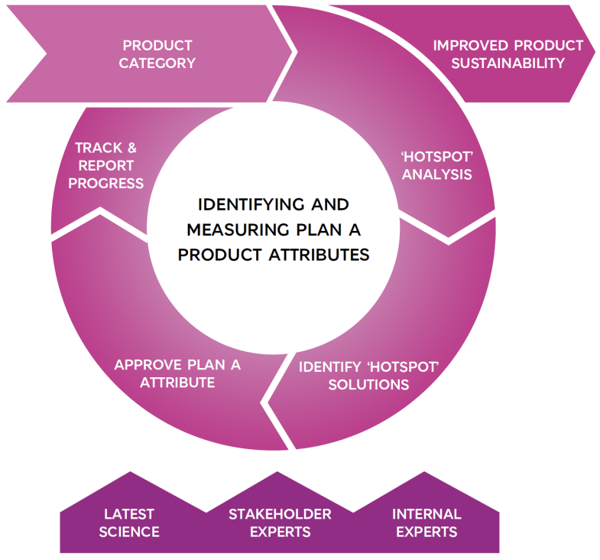
(Marks and Spencer, 2019)

7.0 Acknowledgements
Thanks go to Maria Heffernan for helping and guiding with this report and being available for support. Other thanks go to Hannah Meiklejohn for providing study skills support. Further thanks to the library staff for helping to find books and journals, and with using databases. Finally, thanks go to friends and family for offering support and understanding throughout this project.

8.0 References
Abbul, R. R., 2013. Quality Tools for Managing Construction Projects. In: Boca Raton: CRC Press, p. 10/11.
Archies, B. & Bucholtz, A., 2015. Business & Society. 9th ed. Boston : Lengang Learing.
Augar, p., 2010. Barclays success comes at a price. [Online]
[Accessed March 27th 2019].
Back, p. F., 2017. The IB's Business EthicsFramework. [Online]
[Accessed 11th March 2019].
Barclays, 2019. Social CRM. [Online]
Available at: https://digital.wings.uk.barclays/for-everyone/milestone/social-crm/
[Accessed 27 March 2019].
Bert, M., 2017. Ethical issues in CRM. [Online]
[Accessed 17th March 2019].
Brown University, 2019. A Fframe for Making Ethical Decisions. [Online]
[Accessed 11th March 2019].
consumer, E., 2019. Fashion and Clothing. [Online]
[Accessed 23th March 2019].
edie.net, 2015. M&S moves from risk to resilience with positive Plan A progress. [Online]
[Accessed 25th March 2019].
Encyclopedia.com, 2019. Normative Theory. [Online]
Available at: https://www.encyclopedia.com/social-sciences-and-law/sociology-and-social-reform/sociology-general-terms-and-concepts/normative
[Accessed 24 March 2019].
Entrepreur, i., 2019. Customer relationship management. [Online]
[Accessed 17th March 2019].
Gallagher, P., 2016. M&S and H&M risk ethical satatus than half of a living wage. [Online]
[Accessed 11th march 2019].
Hassan, M., 2017. 7 Reason Why CRM and Saleare Correlated to Sutainablility Bussines Growth. [Online]
[Accessed 2019 March 17th].
Hassan, M., n.d. 7 Reason why CRM and sale are Correlated to Sustainablilty b. [Online].
Institute of Corporate Responsibility and Sustainability , 2019. The IBE’s Business Ethics Framework. [Online]
Available at: https://icrs.info/articles/icrs-news/ibe’s-business-ethics-framework
[Accessed 11 March 2019].
kiyment, C. a. U., 2017. Suatainability and Management. In: London and New york: Routledge, p. 2.
Lynn, B., 2012. M&S doing the right thing Leads to change for the better. [Online]
[Accessed March 26th 2019].
Mar, A., 2013. 7 Definitions of Quality. [Online]
Available at: https://business.simplicable.com/business/new/7-definitions-of-quality
[Accessed 12th March 2019].
Marks and Spencer, 2019. Ethical Consumer. [Online]
[Accessed 25th March 2019].
Marks and Spencer, 2019. Supplier Management. [Online]
[Accessed 25th March 2019].
Micheal, M. & Alan, M., 2011. Coorporate Responsibility. Oxford: Oxford University Press.
Muller, A., 2014. Sustainability and Customer relationship management: Current state of research and future research opportunities. Management Review Quarterly , 64(4), pp. 201-224.
Rohit, P., 2018. 7 Powerful reason to invest in CRM software. [Online]
[Accessed 25th March 2019].
Thwink.org, 2014. The Three Pillars of Sustainability. [Online]
Available at: http://www.thwink.org/sustain/glossary/ThreePillarsOfSustainability.htm
[Accessed 10th March 2019].

9.0 Bibliography

Ethic: Fundamental Element. Springer International. Published. Switzerland.2016.
file:///C:/Users/begum/Documents/ethics%20(springer.pdf. Accessed 12thMarh 2019.

