Tentative Teaching Plan

Session | Topics
1  4/9/22 | - The Nature of Strategic Management  - The Analysis of External Assessment (I)
2  11/9/22 | - The Analysis of External Assessment (II)  - The Analysis of Internal Environment (I)  - Assignment Briefing (I)
3  18/9/22 | - The Analysis of Internal Environment (II)  - Strategy at the Corporate Level (I)  - Assignment Briefing (II)
4  25/9/22 | - Strategy at the Corporate Level (II)  - Strategy at the Business Level (I)  - Assignment Briefing (III)
5  2/10/22 | - Strategy at the Business Level (II)  - Assignment Briefing (IV)
6  9/10/22 | - Strategy Analysis and Choice  - Implementing Strategies: Management & Operations Issues  - Assignment Briefing (V)
7  16/10/22 | - Implementing Strategies: Marketing, Finance/Accounting, R&D, & MIS Issues  - Module Review  - Assignment Briefing (VI)

Deconstructing Zara's Strategy

Go to Zara.com, and there is a white page with the brand’s Studio Collection only. It’s simple, it’s confident, and it’s modern. Website homepages are not a place for brand narrative; they are shopping destinations that drive us to products as quickly as possible (go to Balenciaga site and you’d be greeted by Crocs mule. Mobile version if the site is even more straightforward as visits are treated with what looks like product detail page. It works).
Click through Studio Collection, and you’d be greeted by impossibly cool-looking sixty-year-old sporting looks from the Collection. She pulls them off perfectly and makes us first wonder who she is, and then makes us want to be her. The lack of copy is refreshing as it spares us retail cliches. This doesn’t mean that there isn’t a story - quite the contrary. Art direction, photography, styling, props, and the mood deliver.
No wonder. Fabien Baron is the art director, Steven Meisel is the photographer and models are legendary: Marisa Berenson, Sasha Pivovarova, Chiharu Okunugi, Yumi Nu. There are short films of Chloë Sevigny in a bubble bath and Charlotte Gainsbourg in a short film promoting her line with Zara. Baron curates Peter Lindbergh’s photography in the form of Zaratribute, with merch to match.

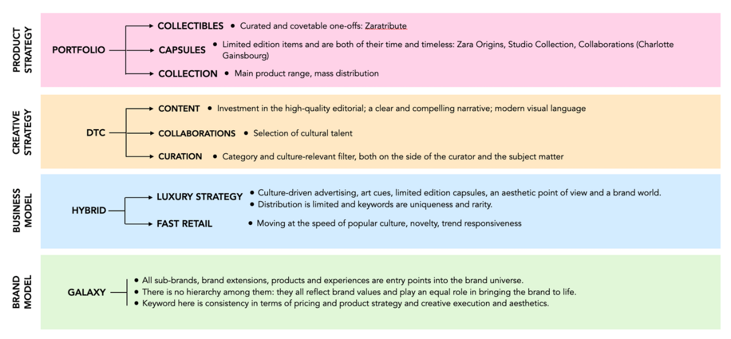

There’s also Zara Origins, which focuses on the building blocks of one’s wardrobe. Described as “project focused upon building a contemporary wardrobe, with aim to conceive, create and offer garments which are newly-refined archetypes of their kind.” Items include a cashmere turtleneck, a canvas bag, Water Repellent Pocket Jacket, a gold pleated chain. There is simplicity, sophistication and focus in the collection. It feels relevant and modern, and it’s highly covetable.
All of this conveys heavy luxury vibes. For a fast-fashion brand, it’s as surprising as it is smart. It reveals Zara’s ambitions: once it dominated the fast-fashion category and millennial and Gen Z demographic, Zara is moving to dominate fashion, and all its demographics. It may shed its stigma in the process, but that is beside the point: people buy Zara (even if they hate to admit it), and with its strategic move, more people will buy Zara.
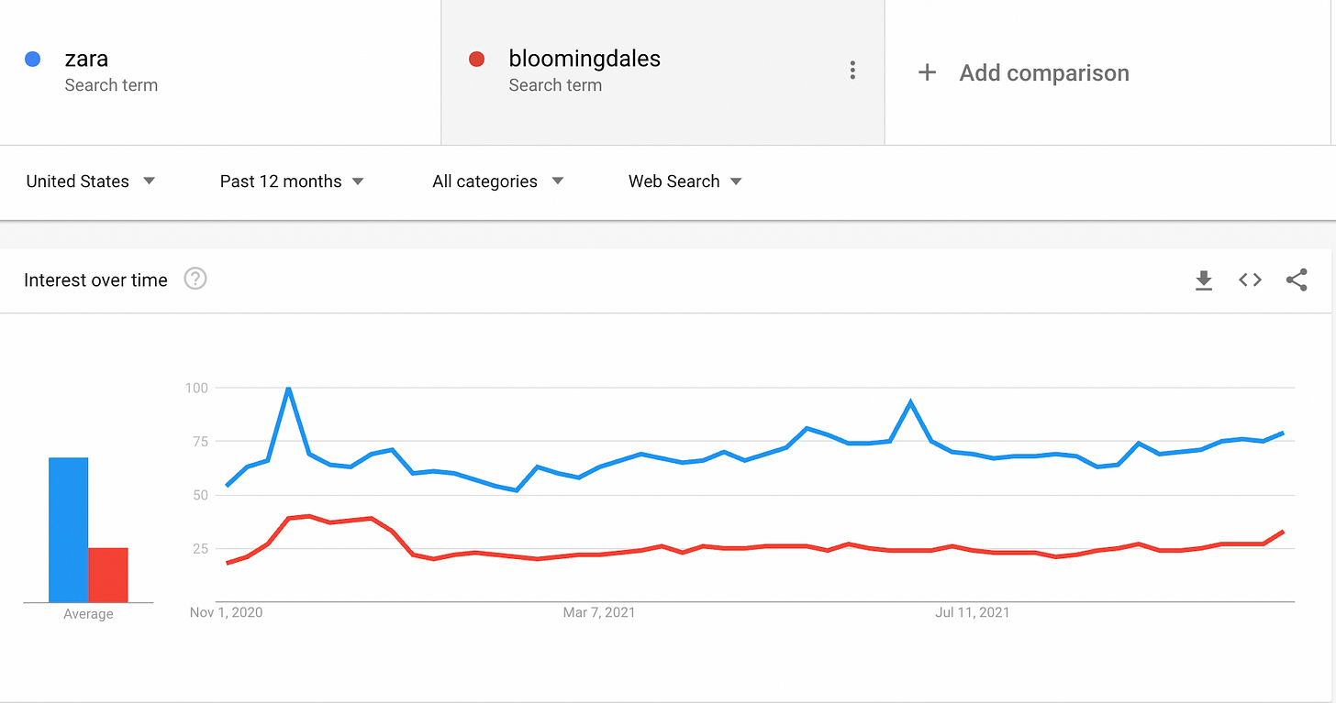

Zara is building a hybrid business model, where it combines fast fashion with cues of luxury (curated capsules, art direction, photography, model selection, styling). Zara is still in the business of the mass consumption of standardized products, but now it’s also in the business of considered consumption of signaling products (Peter Lindbergh merch, Charlotte Gainsbourg collection, Studio Collection). Prices of the latter are higher, but not forbiddingly so.

Zara’s bifurcated strategy works for two reasons:
- It still services the core Zara customer (trend-chasing, deal-seeking), but it adds aspirational dimension to their consumption. Getting a $9 turtleneck feels more aspiring with Sasha Pivovarova’s editorial next to it.
- It attracts a more discerning, quality-seeking customer that wouldn’t normally consider Zara - if it weren’t for it’s Studio Collection and Zara Origins. They may stop there; most likely, they will explore other product categories as well, driven by strong product photography and seamless site navigation.

Zara’s mission, which refers to the business the company is in and how it makes money, is to “give customers what they want and get it to them faster than anyone else.” It hits on two core sources of Zara’s competitiveness: speed of trends and speed to market. The former has to do with understanding of culture; the latter with the flexible and data-driven supply chain.
Zara’s vision is to be a contributor to the “sustainable development of society and of the environment with which we interact.” With the ongoing strategic pivot, they may as well deliver on it.
Zara is pursuing the galaxy model of its growth. The Galaxy model refers to the brand and business strategy where products create a system held together by the gravity of the funder or story at its center. Some of the examples of the Galaxy model are Ralph Lauren, H&M, or Armani. In this model, all sub-brands, brand extensions, products and experiences are entry points into the brand universe. There is no hierarchy among them: they all reflect brand values and play an equal role in bringing the brand to life. Keyword here is consistency in terms of pricing and product strategy and creative execution and aesthetics. The Galaxy model is most often used by brands selling at an accessible price point. Only by having a galaxy of horizontal brand extensions, a company can command wide distribution, a sizable advertising budget, and increased brand recognition. In Zara’s scenario, the galaxy model strategically adds capsules to its core collection (Origins, Studio, Athleticz), along with the new categories: Zara Kids, Zara Home, and Zara Beauty.

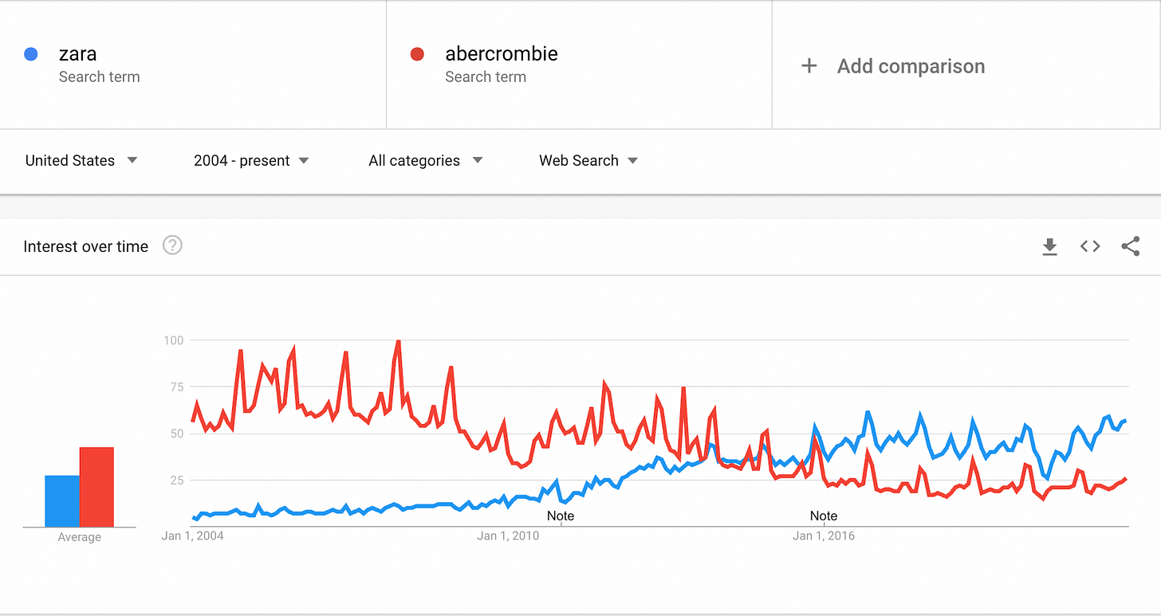

Source: Adapted from “Deconstructing Zara’s Strategy,” by Ana Andjelic, Nov 1, 2021, < https://andjelicaaa.substack.com/p/unlocking-zaras-strategy>

Task:

Write a report (5000 words +/- 10%) that addresses the following:

- Tallant (2009) claims that “The importance of an organization to develop a vision, mission, and values is important for strategic direction.” Using Zara as an example, assess the relationship between “Strategic Direction” and the “Vision, Mission, and Values (VMV) of a company.

- Conduct a macro-environmental analysis for the Hong Kong casual wear industry and determine the opportunities and threats for the industry.

- Critically describe and analyse the value chain of Zara. Discuss the strengths and weaknesses of each.

- Evaluate the corporate and business strategy recently proposed by Zara and appraise the effectiveness of these strategies based on the Balanced Scorecard.

- Propose recommendations for both corporate and business level strategies for Zara? Analyze how these strategies can be effectively implemented.

