3/22/2026

Personal Development Plan in Cyber Security
Kwakye Kerlvin Boatey ID number: 2520439
ACCA4025
Learning In Digital Era
TASK 1
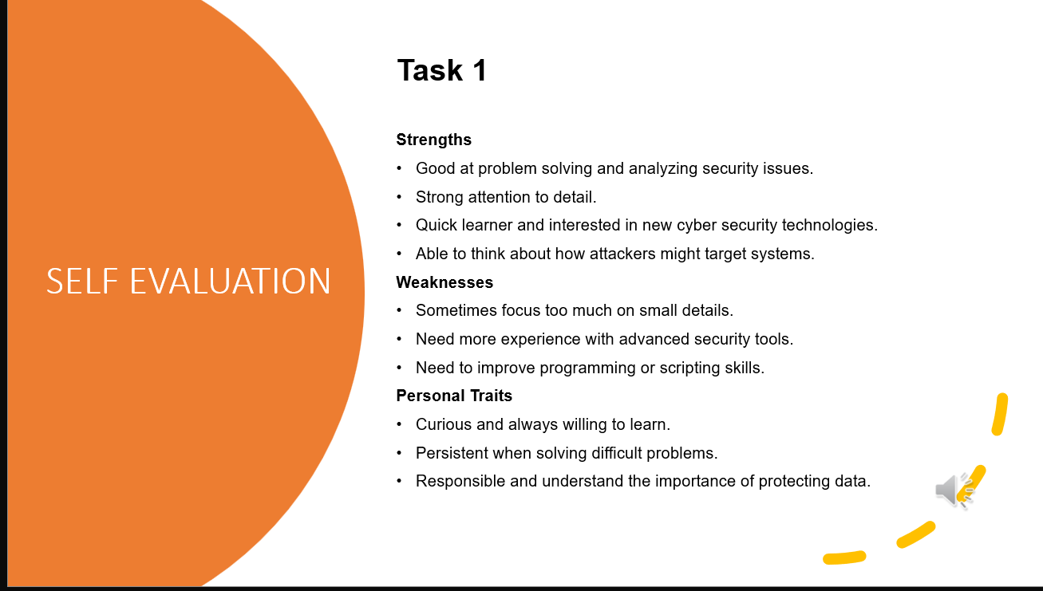

TASK 2
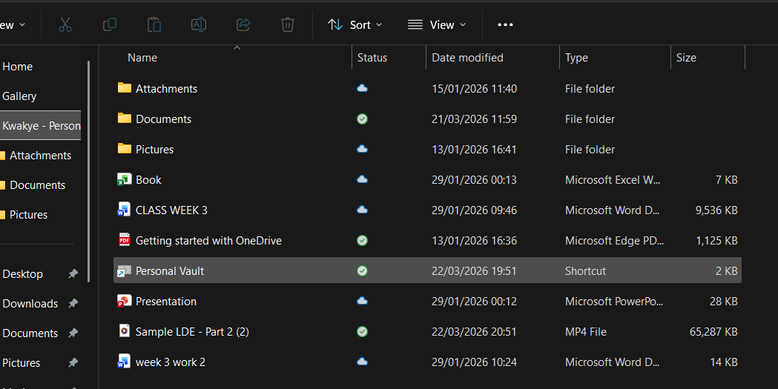
Sample LDE - Part 2 (2).mp4
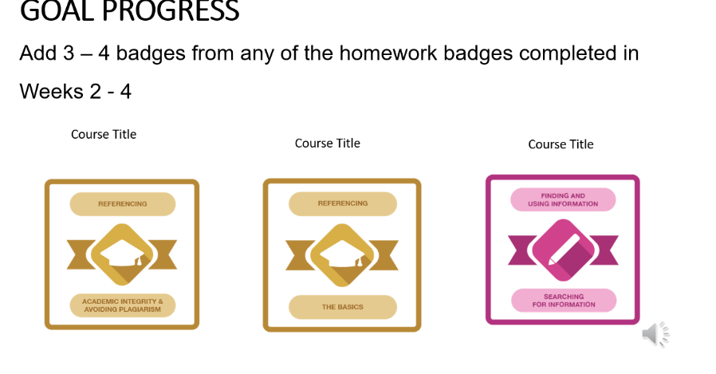

TASK 3

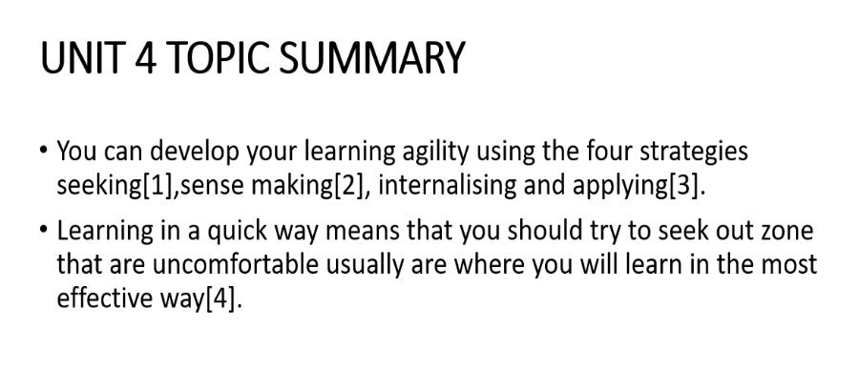

TASK 4

1.
https://youtu.be/Mr4JCLVJEsg?si=SLBnCxvLEMM8xqxE
2.
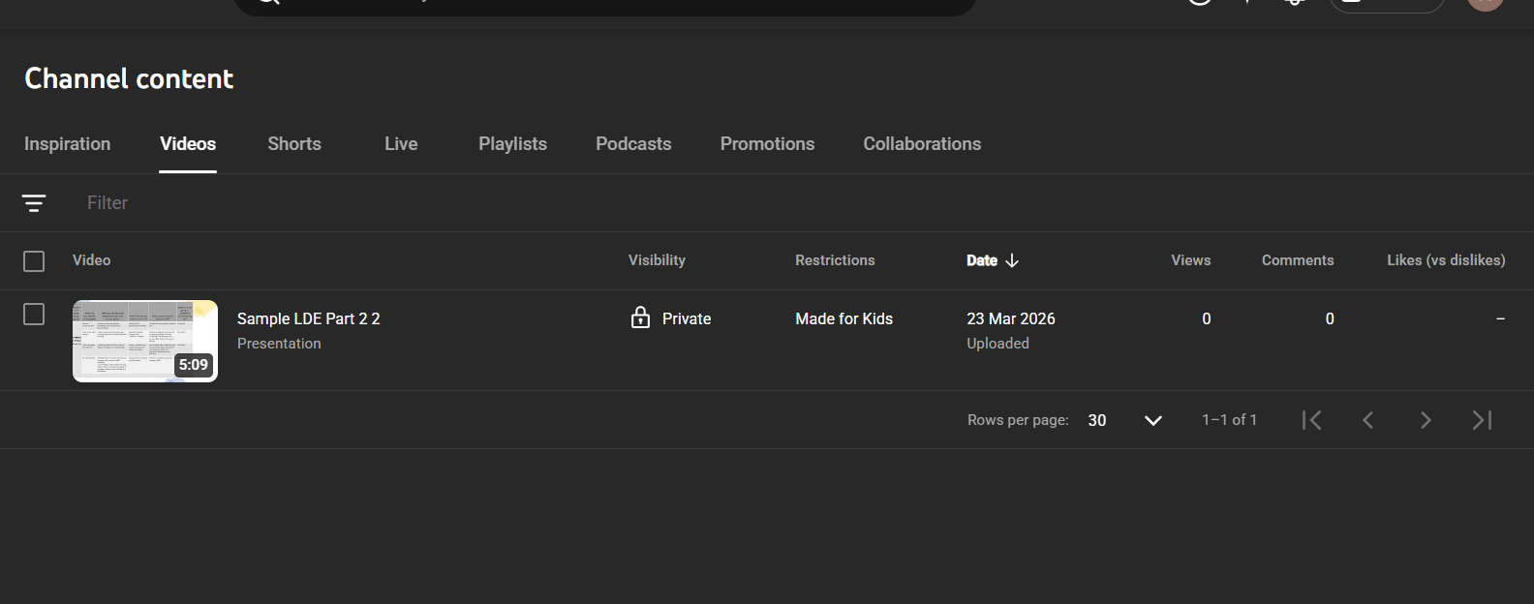
3. https://1drv.ms/p/c/49a0a0e86d9b0c96/IQBTsVy15ZdTT6nwbDcGpXy6ASs11ZWgW2nDUf39r25JjF4?email=m.ben-farah%40uwtsd.ac.uk&e=YQVhNB

