MODULE CODE: ACCA5024
Advance Networking FINAL Exam Answer Sheet

Student Name: Ivan Naydenov

Student ID: 2025312

Date: 21.11.2022

I- IPv4 Addressing Table
Specification | Subnet A | Subnet B
Subnet IP address | 192.168.202.0 | 192.168.202.128
Subnet mask (slash notation) | /26 | /25
Subnet mask (dotted decimal) | 255.255.255.192 | 255.255.255.128
1st Host IP address | 192.168.202.1 | 192.168.202.129
Last Host IP address | 192.168.202.62 | 192.168.202.254
Number of usable hosts per subnet | 62 | 126
Broadcast address | 192.168.202.63 | 192.168.202.255

II- IPv4 Address assignment
Device | IP address | Subnet Mask | Gateway
PC-A | 192.168.202.15 /26 | 255.255.255.192 | 192.168.202.1
R1-G0/0/0 | 192.168.202.129 /25 | 255.255.255.128
R1-G0/0/1 | 192.168.202.1 /26 | 255.255.255.192
S1 | 192.168.202.2 /26 | 255.255.255.192 | 192.168.202.1
PC-B | 192.168.202.150 /25 | 255.255.255.128 | 192.168.202.129

III- IPv6 Addressing Table
Assigned to Interface | IPv6 Subnet Address | Prefix Length
R1-G0/0/1 | 2001:db8:acad:0001:: | /64
R1-G0/0/0 | 2001:db8:acad:0002:: | /64

IV-IPv6 Address assignment
Device | IPv6 address | Prefix Length | Gateway
R1-G0/0/0 | 2001:db8:acad:0002::1 | /64 | Fe80::1
R1-G0/0/1 | 2001:db8:acad:0001::1 | /64 | Fe80::1
S1 | 2001:db8:acad:0001::2 | /64 | Fe80::1

Task 2: Device Configuration
- Hostname

Router>enable
Router#conf
Configuring from terminal, memory, or network [terminal]?
Enter configuration commands, one per line. End with CNTL/Z.
Router(config)#hostname R1
R1(config)#

Switch>enable
Switch#conf
Configuring from terminal, memory, or network [terminal]?
Enter configuration commands, one per line. End with CNTL/Z.
Switch(config)#hostname S1
S1(config)#

- Encrypted privileges EXEC password

S1(config)#enable secret ccnaenpass

R1(config)#enable secret ccnaenpass

- Secure the console access password
S1(config)#line console 0
S1(config-line)#password ccnaconpass
S1(config-line)#login
S1(config-line)#end

R1(config)#line console 0
R1(config-line)#password ccnaconpass
R1(config-line)#login
R1(config-line)#end
R1#

- Minimum length passwords

R1#conf
Configuring from terminal, memory, or network [terminal]?
Enter configuration commands, one per line. End with CNTL/Z.
R1(config)#security passwords mi
R1(config)#security passwords min-length 10
R1(config)#

- Create an administrative user

R1(config-line)#
R1(config-line)#exit
R1(config)#
R1(config)#username admin password 0 admin1pass
R1(config)#

S1(config-line)#
S1(config-line)#exit
S1(config)#username admin password 0 admin1pass
S1(config)#

- Configure an MOTD banner

S1#conf
Configuring from terminal, memory, or network [terminal]?
Enter configuration commands, one per line. End with CNTL/Z.
S1(config)#line console 0
S1(config-line)#banner motd #No Unauthorised Access!#
S1(config)#

R1#conf
Configuring from terminal, memory, or network [terminal]?
Enter configuration commands, one per line. End with CNTL/Z.
R1(config)#line console 0
R1(config-line)#banner motd #No Unauthorised Access!#
R1(config)#

- Encrypt all passwords

R1(config)#service password-encryption
R1(config)#

S1(config)#service password-encryption
S1(config)#

- Disable IP domain lookup

R1(config)#
R1(config)#no ip domain-lookup
R1(config)#

S1(config)#
S1(config)#no ip domain-lookup
S1(config)#

- Enable synchronous logging

S1(config)#line console 0
S1(config-line)#loggin synchronous
S1(config-line)#

R1(config)#
R1(config)#line console 0
R1(config-line)#loggin synchronous
R1(config-line)#

- Configure router’s interfaces

R1(config)#interface g0/0
R1(config-if)#description Connection to Subnet B
R1(config-if)#ip address 192.168.202.129 255.255.255.128
R1(config-if)#no shutdown

R1(config-if)#
%LINK-5-CHANGED: Interface GigabitEthernet0/0, changed state to up

%LINEPROTO-5-UPDOWN: Line protocol on Interface GigabitEthernet0/0, changed state to up

R1(config-if)#

R1(config-if)#exit
R1(config)#interface g0/1
R1(config-if)#description Connection to Subnet A
R1(config-if)#ip address 192.168.202.1 255.255.255.192
R1(config-if)#no shutdown

R1(config-if)#
%LINK-5-CHANGED: Interface GigabitEthernet0/1, changed state to up

%LINEPROTO-5-UPDOWN: Line protocol on Interface GigabitEthernet0/1, changed state to up

R1(config-if)#

R1(config-if)#
R1(config-if)#exit
R1(config)#
R1(config)#
R1(config)#interface g0/0
R1(config-if)#ipv6 address 2001:db8:acad:0002::1/64
R1(config-if)#ipv6 address fe80::1 link-local
R1(config-if)#exit
R1(config)#ipv6 unicast-routing
R1(config)#
R1(config-if)#no shutdown

R1(config)#
R1(config)#interface g0/1
R1(config-if)#ipv6 address 2001:db8:acad:0001::1/64
R1(config-if)#ipv6 address fe80::1 link-local
R1(config-if)#
R1(config-if)#no shutdown

- Configure switch’s management (SVI) interface

No Unauthorised Access!

User Access Verification

Password:
Password:
Password:

S1>
S1>
S1>
S1>enable
Password:
Password:
Password:
S1#
S1#
S1#
S1#conf
Configuring from terminal, memory, or network [terminal]?
Enter configuration commands, one per line. End with CNTL/Z.
S1(config)#
S1(config)#sdm prefer dual-ipv4-and-ipv6 default
Changes to the running SDM preferences have been stored, but cannot take effect until the next reload.
Use 'show sdm prefer' to see what SDM preference is currently active.
S1(config)#

S1(config)#interface vlan 1
S1(config-if)#description Connection to Lan A
S1(config-if)#ip address 192.168.202.02 255.255.255.192
S1(config-if)#ip default-gateway 192.168.202.1
S1(config)#

Press RETURN to get started!

No Unauthorised Access!

User Access Verification

Password:

S1>enable
Password:
S1#
S1#
S1#conf
Configuring from terminal, memory, or network [terminal]?
Enter configuration commands, one per line. End with CNTL/Z.
S1(config)#
S1(config)#inter
S1(config)#interface vlan 1
S1(config-if)#ipv6 address 2001:db8:acad:0001::2/64 eui 64
^
% Invalid input detected at '^' marker.

S1(config-if)#ipv6 address 2001:db8:acad:0001::2/64
S1(config-if)#ipv6 address fe80::1 link-local
S1(config-if)#no shutdown

S1(config-if)#
%LINK-5-CHANGED: Interface Vlan1, changed state to up

%LINEPROTO-5-UPDOWN: Line protocol on Interface Vlan1, changed state to up

S1(config-if)#

Task 3: Verify Network connectivity

From | To | Protocol | IP Address | Ping Results
PC-A | R1 G0/0/0 | IPv4 | 192.168.202.129/25 | 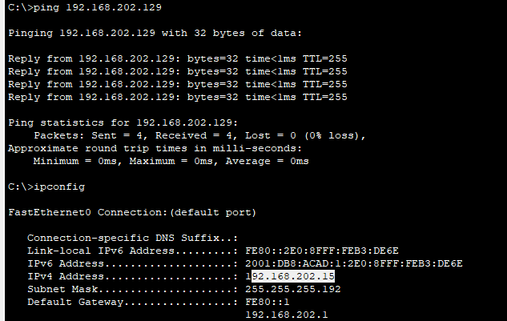
PC-A | R1 G0/0/0 | IPv6 | 2001:db8:acad:0002::1 | 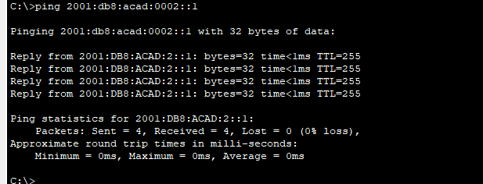
PC-A | R1 G0/0/1 | IPv4 | 192.168.202.1 /26 | 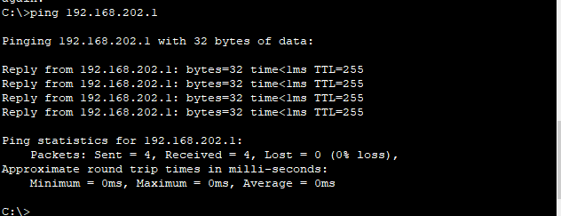
PC-A | R1 G0/0/1 | IPv6 | 2001:db8:acad:0001::1 | 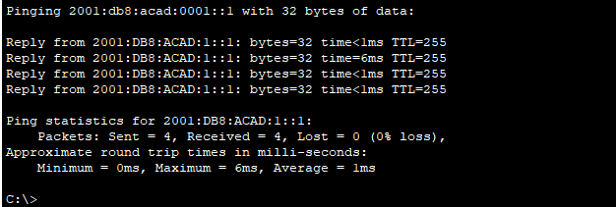
PC-A | S1 VLAN 1 | IPv4 | 192.168.202.2 /26 | 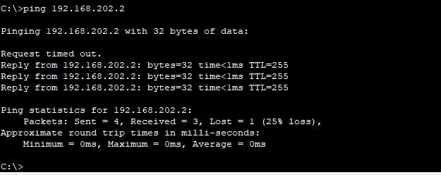
PC-A | S1 VLAN 1 | IPv6 | 2001:db8:acad:0001::2 /64 | 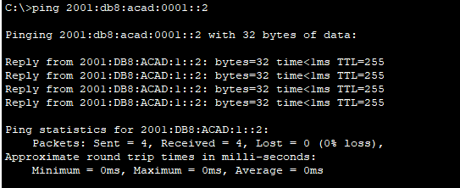
PC-A | PC-B | IPv4 | 192.168.202.150 /25 | 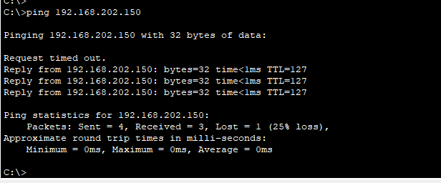
PC-A | PC-B | IPv6 | 2001:db8:acad:2:200:cff:fe80:ae2 | 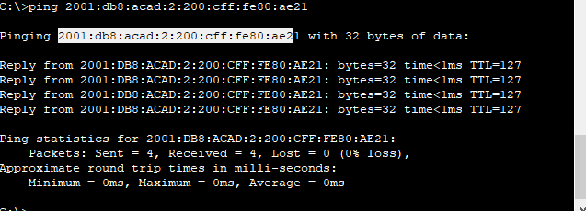
PC-B | R1 G0/0/0 | IPv4 | 192.168.202.129/25 | 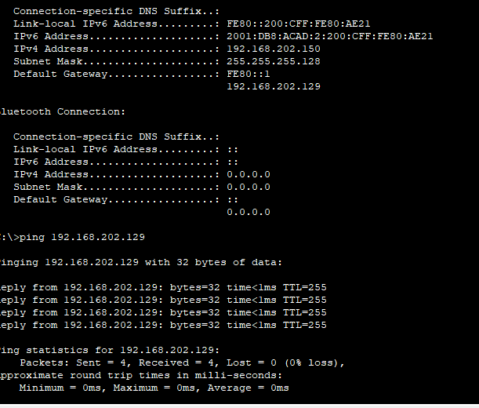
PC-B | R1 G0/0/0 | IPv6 | 2001:db8:acad:0002::1 /64 | 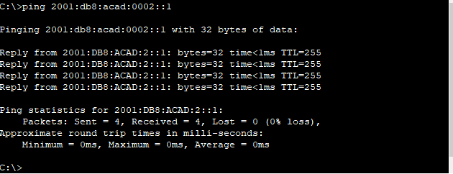
PC-B | R1 G0/0/1 | IPv4 | 192.168.202.1 /26 | 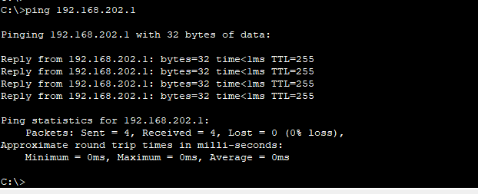
PC-B | R1 G0/0/1 | IPv6 | 2001:db8:acad:0001::1 /64 | 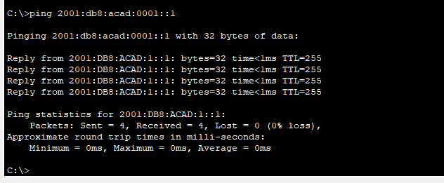
PC-B | S1 VLAN1 | IPv4 | 192.168.202.2 /26 | 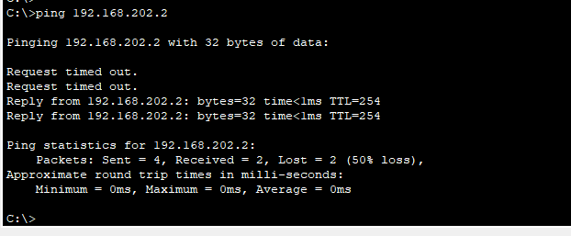
PC-B | S1 VLAN1 | IPv6 | 2001:db8:acad:0001::2 /64

