

An investigation into Biometric concepts to facilitate the attendance system in educational Institutions

By
Darren H Jones (178245)

Supervisor: Jeanette Adams
Second Marker: John Williams

Project submitted as part of the requirements for the award of BSc (Hons) Computing & Information Systems.

DECLARATION

I, Darren Hedley Jones declare that I am the sole author of this Project; that all references cited have been consulted; that I have conducted all work of which this is a record, and that the finished work lies within the prescribed word limits.

This work has not previously been accepted as part of any other degree submission.

Signed: DHJones

Date: .......22/04/2018........................................

FORM OF CONSENT

I, Darren H Jones hereby consent that my Project, submitted in candidature for the B.Sc.(Hons) Computing & Information Systems degree, if successful, may be made available for inter-library loan or photocopying (subject to the law of copyright), and that the title and abstract may be made available to outside organisations.

Signed: DHJones

Date: 22/04/2018...............................................

(Where necessary replace B.Sc. (Hons) Computing & Information Systems with your named award)

ABSTRACT

It is very important to accurately record the attendance of students, and nearly every academic institution has some concerns of how the attendance is to be confirmed in the class, laboratory sessions and examination halls [1] [2] [3]. Using these out-dated methods can make it difficult for management to accurately record and calculate the percentage of student attendance in classes, errors can arise and records will frequently require up-dating.
As an alternative to the traditional manual attendance process in classes or examination halls, biometric characteristics can be used for authenticating student attendance.
The most successful application of biometric technology is the fingerprint biometrics and this is the reason it is adopted in this research work. [1] [2]
Identifying theft as well as online terrorism is the trend concerning the modern world when regarding national security. This research refers to using biometrics as the solution for detecting the user’s identity and the security challenges arising in this modern day. Biometric identification is automatically measurable, robust and the distinctive physical characteristic or personal trait that can be used to identify an individual or verify the cleaned identity of an individual [1] [2] [3].

Biometrics science utilises the measurements of a person’s behavioural characteristics, for example, mouse movement, and keyboard strokes, also biological characteristics such as fingerprint, iris, nose, eyes, jaw, and voice patterns [1] [2] [3]. It is the captured features that are being transformed digitally to the template. With the use of recognition software this can be used to discover if an individual is the person they claim to be. When identifying and verifying a person based on psychological and behavioural traits, automated methods are used by the various technology built into the biometric system. The issue of losing your ID card or forgetting your password, or someone guessing your password is avoided because physical aspects of the human body are used when using a biometric system [2]. In most cases using the biometric system is considered to be more efficient, it is faster and more convenient than employing the password and ID cards methods [3].

When using someone’s fingerprint as a form of authentication it is just like using natural, physical data as a password. The most beneficial aspect of using biometric authentication is that it is distinct to each person [3]. There are no two individuals with the same fingerprint, it is impossible for another person to have the same fingerprint exactly like another individual. Another beneficial trait for using a biometric fingerprint system is that a fingerprint can never be guessed by a criminal like a password, whereby the criminal can sometimes predict using birth date or any other common password [1] [2].

Fingerprint is categorised as one of the first biometric traits and is accepted in courts of law as legitimate evidence. Investigations of a criminal’s fingerprints are adopted in forensic analysis globally [2]. But now there are growing numbers of individuals and commercial users using fingerprint-based identification for no other reason other than its matching performance. Biometric technology has demonstrated a much better understanding of fingerprints [1].

TABLE OF CONTENTS

1. INTRODUCTION 7
2. RESEARCH AND REVIEW LITERATURE 8
2.1. Introduction 8
2.2. Attendance in Education 8
2.3. Registration Methods 9
2.4. Registration Technologies 11
2.5. Registration Tools 20
2.6. Ethical / Legal Issues 22
2.7. Critical Review 22
3. RESEARCH AND DEVELOPMENT METHODOLOGIES 24
3.1. Research Methodology 24
3.2. Development Methodology 26
4. DESIGN AND IMPLEMENTATION 28
5. EVALUATION 31
6. CONCLUSIONS AND RECOMENDATIONS 32
7. REFLECTION 33
8. REFERENCES / BIBLIOGRAPHY 34

INTRODUCTION

This project report is based on the student attendance biometric fingerprint system, and the aims of this project is to design and develop a reliable, scalable and cost effective Fingerprint based Student Attendance Monitoring system. This project uses a biometric system to facilitate the attendance in an educational institute. It uses the most reliable way of uniquely identifying students through fingerprint reading. This type of application is very useful in school as well as in college for daily attendance. Through this application it can keep an efficient track of the student's attendance. This project enables an effective method of maintaining class attendance with fewer efforts. To achieve its aims the report investigates the background of study on the day to day problems of attendance and how different colleges and universities deal with this concerning problem that can affect the student from having a good start in life, and how regular attendance at school is vital to help children at an early age. This research also looks at the importance of security in education and it investigates how various institutions regularly try to improve security issues which is becoming ever more worrying with the need of technologies to be implied to verify a particular person. The research focuses on how keeping accurate records for attendance is so important, and that the approach of using the old conventional methods that have been used for many years for using paper sheets to record attendance are still widely used today.
Chapter 2
In this chapter the reports investigates the administrative difficulties with the manual systems, and how the automated electronic systems for monitoring attendance have evolved. Then looks at the various unique ways an automated electronic systems may be used to identify students, for example identification cards, or the use of biometrics and gives the advantages and disadvantages. In chapter four the report then explores the many different types of registration tools and software looking at their advantages and disadvantages. The report looks at the ethical and legal issues. In chapter 3 the research and development methods are discussed covering the five layers of the Research Onion - including reasons why each selection is being adopted.

Chapter 3
Research and development methodologies this sections of the report covers and discusses the research Methodology based on the 5 layers of the Research Onion - including reasons why each selection is being adopted? And also the Resources being used that are relevant to the project and the advantages and disadvantages and solution to the problems.

Chapter 4
In this chapter the report takes the reader through the design and development used in the project taking the reader through the various phases of the design and development using Evolutionary prototyping as the chosen methodology used in developing the application for this research project. And also the advantages and disadvantages and solution to problems of using this methodology.

Chapter 5
In this chapter the evaluation of the project which provides the conclusions what was drawn from data and if the data backed up the research and if the aims and objectives where met.

Chapter 6 Conclusion and recommendation ties up all the loose ends in the previous chapters.

Chapter 7 Reflection looks back at the whole project and what was learnt from completing the project.

RESEARCH AND REVIEW LITERATURE

Introduction

A critical review of published work in the fields related to this research provided an essential insight into the past and present techniques and methodologies employed by researchers and authors in both academic and industrial areas of attendance.

Attendance in Education

Senior managers and staff at all levels are very committed to improving attendance, and aware that the reasons for poor attendance are wide ranging and can be complex. “Colleges in London in particular face greater challenges in terms of student attendance” according to Ofsted [1] [2] who are the office for standards in Education. Colleges will use many of its resources to regularly try to improve attendance but without clearly understanding the problems that are influencing it [2]. At The Manchester College they found that by monitoring the attendance and then having meetings with the Head of Department about the students attendance before attending class and asking students if there were any problems they wanted to address would help to improve the attendance of the students[1] [2].
In June 2014 as many as 50 colleges had their license suspended by the Immigration Office because of abusing the attendance records for foreign students. At one college (Glyndwr University) quoted by a member of staff they said that, “They were not encouraged to report students' absence or failures because doing so would reduce the college's income and jeopardies its right to sponsor foreign students”[3]. On 12th of November 2017 Cook County Jail high school reinstated the principle who was wrongly accused of falsifying the student attendance records at the school [3].
To achieve the best possible start in life, regular attendance at school is vital to help children. Children often fall behind when they frequently miss school. Achieving good results is often linked between good school attendances [1]. For example, only 12% of pupils with below 80% school attendance achieved five or more GCSEs at grades A* - C including English math’s, compared to 60% of pupils with attendance greater than 95% [2].
Having good attendance at school shows any potential employers that the young person is reliable. Anti-social behavior and crime are often linked with children that are frequently absent from school and they can either be involved with crime or be the victim. For instance, all schools in Leeds have their own attendance policies and are responsible for keeping accurate records of pupils’ attendance. If they have any concerns regarding a child’s attendance they will contact the parents directly. Leeds City Council offers a vast range of services to support the families who encounter difficulties in ensuring their children attend school regularly.
School is very different to university, and for some people such disengagement is not a problem [2]. In high education it is argued that it is more about independent learning, and students have the right to manage the time as they see fit even if this means missing class.
Even though it is important for students to have freedom and flexibility during their studies, any lax in the attendance policy can damage both their own studies and the University itself.
When allowing students to skip class this undermines the sense of academic community that is so greatly important to universities, especially in fields where there is emphasis on sharing ideas. The only solution is enforcing compulsory attendance.
Some of these issues vary between departments and the different styles of teaching. For example an English lecture may call for a different mode of regulation than a practical medical lesson in surgery [3]. The tendency in the UK is for seminar like lessons to be compulsory where the administrative capacity exists. One example is the University of Glasgow who blamed the lack of an effective attendance monitoring system on “resource constraints”. Lectures, meanwhile, are generally not compulsory, except in medical departments where the split is almost 50: 50 that is according to 2012 poll by the British Medical Association [3].

Registration Methods and Technologies

    - Introduction

To monitor the attendance of students, many education institutions have developed a variety of manual and automated electronic systems. Manual attendance monitoring systems consist of student sign in sheets, student roll calls, or student logbooks, using tutor signatures. There are many administrative difficulties with the manual systems, and now automated electronic systems for monitoring attendance have evolved. There are many unique ways an automated electronic systems may be used to identify students, for example identification cards, or the use of biometrics [28]. Fingerprints are the most commonly used as the identifying biometric, although there are many others that are used, including eyes, face, ear shape, and voice recognition [30].
The old conventional methods such as roll calling, paper-based attendance and card punching have many limitations and are very prone to inaccuracies. Unnecessary time is taken by teachers and administrators tracking student attendance via the old traditional methods, particularly in order to compensate for the limitations that are associated with this old outdated methods [29]. Also, it is very difficult to manage the attendance of large groups of students manually, and there are many loopholes in the traditional student tracking methods which cannot prevent proxy attendance, ID card theft and also any attendance tracking errors [30].

Manual Attendance System
If executed consistently and fairly the old tested methods of attendance control can be effective, but on the other hand, systems of this kind rely on human factor too much.

Advantages | Disadvantages
Resistant to power outage. | High possibility of human error
No technology expenses. | Low scalability and no integration with other systems
Simple to implement and administer | Calculating student data is difficult
 | Inaccurate and subject to manipulation
 | The teaching staff may misplace the attendance paper or excel file they were using.
 | Attendance is not kept in real time.
 | Teaching Staff, lose a lot of time cumulatively taking attendance manually.
 | Staff must be present to record attendance, meaning resources such as libraries and resource rooms will not record student attendance.
 | The larger the class, the greater the challenges.
Reference [28] [30]
Automatic Attendance System

With software solutions for monitoring and managing student attendance constantly advancing, it is now considered far more reliable than manual timekeeping. It allows easy access to the data and can be statistically analysed.

Advantages | Disadvantages
Reduces the amount of work needed for attendance management | High cost for maintaining and installing
Easy data sharing between multiple locations in real time | Potentially difficult to implement in the more remote rural locations
Greater precision and elimination of errors | Loss of data if there is a power outage
More transparent performance tracking | Training to use a system will be needed
Automation requires little or no teaching class time. Students can scan in as they enter the facility, building or room.
Rules around lateness can be defined to mark late comers or absentees. Depending on your SIS, various alerts could be triggered by constant lateness.
Administrators can see real-time, accurate attendance. This is powerful because faculty can send alerts to students querying their lack of attendance, and requesting follow-up if required.
For exam attendance, supervisors can verify in real time that the student presented looks like their photo recorded in the SIS. Extra information about the student can be available in real time including cheating history or, if they have not shown up, alerted so they can potentially arrive and begin before test material can be compromised by students leaving the exam.
Accurate attendance information when you need them from your SIS. No more time spent chasing up staff to complete attendance or query anomalies.
Reference for this table [30] [33] [35]

    - Conventional methods

Attendance register

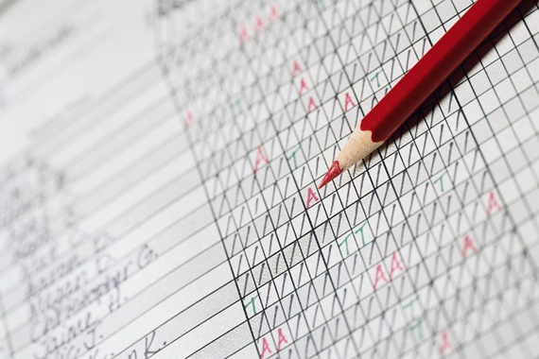
An attendance register in a school or college or any educational institutions is a list of students that are present that day [11].
Even though technology has advanced dramatically, there are still some academic institutions who use the old method of recording student attendance. The lecturer distributes a sheet of paper to the students in class or the examination hall for them to write their name, ID number and signature to mark themselves present [11]. However, this paper-based method can be misused, deception can arise when a student can sign the attendance record sheet for a fellow student who is absent. It is difficult to prevent this false representation from happening and it will become even more difficult with larger classes [11].

    - Automated methods

Barcodes
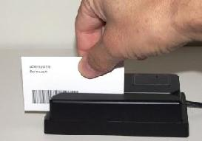
Fig 1 [30]

A good substitute for a manual system for recording student attendance is the barcode attendance monitoring system. The old manual process of logging students in and out are replaced with automated barcode readers [50]. The difference is the data is now digitised. For the system to be able to capture the time and attendance data the lecturer must have a quick and accurate method for recording time transactions. This is accomplished by using a fixed and movable coded barcode scanner with an ID card that has the student number in the barcode [55]. The back of each student ID card would have a barcode and the information that is embedded into would contain unique data on that particular student for example enrolment number, year, faculty and all the other information that may be important about the student. Students will only be able to participate in class once they swipe the identity card through the provided barcode reader. Barcode technology works in the same way as a keyboard. As pressing a key sends a signal containing a character code to the computer, reading a barcode results in the same kind of signals being sent to the processor [55].
The barcode acts as a unique control number which provides a record giving details of an individual item. A light is reflected from the barcode when it is scanned and the pickup optical device receives less light from the dark bars than from the spaces between them. The signals are then converted into a form which is recognised by the computer [55].

Advantages | Disadvantages
It Improves efficiency of the staff and quality of services when compared to roll calling | Barcode scanners need a direct line of sight to the barcode to be able to read.
It Increased accuracy of data input (error free) | In order to read the barcode, the barcode scanner needs to be quite close; around no more than 15ft.
It Increased user satisfaction | Barcodes have no read/write capabilities; they do not contain any added information such as expiry date etc. They only contain the manufacturer and product.
Reliable statistics for Management | They are very labour intensive; as they must be scanned individually.
Real time data collection Aid effective management of resources and inventories. | Barcodes have less security than RFID; as they can be more easily reproduced or forged.
Improves information availability and data integrity. | Barcodes are more easily damaged If a barcode is ripped or damaged there is no way to scan the product.
 | May not work if in a plastic holder.
Reference for table [55]

Radio Frequency identification

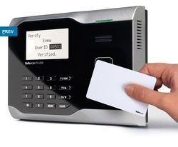
Fig 3 [30]

Radio Frequency Identification (RFID) system is an identification system that uses radio waves to retrieve data from a device called a tag or transponder [30].

RFID is an area of automatic identification which is now seen as a major means of enhancing data handling processes, complimenting other data capture technologies, for example bar coding [30]. An RFID system is used to carry data in suitable transponders, known as tags, to retrieve data, by machine readable means at a time and place to satisfy application needs.
A complete picture of the RFID attendance system combines the RFID tags and readers with access to global standardised database, ensuring real time access to up-to-date information on the card [30]. The card contains a unique identification number called an electronic product code (EPC).

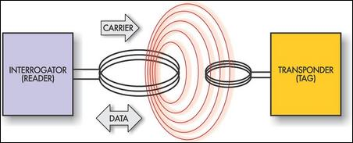
Fig 4 [55]

The RFID attendance system offers an organisation the efficiency and convenience associated with RFID technology at a low cost. This method is fast as well as simple [28]. Each student uses an RFID card and the reader records the data when the student enters or exits [29]. RFID devices and software must be supported by a sophisticated software architecture that enables the collection and distribution of location based information in near real time [33].
Data within a tag provides identification of an individual student. An RFID reader/writer contains a scanning antenna and a transceiver. It uses the scanning antenna to send out radio frequency signals in a relative short range [33]. The radio frequency sent out is used to communicate, and power tags (also known as transponders) that are within range, which will then transmit the data on the tag back to the reader [30]. The scanning antenna then picks up the information sent out by the tag. The data is then interpreted and decoded by the transceiver [30].

Advantages | Disadvantages
Can read RFID tags from a greater distance than barcodes. | RFID involves assembling and inserting a computerized chip; which works out to be more expensive.
RFID tags don’t need to be positioned in a line of sight with the scanner. | RFID readers struggle picking up information when passing through metal or liquid.
RFID tags can be read at a faster rate than barcodes; as approximately 40 RFID tags can be read at the same time. | Reader collision can occur where two signals from different readers overlap and the tag is unable to respond to both.
RFID tags can work within much greater distances; information can be read from a tag at up to 300 ft. | Tag collision can occur when numerous tags in the same area respond at the same time.
RFID tags are read/write devices. | RFID still has two separate chips (read only and readable/writable), which cannot be read by the same machine.
RFID contain high levels of security; data can be encrypted, password protected or set to include a ‘kill’ feature to remove data permanently.
RFID tags carry large data capabilities such as Student name, address, grades and any other information which can all be programmed to the tag.
Once these are set up; it can be run with minimal human participation.
RFID tags are more reusable and rugged as they are protected by a plastic cover.
Reference for this table [28] [30] [33]

Smart Cards / Magnetic strip

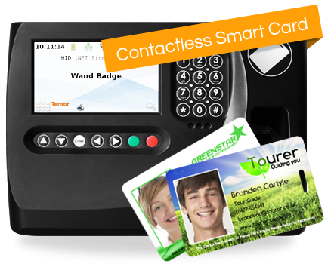
Fig 5 [36]

Smart Card
Each student is provided with a preprogrammed card where the card will have the details of that particular student stored [26]. Smart Cards in general are made of polyvinyl chloride plastic, but sometimes can be made from polyethylene terephthalate based polyesters, they have embedded integrated circuits that can be either a secure microcontroller or equivalent intelligence with internal memory or a memory chip alone [26]. Smart cards can be either contact or contact less smart card [26].
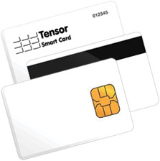Fig 6 [34]
Smart Card Readers
The card reader will be present at the lecture. When a student wants to register his attendance, he has to insert his card into the reader and the reader reads this information and passes the same data to the controlling unit [34].
Smart card readers can also be known as programmers (because they can write to a card), card terminals, card acceptance device (CAD), or an interface device (IFD). When the smart reader comes into contact with the smart card, they identifies to each other by sending and receiving information. If there is no match when the messages exchange, no further processing will take place. Smart cards can defend themselves against unauthorized users and uses its advanced security measures. There are two primary types of contact Card these are landing contact and friction contact (also known as sliding or wiping) [34]. Contact Types refers to how the contact between a card reader and a smart card is physically made. The contact part is fixed for card readers featuring friction contact. The contact wipes on the card surface and the chip when a card is inserted [34]. The contact part is movable, for card readers featuring the landing type [34]. The contact “lands” on the chip after a card is only inserted. In general, card readers of the landing type provide better protection to the card than that of the friction type.
Advantages | Disadvantages
Security The biggest advantage of the smart card technology is the security they provide. Smart card technology provides better security than another type of data storage devices. This technology uses encryption to protect information from unauthorized disclosure and frauds. By using encryption, data can be safely transferred through wireless or regular networks. | Processing power and memory of smart cards are limited at this moment in time.
To use the card, it is necessary to know the appropriate code for activating the PIN (Personal Identification Number). The existence of a PIN eliminates the possibility of abusing the card in the case of theft or loss. Identification by PIN code is more secure than any other way of identification. | Cost of production. Smart cards cost from £10 to £25 to produce. The smart card reader can even cost up to $200. Time needed for the production is long, and there aren’t many smart card manufacturers in the world.
Smart cards use two-factor authentication, which is an extra layer of security. Some smart cards use biometric technology like a fingerprint, retina scanner and other biometric information. | A more powerful virus can access the data and compromise the safety. Smart cards are often the target of different attacks (Trojan horse, viruses, etc.).
The data on a smart card cannot be erased, if it ever leaves the safe environment. Smart cards are portable, and because of that, they’re ideal for safe distribution of private keys. Data stored on the smart card can only be accessed through the smart card operating system. | The smart card reader is needed when using the smart card. The problem arises when smart card readers often can’t perform requested operation, or there’s trouble with reading the card.
The card reader can check the authenticity of the smart card by sending a randomly chosen word to the smart card. Smart cards are then required to sign that word by its private key, then return the “signed word” to the outside world, where the verification is done by the private key. | From the customer’s perspective, a disadvantage is that smart cards can be easily lost or stolen…
Reference for table [34] [55]

Biometrics

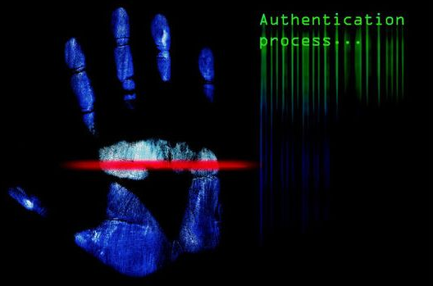
Fig 7 [30]
Biometrics is the science and technology of measuring and breaking down natural information. In data innovation, biometrics relates to technologies that examine and measure physical human body features, such as DNA, fingerprints, hand geometry, hand measurements, eye retinas and irises, earlobe geometry, voice patterns, facial patterns and signatures, for validation or authentication purposes [30]. The characteristics of a biometric system are, that it is very robust and distinctive. In that it is physiologically used to identify an individual. Scientific measurements are used for biometric systems that uses a person’s unique behavior patterns, for example, keyboard strokes and mouse movements which are then captured and transformed into a digital template [35]. Only biometrics can recognize an individual. Biometric verification is becoming more popular for authentication in corporate and public security systems [30]. The areas in which biometrics can be valid are government, commercial, forensic, institutions, access control, counter terrorism, law enforcement agency, airport security and so on [34].
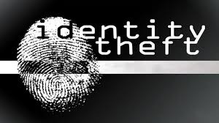
Fig 8 [33]
Some of these areas will be briefly discussed below, as well as those areas where biometrics is being applied. As well as security purposes, biometric verification is an accessible system used to avert identity theft [33]. As biometrics is automated and the most convenient method of recording student check-in and check-out times, educational institutions are increasingly opting to use this method. Not only is it simple to use, requiring minimal technical knowledge, but it also provides faster and more efficient processes when logging student attendance [34]. This means that both staff and students can make full use of the system without requiring any sort of extensive training [32].
Users simply place their finger or palm on a biometric hardware device in order to access their personal accounts. The accuracy of identification can be ensured thanks to the way in which biometrics uses the human physical and biometric characteristics, which are completely unique for every individual user of the system [33].
Using biometrics for identification has many unique advantages. Biometrics is used to identify a person as a person! With other identification methods for example Smart cards and photo ID cards which can be left at home, lost or even stolen. Pin codes or passwords can be forgotten or shared [8] [9]. Not only is the use of biometrics a more secure option to use, it is can also be more efficient than memorising all the different passwords that we use in modern day life. For example, by using a person’s fingerprint as a method to uniquely identify the authentication of a person, is like using a natural physical data instead of a password [8] [9].The different types of biometric frequently in use today are devices that capture data in various formats using different devices. Some of these biometric devices are generally detected in common places, as researched in this report for recording attendance. Biometrics is essentially the identification of human features that are distinct to each person.

Facial Recognition
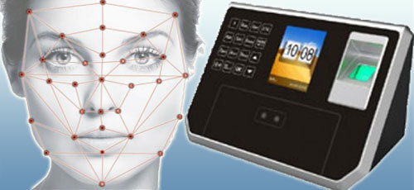
Fig 9 [30]
Facial Recognition is the method of identification of a person by their facial image this can be done using many different ways, for example, using a camera to capture the image of the person’s face, or using infrared and heat emission patterns [7] It compares the structure, ratio and shape of the face, top outlines of the eye sockets, the eyes, the mouth, the sides of the mouth, the interval between the jaw, the region of the cheek bones, the nose and the positioning of the nose and eyes. When taking part in a facial recognition program, various images of the individual are captured at different angles and with various facial expressions. As part of the security criteria, a facial thermograph will be used to store the heat in the face and the user may be asked to nod their head or blink their eyes during scanning to ensure the user does not put on a mask or picture during scanning [33].
The image or video is then compared to the saved template in the database to see if there is a match. It compares all the different shapes and structures of the face and ratios. When the user is being enrolled on the system it takes numerous images of the facial structure and positions and angles of the nose, and eye sockets [8] [9]. Some of the challenges that facial recognition has to deal with, is detecting in the various type of lighting that may occur. Some types need to be stationed or fixed in one place to capture the image needed to authenticate a user, but some can use real time to detect the user, and automatically locates the users face. The main benefit of using face recognition is it is hands free and not as invasive as other methods [10] [11].
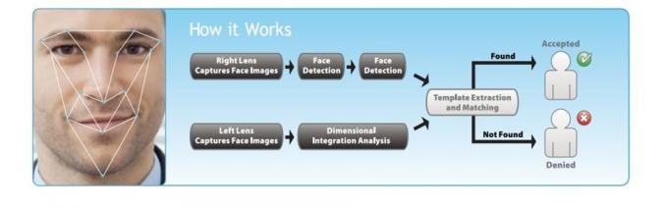
Fig 10 [33]
Facial biometrics is particularly useful for facial authentication rather than for identification purposes, due to the fact that an individual’s face can be altered or disguised. The environment can also affect the camera during the process of capturing.
Facial biometrics has been confirmed as a method that can improve validation and authentication of users tremendously [38].
The technique used is referred to as skin texture analysis, which turns the distinct patterns, lines, and spots obvious in an individual’s skin into a mathematical space [30]. Facial biometrics is very good when being utilised for facial authentication rather than for identification purposes, because of the fact that an individual face can have a physical damage or altered, disguise with a mask, [30]. Environment can also affect the camera during the process of capturing. Facial biometrics has been confirmed as a method that can improve validation and authentication of users tremendously [40].
Advantages | Disadvantages
No contact required | Face can be obstructed by hair, glasses, hats, scarves etc
Commonly available sensors (cameras). | Difficult to distinguish between twins

Voice Recognition
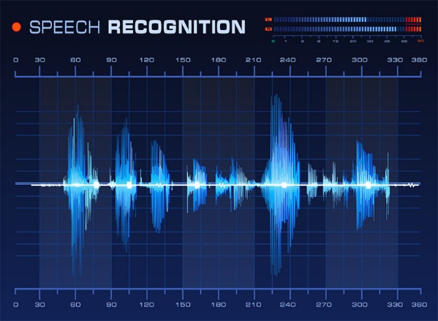
Fig 11 [33]
Speaker Recognition has been used dating back for some decades, the output of many analog filters were measured by averaging over time, for matching. Every person has their own distinctive voice pattern [33]. It is not always noticeable to the human ear because it only slightly changes. But with the use of ever improving software technology for voice recognition, those slight variations for each individual persons speech can be filtered and compared and tested to then authenticated or not [8] [9].
Voiceprint recognition biometrics compares the vocal patterns that are already stored on the database, it has the ability to rigorously examining the patterns of stress in the person’s voiceprint. This feature gives it an advantage over other forms. There are various ways to process and store voiceprints, these include pattern matching algorithms, hidden Markov models, neural networks, and matrix representation and decision trees [8] [9]. Cohort models and world models are some techniques that are used, these are called anti-speaker. Some of the challenges voice recognition faces, is the change of voice due to aging and also performance degradation.
Advantages | Disadvantages
Simple and cost-effective technological application | Voice and language usage change over time (e.g. as a result of age or illness).
Can be used for remote authentication.
Reference for table [33]

Iris Recognition, Iris Scanners and Retina Scanners
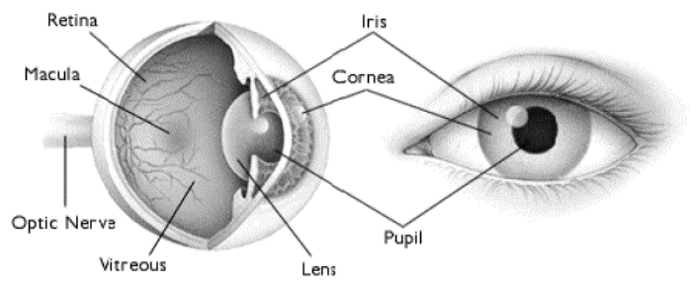
Fig 12 [37]
Iris recognition techniques use the iris part of the eye, this is the coloured area that surrounds the pupil. The patterns in the iris are unique to each person. The iris patterns are stored and obtained by using mathematical calculations in a video based system, these scanning device systems have been in use for many years [8] [9]. The price of these systems have dramatically decreased over the years and this is expected to continue. The verification and identification in the way the system stores the data or templates in the database works very well. The system can also be used if the person or user is wearing contact lenses or glasses. The most significate benefit of the iris system is not just the flawless resistance to false matches, but also the speed and convenience [8] [9].
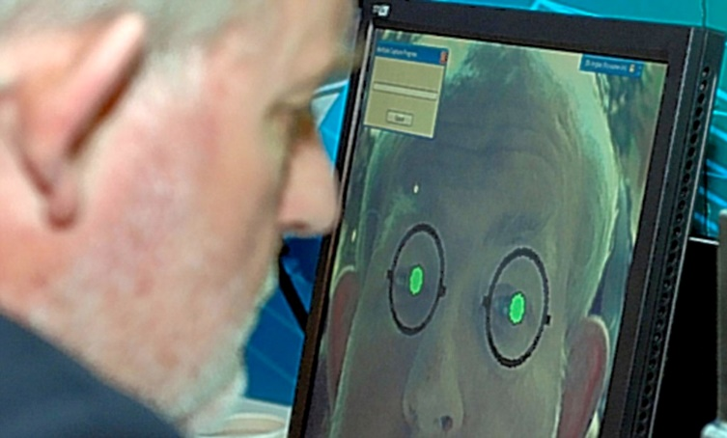
Iris scanning is an automated method of biometric identificaton which uses mathematical pattern recognition techniques on video images of the iris of a person’s eyes [37]. The complex, random patterns are distinct and can be spotted from a far range. Templates or digital formats are converted from the patterns by using mathematical and statistical algorithms. These algorithms identify an indiviudal or someone trying to impersonate the legitimate person. There are millions of individuls who have been enrolled into the iris recognition systems, generally for the convenience of passport free automated border crossings, and some national ID systems based on this technology are being used. The benefit of iris recognition is its resistance to false matches and the speed of process, it is also a stable, internal, protected and externally visible organ of the eye [37].

The iris of the eye is an ideal and accurate part of the human body for biometric recognition. It is protected from damage and wear by an extremely sensitive and transparent membrane called the cornea. It is mostly flat which makes the iris shape far more predictable than, for example the face. Although the iris is fine textured and like fingerprints are determined randomly during gestation, the iris is a better option as fingerprints may not be as accurate due to years of rough manual labour [33] [34].
A retinal scanner scans the distinct biometric features and patterns in an individual’s iris and compares it with a number of distinct recognising patterns.
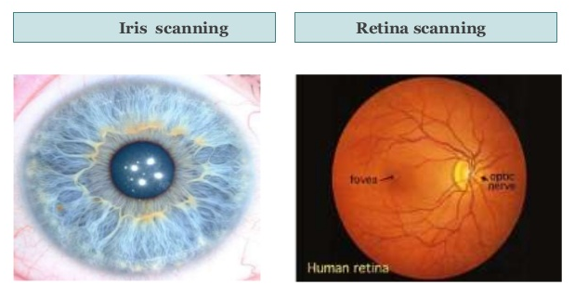
Fig 13 [33] Fig 14 [38]
These patterns distinguish each individual from another person, even identical twins do not have the same pattern. Retina patterns are generally permanent from child birth until death, but may be modified for people suffering from diabetes, glaucoma or retinal degenerative disorders [33].
A retinal scan is performed by absorbing an unperceived beam of low-energy infrared light into a person’s eye as they look through the scanner's eyepiece. This beam of light draws a similar pattern like a path on the retina. At the back of the eye a biometric format is shaped by recording the patterns of capillary blood vessels [36]. The total reflection differs due to the absorbent nature of retinal blood vessels of the light than other parts of the eye. The format of the variations from the scanner is translated to computer code and stored in a database [35].

Advantages | Disadvantages
Iris recognition is very accurate with very low false acceptance rate | Complex procedure.
 | High cost
Iris and retinal scanners are both efficient processes, but implementing them is more costly and complex. However, retinal scanners are regularly used for authentication and identification purposes and have been used in Government agencies, prisons, ATM validation and against fraud, also medical applications, such as transmitted diseases (AIDS, Malaria, Chicken Pox). The distinct and permanence feature of the retina makes it the most accurate, and authentic of all the biometric, except DNA, its accuracy level is estimated to be one in a million [37].
Reference for table [38]

Signature Verification
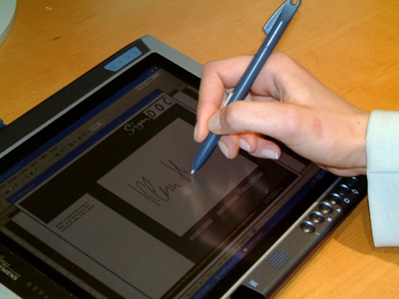
Fig 14 [34]
Biometric signature recognition systems is process of measuring and analysing the physical movement of signing. The pressure applied, the stroke order, the pen-up movements are the important characteristics, the way the pen is held, the pace and acceleration, and the time take to sign the signature [30]. But also some systems compare the visual image of the signatures, the focus in signature biometrics lies on writer-specific information rather than visual handwritten content. It may seem to be easy to copy the appearance of a signature, but it is less easy to mimic the process and behavior of signing [34]. The data of the signature can be captured via pens that integrate sensors or through touch-sensitive surface which senses the unique signature characteristics. Touch-sensitive surfaces are being used commonly today such as, mobile phones, laptops, tablets [30].
Advantages | Disadvantages
Main uses of signature biometrics include limiting access to restricted documents and contracts, delivery acknowledgement and banking/finance related applications. | A person’s signature changes over time as well as under physical and emotional influences.

Fingerprint Recognition and Scanners
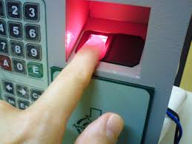
Fig 15 [32]
The fingerprint system is one of the oldest and one of the most successful application of biometric technology. A fingerprint system when compared with the other biometric systems on the market are at the lower end of the price range. Some of the fingerprint systems just scan the actual print of the fingerprint. The more expensive scanners take the measurements of the shape and sizes of the thumb and also the presence of blood in the fingerprint and various other characteristics of the finger [10] [11]. The high end fingerprint scanners capture a 3D image of the finger and because it can take a high detailed image, it makes it even harder to be duplicated. Optical scanning or capacitance sensing are the different processes of capturing the image of the finger [8] [9]. The more recent types of scanners are Ultrasound readers, they use high frequency sound waves which can penetrate the outer layer of the skin. This means that the scanner will read the dermal skin layer of the fingerprint, which means it can still read the print even if the skin is scarred. There are also Thermal readers, they scan and detect the difference of temperature in between the fingerprint ridges and valleys.
Generation of biometric templates are based on matching minutiae characteristic features in fingerprints. The examining of fingerprints for the purpose of authentication generally requires the comparison of many features of the print format [32]. These comprise of patterns which are aggregated features of ridges and the minutia points, that are distinct features found within these patterns. Knowing the attributes of human skin and structure is paramount to successfully utilise some of the technologies of imaging [32].

The three fundamental patterns of fingerprint ridges are presented below.
Arch: In arch, the ridges will enter from one side of the finger then rise in the center forming an arc, and then exit the other side of the finger. | Loop: The ridges enter from one side of a finger, form a curve, and then exit on that same side. | Whorl: Ridges form circularly around a central point on the finger.
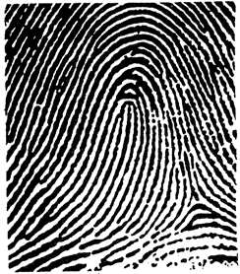 | 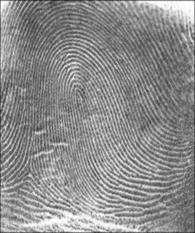 | 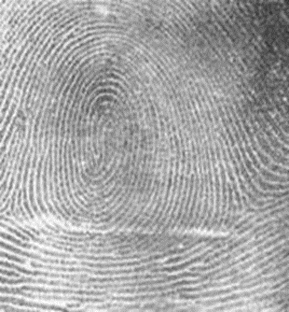
Fig 16 [32]
There are basically two types of software used for matching fingerprints, these are minutiae matching and pattern matching. Minutiae matching is the most popular used method and relies on recognition of the minutiae points [9]. There are three types of minutiae features, these are the ridge ending, this is where the ridge of the finger ends. A bifurcation, this is where the ridge splits into two ridges, and the ridge dots, these are an isolated unit. Pattern matching is when the system tries to match two images to find the similarities between them and detect any duplicates [8] [9].

Fingerprint patterns

Minutia features
The major minutia features of fingerprint ridges are ridge ending, bifurcation, and short ridge (or dot) [32]. The ridge ending refer to the point at which a ridge terminates. Bifurcations are points whereby a single ridge is divided into two ridges. Short ridges are ridges which are importantly shorter than the average ridge length on the fingerprint. Since there has not been any record of two fingerprints proven to be identical minutiae and patterns are very important when examining fingerprints [32].
The ridge ending | Bifurcation | Short ridge (dot)
 | 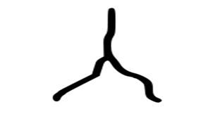 | 
Fig 17 [32]

Fingerprint sensors
An electronic device, called a fingerprint sensor is used to capture a digital image of the finger print pattern, this is referred to as a live scan. The live scan is then digitally processed to develop an accumulation of extracted features (Biometric Template). The template is stored in a database and used for matching [32].
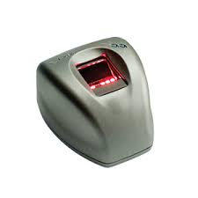Fig 18 [32]
Advantages | Disadvantages
Fingerprint recognition equipment is relatively low-priced compared to other biometric system. | Some people have damaged or eliminated fingerprints
Fingerprints are unique to each finger of each individual and the ridge arrangement remains permanent during one's lifetime. | Vulnerable to noise and distortion brought on by dirt and twists
Fig Reference of this table [32]

Hand geometry recognition system
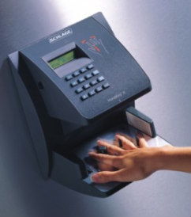
Fig 19 [38]
A number of measurements taken from the human hand, including its shape, size of palm, and lengths and widths of the fingers, are the characteristics that hand geometry recognition systems are based on [38]. The process is easy to perform and also inexpensive. Verification accuracy of hand geometry-based systems are not effected by environmental factors such as dry weather or individual anomalies such as dry skin. Hand geometry based recognition systems cannot be scaled up for systems requiring identification of an individual from a large population, as the geometry of the hand is not known to be very distinctive.Hand geometry information has limitation though for example if a person is wearing any rings, or the person may have arthritis, which will give dexterity limitations [38]. The system does not work efficiently with children during their growth period. The physical size of a hand geometry-based system is large, and it cannot be embedded in certain devices like laptops [38].
Advantages | Disadvantages
Easy to capture. | Use requires some training.
The major advantage is that most people can use it and as such, the acceptance rate is good. | System requires a large amount of physical space.
Believed to be a highly stable pattern over the adult lifespan.
Reference for this table [38]

Registration Tools

    - Introduction

When evaluating what software and automation tools to use, it is essential to choose a solution that works for all the students, it is needed to take inconsideration for example if the chosen option of software needs a mobile app on the students phone will they have the phone charged or forget to bring it with them [26].
Attendance is typically taken by a lecturer at the start of each lecture or lab session. This process is time-consuming and disruptive because if a student is late, teaching staff must stop to record it, or remember it later on. Many Student Information Systems (SIS) now facilitate the manual entry of attendance directly into the system this may be slower than using paper and pen. Some lectures will take attendance quickly during class using Excel, or pen and paper, then transfer it into the Student Information System at the end of the day or week [26].

Where is your data coming from and where is it going?

An important aspect of automated attendance system is data flow. If there is already a student information system in place and also a separate learning management system, and or a time table management system [26]. All the students and class data are stored on these systems which needs to be employed in the process of tracking the student’s attendance [26].
Then these need to be robustly integrated between these systems so that attendance records can be reconciled against students and classes in the right system for the right time. This kind of integration may affect the automation to some degree [26].
If you run a separate time table management system, this could be the source of all the data that’s required for attendance tracking [26].
If the student information system provides time table and attendance tracking functionality, then this would be the source and destination for tracking the attendance data [26].
It is only possible to automatically track each student’s attendance with accurate data for example the student’s enrolment details are up to date, and the classes are also set by location and time [26].
Servers | Considerations
Local / On-site | An on-site server will process the incoming scans and direct them to the SIS. If you do not maintain servers, this will add cost through infra Structure and maintenance to the IT budget.
Cloud | Cloud-based allows you to subscribe to a service that provides the application hosting, maintenance, backups and guaranteed uptime/redundancy.
Reference for this table is [26]

Location Considerations

Location also must be take into consideration especially when the scanner is in a fixed location.

Monitor building/floor/department entry (and exit)

This type of monitoring shown below is used to regulate a student entering or leaving a building. This scenario is useful if the student’s time table does not restrict them to one room. For example it should be used when a student moves between rooms, like class to a lab [26].
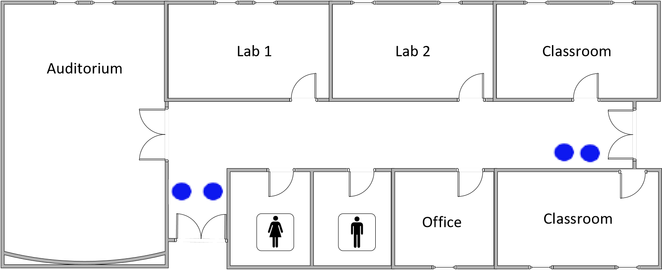
Fig 20 [26]

Monitor entry (and exit)
This type of monitoring as shown below is used to determine when a student arrives at a particular class with set times.
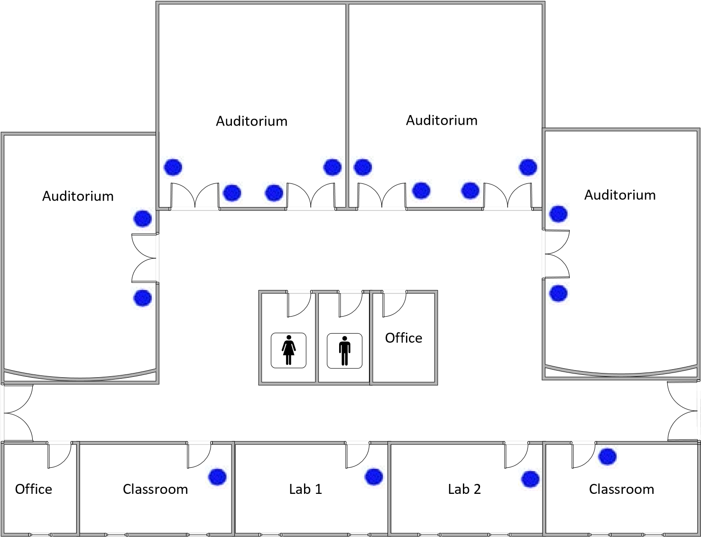
Fig 21 [26]

Mobile - exam tracking, tutorials, in the field

This type of monitoring as shown below is used to authorise the Identity of students in an exam situation. The students ID’s are scanned at the door by a mobile device, allowing the lecturer/ examiner to verify that each student is who they say they are, a pop up on a screen will provide a photo and details of the student so they can be authenticated and their time of attendance will be recorded to the attendance system [26].
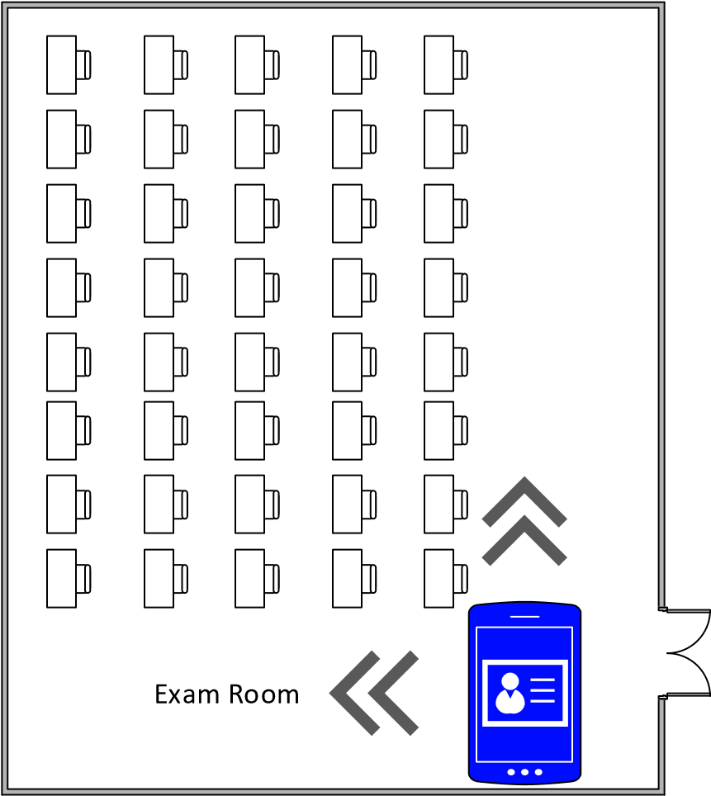Fig 22 [26]

The Most popular technologies used in educational Institutions

As mentioned in this research there are many different types and varieties of technologies for tracking attendance in all different types of organisations. As shown below are the most widely used technologies for tracking students in colleges and universities [26].

RFID

Very small contactless tag that are integrated into either the student’s identification cards, or key fobs, Students can scan their cards without removing it from their wallet or lanyard [26]. Many students can use the scanner very quickly.

Magnetic stripe

It uses a magnetic card reader to read the magnetic stripe on the card [26]. Can take much longer than RFID and students need to get the card out of holder to swipe it.

Barcode / QR code

It also take a longer time to scan as it needs a use of ac camera or laser and can be difficult to scan, as they need to be orientated a certain way [26] and will not work also in a holder [26].

Biometric (finger print scanning)

Very accurate and fool proof. May be concerns when storing biometric data, Sometimes it can take a long time to scan due to dirt on fingers or the scanner.

Face Recognition

Not cost efficient enough as technologies as not advanced enough at the moment [26].
Comparing the technologies
Technology | Contactless? | Speed of Scan | Card Resilience | Location Accuracy | Risk of  Impersonation
RFID | Y | Fastest | High | High | Medium  (Student can bring others card)
Magnet Stripe | N | Fast | Mid | High | Medium  (Student can bring others card)
Barcode or  QR Code | Y | Slow | Mid | High | High  (Students can photocopy barcodes)
Biometrics Fingerprint | Y | Depends | N/A | High | Low
Face Recognition | Y | Depends | N/A | High | Low
Reference for this table [26]

Attendance tracking hardware Considerations

Laptop connected to scanner via USB cable

Nearly all off the shelf USB scanners can read magnetic strip, barcodes, and RFID. This option can be the quickest way to record the attendance of the students, the records then directed into a desktop application for example Excel [26].

Advantages | Disadvantages
Fast start up and off the shelf hardware | Laptop must be maintained and kept updated
 | May not be desirable to be left unattended due to easy tampering
Laptop or components could be stolen
Not scalable

Tablet or Smartphone Based System
There several ways Mobile devices can be used to automate student attendance, Barcodes can be read using the on-board phone/tablet cameras. Most devices now come with RFID readers built in. With using the right app, these can be translated into attendance recording devices [26].

Advantages | Disadvantages
Extremely mobile, a good option if you are using one device to record attendance in different locations. | Cannot be left unattended
 | Requires updates and charging
 | Have to scan from the back of the device
Reference for table [53]

Specialized Attendance Scanners
Specifically designed attendance scanners that are made exclusively for tracking of attendance.

Advantages | Disadvantages
Hardware device, requiring no updating or maintenance | The vast majority are designed for tracking employee attendance (time clock) and to control door entry, rather than for tracking student attendance in education. This means many hardware devices are slow and not designed to integrate with educational systems.
Wall or desk mounted
Ethernet or Wi-Fi connectively to prevent infrastructure installation
Can be left unattended, fully automated
Reference for table [53]

Existing Access Control System
If you have electronic door locks on rooms, that require a card access, then it is possible that these systems will be able to integrate with an attendance system. Integration would be required to convert the scans into attendance (Tardy, absent, etc.). However, these systems are not designed for tracking attendance and repurposing them for this may not be possible – check with your vendor.
Hardware considerations
Unit Type | Considerations
Accessory  (Connected to a computer via USB) | This option requires a PC at every scanner/reader. Requiring that the PC is kept updated and maintained. Increasing costs in the long term. The chances of failure double, as you have the PC and the scanner to keep running.
Standalone Unit  (Network/Internet connected) | Standalone unit handles scanning data and data transfer automatically, with direct connection to the network or internet. Data processing handled by a centralized server or cloud service.
Mobile Device  (with RFID built-in) | Similar to a stand-alone scanner, with an advantage that it can be highly mobile, allowing for attendance to be recorded outside of the classroom or lecture theatre environment. Any mobile device with a camera can read barcodes and QR codes, most android devices now contain a built in RFID reader as well.
Reference for table [53]

Software Consideration



“SEAtS Company develop Attendance software and Capture Devices that will read current student RFID cards [56]. This makes them highly cost effective and also significantly increases the speed of implementation of the solution on a college campus. SEAtS devices use a push-to-cloud technology to reduce the need for hardware on campus [56]. They also work on wireless and PoE networks which mean significant time and money savings on system setup, wiring and infrastructure” [56].
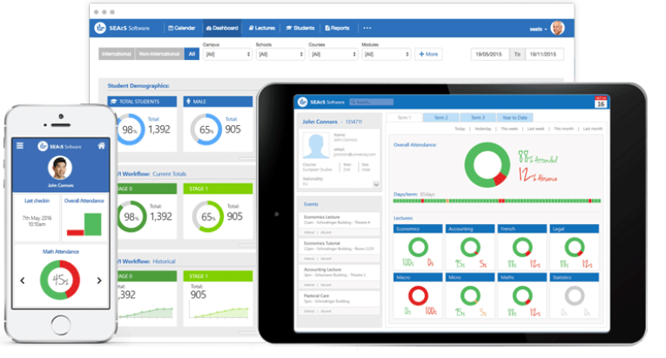

Advantages | Disadvantages
Cloud based  so it is very cost effective, and also considerably increases the speed of adoption to the solution for the College/Uni | Only cloud based  If the network goes down for some reason the software won’t work.
Reduced need for hardware on campus. | No biometric integration only a RFID system risk of impersonation.
Works on wireless and PoE networks which means substantial time and money savings on system setup. | No integration with Moodle must use the provided system.
The costs of wiring and installation are minimised too. | No customisation of the software
The instant on cloud platform means that reports, alerts and dashboards work as soon as you switch on the software. | Cost to have any lost data restored
Retain students through critical early informed interventions.
Increase completion through better analytical insights into progression.
Enhance resource and space utilisation with instant analytics
RFID Cards These allow students to scan their card past a scanner without removing it from their wallet or lanyard. This makes it possible to scan several students within a short time.
Reference for this table [56]



Telepen is a supplier of Student Engagement Systems and Student Retention Systems for universities and colleges in the UK [26]. Developed in conjunction with key academic institutions. They have two versions of software solutions; Collector and Advantage [26]. Both monitoring systems incorporate robust tools for the automated collection of student attendance and engagement data and are designed to aid student retention through the early identification of course disengagement. They are both also designed to assist with the institution’s obligations under the UK Visas and Immigration (UKVI) Regulations [26].

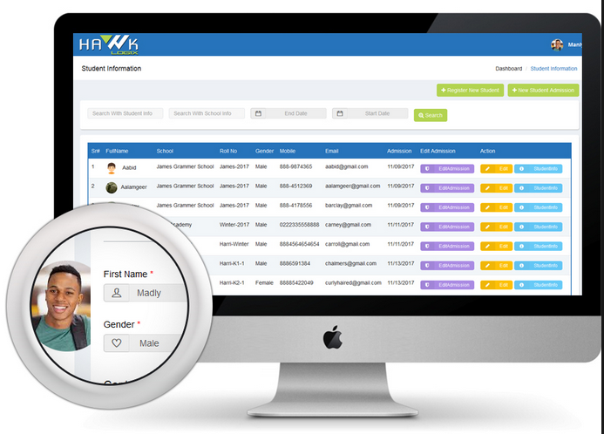

Advantages | Disadvantages
Data Collection Devices: A available are a large range of fixed and portable ID card scanners. Fixed readers, such as the TBox, communicate with the central application through the organisation’s network infrastructure via standard LAN, PoE or WiFi. In the event of a network failure, the units will continue to operate offline, storing attendance data locally then transmitting the data once the network is restored. Biometric readers and portable scanners are also available. | Expensive: Cost to have induvial scanners implemented in each class room is high. And also, extra ongoing annually cost to use their analytic software.
System Integration: All events are recorded for future analysis from within Telepen. Telepen integrates with student and timetabling data from a variety of different sources including external software products such as Agresso, SITS, Syllabus+ and Celcat. Telepen Onyx system accepts MS Excel or CSV file imports or links directly to other databases. The import can be scheduled for daily automated operation.
The Marking System: The card readers record present and late attendances. Authorised users can view and modify this data. Manual marks of present, late, approved and unapproved absence can be posted. Staff can manually block mark and block edit the marks of students. Staff can also call up and mark online students expected at a teaching event during the session.
Reports: Onyx Advantage software provides a comprehensive range of attendance reports, which typically can be viewed, printed or exported to file. These include a specified student report and a specified teaching event report. Multiple teaching events can be linked together to enable analysis of overall attendance. An extensive amount of hot-swapping between the on-screen reports is available.
A major summary report shows overall percentage attendance information. The user selects their chosen starting point for analysis from Department, course, year, group or similar. The resulting analysis displayed details the next level down. They can then drill down (or up) through the levels potentially to individual students.

Zero Attendance reports help identify last minute room and timetable changes, enabling administrators to ensure these changes are tracked. Further reports allow for the analysis of room utilisation and occupancy.
Web Portal:
The system data, reports, and analysis tools will be accessible from any on-line machine.
Access is granted to authorised users under password control either managed within Onyx or via Active Directory.
All the Onyx Advantage functions can be accessed through the web portal under comprehensive user privilege control. Students and/or parents could have access to their attendance details if the institution chooses to allow this function.
Email Reports:
Onyx produces absentee reports, which give details of students who have failed to attend their expected timetabled engagements. Emails can be sent automatically to multiple email addresses which could include the tutor or administrator associated with the relevant timetabled engagement as soon as the card scanning time closes.
Reports are also produced with details of students who have reached a specified number of consecutive absences. This threshold is user configurable. Emails are again sent automatically and immediately to relevant parties.
Reference for this table [56]


Solutionpath provides award-winning software, developed in sector with higher education partners to support decision making, enabling higher education institutions to maximise their resources [57]. Our StREAM learning analytics solution is proven to dramatically improve student engagement, progression and ultimately attainment, including accurately predicting early student withdrawal [57].

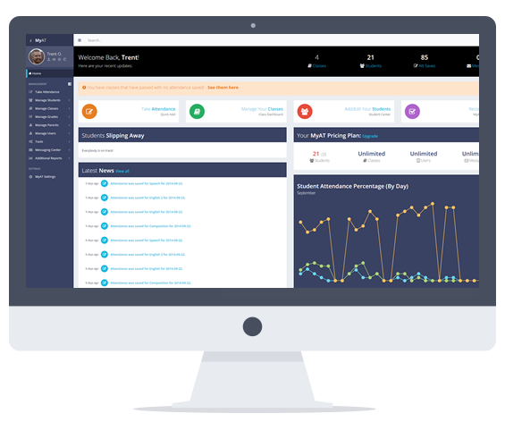
Advantages | Disadvantages
LOCATION BASED ATTENDANCE MONITORING  No need for extra does not need a wireless infrastructure or authentication stations. | No cloud integration system works on the organisations network either Lan or Wi-Fi in the event of a network failure the software won’t work.
AUTOMATIC MONITORING OF LARGE GROUPS  The ability to monitor very large amount of students at a single location, inside or outside, at onsite and offsite locations. | Not compatible with any data collection devices such as biometric or smart cards.
Cost reductions  No extra cost to for additional consultancy for monitor specific locations. | No customisation on software dash board
FULL INTEGRATION
The software integrates with existing applications such as the student’s time table, and room availability.
A RESULTS DASHBOARD
Give staff and students the ability to view of attendance records via an interactive portal which can be published on your preferred web devices. The dashboard allows organisations to identify trends or changes in attendance.
Reference for this table [57]

Ethical / Legal Issues

- Considerations will be taken of
- Ethical issues
- Personal data used for something other than it advertised purpose.

- Privacy issues
- Who can access data?
- Misuse of personal data

- Public concern
- What happens to biometric data after the intended use is over
- Security of biometric data assured during transmission and storage [24]

Actions to be taken:

The Institution and subjects must explicitly sign and agree to participate in this study.

If data for other, not yet defined purposes is to be intended to use by the researcher additional separately signed forms will be provided to allow any participates the choice to allow the data to be used just strictly for current study or any possible further studies.

The researcher and study Institution will be regulated in a contract on Issues on confidentiality.

Only the researcher and study Institution can access the data.

All biometric data and assured data will be kept secure by only the researcher.

All data will be erased after the intended use is over [24].

Critical Review
The strong evidence from this research, is that regular attendants is an essential aspect in educational institutions. Not only does regular attendance open various opportunities that are available at the institution, there is also an overwhelming evidence that students often fall behind when they frequently miss classes in college or school. And achieving good results is often linked between good school attendances [38]. Also from this research there is a concerning issue from various institutions for the tracking and monitoring of the students. Using the manual methods of tracking the students take valuable teaching time and is also prone to errors for example the attendance sheet can be missed placed or is susceptible to falsification where by students sign on behalf of their friend. This means that the analysed attendance records that are required can take extra time to be rectified would leads to prolong the time to inform the parents about the truancy students [30]. The other major concern in this modern world is regarding national security, theft identity as well terrorism. This research refers to Biometric as a solution for detecting user’s identity and security challenges arising in this modern day [9] [33] . Biometric identification is any automatically measurable, robust and distinctive physical characteristic or personal trait that can be used to identify an individual or verify the claimed identify of an individual.
There are many different software and automation tools that had been researched and carefully reviewed for this project, it is essential to choose a solution that works for all the students, it is needed to take inconsideration for example if the chosen option of software needs a mobile app on the students phone will they have the phone charged or forget to bring it with them. After investigating and reviewing the different methods of registering attendance from the Conventional and Automated attendance methods. Biometrics has made the more significant impact on society in recent years. This method helps people get rid for the need to carry ID cards, documents, and remembering pins and passwords, allowing them to prove their identity or attendance by their unique physiological or behavior characteristics [6]. After researching and studying the different types and suitable biometric systems that could be used for the intended project, the two best candidates for the attendance system was narrowed down to either facial recognition system, or the fingerprint scanner biometric system [8]. The two recognition methods are considerably different from each other and both have their advantages and disadvantages. The facial recognition is better suited in mass surveillance applications in crowded places. But personal identification with the users consent is better achieved by the fingerprint system [6] [10] [11].

After some considerations the implemented system for this project will be the fingerprint biometric system to monitor the student’s attendance. According to Pike J from Global Security “The leading modality is fingerprint biometrics thanks to its wide users’ acceptability, accuracy and security as well as to its inexpensive” [8]. By implementing a biometric fingerprint recognition system it will efficiently aid the monitoring of the students time keeping or attendance of a particular class [7]. Unlike using barcode codes and smart cards, fingerprints are a unique feature to everyone. This new system when implement, will stop the tedious and time consuming aspects of recording the student’s attendance and will help prevent human error. It will also eliminate the possibility of students forging their friend’s signatures to falsify their attendance. [8] [9].

RESEARCH AND DEVELOPMENT METHODOLOGIES

Research Methodology

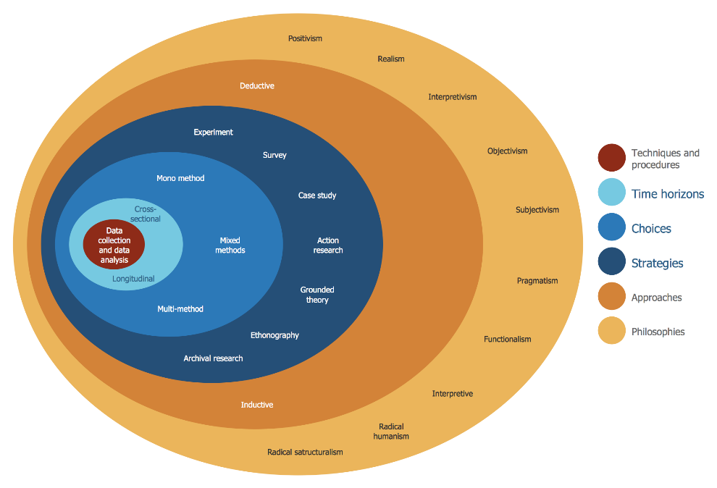

3.1.1. Philosophy
Phenomenology is the name given for a method for investigating or inquiring into the meanings of our experiences as we live them [14] [15] The method tries to understand people’s perceptions and understandings of a particular situation [15].

Advantages for using Phenomenology
• It is flexible and can look at change processes over time.
• Help to understand people’s meanings.
• It can adjust to new issues and ideas as they emerge.
• Contribute to the development of new theories.
• Gather of qualitative data which is seen as natural rather than artificial [14] [15].

Problem | Solution
It takes time and resources to gather data | Close monitoring of the project plan is needed and agree time schedules with the College management
Every difficult to develop and control pace of end points | Development on project plan must be  Strictly monitored.

3.1.2. Approach

Inductive reasoning moves from the particular to the general. It gathers together particular observations in the form of premises, then it reasons from these particular premises to a general conclusion [17].

Inductive approach and Phenomenology philosophy are very much related.

Advantages for using an Inductive approach.

- Subjective reasoning will be allowed to the researcher with the help of real life example.
- Probability will be established by inductive reasoning this will allow the researcher to be wrong.
- Free to follow unexpected directions and the researcher does not start the research with any prejudices [15].
Problem | Solution
It may not be solid information being based on observation and it might be subjective. | Within the literature review it will analyse and study the existing research in the field and secondary data can then be used to back up the find.  The software that is developed will produce test results, this will provide the evidence to back up the research
In some cases the data may be able to support, or fail to support, and also discredit a generalisation. Therefore cannot be used prove anything.

Does not test alternative theoretical explanations
There can be a possibility that no theory will materialise

Reference for this table [18]

3.1.3. Strategy
The case study is the most common qualitative method used in information systems according to (Orlikowski and Baroudi, 1991; Alavi and Carlson, 1992.
(Benbasat et al. 1987) said that the case study research method is particularly well-suited to information systems research, since the object of our discipline is the study of information systems in organizations, and "interest has shifted to organizational rather than technical issues" (Benbasat et al. 1987) [17] [18].

Advantages for using a case study
• No pressure on the researcher to change or control any circumstances with the research as the approach investigates as it naturally occurs.
• Included in the research is a detailed information why and how a technology is used.
• Provides detailed (rich qualitative) information and high validity of explanation and analysis.
• Provides insight for further research for better understandings and more detail and behaviour of topics of interest [18].

Problem | Solution
To analyse and collect data it takes time and resources. | The project plan needs to be closely monitored.
Observing and also recording social behaviour training is required. | Necessary training for the researcher must be given
Detailed project data must be made available  As it will be required by the organisation. | Any access for the project data to the organisation has been authorised by the researcher
The strategy is condemned for its lack of thoroughness and lead to the researcher to have a biased interpretation of the data | Thoroughness and exceptional attention to detail within the use of the report.  Procedures are well documented so that the results can be repeated every time.
No statistical significance with conclusion will be provided with using this strategy. | To support a solid and relevant conclusion, sufficient amount of evidence, documents, will be linked together.
The limitations of the case can prove difficult to define, On the technical side. | The sponsor has agreed on the scope of the study
History and a future of the organisations is what influences the understandings of the present. | The history as well as future plans of the organisation is already known by the researcher.
Criticised in relation to the credibility of generalisations made from its findings | A careful and detailed demonstration will be to the extent to which the case is similar to, or contrasts with, others of its type.  Help from the literature review as well as  Techniques such as cross-case examination and within case examination review to ensure external validity.
Reference for this table [18]

3.1.4. Time Horizon
With the Time Horizon research method a one certain fixed point in time the process must be evaluated or assumed to end. Since the project end cycle is 6 months the cross sectional time horizon is the selected research method for the project [19].
Reasons for a cross-sectional study include:
• Not too expensive to perform and does not require a lot of time
• Captures a specific point in time
• Used to prove and/or disprove assumptions
• Contains multiple variables at the time of the data snapshot
• The data can be used for various types of research in the project [19]

3.1.5. Data Collection Methods
A triangulation of data is used to again different views on the results, qualitative (minutes, documents, charts) and quantitative (records, metrics) approaches of data collection is need to provide a degree of reliability to the findings of case study [19 [20]. Also important to case studies is the data collection through interviews and observations. Archival data will definitely help the research for the project by looking at the original data [20].
Qualitative Data Analysis
• Provides depth and detail: looks deeper than analysing ranks and counts by recording attitudes, feelings and behaviours
• Creates openness: encouraging people to expand on their responses can open up new topic areas not initially considered
• Simulates people's individual experiences: a detailed picture can be built up about why people act in certain ways and their feelings about these actions
• Attempts to avoid pre-judgements: if used alongside quantitative data collection, it can explain why a particular response was given [18] [19] [20]
Quantitative research allows the researcher to measure and analyse data. The relationship between an independent and dependent variable is studied in detail. This is advantageous because the researcher is more objective about the findings of the research. Quantitative research can be used to test hypotheses in experiments because of its ability to measure data using statistics [19]

3.1.5. Success Criteria

- More efficient.
- Ease of use.
- Accurate.
- Secure.

Development Methodology

Evolutionary prototyping is a chosen methodology used in implementing this research project. Evolutionary prototyping software development method in which an initial prototype of the software is developed then it is refined through a number of cycles until the final system is complete [42]. The reason evolutionary prototyping methodology is considered to be used in this project is it allows the developer continuously to get any suggestions and feedbacks for any improvements on the software prototype that been presented in meetings until the final system is delivered. There are four phases that is used in a revolutionary prototyping which includes initial concept, design and implement initial prototype, refine prototype, and deliver the complete system [42] [43]. There are a number of advantages when using evolutionary prototyping methodology these are the speed that developer can build the system, and also help in improving the quality of the final product since it has to undergo few prototypes until the complete version is finalised and all the requirements and functionalities are met [42]. Another advantage of using this methodology is there being greater chance of satisfaction for the end user when using the system because every generated prototype the requirements specified in the end-user has been established [43].

Some weaknesses can be found when using the evolutionary prototyping methodology, for example it is hard to predict the date of completion and the total cost of the project since the requirements can be changed from time to time based on the end user’s requirements. This can cause the developer to feel frustrated due to time lose and wasted effort. Not only can time and effort be sacrificed but also as a higher risk of software being damaged or poorly structured due to changes being made to meet the requirements specified by the end-user [42] [43] [44].

Advantages
The main functionality will be produced first
There by solving the user’s basic needs. This avoids the users from waiting through the entire software process to get a system that is functional and having to wait for another period of time if there are any discrepancies in the user's requirements.
User engagement is established with this system. An increase in chances of producing a system that meets the users' requirements,

Reference for this table [43]

Problems | Solution
Management problem is the first problem that arises.  The evolutionary prototype's existing management processes always assumes a waterfall model of development which provides more visibility. Throughout the process specialist skills are required and it may not be available in all development teams. | Good communication is essential. And the availability of required skills must be put in place before the development starts.
Evolutionary prototyping requires frequent changes to the system in order to meet all users' requirements. This causes a huge increase in the maintenance cost of the system on a long-term basis. As well, this prototyping approach also tends to corrupt the system structure through continual changes during the development phases. | Good communication is essential so the changes to the system are not so frequent and there not any drastic changes to the system.
Evolutionary prototyping does not develop a software specification, thus, causing contractual problems in the process. Software specification normally acts as a basis for a contract between the developers and the customer. Contract writing for software development becomes a difficult task since evolutionary prototyping does not develop a software specification, and requirements may sneak into the system and the intended budget could be exceeded. | All contract writing for what functions the system will have is clearly written down and explained before development take place, and after every meeting.
Reference for this table [43]

DESIGN AND IMPLEMENTATION

SYSTEM DESIGN

The biometric fingerprint student attendance system is a system that firstly records a student’s personal records along with the student’s photo, and fingerprint. It then records the students’ attendance by comparing a single fingerprint image with the image of the student’s fingerprint that has been previously by saved to the database. The key factors when designing the biometric fingerprint system include: selecting the appropriate hardware and software components and integrating them together. Three main parts the system framework is divided into Hardware design, Software design,

The Design approach the Hardware.
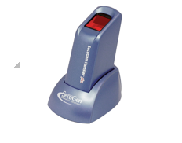

The hardware design used for the project is divided into categories first of all the fingerprint scanner this is the hardware that captures the image of the fingerprint, and the second piece of hardware is the surface pro laptop that runs the software and where the database is stored.
The fingerprint scanner is connected to the laptop by its USB cable, to enable the Secugen Fingerprint scanner to operate correctly, the Secugen software developer kit is needed to be required and is then intergraded with visual studio [47] [53].

The reason to use SecuGen fingerprint reader is because they are easy to use and can be installed quickly on any Windows PC. also they have many years of field use and proven reliability under extreme conditions, SecuGen fingerprint readers provide consistent performance and security for a growing number of software applications for desktop, mobile, network, enterprise and Internet environments [47].

According to SecuGen “When used for biometric authentication as part of an overall security program, SecuGen fingerprint readers can help reduce the hassles of password overload, decrease the risks of security breaches, improve accountability and add true non-repudiation, all while making it more convenient and intuitive for any user” [47].

Software Design

The software design consists of the database and the application program.

Database Design



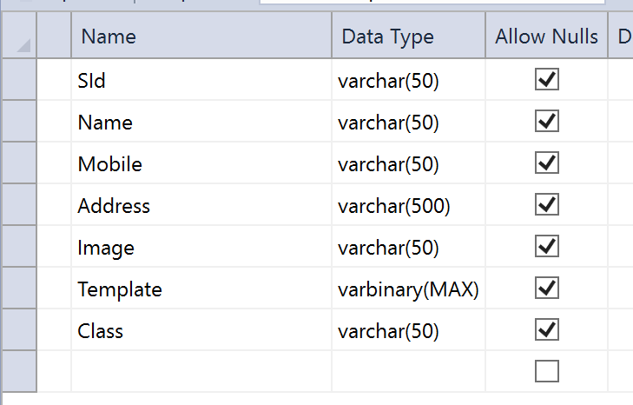

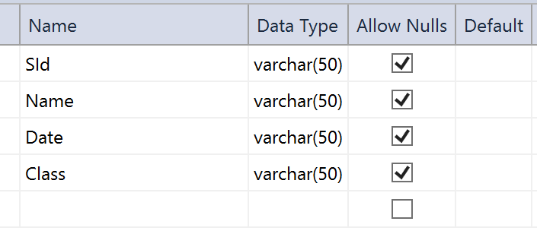

Database: The database consists of tables that stores records implemented in Microsoft SQLServer database. However, this can be migrated to any other relational database of choice. SQLServer is fast and easy, it can store a very large record and requires little configuration [53].

Fig 22 [53]

Application Program: The application program is developed with Microsoft C# programming language using Microsoft Visual Studio framework and it provides a user interface for the Attendance Management System. The advantages of Microsoft C# programming language are its robustness, easy to program, has an excellent database connectivity, runs on the two most common operating system platforms (Windows and Unix) and it has a larger user community that provides online support [53].

Methodology
The system process
The software application that is developed in this report is for a student attendance system using fingerprint biometrics for identification. The way the system works it recognises an individual by matching their fingerprint biometrics with the records that have been stored in the database.
The biometric identification consists of two stages, these are Enrolment and Authentication
The biometric fingerprint of the student is captured during enrolment or the first day at class (using a biometric fingerprint reader) and the fingerprint image is then stored in a database as a template for the student with their student ID [38].The propose of enrolment of the student is to have their biometrics and information and what class they are participating in stored on to the database. These features are then used to authenticate a student’s identity by placing their finger on the biometric scanner and then authentication is granted or not by extracting the features and comparing them (using a matching algorithm) to the images in the database, if matching is successful the attendance in marked [38].

Using Evolutionary prototyping do design and implement
Design and implement initial concept
Initial Concept

The need to identify all the basic requirements in developing the system is during the first phase/initial concept. In this project phase developer will come out with the creation of initial concept identified the required materials related to the project. The list of requirements for this project for example are taken from the lecturer, and students. Once all the requirements are gathered is then put forward to the organisation through a business plan for developing the given system. The use of the business plan means the developer can specify and create the project plan. The completed project plan provides information for the developer for example the schedules for the project and clear descriptions of the project [43]. So at the end of this phase the initial list of requirements from the end user alongside the completed business plan, project plan. So the initial concept for the replacement of the current existing student attendance system process fully automated and computerised system has been stated. Therefore one of the objectives has been stated in this phase [43].

ERD SYSTEM DESIGN
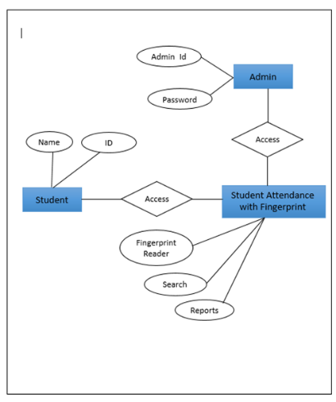

Design and implement initial concept

All the basic information has been identified from the previous phase which includes business plan, project plan, and the initial requirements needed from the user. The developer will carry out the initial design and then implement initial concept in developing the system. To make sure the development is moving in the right direction, the development of the basic user interface prototype will be established first. This allows the end-user to have a clear idea how the system will look. It also allows the developer to perform the initial system design analysis based on the requirements list at this phase. The user interface is created and shown to the end-user after developing the first initial system design. This allows the end-user to evaluate the interface prototype and give feedback to the developer to modify the requirements or any missing requirements that is needed for the next phase.

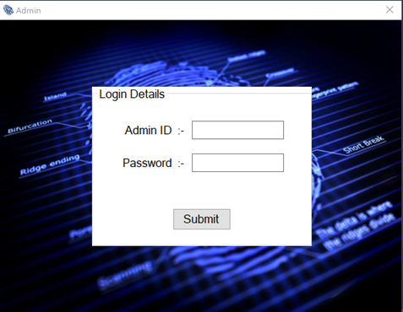

Refine prototype until acceptable
After evaluation and feedback from the user in the previous phase, a new list of validated requirements, are ready for the next phase of the system design. The developer can now modify and make changes to the system design from the feedback from the user from the previous phase. In developing the first prototype, it will be insured that all validated requirements and system design obtained from the end-user has been satisfied. Also in addition the developer will take any considerations about the quality of the system while implementing it as well as programmer system, test the system, and debug. After this the first prototype of the fingerprint attendance system is implemented, and now this first prototype of the system from this phase will be shown the end-user for them to evaluate. Now that the first prototype has been evaluated, the developer will now make a list and record the new requirements or any modification that are required by the user ready to review for the next prototype development. This phase will be repeated time after time until the final set of requirements reached and stated by the end-user. The final set of requirements are validated at the end of this phase.

Add a class to the system database in the admin page
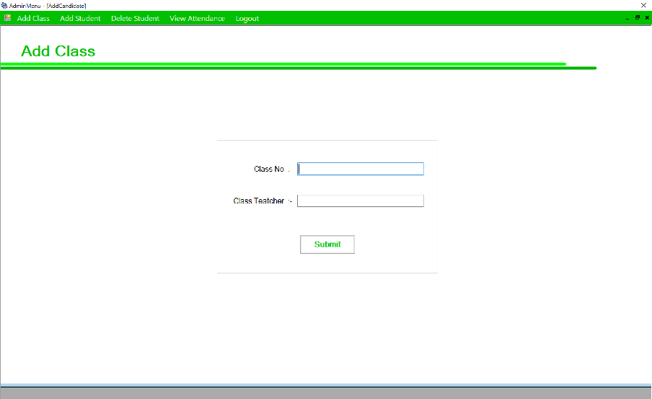

Adding a student to the records
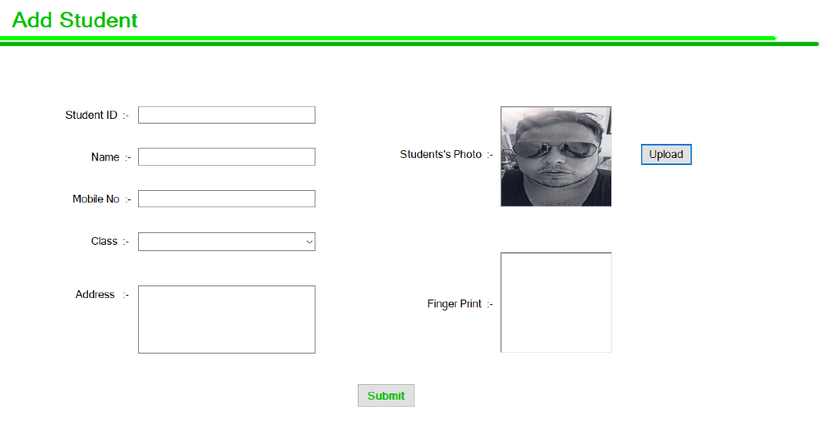

Complete and release prototype
This final phase, the developer will implement, and test and complete the student attendance system based on the validated and final set of requirements obtained from the end-user. The final system with all the needed functionality and design quality that’s been approved from the end user. This means all of the system objectives/sub objectives will have been met at the end of this phase. The new attendance system can now replace the old attendance system at the end of this phase.

Viewing the students attendance
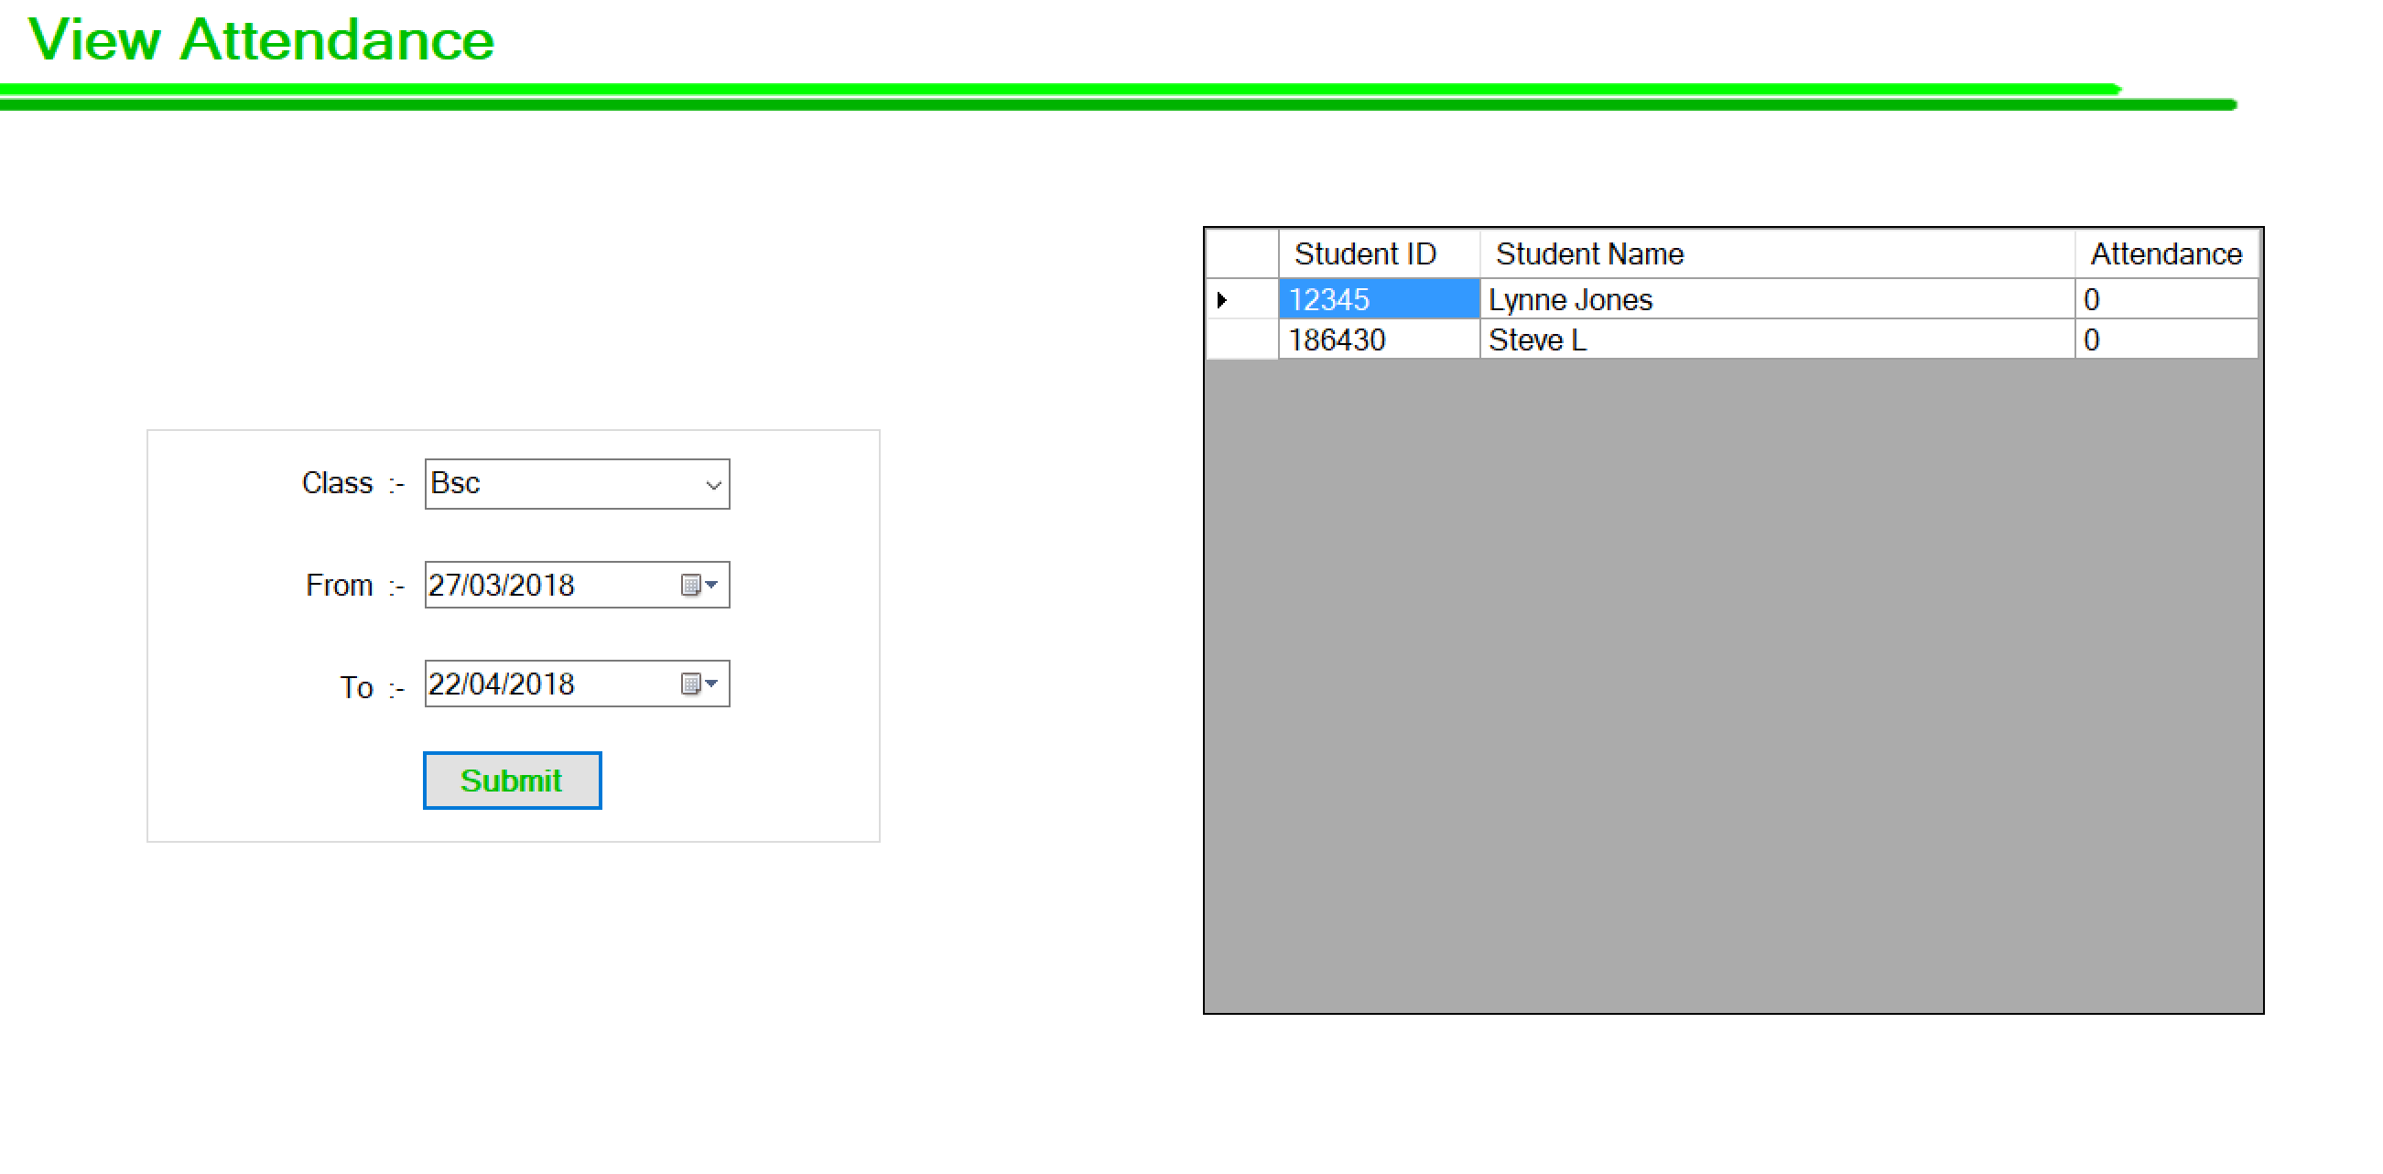

EVALUATION

In developing the new student attendance system, there many improvements aims and objectives that had to be met that was discussed in the project proposal as follows.
Aims
• The aim of the project is to design and develop a reliable, scalable and cost effective Fingerprint based Student Attendance Monitoring system. This is to be achieved by the following objectives:
2.11 Objectives
• To analyses the attendant’s methods and techniques used by the Institution and identify functions the biometric system could perform.
• Develop a Biometric fingerprint attendants system, using Biometric system technology, based on appropriate knowledge gained from the report and to suit the business/user requirements.
• To provide an interface from the new biometric fingerprint attendants system software, to the college institution
• Evaluate the success of using technology in the context/domain.

The improvements needed to be focused on the accuracy, efficiency, and cost of the new system, and also security form identity theft as well as terrorism as it is the trend concerning the modern world when regarding national security. From the research the biometric fingerprint scanner can be confirmed to be a much more efficient and reliable method of recording students’ attendance that also prevents human error and also stop falsifying their attendance compared to the previous conventional system.
Unlike using barcode codes and smart cards, fingerprints are a unique feature to everyone, and cannot be replicated.
According to user feedback, the new system provides an efficient, easier and more accurate and secure method of recording the student’s attendance. The system meets all aims and objectives and it performs as expected. The system is easy to use, even for novice users. The new system successfully recorded the student’s attendance and also captured new fingerprints and stored them in the database, and also successfully matched the fingerprint from the database when the student placed their finger onto the finger print scanner. The new systems performance was more than satisfactory and would be considered to be implemented simply because of its efficiency and time and reports generation. Overall because the system was developed using the prototype methodology, the feedback from various phases enabled the new student attendance system to ensure the accuracy of recording the students attendance, And now since every student will be required to mark their attendance by using their fingerprint to authenticate their attendance, therefore, the students will not be able to falsify their attendance with the new developed system. As well as the system will automatically update the student attendance record in database, and also generate a report feature that will provide very accurate data and result for analysis purpose. The new attendance system will help in save cost and time because there is no need for paperwork, and also excluding the need for the students to sign on a piece of paper which require them to pass the paper around whole class in order to prove their attendance which is very time consuming.

CONCLUSIONS AND RECOMMENDATIONS

Conclusion
This research is focused on the importance of regular attendance in education and it investigates how various institutions regularly try to improve attendance and how security issues are becoming ever more concerning, with the need of technologies to be implied to verify a particular person.
The research focuses on how keeping accurate records for attendance is so important, and that the approach of using the old conventional methods that have been used for many years of using paper sheets are still widely used today. However with there being so many bottle necks with the old manual system such as the time it takes to record the attendance and to calculate and to modify the weekly attendants for the students, this paper-based method can also be misused, deception can arise when a student can sign the attendance record sheet for a fellow student who is absent. It is difficult to prevent this false representation from happening and it will become even more difficult with larger classes.
There a many alternative automatic methods for tracking and monitoring student attendance that are investigated in this report, from barcodes, smart cards, and biometrics. Biometrics has made the more significant impact on society in recent years. This method helps people get rid for the need to carry ID cards, documents, and remembering pins and passwords, allowing them to prove their identity or attendance by their unique physiological or behaviour characteristics [6]. After researching and investigating the different types and suitable biometric systems that could be used for the intended project, the two best candidates for the attendance system was narrowed down to either facial recognition system, or the fingerprint scanner biometric system [8]. After more extensive research a biometric fingerprint recognition system it will efficiently aid the monitoring of the students time keeping or attendance of a particular class [7]. Unlike using barcode codes in smart cards, fingerprints are a unique feature to everyone. It will also eliminate the possibility of students forging their friend’s signatures to falsify their attendance. The report then focus on technical details of how the fingerprint biometrics works and identifies the risk and control points of authentication system [9].
The research moves on from the literature review to the methodologies and how it is used in the approach to developing the new system. This report also investigates development methodologies, programming languages and platforms, in order to select the most appropriate for implementing this project. Evolutionary prototyping was the chosen methodology and the software was developed then refined through a number of cycles until the final system was complete. The chosen language was Microsoft Visual C# on the .net framework, using the Visual Studio platform.
Although there is a strong connection from the research between attendance and performance that was found in the study, it cannot be assured without further investigation and data that the students with bad attendance are susceptible to receive failing grades regardless the attendance. However, the evidence presented in this research suggest that the higher the attendance is the lower the probability of receiving failing grades appears to be as well. Regardless of all the limitations, in the research study on connection between attendance performance it came to the conclusion that the by using compulsory attendance policy would be in students’ best interest and it will serve well for the whole educational process. And to achieve the best possible start in life, regular attendance at school is vital to help children.

The outcome of this project is a software system which can be concluded from the above discussion that the development of a reliable, secure, fast and an efficient system has been successfully achieved replacing a manual and unreliable system. From the evidence that has been shown it can be implemented in the educational institutes for improved results regarding the management of attendance. This new system will replace the old paper and manual method of recording the attendance. Therefore a system with expected results has been developed but there is still room for improvements.

Recommendations

How would enhance your software solution – what extra functions
In this research as security is a major reason to implement the fingerprint system, the use of encryption files in the database as an area of protection that strongly should be visited. Therefore it highly is recommended that the institution use a Window based authentication system for added protection. Another recommendation is to add extra functions to the report generation. From the literature review, it has been identified that the system only provided the report regarding the student attendance status, and there is no further information and if a student had been excluded from the course or if the student had quit the course. So the recommendations are added functions to the report generation, for example as soon as the classes finished, the system will automatically send a report of this student’s attendance for the given class the head of faculty. And at the end of each semester, the head of faculty would be able to automatically generate a report based on the percentage of each students attendance and also the names highlighted that has either quit the course all that been excluded for having poor attendance, as well as the lecturer to be able to generate daily, and weekly reports. Another recommendation is that the system only provides two different attendance status, which are present or absent, so another recommendation is to have the ability to record the students that are 20 minutes later or more and if this happens to particular student over certain amount of times it is flagged up in the system, so the lecturer can question individual for the reasons of being late. A further enhancement to the system that would be recommended is an email service, so when a student has been verified by the fingerprint system and automatic email would be sent to the students email address to confirm that they were present for that day and if the student was absent from class an automatic email will be sent out to the parent Guardian or student to request information why they were absent. The system was designed for the lecture to use the system without any extensive training and to be able to make the lecturers ease of work and be more efficient. If any amendments or improvement are required it should be done with the idea of making it a user friendly and easily accessible to users, efficient and readily available to the user.

REFLECTION
For my reflection on this report I’ll be using Gibbs’ reflective cycle, Gibbs’ reflective cycle is a popular model for reflection. The model includes 6 stages of reflection and is presented below.

Description
What
Happened?
Feelings
What were
You thinking
Or feeling?
Evaluation
What was
Good/bad
About the
Situation?
Analysis
What sense
Can you
Make of
Situation?
Conclusion
What else
Could you
Have done?
Action plan
If situation
Arose again,
What would
You do?

Description
The programming language that was used in developing the system was in c# and is developed in Microsoft visual studio.

Feelings
This choice made me feel like I was restricted to the Microsoft platform.

Evaluation
Though it had many useful tools that helped build the interface and also easy to integrate with a database.

Analysis
There are advantages to using Visual studio but they are slight.

Conclusion
The other choice of programing language I could have used is Java though they are very similar java is an open source platform meaning it is free to use and huge open community where there are many problems that have already been solved and source code there to use which would aid the speed of developing the system as it is easily available to download. It has also the ability to be used on different operating system much simpler that c#.

Action Plan
If would be in a situation to develop a similar application I would consider using Java.

Description of what happened
The developing method that was used was evolutionary prototyping because it allowed me to continuously get any suggestions and feedbacks for any improvements on the software prototype that been presented to me in meetings.

Feelings
I felt frustrated due to time loss and wasted effort.

Evaluation
Using this method it is hard to predict the date of completion and the total cost of the project since the requirements can be changed from time to time based on the end user’s requirements.

Analysis

Using this methodology is there was a greater chance of satisfaction form the end user when using the system because every generated prototype the requirements specified in the end-user has been established.

Conclution
The other methodology that I could have used was time boxing it is also very similar methodology because it has the ability to break the project down into smaller parts (time boxed durations) also referred to as iterations [21]. Because the iterations are fixed and not flexible this means the project will end regardless if the project is completely finished or not. Any outstanding work will then either be assigned the next iteration, or reprioritised at a later date. The iterations are normally set at a 30 day duration this methodology might have been less stressful.

Action Plan
Time boxing methodology would be considered to be used if the same situation would arise where there weren’t much time to develop an application.

Description
The research on how important regular attendance and security is for educational institutions.

Feelings
I felt surprised that while some educational institutions are make huge effort on security and monitoring attendance, but only recently as many as 50 colleges had their license suspended by the Immigration Office because of abusing the attendance records for foreign students.

Evaluation
I think there is a very good reasons for children to attend regularly at their Early Years and not just in college or universities so they are setting up to support their learning and development, early on and also so the children are kept safe, and their wellbeing is promoted and they do not miss out on their entitlements and opportunities. Also from the research there is proof that good attendance promotes good outcomes for children. In some small minority of cases, good attendance practice may also lead to the earlier identification of more serious concerns for a child or family and may have a vital part to play in keeping a child or family members away from harm.

Analysis
There should good policies and procedures in promoting, supporting, and recording and monitoring the attendance of children in Schools/ colleges this includes keeping accurate records of the daily times of arrival and departure for each child or student.

Conclusion
The research shows that attendance is statistically significant in explaining class grade and overall performance of students. And students or children who skip class frequently significantly increase their odds of a poor grade in a given course. But it would be beneficial to investigate what different methods could be put in place to help with regular attendance.

Action plan
More time to research and investigate on different approaches on helping to regulate and monitor attendance.

REFERENCES / BIBLIOGRAPHY

Reference

- Ofsted - GOV.UK [Internet]. Gov.uk. 2017 [cited 7 December 2017]. Available from: https://www.gov.uk/government/organisations/ofsted

- Cite a Website - Cite This For Me [Internet]. Tmc.ac.uk. 2017 [cited 8 December 2017]. Available from: http://www.tmc.ac.uk/sites/default/files/policies/TMC%20attendance%20strategy.pdf

- More than 50 colleges have licenses suspended as Immigration Minister makes statement on student visa abuses | www.ein.org.uk [Internet]. Ein.org.uk. 2017 [cited 8 December 2017]. Available from: https://www.ein.org.uk/news/more-50-colleges-have-licenses-revoked-immigration-minister-makes-statement-student-visa-abuses

- Jr. J. CPS reinstates Cook County Jail high school principal accused of fraud [Internet]. chicagotribune.com. 2017 [cited 8 December 2017]. Available from: http://www.chicagotribune.com/news/local/breaking/ct-met-chicago-jail-principal-reinstated-fraud-20171108-story.html

- CPS Watchdog: School In Cook County Jail Falsified Attendance, Credit Rates [Internet]. Chicago Tonight | WTTW. 2017 [cited 8 December 2017]. Available from: http://chicagotonight.wttw.com/2017/09/12/cps-watchdog-school-cook-county-jail-falsified-attendance-credit-rates

- Belhadj F. Biometric system for identification and authentication [Internet]. Hal.archives-ouvertes.fr. 2017 [cited 8 December 2017]. Available from: https://hal.archives-ouvertes.fr/tel-01456829/

- IJCSNS - International Journal of Computer Science and Network Security [Internet]. Search.ijcsns.org. 2017 [cited 8 December 2017]. Available from: http://search.ijcsns.org/02_search/02_search_03.php?number=201110003

- Pike J. Biometrics [Internet]. Globalsecurity.org. 2017 [cited 8 December 2017]. Available from: https://www.globalsecurity.org/security/systems/biometrics.htm

- Fingerprint Recognition [Internet]. Biometrics. 2017 [cited 8 December 2017]. Available from: http://www.biometric-solutions.com/fingerprint-recognition.html

- Gaikwad P, Narule S, Thakre N, Chandekar P. RFID Technology Based Attendance Management System. International Journal Of Engineering And Computer Science. 2017;.

- Uddin M, Allayear S, Das N, Talukder F. A Location Based Time and Attendance System. International Journal of Computer Theory and Engineering. 2014;:36-38.

- RFID BASED ATTENDANCE SYSTEM. International Journal of Recent Trends in Engineering and Research. 2017;3(4):94-97.

- Bantle A. Automated workforce tracking keeps you flexible. Nursing Management (Springhouse). 2007;&NA;(Supplement):29-30.

- Cite a Website - Cite This For Me [Internet]. Anlp.org. 2017 [cited 18 December 2017]. Available from: https://anlp.org/files/research-onion-layers_42_357.pdf

- Research Onion [Internet]. Onion.derby.ac.uk. 2017 [cited 8 December 2017]. Available from: https://onion.derby.ac.uk/

- Research methodologies [Internet]. Socscidiss.bham.ac.uk. 2017 [cited 18 December 2017]. Available from: http://www.socscidiss.bham.ac.uk/methodologies.html

- Cite a Website - Cite This For Me [Internet]. Repository.up.ac.za. 2017 [cited 18 December 2017]. Available from: https://repository.up.ac.za/bitstream/handle/2263/24016/04chapter4.pdf?sequence=5

- Cite a Website - Cite This For Me [Internet]. Citeseerx.ist.psu.edu. 2017 [cited 18 December 2017]. Available from: http://citeseerx.ist.psu.edu/viewdoc/download?doi=10.1.1.102.4717&rep=rep1&type=pdf

- Cite a Website - Cite This For Me [Internet]. Samuellearning.org. 2017 [cited 18 December 2017]. Available from: http://www.samuellearning.org/MSc_Research_Methods/Week_6_ResearchMethodology.pdf

- Edwards R, Brannelly T. Approaches to democratising qualitative research methods. Qualitative Research. 2017;17(3):271-277.

- What is a Timebox? [Internet]. Agile Alliance. 2017 [cited 18 December 2017]. Available from: https://www.agilealliance.org/glossary/timebox/

- Jalote P, Palit A, Kurien P, Peethamber V. Timeboxing: a process model for iterative software development. Journal of Systems and Software. 2004;70(1-2):117-127.

- Timeboxing: A Motivational Factor for Scrum Teams - Scrum Alliance [Internet]. Scrumalliance.org. 2017 [cited 18 December 2017]. Available from: https://www.scrumalliance.org/community/articles/2014/february/timeboxing-a-motivational-factor-for-scrum-teams

- Alterman A. ``A piece of yourself'': Ethical issues in biometric identification. Ethics and Information Technology. 2003;5(3):139-150.

- Rho S. Analysis of RFID Standard Patent Data for RFID Technology Trends. The Journal of Korea Navigation Institute. 2014;18(2):185-190.

- Access Control | Student Attendance Monitoring | Secure Room Booking [Internet]. Telepen.co.uk. 2018 [cited 22 April 2018]. Available from: https://telepen.co.uk/

- Radio-frequency identification - Wikipedia [Internet]. [cited 2018]. Available from: https://en.wikipedia.org/wiki/Radio-frequency_identification
- Frequently Asked Questions - RFID Journal [Internet]. [cited 2018]. Available from: http://www.rfidjournal.com/site/faqs

- Radio Frequency Identification (RFID) [Internet]. [cited 2018]. Available from: https://www.fda.gov/Radiation-EmittingProducts/RadiationSafety/ElectromagneticCompatibilityEMC/ucm116647.htm

- How RFID Works - Technovelgy [Internet]. [cited 2018]. Available from: http://www.technovelgy.com/ct/Technology-Article.asp?ArtNum=2

- Biometric Facial Recognition - FindBiometrics [Internet]. [cited 2018]. Available from: https://findbiometrics.com/solutions/facial-recognition/

- Biometrics | Homeland Security [Internet]. [cited 2018]. Available from: https://www.dhs.gov/biometrics

- CBP Deploys Facial Recognition Biometric Technology at 1 ... [Internet]. [cited 2018]. Available from: https://www.cbp.gov/newsroom/national-media-release/cbp-deploys-facial-recognition-biometric-technology-1-tsa-checkpoint

- Fingerprints and Other Biometrics — FBI [Internet]. [cited 2018]. Available from: https://www.fbi.gov/services/cjis/fingerprints-and-other-biometrics/

- Biometrics - Wikipedia [Internet]. [cited 2018]. Available from: https://en.wikipedia.org/wiki/Biometrics

- IBIA I Biometric Technologies I Fingerprints [Internet]. [cited 2018]. Available from: https://www.ibia.org/biometrics-and-identity/biometric-technologies/fingerprints

- Ratha N, Bolle R. Automatic Fingerprint Recognition Systems. Dordrecht: Springer; 2006.
- Zhang D. Automated biometrics. Boston: Kluwer Academic Publishers; 2000.

- Ratha N, Govindaraju V. Advances in biometrics. London: Springer; 2008.

- Tistarelli M, Li S, Chellappa R. Handbook of Remote Biometrics. London: Springer
- London; 2009.

- 1. Evolutionary Prototyping - SQA [Internet]. [cited 2018]. Available from: http://www.sqa.org.uk/e-learning/IMAuthoring01CD/page_10.htm

- 2. Prototyping in Systems Analysis - University of Missouri ... [Internet]. [cited 2018]. Available from: http://www.umsl.edu/~sauterv/analysis/488_f01_papers/Hammer/term_paper_body.htm

- 3. Cagnoni S. Applications of evolutionary computing. Berlin: Springer; 2002.

- 4. Software Prototyping in Data and Knowledge Engineering. Springer-Verlag New York Inc; 2013.

- 5. Hekmatpour S. Experience with evolutionary prototyping in a large software project. ACM SIGSOFT Software Engineering Notes. 1987;12(1):38-41.

- 6. SecuGen – World leading optical fingerprint technology [Internet]. [cited 2018]. Available from: https://secugen.com/

- 7. SQL Server 2017 on Windows and Linux | Microsoft [Internet]. [cited 2018]. Available from: https://www.microsoft.com/en-us/sql-server/sql-server-2017

- 8. Database Software and Applications | Microsoft Access [Internet]. [cited 2018]. Available from: https://products.office.com/en-us/access

- 9. Visual Studio IDE, Code Editor, VSTS, & App Center [Internet]. [cited 2018]. Available from: https://www.visualstudio.com/

- 10. Welcome to Visual Studio 2015 - msdn.microsoft.com [Internet]. [cited 2018]. Available from: https://msdn.microsoft.com/en-us/library/dd831853.aspx

- 11. Windows 10 SDK and developer tools - Windows app development [Internet]. [cited 2018]. Available from: https://developer.microsoft.com/en-us/windows/downloads

- Hu W, Mousavinezhad S. Mobile and handheld computing solutions for organizations and end-users.
- Juang J, Huang Y. Intelligent technologies and engineering systems. New York, NY: Springer; 2013.

- PARK J. FUTURE INFORMATION TECHNOLOGY - II. [Place of publication not identified]: SPRINGER; 2016.

- SEAtS Software - Engage, Retain, Achieve [Internet]. [cited 2018]. Available from: https://www.seatssoftware.com/

- StREAM | Solutionpath [Internet]. [cited 2018]. Available from: https://www.solutionpath.co.uk/

