Cluster concepts

1. Introduction
Cloud computing plays a major role in current day networking technology. It has a number of advantages, such as greater computational speed and large storage capacity [1]. Failover clusters is a group of independent servers that works together to increase the availability and scalability of the service [2]. Failover clusters are an integral part of backing up the data. With the increased use of cloud computing in the present day, the use of failover clusters would ensure data is safely backed up.
The assignment below firstly outlines the key concepts underpinning a failover cluster, including the differences between failover cluster and network load balance. Then it moves on to explaining the build process of a failover cluster from a technical viewpoint, while also critically evaluating the implemented cluster architecture for both, operation and its performance. The deployment of a cloud-based application to such a cluster is also discussed. It also explains the difference between failover and network load balance.

2. Key concepts underpinning failover clusters

2.1 Rationale for Failover Cluster
As we cannot rely on one computer for storing the data, it is safer and better to have a back up. This process is know as failover cluster [3]. This is especially important for high-availability applications and services (such as educational institutions), where a group of servers are maintained to work together. This is in reference to the concept of redundancy (duplicate data for the purpose of backup) of cloud computing [4] . Data will be maintained parallely i.e., same data will be avaliable in another server. This is so that if one server or node gets affected, then the other one will serve the purpose and take over without any delay or downtime. A minimum of two servers, network services and storage area network are required to form a cluster. Communication between both the servers occurs at regular time intervals simultaneously - this is process is known as Heartbeat [5] (see below).
2.3 Quorum, the quorum device and its relevance to the cluster

When there is a shared storage [6], one part of it is the quorum disk and the other is the data. The quorum disk contains the configuration of the cluster, such as which node is active, and which is passive or inactive. If communication breaks between the nodes, they will continue to communicate with the quorum and the quorum will indicate which node can offer the service based on what majority of nodes are activated for the cluster [7]. If any of the nodes are unable to communicate and no majority was achieved, waits unit more nodes come and re-establish the communication. This is the traditional quorum disk, which manages the whole cluster configuration [8].
This works great if we have odd number of nodes, but there is no such good solution when there are an even number of nodes.

2.4 Cluster nodes and resource groups
There are two main types of clustering; server cluster and network load balance (NLB) [5]. There will be several active nodes and many passive nodes in a cluster. Active nodes provide services and they have a number of resource groups which have an IP address and services like VM and Hyper-V. Passive nodes are essentially ready in event of anything happening to the Active node – such as if it fails, then the passive node will automatically take the services over at this point of time. They then stop communicating to each other.

2.5 Heartbeat network and its operation
In the current word data is very much important. So large organization are maintaing backups by having two servers. Now communication between servers through a process known as Heartbeat [6]. If five sequential Heartbeats are missed from one of the servers, then the cluster configuration gets activated such that any data request from the client goes through without any interruption. One server is active and the other is passive. If active server failes then automaticallity passive server is activated
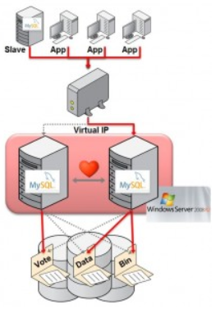
Figure 1

3. Failover versus Network Load Balancing clusters:
For any type of applications that are complex or large, Network Load Balance cluster provides more reliability and scalability [5]. It operates only on specific “stateless” applications, such as standalone applications and static web pages. These are generally network heavy, for example, VPN, firewall, FTP etc. The network load balance cluster will not maintain the sessions or save the data for next time use. This is because the state between the network connections will not be maintained, which means it will not store the data. Whereas in a “stateful” application, the failover cluster will maintain the stored data and keep backing up the storage. Failover supports stateful applications like Hyper-V and DHCP and is also capable of running the stateless applications.
In contrast, in web applications both failover and network load balancing clusters can be implemented. This is because in a web setup, it runs a database server in the backend with a Failover cluster and Network Load Balance cluster in the frontend. Failover cluster provides high availability of redundancy and will not spread the load.

4. Build process of a failover cluster
We have installed System Control Virtual Machine Manager (SCVMM) on our local desktop. Within SCVMM we have connected to a VM called Tesla. We have configured a Storage Area Network (SAN) tray within this VM for storing the networking configuration. SAN can handle multiple storage devices and make devices available to all local area network (LAN).
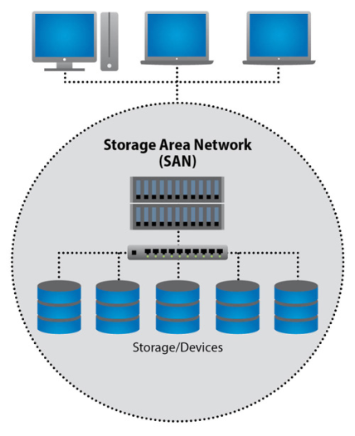
Figure 2.
SAN is a high-speed dedicated network which pools all the storage network devices and enables multiple servers to access the shared storage devices [7]. Cost and complexity are the disadvantages. The hardware of SAN is expensive and a specialist is required to maintain it.
We have created three new VMs using the wizard of the VM. We have provided an identity to the virtual machine by naming it as “Cardiff” and clicked next. Then we have configured the hardware by filling the necessary fields like cloud compatibility, processor and static memory of 4GB. We have then selected the destination for this virtual machine which is cloud and it was named as “DWAGroup1”.
In the same way we have created other server and named it as “Swansea”. We then have started the installation of Windows Server 2016 operating system. We did monitor the installation of this OS until it was installed successfully by checking the status. After which we have opened the VM via the console and provided the login credentials. If any errors occur after the console is launched, then it could be due to incorrect credentials being provided.
Once the correct credentials were provided, “Hyper-V” was shown on the console screen and VM booting summary was also displayed. Setup of Windows operating system was performed successfully and made it as a licenced version by providing the licence key.
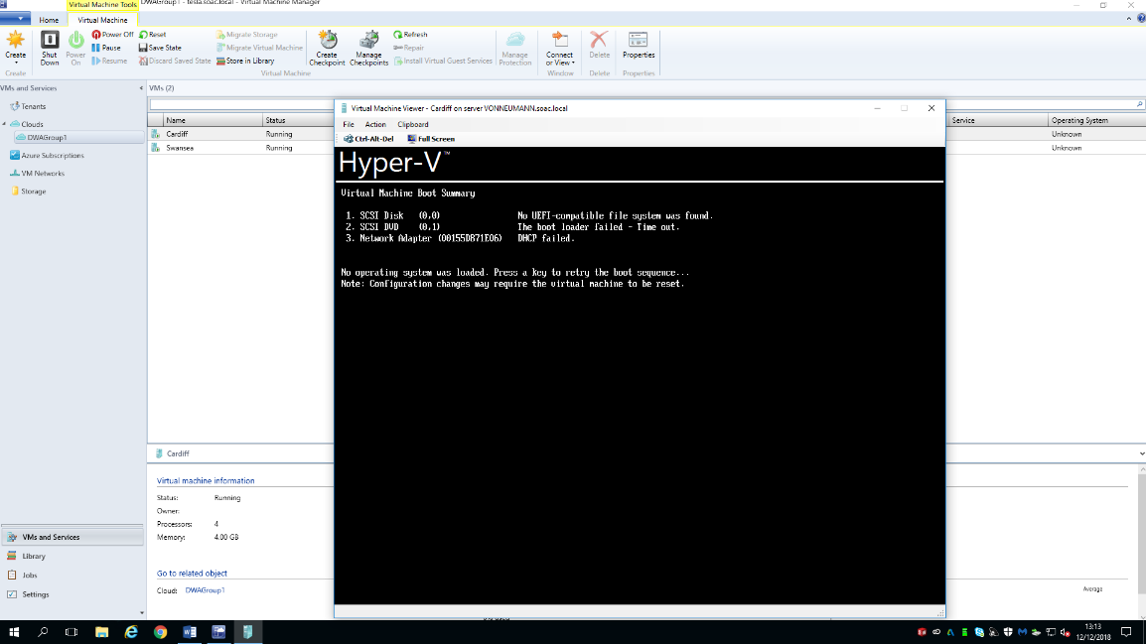

Figure 3
Figure 3 shows the working screen of the server. During the process, it asks to choose the disks within the server for the disk partitions. We have selected the required disk and clicked “Next” to install.
Computer name was also changed to “Cardiff” for better identification. Open “Cardiff” server properties and setup the network configurations which is available within Hardware configuration. Select a VM network which is appropriate to establish network connections. After opening the network configuration, open Ethernet properties and select Internet Protocol Version 4 (IPv4), now provide the appropriate IP address (192.168.0.1) and Subnet mask (255.255.255.255) which is automatically shown after entering the IP address and then provide the default gateway which is a network provider.
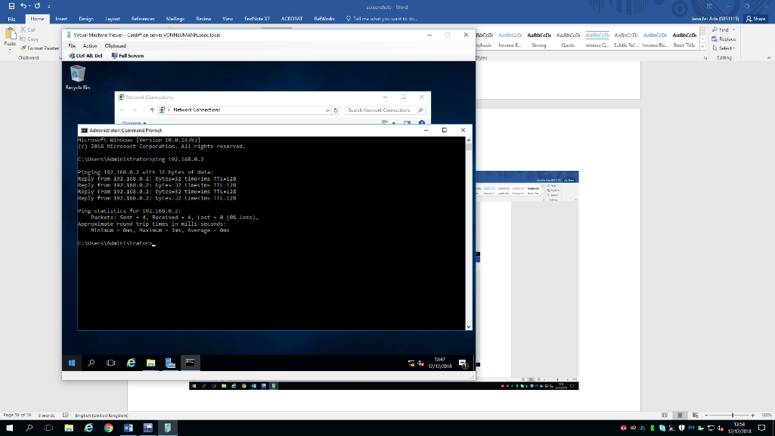
Figure 4
In figure 4 we can see the testing of the configured network. We have implemented another VM named “Lab-01”.
Network IP address will help the router to identify a network for internet. Select router role from Add Roles and Features as shown in figure 5.
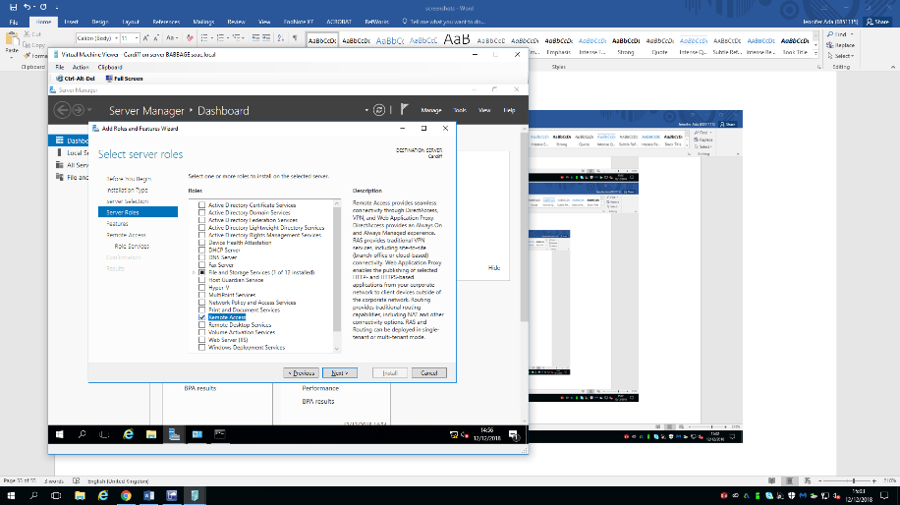
Figure 5
After installation, routing and remote access was enabled. This helps the server to connect to other networks and it establishes the connection from remote client. We can find all the networks that were created on the server.
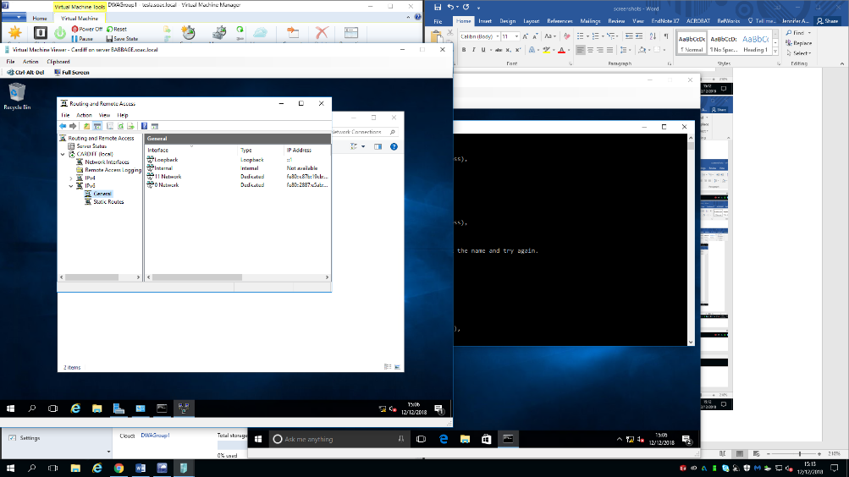
Figure 6
Routing Information Protocol (RIP) is a routing protocol which dynamically finds the best path between source and destination using hop count as routing metric. Now routing the networks which is present in the server. Figure 7 shows the internet working on other servers.
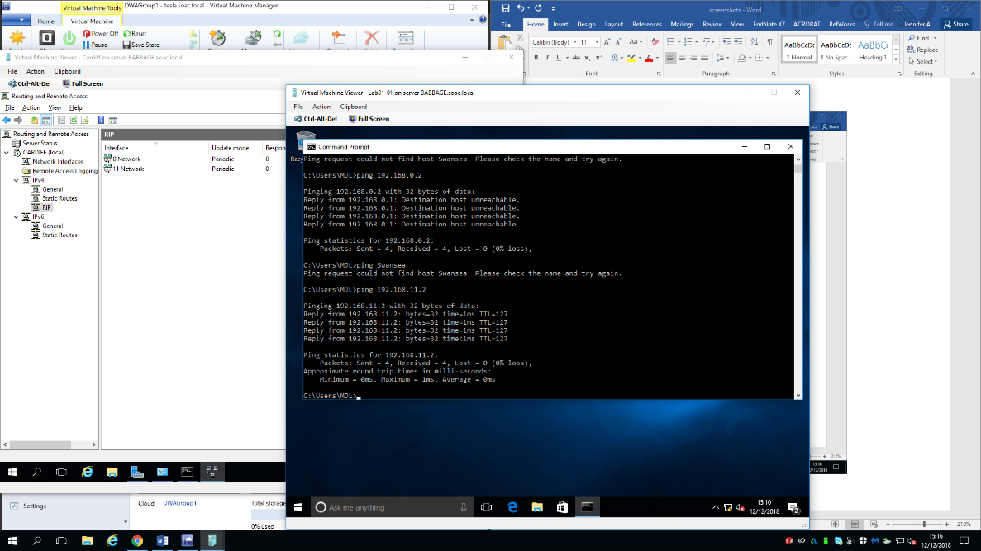
Figure 7

Information will be exchanged between source and destination for every 30 seconds. The count is allowed up to 15. If the count is greater than 15, then it is ignored. Now all the servers can communicate via networking.
We have added Dynamic Host Configuration Protocol (DHCP) server as a role which helps the network administrator to monitor all the network configuration. It requires IP address, subnet mask, and DNS. There will be a specific period which is known as lease and it should be renewed, or it expires. There will be scope in DHCP, which specifies start and end dates and another network configuration.
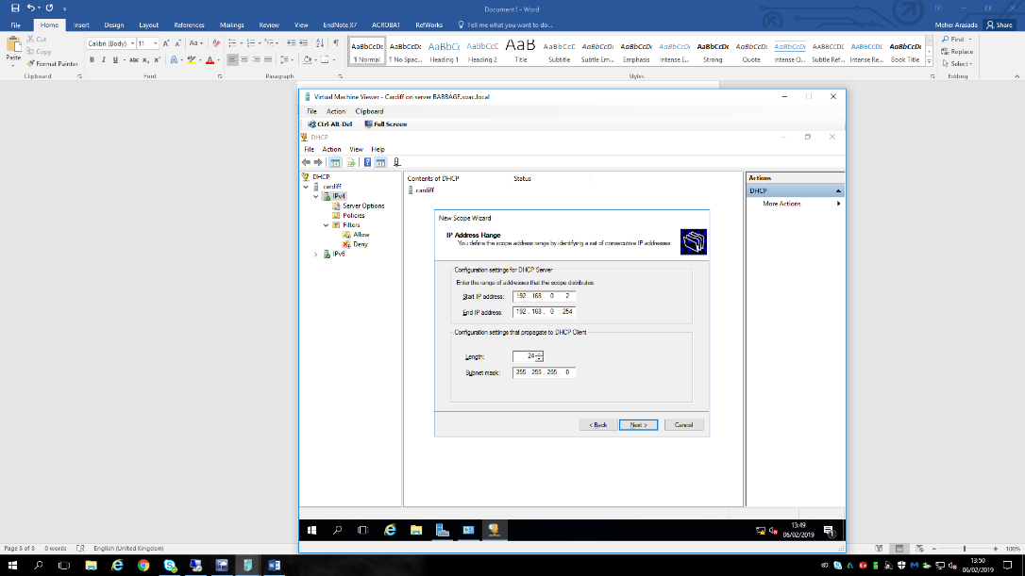
Figure 8
In the figure 8 we can see the configuration of DHCP. Figure 9 shows the DNS is been add. All the required requirements for DHCP we full filled and at the same time ensure that the client is assigned with the same IP address where we need to reserve it, so we add reservation with the MAC address for the specific rage of IP address.
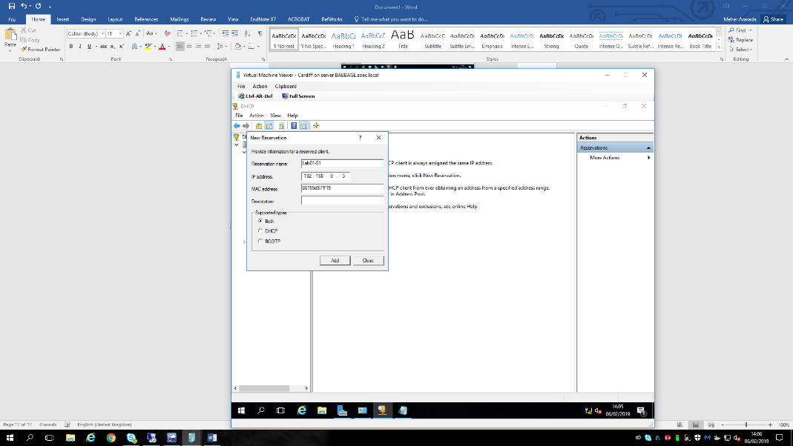
Figure 9

Domain Name System (DNS) allows namespace to divide into zone. Zone like root zone can be said as root domain which starts from here. Then next level of zone is top-level domain where com, edu, net, org etc., these will come. Second level domain like organization’s name which is “nwtraders” in this scenario. Last level is subdomain like north, west, south etc. Now Fully qualified domain name (FQDN) is server1.sales.south.nwtraders.com. If any unresolvable query like non-authoritative DNS server and then the query is forwarded to a specific query server called as Forwarder. Completed zone can be seen in figure 10.
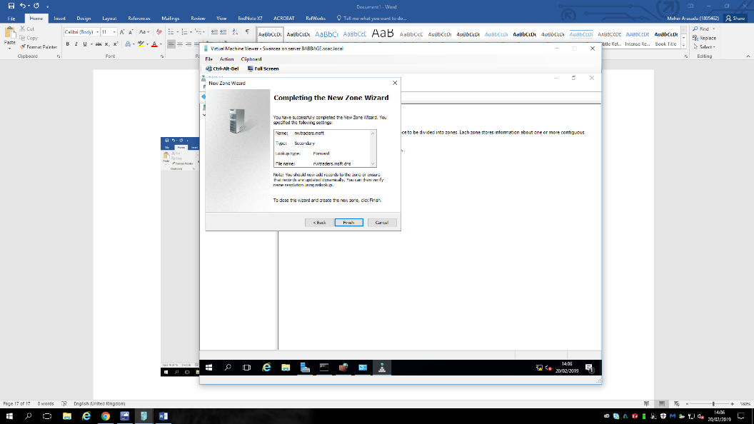
Frigure 10
Internet Information Service (IIS) which is designed by Microsoft for windows server. It is used for hosting the website and graphic user interface for managing the website and associated users. Now create a test website by adding a virtual directory and provide alias path. Provide all the permissions for the test connection and a file with the name “test”. Now open the website with the name “server.web.nwtraders.msft/test”, what ever content is present in that file, it will be displayed. We can see in the figure 11, where the website is accessed.
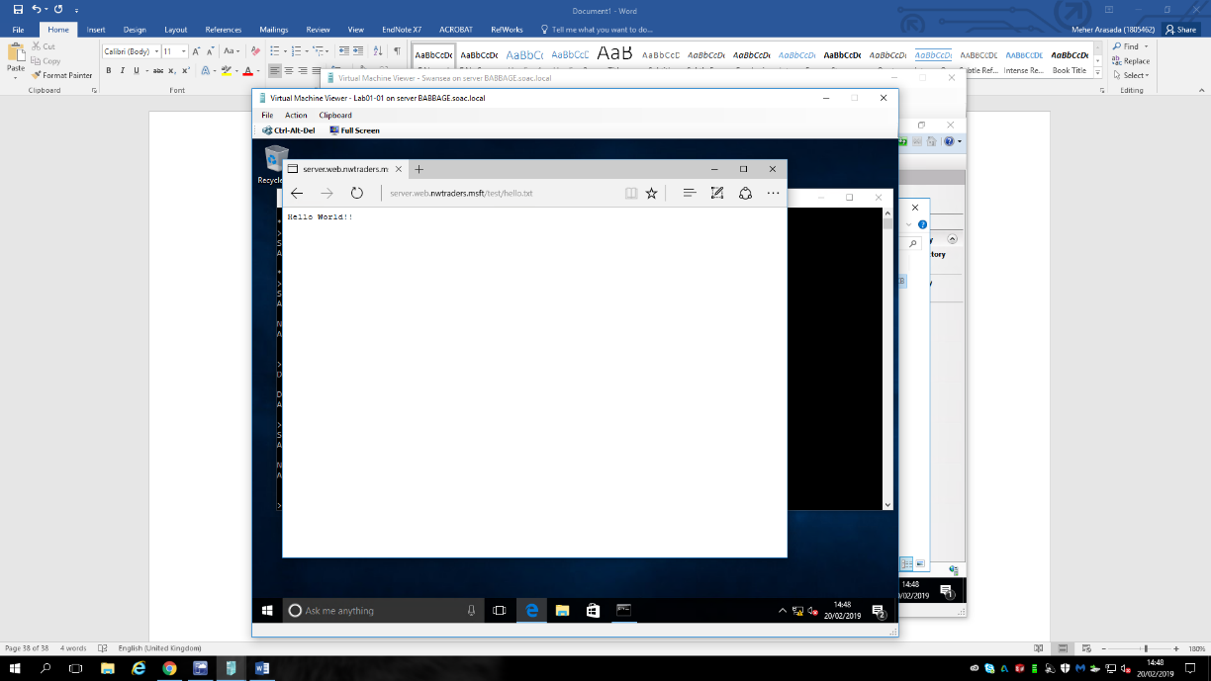
Figure 11
Active Directory (AD) is used for manging the security principles, users, computers and the range of the domaine related proess. It is a single point of contact with all the controlls.

5. Evaluating the built cluster
Previously we have discussed and setup the cluster architecture for operation and performance. We have two serves ready where networking is implemented properly and now let us see the implementation.
Layout of the cluster is:
Domain Controller (Cardiff)
Node 1 (Swansea)
Node 2 (Bridgend)
Client (Lab01-01)
Initially a new virtual hard disk must be created in the domain controller with the size 25GB. Now we need to do into two partitions where one is 500MB for recovery, system files etc., and all the remaining partition is primary disk and both disks were formatted with NTFS. Multiple nodes need to access the cluster storage or disk just for witness purpose. We have used Internet Small Computer Systems Interface (iSCSI) technology to mange disks of the cluster. Now create new iSCSI initiator for both the partition of the disk. Make service and storage device exchange the information by using the IP address. We can see figure 10, iSCSI virtual disk on domain controller and initiated.
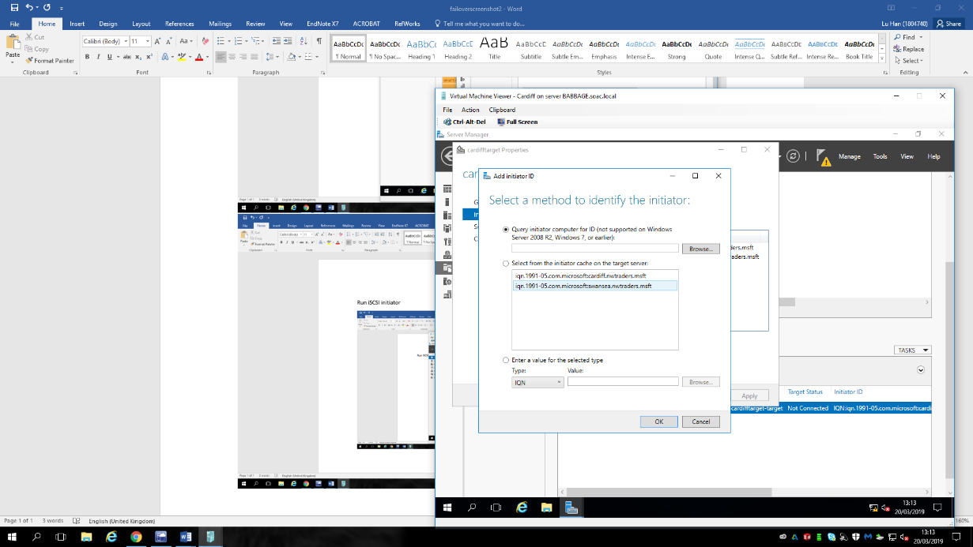
Figure 12
Now disks must be online but not with the driver letters. Both the partitions were named as “quorum” for smaller partition and “data” for bigger one. Add failover cluster to both the nodes, see figure 12.
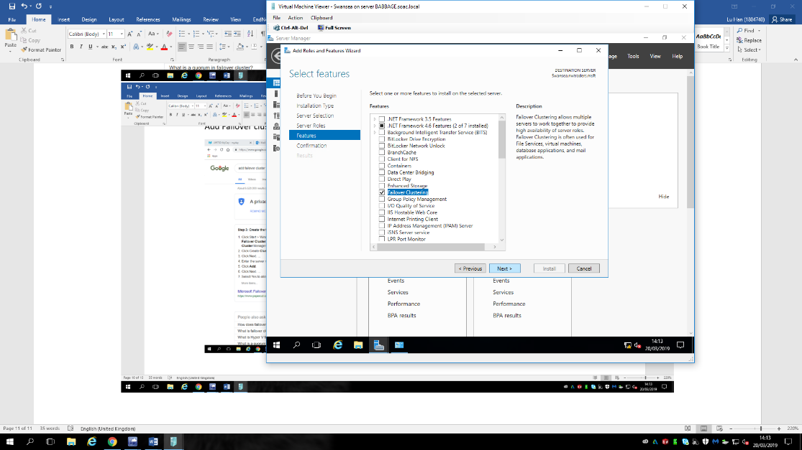
Figure 13
Node 2 (Bridgend) is the clone of Node 1 (Swansea). Now open the Failover cluster manager on any node and validate them. We can see in figure 14
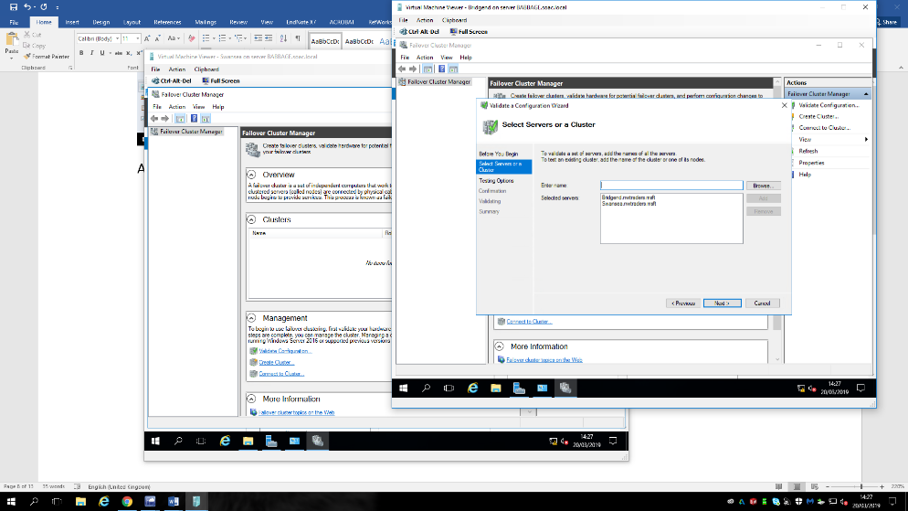
Figure 14
After validating both the disks will appear and make sure that quorum volume the smaller disk will be the witness. You can see the result of the validation in figure 15.
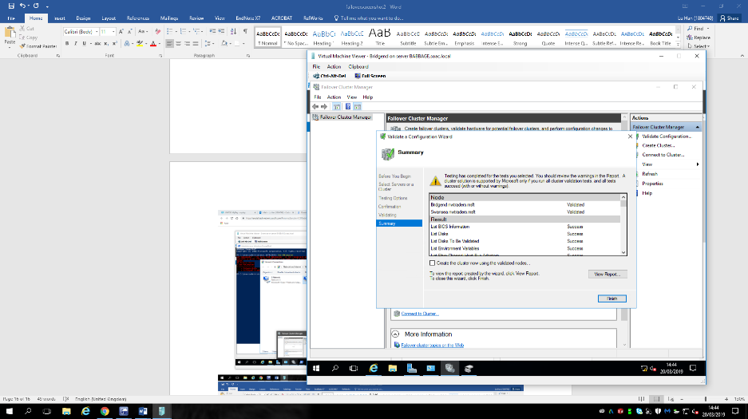
Figure 15
Now created cluster with the name “Wales”, in figure 16 you can see the summary of the cluster
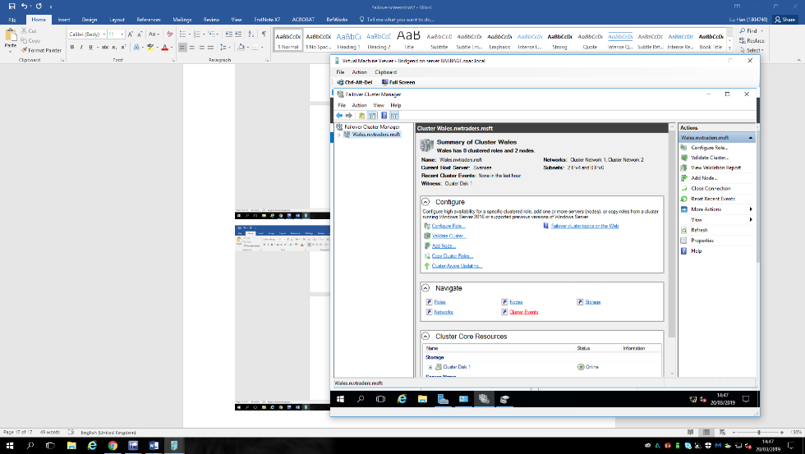
Figure 16
Delete DHCP role in domain controll and install DHCP in both the nodes. Configure the roles in the failover cluser and storage witness. Add cluster to the shared volume and select DHCP role and set the client access point with the name “BrigdendCluster” and see the figure 17 for the summary.
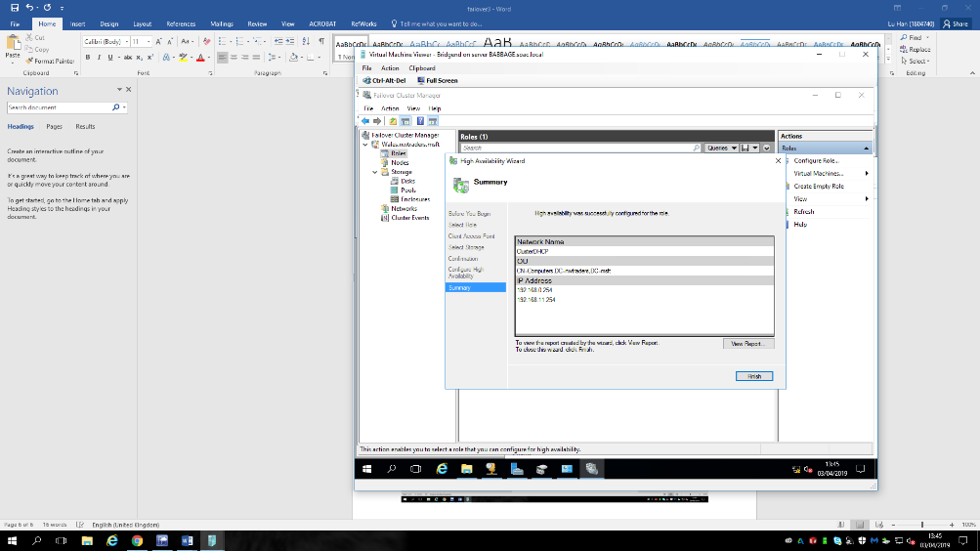
Figure 17
Specify the router by adding new scope which is to be distributed. Below figure 18,19, and 20 are evidence of failover cluster. We have switched off one server Bridgend means one server has failed and automatically other server will be activated that is Swansea server has been activated.

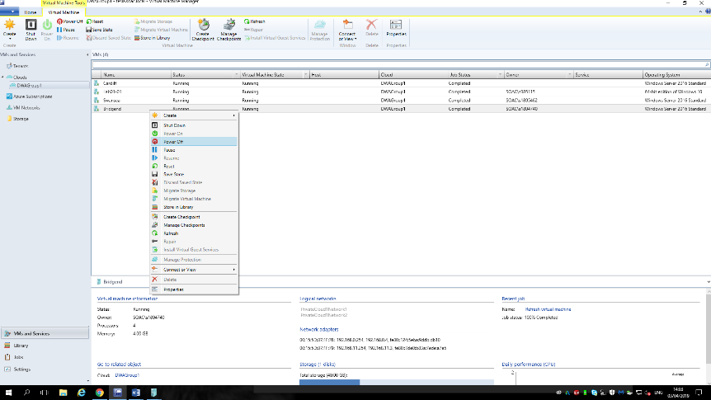
Figure 18
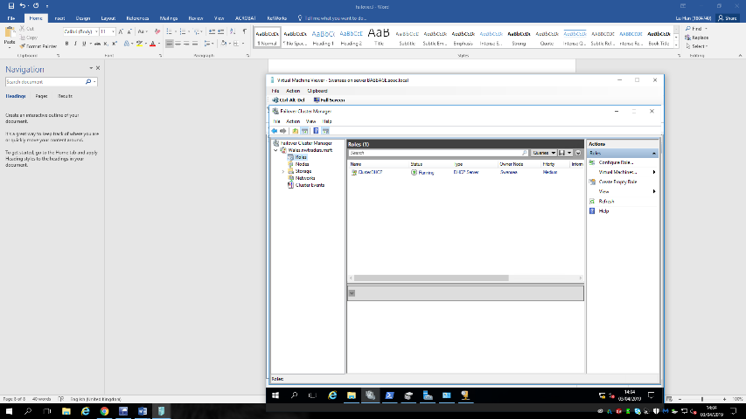
Figure 19
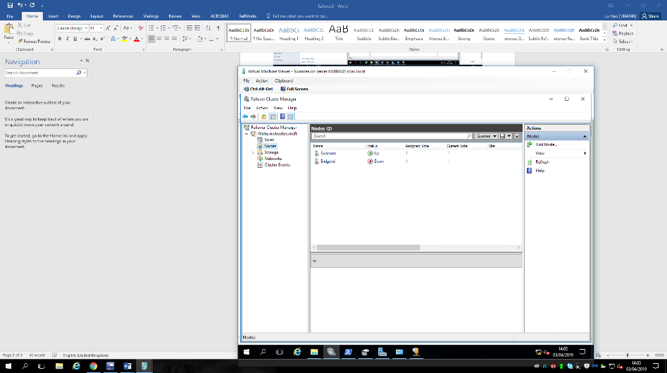
Figure 20
So, this is how we have performed Failover cluster practically and saw the advantege of the it.
6. Cloud Computing
Cloud is where every one stores and access data and programs over the internet. People involves hosted services over the internet. In flowcharts intrnet is been represented with a shape cloud, that is how cloude name came into existing. Cloude computing services are broadly categorised in to three services, as below [12].

6.1 Infrastructure as a service (IaaS):
It is the fist layer of the cloud computing, which is provided and managed by the external providers, in simple terms it is a hardware layer. It connects all the networking activities and gives access to virtualised components in order to build their own IT platform.
Benefits, scalability there will not be any delay in increasing the capacity. Pay the amount for which you have been used. Services are available through public cloud or private cloud for the people by the cloud providers.
As a part of this project we have used the System Center Virtual Machine Manager, SAN and networking as Infrastructure as a service.

6.2 Platform as a Service (PaaS):
It provides a platform and environment to the developer for building an application which they are planning to server the client through internet. It is a layered operating system in the cloud computing and mainly utilised by the software developers. They can develop, perform testing and host the application and make it available to the clients.
Benefits, it is not necessary to check with hardware requirements, because every developer need to check whether they have updated software and hardware to develop their application which costs you a lot and further developer may not work on it. So, the main advantage is developer can use wherever they want where they can find an updated software to develop their application. Developer need to pay for what they use, either it may be web developer or software developer. They can grow their business easy and faster.
We have used Microsoft Windows Serer is the Platform as a Service which provides all essential functionality.

6.3 Software as a Service (SaaS):
In general, we buy software and install in our devices and server our purpose. In the same base model where the software is hosted and provide the services to clients through internet. We can feel as if it is been install in our hard drives, but in real they are not. Best example for this SaaS is Office 365, most of them were familiar with this application. There are some more familiar examples like Google App, Salesforce, GoToMeeting, Netflix etc., and whenever they required to unsubscribe easily can be done without any loss.
Benefits of this is, saves money by not purchasing the hard disk and not necessary to do any initially setup cost. It is scalable, because additional services can be used without any setups like installing software and hardware. Updates automatic, compatible, customised and accessible from any location.
Hyper-V is a virtualization software which has been used for developing a failover cluster. It virtualizes entire hardware drives and network switches

7. Conclusion
As a part of my research, failover clusters are very important. Backing up the data is required for all, whether it might be small or big organization. We have created Hyper-V failover cluster. Hyper-V enabled using the Windows Server Failover Cluster manager. It includes network layout, SAN and features of failover cluster. We have developed and evaluated the failover cluster. As we discussed failover cluster maintains the high availability of the application and services. Identified the networking concepts with clear understanding.

