University of Wales Trinity Saint David
Wales Institute of Science & Art



Design of Filter Circuit
Electrical Principles (ACMA4031)

Dominic Jowitt
2510904
April 2026

Abstract
The experiment was to use low-pass and high-pass filter circuits to determine at what frequency each circuit reached their -3dB cutoff frequency. This was done through simulation (theoretical) testing and actual (lab) testing to then compare the two results, of which show that the theoretical results were very close to the actual results. The following cutoff ranges have been identified from the experiment:
Frequency cutoff results
 | Theoretical (Hz) | Actual (Hz)
Low-pass | 28k-29k | 20k-30k
High-pass | 1.1k | 1000-1050

- Contents
1. Abstract 1
3. Introduction 2
3.1. What are RC filters 2
3.2. Theory used in investigation 2
4. Circuit Descriptions 3
4.1. Testing Parameters 3
4.2. Theoretical Circuit 4
4.3. Actual Circuit 5
5. Results 7
5.1. Low-pass results 7
5.2. High-pass results 8
5.3. Calculated cutoff frequencies 8
6. Discussion 9
7. Conclusion 9
8. References 9
9. Appendix 9

Introduction

What are RC filters
  - Low-pass filter
A low-pass filter is one that allows frequencies to pass through below a certain cutoff frequency so in this example the cutoff frequency was -3dB. It typically has a resistor in series with the input supply and a capacitor connected to a ground cable and the output is taken across the capacitor. Low-pass filters work relative to the input frequency. If the input frequency is low then the capacitor reactance is high which causes most of the input voltage to pass through the capacitor. On the other hand, when the input frequency is high the opposite happens and the voltage passes through the resistor which means that high frequencies are blocked while low frequencies are free to pass through. These low-pass filters are used in audio devices to remove high-frequency noise to make them sound better.
  - High-pass filter
A high-pass filter is the opposite and prevents low frequencies from passing through. Any frequencies lower than its cutoff frequency are blocked. Most high-pass filters contain a capacitor which is in series with the input supply and a resistor connected to the ground and has the output taken across it. When the input frequency is low in a high-pass filter its capacitor reactance is high blocking most of the signal from passing through because very little voltage reaches the output. The opposite happens when the input frequency is high therefore as more voltage reaches the output more signal also passes through.

Theory used in investigation
  - Reactance of capacitors
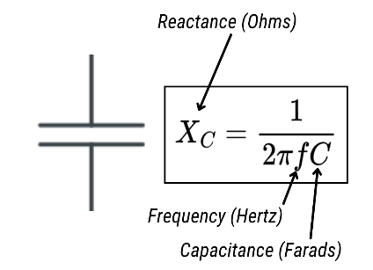
Figure 1 – Capacitive reactance formula
The formula shown in Figure 1 is the calculation for reactance of a capacitor. Capacitors oppose current similar to a resistor but instead they provide reactance instead of resistance, and the level of reactance is based on the frequencies, therefore depending on the frequency being put through them depends on how they act. The way they act can also depend on where they are placed in the circuit as explained earlier.

  - Attenuation and cutoff frequency
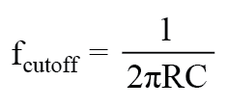
Figure 2 - Cutoff frequency formula
Cutoff frequency
The cutoff frequency is the point where the voltage drops to 70.7% of the input voltage and also where the signal power drops to 50% of the input power, this is calculated using the equation above. This typically is where the attenuation is equal to -3dB and is calculated using the formula in Figure 3. In my experiment we determined an estimated range of frequencies where the cutoff frequency would appear and then by simulating and building the circuit a specific value was achieved.
Attenuation
Attenuation occurs at all frequencies however, beyond the cutoff frequency is where the rate of attenuation has more of a significant impact. Attenuation is the reduction of output amplitude relative to the input.
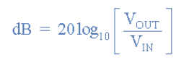
Figure 3 - Attenuation in dB formula
  - Report Outline
The report consists of information on the circuits including the components and diagrams as well as the parameters of the experiment. It also includes the results of each circuit in both theoretical and actual tests, all of which are plotted onto a frequency response curve graph. The results are then discussed and analysed before the report is then concluded.

Circuit Descriptions

Testing Parameters
The investigation being carried out was to use 2 circuits (Low-pass and a High-pass) and apply a peak-to-peak voltage of 4Vpp and change the input frequency to measure what the input and output voltages would be at each interval frequency (Figure 2 and Figure 3). Then by building each circuit in the online electrical simulation software (Proteus), and in the University Laboratory using breadboards, electrical wiring and components to then evaluate and compare the results. After this the attenuation is calculated and plotted onto a graph against the frequency on a logarithmic x-axis. Finally, by identifying the cutoff frequency, the theoretical and actual frequencies can be compared. The yellow highlighted sections in both Figure 2 and Figure 3 were the range where the cutoff frequency is expected to appear.
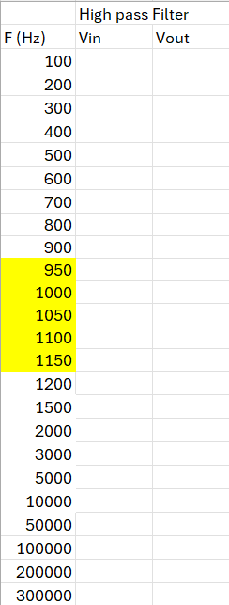
Figure 4 - Low-pass frequencies
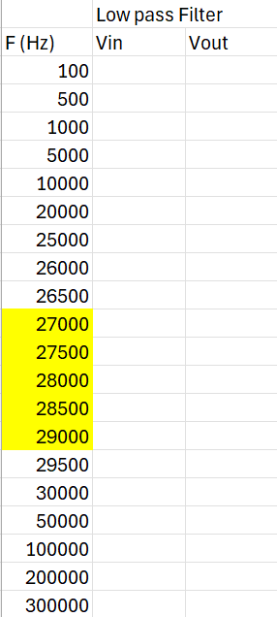
Figure 5 - High-pass frequencies

Theoretical Circuit
The theoretical values were recorded from Proteus simulations, as represented in the two figures below, before being put into a spreadsheet for calculating and comparing.

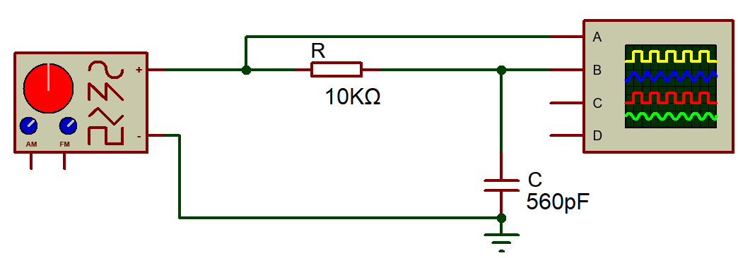
Figure 6 - Low-pass filter circuit
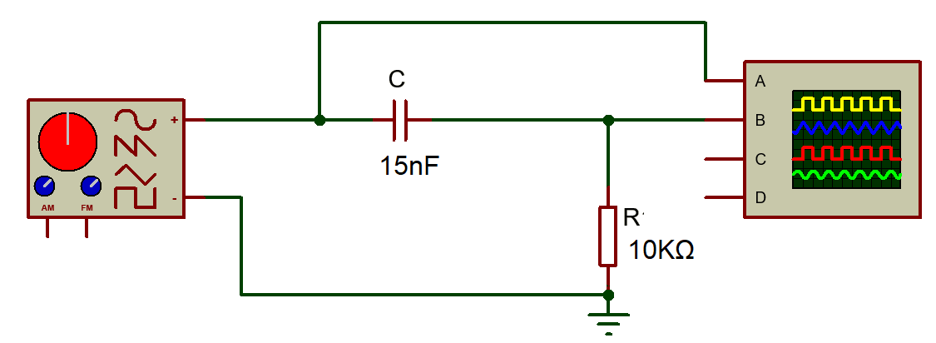
Figure 7 - High-pass filter circuit
Figure 4 and Figure 5 are images of each circuit with the components that were used for both the theoretical and actual results. The low-pass filter circuit components consist of a 10KΩ resistor, a 560pF capacitor, a signal generator and an oscilloscope. The high-pass filter circuit components consist of a 10KΩ resistor, a 15nF capacitor, a signal generator and an oscilloscope.

Actual Circuit
The circuit was then constructed using the same components to get the actual results to be compared to the theoretical values from the Proteus simulation.

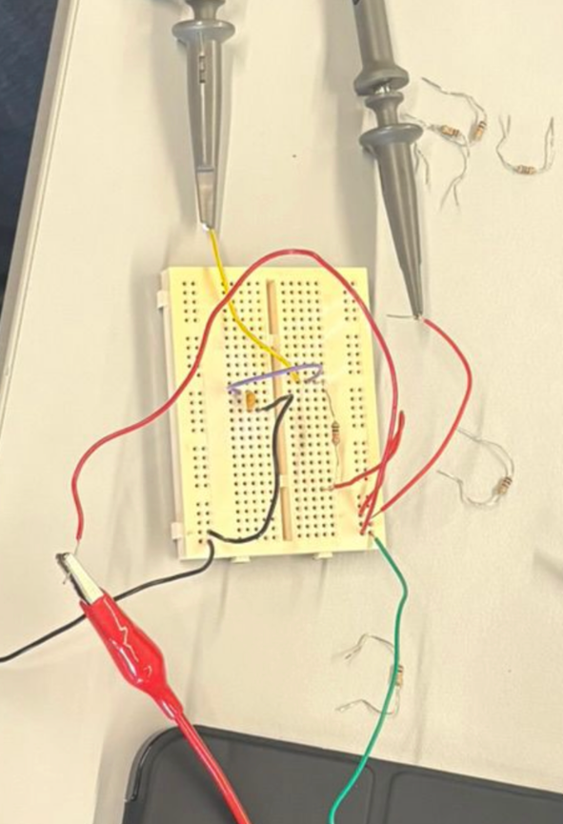
Figure 8 - Low-pass circuit

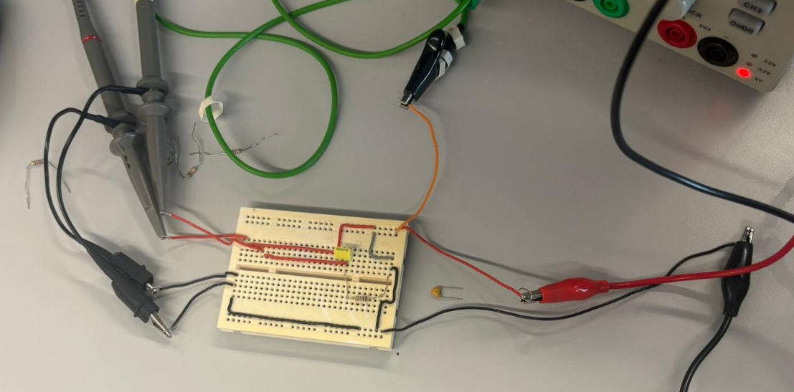
Figure 9 - High-pass circuit

Results

Low-pass results

High-pass results

Calculated cutoff frequencies

- Low-pass theoretical cutoff is 28.4kHz
- Low-pass actual cutoff is 24.3kHz
- High-pass theoretical cut-off is 1.06kHz
- High-pass actual cut-off is 1.10kHz

Discussion
Actual could have had other frequency interference due to being in the university labs which could be evaluated against the theoretical values recorded.
Length of wiring and any nearby items that effect frequency

Conclusion

References
“a computer simulation is an attempt to model a real-life or hypothetical situation on a computer so that it can be studied to see how the system works. By changing variables in the simulation, predictions may be made about the behaviour of the system. So, computer simulation is a tool to virtually investigate the behaviour of the system under study.” (Asadi, F. 2022).

Asadi, F. (2022). Essential Circuit Analysis Using Proteus®. [online] Google Books. Available at: https://books.google.co.uk/books?hl=en&lr=&id=wVOZEAAAQBAJ&oi=fnd&pg=PR7&dq=what+is+proteus+and+why+is+it+used+in+electronics&ots=9dUwwau0Uz&sig=ztDSW2GdDr7w7MautAYDR7buHbI#v=onepage&q=what%20is%20proteus%20and%20why%20is%20it%20used%20in%20electronics&f=false [Accessed 2026].

Figure 1 - Stompbox Electronics (n.d.). Capacitive Reactance (Xc) Calculator. Available at: https://stompboxelectronics.com/resources/capacitive-reactance-xc-calculator/ [Accessed 2026].

Figure 2 - All About Circuits (2019). Low-pass Filters | Filters | Electronics Textbook. [online] Allaboutcircuits.com. Available at: https://www.allaboutcircuits.com/textbook/alternating-current/chpt-8/low-pass-filters/.

Appendix

