
Exam – Dawid Trochim 1900457
Information Engineering

January 14, 2020
University of Wales Trinity Saint David

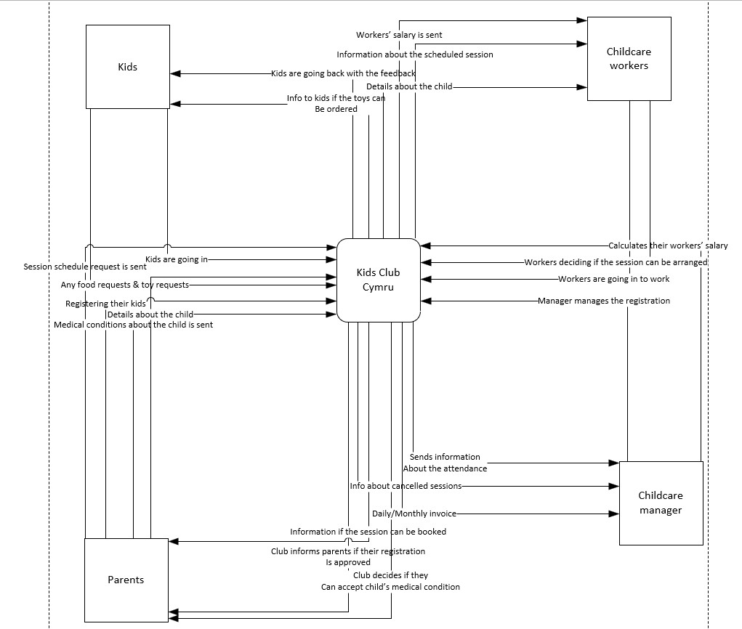
Context Diagram
Here is my context diagram showing the fundamentals of Kids Club Cymru

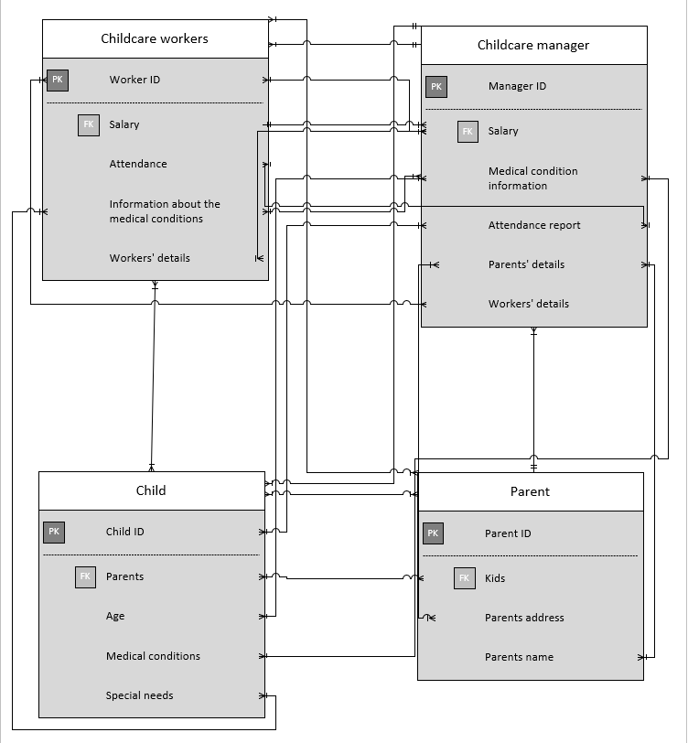
ERD Diagram
Here is my ERD Diagram showing all the connections and relationships between fields and entities

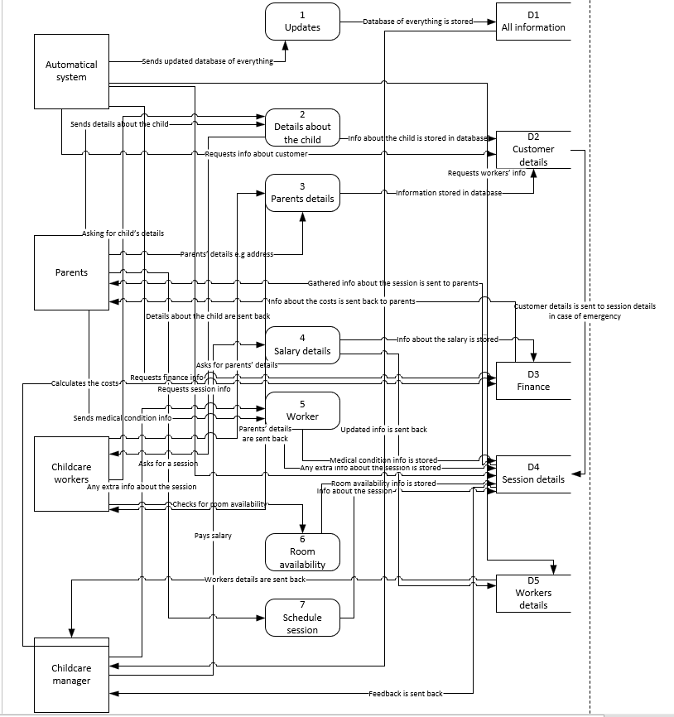
DFD Level 0 Diagram
The diagram above shows my Level 0 DFD Diagram

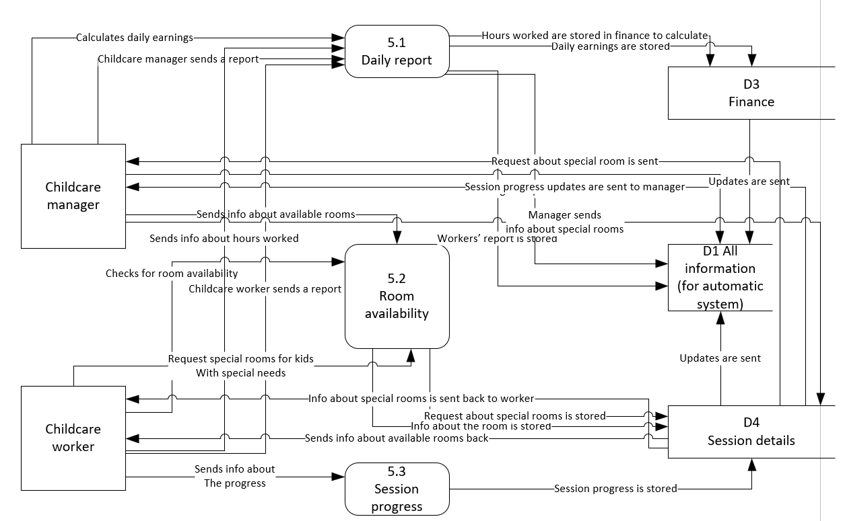
DFD Level 1 Diagram

This diagram shows my DFD Level 1 Diagram.

