LINKERS
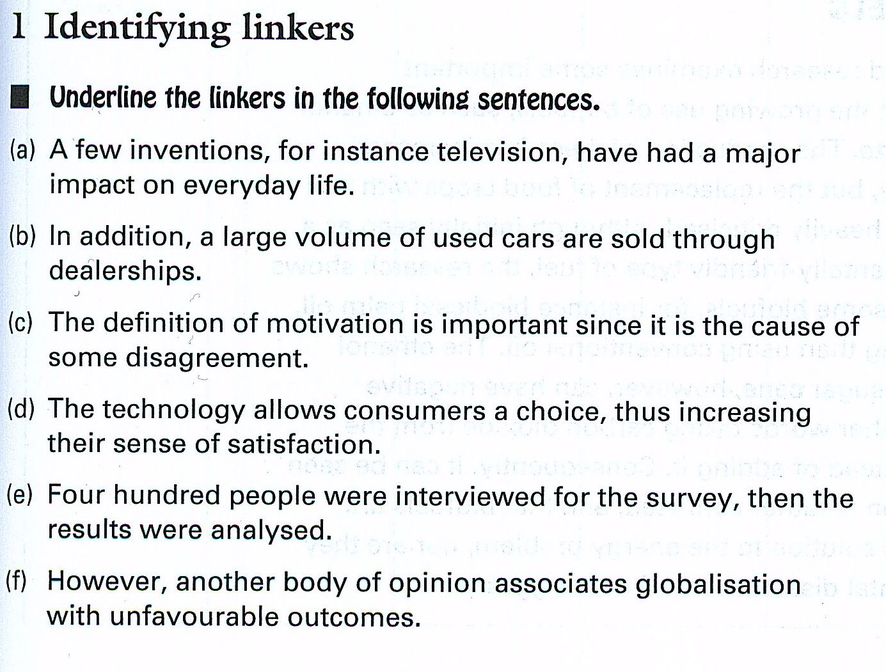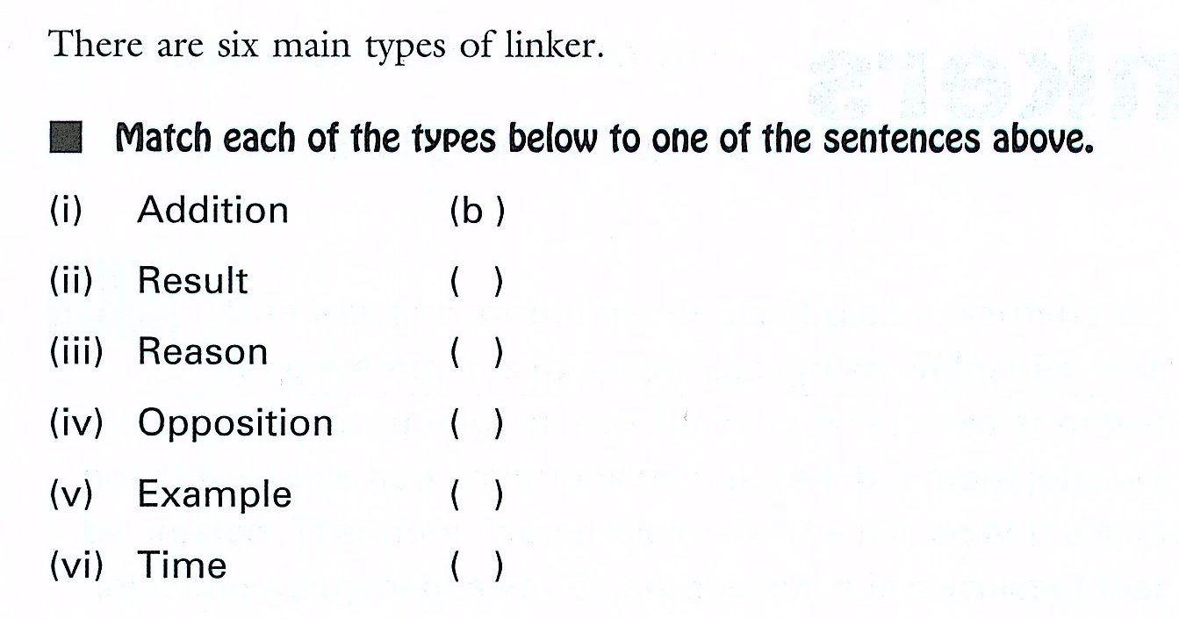 | 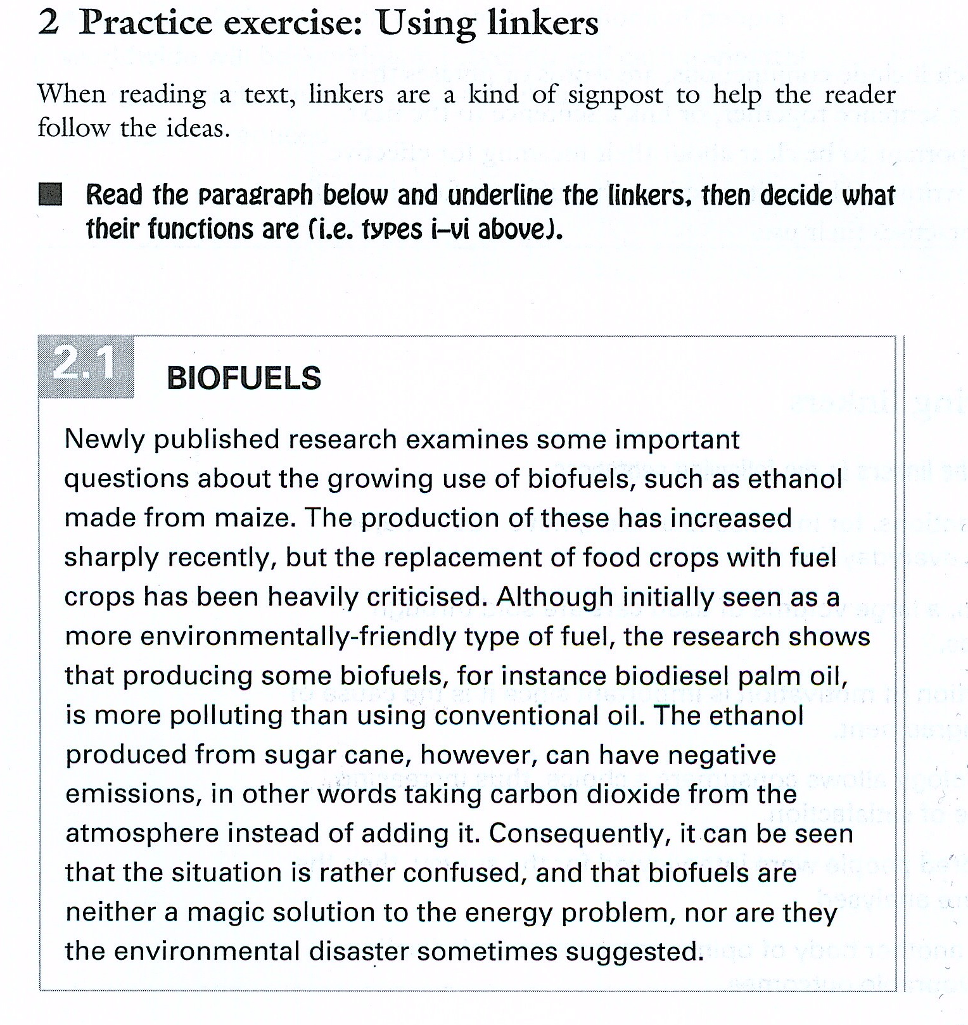

ss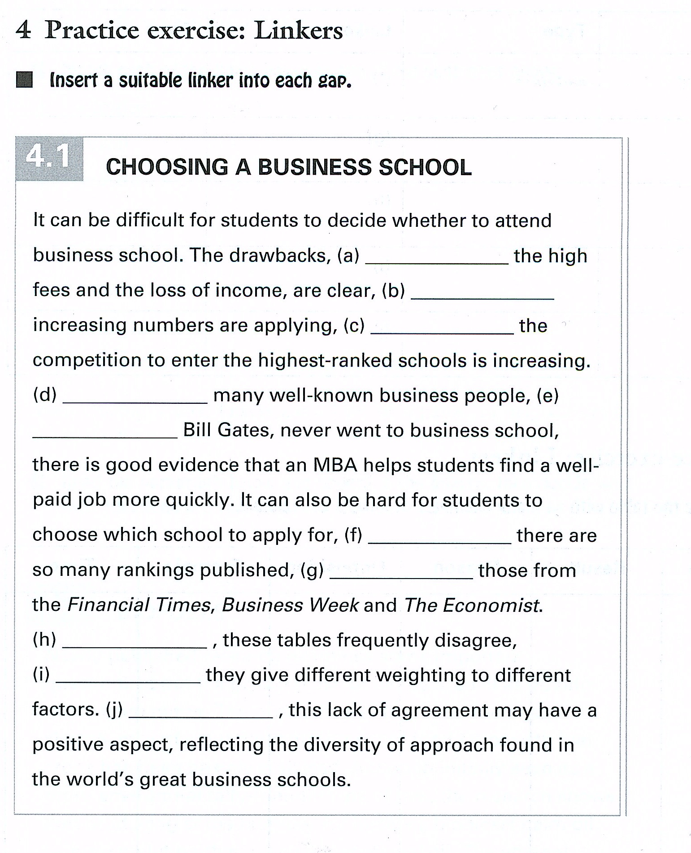 | - Such as / for example / for instance (provide examples)  - But / yet/ however/ nevertheless  - And / consequently / thus/ therefore  - Although  - Such as / for example  - Because / as / since  - For example / such as  - Furthermore / moreover / in addition,  - Because  - However / Nevertheless

LINKING WORDS
EXAMPLES:
For example / For instance / such as / Another example is
ADD SIMILAR ARGUMENTS
First (never firstly!!), Second / in addition/ furthermore, besides/despite (informal) / also / moreover
Contrast / the opposite viewpoint
However/ on the other hand / Nevertheless
Cause and effect
Covid resulted in people losing their job. ……………..an increasing number of employees lost their homes.
As result / therefore/ consequently/ for this reason / thus/ hence/ ergo (archaic English)

